Appendix: Cultural and morphological characteristics of the mean entomopathogenic fungi genera isolated from Argania spinosa soils and nearby area using C. capitata pupae as bait
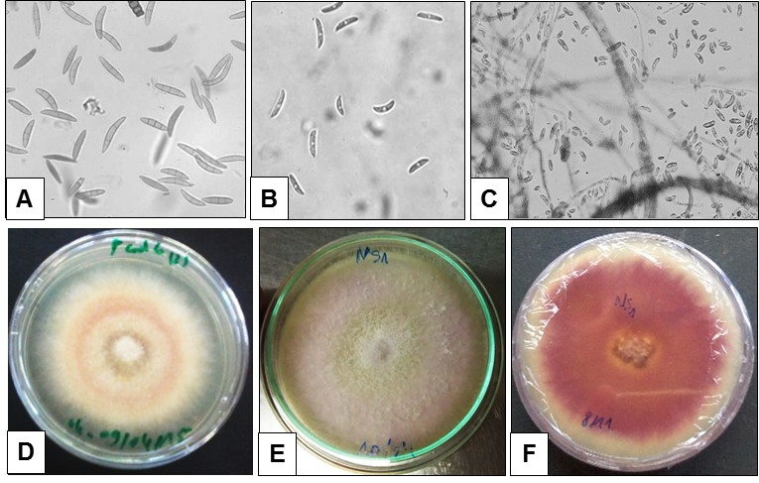
Fig. 1: Cultural and microscopic morphological characteristics of Fusarium sp. isolates. A, B: Macroconidia and microconidia observed at x1000 magnification; C: Conidia and observed at x400 magnification; D, E, F: colonies aspects on PDA (E and F are representing the F. oxysporum NS1 isolate).
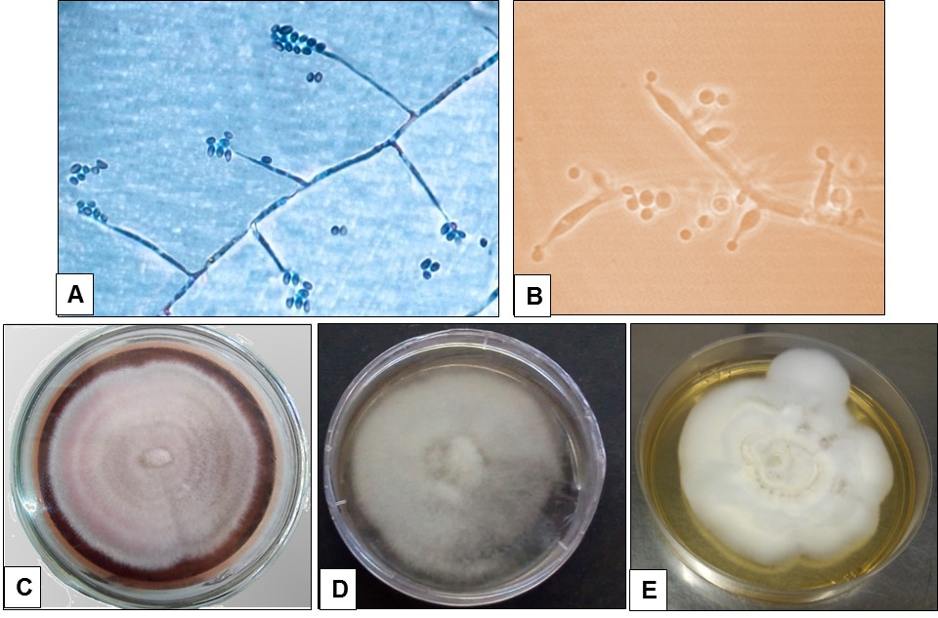
Fig. 2: Cultural and microscopic morphological characteristics of Beauveria bassiana. A, B: Hypha and conidia observed at x400 and x1000 magnification, respectively; C, D, E: colonies aspects on PDA.

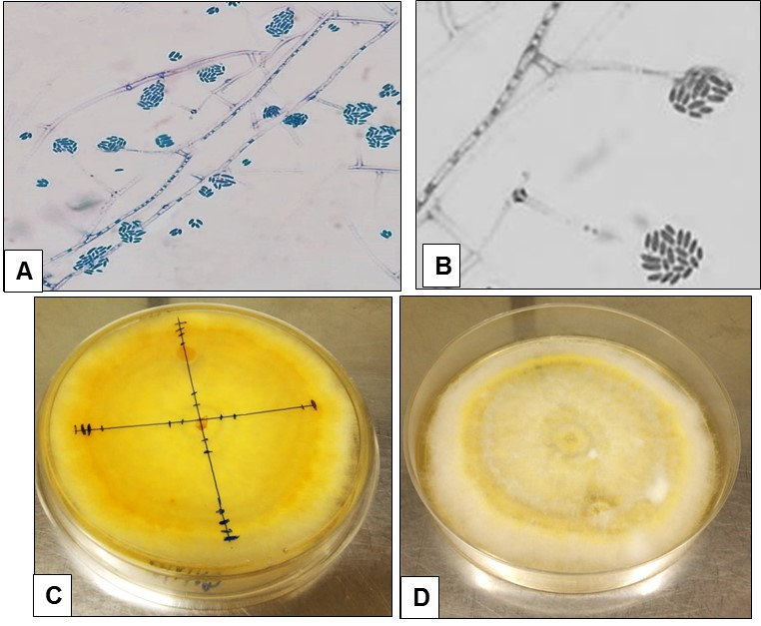
Fig. 3: Cultural and microscopic morphological characteristics of Acremonium sp. Pt34 isolate. A, B: Hypha and conidia observed at x400 and x1000 magnification, respectively; C, D: colony aspect on PDA.
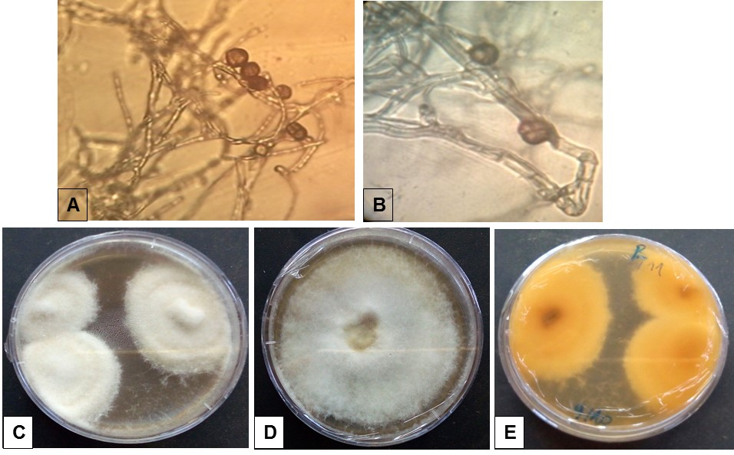
Fig. 4: Cultural and microscopic morphological characteristics of Epicoccum sp. isolates. A, B: Hypha and conidia observed at x400 and x1000 magnification, respectively; C, D, E: colonies aspects on PDA.

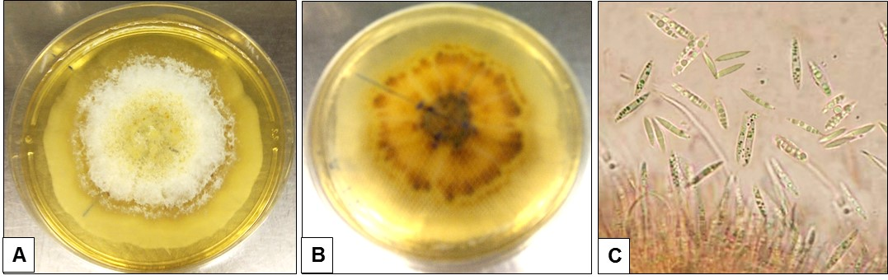
Fig. 5: Cultural and microscopic morphological characteristics of Aschersonia sp. Pt14 isolate. A, B: colony aspect on PDA; C: Macroconidia observed at x1000 magnification.

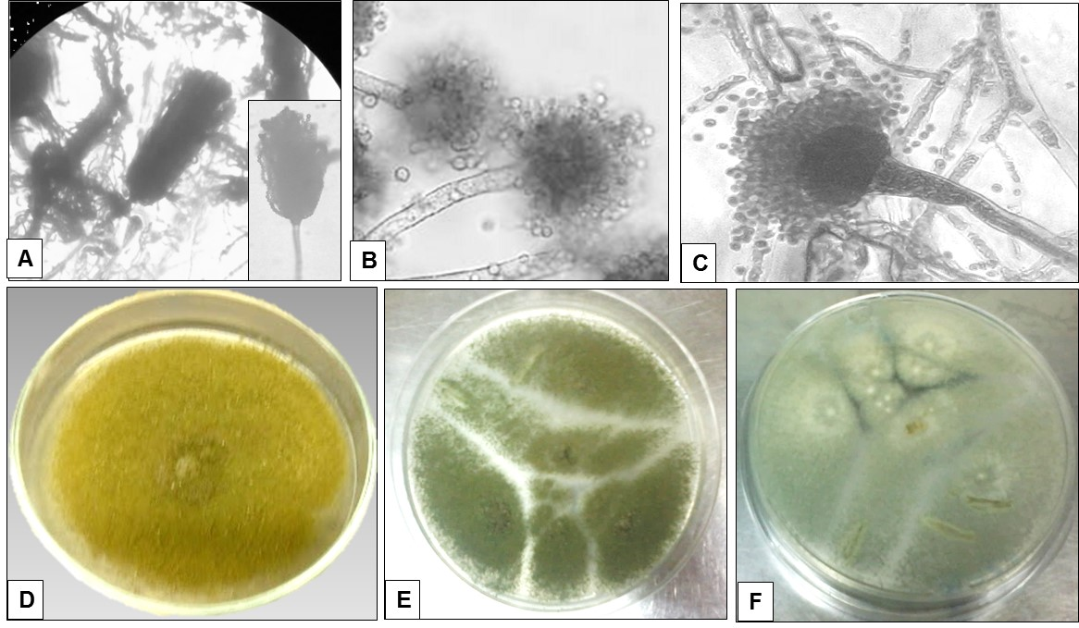
Fig. 6: Cultural and morphological characteristics of Aspergillus flavus isolates. A, B, C: hypha conidiophores and conidia at x1000 magnification (A shows A. flavus NS14 isolate conidiophore); D, E, F: colonies aspects on PDA.
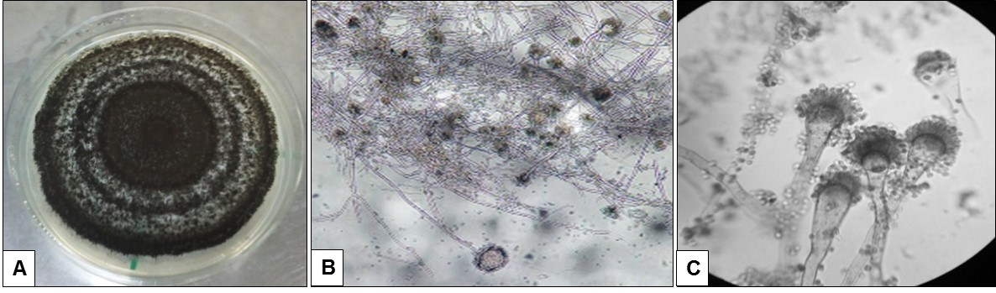
Fig. 7: Cultural and morphological characteristics of Aspergillus niger. A: colony aspect on PDA; B: hypha conidiophores and conidia at x400 magnification C: conidiophores and conidia at x1000 magnification.
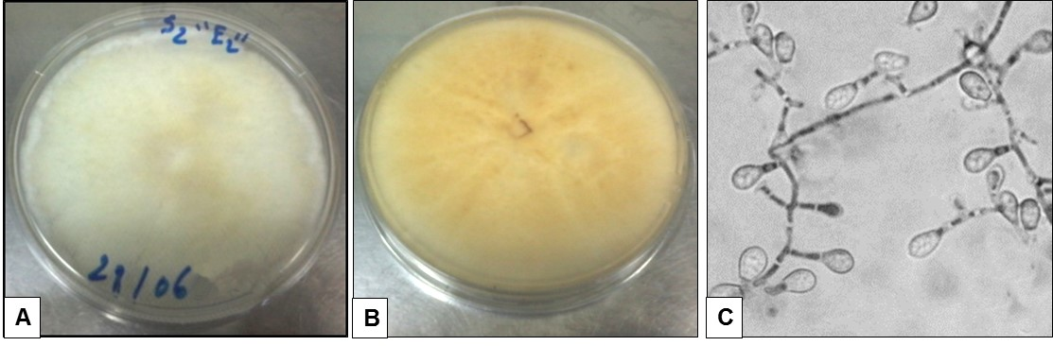
Fig. 8: Cultural and microscopic morphological characteristics of Scedosporium sp. A, B: colony aspect on PDA; C: Hypha and conidia observed at x1000 magnification.
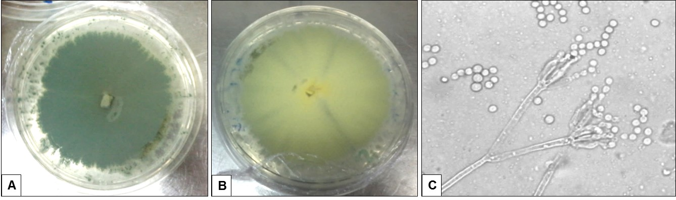
Fig. 9: Cultural and microscopic morphological characteristics of Penicillium sp. A, B: colony aspect on PDA; C: Hypha and conidia observed at x1000 magnification.
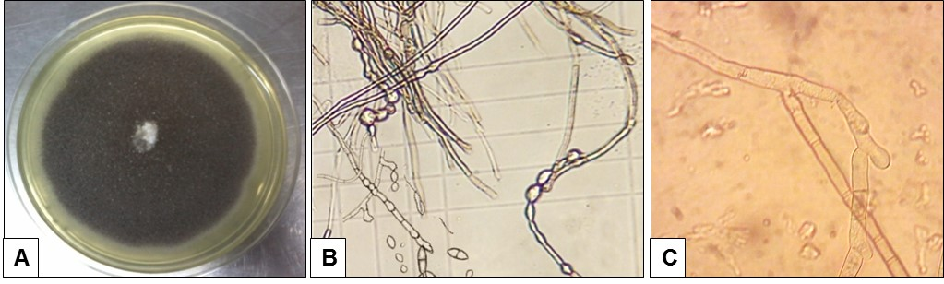
Fig. 10: Cultural and microscopic morphological characteristics of Cladosporium sp. A: colony aspect on PDA; B, C: Hypha and conidia observed at x400 and x1000 magnification, respectively.

