APPENDIX 1
Area covered by the various land cover changes in GAMA from 1991 to 2002.
Land Cover Change (1991-2002) | Area (Km2)
Vegetation-Transition | 167.15
Vegetation-Built-up | 107.53
Transition-Built-up | 102.05
Transition-Vegetation | 46.35
Built-up-Transition | 34.06
Built-up-Vegetation | 6.52
Water-Built-up | 4.32
Water-Vegetation | 4.01
Vegetation-Water | 2.70
Built-up-Water | 2.09
Water-Transition | 0.91
Transition-Water | 0.67

APPENDIX 2
Area covered by the various land cover changes in GAMA from 2002-2013
Land Cover Change (2002-2013) | Area (Km2)
Vegetation -Transition | 224.79
Transition -Built-up | 151.54
Vegetation -Built-up | 77.56
Transition -Vegetation | 65.19
Built-up -Transition | 23.29
Built-up -Vegetation | 13.72
Water -Vegetation | 3.40
Water -Built-up | 2.85
Built-up -Water | 1.23
Vegetation -Water | 0.60
Water -Transition | 0.33
Transition -Water | 0.09

APPENDIX 3
Area covered by the various land cover changes in GAMA from 2013-2022.
Land Cover Change (2013-2022) | Area (Km2)
Vegetation-Transition | 169.83
Transition-Built-up | 147.54
Built-up-Transition | 59.38
Vegetation-Built-up | 46.37
Transition-Vegetation | 36.97
Built-up-Vegetation | 7.21
Vegetation-Water | 3.70
Built-up-Water | 3.13
Water-Vegetation | 0.84
Water-Built-up | 0.47
Water-Transition | 0.12
Transition-Water | 0.08

APPENDIX 4
Transition Variables
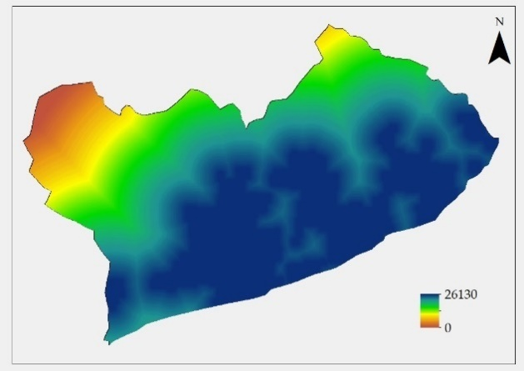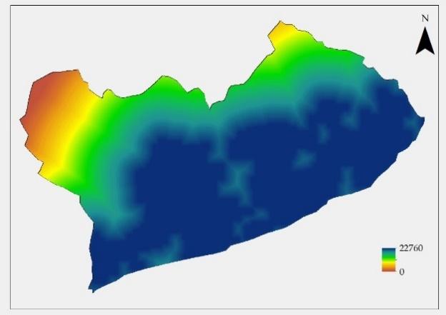
Appendix 4a Distance to CBD 2013 Appendix 4b Distance to CBD 2022
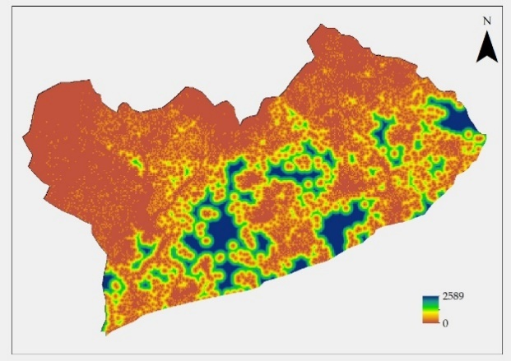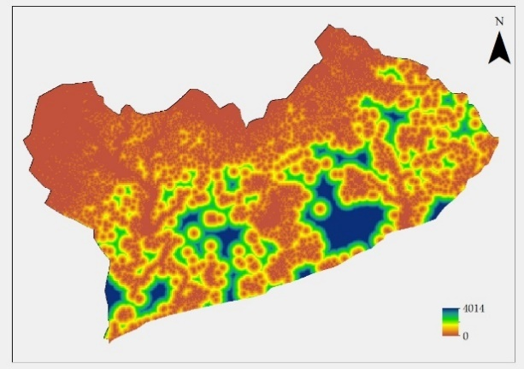
Appendix 4c Distance to Vegetation 2013 Appendix 4d Distance to Vegetation 2022

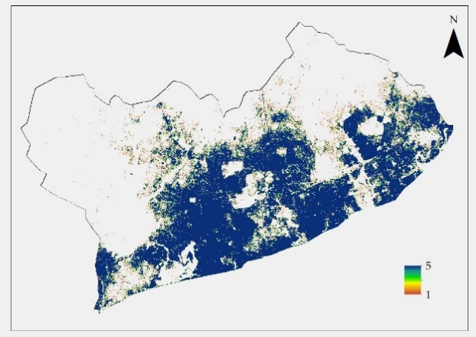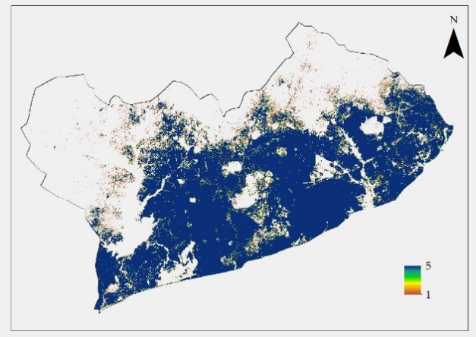
Appendix 4e fractal dimension 2013 Appendix 4f fractal dimension 2022

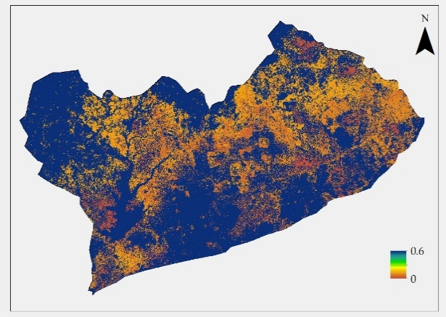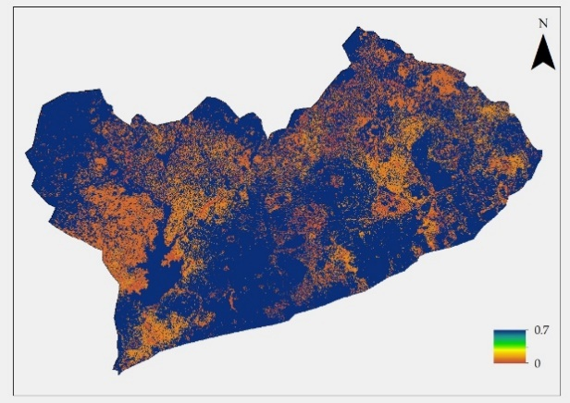
Appendix 4g Evlikelihood 2002-2013 Appendix 4h Evlikelihood 2013-2022

APPENDIX 5

Land Change Modeler MLP Model Results
(Created: 10/05/2023 13:36:56)

1. General Model Information
1) Input Files
Independent variable 1 | Evlikelihood2002-2013
Independent variable 2 | 2013_frac
Independent variable 3 | Dist_veg_2013
Independent variable 4 | Dist_urb_2013
Training site file | ch4_pred_Train_Urbanisation
2) Parameters and Performance
Input layer neurons | 4
Hidden layer neurons | 5
Output layer neurons | 5
Requested samples per class | 10000
Final learning rate | 0.0000
Momentum factor | 0.5
Sigmoid constant | 1
Acceptable RMS | 0.01
Iterations | 10000
Training RMS | 0.2123
Testing RMS | 0.2101
Accuracy rate | 86.78%
Skill measure | 0.8347
3) Model Skill Breakdown by Transition & Persistence
Class | Skill measure
Transition : Vegetation to Transition | 0.8974
Transition : Vegetation to Built-up | 1.0000
Transition : Transition to Built-up | 0.7916
Persistence : Vegetation | 0.6285
Persistence : Transition | 0.8555

2. Weights Information of Neurons across Layers
1) Weights between Input Layer Neurons and Hidden Layer Neurons
Neuron | h-Neuron 1 | h-Neuron 2 | h-Neuron 3 | h-Neuron 4 | h-Neuron 5
i-Neuron 1 | -15.0064 | 11.9790 | 11.0173 | -15.1586 | 0.5081
i-Neuron 2 | -7.3010 | -1.0642 | 1.0303 | 4.4292 | 0.1636
i-Neuron 3 | -1.6095 | 0.5460 | -1.6145 | 5.2878 | -0.5174
i-Neuron 4 | 13.4831 | -0.6015 | -3.3518 | -3.4671 | 3.0182
2) Weights between Hidden Layer Neurons and Output Layer Neurons
Neuron | o-Neuron 1 | o-Neuron 2 | o-Neuron 3 | o-Neuron 4 | o-Neuron 5
h-Neuron 1 | 9.7176 | 8.6705 | -11.3918 | 5.5396 | -11.8220
h-Neuron 2 | 0.3593 | -12.9177 | 2.5852 | -3.6545 | 2.9132
h-Neuron 3 | -6.8030 | -13.3452 | -1.6210 | 3.0526 | 4.9523
h-Neuron 4 | -12.5072 | 6.7141 | 7.2890 | -10.7864 | -0.2356
h-Neuron 5 | -3.9226 | -2.4568 | -3.5285 | -1.7953 | -3.0675

3. Sensitivity of Model to Forcing Independent Variables to be Constant
1) Forcing a Single Independent Variable to be Constant
Model | Accuracy (%) | Skill measure | Influence order
With all variables | 86.78 | 0.8347 | N/A
Var. 1 constant | 34.91 | 0.1863 | 1 (most influential)
Var. 2 constant | 40.33 | 0.2542 | 2
Var. 3 constant | 86.78 | 0.8347 | 4 (least influential)
Var. 4 constant | 75.00 | 0.6876 | 3
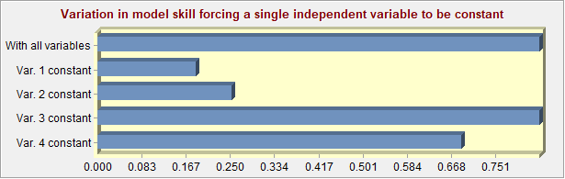
2) Forcing All Independent Variables Except One to be Constant
Model | Accuracy (%) | Skill measure
With all variables | 86.78 | 0.8347
All constant but var. 1 | 40.10 | 0.2512
All constant but var. 2 | 34.91 | 0.1863
All constant but var. 3 | 20.04 | 0.0005
All constant but var. 4 | 12.07 | -0.0991
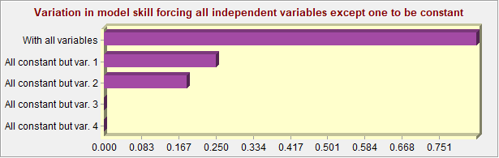
3) Backwards Stepwise Constant Forcing
Model | Variables included | Accuracy (%) | Skill measure
With all variables | All variables | 86.78 | 0.8347
Step 1: var.[3] constant | [1,2,4] | 86.78 | 0.8347
Step 2: var.[3,4] constant | [1,2] | 75.00 | 0.6876
Step 3: var.[3,4,2] constant | [1] | 40.10 | 0.2512
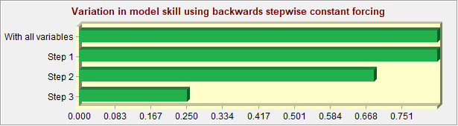

Land Change Modeler MLP Model Results
(Created: 10/05/2023 13:44:16)

1. General Model Information
1) Input Files
Independent variable 1 | Evlikelihood2002-2013
Independent variable 2 | 2013_frac
Independent variable 3 | Dist_veg_2013
Independent variable 4 | Dist_urb_2013
Training site file | ch4_pred_Train_Afforestation
2) Parameters and Performance
Input layer neurons | 4
Hidden layer neurons | 4
Output layer neurons | 4
Requested samples per class | 10000
Final learning rate | 0.0001
Momentum factor | 0.5
Sigmoid constant | 1
Acceptable RMS | 0.01
Iterations | 10000
Training RMS | 0.2290
Testing RMS | 0.2285
Accuracy rate | 86.15%
Skill measure | 0.8154
3) Model Skill Breakdown by Transition & Persistence
Class | Skill measure
Transition : Transition to Vegetation | 0.7494
Transition : Built-up to Transition | 0.8083
Persistence : Transition | 0.7856
Persistence : Built-up | 0.9181

2. Weights Information of Neurons across Layers
1) Weights between Input Layer Neurons and Hidden Layer Neurons
Neuron | h-Neuron 1 | h-Neuron 2 | h-Neuron 3 | h-Neuron 4
i-Neuron 1 | -11.0221 | -0.7713 | 7.4612 | 1.9104
i-Neuron 2 | -0.9747 | -0.6502 | -3.4820 | 0.3592
i-Neuron 3 | 2.8321 | -7.5729 | -15.2060 | 16.2359
i-Neuron 4 | 1.2936 | 8.0707 | 15.7859 | -17.7950
2) Weights between Hidden Layer Neurons and Output Layer Neurons
Neuron | o-Neuron 1 | o-Neuron 2 | o-Neuron 3 | o-Neuron 4
h-Neuron 1 | 6.7628 | 8.6903 | -10.0777 | -8.3956
h-Neuron 2 | 3.2304 | -3.8920 | 0.5528 | -7.6366
h-Neuron 3 | -0.5786 | -15.8761 | 7.8819 | -5.2153
h-Neuron 4 | -15.8032 | 0.1971 | -6.4455 | 6.5447

3. Sensitivity of Model to Forcing Independent Variables to be Constant
1) Forcing a Single Independent Variable to be Constant
Model | Accuracy (%) | Skill measure | Influence order
With all variables | 86.15 | 0.8154 | N/A
Var. 1 constant | 44.74 | 0.2632 | 1 (most influential)
Var. 2 constant | 61.37 | 0.4849 | 2
Var. 3 constant | 81.37 | 0.7516 | 3
Var. 4 constant | 84.94 | 0.7992 | 4 (least influential)
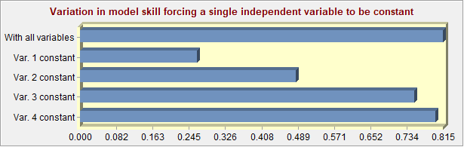
2) Forcing All Independent Variables Except One to be Constant
Model | Accuracy (%) | Skill measure
With all variables | 86.15 | 0.8154
All constant but var. 1 | 50.03 | 0.3337
All constant but var. 2 | 44.39 | 0.2586
All constant but var. 3 | 37.12 | 0.1617
All constant but var. 4 | 38.12 | 0.1749
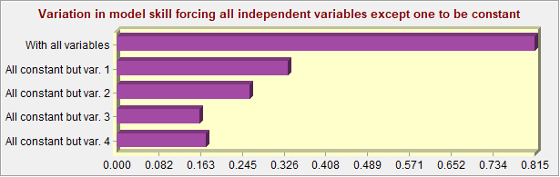
3) Backwards Stepwise Constant Forcing
Model | Variables included | Accuracy (%) | Skill measure
With all variables | All variables | 86.15 | 0.8154
Step 1: var.[4] constant | [1,2,3] | 84.94 | 0.7992
Step 2: var.[4,3] constant | [1,2] | 69.40 | 0.5920
Step 3: var.[4,3,2] constant | [1] | 50.03 | 0.3337
