Non-communicable diseases and injuries in Nepal from 1990-2017: A review of evidence from Global Burden of Disease Study 2017

Brief title: Non-communicable diseases and injuries in Nepal
Authors: Mishra, Shiva Raj, MPH^{1*}, Shrestha, Nipun, MBBS, MPH^{1, 2}, Gyawali, Bishal, PhD³, Vaidya, Abhinav, PhD⁴, Schwarz, Dan, MD^{5, 6, 7, 8}, Neupane, Dinesh, PhD⁹, Aryal, Krishna, PhD¹⁰, Shrestha, Abha, MD¹¹, Karmacharya, Biraj, MD¹¹, Koirala, Bhagawan, MD¹², Shrestha, Archana, PhD,^{11,13-14}
- Nepal Biobanking Initiative, Nepal Development Society, Chitwan, Nepal
- Institute for Health and Sport (IHeS), Victoria University, Melbourne, Australia
- Community Health Development Nepal (CHEDEN), Kathmandu, Nepal
- Department of Community Medicine, Kathmandu Medical College
- Nyaya Health Nepal, Kathmandu, Nepal
- Ariadne Labs, Harvard T.H. Chan School of Public Health and Brigham and Women’s Hospital, Boston, MA, USA
- Division of Global Health Equity, Department of Medicine, Brigham and Women’s Hospital, Boston, MA, USA
- Department of Medicine, Harvard Medical School, Boston, MA, USA
- The Welch Center for Prevention, Epidemiology and Clinical Research, Johns, Hopkins Bloomberg School of Public Health, Baltimore, Maryland
- DFID/NHSP3/MEOR, Abt Associates, Lalitpur, Nepal
- Department of Public Health, Kathmandu University School of Medical Sciences, Kathmandu University, Dhulikhel, Nepal
- Manmohan Cardiothoracic Vascular and Transplant Center, Institute of Medicine, Nepal
- Department of Epidemiology, Harvard T Chan School of Public Health, Boston, MA, USA
- Department of Epidemiology, Yale School of Public Health, New Haven, CT, USA

Corresponding author
Shiva Raj Mishra, MPH
Nepal Biobanking Initiative, Nepal Development Society, Bharatpur-10, Nepal
Email: shivarajmishra@gmail.com
Keywords
Global Burden of Disease, Non-communicable diseases, Nepal

Supplementary Appendices
eSupplementary figure 1: Distribution of total number of deaths by age groups in Nepal for both sexes (2017)
eSupplementary figure 2: Distribution of total YLL by age groups in Nepal for both sexes (2017)
eSupplementary figure 3: Distribution of total DALYs by age groups in Nepal (2017) for both sexes
eSupplementary figure 4: YLDs rate (per 100,000) of all injuries among both sexes 15-49 in Nepal and comparator countries for both sexes (2017)
eSupplementary figure 5: Ranking of YLL rates for both sexes for Nepal and the comparator countries for all ages (both sexes) in 2017
eSupplementary figure 6: Ranking of YLDs rates for both sexes for Nepal and the comparator countries for all ages (both sexes) in 2017
eSupplementary figure 7: Prevalence of hypertension, overweight/obesity, tobacco smoking and indoor air pollution markers (>=1) at sub-national level (2016)
eSupplementary figure 8: Prevalence of hypertension, overweight/obesity, tobacco smoking and indoor air pollution markers (>=1) disaggregated by socio-economic status at sub-national level (2016)
eSupplementary figure 9: Prevalence (%) & 95% Confidence intervals for selected NCDs at the provinces level in Nepal
eSupplementary methods: Prevalence of chronic kidney disease, coronary artery disease, chronic obstructive pulmonary disease, diabetes, hypertension, overweight/obesity, tobacco smoking and indoor air pollution markers (>=1) at sub-national level in Nepal

eSupplementary figure 1: Distribution of total number of deaths by age groups in Nepal for both sexes (2017)
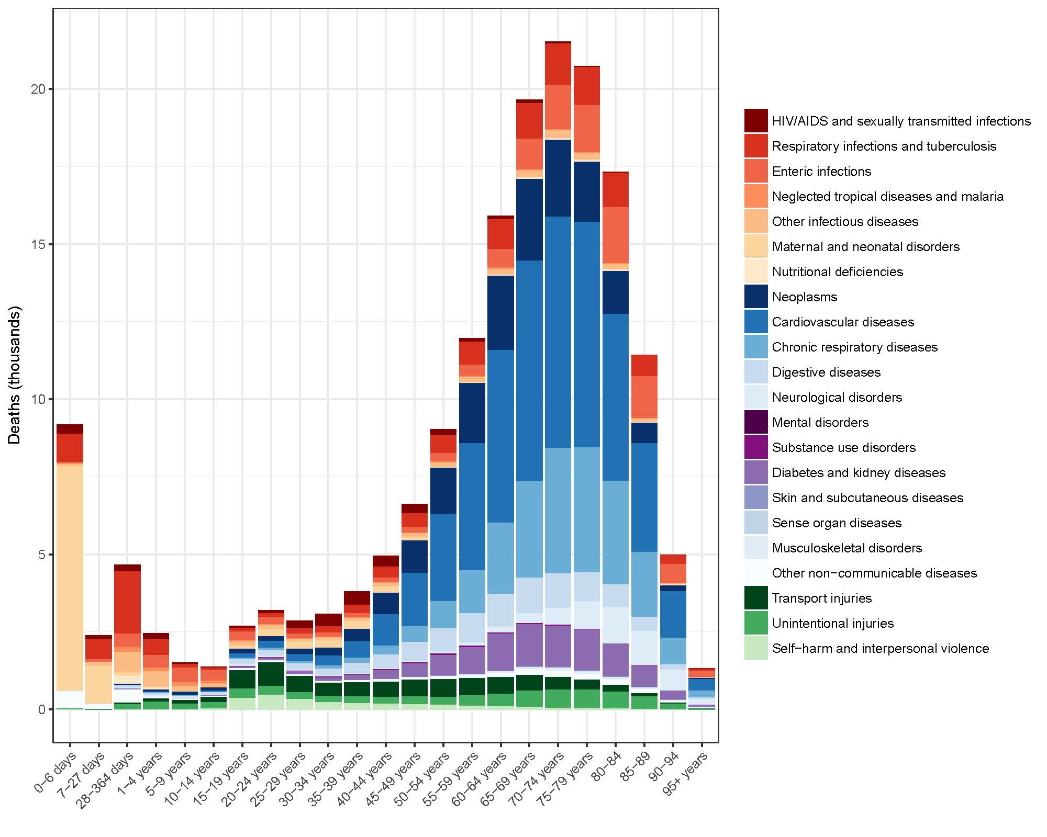
eSupplementary figure 2: Distribution of total YLL by age groups in Nepal for both sexes (2017)
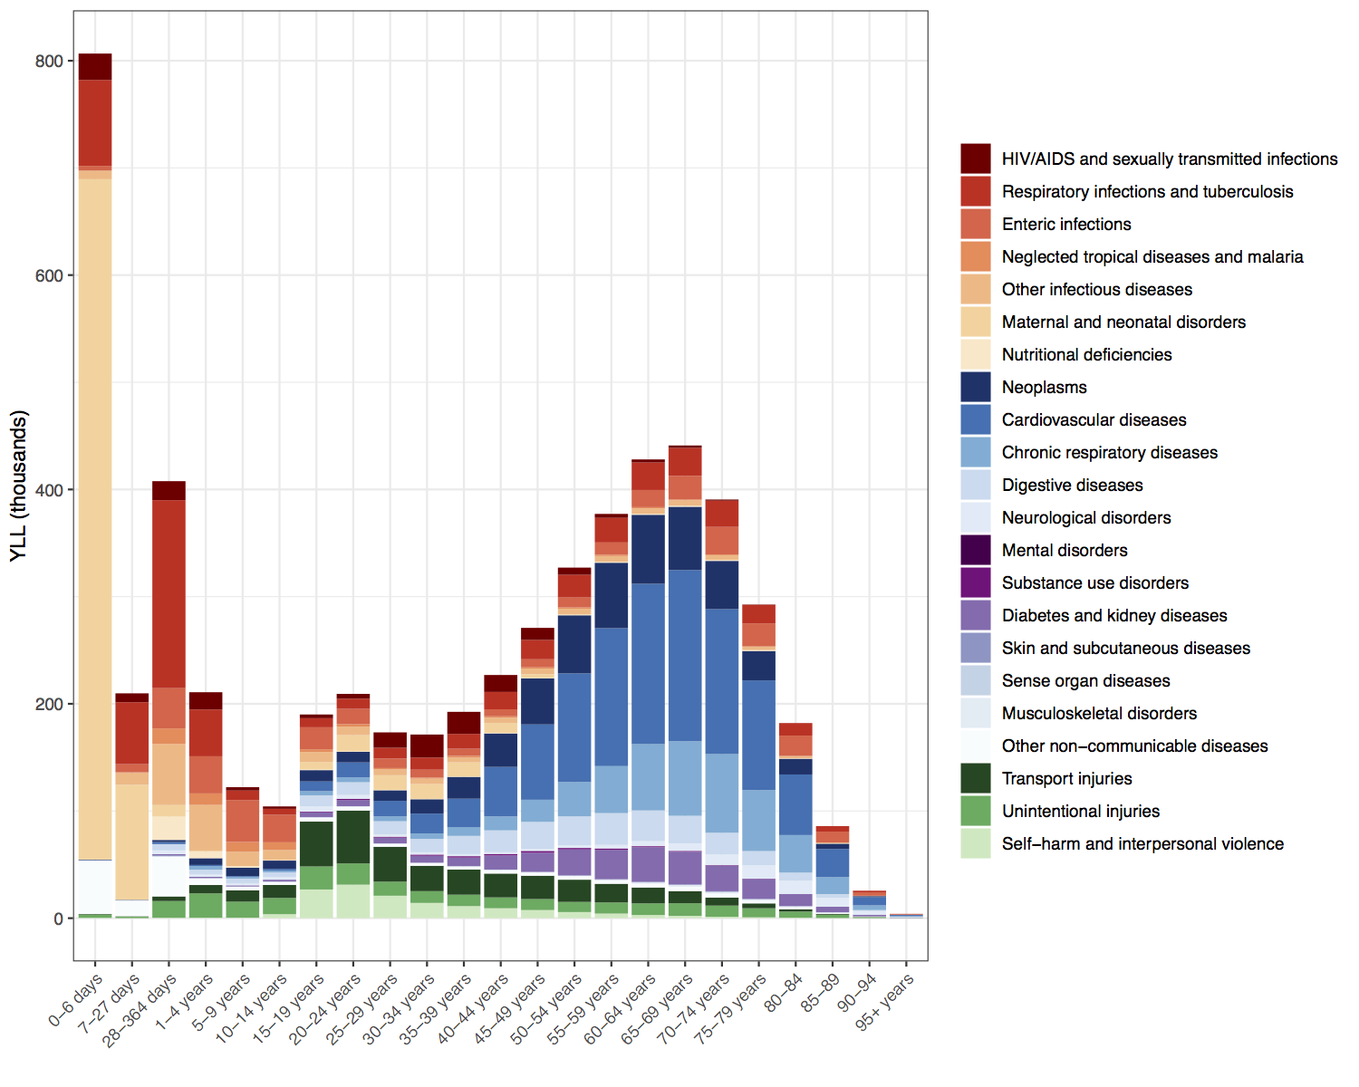

eSupplementary figure 3: Distribution of total DALYs by age groups in Nepal (2017) for both sexes
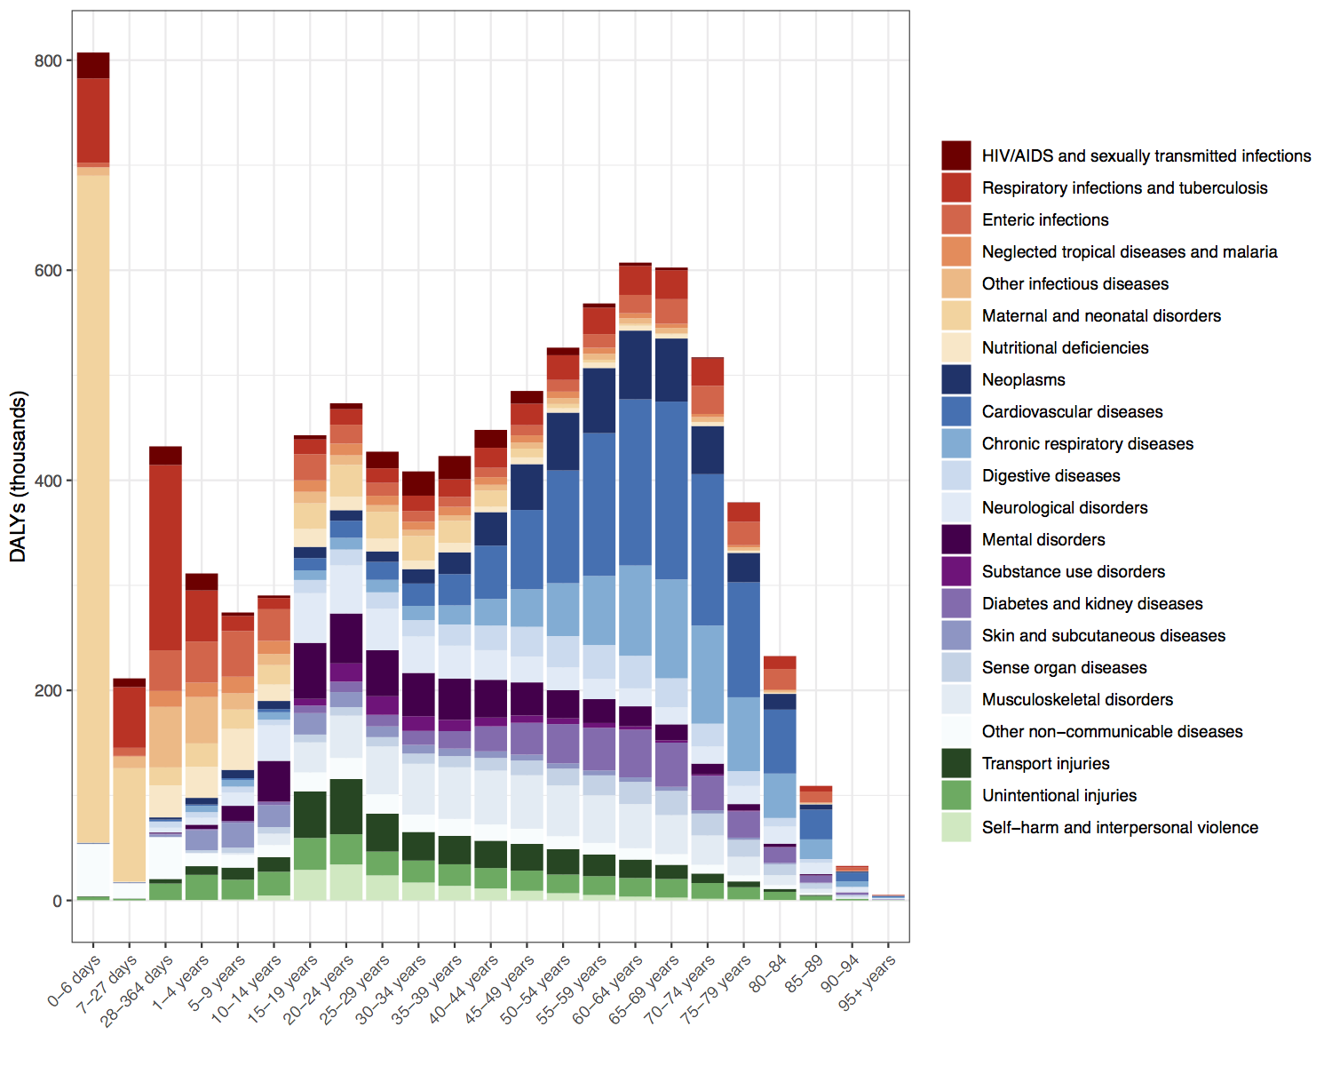
eSupplementary figure 4: YLDs rate (per 100,000) of all injuries among both sexes 15-49 in Nepal and comparator countries for both sexes (2017)
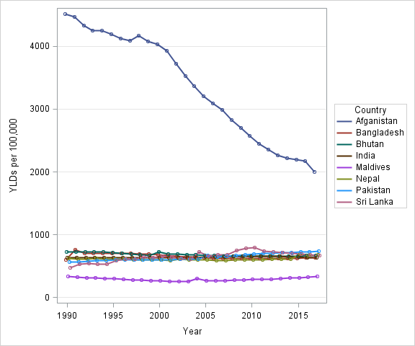
eSupplementary figure 5: Ranking of YLL rates for both sexes for Nepal and the comparator countries for all ages (both sexes) in 2017
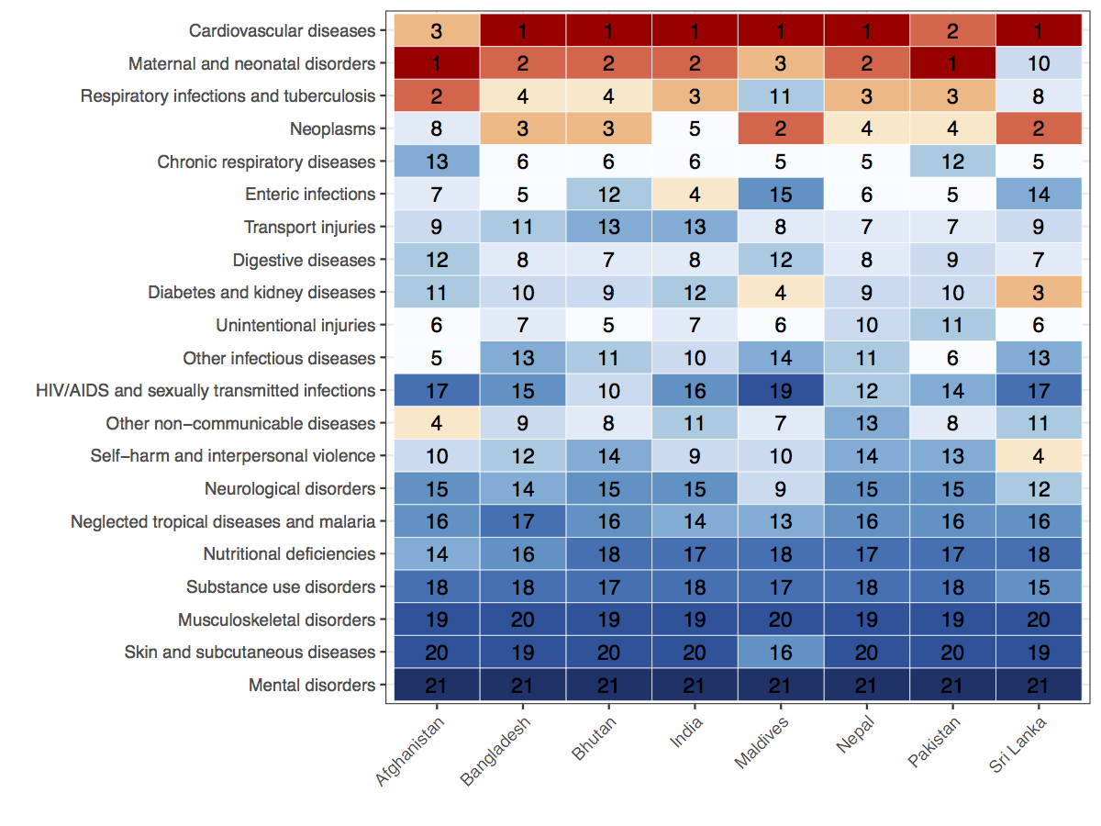
eSupplementary figure 6: Ranking of YLDs rates for both sexes for Nepal and the comparator countries for all ages (both sexes) in 2017
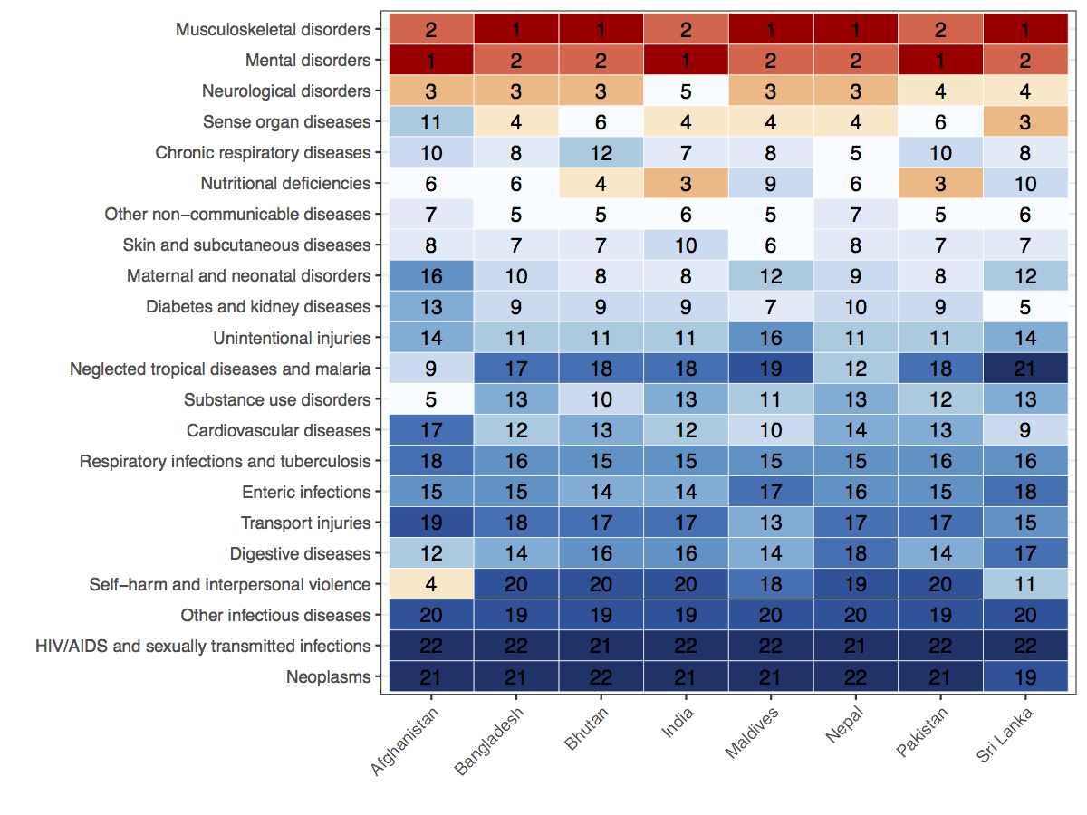
eSupplementary figure 7: Prevalence of hypertension, overweight/obesity, tobacco smoking and indoor air pollution markers (>=1) at sub-national level (2016)*
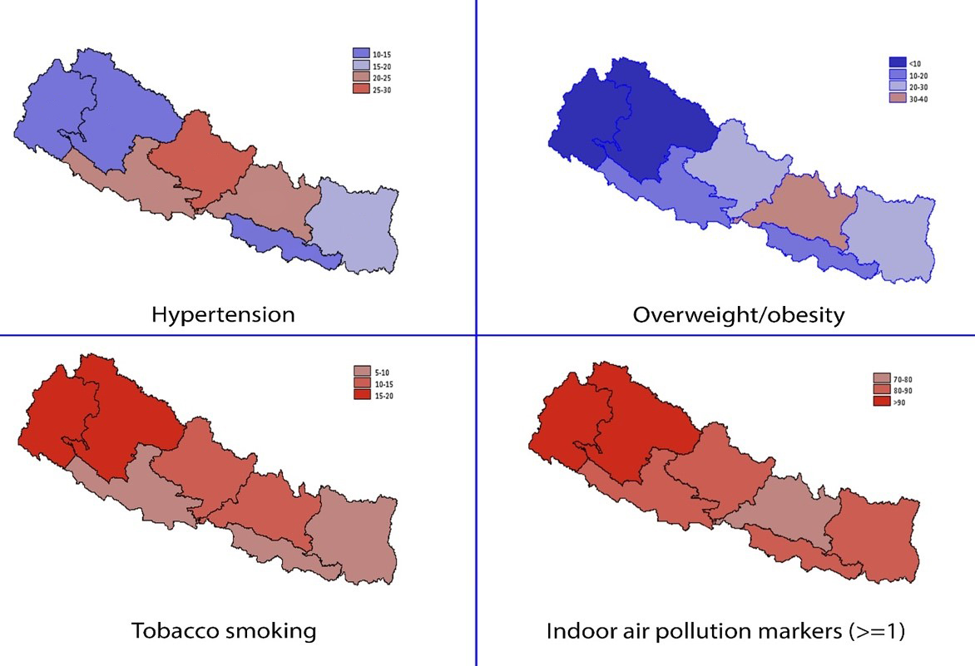
Province 6
Province 7
Province 5
Province 2
Province 4
Province 3
Province 1
* A detailed description of these variables are available in the methods sections of this paper, as well as other publications using the demographic and health survey data on hypertension (JNC-7:≥140 mmHg systolic and/or ≥90 mmHg diastolic blood pressure)¹, overweight/obesity (≥25 kg/m2) ², tobacco smoking ³, and indoor air pollution makers (≥1). ⁴

eSupplementary figure 8: Prevalence of hypertension, overweight/obesity, tobacco smoking and indoor air pollution markers (>=1) disaggregated by socio-economic status at sub-national level (2016) *
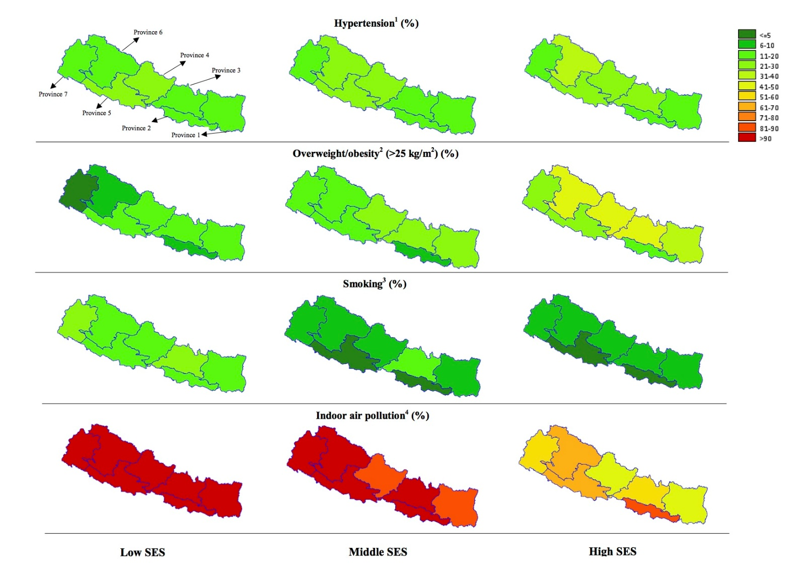
* A detailed description of these variables are available in the methods sections of this paper, as well as other publications using the demographic and health survey data on hypertension (JNC-7:≥140 mmHg systolic and/or ≥90 mmHg diastolic blood pressure) ¹ overweight/obesity (≥25 kg/m²) ² tobacco smoking ³, and indoor air pollution makers (≥1) ⁴. Socio-economic status (SES) is defined based on household wealth quintile (20): ‘poorest’ and ‘poor’ is merged as ‘low ses’, ‘richer’ and ‘richest’ category is merged as ‘high ses’ whereas ‘middle’ remained the same.

eSupplementary figure 9: Prevalence (%) & 95% Confidence intervals for selected NCDs at the provinces level in Nepal (n=12,577)*
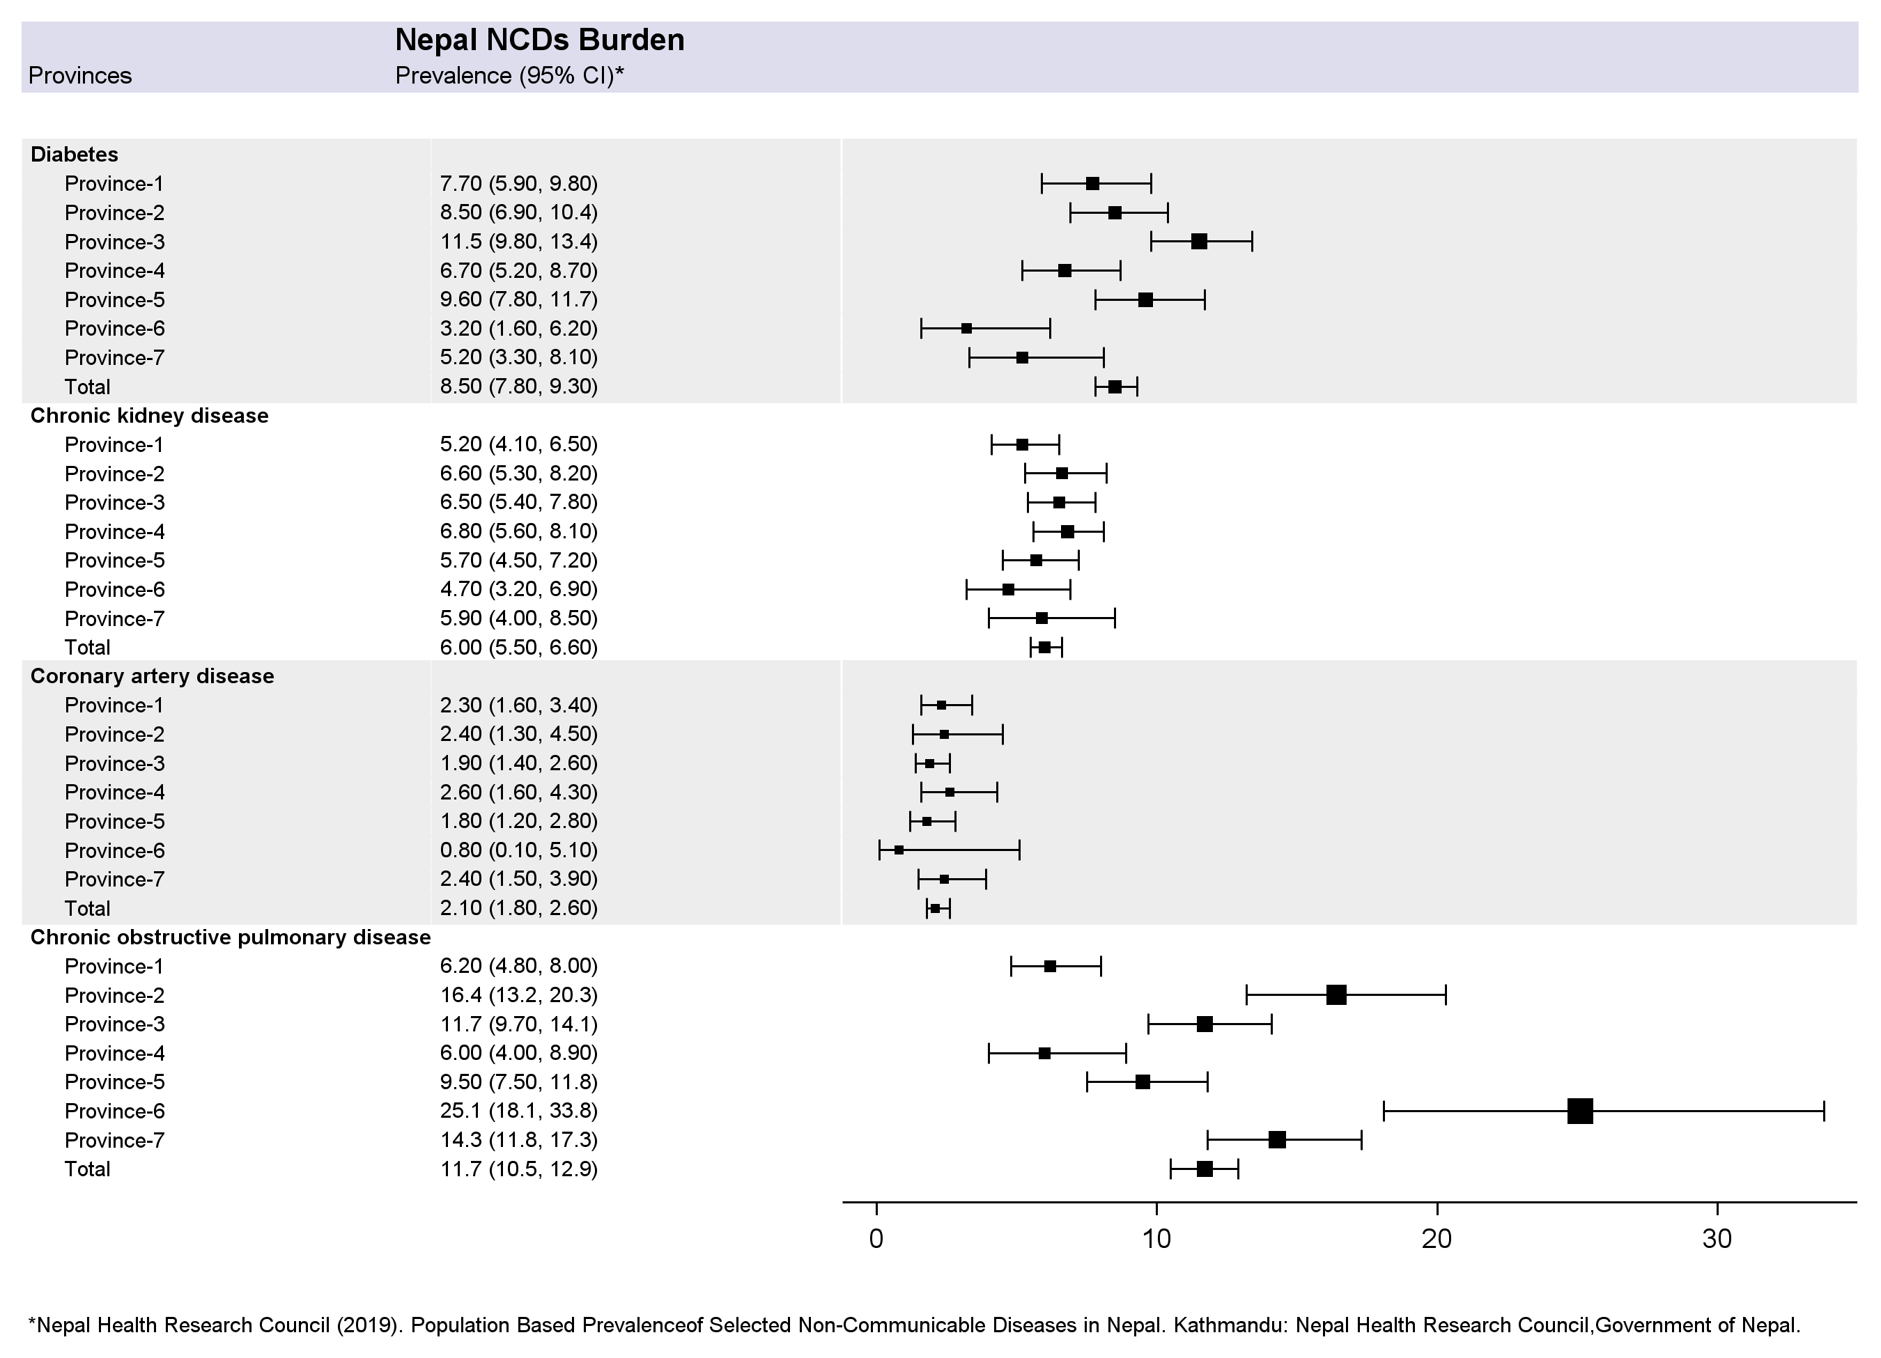
* Data for this graph is based on “Population Based Prevalence of Selected Non-Communicable Diseases in Nepal”, which is a nationally presentative prevalence survey conducted by Nepal Health Research Council in 2019. More details are available in the methods section of this appendix.
eSupplementary Methods
Data for eSupplementary figure 7-9 are drawn from two sources. First, the Nepal Demographic and Health Survey 2016 (NDHS) was used to assess burden of hypertension, overweight/obesity, tobacco smoking and indoor air pollution. Second, Nepal NCDs Survey 2019, was used to assess the burden of diabetes, chronic kidney disease, coronary artery disease, chronic obstructive pulmonary disease in Nepal.
Nepal Demographic and Health Survey 2016
The Nepal Demographic and Health Survey 2016 (NDHS), is a nationally representative population survey conducted periodically every 5 years in Nepal. A multistage stratified cluster sampling method was used to collect data based on the updated version 2011 National Population and Housing Census (NPHC) sampling frame. Samples were stratified and selected in two stages in rural areas and three stages in urban areas. The seven provinces of Nepal were stratified into urban and rural areas, resulting in 14 sampling strata for the NDHS 2016.
In the first stage, primary sampling unit comprising of 383 wards were selected with probability proportional to ward size from each stratum which served as the sampling frame for the selection of households in the next stage. The equal probability systematic selection criterion was employed in selecting 30 household per cluster resulting in selection of 11040 households (6,978 in urban and 4,062 in rural). The demographic, clinical, anthropometric and biochemical measurements were collected from all the selected household by trained research assistants. The NDHS 2016 data was collected between June 19, 2016 and January 31, 2017, and the details of its methodology can be found elsewhere.⁵
Participant’s height was measured using stadiometer and weight measured using digital weighing scale. Body mass index (BMI) was then computed as weight in kilograms divided by the square of the height in meters (kg/m2). Overwight/obese participants were then described as those having BMI in excess of 25 kg/m2.
Blood pressure measurements were taken in women and men aged 15-69 years, who stayed in the household the night before the household interview using UA-767F/FAC (A&D Medical, Tokyo, Japan) blood pressure monitors. The measurements were recorded three times in sitting posture with 5-min intervals and were advised to rest in between the measurements. The average of the last two measurements was used to classify individuals to World Health Organization recommended hypertension categories: prehypertensive: individual with SBP level of 120–139 mmHg and DBP of 88–89 mmHg; hypertensive: individuals with SBP was 140 mmHg or higher and/or if their DBP was 90 mmHg or higher.
For tobacco smoking, dichotomous outcome variables were created from the information obtained from questionnaires on tobacco smoking asked in the survey. The Nepal Demographic Health Survey used following questions to collect information on tobacco use:
1. Do you currently smoke tobacco every day, somedays, or not at all?
2. In the past, have you ever smoked tobacco every day, some days, or not at all?
3. On average, how many of the following products do you currently smoke? (Multiple response: manufactured cigarettes/hand rolled cigarettes/pipes full of tobacco/cigars, cheroots or cigarillos/water pipe/any other).
The NDHS 2016 collected household-level data on markers of indoor air pollution such as indoor smoking, fuel types used, and cooking practice. The participant’s responses for use of fuel was dichotomized into use of clean (electricity, Liquefied petroleum gas, natural gas, and biogas) or unclean fuel (kerosene, charcoal, wood, straw/shrubs/grass, agricultural crop, and animal dung), indoor cooking practices was dichotomized presence or absence of separate kitchen and indoor smoking practices into presence or absence of indoor smoking for the purpose of analysis. Indoor air pollution was defined as presence or absence of at least one of the three markers of indoor air pollution: use of unclean fuel, no separate kitchen to cook in, and presence of indoor smoking.
The wealth index is a composite measure of a household's cumulative living standard. Households are assigned scores using principal component analysis based on the housing characteristics such as source of drinking water, toilet facilities, and flooring materials and the number and kinds of consumer goods they own, ranging from a television to a bicycle or car. Then, wealth quintiles are compiled by dividing the distribution into five equal categories, each comprising 20% of the population:
A_{i} = ∑_{k} [$\frac{{ a}_{ik}-{\overline{a}}_{k}}{S_{k}}$]
where $a_{ik}$ is the value of assets k for household i, ${\overline{a}}_{k}$ is sample mean, and $s_{k}$ is sample standard deviation.
The geographic analyses of provinces and districts of Nepal for tobacco smoking, overweight obesity, hypertension and indoor air pollution was performed in SAS v9.4 using Gmap procedure. For plotting geographic variation for tobacco smoking, overweight obesity, hypertension and indoor air pollution according to wealth quintile, poorest and poor was collapsed into low socioeconomic status and richer and richest was collapsed into higher socioeconomic status.

Nepal NCDs Survey 2019
Nepal NCDs Survey 2019 was conducted to assess the prevalence of NCDs and their risk factors at entire population level, with data collected between 2016 and 2018.⁶ A multistage cluster sampling was used to select a representative sample of 132,00 participants from 400 clusters across 72 districts of Nepal. Within each cluster, wards of village development committees and municipalities—the smallest administrative units of the country---were taken as the primary sampling units. Thirty-three households from each cluster were selected using systematic sampling and finally one participant in each household were selected from the eligible frame (aged 20 years and above) using Kish method. The final sample size was 12,557 (averaging 33 participants across 400 clusters selected across the country after excluding non-responses) participants representing the adult target population aged 20 years and above in Nepal and the details of its methodology can be found elsewhere.⁶
A team consisting of field supervisor, medical laboratory technologist, laboratory technician and other medical professionals having health background were assigned for data collection which included filling out the questionnaires, carrying out physical measurements, collecting blood samples, conducting echocardiography and spirometry tests. Quality control was ensured by strictly following the standard operating procedure. Survey instruments were adapted from three key sources, i) WHO’s STEPwise approach to NCD risk factor surveillance ⁷ , ii) Rose Angina Questionnaire ⁸ , iii) COPD questionnaire.⁹ All these instruments have previously been validated in Nepal. Diabetes was defined as a fasting plasma glucose (FPG) level of 126 mg/dL (7.0 mmol/L) or raised post prandial blood glucose (≥200 mg), or taking antidiabetic medications. CKD was defined based on urinary albumin to creatinine ration (uACR) ≥30 mg/g or e-GFR <60 ml/min/1.73 m².¹⁰ eGFR was calculated based on Modification of Diet in Renal Disease equation.¹¹ CAD is defined based on affirmative response to Rose angina questionnaire after applying exclusions for local causes of pain. COPD was assessed based on spirometry report of FEV1 to FVC ratio of < 0·7. The details of these tests can be found elsewhere.⁶
We summarized the prevalence estimation from Nepal NCDs Survey 2019 using a forest plot. The prevalence (%) and 95% CI are shown for all Nepal’s seven newly demarcated provinces named as provinces 1-7. The analysis was conducted in SAS 9.4.
References
1. Mehata S, Shrestha N, Mehta R, et al. Prevalence, awareness, treatment and control of hypertension in Nepal: data from nationally representative population-based cross-sectional study. J Hypertens 2018; 36(8): 1680-8.
2. Rawal LB, Kanda K, Mahumud RA, et al. Prevalence of underweight, overweight and obesity and their associated risk factors in Nepalese adults: Data from a Nationwide Survey, 2016. PLoS One 2018; 13(11): e0205912.
3. Shrestha N, Mehata S, Pradhan PM, Joshi D, Mishra SR. A nationally representative study on socio-demographic and geographic correlates, and trends in tobacco use in Nepal. Scientific Reports 2019.
4. Ghimire S, Mishra SR, Sharma A, Siweya A, Shrestha N, Adhikari B. Geographic and socio-economic variation in markers of indoor air pollution in Nepal: evidence from nationally-representative data. BMC Public Health 2019.
5. Ministry of Health, Nepal; New ERA; and ICF. Nepal Demographic Health Survey 2016. https://dhsprogram.com/pubs/pdf/FR336/FR336.pdf.
6. Nepal Health Research Council. Population Based Prevalence of Selected Non-Communicable Diseases in Nepal. Kathmandu: Nepal Health Research Council, Government of Nepal. 2019.
7. World Health Organization STEPS Surveillance Manual. 2017 (last updated). Available from: https://www.who.int/ncds/surveillance/steps/STEPS_Manual.pdf.
8. Rose GA. The diagnosis of ischaemic heart pain and intermittent claudication in field surveys. Bull World Health Organ 1962; 27: 645-58.
9. Stanley AJ, Hasan I, Crockett AJ, van Schayck OC, Zwar NA. COPD Diagnostic Questionnaire (CDQ) for selecting at-risk patients for spirometry: a cross-sectional study in Australian general practice. NPJ Prim Care Respir Med 2014; 24: 14024.
10. The National kidney foundation kidney disease outcomes quality initiative (NKF KDOQI). Clinical Practice guidelines for chronic kidney disease: evaluation, classification and stratification 2002. Available from https://www.kidney.org/sites/default/ files/docs/ckd_evaluation_classification_stratification.pd.
11. Hallan S, Asberg A, Lindberg M, Johnsen H. Validation of the Modification of Diet in Renal Disease formula for estimating GFR with special emphasis on calibration of the serum creatinine assay. Am J Kidney Dis 2004; 44(1): 84-93.

