Figure
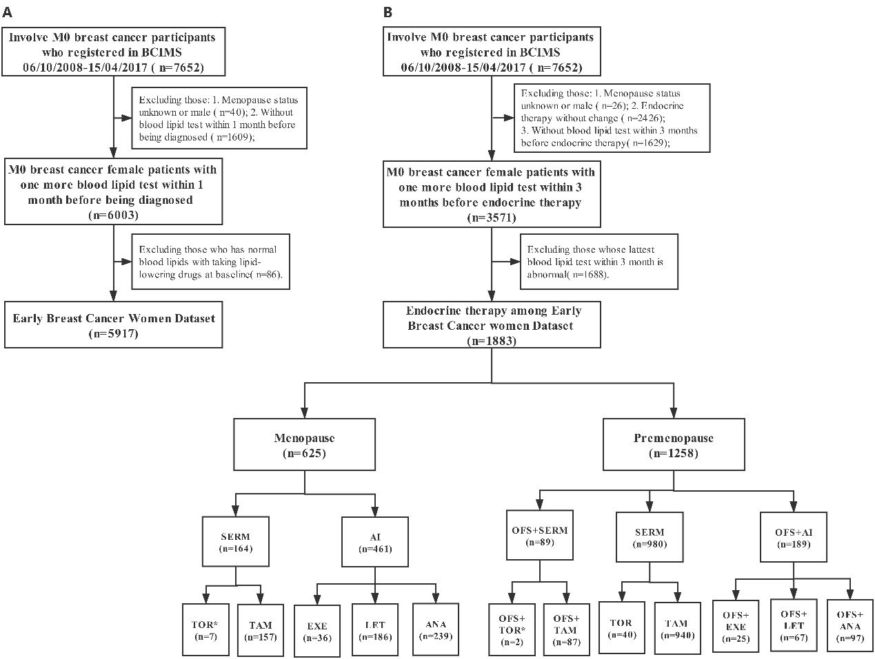
Figure 1 Flowchart
The flowchart shows the process of inclusion and exclusion of the study population, A refers to EBC women dataset and B refers to EBC data sets of endocrine therapy. * Due to the case was too small, we removed those drugs in the cumulative dyslipidemia incidence analysis of different endocrine therapy drugs.

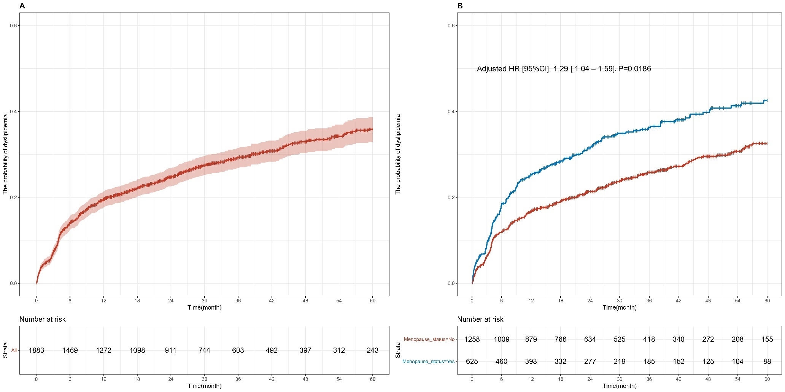
Supplement Figure 1 Cumulative dyslipidemia incidence among premenopause and menopause early breast cancer patients (EBC).
Cumulative curves (A) showing dyslipidemia incidence of all EBC patients with receiving endocrine therapy, and (B) showing dyslipidemia incidence among different menopause status group.

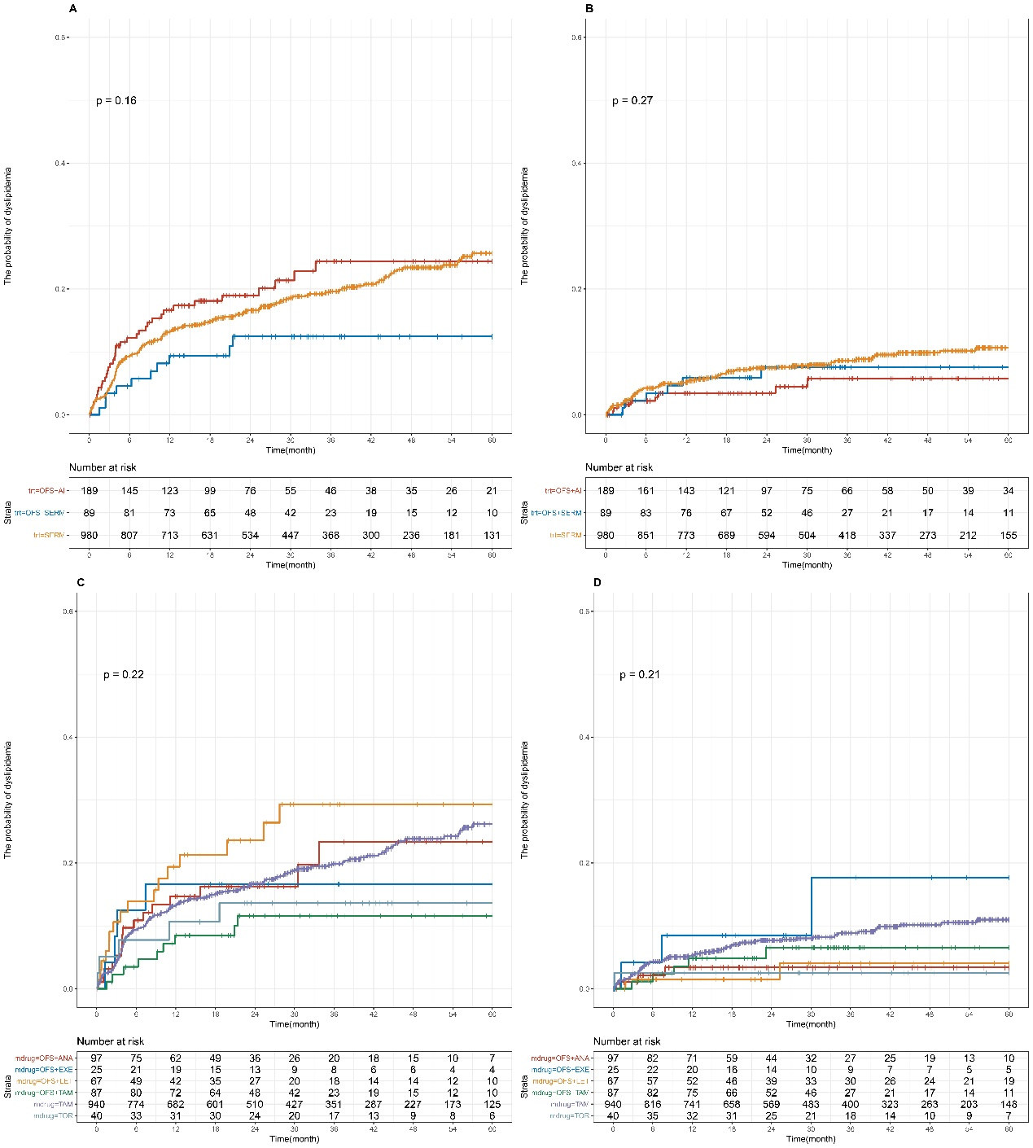
Supplement Figure 3 Cumulative abnormal TG and HDL-C incidence among early breast cancer pre-menopause patients for different endocrine therapy
Cumulative curves showing TG (A and C) and HDL-C (B and D) dyslipidemia incidence. P values were obtained from log-rank tests for comparisons of abnormal TG and HDL-C incidence between different endocrine therapy groups. SERM, selective estrogen receptor modulator; TAM, tamoxifen; TOR, Toremifene; AI, aromatase inhibitor; ANA, Anastrozole; LET, Letrozole; EXE, Exemestane; OFS, ovarian function suppression; TG, Triglyceride; HDL-C, HDL cholesterol.

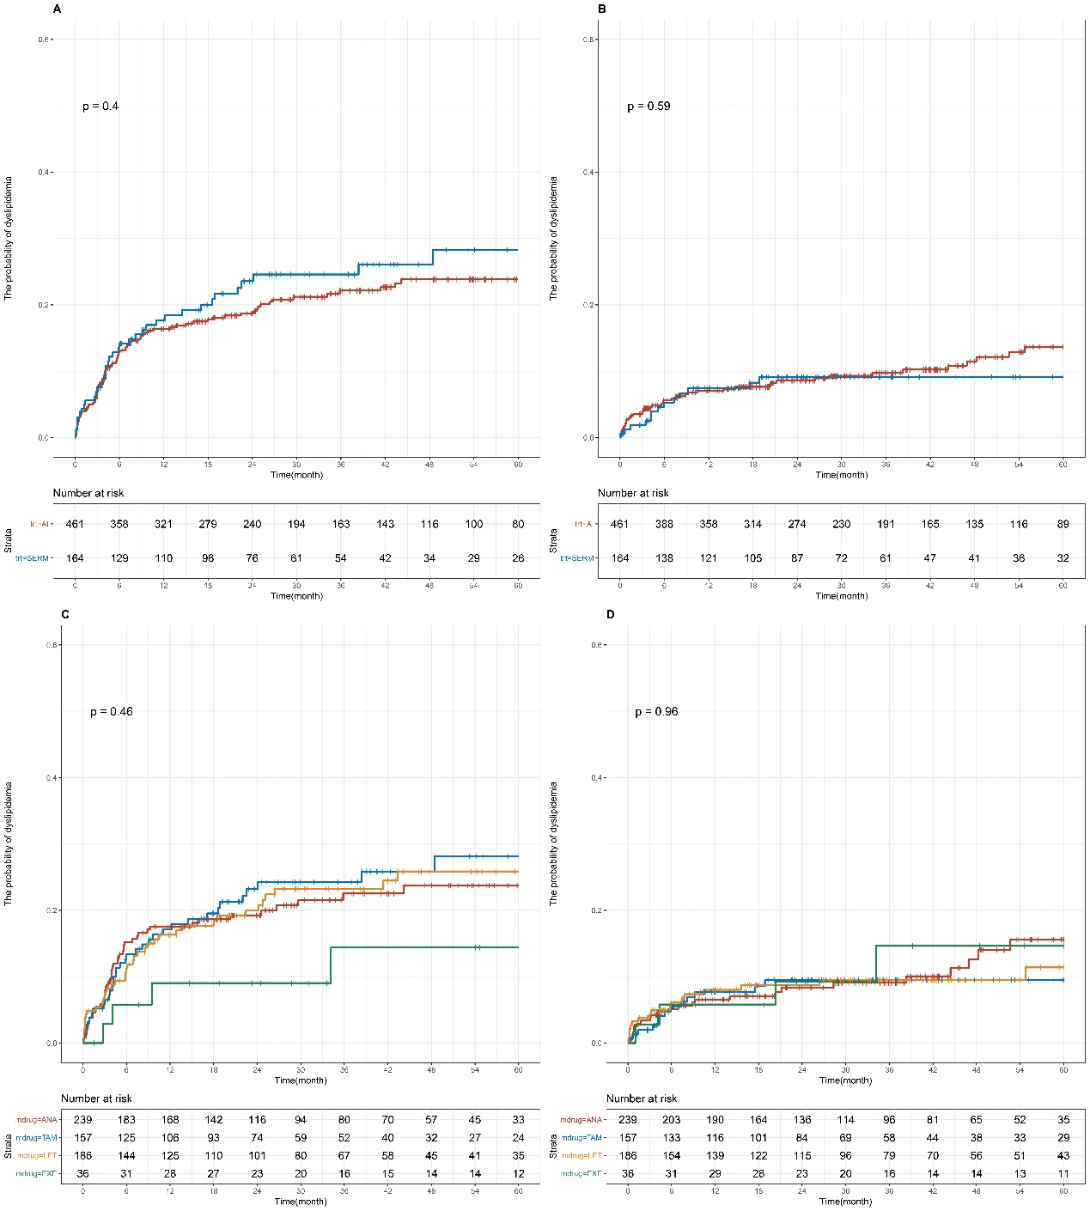
Supplement Figure 4 Cumulative abnormal TG and HDL-C incidence among early breast cancer menopause patients for different endocrine therapy
Cumulative curves showing TG (A and C) and HDL-C (B and D) dyslipidemia incidence. P values were obtained from log-rank tests for comparisons of abnormal TG and HDL-C incidence between different endocrine therapy groups.S ERM, selective estrogen receptor modulator; TAM, tamoxifen; TOR, Toremifene; AI, aromatase inhibitor; ANA, Anastrozole; LET, Letrozole; EXE, Exemestane; TG, Triglyceride; HDL-C, HDL cholesterol.
Table
Supplement Table 1 Baseline Characteristics and Dyslipidemia of Early Breast Cancer Patients
 |  |  | Menopause Status
 | Group | All (n=1883) | Yes (n = 625) | No (n = 1258)
Age, median (IQR) |  | 46.00 [41.00, 53.00] | 57.00 [52.00, 62.00] | 43.00 [39.00, 47.00]
 |  | 47.31 (9.63) | 57.42 (7.18) | 42.28 (6.10)
BMI, median (IQR) |  | 22.58 [20.70, 24.69] | 23.44 [21.23, 25.63] | 22.22 [20.45, 24.14]
 |  | 22.88 (3.02) | 23.63 (3.16) | 22.51 (2.88)
Stage, No (%) | 0 | 36 (1.9) | 11 (1.8%) | 25 (2.0%)
 | Ⅰ | 433 (23.0) | 141 (22.6%) | 292 (23.2%)
 | Ⅱ | 887 (47.1) | 297 (47.5%) | 590 (46.9%)
 | Ⅲ | 431 (22.9) | 159 (25.4%) | 272 (21.6%)
 | Unkown | 96 (5.1) | 17 (2.7%) | 79 (6.3%)
pT status, No (%) | 0 | 45 (2.4) | 17 (2.7%) | 28 (2.2%)
 | 1 | 668 (35.5) | 229 (36.6%) | 439 (34.9%)
 | 2 | 891 (47.3) | 307 (49.1%) | 584 (46.4%)
 | 3 | 79 (4.2) | 18 (2.9%) | 61 (4.8%)
 | 4 | 109 (5.8) | 43 (6.9%) | 66 (5.2%)
 | Unkown | 91 (4.8) | 11 (1.8%) | 80 (6.4%)
pM status, No (%) | 0 | 1883 (100.0) | 625 (100.0%) | 1258 (100.0%)
pN status, No (%) | 0 | 927 (49.2) | 293 (46.9%) | 634 (50.4%)
 | 1 | 593 (31.5) | 196 (31.4%) | 397 (31.6%)
 | 2 | 207 (11.0) | 78 (12.5%) | 129 (10.3%)
 | 3 | 144 (7.6) | 51 (8.2%) | 93 (7.4%)
 | Unkown | 12 (0.6) | 7 (1.1%) | 5 (0.4%)
Subtype, No (%) | Luminal A | 297 (15.8) | 83 (13.3%) | 214 (17.0%)
 | Luminal B (Her2 +) | 299 (15.9) | 91 (14.6%) | 208 (16.5%)
 | Luminal B (Her2 -) | 752 (39.9) | 237 (37.9%) | 515 (40.9%)
 | TNBC | 22 (1.2) | 12 (1.9%) | 10 (0.8%)
 | Her2 positive | 25 (1.3) | 10 (1.6%) | 15 (1.2%)
 | Unkown | 488 (25.9) | 192 (30.7%) | 296 (23.5%)
ER, No (%) | Negative | 139 (7.4) | 67 (10.7%) | 72 (5.7%)
 | Positive | 1714 (91.0) | 543 (86.9%) | 1171 (93.1%)
 | Unkown | 30 (1.6) | 15 (2.4%) | 15 (1.2%)
PR, No (%) | Negative | 253 (13.4) | 139 (22.2%) | 114 (9.1%)
 | Positive | 1599 (84.9) | 471 (75.4%) | 1128 (89.7%)
 | Unkown | 31 (1.6) | 15 (2.4%) | 16 (1.3%)
HER2, No (%) | Negative | 1198 (63.6) | 384 (61.4%) | 814 (64.7%)
 | Positive | 357 (19.0) | 118 (18.9%) | 239 (19.0%)
 | Unkown | 328 (17.4) | 123 (19.7%) | 205 (16.3%)
KI67, No (%) | <14% | 418 (22.2) | 128 (20.5%) | 290 (23.1%)
 | ≥14% | 1369 (72.7) | 460 (73.6%) | 909 (72.3%)
 | Unkown | 96 (5.1) | 37 (5.9%) | 59 (4.7%)
Comorbidity ª, No (%) | No | 1669(88.6) | 475 (76.0%) | 1194(95.0%)
 | Yes | 214 (11.4) | 150 (24.0%) | 64 (5.1%)
TC (mmol/L), median (IQR) |  | 4.82 [4.29, 5.33] | 4.98 [4.44, 5.45] | 4.74 [4.22, 5.25]
Mean (SD) |  | 4.79 (0.72) | 4.92 (0.71) | 4.72 (0.72)
TG (mmol/L), median (IQR) |  | 1.33 [1.01, 1.66] | 1.42 [1.09, 1.72] | 1.28 [0.97, 1.64]
Mean (SD) |  | 1.35 (0.43) | 1.42 (0.42) | 1.32 (0.43)
HDL-C (mmol/L), median (IQR) |  | 1.43 [1.25, 1.67] | 1.41 [1.23, 1.65] | 1.45 [1.27, 1.68]
Mean (SD) |  | 1.49 (0.32) | 1.47 (0.31) | 1.50 (0.32)
LDL-C (mmol/L), median (IQR) |  | 2.80 [2.37, 3.23] | 2.93 [2.50, 3.37] | 2.75 [2.31, 3.16]
Mean (SD) |  | 2.79 (0.61) | 2.91 (0.61) | 2.73 (0.60)
No. of event within 5-years, No |  | 505 | 207 | 298
Durations from baseline to dyslipidemia, median (range) |  | 23.16  [0.03, 60.00] | 20.06  [0.03, 60.00] | 24.40  [0.03, 60.00]
Incidence within  1-year [95%CI] |  | 19.6%  [21.4%, 17.7%] | 25.2 %  [21.6 %, 28.7 %] | 16.8%  [14.6%, 18.9%]
Incidence within  5-years [95%CI] |  | 35.9%  [38.7 %, 32.9 %] | 42.6%  [47.4%, 37.3 %] | 32.6%  [36.0%, 28.9%]
a, Comorbidity for hypertension, diabetes, and chronic kidney disease; ER, estrogen receptor; PR, progesterone receptor; HER2, human epidermal growth factor receptor-2; TNBC, Triple-negative Breast Cancer; TC, Total cholesterol; TG, Triglyceride; HDL-C, HDL cholesterol; LDL-C, LDL cholesterol;

Supplement Table 2 A Comparison of TC and TG dyslipidemia among premenopause early breast cancer patients within five-years
 | TC |  |  |  |  |  | TG
Treatment | No. of  event | Duration,  Median [range] | Incidence within 1 year [95%CI] | P | Incidence within 5 years [95%CI] | P |  | No. of  event | Duration,  Median [range] | Incidence within 1  year [95%CI] | P | Incidence within 5  years [95%CI] | P
OFS+AI (n=189) | 25 | 22.97 [0.13, 60.00] | 8.7% [4.4 %, 12.8 %] | <0.001 | 22% [ 12.3%,30.5%] | <0.001 |  | 36 | 19.16 [0.13, 60.00] | 16.7% [ 10.9%,22.1%] | 0.31 | 24.4% [ 16.4%,31.6%] | 0.16
OFS+SERM (n=89) | 0 | 32.32 [2.32, 60.00] | - | <0.001 | - |  |  | 10 | 27.71 [1.55, 60.00] | 9.4% [ 3%, 15.4%] | 0.31 | 12.4% [ 4.8%, 19.4%] | 0.16
SERM (n=980) | 28 | 32.06 [0.03, 60.00] | 2.2% [ 1.3%, 3.2%] | <0.001 | 3.5% [ 2.1%, 4.8%] |  |  | 182 | 27.27 [0.03, 60.00] | 13.2%[ 11%, 15.4%] | 0.31 | 25.7% [ 21.8%,29.3%] | 0.16
Drug | No. of  event | Duration,  Median [range] | Incidence within 1 year [95%CI] | P | Incidence within 5 years [95%CI] | P |  | No. of  event | Duration,  Median [range] | Incidence within 1  year [95%CI] | P | Incidence within 5  years [95%CI] | P
OFS+ANA (n=97) | 13 | 20.19 [0.13, 60.00] | 6.8% [ 1.4%, 11.9%] | <0.001 | 31.5% [ 10.4%,47.7%] | 0.001 |  | 16 | 19.03 [0.13, 60.00] | 14.7%[ 6.9%, 21.8%] | 0.42 | 23.4% [ 10.5%,34.4%] | 0.22
OFS+LET (n=67) | 11 | 25.81 [1.10, 60.00] | 14.8% [ 5.3%, 23.3%] | <0.001 | 20.9% [ 8.2%, 31.9%] |  |  | 16 | 19.97 [0.26, 60.00] | 19.4%[ 8.8%, 28.8%] | 0.42 | 29.3% [ 15.4%,41.0%] | 0.22
OFS+EXE (n=25) | 1 | 26.00 [0.29, 60.00] | - | <0.001 | 4.5% [ 0%, 12.9%] |  |  | 4 | 25.84 [0.29, 60.00] | 16.7%[ 0.3%, 30.3%] | 0.42 | 16.7% [ 0.3%, 30.3%] | 0.22
OFS+TAM (n=87) | 0 | 32.32 [2.32, 60.00] | - | <0.001 | - |  |  | 9 | 27.77 [1.55, 60.00] | 8.5%[ 2.3%, 14.3%] | 0.42 | 11.6% [ 4.1%, 18.5%] | 0.22
TOR (n=40) | 2 | 31.45 [0.13, 60.00] | 5.1% [ 0%, 11.8%] | <0.001 | 5.1% [ 0%, 11.8%] |  |  | 5 | 29.29 [0.13, 60.00] | 10.6%[ 0.2%, 20%, ] | 0.42 | 13.6% [ 1.7%, 24.1%] | 0.22
TAM (n=940) | 26 | 32.06 [0.03, 60.00] | 2.1% [ 1.2%, 3%] | <0.001 | 3.4% [ 2%, 4.8%] |  |  | 177 | 27.13 [0.03, 60.00] | 13.3%[ 11%, 15.5%] | 0.42 | 26.2% [ 22.2%,29.9%] | 0.22
SERM, selective estrogen receptor modulator; TAM, tamoxifen; TOR, Toremifene; AI, aromatase inhibitor; ANA, Anastrozole; LET, Letrozole; EXE, Exemestane; OFS, ovarian function suppression; TC, Total cholesterol; TG, Triglyceride;

Supplement Table 2 B Comparison of HDL-C and LDL-C dyslipidemia among premenopause early breast cancer patients within five-years
 | HDL-C |  |  |  |  |  | LDL-C
Treatment | No. of  event | Duration,  Median [range] | Incidence within 1 year [95%CI] | P | Incidence within 5 years [95%CI] | P | No. of  event | Duration,  Median [range] | Incidence within 1 year [95%CI] | P | Incidence within 5  years [95%CI] | P
OFS+AI (n=189) | 8 | 24.65 [0.13, 60.00] | 3.5% [ 0.7%, 6.1%] | 0.81 | 5.8% [ 1.5%, 9.8%] | 0.27 | 16 | 23.26 [0.13, 60.00] | 6.3% [ 2.6%, 9.9%] | <0.001 | 12.2% [ 5.5%, 18.4%] | 0.003
OFS+SERM (n=89) | 6 | 30.39 [2.32, 60.00] | 5.9% [ 0.7%, 10.8%] | 0.81 | 7.6% [ 1.5%, 13.3%] | 0.27 | 0 | 32.32 [2.32, 60.00] | - | <0.001 | - | 0.003
SERM (n=980) | 78 | 30.66 [0.03, 60.00] | 5.2% [ 3.8%, 6.6%] | 0.81 | 10.7% [ 8.2%, 13.1%] | 0.27 | 12 | 32.58 [0.03, 60.00] | 0.9% [ 0.3%, 1.5%] | <0.001 | 1.4% [ 0.6%, 2.2%] | 0.003
Drug | No. of  event | Duration,  Median [range] | Incidence within 1 year [95%CI] | P | Incidence within 5 years [95%CI] | P | No. of  event | Duration,  Median [range] | Incidence within 1 year [95%CI] | P | Incidence within 5  years [95%CI] | P
OFS+ANA (n=97) | 3 | 22.29 [0.13, 60.00] | 3.4% [ 0.0%, 7.1%] | 0.75 | 3.4% [ 0.0%, 7.1%] | 0.21 | 11 | 19.71 [0.13, 60.00] | 8.0% [ 2.1%, 13.6%] | <0.001 | 21.2% [ 5.0%, 34.7%] | 0.22
OFS+LET (n=67) | 2 | 29.87 [1.10, 60.00] | 1.5% [ 0.0%, 4.5%,] | 0.75 | 4.1% [ 0.0%, 9.6%] | 0.21 | 3 | 29.87 [1.10, 60.00] | 4.8% [ 0.0%, 9.9%,] | <0.001 | 4.8% [ 0.0%, 9.9%,] | 0.22
OFS+EXE (n=25) | 3 | 26.00 [0.29, 60.00] | 8.5% [ 0.0%, 19.2%] | 0.75 | 17.7% [ 0.0%, 35.3%] | 0.21 | 2 | 26.00 [0.29, 60.00] | 4.2% [ 0.0%, 11.8%] | <0.001 | 8.7% [ 0.0%, 19.6%] | 0.22
OFS+TAM (n=87) | 5 | 30.52 [2.32, 60.00] | 4.9% [ 0.1%, 9.4%] | 0.75 | 6.6% [ 0.8%, 12.0%] | 0.21 | 0 | 32.32 [2.32, 60.00] | - | <0.001 | - | 0.22
TOR (n=40) | 1 | 31.45 [0.13, 60.00] | 2.6% [ 0.0%, 7.4%] | 0.75 | 2.6% [ 0%, 7.4%] | 0.21 | 2 | 31.45 [0.13, 60.00] | 5.1% [ 0.0%, 11.8%] | <0.001 | 5.1% [ 0.0%, 11.8%] | 0.22
TAM (n=940) | 77 | 30.66 [0.03, 60.00] | 5.3% [ 3.8%, 6.8%] | 0.75 | 11.0% [ 8.4%, 13.5%] | 0.21 | 10 | 32.60 [0.03, 60.00] | 0.8% [ 0.2%, 1.3%] | <0.001 | 1.2% [ 0.5%, 2%] | 0.22
SERM, selective estrogen receptor modulator; TAM, tamoxifen; TOR, Toremifene; AI, aromatase inhibitor; ANA, Anastrozole; LET, Letrozole; EXE, Exemestane; OFS, ovarian function suppression; HDL-C, HDL cholesterol; LDL-C, LDL cholesterol;

Supplement Table 3 A Comparison of TC and TG dyslipidemia among menopause early breast cancer patients within five-years
 |  | TC |  |  |  |  |  | TG
Treatment | No. of  event |  | Duration,  Median [range] | Incidence within 1 year [95%CI] | P | Incidence within 5 years [95%CI] | P |  | No. of  event | Duration,  Median [range] | Incidence within 1  year [95%CI] | P | Incidence within 5  years [95%CI] | P
AI (n=461) | 78 |  | 25.26 [0.13, 60.00] | 13.9% [ 10.5%,17.2%] | 0.002 | 21.9% [ 17.0%, 26.4%] | <0.001 |  | 91 | 25.10 [0.10, 60.00] | 16.4% [ 12.8%,19.8%] | 0.33 | 23.8% [ 19.2%,28.3%] | 0.40
SERM (n=164) | 9 |  | 26.74 [0.03, 60.00] | 4.5% [ 1.2%, 7.8%] | 0.002 | 8.2% [ 2%, 14%] |  |  | 37 | 22.53 [0.06, 60.00] | 17.7% [ 11.4%,23.6%] | 0.33 | 28.3% [ 19.2%,36.3%] | 0.40
Drug | No. of  event |  | Duration,  Median [range] | Incidence within 1 year [95%CI] | P | Incidence within 5 years [95%CI] | P |  | No. of  event | Duration,  Median [range] | Incidence within 1  year [95%CI] | P | Incidence within 5  years [95%CI] | P
ANA (n=239) | 47 |  | 23.97 [0.19, 60.00] | 14.6% [ 9.8%, 19.2%] | 0.026 | 27.4% [ 19%, 35%] | 0.001 |  | 48 | 23.58 [0.10, 60.00] | 17.6% [ 12.5%,22.4%] | 0.68 | 23.8% [ 17.2%,29.8%] | 0.46
TAM (n=157) | 8 |  | 27.26 [0.03, 60.00] | 4.1% [ 0.8%, 7.2%] | 0.026 | 7.9% [ 1.5%, 13.9%] |  |  | 35 | 22.65 [0.06, 60.00] | 17.1% [ 10.8%,23%, ] | 0.68 | 28.2% [ 18.8%,36.4%] | 0.46
LET (n=186) | 27 |  | 27.81 [0.13, 60.00] | 13.4% [ 8.0%, 18.5%] | 0.026 | 17.6% [ 11.2%,23.6%] |  |  | 39 | 26.68 [0.13, 60.00] | 16.3% [ 10.6%,21.7%] | 0.68 | 25.9% [ 18.1%,32.9%] | 0.46
EXE (n=36) | 4 |  | 32.18 [1.52, 60.00] | 12.0% [ 0.2%, 22.4%] | 0.026 | 12.0% [ 0.2%, 22.4%] |  |  | 4 | 33.40 [1.52, 60.00] | 9.0% [ 0.0%, 18.3%] | 0.68 | 14.4% [ 0.0%, 27.1%] | 0.46
SERM, selective estrogen receptor modulator; TAM, tamoxifen; TOR, Toremifene; AI, aromatase inhibitor; ANA, Anastrozole; LET, Letrozole; EXE, Exemestane; OFS, ovarian function suppression; TC, Total cholesterol; TG, Triglyceride;

Supplement Table 3 B Comparison of HDL-C and LDL-C dyslipidemia among menopause early breast cancer patients within five-years
 | HDL-C |  |  |  |  |  | LDL-C
Treatment | No. of  event | Duration,  Median [range] | Incidence within 1 year [95%CI] | P | Incidence within 5 years [95%CI] | P | No. of  event | Duration,  Median [range] | Incidence within 1  year [95%CI] | P | Incidence within 5  years [95%CI] | P
AI (n=461) | 45 | 29.58 [0.10, 60.00] | 7.1% [ 4.6%, 9.5%,] | 0.80 | 13.7% [ 9.4%, 17.8%] | 0.59 | 47 | 28.71 [0.13, 60.00] | 8.6% [ 5.8%, 11.2%] | 0.095 | 13.3% [ 9.2%, 17.1%] | 0.002
SERM (n=164) | 13 | 25.34 [0.06, 60.00] | 7.4% [ 3.1%, 11.6%] | 0.80 | 9.1% [ 4.2%, 13.8%] | 0.59 | 4 | 29.23 [0.13, 60.00] | 2.5% [ 0.1%, 4.9%] | 0.095 | 2.5% [ 0.1%, 4.9%] | 0.002
Drug | No. of  event | Duration,  Median [range] | Incidence within 1 year [95%CI] | P | Incidence within 5 years [95%CI] | P | No. of  event | Duration,  Median [range] | Incidence within 1  year [95%CI] | P | Incidence within 5  years [95%CI] | P
ANA (n=239) | 24 | 28.71 [0.10, 60.00] | 6.6% [ 3.3%, 9.7%] | 0.81 | 15.6% [ 8.6%, 22%] | 0.96 | 27 | 25.23 [0.19, 60.00] | 8.2% [ 4.5%, 11.8%] | 0.19 | 16.4% [ 9.3%, 22.8%] | 0.012
TAM (n=157) | 13 | 25.35 [0.06, 60.00] | 7.7% [ 3.2%, 12.0%] | 0.81 | 9.5% [ 4.4%, 14.3%] | 0.96 | 3 | 29.26 [0.13, 60.00] | 2.0% [ 0.0%, 4.1%,] | 0.19 | 2.0% [ 0.0%, 4.1%,] | 0.012
LET (n=186) | 17 | 30.63 [0.16, 60.00] | 8.0% [ 3.9%, 12.0%] | 0.81 | 11.4% [ 5.5%, 16.9%] | 0.96 | 17 | 29.44 [0.13, 60.00] | 9.0% [ 4.6%, 13.3%] | 0.19 | 10.8% [ 5.7%, 15.6%] | 0.012
EXE (n=36) | 4 | 33.40 [1.06, 60.00] | 5.8% [ 0.0%, 13.3%] | 0.81 | 14.6% [ 0.0%, 27.5%] | 0.96 | 3 | 32.18 [1.52, 60.00] | 8.8% [ 0.0%, 17.8%] | 0.19 | 8.8% [ 0.0%, 17.8%] | 0.012
SERM, selective estrogen receptor modulator; TAM, tamoxifen; TOR, Toremifene; AI, aromatase inhibitor; ANA, Anastrozole; LET, Letrozole; EXE, Exemestane; OFS, ovarian function suppression; HDL-C, HDL cholesterol; LDL-C, LDL cholesterol;

Supplement Table 4 Pairwise comparisons among premenopause patients
adjusted by Benjamini-Hochberg procedure
 |  | OFS+AI |  |  | OFS+SERM
 |  | 12 months | 60 months | 12 months |  | 60 months
TC | OFS+SERM | 0.019 | <0.001 | - |  | -
 | SERM | 0.001 | <0.001 | 0.181 |  | 0.106
TG | OFS+SERM | 0.353 | 0.149 | - |  | -
 | SERM | 0.353 | 0.421 | 0.353 |  | 0.150
HDL-C | OFS+SERM | 0.985 | 0.683 | - |  | -
 | SERM | 0.985 | 0.342 | 0.985 |  | 0.683
LDL-C | OFS+SERM | 0.050 | 0.006 | - |  | -
 | SERM | <0.001 | <0.001 | 0.390 |  | 0.289
TC, Total cholesterol; TG, Triglyceride; HDL-C, HDL cholesterol; LDL-C, LDL cholesterol;
The bold font represents the drugs group for further analysis, followed the selection criteria as: 1. p-value is less than 0.05; 2. Incidence of interest events is not very few.

Supplement Table 5 Pairwise comparisons among menopause patients adjusted by Benjamini-Hochberg procedure
 |  | AI
 |  | 12 months | 60 months
TC | SERM | 0.002 | <0.001
TG | SERM | 0.327 | 0.403
HDL-C | SERM | 0.795 | 0.591
LDL-C | SERM | 0.095 | 0.003
TC, Total cholesterol; TG, Triglyceride; HDL-C, HDL cholesterol; LDL-C, LDL cholesterol;
The bold font represents the drugs group for further analysis, followed the selection criteria as: 1. p-value is less than 0.05; 2. Incidence of interest events is not very few.
Supplement Table 6 Pairwise comparisons among premenopause patients
adjusted by Benjamini-Hochberg procedure
 |  | OFS+ANA |  | OFS+EXE |  |  | OFS+LET |  | OFS+TAM |  | TAM
 |  | 12 m | 60 m | 12 m |  | 60 m | 12 m | 60 m | 12 m | 60 m | 12 m | 60 m
TC | OFS+EXE | 0.375 | 0.164 | - |  | - | - | - | - | - | - | -
 | OFS+LET | 0.180 | 0.952 | 0.182 |  | 0.164 | - | - | - | - | - | -
 | OFS+TAM | 0.180 | <0.001 | 1.000 |  | 0.164 | 0.005 | <0.001 | - | - | - | -
 | TAM | 0.253 | <0.001 | 0.580 |  | 0.788 | <0.001 | <0.001 | 0.337 | 0.164 | - | -
 | TOR | 0.877 | 0.164 | 0.359 |  | 0.893 | 0.359 | 0.164 | 0.170 | 0.101 | 0.262 | 0.485
TG | OFS+EXE | 0.846 | 0.920 | - |  | - | - | - | - | - | - | -
 | OFS+LET | 0.670 | 0.649 | 0.875 |  | 0.649 | - | - | - | - | - | -
 | OFS+TAM | 0.737 | 0.469 | 0.670 |  | 0.649 | 0.577 | 0.157 | - | - | - | -
 | TAM | 0.957 | 0.972 | 0.846 |  | 0.920 | 0.670 | 0.469 | 0.670 | 0.440 | - | -
 | TOR | 0.875 | 0.649 | 0.846 |  | 0.846 | 0.670 | 0.469 | 0.875 | 0.846 | 0.875 | 0.649
HDL-C | OFS+EXE | 0.852 | 0.413 | - |  | - | - | - | - | - | - | -
 | OFS+LET | 0.875 | 0.908 | 0.852 |  | 0.413 | - | - | - | - | - | -
 | OFS+TAM | 0.970 | 0.606 | 0.852 |  | 0.499 | 0.875 | 0.606 | - | - | - | -
 | TAM | 0.875 | 0.413 | 0.852 |  | 0.606 | 0.852 | 0.413 | 0.875 | 0.606 | - | -
 | TOR | 0.915 | 0.908 | 0.852 |  | 0.413 | 0.875 | 0.908 | 0.915 | 0.606 | 0.875 | 0.499
LDL-C | OFS+EXE | 0.836 | 0.609 | - |  | - | - | - | - | - | - | -
 | OFS+LET | 0.584 | 0.134 | 0.844 |  | 0.609 | - | - | - | - | - | -
 | OFS+TAM | 0.078 | 0.004 | 0.122 |  | 0.031 | 0.188 | 0.078 | - | - | - | -
 | TAM | <0.001 | <0.001 | 0.119 | <0.001 |  | 0.115 | <0.001 | 0.678 | 0.447 | - | -
 | TOR | 0.844 | 0.283 | 0.853 |  | 0.696 | 0.785 | 0.876 | 0.115 | 0.073 | 0.016 | 0.063
TC, Total cholesterol; TG, Triglyceride; HDL-C, HDL cholesterol; LDL-C, LDL cholesterol;
The bold font represents the drugs group for further analysis, followed the selection criteria as: 1. p-value is less than 0.05; 2. Incidence of interest events is not very few.

Supplement Table 7 Pairwise comparisons among menopause patients
adjusted by Benjamini-Hochberg procedure
 |  |  | ANA |  | TAM |  | LET
 |  | 12 m | 60 m | 12 m | 60 m | 12 m | 60 m
TC | TAM | 0.016 | <0.001 | - | - | - | -
 | LET | 0.706 | 0.261 | 0.024 | <0.001 | - | -
 | EXE | 0.706 | 0.261 | 0.365 | 0.261 | 0.706 | 0.551
TG | TAM | 0.747 | 0.851 | - | - | - | -
 | LET | 0.889 | 0.851 | 0.747 | 0.851 | - | -
 | EXE | 0.733 | 0.347 | 0.733 | 0.347 | 0.733 | 0.347
HDL-C | TAM | 0.796 | 0.981 | - | - | - | -
 | LET | 0.796 | 0.981 | 0.973 | 0.981 | - | -
 | EXE | 0.796 | 0.996 | 0.796 | 0.981 | 0.796 | 0.981
LDL-C | TAM | 0.383 | <0.001 | - | - | - | -
 | LET | 0.538 | 0.657 | 0.168 | <0.001 | - | -
 | EXE | 0.897 | 0.657 | 0.473 | 0.108 | 0.872 | 0.849
TC, Total cholesterol; TG, Triglyceride; HDL-C, HDL cholesterol; LDL-C, LDL cholesterol;
The bold font represents the drugs group for further analysis, followed the selection criteria as: 1. p-value is less than 0.05; 2. Incidence of interest events is not very few.

