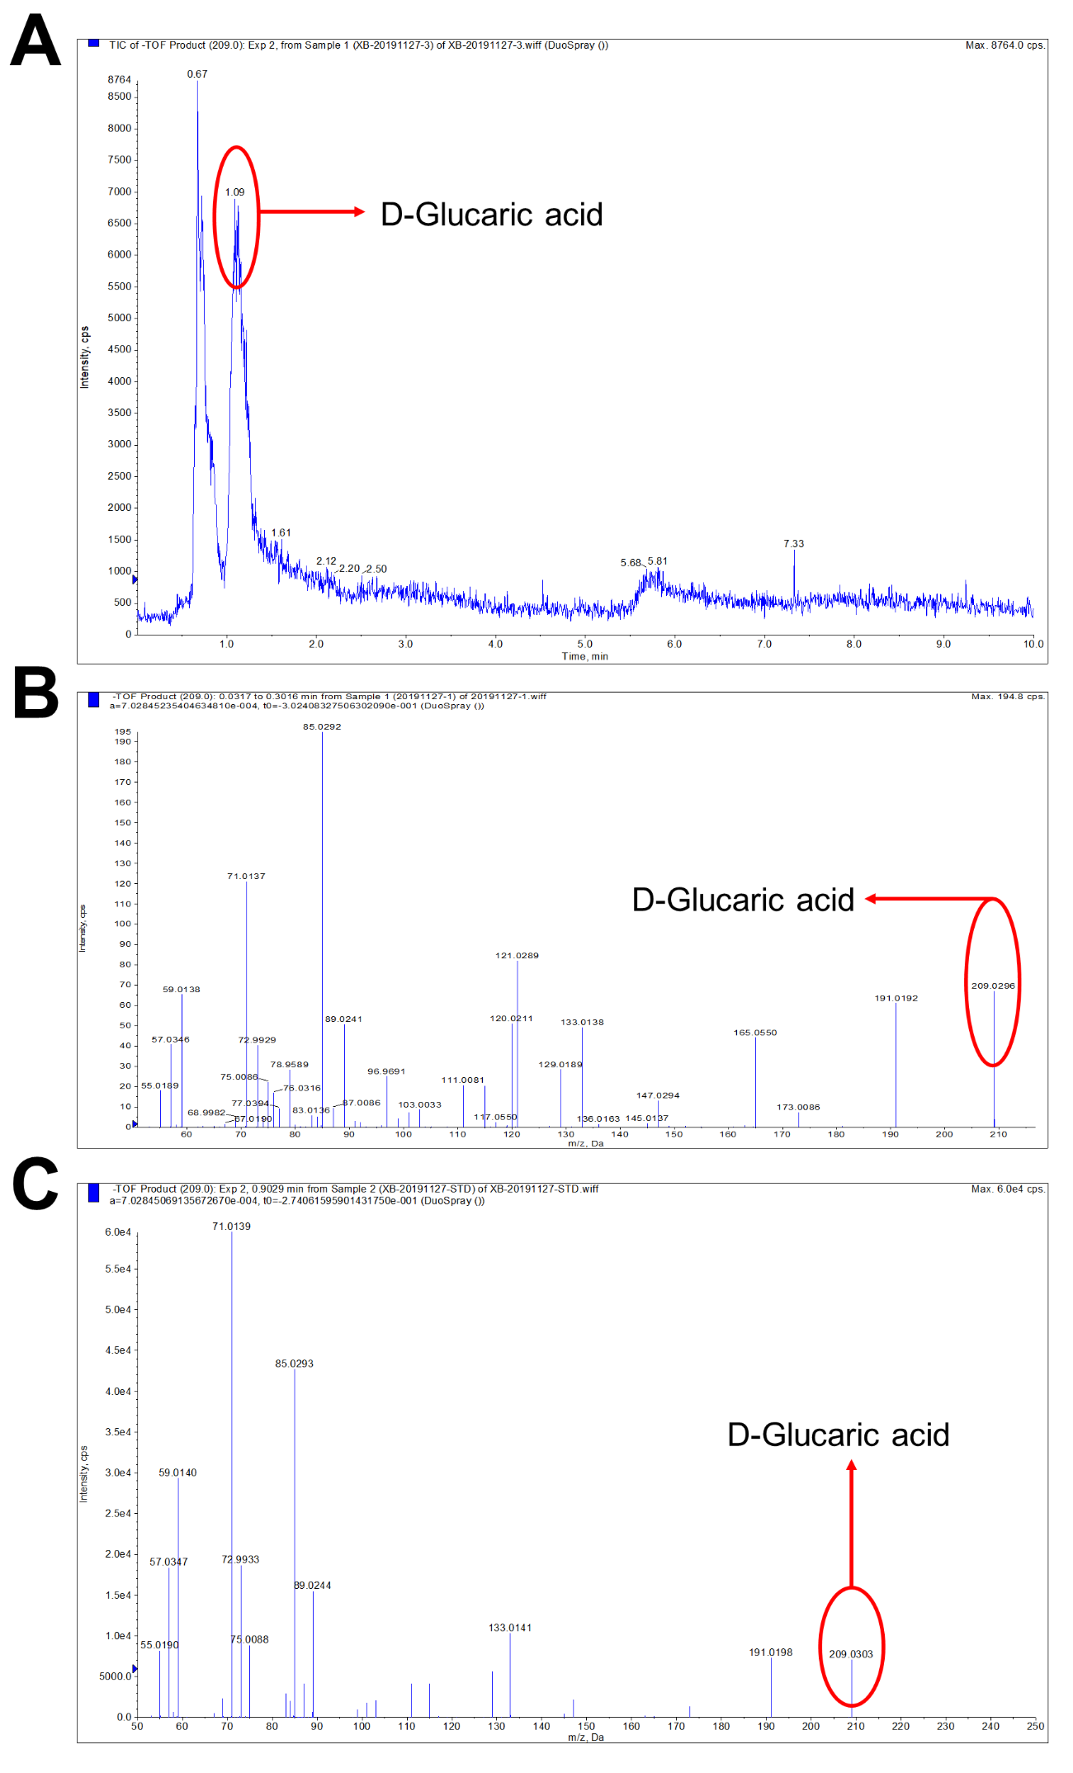
Fig. S1. Results of LC-MS analysis. LC graph (A) and MS graph (B) of the fermentation broth of S. cerevisiae LGA-1 after 7 d fed-batch fermentation on YPD medium supplemented with 10 g/L glucose and 10.8 g/L myo-inositol. (C) MS graph of the standard of D-glucaric acid.

