Appendix

Impacts of landscape pattern evolution on typical ecosystem services in the Ganjiang River Basin, China

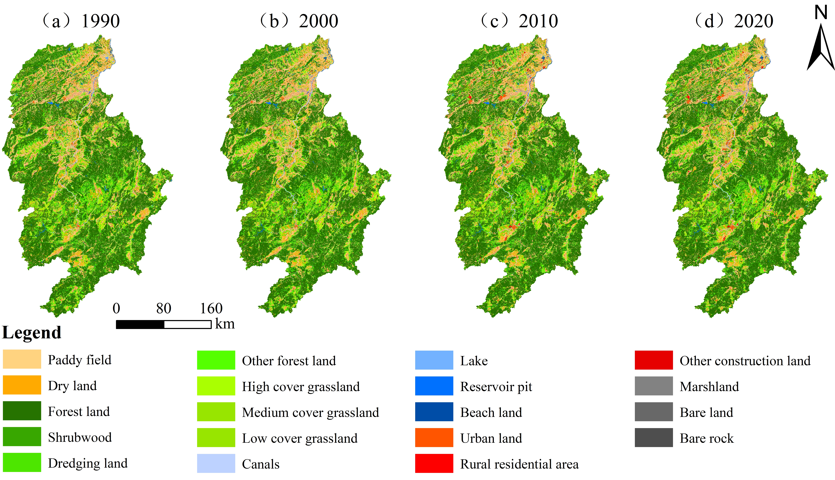
Fig. S.1 Spatial distribution of land use in Ganjiang River Basin from 1990 to 2020
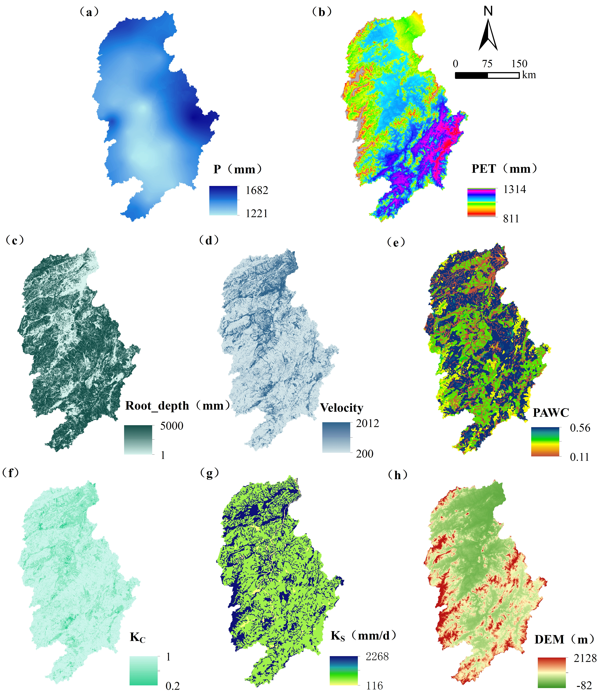
Fig. S.2 Spatial parameters of water conservation in InVEST model.
(a: average annual rainfall; b: average potential evapotranspiration; c: root_depth; d: velocity coefficient; e: available water content of vegetation; f: evapotranspiration coefficient; g: soil saturated water conductivity; h: digital elevation mode

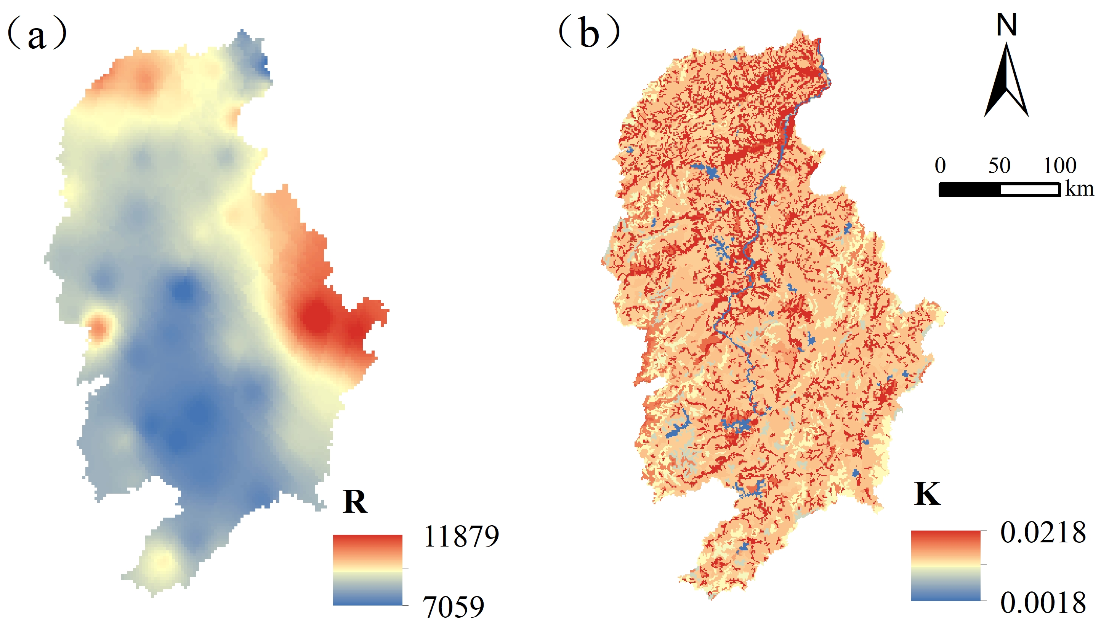
Fig. S.3 Spatial parameters of soil conservation in InVEST model.
(a: rainfall erosivity factor; b: soil erodibility factor)
Fig. S.4 Spatial distribution of landscape index in Ganjiang River Basin from 1990 to 2020

Table S.1 The multicollinear diagnosis of regression equations
Model 1 | PD | CONTAG | AI | LPI | LSI | SHDI | AREA_MN
VIF | 56.26 | 524.53 | 4239.62 | 183.60 | 5089.48 | 157.54 | 5.19
Model 1 | COHESION | DIVISION | IJI | SPLIT | SHAPE_MN | SHEI
VIF | 72.13 | 242.88 | 5.26 | 54.84 | 14.85 | 485.38
Model 2 | AREA_MN | IJI | SPLIT | SHAPE_MN | PD | SHDI
VIF | 4.50 | 1.43 | 4.08 | 1.79 | 5.91 | 5.23

Table S.2 C value and P value of different land use types in Ganjiang River Basin
LUCC_name | C | P | LUCC_name | C | P
Paddy field | 0.180 | 0.150 | Lake | 0 | 0
Dry land | 0.228 | 0.352 | Reservoir pit | 0 | 0
Forest land | 0.005 | 1 | Beach land | 0.910 | 0
Shrubwood | 0.060 | 1 | Urban land | 0 | 0.001
Dredging land | 0.220 | 1 | Rural residential area | 0 | 0.001
Other forest land | 0.180 | 1 | Other construction land | 0 | 0.001
High cover grassland | 0.240 | 1 | Marshland | 0.910 | 0
Medium cover grassland | 0.150 | 1 | Bare land | 1 | 1
Low cover grassland | 0.800 | 0.69 | Bare rock | 0 | 1
Canals | 0 | 0
Note: C means vegetation cover factor; P means soil and water conservation measures factor.

Table S.3 Evaluation results of OLS model of ecosystem services and landscape index
Variables | Water conservation | Soil conservation | Carbon storage
R² | 0.22 | 0.34 | 0.42
Log Likelihood | -19231.00 | -3796.89 | -3593.81
AIC | 38476.00 | 7607.78 | 7201.61
SC | 38518.30 | 7650.14 | 7243.97
Moran’s I（error） | 70.10* | 65.27* | 52.73*
Lagrange Multiplier（lag） | 4613.14* | 3957.42* | 2572.01*
Robust LM（lag） | 111.60* | 196.67* | 178.46*
Lagrange Multiplier（error） | 4858.93* | 4210.65* | 2745.87*
Robust LM（error） | 357.39* | 449.90* | 352.31*

