 | N cases/controls | GS measure | Result
Schizophrenia
Gluck et al., 2002 [1] | 27/13 | GS activity | No change, “DLPFC” (BA46)
Burbaeva et al., 2003 [2] | 8/9 | Protein | Decrease in “PFC” (BA10)
Prabakaran et al., 2004 [3] | 10/10 | Protein | Decrease in “PFC” (BA9)
Bruneau et al., 2005 [4] | 13/8 | mRNA | Increase in thalamus
Toro et al., 2006 [5] | 15/15 | Protein | Unchanged “PFC” (BA9) and “OFC” (BA11/47)
Burbaeva et al., 2007 [6] | 23/22 | Protein | Increase in “PFC”, cerebellum, no change in caudate nucleus.
Steffek et al., 2008 [7] | 23/27 | Protein | Decrease in “ACC” and STG, unchanged “DLPFC”, PVC, HC
Martins de Souza et al., 2010 [8] | 11/8 | Protein | Increase “ACC”
Katsel et al., 2011 [9] | 18/21 | mRNA | “ACC” (cingulate gyrus, BA24/32): no difference in layers I–III or underlying white matter; decrease in layers IV–VI.
Zhang et al., 2020 [10] | 35/34 | mRNA | Increase in “DLPFC” (BA46), no difference in “ACC (BA24)”
Depression and / or suicide
Choudary et al., 2005 [11] | 9/7 | mRNA | Decrease “ACC” (BA24) and “DLPFC” (BA9/46)
Toro et al. 2006 [5] | 15/15 | Protein | Unchanged “PFC” (BA9) and “OFC” (BA11/47)
Kim et al., 2007 [12] |  | mRNA | “PFC” (BA10/46): Within schizophrenia, decreased in suicide (n=10) vs. non-suicide (n=35); within bipolar disorder, no difference in suicide (n=22) vs. non-suicide (n=23).
Karolewicz et al., 2009 [13] | 14/14 | Protein | No change amygdala
Sequeira et al., 2009 [14] | <20, varying by region. | mRNA | Of 17 regions analysed, decrease in “DLPFC” in BA44 BA45, BA46, and in amygdala.
Klemplan et al., 2009 [15] | 24/13 | mRNA | Decrease in “ventral PFC“ (BA44, 45, 46, 47)
Kekesi et al., 2012 [16] | 6/6 | Protein | Increase in “PFC”, no difference in amygdala.
Chandley et al., 2013 [17] | 19/20 | mRNA | Decreased in pontine LC homogenates, no difference in “PFC” (BA10)
Zhao et al., 2016 [18] | 17 MDD-S  7 MDD-NS  12-Con | mRNA | Decreased in MDD+suicide compared to MDD non-suicide in “DLPFC” (BA46), no difference in “ACC” (BA24).
Zhang et al., 2020 [10] | 17/7 | mRNA | Increased in schizophrenia suicide completers (n=17) compared to schizophrenia non-suicide (n=7) in “DLPFC” (BA46), no difference in “ACC” (BA24)
Bipolar disorder
Toro et al. 2006 [5] | 15/15 | Protein | Unchanged “PFC” (BA9) and “OFC” (BA11/47)
Choudary et al., 2005 [11] | 6/7 | mRNA | Unchanged in “ACC” (BA24) and “DLPFC” (BA9/46)
Bernard et al 2011 [19] | 6/9 | mRNA | Unchanged in LC
Autism Spectrum Disorder
Shimmura et al., 2013 [20] | 7/13 | Protein | Unchanged “ACC”
Temporal Lobe Epilepsy (TLE)
van der Hel et al., 2005 [21] |  | Protein and activity | decreased in TLE with sclerosis hippocampus (CA1, CA4)
Eid et al., 2013 [22] | Autopsy 3  MTLE 9  Non-MTLE 6 | mRNA | Increased in CA3 (but not CA1, CA2, subiculum, dentate gyrus or hilus) in non-MTLE CA3
Alcohol use disorder
Matsuda-Matsumoto et al., 2007 [23] | 6/8 | Protein | Decrease HC
Miguel-Hilgado et al., 2010 [24] | 13/13 | Protein | No change “OFC” (BA47)
Huntington’s Disease
Carter et al., 1982 [25] | 15-21/15-20 | GS activity | Decreased in frontal, temporal cortex, putamen, cerebellum. Unchanged thalamus, hippocampus, olivary nucleus
Alzheimer’s Disease
Gluck et al., 2002 [1] | 10/13 | GS activity | No change “DLPFC” (BA46)
Burbaeva et al., 2005 [26] | 11/11 | Protein | Increased “PFC” (BA10)
Hepatic encephalopathy
Lavoie et al., 1987 [27] | 9/9 | GS activity | Decreased caudate.
Supplement Table 1. Post-mortem studies of glutamine synthetase (GS, also known as glutamate-ammonia ligase) in psychiatric or neurological disorders. N c/c: number of cases / controls. MTLE: temporal lobe epilepsy with hippocampal sclerosis; non-MTLE: TLE without hippocampal sclerosis. Region abbreviations: ACC: anterior cingulate cortex; BA Brodmann area; “DLPFC”: dorsolateral prefrontal cortex; HC: hippocampus; LC: locus coeruleus; OFC: orbitofrontal cortex: PFC: prefrontal cortex; PVC: primary visual cortex; STG: superior temporal gyrus

glutamine synthetase
glutamate
k₄
k₃
k₂
K₁
CBF
BBB
Brain tissue
Capillary
[¹³N]glutamine
[¹³N]NH₃
[¹³N]NH₃ uptake
[¹³N]N H₃ washout
C₁
C₂

Supplement Figure 1. Two tissue [¹³N]NH₃ Compartmental Model (simplified model based on Cooper 2011 [28]). K₁, (mL blood/ min/mL tissue) is the rate constant of initial uptake (or “blood clearance”) of [¹³N]NH₃ from the blood to brain tissue (compartment 1, C₁) across the blood brain barrier. This parameter would be expected to be a function of blood flow and capillary permeability. k₂ (1/min) is the rate constant of backflux of [¹³N]NH₃ from brain to blood (1/min). The rate constant k₃ (1/min) represents the conversion by glutamine synthetase of [¹³N]NH₃ and endogenous glutamate to [¹³N]glutamine (compartment C₂). k₄ (1/min) is the rate constant representing the recycling of [¹³N]glutamine to [¹³N]glutamate and [¹³N]NH₃ by glutaminase and glutamate dehydrogenase. This route would be considered negligible in the irreversible two tissue compartment model considered by Keiding et al.[29] Further simplification of this model (i.e. reversible and irreversible one tissue compartment model) would assume either rapid equilibration of C₁ and C₂, or k₃ ~ 0, with remaining rate constants representing a mixture of the processes described.

ROI | PSbbb (ml/100g/min) |  |  | Kmet (ml/100g/min) |  |  | PSmet (ml/100g/min) |  |  | CMRA (nmol/100g/min)
-- | S1 | S2 | AbsVAR | S1 | S2 | AbsVAR | S1 | S2 | AbsVAR | S1 | S2 | AbsVAR
Grey Matter | 28.8 ± 4.2 | 25.4 ± 1.9 | 15 ± 18 | 12.3 ± 3.7 | 11.5 ± 1.7 | 18 ± 13 | 15.3 ± 5.9 | 13.6 ± 2.5 | 22 ± 18 | 343.4 ± 158.4 | 284.6 ± 76.5 | 49 ± 13
OL_ling_G_l | 36.8 ± 9.2 | 30.6 ± 1.9 | 23 ± 22 | 13.4 ± 4.5 | 13.6 ± 2.3 | 13 ± 17 | 16.9 ± 6.9 | 16.6 ± 3.3 | 18 ± 19 | 373.2 ± 174.8 | 337.4 ± 90.1 | 44 ± 16
G_cing_post_l | 31.6 ± 4.8 | 28.2 ± 1.8 | 15 ± 16 | 14.0 ± 4.8 | 11.9 ± 1.5 | 23 ± 13 | 17.9 ± 8.1 | 14.0 ± 2.2 | 30 ± 18 | 395.9 ± 203.0 | 291.8 ± 50.0 | 37 ± 33
Putamen_l | 32.7 ± 5.6 | 28.1 ± 2.1 | 18 ± 18 | 14.4 ± 5.6 | 13.0 ± 1.7 | 35 ± 27 | 17.9 ± 7.7 | 15.3 ± 2.5 | 41 ± 28 | 397.8 ± 190.2 | 318.9 ± 63.3 | 55 ± 27
Thalamus_l | 32.8 ± 6.9 | 28.6 ± 1.9 | 19 ± 19 | 13.1 ± 3.7 | 12.9 ± 1.4 | 18 ± 10 | 16.2 ± 6.1 | 15.2 ± 2.0 | 23 ± 14 | 366.7 ± 164.4 | 320.4 ± 86.9 | 41 ± 24
Cerebellum_l | 32.6 ± 5.4 | 28.0 ± 1.9 | 17 ± 18 | 14.5 ± 3.3 | 12.6 ± 2.3 | 16 ± 13 | 18.4 ± 5.8 | 15.0 ± 3.5 | 21 ± 18 | 406.7 ± 164.5 | 310.2 ± 77.9 | 48 ± 20

Supplement Table 2: Permeability–surface area and fractional uptake rate parameters calculated from [¹³N]NH₃ model parameters from subjects 1-5.
The table provides model parameters for test (S1) & retest (S2) scans for grey matter and selected regions of interest (ROIs). The table presents estimates of PS_{BBB} (flow independent permeability-surface area product of the blood brain barrier to [¹³N]ammonia); Kmet (net metabolic clearance of [¹³N]ammonia in blood into intracellular [¹³N]glutamine), PSmet (flow-independent permeability-surface area product of conversion of ammonia to intracellular glutamine) and CMRA (cerebral metabolic rate of ammonia).Data are presented as mean ± standard deviation for grey matter and the left (l) lingual gyrus (OL_ling_G), posterior cingulate gyrus (G_cing_post), putamen, thalamus, and cerebellum.

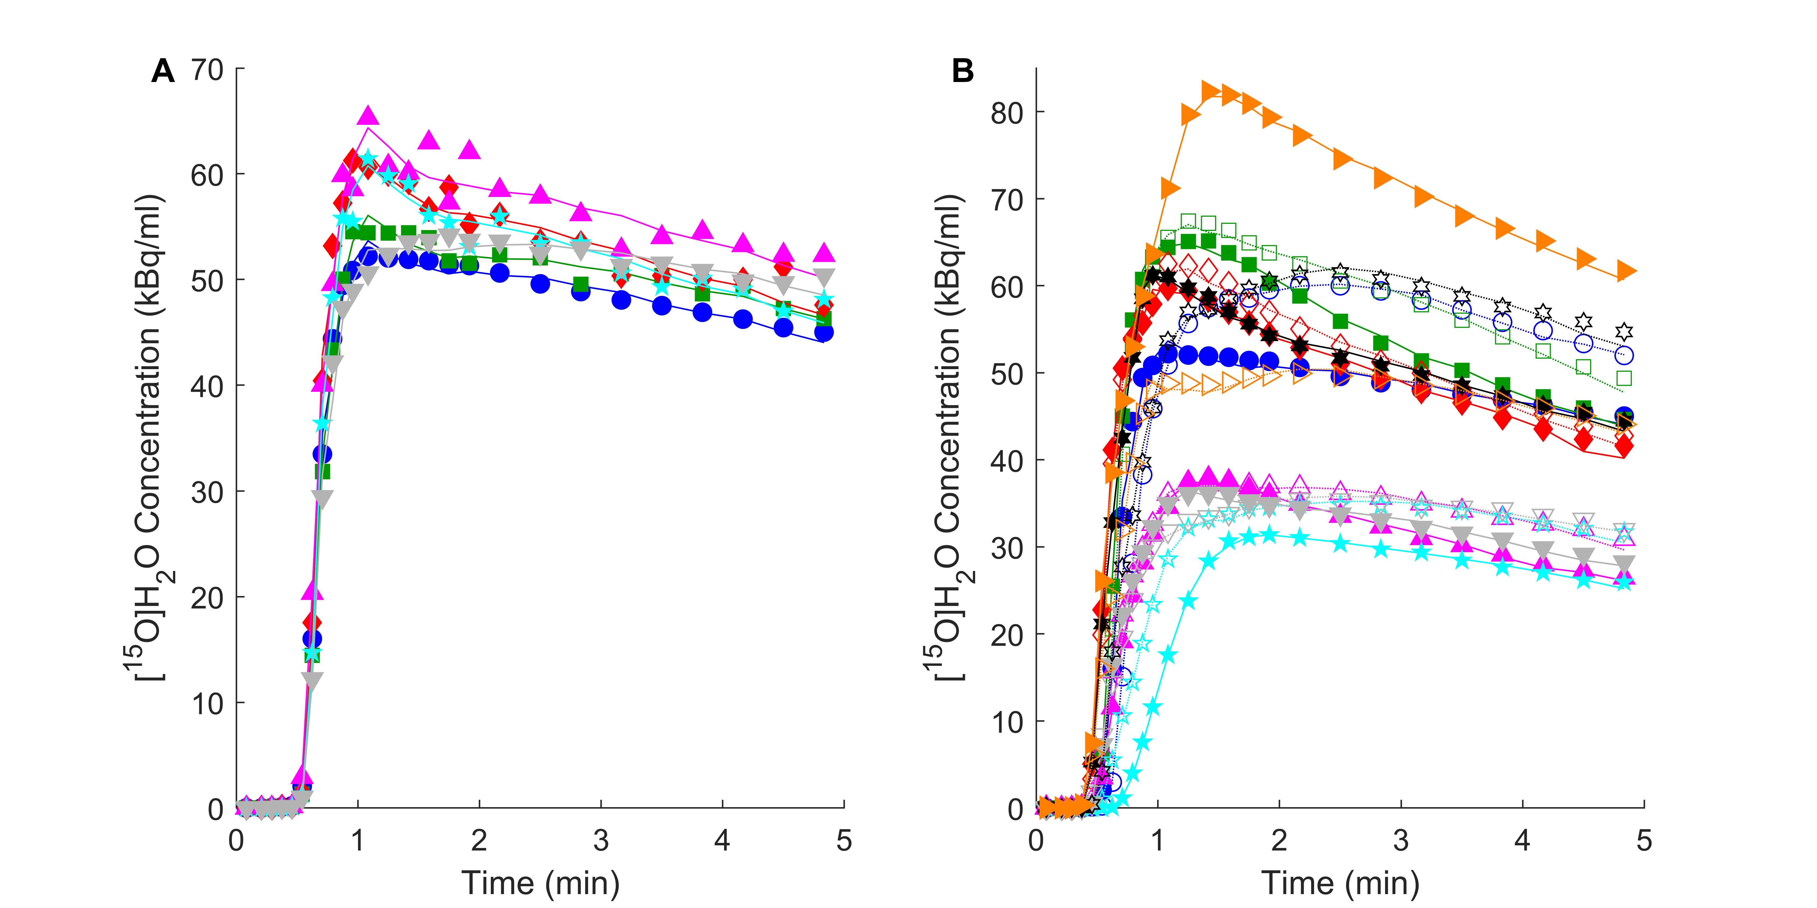
Supplement Figure 2: Cerebral blood flow (CBF) Time-Activity Curve (TAC) data & fits. Symbols show TAC data points from water PET scans, lines model fits. A: TAC and model fits from subject 1 for grey matter (circle), left orbitolateral lingual gyrus (square), left posterior cingulate gyrus (diamond), left putamen (up triangle), left thalamus (star) and left cerebellum (down triangle). B: TACs and model fits for grey matter in subjects 1-8 (colour coded). Solid symbols and solid lines show scan 1, open symbols and dashed lines scan 2.

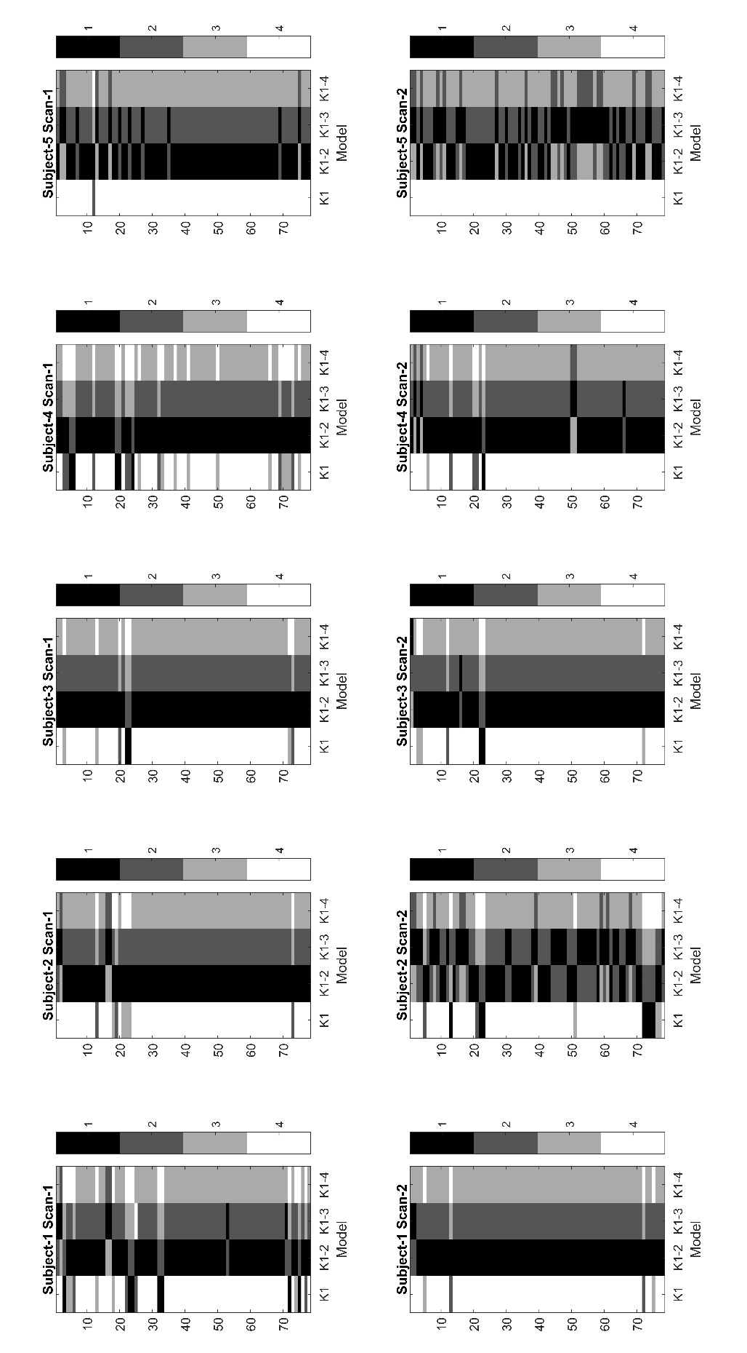
Supplement Figure 3. Graphical representation of best model choice for each of the 78 ROIs for each subject and scan. Regions are represented by rows, and four candidate models are shown as columns. Best model choice, shown in black, is defined by the model fit with the lowest Akaike Information Criterion, within each region (for each subject and scan), with least favoured model show in white. Model K1 is the irreversible 1TCM, K1-2 is the reversible 1TCM, K1-3 is the irreversible 2TCM, and K1-4 is the reversible 2TCM. All candidate models included a blood fraction as a free parameter. Most subjects show model K1-2 (reversible 1TCM) as the most favourable model across the majority of regions. Subjects 2 and 5 showed more regions favouring the irreversible 2TCM (K1-3) in their second scans, but this was not observed in their first.

References

1. Gluck MR, Thomas RG, Davis KL, Haroutunian V. Implications for altered glutamate and GABA metabolism in the dorsolateral prefrontal cortex of aged schizophrenic patients. Am J Psychiatry. 2002;159(7):1165-73. doi:10.1176/appi.ajp.159.7.1165.
2. Burbaeva G, Boksha IS, Turishcheva MS, Vorobyeva EA, Savushkina OK, Tereshkina EB. Glutamine synthetase and glutamate dehydrogenase in the prefrontal cortex of patients with schizophrenia. Prog Neuropsychopharmacol Biol Psychiatry. 2003;27(4):675-80. doi:10.1016/s0278-5846(03)00078-2.
3. Prabakaran S, Swatton JE, Ryan MM, Huffaker SJ, Huang JT, Griffin JL et al. Mitochondrial dysfunction in schizophrenia: evidence for compromised brain metabolism and oxidative stress. Mol Psychiatry. 2004;9(7):684-97, 43. doi:10.1038/sj.mp.4001511.
4. Bruneau EG, McCullumsmith RE, Haroutunian V, Davis KL, Meador-Woodruff JH. Increased expression of glutaminase and glutamine synthetase mRNA in the thalamus in schizophrenia. Schizophr Res. 2005;75(1):27-34. doi:10.1016/j.schres.2004.12.012.
5. Toro CT, Hallak JE, Dunham JS, Deakin JF. Glial fibrillary acidic protein and glutamine synthetase in subregions of prefrontal cortex in schizophrenia and mood disorder. Neurosci Lett. 2006;404(3):276-81. doi:10.1016/j.neulet.2006.05.067.
6. Burbaeva G, Boksha IS, Tereshkina EB, Savushkina OK, Starodubtseva LI, Turishcheva MS et al. Systemic neurochemical alterations in schizophrenic brain: glutamate metabolism in focus. Neurochem Res. 2007;32(9):1434-44. doi:10.1007/s11064-007-9328-7.
7. Steffek AE, McCullumsmith RE, Haroutunian V, Meador-Woodruff JH. Cortical expression of glial fibrillary acidic protein and glutamine synthetase is decreased in schizophrenia. Schizophr Res. 2008;103(1-3):71-82. doi:10.1016/j.schres.2008.04.032.
8. Martins-de-Souza D, Schmitt A, Roder R, Lebar M, Schneider-Axmann T, Falkai P et al. Sex-specific proteome differences in the anterior cingulate cortex of schizophrenia. J Psychiatr Res. 2010;44(14):989-91. doi:10.1016/j.jpsychires.2010.03.003.
9. Katsel P, Byne W, Roussos P, Tan W, Siever L, Haroutunian V. Astrocyte and glutamate markers in the superficial, deep, and white matter layers of the anterior cingulate gyrus in schizophrenia. Neuropsychopharmacology. 2011;36(6):1171-7. doi:10.1038/npp.2010.252.
10. Zhang L, Verwer RWH, Lucassen PJ, Huitinga I, Swaab DF. Prefrontal cortex alterations in glia gene expression in schizophrenia with and without suicide. J Psychiatr Res. 2020;121:31-8. doi:10.1016/j.jpsychires.2019.11.002.
11. Choudary PV, Molnar M, Evans SJ, Tomita H, Li JZ, Vawter MP et al. Altered cortical glutamatergic and GABAergic signal transmission with glial involvement in depression. Proc Natl Acad Sci U S A. 2005;102(43):15653-8. doi:10.1073/pnas.0507901102.
12. Kim S, Choi KH, Baykiz AF, Gershenfeld HK. Suicide candidate genes associated with bipolar disorder and schizophrenia: an exploratory gene expression profiling analysis of post-mortem prefrontal cortex. BMC Genomics. 2007;8:413. doi:10.1186/1471-2164-8-413.
13. Karolewicz B, Szebeni K, Gilmore T, Maciag D, Stockmeier CA, Ordway GA. Elevated levels of NR2A and PSD-95 in the lateral amygdala in depression. Int J Neuropsychopharmacol. 2009;12(2):143-53. doi:10.1017/S1461145708008985.
14. Sequeira A, Mamdani F, Ernst C, Vawter MP, Bunney WE, Lebel V et al. Global brain gene expression analysis links glutamatergic and GABAergic alterations to suicide and major depression. PLoS One. 2009;4(8):e6585. doi:10.1371/journal.pone.0006585.
15. Klempan TA, Sequeira A, Canetti L, Lalovic A, Ernst C, ffrench-Mullen J et al. Altered expression of genes involved in ATP biosynthesis and GABAergic neurotransmission in the ventral prefrontal cortex of suicides with and without major depression. Mol Psychiatry. 2009;14(2):175-89. doi:10.1038/sj.mp.4002110.
16. Kekesi KA, Juhasz G, Simor A, Gulyassy P, Szego EM, Hunyadi-Gulyas E et al. Altered functional protein networks in the prefrontal cortex and amygdala of victims of suicide. PLoS One. 2012;7(12):e50532. doi:10.1371/journal.pone.0050532.
17. Chandley MJ, Szebeni K, Szebeni A, Crawford J, Stockmeier CA, Turecki G et al. Gene expression deficits in pontine locus coeruleus astrocytes in men with major depressive disorder. J Psychiatry Neurosci. 2013;38(4):276-84. doi:10.1503/jpn.120110.
18. Zhao J, Verwer RW, van Wamelen DJ, Qi XR, Gao SF, Lucassen PJ et al. Prefrontal changes in the glutamate-glutamine cycle and neuronal/glial glutamate transporters in depression with and without suicide. J Psychiatr Res. 2016;82:8-15. doi:10.1016/j.jpsychires.2016.06.017.
19. Bernard R, Kerman IA, Thompson RC, Jones EG, Bunney WE, Barchas JD et al. Altered expression of glutamate signaling, growth factor, and glia genes in the locus coeruleus of patients with major depression. Mol Psychiatry. 2011;16(6):634-46. doi:10.1038/mp.2010.44.
20. Shimmura C, Suzuki K, Iwata Y, Tsuchiya KJ, Ohno K, Matsuzaki H et al. Enzymes in the glutamate-glutamine cycle in the anterior cingulate cortex in postmortem brain of subjects with autism. Mol Autism. 2013;4(1):6. doi:10.1186/2040-2392-4-6.
21. van der Hel WS, Notenboom RG, Bos IW, van Rijen PC, van Veelen CW, de Graan PN. Reduced glutamine synthetase in hippocampal areas with neuron loss in temporal lobe epilepsy. Neurology. 2005;64(2):326-33. doi:10.1212/01.WNL.0000149636.44660.99.
22. Eid T, Lee TS, Wang Y, Perez E, Drummond J, Lauritzen F et al. Gene expression of glutamate metabolizing enzymes in the hippocampal formation in human temporal lobe epilepsy. Epilepsia. 2013;54(2):228-38. doi:10.1111/epi.12008.
23. Matsuda-Matsumoto H, Iwazaki T, Kashem MA, Harper C, Matsumoto I. Differential protein expression profiles in the hippocampus of human alcoholics. Neurochem Int. 2007;51(6-7):370-6. doi:10.1016/j.neuint.2007.04.001.
24. Miguel-Hidalgo JJ, Waltzer R, Whittom AA, Austin MC, Rajkowska G, Stockmeier CA. Glial and glutamatergic markers in depression, alcoholism, and their comorbidity. J Affect Disord. 2010;127(1-3):230-40. doi:10.1016/j.jad.2010.06.003.
25. Carter CJ. Glutamine synthetase activity in Huntington's disease. Life Sci. 1982;31(11):1151-9. doi:10.1016/0024-3205(82)90090-x.
26. Burbaeva G, Boksha IS, Tereshkina EB, Savushkina OK, Starodubtseva LI, Turishcheva MS. Glutamate metabolizing enzymes in prefrontal cortex of Alzheimer's disease patients. Neurochem Res. 2005;30(11):1443-51. doi:10.1007/s11064-005-8654-x.
27. Lavoie J, Giguere JF, Layrargues GP, Butterworth RF. Activities of neuronal and astrocytic marker enzymes in autopsied brain tissue from patients with hepatic encephalopathy. Metab Brain Dis. 1987;2(4):283-90. doi:10.1007/bf00999698.
28. Cooper AJ. 13N as a tracer for studying glutamate metabolism. Neurochem Int. 2011;59(4):456-64. doi:10.1016/j.neuint.2010.11.011.
29. Keiding S, Sorensen M, Bender D, Munk OL, Ott P, Vilstrup H. Brain metabolism of 13N-ammonia during acute hepatic encephalopathy in cirrhosis measured by positron emission tomography. Hepatology. 2006;43(1):42-50. doi:10.1002/hep.21001.

