Supporting Information

Extended Nucleic Acid (exNA): A Novel, Biologically Compatible Backbone that
Significantly Enhances Oligonucleotide Efficacy in vivo.

Ken Yamada¹*, Vignesh Narayan Hariharan¹, Jillian Caiazzi¹, Rachael Miller^{1, 3}, Chantal Furguson^{1, 3}, Ellen Sapp⁴,
Hassan Fakih¹, Qi Tan¹, Nozomi Yamada¹, Raymond C. Furgal¹, Joseph Paquette^{1,3}, Brianna Bramato¹, Nicholas McHugh¹, Ashley Summers¹, Clemens Lochmann¹, Bruno M.D.C. Godinho¹, Samuel Hildebrand¹, Dimas Echeverria¹, Matthew R. Hassler¹, Julia F. Alterman¹, Marian DiFiglia⁴, Neil Aronin^{1, 3}, Anastasia Khvorova^{1,2}*
¹RNA Therapeutics Institute, University of Massachusetts Medical School, 368 Plantation Street, Worcester, Massachusetts 01605, United States; ²Program in Molecular Medicine, University of Massachusetts Medical School; ³Department of Medicine, University of Massachusetts Medical School; ⁴ Department of Neurology, Harvard Medical School and Mass General Institute for Neurodegenerative Disease, Charlestown, Massachusetts, United State.
*Corresponding author: Ken.Yamada@umassmed.edu and Anastasia.Khvorova@umassmed.edu

Contents
General remarks ---------------------------------------------------------------------------------------------------------------------- S2
Scheme S1 ------------------------------------------------------------------------------------------------------------------------ S3
Synthesis of compound 5a ----------------------------------------------------------------------------------------------------------- S3
Synthesis of compound 6a ----------------------------------------------------------------------------------------------------------- S3-4
Synthesis of compound 8a ---------------------------------------------------------------------------------------------------------- S4
Synthesis of compound 9a -------------------------------------------------------------------------------------------------- S4-5
Scheme S2 ------------------------------------------------------------------------------------------------------------------------ S5
Synthesis of compound 5b ----------------------------------------------------------------------------------------------------------- S5-6
Synthesis of compound 7b ----------------------------------------------------------------------------------------------------------- S7
Synthesis of compound 8b ---------------------------------------------------------------------------------------------------------- S7-8
Synthesis of compound 9b ------------------------------------------------------------------------------------------------------------------ S8
Scheme S3 ------------------------------------------------------------------------------------------------------------------------ S8
Synthesis of compound 6 ----------------------------------------------------------------------------------------------------------- S8-9
Synthesis of compound 7 ----------------------------------------------------------------------------------------------------------- S9
Synthesis of compound 8 ---------------------------------------------------------------------------------------------------------- S9
Synthesis of compound 9 ---------------------------------------------------------------------------------------------------------------- S9-10
Table S1 ------------------------------------------------------------------------------------------------------------------------ S10
Table S2 ------------------------------------------------------------------------------------------------------------------------ S10
Table S3 ------------------------------------------------------------------------------------------------------------------------ S11
Table S4 ------------------------------------------------------------------------------------------------------------------------ S12
Table S5 --------------------------------------------------------------------------------------------------------------------- S12
Table S6 --------------------------------------------------------------------------------------------------------------------- S12-13
Table S7 --------------------------------------------------------------------------------------------------------------------- S13
Table S8 --------------------------------------------------------------------------------------------------------------------- S13-14
Table S9 --------------------------------------------------------------------------------------------------------------------- S14
Table S10 --------------------------------------------------------------------------------------------------------------------- S15
Table S11 --------------------------------------------------------------------------------------------------------------------- S16
Figure S1 --------------------------------------------------------------------------------------------------------------------- S16
Figure S2 --------------------------------------------------------------------------------------------------------------------- S17
Figure S3 --------------------------------------------------------------------------------------------------------------------- S18
Figure S4 --------------------------------------------------------------------------------------------------------------------- S18

■ General remarks

The NMR spectra were recorded using Brucker 500 MHz spectrometer. ¹H, ¹³C, ¹⁹Fand ³¹P NMR spectra were recorded at 500 MHz (¹H NMR, 500 MHz; ¹³C-NMR, 125 MHz; ³¹P-NMR, 202 MHz). The chemical shifts were measured from tetramethylsilane (0 ppm), CDCl₃ (7.26 ppm), DMSO-d₆ (2.49 ppm) and CD₃CN-d₃ (1.93 ppm) for ¹H-NMR spectra, CDCl₃ (77.0 ppm), DMSO-d₆ (39.7 ppm) and CD₃CN-d₃ (1.30 ppm) for ¹³C-NMR spectra, and 85% H₃PO₄ for ³¹P-NMR spectra as external standards. High-resolution electrospray ionization mass spectrometry (HR-ESI-MS) analysis for the monomers and dimer nucleos(t)ides were performed on a Thermo Scientific Orbitrap Velos Pro mass spectrometer in the positive ion mode. The mass analysis of oligonucleotides was conducted by LC-MS on an Agilent 6530 accurate-mass Q-TOF LC/MS (Agilent technologies, Santa Clara, CA). Thin-layer chromatography (TLC) analysis was conducted using silica gel-coated aluminium-backed TLC plates (0.20 mm thickness) containing F-254 UV indicator (Silicycle Inc., Canada). Column chromatography was performed with silica column (Flash Column Silica-CS-Agela; 12-330 g; 40-60 μm), using the CombiFlash Rf200 (Teledyne Isco, Inc.) Companion Chromatograph. The synthesis of modified oligonucleotides was performed using MerMaid-12 DNA/RNA synthesizer (Bio automation, USA). Analytical anion-exchange HPLC and reverse phase HPLC were performed on Agilent 1260 Infinity Analytical SFC System combined with an Agilent 1100 series quaternary pump with a degasser. Purified oligonucleotides were desalted by Sephadex G-25 (GE Healthcare).

Scheme S1. 2′-OMe-Ur exNA phosphoramidite
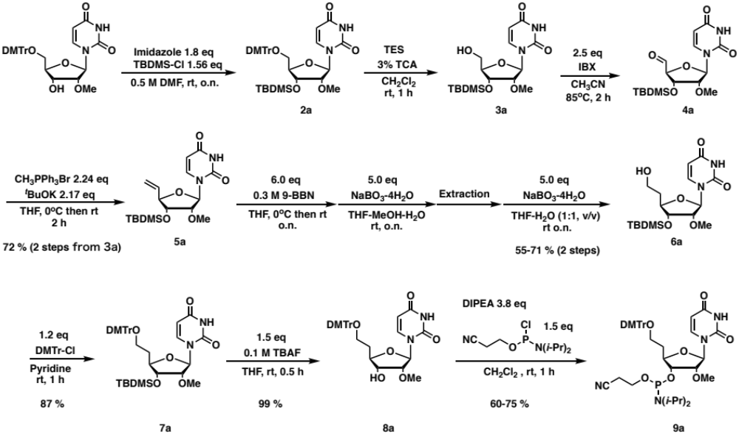

Synthesis of compound 5a. Anhydrous solution of compound 3a (2.94 g, 7.89 mmol) in CH₃CN (80 mL) was added IBX (5.53 g, 19.7 mmol) and stirred for 2 h at 85 ºC. After cooling the mixture in an ice bath, the precipitate in the solution was filtered off through celite. The collected eluent was evaporated, and co-evaporated with anhydrous CH₃CN three times under an argon atmosphere, and obtained compound 4a as a white foam was used without further purification. In a separate flask, anhydrous THF (80 mL) solution containing methyltriphenylphosphonium bromide (8.47 g, 23.7 mmol) was added tert-BuOK (2.57 g, 22.9 mmol) at 0 ºC and stirred for 30 min at 0 ºC. To this solution, anhydrous THF solution (80 mL) of compound 4a was added dropwise (10 min) at 0 ºC and stirred for 7 h at rt. After evaporating excess THF, the obtained mixture was dissolved in excess ethyl acetate, washed by aq. sat. NH₄Cl, dried over MgSO₄, filtered, and evaporated. The obtained material was dissolved into a minimum amount of CH₂Cl₂ and added dropwise to excess diethyl ether solution under vigorous stirring under the icing. Precipitate in solution was filtered off through celite and eluents was evaporated. The obtained crude material was purified by silica gel column chromatography (hexane/ethyl acetate, 9:1 to 1:2) yielding compound 5a as a white foam (2.19 g, 75 % in 2 steps). ¹H NMR (500 MHz, CDCl₃) δ 9.55 (br-s, 1H), 7.38 (d, 1H, J = 8.2 Hz), 5.89 (ddd, 1H, J = 17.1, 10.6, 6.6 Hz), 5.82 (d, 1H, J = 2.0 Hz), 5.77 (dd, 1H, J = 8.1, 1.5 Hz), 5.44 (dt, 1H, J = 17.2, 1.2 Hz), 5.34 (dt, 1H, J = 10.5, 1.1 Hz), 4.43-4.40 (m, 1H), 3.90 (dd, 1H, J = 7.7, 5.1 Hz), 3.71 (dd, 1H, J = 5.0, 2.0 Hz), 3.55 (s, 3H), 0.89 (s, 9H), 0.09 (s, 3H), 0.07 (s, 3H); ¹³C NMR (125 MHz, CDCl₃) δ 163.4, 150.0, 139.7, 134.4, 119.2, 102.4, 89.7, 84.0, 83.5, 74.5, 58.7, 25.7, 18.2, -4.6, -4.7; HRMS (ESI) calcd. for C₁₇H₂₉N₂O₅Si⁺ [M + H]⁺ m/z 369.1840, found m/z 369.1838.

Synthesis of compound 6a. Anhydrous solution of compound 5a (7.29 g, 19.8 mmol) in THF (158.3 mL) was added 0.5 M 9-BBN/THF solution (237.4 mL, 118.7 mmol) dropwise for 10 min at 0ºC. After stirring the mixture at rt 6 h, the solution was iced and added methanol (65.4 mL) and stirred until bubbling cease down. Then under vigorous stirring, H₂O (98.4 mL) was added dropwise for 10 min to avoid precipitation of an intermediate compound. At 0ºC, NaBO₃-4H₂O (15.7 g, 102.0 mmol) was added in one portion and stirred at rt o.n. After evaporation of excess THF, obtained crude mixture was dissolved into excess ethyl acetate, and washed repeatedly by sat. aq. NH₄Cl solution. After evaporating organic layer, obtained material was dissolved in THF (450 mL) and H₂O (450 mL). To this solution, NaBO₃-4H₂O (15.7 g, 102.0 mmol) was added in one portion at rt, then stirred o.n. at rt. After evaporating of excess THF, the mixture was added ethyl acetate, then extracted. Obtained organic layer was repeatedly washed by aq. sat. NH₄Cl, dried over MgSO₄, filtered, and evaporated. Obtained crude material was purified by silica gel column chromatography (hexane/ethyl acetate, 7:3 to 0:10) yielding compound 6a as a white foam (4.73 g, 62 % in 2 steps). ¹H NMR (500 MHz, CDCl₃) δ 9.21(br-s, 1H), 7.35 (d, 1H, J = 8.1 Hz), 5.78-5.76 (m, 2H), 4.14-4.10 (m, 1H), 3.92-3.79 (m, 4H), 3.75 (dd, 1H, J = 5.2, 2.3 Hz), 2.06-2.00 (m, 1H), 1.90-1.82 (m, 1H), 0.91 (s, 9H), 0.11 (s, 3H), 0.10 (s, 3H); ¹³C NMR (125 MHz, CDCl₃) δ 163.1, 149.9, 140.0, 102.6, 90.1, 83.0, 82.0, 74.5, 60.3, 58.4, 35.5, 25.7, 18.1, -4.6, -4.9; HRMS (ESI) calcd. for C₁₇H₃₁N₂O₅Si⁺ [M + H]⁺ m/z 387.1946, found m/z 387.1944.

Synthesis of compound 8a. Anhydrous solution of compound 6a (9.46 g, 24.5 mmol) in pyridine (240 mL) was added DMTrCl (9.95 g, 29.4 mmol) and stirred at rt for 2h. After quenching the reaction mixture by MeOH (20 mL), excess pyridine was evaporated, then obtained material was dissolved into excess ethyl acetate. The organic solution was washed by aq. sat. NaHCO₃, dried over MgSO₄, filtered, evaporated, then co-evaporated with toluene to remove pyridine residues. This crude mixture containing compound 7a was dissolved into THF (330 mL), added 1.0 M TBAF-THF solution (36.7 mL, 36.7 mmol), then stirred for 1 h at rt. After evaporation excess THF and co-evaporation with CH₂Cl₂, the crude material was purified by silica gel column chromatography yielding compound 8a (13.15 g, 93 % in 2 steps). ¹H NMR (500 MHz, CDCl₃) δ 8.91 (br-s, 1H), 7.43-7.21 (m, 2H), 7.32-7.14 (m, 8H), 6.83-6.82 (m, 1H), 5.80 (d, 1H, J = 1.8 Hz), 5.69 (d, 1H, J = 8.2 Hz), 4.02-3.98 (m, 1H), 3.85 (dd, 1H, J = 6.7, 6.7 Hz), 3.79 (s, 6H), 3.72 (dd, 1H, J = 5.5, 1.9 Hz), 3.34-3.25 (m, 2H), 2.91 (br-s, 1H), 2.11-2.04 (m, 1H), 1.95-1.89 (m, 1H); ¹³C NMR (125 MHz, CDCl₃) δ 163.2, 163.1, 158.4, 149.9, 114.8, 139.1, 136.1, 136.0, 129.92, 129.90, 128.0, 127.8, 126.8, 113.1, 102.5, 88.1, 86.6, 83.5, 81.3, 73.2, 60.1, 58.8, 55.2, 53.4, 33.4; HRMS (ESI) calcd. for C₃₂H₃₄N₂O₈Na [M + Na]⁺ m/z 597.2203, found m/z 597.2153.

Synthesis of compound 9a. Compound 8a (9.57 g, 16.65 mmol) was rendered anhydrous by repeated co-evaporation with anhydrous CH₃CN and then dissolved into anhydrous CH₂Cl₂ (150 mL). To this solution N,N-diisopropylethylamine (7.6 mL, 62.4 mmol) and 2-cyanoethyl N,N-diisopropylchlorophosphoramidite (4.85 mL, 25.0 mmol) were added at 0 °C. After stirring for 4 h at rt, the reaction mixture was added CH₂Cl₂ (200 mL) then aq. sat. NaHCO₃ (350 mL). The organic layer was repeatedly washed by aq. sat. NaHCO₃, dried over MgSO₄, filtered, then evaporated. The obtained crude material was purified by silica gel column chromatography (1%TEA-hexanes-ethyl acetate, from 80:20 to 30:70) yielding compound 9a with an impurity of phosphorylating reagent residues. To remove the impurity, obtained material was dissolved in Et₂O-ethylacetate (1:1, v/v, 400 mL), then repeatedly washed by aq. sat. NaHCO₃ yielding compound 9a as a white solid (11.12 g, 86 %); ³¹P NMR (202 MHz, CDCl₃) δ 150.0, 149.9; HRMS (ESI) calcd. for C₄₁H₅₂N₄O₉P [M + H]⁺ m/z 775.3486, found m/z 775.3414.

Scheme S2. Synthesis of 2′-F-Ur exNA phosphoramidite
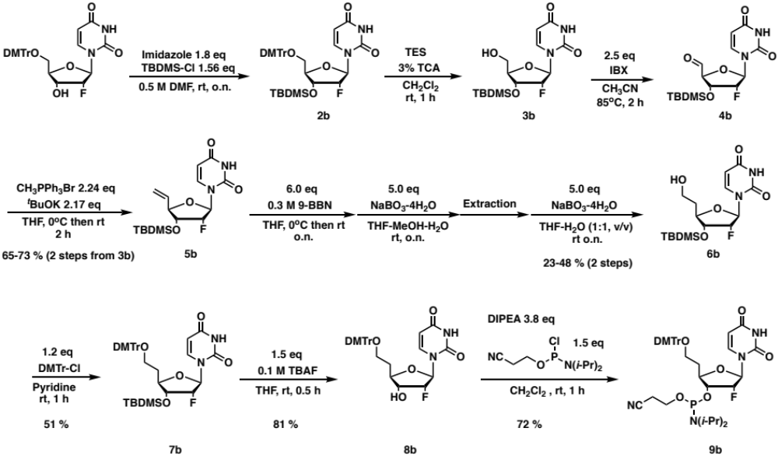
Synthesis of compound 5b. Anhydrous solution of compound 3b (10.8 g, 30.0 mmol) in CH₃CN (300 mL) was added IBX (21.0 g, 75.0 mmol) and stirred for 2 h at 85 ºC. After cooling the mixture in an ice bath, the precipitate in the solution was filtered off through celite. Collected eluent was evaporated, co-evaporated with anhydrous CH₃CN three times under argon atmosphere, and obtained compound 4b as a white foam was used without further purification. In a separate flask, anhydrous THF (250 mL) solution containing tert-BuOK (7.30 g, 65.1 mmol) was added methyltriphenylphosphonium bromide (24.0 g, 68.1 mmol) was added in one portion at 0 ºC and stirred for 1 h at 0 ºC. To this solution, anhydrous THF solution (150 mL) of compound 4b was added dropwise (10 min) at 0 ºC and stirred o.n. at rt. After evaporating excess THF, the obtained mixture was dissolved in excess ethyl acetate, washed by aq. sat. NH₄Cl, dried over MgSO₄, filtered, and evaporated. The obtained material was dissolved into minimum amount of CH₂Cl₂ and added dropwise to excess diethyl ether solution under vigorous stirring under the icing. Precipitate in the solution was filtered off through celite and eluents were evaporated. Obtained crude material was purified by silica gel column chromatography (hexane/ethyl acetate, 8:2 to 6:4) yielding compound 5b as a white foam (7.12 g, 67 % in 2 steps). ¹H NMR (500 MHz, CDCl₃) δ 11.4 (br-s, 1H), 7.65 (d, 1H, J = 8.1 Hz), 5.93 (ddd, 1H, J = 17.5, 10.4, 7.5 Hz), 5.82 (dd, 1H, J_{HF} = 22.2 Hz, J_{HH}= 1.3 Hz), 5.65 (d, 1H, J = 8.1 Hz), 5.42-5.38 (m, 1H), 5.33-5.31 (m, 1H), 5.15 (ddd, 1H, J_{HF} = 53.4 Hz, J_{HH}= 4.6, 1.2 Hz), 4.27 (ddd, 1H, J_{HF} = 20.6 Hz, J_{HH} = 8.4, 4.9 Hz), 4.18 (dd, 1H, J = 7.7, 7.7 Hz), 0.88 (s, 9H), 0.08 (s, 3H), 0.07 (s, 3H); ¹³C NMR (125 MHz, CDCl₃) δ 170.8, 183.7, 150.7, 142.5, 135.3, 120.2, 102.4, 92.9 (d, J_{CF} = 186.2 Hz), 90.2 (d, J_{CF} = 36.4 Hz), 83.4, 73.8 (d, J_{CF} = 15.5 Hz), 60.2, 26.0, 21.2, 18.2, 14.6, -4.4, -4.5; ¹⁹F NMR (470 MHz, DMSO-d6) δ -198.3 (ddd, J = 53.8, 20.8, 20.8 Hz). HRMS (ESI) calcd. for C1₆H₂₆FN₂O₄Si [M + H]⁺ m/z 357.1640, found m/z 357.1649.

Synthesis of compound 7b. Anhydrous solution of compound 5b (10.15 g, 28.5 mmol) in THF (228 mL) was added 0.5 M 9-BBN/THF solution (342 mL, 171 mmol) dropwise for 20 min at 0ºC. After stirring the mixture at rt 4 h, the solution was iced and added methanol (131 mL) and stirred until bubbling cease down. Then under vigorous stirring, H₂O (197 mL) was added dropwise for 15 min to avoid precipitation of an intermediate compound. At 0ºC, NaBO₃-4H₂O (21.9 g, 142.5 mmol) was added in one portion and stirred at rt o.n. After evaporation of excess THF, obtained crude mixture was dissolved into excess ethyl acetate, and washed repeatedly by sat. aq. NH₄Cl solution. After evaporating organic layer, obtained material was dissolved in THF (450 mL) and H₂O (450 mL). To this solution, NaBO₃-4H₂O (21.9 g, 142.5 mmol) was added in one portion at rt, then stirred o.n. at rt. After evaporating of excess THF, the mixture was added ethyl acetate, then extracted. Obtained organic layer was repeatedly washed by aq. sat. NH₄Cl, dried over MgSO₄, filtered, and evaporated. Obtained crude material was purified by silica gel column chromatography (CH₂Cl₂/methanol, 100:0 to 93:7) yielding compound 6b as a syrup (2.44 g with reagent impurity); HRMS (ESI) calcd. for C₁₆H₂₈FN₂O₅Si⁺ [M + H]⁺ m/z 375.1746, found m/z 375.1746. This compound 6b with reagent impurity was rendered anhydrous by repeated co-evaporation with anhydrous pyridine under argon atmosphere, then dissolved in anhydrous pyridine (64 mL). To this solution, DMTrCl (2.64 g, 7.79 mmol) was added and stirred at rt for 1 h. After the reaction was quenched by addition of methanol (5 mL), reaction mixture was diluted with ethyl acetate (300 mL) and washed repeated by aq. sat. NaHCO3, dried over MgSO4, filtered, evaporated, then co-evaporated with toluene three times to remove remaining pyridine. Obtained crude material was purified by silica gel chromatography (hexane-ethyl acetate from 2:8 to 4:6) yielding compound 7b as a white solid (2.25 g, 12% in 2 steps). ¹H NMR (500 MHz, CD₃CN) δ 9.16 (br-s, 1H), 7.43-7.42 (m, 2H), 7.31-7.28 (m, 8H), 6.86-6.85 (m, 4H), 5.75 (dd, 1H, J_{HF} = 20.0 Hz, J_{HH} = 1.9 Hz), 5.59 (d, 1H, J = 8.1 Hz), 4.96 (ddd, J_{HF} = 53.3 Hz, J_{HH} = 4.6, 1.8 Hz), 4.06-3.98 (m, 2H), 3.76 (s, 6H), 3.19 (dd, 2H, J = 7.4, 5.6 Hz), 2.09-2.02 (m, 1H), 1.89-1.82 (m, 1H), 0.91 (s, 9H), 0.10 (s, 3H), 0.09 (s, 3H); ¹³C NMR (125 MHz, CD₃CN) δ 163.9, 159.6, 151.1, 146.4, 141.9, 137.31, 137.26, 130.92, 130.89, 128.9, 128.8, 127.8, 114.0, 102.9, 93.7 (d, J_{CF} = 188.0 Hz), 90.6 (d, J = 36.4 Hz), 87.0, 80.7, 74.6 (d, J = 15.4 Hz), 60.9, 55.9, 33.8, 26.1, 18.7, -4.5, -4.8; ¹⁹F NMR (470 MHz, CD₃CN) δ -201.4 (ddd, J = 53.7, 19.1, 19.1 Hz); HRMS (ESI) calcd. for C₃₇H₄₅FN₂O₇Na [M + Na]⁺ m/z 699.2872, found m/z 699.2866.

Synthesis of compound 8b. Compound 7b (2.24 g, 3.30 mmol) was dissolved into THF (36.0 mL), then added 1.0 M TBAF-THF solution (4.0 mL, 4.0 mmol), then stirred for 30 min at rt. After evaporation excess THF and co-evaporation with CH₂Cl₂, the crude material was purified by silica gel column chromatography [CH₂Cl₂(1% TEA)-methanol from 100:0 to 95:5] yielding compound 8b (1.51 g, 81%). ¹H NMR (500 MHz, CDCl₃) δ 9.20 (br-s, 1H), 7.45-7.43 (m, 2H), 7.32-7.13 (m, 8H), 6.87-6.85 (m, 4H), 5.77 (dd, 1H, JHF = 20.1 Hz, JHH = 1.5 Hz), 5.60 (d, 1H, J = 8.1 Hz), 4.98 (ddd, JHF= 51.0 Hz, JHH = 4.6, 1.6 Hz), 4.04-3.92 (m, 2H), 3.76 (s, 6H), 3.23-3.17 (m, 2H), 2.20 (br-s, 1H), 2.11-2.06 (m, 1H), 1.91-1.87 (m, 1H); ¹³C NMR (125 MHz, CD₃CN) δ 164.1, 159.7, 151.2, 146.4 141.7, 139.0, 137.33, 137.29, 131,00, 130.97, 129.3, 129.0, 128.9, 127.8, 126.3, 114.1, 103.0, 94.7 (d, J = 184.4 Hz), 90.3 (d, J = 35.4 Hz), 87.2, 80.5, 73.9 (d, J = 16.4 Hz), 61.0, 56.0, 33.9; ¹⁹F NMR (470 MHz, CD₃CN) δ -201.8 (ddd, J = 53.7, 20.8, 20.8 Hz). HRMS (ESI) calcd. for C₃₁H₃₁FN₂O₇Na [M + Na]⁺ m/z 585.2013, found m/z 585.1999.

Synthesis of compound 9b. Compound 8b (1.5 g, 2.67 mmol) was rendered anhydrous by repeated co-evaporation with anhydrous CH₃CN and then dissolved into anhydrous CH₂Cl₂ (30 mL). To this solution N,N-diisopropylethylamine (1.76 mL, 10.1 mmol) and 2-cyanoethyl N,N-diisopropylchlorophosphoramidite (0.90 mL, 4.01 mmol) were added at 0 °C. After stirring for 2 h at rt, the reaction mixture was added CH₂Cl₂ (70 mL) then aq. sat. NaHCO₃ (100 mL). Organic layer was repeatedly washed by aq. sat. NaHCO₃, dried over MgSO₄, filtered, then evaporated. Obtained crude material was purified by silica gel column chromatography (1%TEA-hexanes-ethyl acetate, from 80:20 to 20:80) yielding compound 9a with an impurity of phosphitylating reagent residues. To remove the impurity, obtained material was dissolved in Et₂O (100 mL), then repeatedly washed by aq. sat. NaHCO₃ yielding compound 9b as a white solid (1.47 g, 64 %); ³¹P NMR (202 MHz, CDCl₃) δ 150.4 (d, J = 9.0 Hz), 149.9 (d, J = 10.0 Hz); ¹⁹F NMR (470 MHz, CD₃CN) δ -198.61, -198.63, -198.66, -198.68, -198.70, -198.73, -198.75, -198.77, -198.79, -198.82, -198.84, -199.04, -199.06, -199.08, -199.10, -199.12, -199.14, -199.15, -199.17, -199.20, -199.21, -199.24, -199.26. HRMS (ESI) calcd. for C₄₀H₄₉FN₄O₈P [M + H]⁺ m/z 763.3267, found m/z 763.3255.

Scheme S3. Synthesis of 2′-riboUr-exNA phosphoramidite
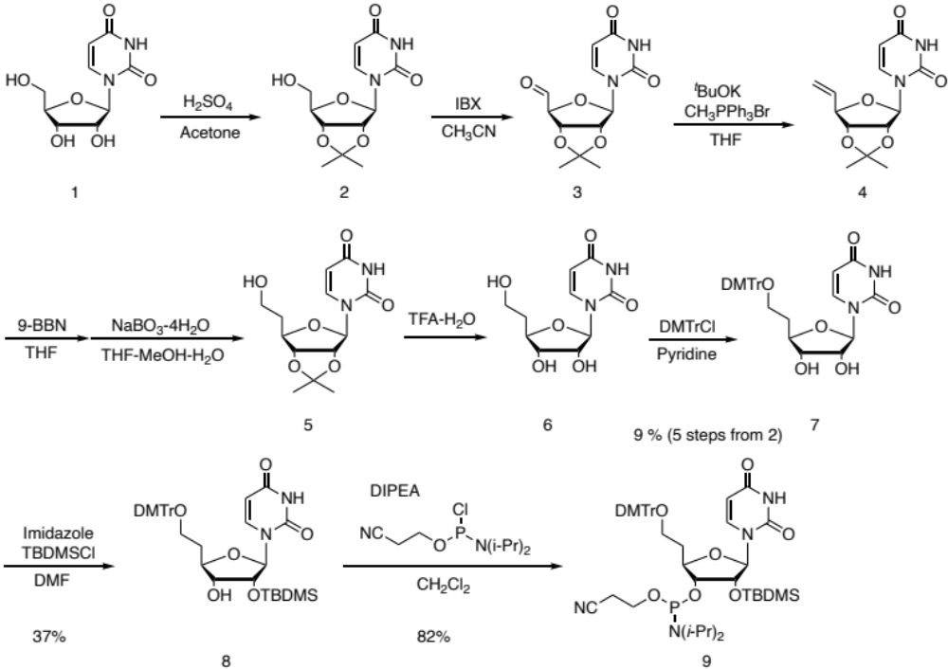
Synthesis of compound 6. Anhydrous solution of compound 2 (15.4 g, 54.1 mmol) in CH₃CN (520 mL) was added IBX (30.3 g, 108.2 mmol) and stirred for 2 h at 85 ºC. After cooling the mixture in an ice bath, the precipitate in the solution was filtered off through celite. Collected eluent was evaporated, co-evaporated with anhydrous CH₃CN three times under argon atmosphere, and obtained compound 3 as a white foam was used without further purification. In a separate flask, anhydrous THF (500 mL) solution containing tert-BuOK (13.2 g, 117.4 mmol) was added methyltriphenylphosphonium bromide (43.3 g, 121.2 mmol) was added in one portion at 0 ºC and stirred for 1 h at 0 ºC. To this solution, anhydrous THF solution (150 mL) of compound 3 was added dropwise (10 min) at 0 ºC and stirred for 4 h. at rt. After evaporating excess THF, the obtained mixture was dissolved in excess ethyl acetate, washed by aq. sat. NH₄Cl, dried over MgSO₄, filtered, and evaporated. Obtained material was dissolved into minimum amount of CH₂Cl₂ and added dropwise to excess diethyl ether solution under vigorously stirring at 0 ºC. Precipitate in solution was filtered off through celite and eluents was evaporated. Obtained crude material was purified by silica gel column chromatography (hexane/ethyl acetate, 8:2 to 3:7) yielding compound 4 with impurity of triphenylphosphineoxide. 3/4 of this crude material was rendered anhydrous by repeated co-evaporation with anhydrous CH₃CN, and then dissolved in anhydrous THF (200 mL). To this solution, 0.5 M 9-BBN/THF (300 mL, 150.0 mmol) was added dropwisely for 10 min, then stirred at rt o.n. After confirming disappearance of starting material by TLC, the solution was iced, then added methanol (200 mL) dropwisely for 10 min. After bubbling is cease down, H₂O (300 mL) was added dropwise then NaBO₃-4H2O (19.2 g, 125.0 mmol) was added in one portion. The solution was stirred o.n. at rt. After evaporation of excess THF, obtained crude mixture was dissolved into excess ethyl acetate, and washed repeatedly by sat. aq. NH₄Cl solution. After evaporating organic layer, obtained material was dissolved in THF (400 mL) and H₂O (400 mL). To this solution, NaBO₃-4H₂O (19.2 g, 125.0 mmol) was added in one portion at rt, then stirred o.n. at rt. After evaporating of excess THF, the mixture was added ethyl acetate, then extracted. Obtained organic layer was repeatedly washed by aq. sat. NH₄Cl, dried over MgSO₄, filtered, and evaporated. Obtained crude material was purified by silica gel column chromatography (CH₂Cl₂-methanol, 100: 0 to 93:7) yielding compound 5 with impurity of reagent residues. This obtained material was added TFA solution [TFA (85 mL) and H2O (9.2 mL)] and stirred at 0ºC for 1 h. After evaporation, co-evaporation with toluene four times, crude material was purified by silica gel column chromatography (CH₂Cl₂-MeOH from 100:0 to 90:10) yielding compound 6 (760 mg, 12% in 3 steps). ¹H NMR (500 MHz, DMSO-d6) δ 11.4 (br-s, 1H), 7.58 (d, 1H, J = 5.0 Hz), 5.71 (d, 1H, J = 5.0 Hz), 5.64 (dd, 1H, J = 8.0, 2.2 Hz), 5.34 (d, 1H, J = 5.2 Hz), 5.09 (d, 1H, J = 4.7 Hz), 4.51 (br-s, 1H), 4.06, (dd, 1H, J = 9.8, 4.9 Hz), 3.80-3.78 (m, 1H), 3.53-3.45 (m, 2H), 1.84-1.70 (m, 2H); ¹³C NMR (125 MHz, DMSO-d6) δ 163.5, 151.1, 141.6, 102.5, 89.0, 80.9, 73.5, 73.2, 58.0, 46.2, 36.8, 9.1; HRMS (ESI) calcd. for C₁₀H₁₄N₂O₆Na [M + Na]⁺ m/z 281.0744, found m/z 281.0730.

Synthesis of compound 7. The compound 6 (760 mg, 2.94 mmol) was added anhydrous pyridine (30 mL) and then added DMTr-Cl (1.3 g, 3.82 mmol). After stirring for 2 h, reaction mixture was first extracted with CH₂Cl₂ an aq. sat. NaHCO_{3,} and organic layer was dried over MgSO₄, filtered, evaporated, co-evaporated to remove pyridine. The obtained crude material was used for the next reaction without further purification. HRMS (ESI) calcd. for C₃₁H₃₂N₂O₈Na [M + Na]⁺ m/z 583.2051, found m/z 583.2025.
Synthesis of compound 8. An anhydrous solution of compound 7 (2.35 g, 4.19 mmol) in pyridine (21 mL) was added imidazole (576.1 mg, 8.46 mmol) and TBDMSCl (1.10 g, 7.33 mmol), and then stirred for 2h at rt. To this reaction mixture was added CH₂Cl₂ (150 mL) was then added aq. sat. NaHCO₃ (150 mL). The organic layer was repeatedly washed by aq. sat. NaHCO₃, dried over MgSO₄, filtered, evaporated, then co-evaporated with toluene to remove pyridine residue. Obtained crude material containing compound 8, 3’-O-TBDMS protected compound, 5’-3’-O-bis-TBDMS protected compound was separated by silica gel column chromatography [CH₂Cl₂ (1% TEA)-Acetone from 100:0 to 85:15] yielding pure compound 8 (780 mg, 28%). ¹H NMR (500 MHz, DMSO-d6) δ 11.4 (br-s, 1H), 7.53-7.52 (m, 2H), 7.39-7.22 (m, 8H), 6.89-6.88 (m, 4H), 5.72 (d, 1H, J = 5.0 Hz), 5.62 (d, 1H, J = 8.1, 2.0 Hz), 5.00 (d, 1H, J = 6.0 Hz), 4.19 (dd, 1H, J = 5.1, 5.1 Hz), 3.92 (ddd, 1H, J = 8.8, 8.8, 4.5 Hz), 3.78-3.73 (m, 7H), 3.07-3.03 (m, 2H), 2.05-1.83 (m, 2H), 0.83 (s, 9H), 0.05 (s, 3H), 0.01 (s, 3H); ¹³C NMR (125 MHz, DMSO-d₆) δ 162.9, 158.0, 150.5, 145.1, 140.7, 135.8, 130.1, 129.4, 128.7, 128.3, 128.1, 127.1, 125.8, 113.6, 102.5, 88.8, 86.0, 81.5, 74.9, 73.4, 60.6, 55.5, 33.8, 26.1, 25.1, 18.4; HRMS (ESI) calcd. for C₃₇H₄₆N₂O₈Na [M + Na]⁺ m/z 697.2916, found m/z 697.2867.
Synthesis of compound 9. Compound 8 (780 g, 1.16 mmol) was rendered anhydrous by repeated co-evaporation with anhydrous CH₃CN and then dissolved into anhydrous CH₂Cl₂ (12 mL). To this solution N,N-diisopropylethylamine (0.53 mL, 4.34 mmol) and 2-cyanoethyl N,N-diisopropylchlorophosphoramidite (0.34 mL, 1.73 mmol) were added at 0 °C. After stirring for 4 h at rt, the reaction mixture was added CH₂Cl₂ (90 mL) then aq. sat. NaHCO₃ (100 mL). Organic layer was repeatedly washed by aq. sat. NaHCO₃, dried over MgSO₄, filtered, then evaporated. Obtained crude material was purified by silica gel column chromatography (1%TEA-hexanes-ethyl acetate, from 80:20 to 50:50) yielding compound 9 (825.9 mg, 82%). ³¹P NMR (202 MHz, CDCl₃) δ 149.6, 149.1.
Table S1. List of exNA-modified siRNA duplexes used for in-vitro screening.
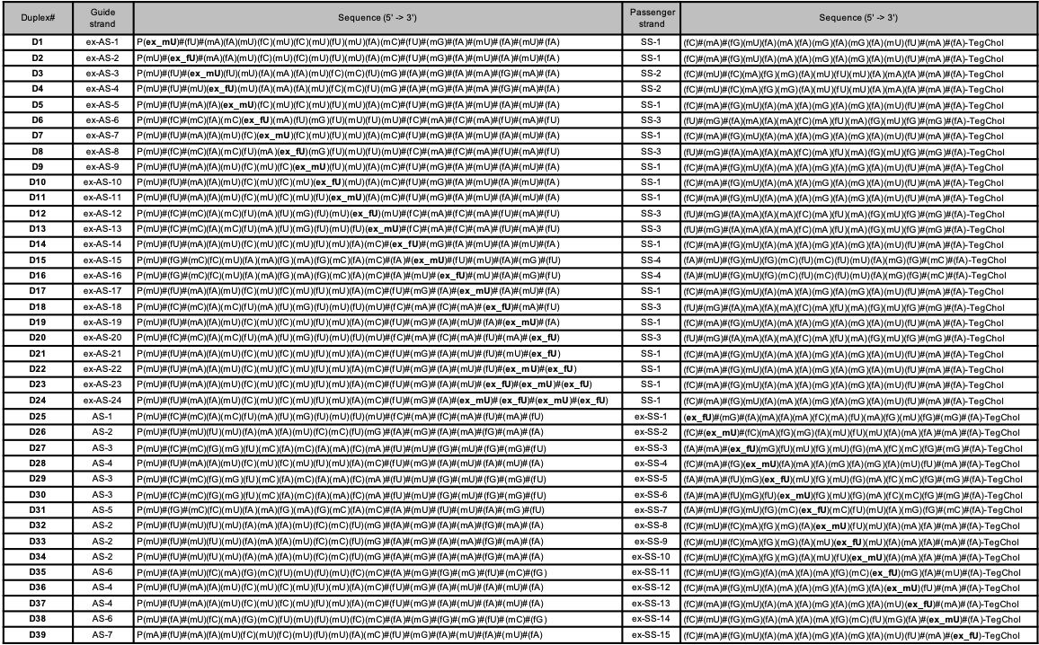

Table S2. List of control siRNA duplexes used for in-vitro screening.
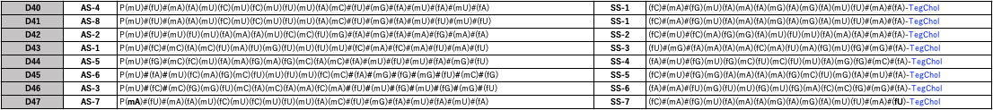

Table S3. IC50 of each exNA modified siRNAs and potency change
siRNA# | D1 | D2 | D3 | D4 | D5
IC50 | 1.619E-07 | 1.703E-07 | 3.825E-07 | 2.034E-07 | 1.864E-07
IC50 of corresponding control | 7.662E-08 | 3.735E-08 | 7.416E-08 | 7.416E-08 | 7.662E-08
% Potency Change | -111.302532 | -355.957162 | -415.776699 | -174.2718447 | -143.2785174
siRNA# | D6* | D7 | D8* | D9 | D10
IC50 | 8.65E-11 | 2.235E-07 | 1.346E-10 | 0.000000097 | 0.000000111
IC50 of corresponding control | 7.086E-11 | 7.662E-08 | 7.086E-11 | 7.662E-08 | 7.662E-08
% Potency Change | -22.07169066 | -191.6992952 | -89.95201806 | -26.59879927 | -44.87079092
siRNA# | D11 | D12* | D13* | D14 | D15
IC50 | 7.196E-08 | 2.09E-10 | 3.541E-10 | 0.000000175 | 3.119E-07
IC50 of corresponding control | 7.662E-08 | 7.086E-11 | 9.675E-11 | 7.662E-08 | 1.411E-07
% Potency Change | 6.081962934 | -194.9477844 | -265.994832 | -128.3998956 | -121.0489015
siRNA# | D16 | D17 | D18* | D19 | D20*
IC50 | 2.782E-07 | 8.911E-08 | 1.924E-10 | 8.779E-08 | 1.589E-10
IC50 of corresponding control | 1.411E-07 | 7.662E-08 | 9.675E-11 | 7.662E-08 | 9.675E-11
% Potency Change | -97.16513111 | -16.30122683 | -98.8630491 | -14.57843905 | -64.2377261
siRNA# | D21 | D22 | D23 | D24 | D25*
IC50 | 3.365E-08 | 3.713E-08 | 3.884E-08 | 7.226E-08 | 1.192E-10
IC50 of corresponding control | 9.633E-08 | 9.633E-08 | 9.633E-08 | 9.633E-08 | 8.502E-11
% Potency Change | 65.06799543 | 61.45541368 | 59.68026575 | 24.98702377 | -40.20230534
siRNA# | D26 | D27* | D28 | D29* | D30*
IC50 | 1.206E-07 | 8.65E-11 | 1.229E-07 | 1.346E-10 | 2.09E-10
IC50 of corresponding control | 7.416E-08 | 7.019E-11 | 7.662E-08 | 7.019E-11 | 7.019E-11
% Potency Change | -62.62135922 | -23.23692834 | -60.40198382 | -91.76520872 | -197.7632141
siRNA# | D31 | D32 | D33 | D34 | D35
IC50 | 1.186E-07 | 1.668E-07 | 8.044E-08 | 9.471E-08 | 3.102E-07
IC50 of corresponding control | 1.411E-07 | 7.416E-08 | 7.416E-08 | 7.416E-08 | 2.972E-07
% Potency Change | 15.94613749 | -124.9190939 | -8.468176915 | -27.71035599 | -4.374158816
siRNA# | D36 | D37 | D38 | D39
IC50 | 4.829E-08 | 4.945E-08 | 2.133E-07 | 3.917E-08
IC50 of corresponding control | 7.662E-08 | 7.662E-08 | 2.972E-07 | 3.266E-08
% Potency Change | 36.97468024 | 35.46071522 | 28.23014805 | -19.93263931

Table S4. Sequence of siRNAs used for mice study
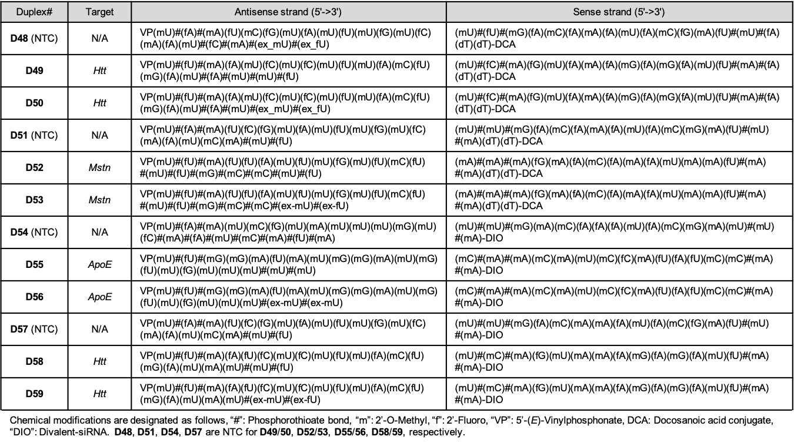

Table S5. The sequence of oligonucleotides used for thermal melting analysis
ON # | Sequence (5′ -> 3′)ª | Calcd mass [M-H]⁻ | Found mass
ON1 | (rC)(rG)(rC)(rA)(rU)(rU)(rA)(rG)(rC)(rC)(rG) | 3465.1 | 3467.0
ON2 | (rC)(rG)(rC)(rA)(rU)(rxU)(rA)(rG)(rC)(rC)(rG) | 3479.6 | 3478.5
cRNA1 | (rC)(rG)(rG)(rC)(rU)(rA)(rA)(rU)(rG)(rC)(rG) | 3505.2 | 3504.5
cRNA2 | (rC)(rG)(rG)(rC)(rU)(rG)(rA)(rU)(rG)(rC)(rG) | 3481.1 | 3480.5
cRNA3 | (rC)(rG)(rG)(rC)(rU)(rU)(rA)(rU)(rG)(rC)(rG) | 3482.1 | 3481.5
cRNA4 | (rC)(rG)(rG)(rC)(rU)(rC)(rA)(rU)(rG)(rC)(rG) | 3521.2 | 3520.4
ª (rN) : 2’-ribonucleosides, (ex-rU): exNA-uridine (2’-OH).

Table S6. Oligonucleotide used for 3'-exonuclease resistance assay
ON# | Sequence (5'->3') | Calcd mass  [M-H]⁻ | Found mass
ON3 | (dT)₁₈(mU)(mU) | 6053.9 | 6053.0
ON4 | (dT)₁₈(ex-mU)(ex-mU) | 6113.9 | 6113.0
ON5 | (dT)₁₈ #(mU)#(mU) | 6086.1 | 6085.9
ON6 | (dT)₁₈ #(ex-mU)#(ex-mU) | 6114.1 | 6114.0

Table S7. Oligonucleotide used for 5'-exonuclease resistance assay
ON# | Sequence (5'->3') | Calcd mass  [M-H]⁻ | Found mass
ON7 | (mU)(dT)(dT)₁₈ | 6037.9 | 6036.9
ON8 | (mU)#(dT)(dT)₁₈ | 6054.0 | 6053.9
ON9 | (ex-mU)(dT)(dT)₁₈ | 6052.0 | 6050.9
ON10 | (mU)(mU)(dT)₁₈ | 6053.9 | 6053.9
ON11 | (mU)#(mU)(dT)₁₈ | 6070.0 | 6070.0
ON12 | (mU)(ex-mU)(dT)₁₈ | 6067.9 | 6067.9

Table S8. Mass analysis of exNA modified antisense strands used in exNA walk study
Name | Sequence (5'->3') | Mass calcd [M-H]⁻ | Mass found
ex-AS1 | P(ex-mU)#(fU)#(mA)(fA)(mU)(fC)(mU)(fC)(mU)(fU)(mU)(fA)(mC)#(fU)#(mG)#(fA)#(mU)#(fA)#(mU)#(fA) | 6633.4 | 6633.7
ex-AS2 | P(mU)#(ex-fU)#(mA)(fA)(mU)(fC)(mU)(fC)(mU)(fU)(mU)(fA)(mC)#(fU)#(mG)#(fA)#(mU)#(fA)#(mU)#(fA) | 6633.4 | 6633.7
ex-AS3 | P(mU)#(fU)#(ex-mU)(fU)(mU)(fA)(mA)(fA)(mU)(fC)(mC)(fU)(mG)#(fA)#(mG)#(fA)#(mA)#(fG)#(mA)#(fA) | 6758.6 | 6758.8
ex-AS4 | P(mU)#(fU)#(mU)(ex-fU)(mU)(fA)(mA)(fA)(mU)(fC)(mC)(fU)(mG)#(fA)#(mG)#(fA)#(mA)#(fG)#(mA)#(fA) | 6758.6 | 6758.8
ex-AS5 | P(mU)#(fU)#(mA)(fA)(ex-mU)(fC)(mU)(fC)(mU)(fU)(mU)(fA)(mC)#(fU)#(mG)#(fA)#(mU)#(fA)#(mU)#(fA) | 6633.4 | 6633.7
ex-AS6 | P(mU)#(fC)#(mC)(fA)(mC)(ex-fU)(mA)(fU)(mG)(fU)(mU)(fU)(mU)#(fC)#(mA)#(fC)#(mA)#(fU)#(mA)#(fU) | 6608.4 | 6608.7
ex-AS7 | P(mU)#(fU)#(mA)(fA)(mU)(fC)(ex-mU)(fC)(mU)(fU)(mU)(fA)(mC)#(fU)#(mG)#(fA)#(mU)#(fA)#(mU)#(fA) | 6633.4 | 6632.7
ex-AS8 | P(mU)#(fC)#(mC)(fA)(mC)(fU)(mA)(ex-fU)(mG)(fU)(mU)(fU)(mU)#(fC)#(mA)#(fC)#(mA)#(fU)#(mA)#(fU) | 6608.4 | 6608.7
ex-AS9 | P(mU)#(fU)#(mA)(fA)(mU)(fC)(mU)(fC)(ex-mU)(fU)(mU)(fA)(mC)#(fU)#(mG)#(fA)#(mU)#(fA)#(mU)#(fA) | 6633.4 | 6633.7
ex-AS10 | P(mU)#(fU)#(mA)(fA)(mU)(fC)(mU)(fC)(mU)(ex-fU)(mU)(fA)(mC)#(fU)#(mG)#(fA)#(mU)#(fA)#(mU)#(fA) | 6633.4 | 6633.7
ex-AS11 | P(mU)#(fU)#(mA)(fA)(mU)(fC)(mU)(fC)(mU)(fU)(ex-mU)(fA)(mC)#(fU)#(mG)#(fA)#(mU)#(fA)#(mU)#(fA) | 6633.4 | 663.7
ex-AS12 | P(mU)#(fC)#(mC)(fA)(mC)(fU)(mA)(fU)(mG)(fU)(mU)(ex-fU)(mU)#(fC)#(mA)#(fC)#(mA)#(fU)#(mA)#(fU) | 6608.4 | 6608.7
ex-AS13 | P(mU)#(fC)#(mC)(fA)(mC)(fU)(mA)(fU)(mG)(fU)(mU)(fU)(ex-mU)#(fC)#(mA)#(fC)#(mA)#(fU)#(mA)#(fU) | 6608.4 | 6608.7
ex-AS14 | P(mU)#(fU)#(mA)(fA)(mU)(fC)(mU)(fC)(mU)(fU)(mU)(fA)(mC)#(ex-fU)#(mG)#(fA)#(mU)#(fA)#(mU)#(fA) | 6633.4 | 6633.7
ex-AS15 | P(mU)#(fG)#(mC)(fC)(mU)(fA)(mA)(fG)(mA)(fG)(mC)(fA)(mC)#(fA)#(ex-mU)#(fU)#(mU)#(fA)#(mG)#(fU) | 6749.6 | 6749.8
ex-AS16 | P(mU)#(fG)#(mC)(fC)(mU)(fA)(mA)(fG)(mA)(fG)(mC)(fA)(mC)#(fA)#(mU)#(ex-fU)#(mU)#(fA)#(mG)#(fU) | 6749.6 | 6749.8
ex-AS17 | P(mU)#(fU)#(mA)(fA)(mU)(fC)(mU)(fC)(mU)(fU)(mU)(fA)(mC)#(fU)#(mG)#(fA)#(ex-mU)#(fA)#(mU)#(fA) | 6633.4 | 6633.7
ex-AS18 | P(mU)#(fC)#(mC)(fA)(mC)(fU)(mA)(fU)(mG)(fU)(mU)(fU)(mU)#(fC)#(mA)#(fC)#(mA)#(ex-fU)#(mA)#(fU) | 6608.4 | 6608.7
ex-AS19 | P(mU)#(fU)#(mA)(fA)(mU)(fC)(mU)(fC)(mU)(fU)(mU)(fA)(mC)#(fU)#(mG)#(fA)#(mU)#(fA)#(ex-mU)#(fA) | 6633.4 | 6633.7
ex-AS20 | P(mU)#(fC)#(mC)(fA)(mC)(fU)(mA)(fU)(mG)(fU)(mU)(fU)(mU)#(fC)#(mA)#(fC)#(mA)#(fU)#(mA)#(ex-fU) | 6608.4 | 6608.7
ex-AS21 | P(mU)#(fU)#(mA)(fA)(mU)(fC)(mU)(fC)(mU)(fU)(mU)(fA)(mC)#(fU)#(mG)#(fA)#(mU)#(fU)#(mU)#(ex-fU) | 6587.4 | 6587.6
ex-AS22 | P(mU)#(fU)#(mA)(fA)(mU)(fC)(mU)(fC)(mU)(fU)(mU)(fA)(mC)#(fU)#(mG)#(fA)#(mU)#(fU)#(ex-mU)  #(ex-fU) | 6601.4 | 6601.6
ex-AS23 | P(mU)#(fU)#(mA)(fA)(mU)(fC)(mU)(fC)(mU)(fU)(mU)(fA)(mC)#(fU)#(mG)#(fA)#(mU)#(ex-fU)  #(ex-mU)#(ex-fU) | 6615.4 | 6615.7
ex-AS24 | P(mU)#(fU)#(mA)(fA)(mU)(fC)(mU)(fC)(mU)(fU)(mU)(fA)(mC)#(fU)#(mG)#(fA)#(ex-mU)#(ex-fU)  #(ex-mU)#(ex-fU) | 6629.4 | 6629.7
P: 5’-phosphate, “m”: 2’-OMe, “f”: 2’-fluoro, “ex-mU”: 2’-OMe-exNA-uridine, “ex-fU”: 2’-F-exNA-uridine, #: phosphorothioate

Table S9. Mass analysis of exNA modified sense strands used in exNA walk study
Name | Sequence (Sense strands) | Mass calcd  [M-H]⁻ | Mass found
ex-SS1 | (ex-fU)#(mG)#(fA)(mA)(fA)(mA)(fC)(mA)(fU)(mA)(fG)(mU)(fG)#(mG)#(fA)-TegChol | 5795.30 | 5795.2
ex-SS2 | (fC)#(ex-mU)#(fC)(mA)(fG)(mG)(fA)(mU)(fU)(mU)(fA)(mA)(fA)#(mA)#(fA)-TegChol | 5716.30 | 5716.2
ex-SS3 | (fA)#(mA)#(ex-fU)(mG)(fU)(mU)(fG)(mU)(fG)(mA)(fC)(mC)(fG)#(mG)#(fA)-TegChol | 5764.30 | 5764.1
ex-SS4 | (fC)#(mA)#(fG)(ex-mU)(fA)(mA)(fA)(mG)(fA)(mG)(fA)(mU)(fU)#(mA)#(fA)-TegChol | 5779.40 | 5778.2
ex-SS5 | (fA)#(mA)#(fU)(mG)(ex-fU)(mU)(fG)(mU)(fG)(mA)(fC)(mC)(fG)#(mG)#(fA)-TegChol | 5764.30 | 5763.2
ex-SS6 | (fA)#(mA)#(fU)(mG)(fU)(ex-mU)(fG)(mU)(fG)(mA)(fC)(mC)(fG)#(mG)#(fA)-TegChol | 5764.30 | 5764.2
ex-SS7 | (fA)#(mU)#(fG)(mU)(fG)(mC)(ex-fU)(mC)(fU)(mU)(fA)(mG)(fG)#(mC)#(fA)-TegChol | 5701.20 | 5701.1
ex-SS8 | (fC)#(mU)#(fC)(mA)(fG)(mG)(fA)(ex-mU)(fU)(mU)(fA)(mA)(fA)#(mA)#(fA)-TegChol | 5716.30 | 5716.2
ex-SS9 | (fC)#(mU)#(fC)(mA)(fG)(mG)(fA)(mU)(ex-fU)(mU)(fA)(mA)(fA)#(mA)#(fA)-TegChol | 5716.30 | 5716.2
ex-SS10 | (fC)#(mU)#(fC)(mA)(fG)(mG)(fA)(mU)(fU)(ex-mU)(fA)(mA)(fA)#(mA)#(fA)-TegChol | 5716.30 | 5716.1
ex-SS11 | (fC)#(mU)#(fG)(mG)(fA)(mA)(fA)(mA)(fG)(mC)(ex-fU)(mG)(fA)#(mU)#(fA)-TegChol | 5771.30 | 5771.2
ex-SS12 | (fC)#(mA)#(fG)(mU)(fA)(mA)(fA)(mG)(fA)(mG)(fA)(ex-mU)(fU)#(mA)#(fA)-TegChol | 5779.40 | 5779.2
ex-SS13 | (fC)#(mA)#(fG)(mU)(fA)(mA)(fA)(mG)(fA)(mG)(fA)(mU)(ex-fU)#(mA)#(fA)-TegChol | 5779.30 | 5779.2
ex-SS14 | (fC)#(mU)#(fG)(mG)(fA)(mA)(fA)(mA)(fG)(mC)(fU)(mG)(fA)#(ex-mU)#(fA)-TegChol | 5771.30 | 5771.2
ex-SS15 | (fC)#(mA)#(fG)(mU)(fA)(mA)(fA)(mG)(fA)(mG)(fA)(mU)(fU)#(mA)#(ex-fU)-TegChol | 5756.30 | 5756.2

Table S10. Mass analysis of control antisense and sense strands used in exNA walk study
Name | Sequence (Antisense strands) | Mass calcd  [M-H]⁻ | Mass found
AS-1 | P(mU)#(fC)#(mC)(fA)(mC)(fU)(mA)(fU)(mG)(fU)(mU)(fU)(mU)#(fC)#(mA)#(fC)#(mA)#(fU)#(mA)#(fU) | 6595.40 | 6594.7
AS-2 | P(mU)#(fU)#(mU)(fU)(mU)(fA)(mA)(fA)(mU)(fC)(mC)(fU)(mG)#(fA)#(mG)#(fA)#(mA)#(fG)#(mA)#(fA) | 6745.60 | 6744.7
AS-3 | P(mU)#(fC)#(mC)(fG)(mG)(fU)(mC)(fA)(mC)(fA)(mA)(fC)(mA)#(fU)#(mU)#(fG)#(mU)#(fG)#(mG)#(fU) | 6728.60 | 6727.7
AS-4 | P(mU)#(fU)#(mA)(fA)(mU)(fC)(mU)(fC)(mU)(fU)(mU)(fA)(mC)#(fU)#(mG)#(fA)#(mU)#(fA)#(mU)#(fA) | 6620.40 | 6619.7
AS-5 | P(mU)#(fG)#(mC)(fC)(mU)(fA)(mA)(fG)(mA)(fG)(mC)(fA)(mC)#(fA)#(mU)#(fU)#(mU)#(fA)#(mG)#(fU) | 6736.40 | 6735.7
AS-6 | P(mU)#(fA)#(mU)(fC)(mA)(fG)(mC)(fU)(mU)(fU)(mU)(fC)(mC)#(fA)#(mG)#(fG)#(mG)#(fU)#(mC)#(fG) | 6705.60 | 6704.7
AS-7 | P(mA)#(fU)#(mA)(fA)(mU)(fC)(mU)(fC)(mU)(fU)(mU)(fA)(mC)#(fU)#(mG)#(fA)#(mU)#(fA)#(mU)#(fA) | 6643.50 | 6642.7
AS-8 | P(mU)#(fU)#(mA)(fA)(mU)(fC)(mU)(fC)(mU)(fU)(mU)(fA)(mC)#(fU)#(mG)#(fA)#(mU)#(fU)#(mU)#(fU) | 6574.40 | 6573.6
SS-1 | (fC)#(mA)#(fG)(mU)(fA)(mA)(fA)(mG)(fA)(mG)(fA)(mU)(fU)#(mA)#(fA)-TegChol | 5765.30 | 5765.2
SS-2 | (fC)#(mU)#(fC)(mA)(fG)(mG)(fA)(mU)(fU)(mU)(fA)(mA)(fA)#(mA)#(fA)-TegChol | 5702.30 | 5702.2
SS-4 | (fU)#(mG)#(fA)(mA)(fA)(mA)(fC)(mA)(fU)(mA)(fG)(mU)(fG)#(mG)#(fA)-TegChol | 5781.30 | 5781.2
SS-5 | (fA)#(mU)#(fG)(mU)(fG)(mC)(fU)(mC)(fU)(mU)(fA)(mG)(fG)#(mC)#(fA)-TegChol | 5687.20 | 5686.1
SS-6 | (fC)#(mU)#(fG)(mG)(fA)(mA)(fA)(mA)(fG)(mC)(fU)(mG)(fA)#(mU)#(fA)-TegChol | 5757.30 | 5757.2
SS-7 | (fA)#(mA)#(fU)(mG)(fU)(mU)(fG)(mU)(fG)(mA)(fC)(mC)(fG)#(mG)#(fA)-TegChol | 5750.30 | 5750.1
SS-8 | (fC)#(mA)#(fG)(mU)(fA)(mA)(fA)(mG)(fA)(mG)(fA)(mU)(fU)#(mA)#(fU)-TegChol | 5742.30 | 5742.2

Table S11. Mass analysis of oligonucleotides used for in vivo study
Name | Sequence (5'->3') | Calcd mass [M-H]⁻ | Found mass
D48-AS | VP(mU)#(fU)#(mA)(fA)(mU)(fC)(mU)(fC)(mU)(fU)(mU)(fA)(mC)(fU)(mG)  (fA)(mU)#(fA)#(mU)#(mU)#(fU) | 6864.4 | 6864.8
D49-AS | VP(mU)#(fU)#(mA)(fA)(mU)(fC)(mU)(fC)(mU)(fU)(mU)(fA)(mC)(fU)(mG)  (fA)(mU)#(fA)#(mU)#(ex-mU)#(ex-fU) | 6892.4 | 6892.8
D50-AS (NTC) | VP(mU)#(fA)#(mA)(fU)(mC)(fG)(mU)(fA)(mU)(fU)(mU)(fG)(mU)(fC)(mA)  (fA)(mU)#(fC)#(mA)#(ex-mU)#(ex-fU) | 6954.5 | 6954.9
D55-AS | VP(mU)#(fU)#(mG)(mG)(mA)(fU)(mA)(mU)(mG)(mG)(mA)(mU)(mG)(fU)  (mU)(fG)(mU)(mU)(mU)#(mU)#(mU) | 7056.6 | 7056.9
D56-AS | VP(mU)#(fU)#(mG)(mG)(mA)(fU)(mA)(mU)(mG)(mG)(mA)(mU)(mG)(fU)  (mU)(fG)(mU)(mU)(mU)#(ex-mU)#(ex-mU) | 7084.6 | 7084.9
ApoE-di-sense strand | (mC)#(mA)#(mA)(mC)(mA)(mU)(mC)(fC)(mA)(fU)(fA)(fU)(mC)(mC)#(mA)#(mA)-Divalent | 10857.3 | 10857.6
D58-AS | VP(mU)#(fU)#(mA)(fA)(fU)(fC)(mU)(fC)(mU)(fU)(mU)(fA)(mC)(fU)(mG)  (fA)(mU)(mA)(mU)#(mU)#(fU) | 6832.2 | 6832.8
D59-AS | VP(mU)#(fU)#(mA)(fA)(fU)(fC)(mU)(fC)(mU)(fU)(mU)(fA)(mC)(fU)(mG)  (fA)(mU)(mA)(mU)#(ex-mU)#(ex-fU) | 6860.3 | 6860.9
Htt-di-  sense strand | (mU)#(mC)#(mA)(fG)(mU)(mA)(mA)(fA)(mG)(fA)(mG)(fA)(mU)(fU)#(mA)  #(mA)-Divalent | 11123.4 | 11123.8

Fig. S1 Tm Values of each siRNA duplexes (D1-47) used in in-vitro exNA walk. Melting temperature analysis was conducted in a buffer 10mM Sodium phosphate buffer (pH 7.2) containing 100 mM NaCl, 0.1 mM EDTA and 1 mM guide/sense strand. T_{m} values were average values determined in triplicate experiments.

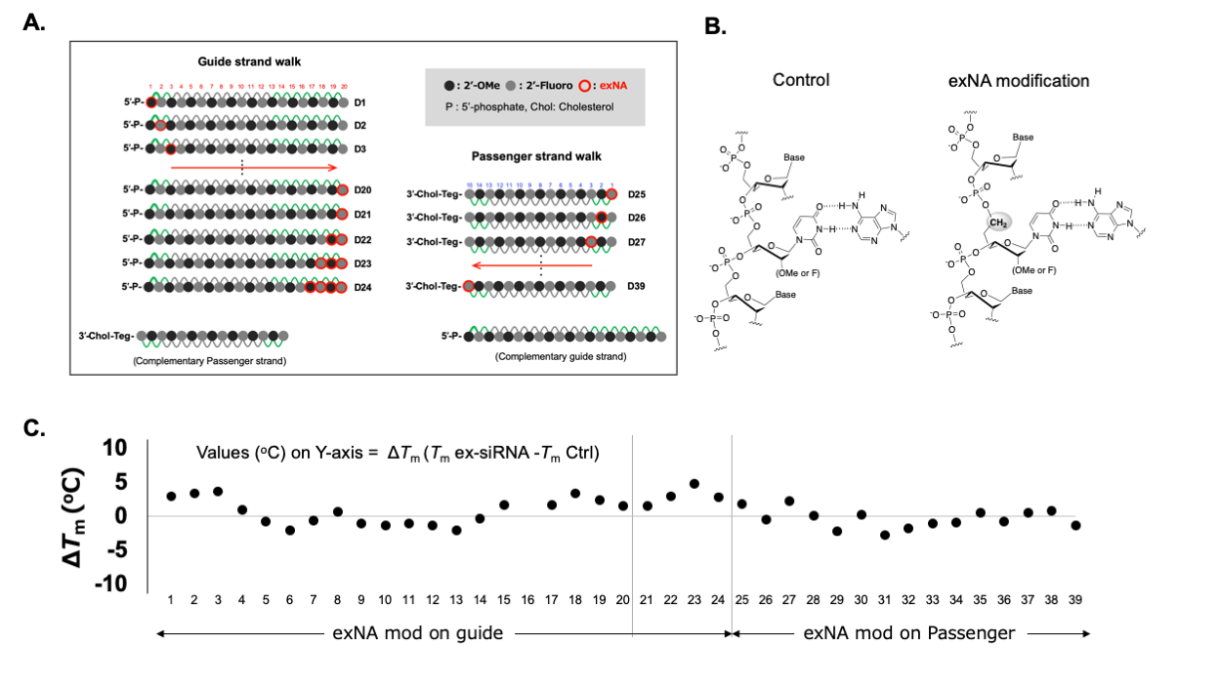
Fig. S2 Delta-Tm of each siRNA duplexes. (A) Schematic of exNA walk and corresponding Duplex numbers. (B) Structural difference between duplex with canonical backbone and with exNA backbone. (C) delta-Tm values for each exNA modification positions on guide and passenger strand. Calculation of delta-Tm was conducted based on Tm values shown in Fig. S1.

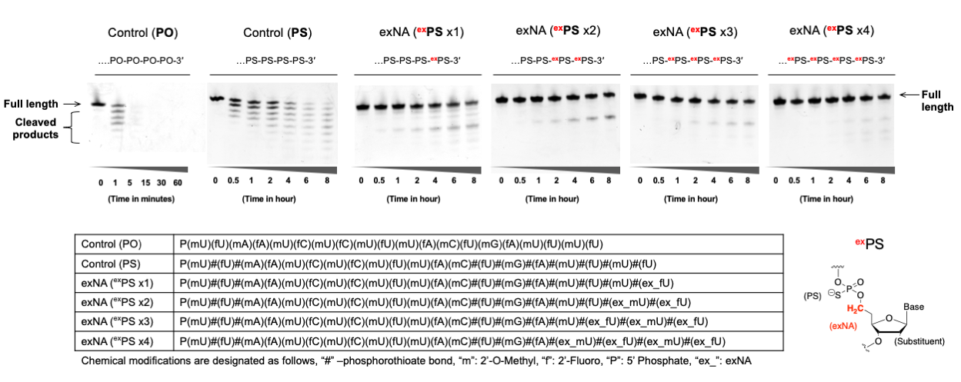
Fig. S3 17.5 uM oligonucleotide was incubated in a 10 mM Tris-HCl (pH 8) buffer containing 2 mM MgCl₂ and 20 mU/mL Snake Venom Phosphodiesterase I. Aliquot at each time point was dissolved into 95% formamide containing 5% EDTA

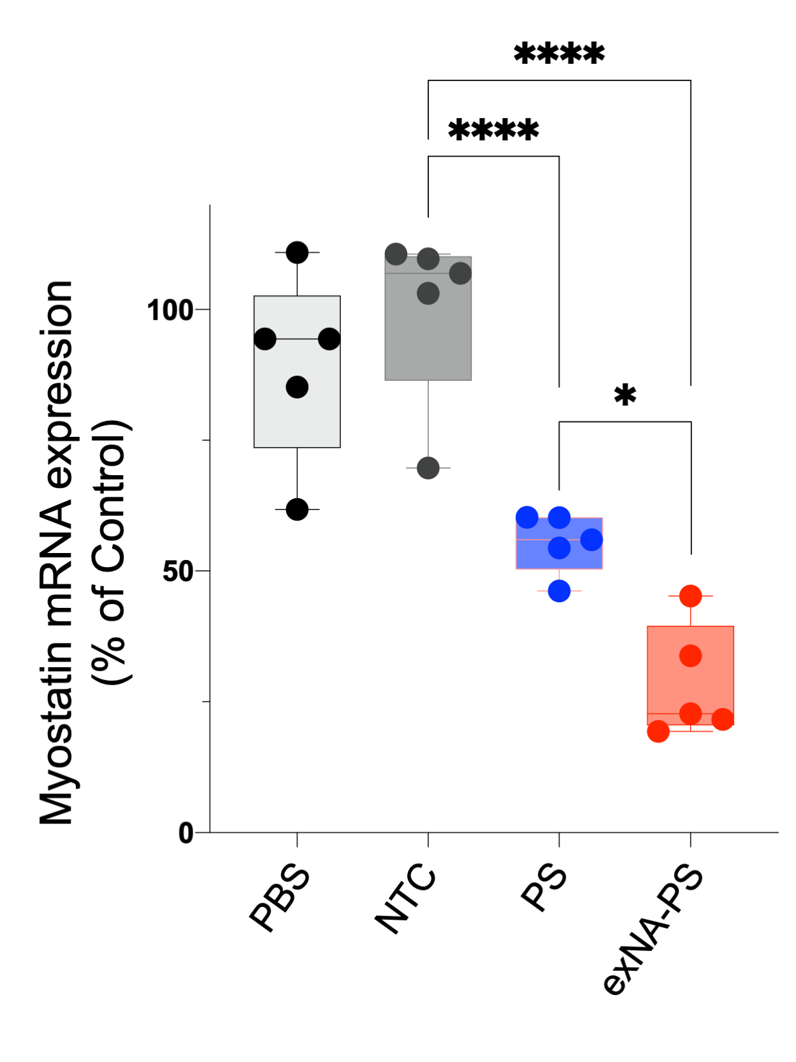
Fig. S4 exNA-PS modification enhances Myostatin-targeting siRNA efficacy. DCA conjugated siRNAs (D51, 52, and 53) were administered to FVB mice (female, 7-8 weeks old) at 20mg/kg dosage twice (3 days apart, s.c.). Mice was sacrificed at 1 week post injection, and muscle quadricep was collected. Myostatin mRNA level was quantified by QuantiGene. NTC: Non-targeting control (D51), PS: non-exNA PS modified siRNA (D52), exNA-PS: exNA-PS modified siRNA (D53). For sequences, see Table S9.

