OHSU Regional Anesthesia
Frequently Asked Questions (FAQs)

Should I be as numb as I was at the hospital?
Not Necessarily. During the placement of your catheter, you are given a stronger numbing medication than the weaker numbing medicine you are getting through your pump. The stronger medication could wear off in as little as 6 hours from the time of placement. Your surgical site may not be as numb as it was right after surgery.

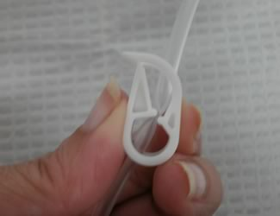
What can I do if my block is making me too numb?
It is OK to stop the medication by closing the clamp (see figure 1) at any time. NOTE: if the medication has been off for a long time, it may take several hours to begin working again. You may not regain the same amount of pain control as you had prior to closing the clamp. If you are still numb after more than 12 hours after shutting the medication off or removing the catheter, please call the home pump doctor on-call.

I closed the clamp, why am I still numb?
Figure 1
It can take several hours for the effects of the medication to begin to wear off.

I am starting to have pain again, how do I restart the medication and when should I restart it?
To restart the pump, open the clamp (see figure 1). NOTE: if the medication has been off for a long time, it may take several hours to begin working again. You may not regain the same amount of pain control as you had prior to closing the clamp.

My pump is not covering all my pain, can I take pain pills too?
Yes. There is no interaction between the local anesthetic numbing medicine from the pump and the pain pills you were prescribed. Please follow the instructions on your pain pill prescription.

I had a nerve block for my arm, what side effects can be normal?
In order to make the arm numb, numbing medicine was injected near a cluster of nerves in the neck/shoulder area. There are other small nerves in the area that may be numbed as well. Numbing these nerves can cause side effects that are not harmful to you. Side effects can include a hoarse voice. You may have decreased sweating, a droopy eyelid, a red eye, and/or a small pupil on the side of the nerve block. Your breathing may feel different. These side effects will go away once the numbing medicine stops working.

I had a nerve block for my leg, what else should I be careful of?
The numbness from the nerve block may affect your balance and strength in the leg. You are at risk for falling and injuring yourself. You must ask your caregiver to assist you when walking or moving around, for example when you need to go to the bathroom.

Where can I learn more information?
To view 3 short informative videos about nerve blocks, how they are placed, and postoperative care, please search for OHSU Home Pump in your internet browser, or visit:

http://tiny.cc/OHSUpump

QUESTIONS?
CALL 503 494-8311
Day or Night
Ask for the Home Pump Physician On-Call

