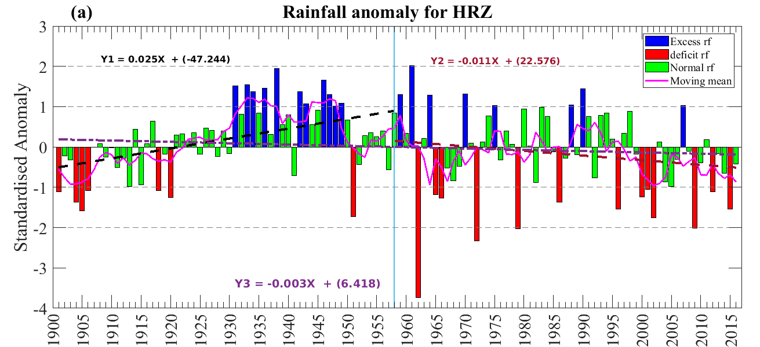
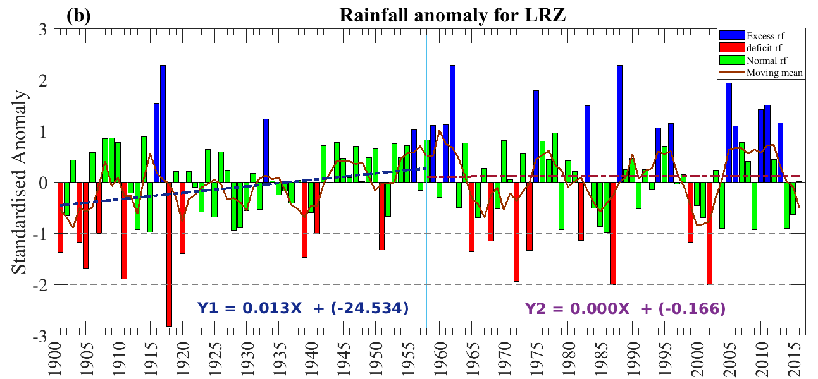
Supplementary Figure 1 Standardized anomaly of rainfall for (a) HRZ, the blue color depicts excess rainfall year, red color depicts deficit rainfall and green rainfall depicts normal rainfall years, the brown line represents the five years running mean, (b) same as (a) but for LRZ.

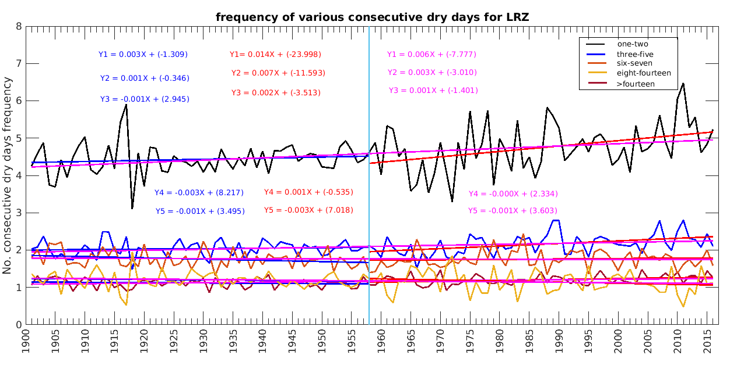
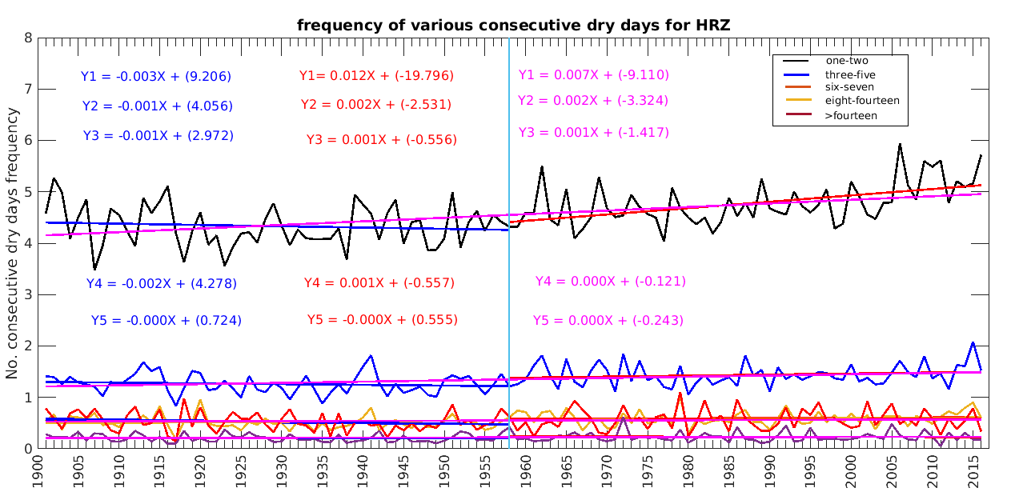
(a)
(b)

Supplementary Figure 2 Frequency of various consecutive dry days during Indian summer monsoon season (a) frequencies of various consecutive dry days for the >80% of normal rainfall area, the black line is presents one to two consecutive dry days followed by blue shows three to five, Orange shows six to seven, Yellow shows eight to fourteen and brown shows more than fourteen consecutive dry days, (b) same as (a), only for <40% rainfall area.

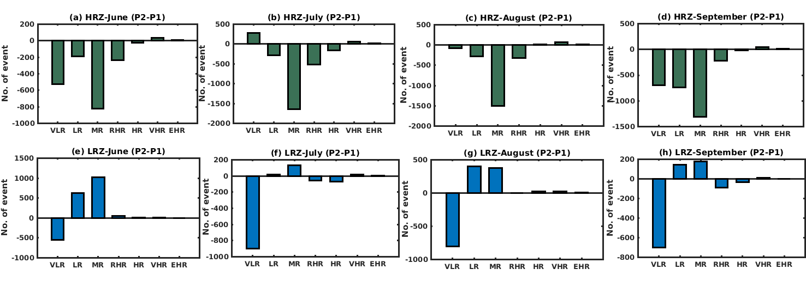

Supplementary Figure 3 The difference between number of various rainfall events during P1 (1901-1958) and P2 (1959-2016) over HRZ, (a) the difference of various rainfall events for the month of June, (b) for the month of July, (c) for the month of August and (d) for the month of September, (e), (f), (g) and (h) are same as (a), (b),(c) and (d) respectively only for LRZ.

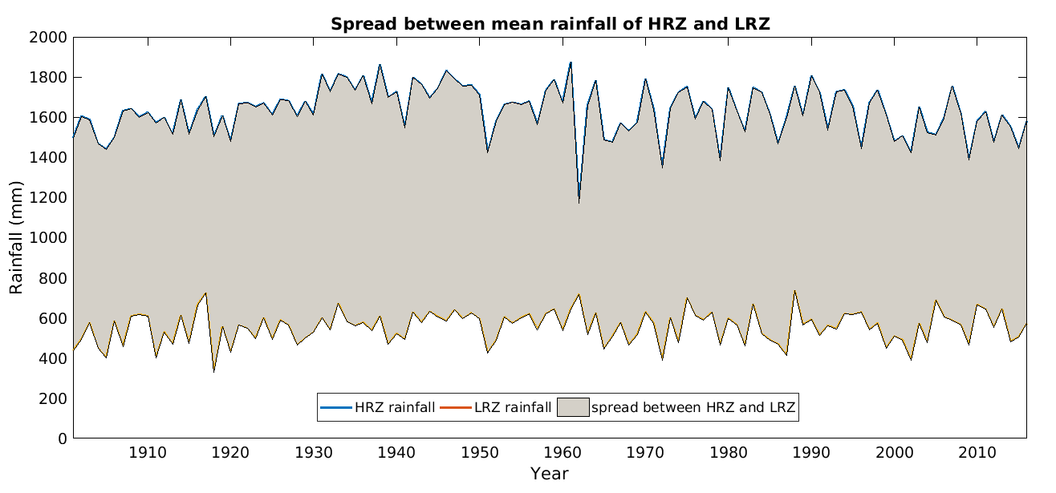
Supplementary Figure 4 The year wise difference between mean seasonal rainfall of HRZ and LRZ.

