SUPPLEMENTARY INFORMATION
Table 1.
Experiment 2 Evaluation Means (Between Subjects)
Dimension | Presumed Human  (n = 140) | Labeled AI-Made  (n = 135) | Ambiguous Source  (n = 146)
Expensive | 4.12 (.01) | 3.85 (.02)*** | 4.07 (.02)
Skillful | 4.95 (.01) | 4.73 (.02)*** | 4.77 (.01)***
Complex | 4.53 (.01) | 4.53 (.02) | 4.48 (.01)
Colorful | 4.26 (.01) | 4.26 (.01) | 4.24 (.02)
Liking | 4.03 (.02) | 4.04 (.02) | 4.03 (.02)
Emotional | 3.26 (.02) | 3.18 (.02)* | 3.34 (.02)*
Bright | 3.99 (.01) | 3.94 (.01) | 3.94 (.01)
Inspiring | 3.12 (.02) | 3.18 (.02) | 3.29 (.02)***
Willingness to Pay | 2.97 (.02) | 2.97 (.02) | 2.98 (.02)
Aggregate of Dimensions Above | 3.92 (.01) | 3.85 (.01)* | 3.91 (.01)
Qualifies as Art?  (no = 1, maybe = 2, yes = 3) | 2.67 (.01) | 2.56 (.01)*** | 2.66 (.01)
Note. P-values reflect OLS regression models comparing the “Labeled AI-Made” and “Ambiguous Source” conditions to the “Unlabeled (Presumed Human)” condition. These effects remain unchanged when controlling for variation attributable to images (i.e., controlling for image id). *p < .05, **p < .01, ***p < .001

Figure 1.
Experiment 3 Stimuli
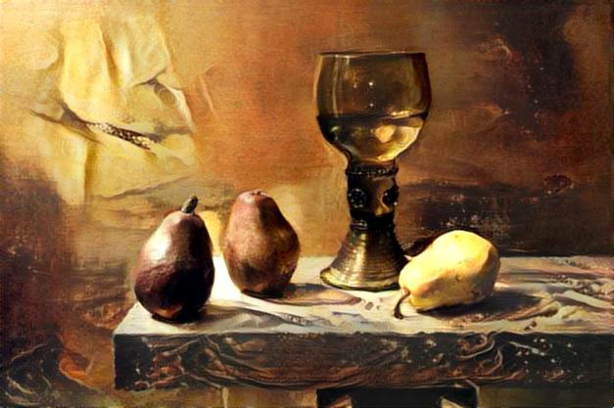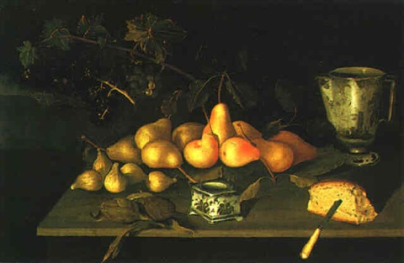

Table 2.
Experiment 3 Evaluation Means for Image 1
Dimension | Human-Label | AI-Label
Artistic Value | 4.07 (.05) | 4.01 (.05)
Source Value | 5.71 (.05) | 5.09 (.06)***
Monetary Value | $171.38 (9.90) | $110.64 (2.57)***
Note. P-values reflect t-tests. *p < .05, **p < .01, ***p < .001

Table 3.
Experiment 3 Evaluation Means for Image 2
 | Human-Anchor |  | AI-Anchor
Dimension | Image 2  Human Label  (Control) | Image 2  AI Label | Image 2  Human Label | Image 2  AI Label
Artistic Value | 3.72 (.11) | 3.69 (.13) | 4.21 (.11)** | 3.78 (.10)
Source Value | 5.31 (.11) | 4.52 (.17)*** | 5.56 (.11) | 4.85 (.13)**
Monetary Value | $152.87 (20.71) | $97.05 (7.56)** | $141.63 (5.08) | $109.83 (4.77)**
Note. P-values reflect regression models dummy-coding conditions and using the “human-label” group as our control condition. *p < .05, **p < .01, ***p < .001

Table 4.
Experiment 4 Evaluation Means for Image 1
Dimension | Human-Label | AI-Label
Creative | 4.60 (.05) | 4.15 (.08)***
Monetary Value | 156.28 (12.03) | 93.56 (5.46)***
Estimated Time to Produce | 32.30 (.90) | 10.04 (1.01)***
Note. P-values reflect t-tests. *p < .05, **p < .01, ***p < .001
Table 5.
Experiment 5 Evaluation Means for Image 1
Dimension | Human-Label | AI-Label | Mean Difference
Artistic Value | 4.75 (.06) | 4.15 (.07) | t(706.57) = 6.17, p < .0001
Monetary Value | 142.21 (17.88) | 80.70 (3.28) | t(346.07) = 3.40, p = .0008
Estimated Time to Produce | 23.25 (1.19) | 6.50 (.58) | t(471.62) = 17.54, p < .0001
Note. Means and standard error reported above. P-values reflect between-subjects T-tests comparing the left and right columns. The direction and significance of effects remained unchanged using OLS regression to additionally control for variation attributable to images and individuals (e.g., anxiety about AI technologies and artistic experience).

Figure 2.
Experiment 6 Stimuli
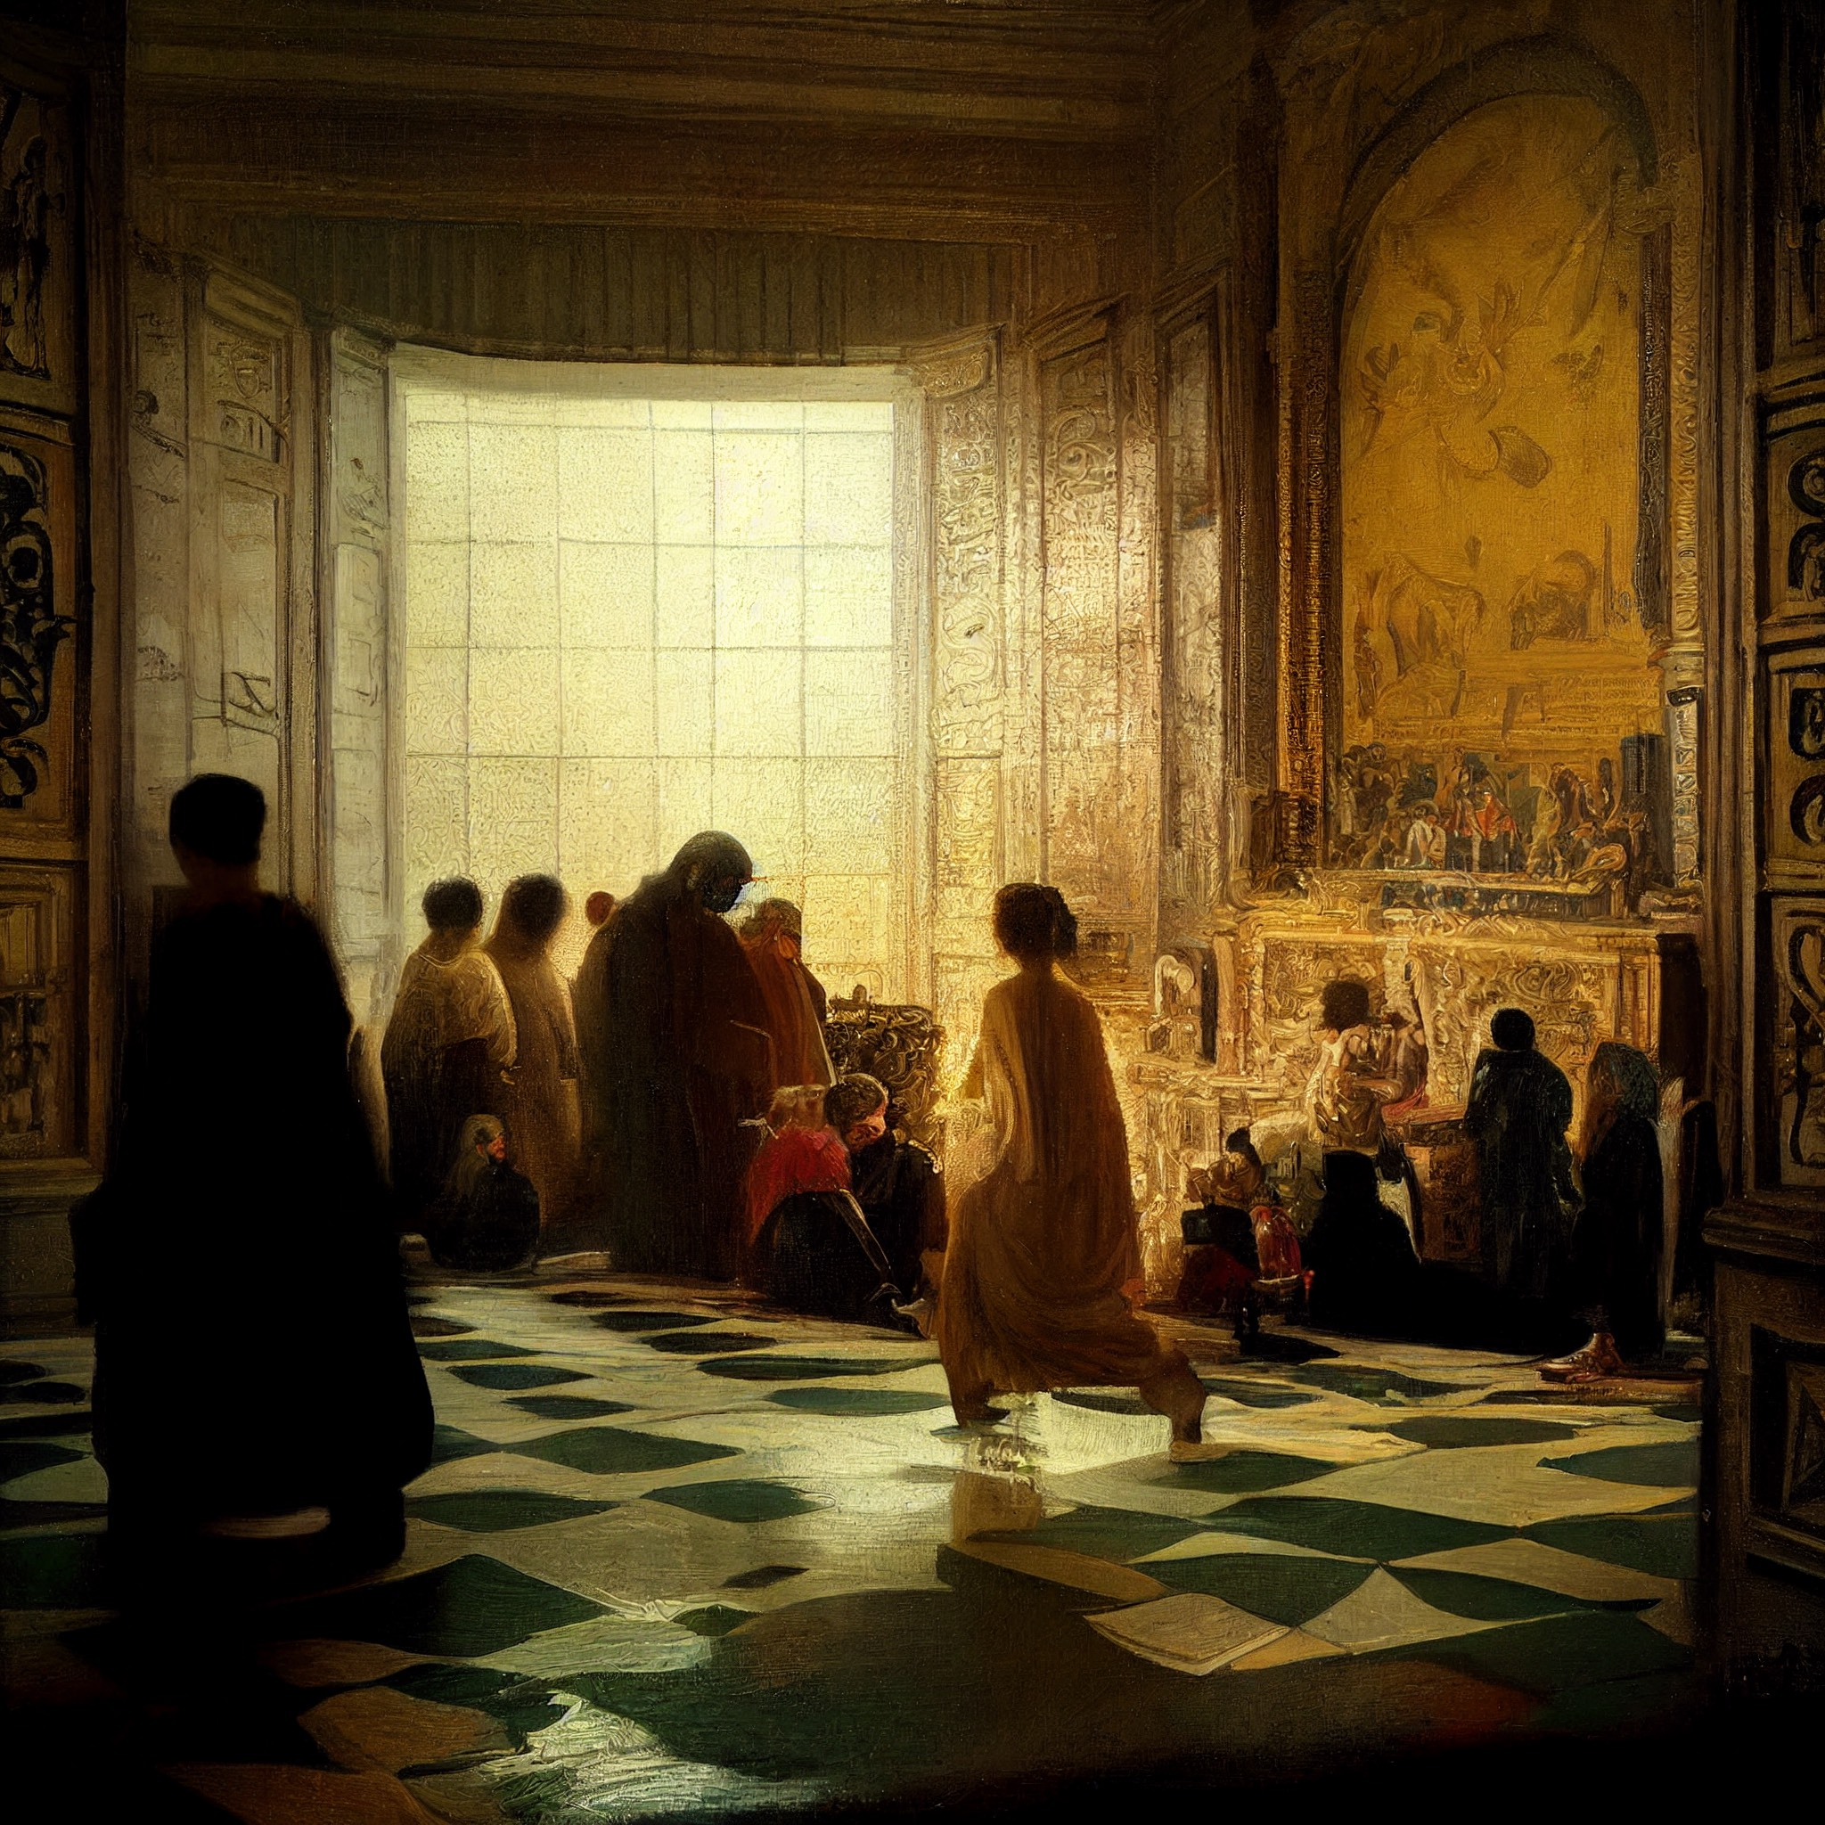
Note. These were generated using Midjourney V4.

Table 6.
Experiment 6 Evaluation Means for Image 1 (Between Subjects)
Dimension | Human-Label | AI-Label
Creative Value | 5.44 (.06) | 4.60 (.08)***
Monetary Value | 239.28 (37.66) | 90.93 (3.32)***
Estimated Time to Produce | 33.55 (1.46) | 7.81 (.80)***
Note. P-values reflect t-tests. Standard errors reflect OLS regression models estimating means. Effects were unchanged when including self-reported anxiety about AI (which was not impacted by the condition). *p < .05, **p < .01, ***p < .001

