Supplementary Material

Figure S1. Geographical location of the study sites. A) Map showing the province of Haut Katanga, DR Congo. B) Map showing the location of the city of Lubumbashi in the Kipushi territory and C) Distribution of the study sites on the soil map of Haut-Katanga (K: Kipopo and M: Mikembo). Soil unit legend: Vertic Cambisols (CMv), Haplic Ferralsols (FRh) and Rhodic Ferralsols (FRr).

Figure S2. Systematic sampling design: soil core collection (green circle), 1 m square plots for herbaceous species inventory (small square) and 10 m square plots for woody species inventory (large square).
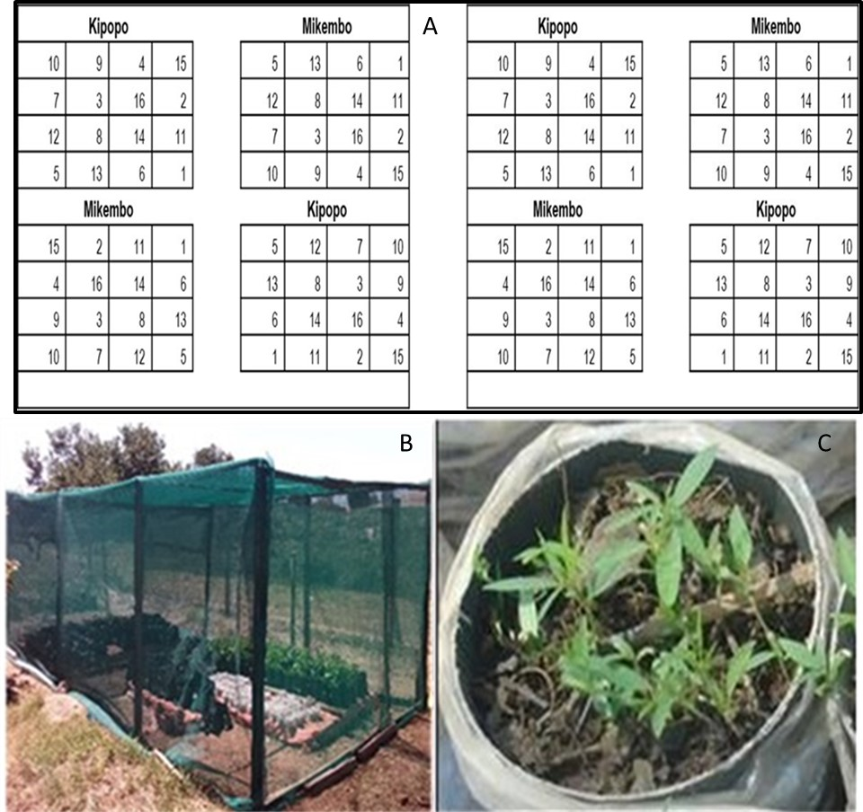

Figure S3. Nursery experimental design (A), nursery (B) and C. juncea seedlings (C); used to estimate soil mycorrhizal inoculum potential in samples from Kipopo and Mikembo around Lubumbashi, DR Congo. Numbers 1 to 16 represent the sample plots, with four replicates per plot.

Table S1. Indval parameters and relative abundance of plant indicator species in the Kipopo and Mikembo sites
Woody species |  | Indval parameters |  |  |  | Abundance at Kipopo |  |  |  |  | Abundance at Mikembo
Woody species | RT | Br | IndVal | p |  | Mean | med | min | max |  | Mean | med | min | max
Albizzia adiantifolia (Schumach.) W.Wight | Ph | 2 | 0.81 | 0.001 |  | 4.25 | 4 | 3 | 5 |  | 1.69 | 2 | 0 | 4
A. antunesiana Harms | Ph | 1 | 0.43 | 0.04 |  | 0.31 | 0 | 0 | 2 |  | 1 | 0.5 | 0 | 3
Baphia bequartii Engl. | Ph | 2 | 0.47 | 0 |  | 0.69 | 1 | 0 | 2 |  | 0 | 0 | 0 | 0
Combretum acutifolium Exell | Ph | 1 | 0.68 | 0.002 |  | 0.25 | 0 | 0 | 1 |  | 2 | 2 | 0 | 4
Combretum collinum Fresen. | Ph | 1 | 0.55 | 0.001 |  | 0 | 0 | 0 | 0 |  | 1.06 | 1 | 0 | 3
Cussonia sp. Thunb. | Ph | 2 | 0.42 | 0.014 |  | 0.69 | 0.5 | 0 | 2 |  | 0 | 0 | 0 | 0
Diplorynchus condilocarpon (Muell. Arg.) Pichon | Ph | 2 | 0.52 | 0.007 |  | 1 | 1 | 0 | 2 |  | 0.25 | 0 | 0 | 3
Harugana madagascariensis Lam. ex Poir. | Ph | 1 | 0.36 | 0.023 |  | 0.13 | 0 | 0 | 2 |  | 0.75 | 0 | 0 | 4
Hymenocardia acida Tul. | Ph | 1 | 0.36 | 0.012 |  | 0 | 0 | 0 | 0 |  | 0.69 | 0 | 0 | 2
Julbernardia paniculata (Benth) Troupin) | Ph | 2 | 0.44 | 0.045 |  | 1.38 | 1.5 | 0 | 3 |  | 0.25 | 0 | 0 | 2
Marquesia macroura Gilg. | Ph | 2 | 0.42 | 0.017 |  | 0.81 | 1 | 0 | 2 |  | 0.06 | 0 | 0 | 1
Monotes katangensis (De Wild.) De Wild. | Ph | 2 | 0.37 | 0.027 |  | 0.56 | 0 | 0 | 2 |  | 0 | 0 | 0 | 0
Securidaca longipendoculata Fresen. Welw. | Ph | 1 | 0.35 | 0.026 |  | 0.13 | 0 | 0 | 1 |  | 0.75 | 0 | 0 | 3
Strichnos spinosa Lam. | Ph | 1 | 0.57 | 0.006 |  | 0.19 | 0 | 0 | 1 |  | 1.25 | 1.5 | 0 | 3
Terminalia sp L. | Ph | 1 | 0.33 | 0.026 |  | 0 | 0 | 0 | 0 |  | 0.75 | 0 | 0 | 2
Uapaca kirkiana Müll. Arg. | Ph | 2 | 0.58 | 0.002 |  | 1 | 1 | 0 | 2 |  | 0 | 0 | 0 | 0
Hemicryptophytes. geophytes and therophytes
Adenodolychos romboïdes (O.Hoffm.) Harms | Ge | 2 | 0.33 | 0.014 |  | 0.4 | 0 | 0 | 2 |  | 0 | 0 | 0 | 0
Afromomum sanguineum (K. Schum.) K. Schum. | Ge | 1 | 0.86 | 0.001 |  | 0.13 | 0 | 0 | 2 |  | 1.75 | 2 | 0 | 2
Bidens oligoflora (Klatt) Wild | Th | 2 | 0.98 | 0.001 |  | 2.07 | 2 | 1 | 3 |  | 0.13 | 0 | 0 | 1
Hyparhenia diplandra (Hack.) Stapf | He | 1 | 0.59 | 0.001 |  | 2.27 | 3 | 0 | 3 |  | 3.38 | 3 | 2 | 5
Imperata cylindrica (L.) Beauv | Ge | 2 | 0.75 | 0.001 |  | 2.33 | 2 | 1 | 3 |  | 0.94 | 1 | 0 | 2
Kocha sp. | Th | 2 | 0.33 | 0.013 |  | 0.4 | 0 | 0 | 2 |  | 0 | 0 | 0 | 0
Panicum maximum Jacq. | He | 1 | 0.72 | 0.001 |  | 0.2 | 0 | 0 | 2 |  | 1.38 | 1.5 | 0 | 3
Pteridium acquilinum (L.) Kuhn | Ge | 1 | 0.69 | 0.001 |  | 0 | 0 | 0 | 0 |  | 0.81 | 1 | 0 | 2
Setaria pumila (Poir.) Roem. & Schult | Th | 2 | 0.96 | 0.001 |  | 2 | 2 | 1 | 3 |  | 0.06 | 0 | 0 | 1
Smilax anceps Willd. | Ge | 1 | 0.73 | 0.001 |  | 0.07 | 0 | 0 | 1 |  | 1.31 | 2 | 0 | 2
Thumbergia sp. Retz. | Th | 2 | 0.33 | 0.02 |  | 0.33 | 0 | 0 | 1 |  | 0 | 0 | 0 | 0
Br: Branch of the multiple regression tree (1: Mikembo and 2: Kipopo), med=median, min=minimum and max=maximum), RT: Raunkiaer's biological types (Ph: phanerophytes, He: hemycryptophytes. Th: therophytes et Ge: geophytes)

