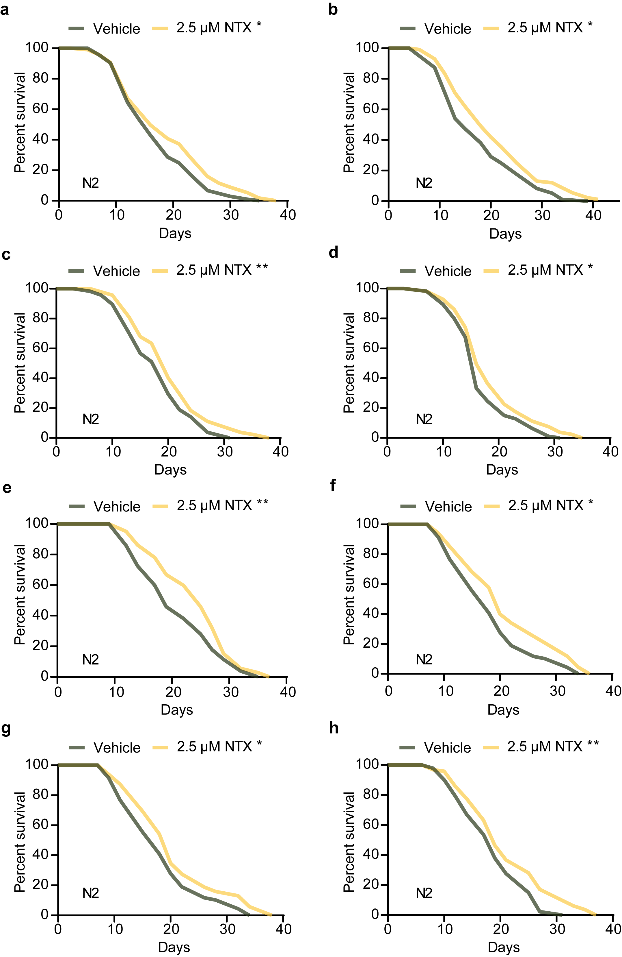
Figure S1. Impact of LDN on lifespan in individual experiments of N2 C. elegans. (a-h) Independent lifespan assays of N2 worms treated with or without 2.5 μM NTX. Related to Figure 1d. The statistical analysis is performed by the log-rank test. **p <0.01, *p < 0.05.

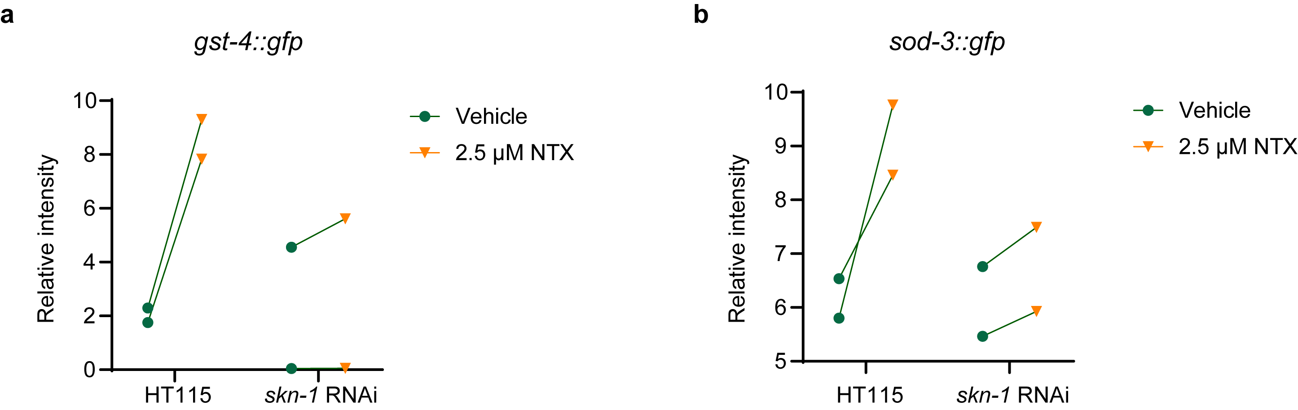
Figure S2. Quantification of GFP signaling on oxidative stress response reporters. (a) Two independent tests for GST-4 signaling with or without LDN treatment. (b) Two independent tests for SOD-3 signaling with or without LDN treatment.

Table S1: Lifespan Statistics
C. elegans strain | Treatment | Median lifespan (days) | % Change | Number animals (died/total) | P – value against control group
Figure 1 Panel D
Wild Type (N2)* | water vehicle | 17 |  | 732/880
Wild Type (N2)* | 2.5 μM naltrexone | 20 | 17.65% | 702/880 | <0.0001
Figure S1 Panel A
Wild Type (N2)* | water vehicle | 16 |  | 108/120
Wild Type (N2)* | 2.5 μM naltrexone | 16 | 0.00% | 114/120 | 0.0288
Figure S1 Panel
Wild Type (N2)* | water vehicle | 15 |  | 104/120
Wild Type (N2)* | 2.5 μM naltrexone | 18 | 20.00% | 102/120 | 0.0096
Figure S1 Panel C
Wild Type (N2)* | water vehicle | 20 |  | 109/120
Wild Type (N2)* | 2.5 μM naltrexone | 20 | 0.00% | 101/120 | 0.0097
Figure S1 Panel D
Wild Type (N2)* | water vehicle | 16 |  | 100/120
Wild Type (N2)* | 2.5 μM naltrexone | 16 | 0.00% | 90/120 | 0.0262
Figure S1 Panel E
Wild Type (N2)* | water vehicle | 19 |  | 80/100
Wild Type (N2)* | 2.5 μM naltrexone | 25 | 31.58% | 73/100 | 0.0124
Figure S1 Panel F
Wild Type (N2)* | water vehicle | 18 |  | 71/100
Wild Type (N2)* | 2.5 μM naltrexone | 20 | 11.11% | 71/100 | 0.0136
Figure S1 Panel G
Wild Type (N2)* | water vehicle | 18 |  | 71/100
Wild Type (N2)* | 2.5 μM naltrexone | 20 | 11.11% | 72/100 | 0.0498
Figure S1 Panel H
Wild Type (N2)* | water vehicle | 19 |  | 89/100
Wild Type (N2)* | 2.5 μM naltrexone | 19 | 0.00% | 84/100 | 0.0062
Figure 1 Panel E
Wild Type (N2)* | water vehicle | 20 |  | 109/120
Wild Type (N2)* | 50 μM naltrexone | 20 | 0.00% | 114/120 | 0.8371
Wild Type (N2) | water vehicle | 18 |  | 71/100
Wild Type (N2) | 50 μM naltrexone | 20 | 11.11% | 82/100 | 0.5641
Wild Type (N2) | water vehicle | 19 |  | 89/100
Wild Type (N2) | 50 μM naltrexone | 19 | 0.00% | 88/100 | 0.9860
Figure 3 Panel F
daf-16(mu86)* | water vehicle | 14 |  | 109/120
daf-16(mu86)* | 2.5 μM naltrexone | 16 | 14.30% | 114/120 | 0.0040
daf-16(mu86) | water vehicle | 17 |  | 78/100
daf-16(mu86) | 2.5 μM naltrexone | 17 | 0.00% | 72/100 | 0.0412
Figure 4 Panel A
pmk-1(km25)* | water vehicle | 19 |  | 79/100
pmk-1(km25)* | 2.5 μM naltrexone | 19 | 0.00% | 74/100 | 0.0011
pmk-1(km25) | water vehicle | 20 |  | 69/80
pmk-1(km25) | 2.5 μM naltrexone | 22 | 10.00% | 60/80 | 0.0024
Figure 3 Panel B
cdk-5(ok626)* | water vehicle | 17 |  | 84/100
cdk-5(ok626)* | 2.5 μM naltrexone | 22 | 29.41% | 76/100 | 0.0486
cdk-5(ok626) | water vehicle | 19 |  | 85/100
cdk-5(ok626) | 2.5μM naltrexone | 22 | 15.79% | 79/100 | 0.0397
Figure 3 Panel C
atf-4(ok576)* | water vehicle | 22 |  | 80/100
atf-4(ok576)* | 2.5 μM naltrexone | 22 | 0.00% | 80/100 | 0.0009
atf-4(ok576) | water vehicle | 21 |  | 102/120
atf-4(ok576) | 2.5 μM naltrexone | 23 | 9.52% | 103/120 | 0.0399
atf-4(ok576) | water vehicle | 22 |  | 85/100
atf-4(ok576) | 2.5 μM naltrexone | 25 | 13.64% | 73/100 | 0.0183
Figure 3 Panel D
aak-2(ok524)* | water vehicle | 22 |  | 57/80
aak-2(ok524)* | 50 μM naltrexone | 24 | 9.09% | 50/80 | 0.0458
aak-2(ok524) | water vehicle | 17 |  | 61/80
aak-2(ok524) | 50 μM naltrexone | 19 | 11.76% | 63/80 | <0.0001
Figure 3 Panel E
unc-13(n2813)* | water vehicle | 27 |  | 64/80
unc-13(n2813)* | 50 μM naltrexone | 29 | 7.41% | 58/80 | 0.0458
unc-13(n2813) | water vehicle | 26 |  | 68/80
unc-13(n2813) | 50 μM naltrexone | 28 | 7.69% | 66/80 | 0.0356
Figure 3 Panel F
skn-1(mg570)* | water vehicle | 16 |  | 105/120
skn-1(mg570)* | 50 μM naltrexone | 16 | 0.00% | 98/120 | 0.0669
skn-1(mg570) | water vehicle | 14 |  | 65/100
skn-1(mg570) | 50 μM naltrexone | 17 | 21.43% | 67/100 | 0.4018
skn-1(mg570) | water vehicle | 22 |  | 80/100
skn-1(mg570) | 50 μM naltrexone | 22 | 0.00% | 89/100 | 0.4750
*experiment represented in figure

Table S3: Quantification of the number of nuclear translocations
 | Vehicle | LDN-treatment
Number of SKN-1 nuclear translocations  (10 images) | 12 | 23
Total nuclei observed (10 images) | 29 | 28

Table S4: Primers used for C. elegans qPCR
Gene | Forward (sequence 5’→3’) | Reverse (sequence 5’→3’)
Reference gene
cdc-42 | TCGACAATTACGCCGTCACA | AGGCACCCATTTTTCTCGGA
pmp-3 | GTCGAACGATGTGGTGGTCT | AGGCACCCATTTTTCTCGGA
Target genes
C32H11.4 | TCCTTTGAAATGCCGAGTCT | GGCTTGTGAACCACATTTCC
F55G11.8 | TCAAACAACCCACGAGAAAA | AGCAAATCCTTCGTTGGAGA
F56D6.2 | GGTGACAGTTCAAAGCCATGT | TTCCAAAAATGCCCGAGTAG
M02F4.7 | GGAACACTGGCTTCTGTTCAT | CCAATATGAATTCGCTTGGAC
F49F1.6 | CCATCAACTACGCCAAAGC | TCCGGTGGATAGAAGGTGTT
skn-1 | AGGCTCAACCTCAGAACATG | AAATGAAATGAGACACGGCAAAGA
C17H12.8 | TGTCATTTCAATGGAGGATATTGT | TGATGGAGTTGGAGGATATTGA
K08D8.5 | TACATTTTCACGTCCCCACA | TGCATGTTCATTCGACTTCC

