Supporting information
to
Facile preparation of KNN thin film with high purity phase and excellent electrical properties
Phuong T. M. Nguyen ¹, Tai Nguyen² and Thu-Hien Vu^{1, *}
¹ International Training Institute for Materials Science (ITIMS), Hanoi University of Science and Technology, No. 1 Dai Co Viet Road, Hanoi, Vietnam
² School of Engineering Physics (SEP), Hanoi University of Science and Technology, No. 1 Dai Co Viet Road, Hanoi, Vietnam
*Corresponding authors

E-mail: hien.vuthu@hust.edu.vn

Tel: (+84)-4-38680787-113
Fax: (+84)-4-38692963
http://itims.edu.vn/
[K_{0.6}Na_{0.6}NbO₃; KNN1] precursor solution was dried in a small beaker at 80 ºC on a hotplate during stiring for 1 hour to get the gel. Afterwards, the gels were sintered at 650 ºC in 15 min. Crystal structure of the KNN1 gels were examined by Synchrotron X–ray powder diffraction (SXRD) at beamline SAXS of the Synchrotron Light Research Institute (Thailand). The diffraction data were analyzed using Rietveld method with the help of FullProf program [1]. The diffraction peaks were modeled by pseudo–Voigt function which is a sum of Gaussian and Lorentzian functions [2]. A standard of LaB₆ was used to determine instrument broadening. The refinement fitting quality was checked by goodness of fit (χ2) and weighted profile R-factor (Rwp). The calculated results are accepted with χ2 should approach 1 and Rwp must be close to or less than 10% [3].
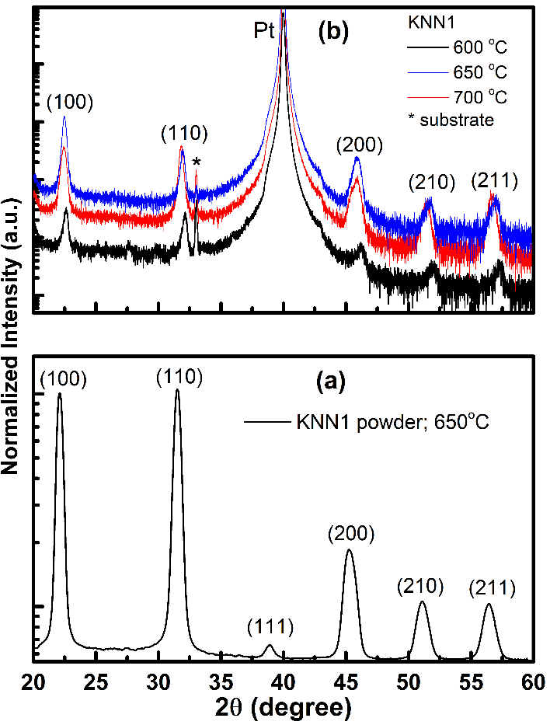
Fig. S1: (a) Synchrotron diffraction pattern of the KNN1 gel-powder processed by the Rietveld method and (b) XRD curves of KNN1 thin films deposited on Pt electrodes annealing at different temperatures.
The diffraction data were analyzed using Rietveld method with the help of FullProf program [4]. The diffraction peaks were modeled by pseudo–Voigt function. A standard of LaB₆ was used to determine instrument broadening. The refinement fitting quality was checked by goodness of fit (χ²) and weighted profile R-factor (R_{wp}). The calculated results are accepted with χ² should approach 1 and R_{wp} must be close to or less than 10% [3].
The synchrotron diffraction patterns and its Rietveld refinement of the KNN1 powder sample is shown in Figure S1a and the corresponding XRD of KNN1 thin films on Pt electrode annealing at various temperatures indicated in Figure S1b. The SXRD pattern of KNN1 exhibits a single-phase pervoskite with orthorhombic structure belonging to space group Amm2 as reported in ref. [5]. The microstructural parameters (the crystallite size D and lattice microstrain Δd/d (where d is interplanar distance) were obtained by analysis of the peak broadening on applying Rietveld method using FullProf program with the instrumental resolution function identified by SXRD analysis of the LaB₆ standard. The refined values of structural parameters including lattice constant (a, b, c), unit cell volume (V), crystallite size (D), microstrain Δd/d and fitting quality (χ2 and Rwp) are given in Table S1.
Table S1: Structural parameters of the samples estimated from Rietveld refinement: lattice parameters (a, c), unit cell volume (V), crystallite size (D)and fitting quality (χ² andR_{wp}). Statistical errors are indicated in the last significant digit.
Sample | KNN1 powder annealed at 650 ºC
a, Å | 3.9363(4)
b, Å | 5.6352(8)
c, Å | 5.6256(5)
V, Å³ | 124.79(3)
D, nm | 50.73(2)
χ² | 1.38
R_{wp}, % | 8.31

Table S2: Factor of textured coefficients, F(hkl) of KNN1 thin films at various annealing temperatures.
Planes (hkl) | 2θ |  |  |  | F(hkl)
Planes (hkl) | KNN1@ 600 ºC | KNN1@ 650 ºC | KNN1@ 700 ºC | KNN Powder | KNN1@ 600 ºC | KNN1@ 650 ºC | KNN1@ 700 ºC
(100) | 22.599 | 22.479 | 22.432 | 22.110 | 0.540 | 0.780 | 0.50
(110) | 32.106 | 31.946 | 31.819 | 31.517 | 0.370 | 0.170 | 0.393
(111) | - | - | - | 38.864 | - | - | -
(200) | 45. 936 | 45.28 | 45.783 | 45.303 | - | - | -
(210) | 51.896 | 50.89 | 51.413 | 51.112 | 0.044 | 0.026 | 0.045
(211) | 57.249 | 56.22 | 56.681 | 56.436 | 0.046 | 0.028 | 0.066
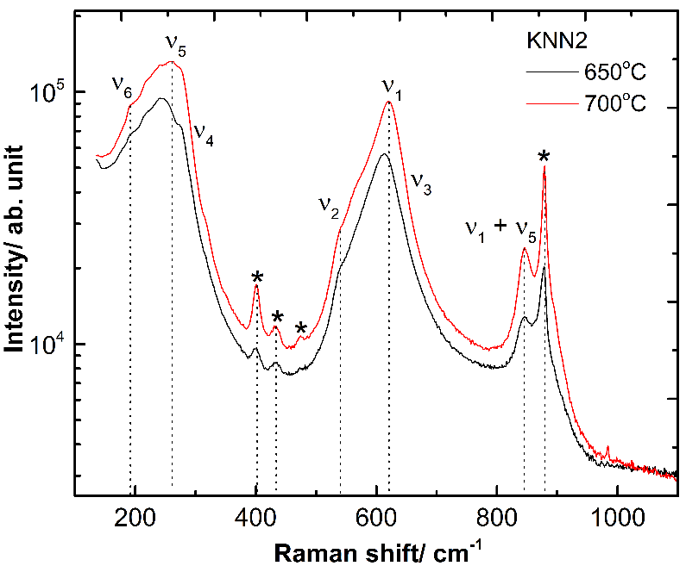
Fig. S2: Raman spectra of KNN2 thin films annealed at 650 and 700 ºC. The secondary phase (K₄Nb₆O₁₇) are noted as asterisks.
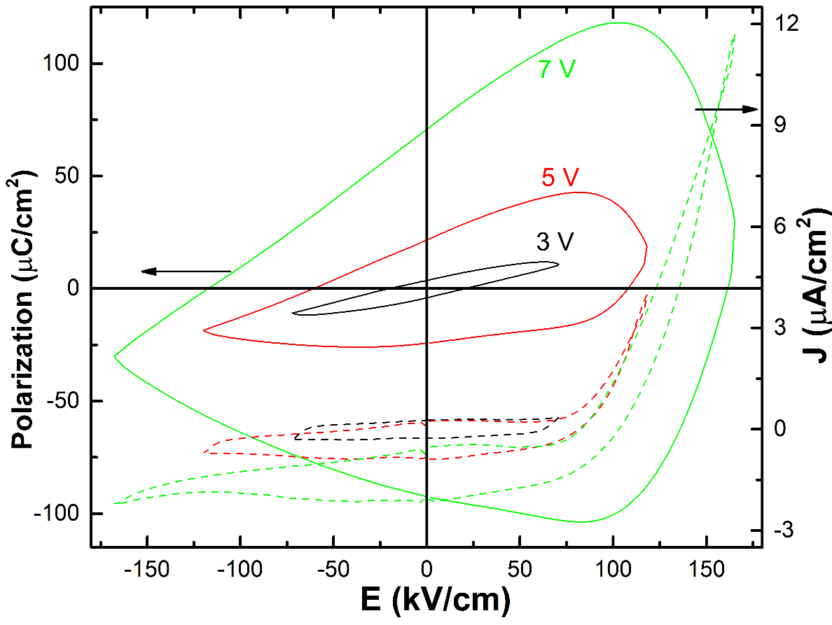
Fig. S3: Polarization-electric field (P-E) loops and switching current flow (J-E) curves of KNN1@ 700 ºC measured at different applied voltages.
Table S3: Comparison of remnant polarization, P_{r}, coercive field, E_{c}, dielectric constant ε_{r}, loss tangent, tanδ as well as leakage current density J for KNN thin films obtained by various research groups.
No. | Thin film | Remanant polarization, P_{r} (µC/cm²) | Coercive field, E_{c} (kV/cm) | Dielectric constant, ε_{r} | Loss tangent, tanδ | Leakage current, J (A/cm²) | Thickness, t (nm) | Fabrication methods | Ref.s
1 | KNN50/Pt | 3.54 | 160 | 258 | 0.05 | - | 120 | Sol-gel | [6]
2 | KNN50/Pt | 8 | 80 | 610 | 0.015 | - | 250 | Sol-gel | [7]
3 | KNN50/Pt | 10 | 35 |  |  | 7×10⁻⁷ @ 50 kV/cm | 250 | Sol-gel | [8]
4 | KNN48/Pt | Weak ferroelectricity | - | 699 | 0.038 | 10⁻⁵ @ 50 kV/cm | 250 | Sol-gel | [9]
5 | KNN50/Pt | 5.47± 2.25 @ 10 Hz | 47.08 ± 12.83 | ~ 750 @ 1 MHz | 0.03 -0.06 | - | 165 - 330 | Sol-gel | [10]
6 | KNN50-2% mol Mn/Pt | 7.2 | ~100 | 650 | 0.05 | 10⁻⁸ @ 50 kV/cm | 1600 | Sol-gel | [11]
7 | KNN50/Pt@ 760 ºC | 8.54 | 57.2 | 930 | 0.03 | - | 363 - 545 | PLD | [12]
8 | KNN50/SRO | 8 | 40 | 677 | 0.03 | 3.48× 10⁻⁶ @ 250 kV/cm | 1000 | RF sputtering | [13]
9 | KNN48-Li-Ta/Pt | 11.3 | 103 | - | - | - | 280 | PLD | [14]
10 | KNN35@ 750 ºC | 8.63 | 21.81 | 351 | 0.1 | 8× 10⁻³ @ 100 kV/cm | 300 | PLD | [15]
 | KNN50 | 10.73 | 74.48 | 775 | 0.02 | 9.23×10⁻¹⁰ @ 5 kV/cm | 380 | Sol-gel | Present study

References
1. J. Rodríguez-Carvajal, Phys. B Condens. Matter 192, 55 (1993).
2. D. Balzar, (n.d.).
3. L. B. McCusker, R. B. Von Dreele, D. E. Cox, D. Louër, and P. Scardi, J. Appl. Crystallogr. 32, 36 (1999).
4. J. Rodriguez-carvajal, Ec. Themat. Cristallogr. Neutrons 418, 73 (1997).
5. J. Tellier, B. Malic, B. Dkhil, D. Jenko, J. Cilensek, and M. Kosec, Solid State Sci. 11, 320 (2009).
6. X. Yan, W. Ren, X. Wu, P. Shi, and X. Yao, J. Alloys Compd. 508, 129 (2010).
7. A. Kupec, B. Malic, J. Tellier, E. Tchernychova, S. Glinsek, and M. Kosec, J. Am. Ceram. Soc. 95, 515 (2012).
8. C. W. Ahn, S. Y. Lee, H. J. Lee, A. Ullah, J. S. Bae, E. D. Jeong, J. S. Choi, B. H. Park, and I. W. Kim, J. Phys. D. Appl. Phys. 42, 215304 (2009).
9. G. Li, X. Wu, W. Ren, and P. Shi, Thin Solid Films 548, 556 (2013).
10. N. H. Gaukås, J. Glaum, M. A. Einarsrud, and T. Grande, J. Mater. Chem. C 8, 5102 (2020).
11. L. Wang, W. Ren, P. Shi, and X. Wu, J. Appl. Phys. 115, 0 (2014).
12. A. Tian, W. Ren, L. Wang, P. Shi, X. Chen, X. Wu, and X. Yao, Appl. Surf. Sci. 258, 2674 (2012).
13. T. Li, G. Wang, K. Li, G. Du, Y. Chen, Z. Zhou, D. Rémiens, and X. Dong, Ceram. Int. 40, 1195 (2014).
14. D. Y. Wang, D. M. Lin, K. W. Kwok, N. Y. Chan, J. Y. Dai, S. Li, and H. L. W. Chan, Appl. Phys. Lett. 98, 0 (2011).
15. S. Sharma, A. Kumar, V. Gupta, and M. Tomar, Vacuum 160, 233 (2019).

