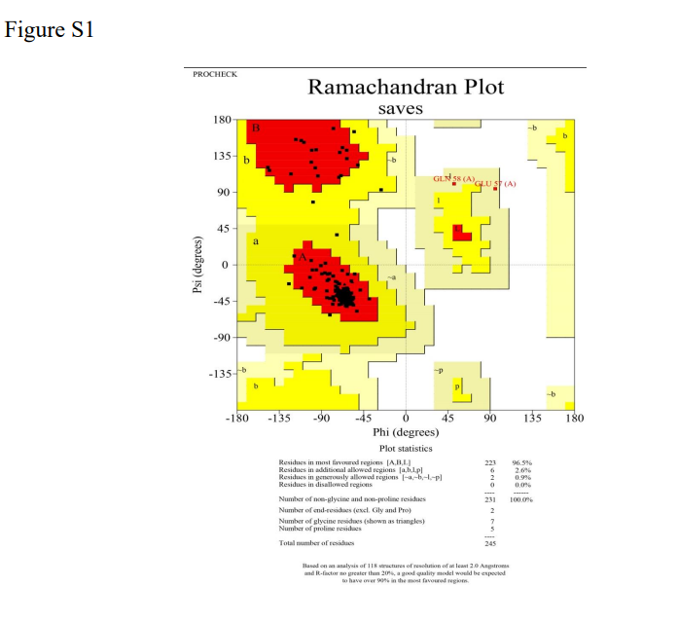

Figure S1: Ramachandran plot. Figure shows Ramachandran plot for predicted structure of full length CBP2 obtained from Alpha fold. All the residues are found in the allowed/ favoured regions.

Table S1
Gene ID |  | X | Y | Z
PF3D7_1301700 | Center | -10.1664 | -2.87387 | 6.75774
 | Size | 34.2688 | 27.7896 | 23.9081

Table S1: Grid box coordinates and dimensions. Table shows centre coordinates and size.

Table S2

Complex Name | Score | ΔG (Kcal\mol)
Complex 1 | -7.189 | -5.39
Complex 2 | -6.924 | -5.23
Complex 3 | -6.841 | -5.39
Complex 4 | -6.548 | -5.49
Complex 5 | -6.483 | -5.62
Complex 6 | -6.466 | -5.45
Complex 7 | -6.45 | -5.51
Complex 8 | -6.375 | -5.47
Complex 9 | -6.138 | -5.31

Complex Name | Score | ΔG (Kcal\mol)
Complex 1 | -7.189 | -5.39
Complex 2 | -6.924 | -5.23
Complex 3 | -6.841 | -5.39
Complex 4 | -6.548 | -5.49
Complex 5 | -6.483 | -5.62
Complex 6 | -6.466 | -5.45
Complex 7 | -6.45 | -5.51
Complex 8 | -6.375 | -5.47
Complex 9 | -6.138 | -5.31
Table S2: Summary of scores and binding energies for all complexes. Nine complexes were obtained after docking CBP2 and ATP. Scores obtained from Autodock in Chimera and binding energies (ΔG values for complexes) are listed.

