Supplementary Table S1. List of NADH dehydrogenase 2 (ND2) GenBank sequences of P. cf bedriagae included in this study with locality, country, coordinates, and reference.
Acc. number | Clade | Locality | Country | Long | Lat | Reference
LN794308 | tan | Mulaik Thoba | Jordan | 31.55 | 35.74 | Plötner et al. 2015
LN794294 | tan | Mulaik Thoba | Jordan | 31.55 | 35.74 | Plötner et al. 2015
LN794293 | tan | Mulaik Thoba | Jordan | 31.55 | 35.74 | Plötner et al. 2015
LN794292 | tan | Mulaik Thoba | Jordan | 31.55 | 35.74 | Plötner et al. 2015
LN794291 | grey | Mersin-Erdemli | Turkey | 36.59 | 34.29 | Plötner et al. 2015
LN794290 | pink | Konya-Mehmetali dam | Turkey | 37.21 | 32.64 | Plötner et al. 2015
LN794289 | yellow | Konya-Mehmetali dam | Turkey | 37.21 | 32.64 | Plötner et al. 2015
LN794288 | pink | Lake Beyşehir | Turkey | 37.68 | 31.72 | Plötner et al. 2015
LN794287 | pink | Lake Beyşehir | Turkey | 37.68 | 31.72 | Plötner et al. 2015
LN794286 | pink | Lake Beyşehir | Turkey | 37.68 | 31.72 | Plötner et al. 2015
LN794285 | yellow | Karaman-Yeşildere | Turkey | 37.20 | 33.40 | Plötner et al. 2015
LN794284 | yellow | Karaman-Belpınarı | Turkey | 36.83 | 32.58 | Plötner et al. 2015
LN794283 | tan | Jesus Baptism site | Jordan | 31.49 | 35.59 | Plötner et al. 2015
LN794282 | tan | Wadi Mujib | Jordan | 31.45 | 35.79 | Plötner et al. 2015
LN794281 | tan | Wadi Mujib | Jordan | 31.45 | 35.79 | Plötner et al. 2015
LN794280 | tan | Wadi Mujib | Jordan | 31.45 | 35.79 | Plötner et al. 2015
LN794279 | tan | Wadi Mujib | Jordan | 31.45 | 35.79 | Plötner et al. 2015
LN794278 | tan | Bab Amman | Jordan | 32.03 | 35.81 | Plötner et al. 2015
LN794277 | tan | Bab Amman | Jordan | 32.03 | 35.81 | Plötner et al. 2015
LN794276 | tan | Al Kerak | Jordan | 31.18 | 35.70 | Plötner et al. 2015
LN794275 | pink | Seydişehir | Turkey | 37.46 | 31.82 | Plötner et al. 2015
LN794274 | tan | Mulaik Thoba | Jordan | 31.55 | 35.74 | Plötner et al. 2015
LN794273 | tan | Mulaik Thoba | Jordan | 31.55 | 35.74 | Plötner et al. 2015
LN794272 | tan | Mulaik Thoba | Jordan | 31.55 | 35.74 | Plötner et al. 2015
MN864875 | red | San Martino | Italy | 43.34 | 10.57 | Bruni et al. 2020
MN864874 | red | Trossa | Italy | 43.32 | 10.75 | Bruni et al. 2020
MN864873 | red | Il Cerreto | Italy | 43.32 | 10.75 | Bruni et al. 2020
MN864872 | red | Masso delle Fanciulle | Italy | 43.31 | 10.92 | Bruni et al. 2020
KX503315 | blue | Anavgay | Russia | 56.05 | 158.99 | Lyapkov et al. 2017
KX503314 | blue | Esso | Russia | 55.93 | 158.68 | Lyapkov et al. 2017
KX503313 | blue | Helios | Russia | 53.01 | 158.27 | Lyapkov et al. 2017
KX503312 | blue | Petropavlovsk-Kamchatsky | Russia | 53.01 | 158.74 | Lyapkov et al. 2017
KX503311 | blue | Malka | Russia | 53.32 | 157.54 | Lyapkov et al. 2017
HM365084 | blue | Tuzluca | Turkey | 40.03 | 43.67 | Akin et al. 2010
GU812132 | orange | Pasargad | Iran | 30.21 | 53.17 | Akin et al. 2010
GU812131 | orange | Bishkek | Kyrgyzstan | 42.84 | 74.64 | Akin et al. 2010
GU812130 | orange | Almaty | Kazakhstan | 50.30 | 57.22 | Akin et al. 2010
GU812129 | phosphoric | Central Nuratau | Uzbekistan | 40.08 | 66.42 | Akin et al. 2010
GU812128 | phosphoric | Central Nuratau | Uzbekistan | 40.08 | 66.42 | Akin et al. 2010
GU812127 | phosphoric | Ashkabad | Turkmenistan | 38.32 | 57.95 | Akin et al. 2010
GU812126 | purple | Abu Kamal | Syria | 34.45 | 40.94 | Akin et al. 2010
GU812125 | purple | Istanbul | Turkey | 41.13 | 28.75 | Akin et al. 2010
GU812124 | purple | Abu Kamal | Syria | 34.45 | 40.94 | Akin et al. 2010
GU812123 | purple | Tuzluca | Turkey | 40.03 | 43.67 | Akin et al. 2010
GU812122 | purple | Abu Kamal | Syria | 34.45 | 40.94 | Akin et al. 2010
GU812121 | blue | Sukhumi | Georgia | 43.00 | 40.98 | Akin et al. 2010
GU812120 | blue | Sukhumi | Georgia | 43.00 | 40.98 | Akin et al. 2010
GU812119 | blue | Batumi | Georgia | 41.64 | 41.68 | Akin et al. 2010
GU812118 | blue | Dakhovskaya | Russia | 44.23 | 40.20 | Akin et al. 2010
GU812117 | blue | Dakhovskaya | Russia | 44.23 | 40.20 | Akin et al. 2010
GU812116 | blue | Atyrau | Kazakhstan | 47.54 | 52.39 | Akin et al. 2010
GU812115 | blue | Atyrau | Kazakhstan | 47.54 | 52.39 | Akin et al. 2010
GU812114 | red | Foça | Turkey | 38.67 | 26.76 | Akin et al. 2010
GU812113 | red | Foça | Turkey | 38.67 | 26.76 | Akin et al. 2010
GU812112 | red | Batumi | Georgia | 41.64 | 41.68 | Akin et al. 2010
GU812111 | red | Ankara | Turkey | 39.58 | 33.05 | Akin et al. 2010
GU812110 | red | Edremit | Turkey | 39.61 | 27.02 | Akin et al. 2010
GU812109 | red | Edremit | Turkey | 39.61 | 27.02 | Akin et al. 2010
GU812108 | green | Akçapınar | Turkey | 37.11 | 28.47 | Akin et al. 2010
GU812107 | green | Akçapınar | Turkey | 37.11 | 28.47 | Akin et al. 2010
GU812106 | green | Samos | Greece | 37.76 | 26.98 | Akin et al. 2010
GU812105 | green | Samos | Greece | 37.76 | 26.98 | Akin et al. 2010
GU812104 | green | Foça | Turkey | 38.67 | 26.76 | Akin et al. 2010
GU812103 | green | Foça | Turkey | 38.67 | 26.76 | Akin et al. 2010
GU812102 | green | Chios | Greece | 38.36 | 26.14 | Akin et al. 2010
GU812101 | green | Lesvos | Greece | 39.21 | 26.18 | Akin et al. 2010
GU812100 | green | Lesvos | Greece | 39.21 | 26.18 | Akin et al. 2010
GU812099 | green | Lesvos | Greece | 39.21 | 26.18 | Akin et al. 2010
GU812092 | yellow | Silifke | Turkey | 36.31 | 33.96 | Akin et al. 2010
GU812091 | yellow | Alanya | Turkey | 36.60 | 32.07 | Akin et al. 2010
GU812090 | yellow | Ikaria | Greece | 37.61 | 26.15 | Akin et al. 2010
GU812089 | yellow | Lake Beyşehir | Turkey | 37.68 | 31.72 | Akin et al. 2010
GU812088 | pink | Northern Cyprus | Cyprus | 35.19 | 33.57 | Akin et al. 2010
GU812087 | grey | Narli | Turkey | 37.33 | 37.04 | Akin et al. 2010
GU812086 | grey | Pazarcik | Turkey | 37.28 | 37.12 | Akin et al. 2010
GU812085 | grey | Hatay Kırıkhan | Turkey | 36.50 | 36.45 | Akin et al. 2010
GU812084 | grey | Kilis-Gaziantep road | Turkey | 36.81 | 37.31 | Akin et al. 2010
GU812083 | grey | Ceyhan | Turkey | 37.09 | 35.83 | Akin et al. 2010
GU812082 | grey | Çevlik District, Antakya | Turkey | 36.12 | 35.93 | Akin et al. 2010
GU812081 | grey | Ceyhan | Turkey | 37.09 | 35.83 | Akin et al. 2010
GU812080 | grey | Çevlik District, Antakya | Turkey | 36.12 | 35.93 | Akin et al. 2010
GU812079 | azure | Troodos | Cyprus | 34.73 | 32.91 | Akin et al. 2010
GU812078 | azure | Nicosia-1 | Cyprus | 35.19 | 33.57 | Akin et al. 2010
GU812077 | tan | As Suwayda | Syria | 32.69 | 36.55 | Akin et al. 2010
GU812076 | tan | Amman | Jordan | 32.03 | 35.81 | Akin et al. 2010
GU812075 | tan | Wadi Mujib | Jordan | 31.45 | 35.82 | Akin et al. 2010
GU812074 | tan | Qalat al-Hisn | Syria | 34.78 | 36.27 | Akin et al. 2010
GU812073 | tan | Ansari Mountains | Syria | 34.82 | 36.12 | Akin et al. 2010
GU812072 | tan | Cairo | Egypt | 29.96 | 31.23 | Akin et al. 2010
NC_029201 | grey | - | Turkey | - | - | Hofman et al. Unpubl.
NC_029200 | tan | - | Jordan | - | - | Hofman et al. Unpubl.
NC_029197 | purple | - | Turkey | - | - | Hofman et al. Unpubl.
NC_029196 | green | - | Greece | - | - | Hofman et al. Unpubl.
KP260934 | grey | - | Turkey | - | - | Hofman et al. Unpubl.
KP260932 | tan | - | Jordan | - | - | Hofman et al. Unpubl.
KP260929 | purple | - | Turkey | - | - | Hofman et al. Unpubl.
KP260928 | green | - | Greece | - | - | Hofman et al. Unpubl.

Supplementary Table S2. List of serum albumin intron-1 (SAI-1) GenBank sequences of P. cf bedriagae included in this study with locality, country, coordinates, and reference.
Acc. number | Clade | Locality | Country | Long | Lat | Reference
KX503316 | blue | Anavgay | Russia | 56.05 | 158.99 | Lyapkov et al. 2017
KX503317 | blue | Esso | Russia | 55.93 | 158.68 | Lyapkov et al. 2017
KX503318 | blue | Helios | Russia | 53.01 | 158.27 | Lyapkov et al. 2017
KX503319 | blue | Petropavlovsk-Kamchatsky | Russia | 53.01 | 158.74 | Lyapkov et al. 2017
LN794309 | yellow | Nicosia | Cyprus | 35.23 | 33.30 | Plötner et al. 2015
LN794311 | yellow | National Observatory | Turkey | 36.83 | 30.34 | Plötner et al. 2015
LN794312 | yellow | National Observatory | Turkey | 36.83 | 30.34 | Plötner et al. 2015
LN794313 | yellow | National Observatory | Turkey | 36.83 | 30.34 | Plötner et al. 2015
LN794314 | grey | Mersin-Erdemli | Turkey | 36.59 | 34.29 | Plötner et al. 2015
LN794315 | red | Lake Eğirdir | Turkey | 38.14 | 30.76 | Plötner et al. 2015
LN794316 | pink | Kovada | Turkey | 37.63 | 30.86 | Plötner et al. 2015
LN794317 | blue | Seydişehir | Turkey | 37.46 | 31.82 | Plötner et al. 2015
LN794318 | red | Seydişehir | Turkey | 37.46 | 31.82 | Plötner et al. 2015
LN794319 | red | Seydişehir | Turkey | 37.46 | 31.82 | Plötner et al. 2015
LN794320 | red | Seydişehir | Turkey | 37.46 | 31.82 | Plötner et al. 2015
LN794321 | pink | Konya-Mehmetali dam | Turkey | 37.21 | 32.64 | Plötner et al. 2015
LN794322 | pink | Lake Beyşehir | Turkey | 37.68 | 31.72 | Plötner et al. 2015
LN794323 | red | Lake Beyşehir | Turkey | 37.68 | 31.72 | Plötner et al. 2015
LN794324 | pink | Lake Beyşehir | Turkey | 37.68 | 31.72 | Plötner et al. 2015
LN794325 | pink | Lake Beyşehir | Turkey | 37.68 | 31.72 | Plötner et al. 2015
LN794326 | pink | Lake Beyşehir | Turkey | 37.68 | 31.72 | Plötner et al. 2015
LN794327 | pink | Lake Beyşehir | Turkey | 37.68 | 31.72 | Plötner et al. 2015
LN794328 | pink | Kayseri-Sultansazlığı | Turkey | 38.39 | 35.37 | Plötner et al. 2015
LN794329 | red | Karaman-Yeşildere | Turkey | 37.20 | 33.40 | Plötner et al. 2015
LN794330 | grey | Jesus Baptism site | Jordan | 31.49 | 35.59 | Plötner et al. 2015
LN794331 | tan | Wadi Mujib | Jordan | 31.45 | 35.79 | Plötner et al. 2015
LN794332 | red | Bucak | Turkey | 37.35 | 30.54 | Plötner et al. 2015
LN794333 | tan | Bab Amman | Jordan | 32.03 | 35.81 | Plötner et al. 2015
LN794334 | tan | Bab Amman | Jordan | 32.03 | 35.81 | Plötner et al. 2015
LN794335 | tan | Bab Amman | Jordan | 32.03 | 35.81 | Plötner et al. 2015
LN794336 | tan | Bab Amman | Jordan | 32.03 | 35.81 | Plötner et al. 2015
LN794337 | red | Aydin-Menderes river | Turkey | 37.55 | 27.24 | Plötner et al. 2015
LN794338 | yellow | Antalya | Turkey | 37.21 | 30.94 | Plötner et al. 2015
LN794339 | yellow | Antalya | Turkey | 37.21 | 30.94 | Plötner et al. 2015
LN794340 | yellow | Antalya | Turkey | 37.21 | 30.94 | Plötner et al. 2015
LN794341 | yellow | Antalya | Turkey | 37.21 | 30.94 | Plötner et al. 2015
LN794342 | yellow | Antalya | Turkey | 37.21 | 30.94 | Plötner et al. 2015
LN794343 | blue | Antalya-Kumluca | Turkey | 36.32 | 30.25 | Plötner et al. 2015
LN794344 | yellow | Antalya-Anamur | Turkey | 36.04 | 32.81 | Plötner et al. 2015
LN794345 | blue | Antalya-Kemer Kesmeboğaz river | Turkey | 36.60 | 30.50 | Plötner et al. 2015
LN794346 | yellow | Antalya-Anamur | Turkey | 36.04 | 32.81 | Plötner et al. 2015
LN794347 | grey | Al Kerak | Jordan | 31.18 | 35.70 | Plötner et al. 2015
LN794348 | red | Aksaray-Yaprakhisar Melendez river | Turkey | 38.30 | 34.27 | Plötner et al. 2015
LN794349 | pink | Aksaray-Yaprakhisar Melendez river | Turkey | 38.30 | 34.27 | Plötner et al. 2015
MF667618 | pink | Lake Beyşehir | Turkey | 37.68 | 31.72 | Dubey et Dufresnes 2017
MF667619 | pink | Lake Beyşehir | Turkey | 37.68 | 31.72 | Dubey et Dufresnes 2017
MF667620 | green | Psalidi, Rhodos | Greece | 36.31 | 28.14 | Dubey et Dufresnes 2017
MF667621 | yellow | Harpinar | Turkey | 37.21 | 30.94 | Dubey et Dufresnes 2017
MF667622 | red | Manisa | Turkey | 38.61 | 27.45 | Dubey et Dufresnes 2017
MF667623 | red | Chios | Greece | 38.36 | 26.14 | Dubey et Dufresnes 2017
MF667624 | red | Fókaia | Turkey | 38.67 | 26.76 | Dubey et Dufresnes 2017
MF667625 | red | Ula | Turkey | 37.11 | 28.47 | Dubey et Dufresnes 2017
MF667626 | red | Fókaia | Turkey | 38.67 | 26.76 | Dubey et Dufresnes 2017
MF667627 | red | Manisa | Turkey | 38.61 | 27.45 | Dubey et Dufresnes 2017
MF667630 | tan | Barza | Jordan | 31.55 | 35.74 | Dubey et Dufresnes 2017
MF667631 | grey | Wadi Arab dam | Jordan | 32.62 | 35.64 | Dubey et Dufresnes 2017
MF667632 | grey | Salah | Syria | 32.67 | 36.73 | Dubey et Dufresnes 2017
MF667633 | grey | Gölbaşı | Turkey | 36.50 | 36.45 | Dubey et Dufresnes 2017
MN497959 | blue | Kaliningrad | Russia | 54.69 | 20.51 | Litvinchuk et al. 2020
HE585230 | yellow | Antalya | Turkey | 37.21 | 30.94 | Plötner et al. 2012
HE585237 | yellow | Silifke | Turkey | 36.31 | 33.96 | Plötner et al. 2012
HE858234 | yellow | Kas | Turkey | 36.28 | 29.68 | Plötner et al. 2012
HE858235 | red | Manisa | Turkey | 38.61 | 27.45 | Plötner et al. 2012
HE858236 | yellow | Marmaris | Turkey | 36.85 | 28.29 | Plötner et al. 2012
FN432371 | blue | Atyrau | Kazachstan | 47.06 | 51.55 | Plötner et al. 2009
HE858227 | green | Karpathos | Greece | 35.74 | 27.17 | Plötner et al. 2012
HE858228 | green | Rhodos | Greece | 36.31 | 28.14 | Plötner et al. 2012

Table S3. Genetic differentiation between populations of water frogs in the Gozo Island. F_{ST} values are below the diagonal, and the P-values of the permutation tests (number of permutations 9999) are above the diagonal.
Population | Mgarr ix-Xini | Ghajn il-Papri | Ramla valley
Mgarr ix-Xini | - | 0.411 | 0.422
Ghajn il-Papri | 0.000 | - | 0.395
Ramla valley | 0.000 | 0.000 | -

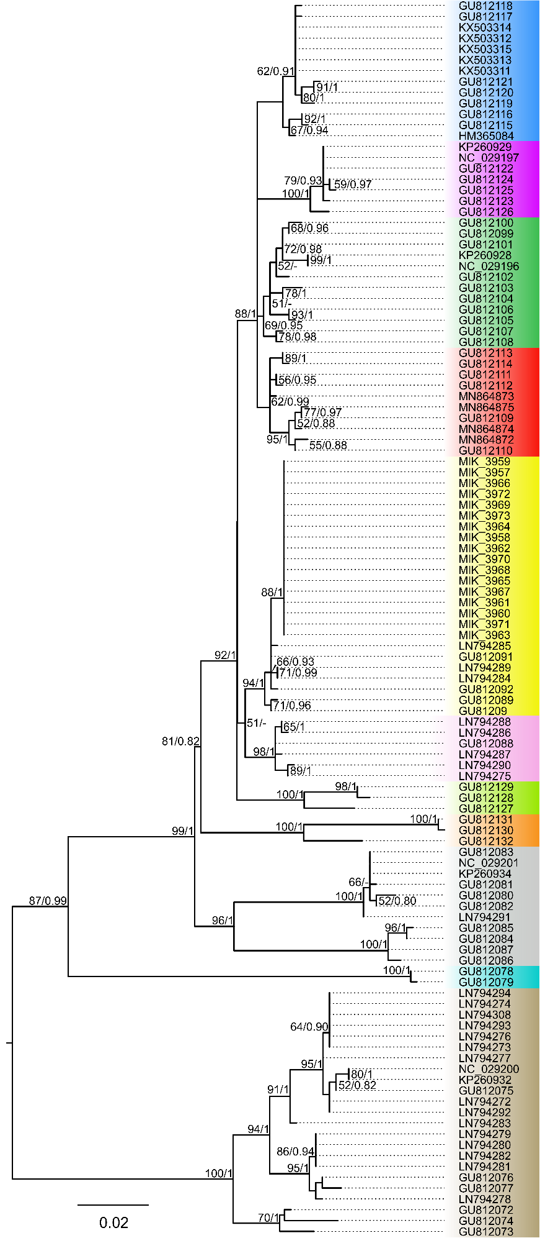
Supplementary Figure S1. Maximum likelihood (ML) ND2 tree of the Pelophylax cf. bedriagae sequences deposited in GenBank and those obtained in this study (MIK_3957-MIK_3973). A sequence of P. nigromaculatus included as an outgroup (not shown). Bayesian interference (BI) tree showed same topology of the major clades and lineages. The numbers above branches indicate bootstrap value greater than 50% based on 1,000 replicates (ML) and posterior probabilities values of BI.
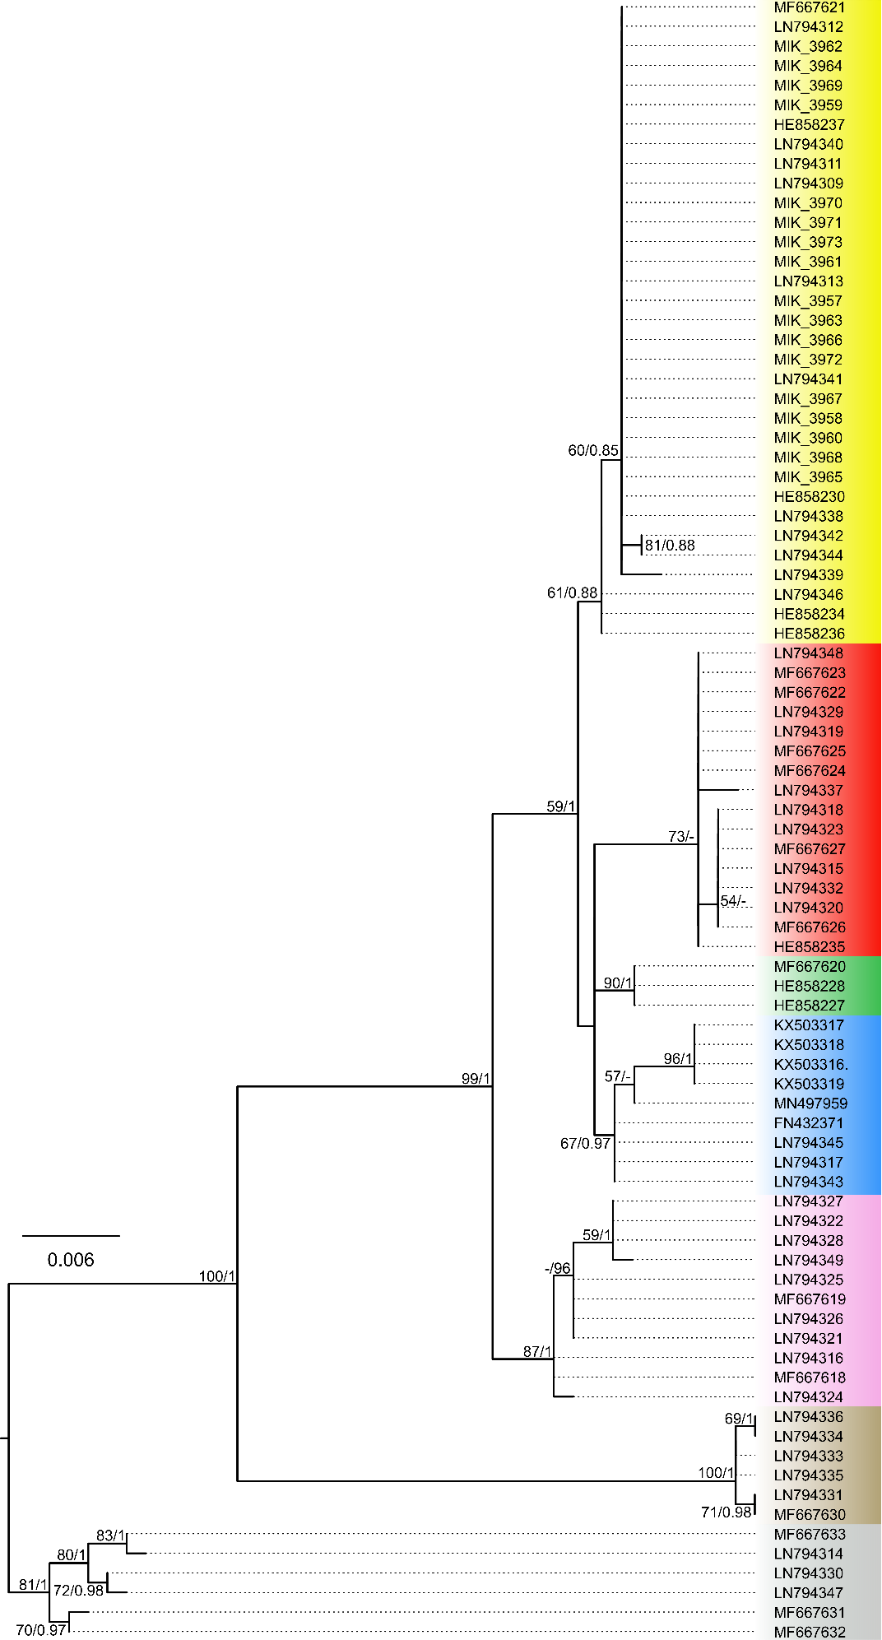
Supplementary Figure S2. Maximum likelihood (ML) SAI-1 tree of the Pelophylax cf. bedriagae sequences deposited in GenBank and those obtained in this study (MIK_3957-MIK_3973). Sequence of P. nigromaculatus included as an outgroup (not shown). Bayesian interference (BI) tree showed same topology of the major clades and lineages. The numbers above branches indicate bootstrap value greater than 50% based on 1,000 replicates (ML) and posterior probabilities values of BI.
Figure S3. Graphical outputs of the population-genetic analysis of water frogs (Pelophylax) from the Gozo Island performed in Structure. The analysis was performed assuming that water frogs belong from one to five genetically distinct clusters (K).

