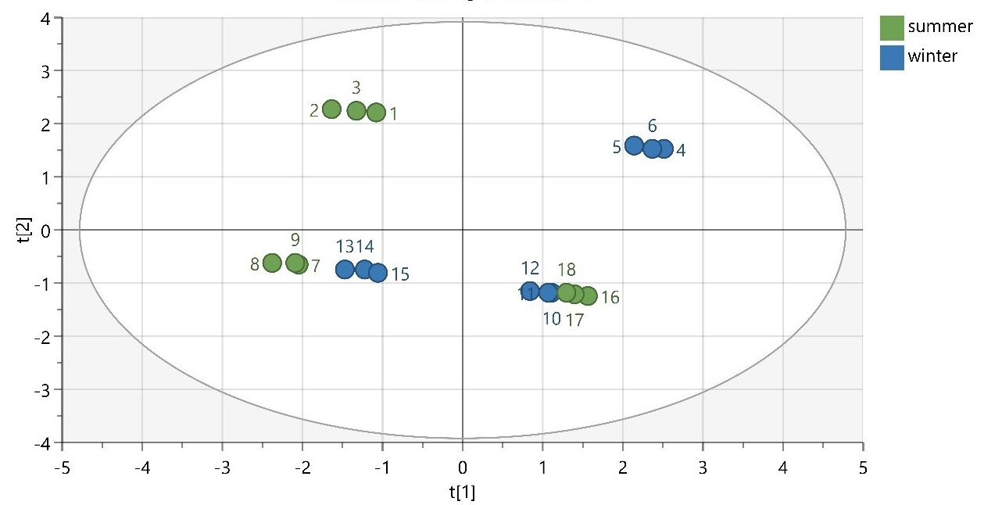
Figure S1: PCA scatter plot based on seasonal variation (N = 18, R²X (cum) = 0.99, Q² (cum) = 0.633).

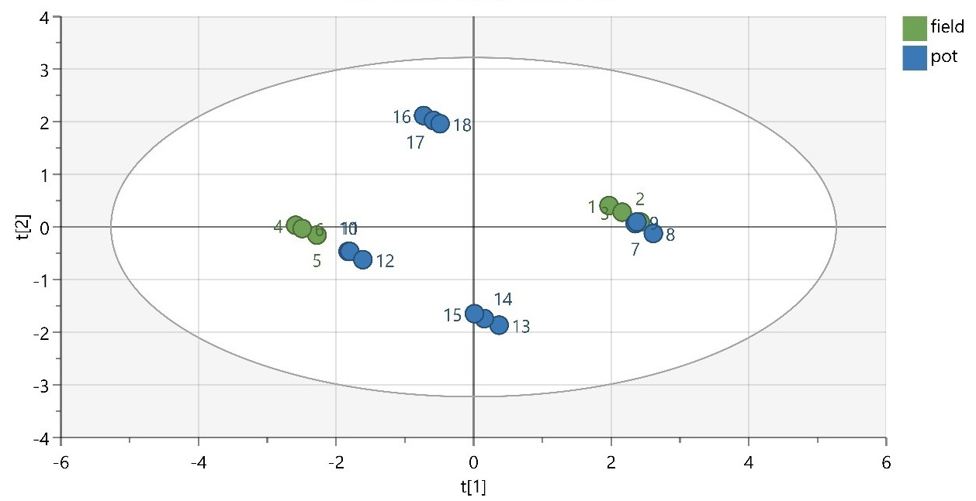
Figure S2: PCA scatter plot based on cultivation conditions (N = 18, R²X (cum) = 0.989, Q² (cum) = 0.932).

