Table 1. Users Understanding of and Concern for Privacy
Question | Response | Discussion
Q) Have you ever read the terms of use and the privacy policies of these platforms before accepting it? | 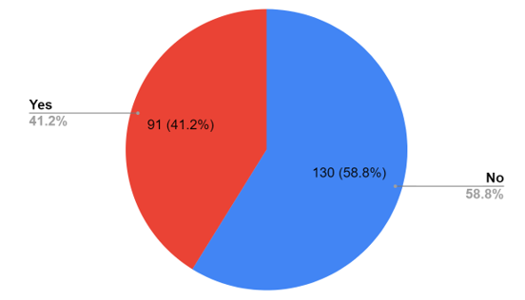  Fig. 2 Users Reading Privacy Policies | A privacy policy is a declaration or legal document that outlines how a party collects, uses, discloses, and manages the data of customers. Nearly 58.8% of users, as shown in Fig. 2, do not read privacy policies before agreeing to them.
Q) Are you aware that you have an option called "Privacy Settings" and you can change it? | 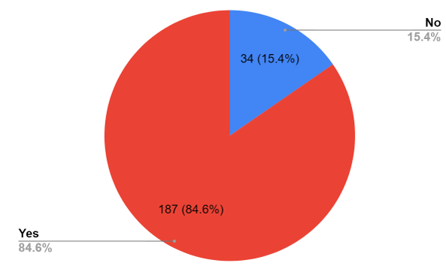  Fig. 3 Users Aware about Privacy Settings | Users can choose who sees information about them using privacy settings. 15.4% of the respondents, as seen in Fig. 3, were unaware of the existence of a privacy settings option.
Table 2. Users Seriousness and Behaviour when Online
Question | Response | Discussion
Q) Are you concerned about your privacy on social media? | 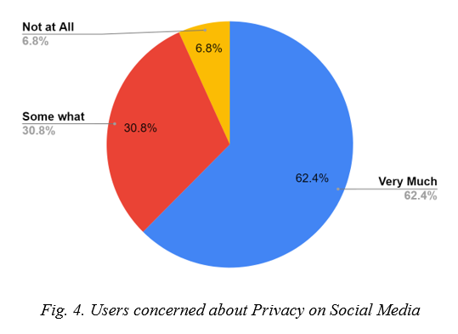  Fig. 4 Users concerned about Privacy on Social Media | About 31% of the respondents had a casual attitude regarding their privacy, while about 63% of the respondents expressed concern about it on social media.
Q) What information are you comfortable in disclosing to anyone on the internet? | 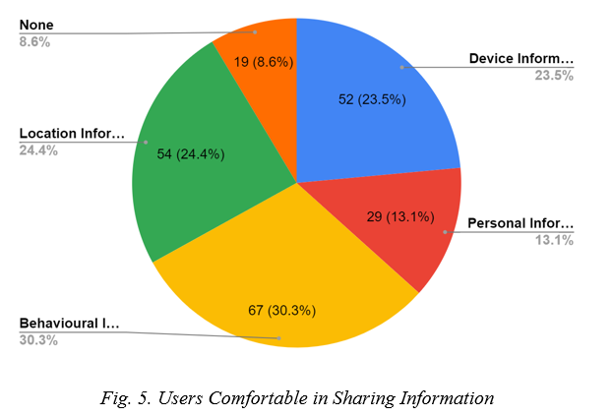  Fig. 5. Users Comfortable in Sharing Information | 8.6% of the respondents were unwilling to disclose any information about themselves online. While some of them felt comfortable sharing some information, such as location information (24.4%), personal information (13.1%), device information (23.5%), and behavioural information (30.3%), others did not.
Q) How frequently do you delete your browser history and/or cookies? | 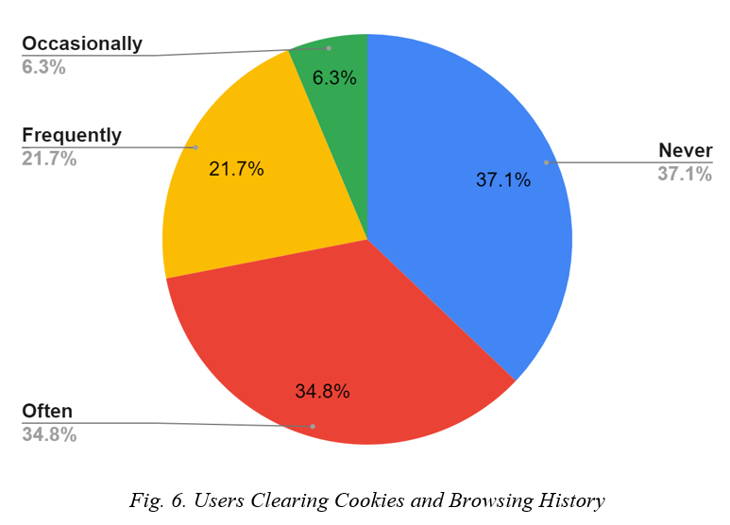  Fig. 6 Users Clearing Cookies and Browsing History | When you browse a website, cookies are very small data files that are used to track your online activity and information. Nearly 22% of respondents were found to routinely remove cookies and browsing data, 37% never delete or clear them, and the remainder respondents rarely do so.
Q) How concerned are you if social media companies are monetizing your data? | 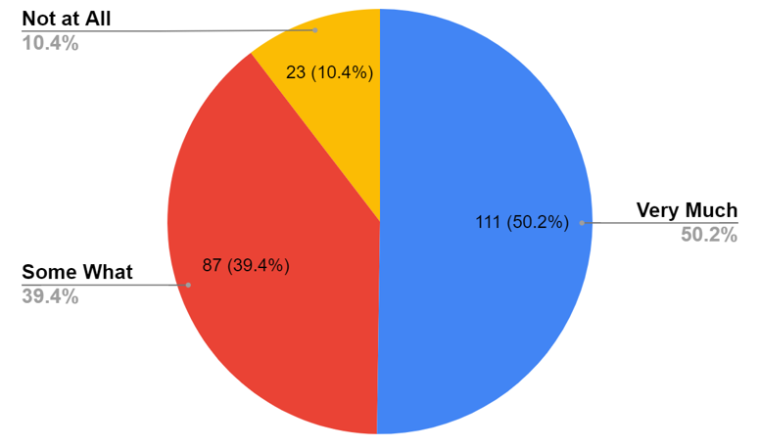  Fig. 7 Users Concerned about Data Monetization | The process of turning valuable data from a company's business operations into new revenue sources is known as data monetization. Only 50% of respondents expressed concern about the monetization of their data, with the remaining respondents expressing mild or no concern.
Table 3. Users Necessity and Requirement of Privacy Awareness Tool
Question | Response | Discussion
Q) Do you think metrics to measure "How Secure" a specific site is related to be of any help or value to you? | 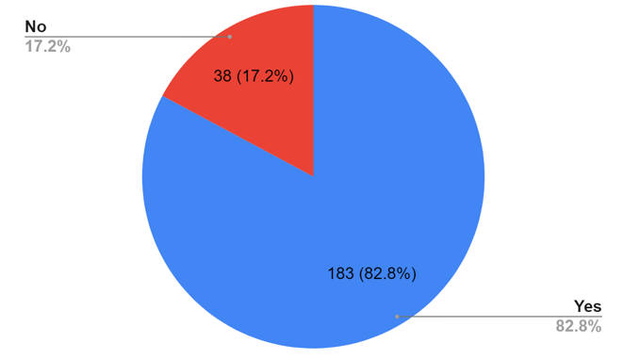  Fig. 8.Users thinking Security Metrics would be helpful | Nearly 83% of the respondents believe having metrics to assess how secure a certain website is would be very useful when it comes to protecting personal information.
Q) Have you ever used such an add-on in your browser which analyzes and summarizes privacy policies? | 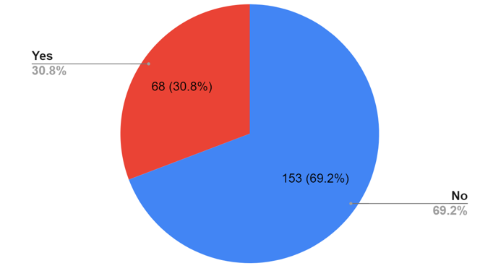  Fig. 9 Users used any Privacy Extraction Tool | For 70% of the participants, a tool or add-on that evaluates and summarizes privacy policies has never been available.
Q) Would you want a browser add-on which will show you what personal information you are submitting to a particular website? | 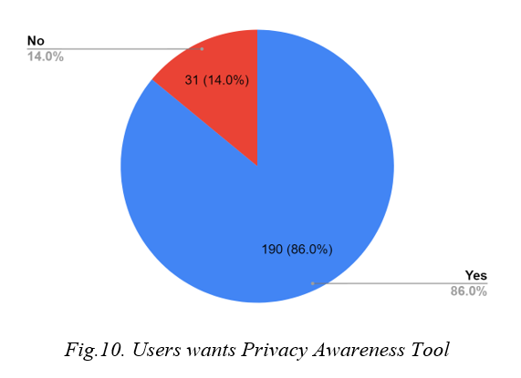  Fig. 10 Users wants Privacy Awareness Tool | A tool or browser add-on that displays the user data being provided to a specific website is desired by 86% of respondents.

