Novel iminocoumarine imidazo[4,5-b]pyridine derivatives: Design, synthesis and biological evaluation

I. Boček Pavlinac¹, K. Starčević², L. Persoons³, M. Banjanac⁴, V. Radovanović⁴, D. Daelemans³ and M. Hranjec¹*
¹Department of Organic Chemistry, Faculty of Chemical Engineering and Technology, University of Zagreb, HR-10000 Zagreb, Croatia; ²Department of Chemistry and Biochemistry, Faculty of Veterinary Medicine, University of Zagreb, Heinzelova 55, HR-10000 Zagreb, Croatia; ³KU Leuven, Department of Microbiology, Immunology and Transplantation, Rega Institute, Leuven, Belgium; ⁴Pharmacology in vitro, Selvita Ltd. Prilaz baruna Filipovića 29, 10000 Zagreb, Croatia

Supporting Information

Contents
1. Table S1: Cytotoxicity and antiviral activity of tested compounds
2. NMR spectra (Figures S1-S48)

Table S1. Cytotoxicity and antiviral activity of tested compounds

Cpd | Cytotoxicity (CC₅₀/µM) |  |  |  | Antiviral activity (EC₅₀ /μM)
Cpd | HEL 229 | Huh-7 | MDCK | Hep-2 | HCoV  229E  HEL 299 | HCoV  OC43  HEL 299 |  | HCoV  NL63  Huh-7 |  | Influenza  H1N1  MDCK |  | Influenza  H3N2  MDCK | Influenza  B  MDCK | RSV  A Long  HEL 299 | HSV-1  KOS  HEL 299 | YFV  17D  Huh-7 | Zika  Mr776  Huh-7 | Sindbis  Huh-7
15 | >50 | >50 | >50 | >50 | >50 | >50 |  | >50 |  | >50 |  | >50 | >50 | >50 | >50 | >50 | >50 | >50
16 | >50 | >50 | >50 | >50 | >50 | >50 |  | >50 |  | >50 |  | >50 | >50 | >50 | >50 | >50 | >50 | >50
17 | >50 | >50 | >50 | >50 | >50 | >50 |  | >50 |  | >50 |  | >50 | >50 | >50 | >50 | >50 | >50 | >50
18 | >50 | >50 | >50 | >50 | >50 | >50 |  | >50 |  | >50 |  | >50 | >50 | >50 | >50 | >50 | >50 | >50
19 | >50 | >50 | >50 | >50 | >50 | >50 |  | >50 |  | >50 |  | >50 | >50 | >50 | >50 | >50 | >50 | >50
20 | >50 | >50 | 23 | >50 | >50 | >50 |  | >50 |  | >50 |  | >50 | >50 | >50 | >50 | >50 | >50 | >50
21 | 39.40 | >50 | >50 | >50 | >50 | >50 |  | >50 |  | >50 |  | >50 | >50 | >50 | >50 | >50 | >50 | >50
22 | >50 | >50 | >50 | >50 | >50 | >50 |  | >50 |  | >50 |  | >50 | >50 | >50 | >50 | >50 | >50 | >50
23 | >50 | >50 | >50 | >50 | >50 | >50 |  | >50 |  | >50 |  | >50 | >50 | >50 | >50 | >50 | >50 | >50
24 | >50 | >50 | >50 | >50 | >50 | >50 |  | >50 |  | >50 |  | >50 | >50 | >50 | >50 | >50 | >50 | >50
25 | >50 | >50 | >50 | >50 | >50 | >50 |  | >50 |  | >50 |  | >50 | >50 | >50 | >50 | >50 | >50 | >50
26 | >50 | >50 | >50 | >50 | >50 | >50 |  | >50 |  | >50 |  | >50 | >50 | >50 | >50 | >50 | >50 | >50
27 | >50 | >50 | >50 | >50 | >50 | >50 |  | >50 |  | >50 |  | >50 | >50 | >50 | >50 | >50 | >50 | >50
28 | >50 | >50 | >50 | >50 | >50 | >50 |  | >50 |  | >50 |  | >50 | >50 | >50 | >50 | >50 | >50 | >50
29 | >50 | >50 | >50 | >50 | >50 | >50 |  | >50 |  | >50 |  | >50 | >50 | >50 | >50 | >50 | >50 | >50
30 | >50 | >50 | >50 | >50 | >50 | >50 |  | >50 |  | >50 |  | >50 | >50 | >50 | >50 | >50 | >50 | >50
31 | >50 | >50 | >50 | >50 | >50 | >50 |  | >50 |  | >50 |  | >50 | >50 | >50 | >50 | >50 | >50 | >50
Remdesivir | >10 | >10 | - | >10 | 0.06 | 0.06 |  | 0.03 |  | - |  | - | - | 0.03 | - | 6.2 | 0.7 | >10
Ribavirin | >250 | 8.9 | 67.0 | 241.4 | 82.6 | 170.1 |  | >250 |  | 10.5 |  | 4.0 | 2.8 | 10.8 | - | >250 | >250 | 148.1
Zanamivir | - | - | >100 | - | - | - |  |  | - |  | 0.1 | 16.8 | 0.05 | - | - | - | - | -
Rimantadine | - | - | >100 | - | - |  | - |  | - |  | 5.0 | 0.05 | >100 | - | - | - | - | -
BVDU | >100 | - | - | - | - |  | - |  | - |  | - | - | - | - | 0.05 | - | - | -

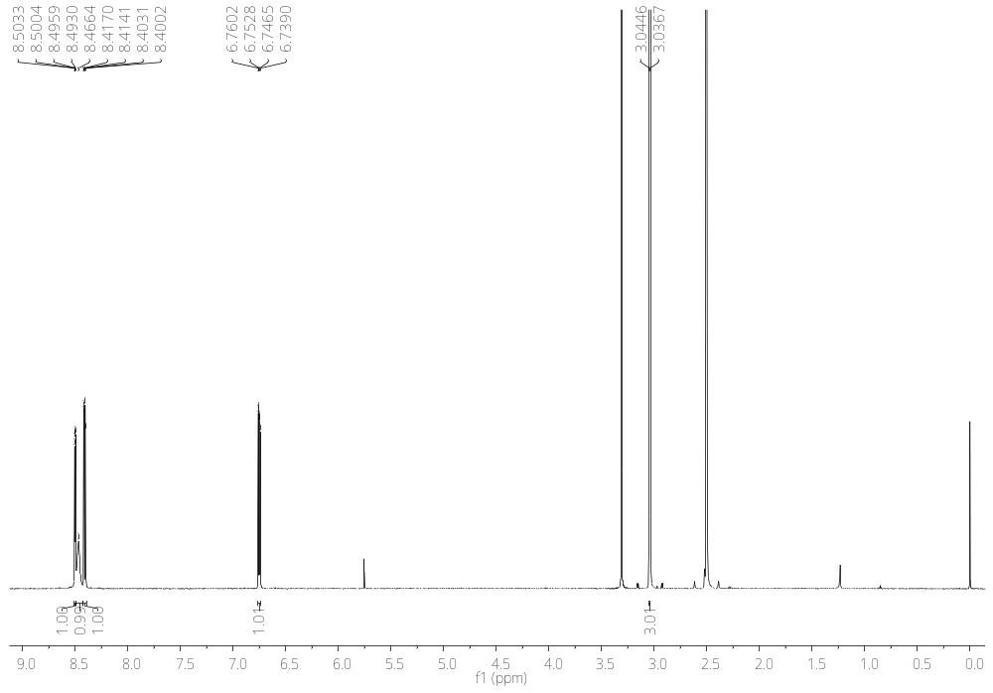
Figure S1. ¹H NMR spectrum (DMSO-d₆, 600 MHz) of N-methyl-3-nitropyridine-2-amine 2

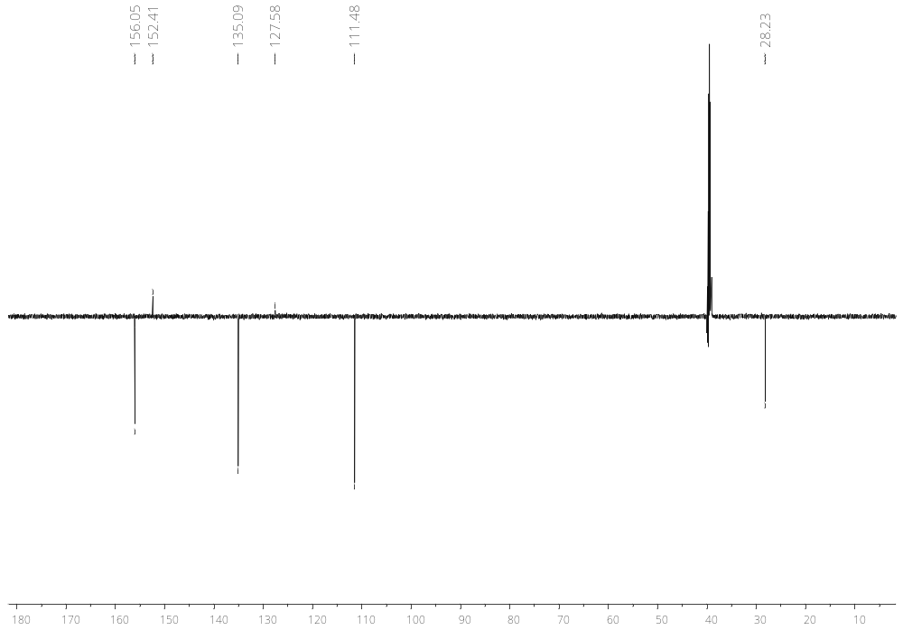
Figure S2. ¹³C NMR spectrum (DMSO-d₆, 151 MHz) of N-methyl-3-nitropyridine-2-amine 2

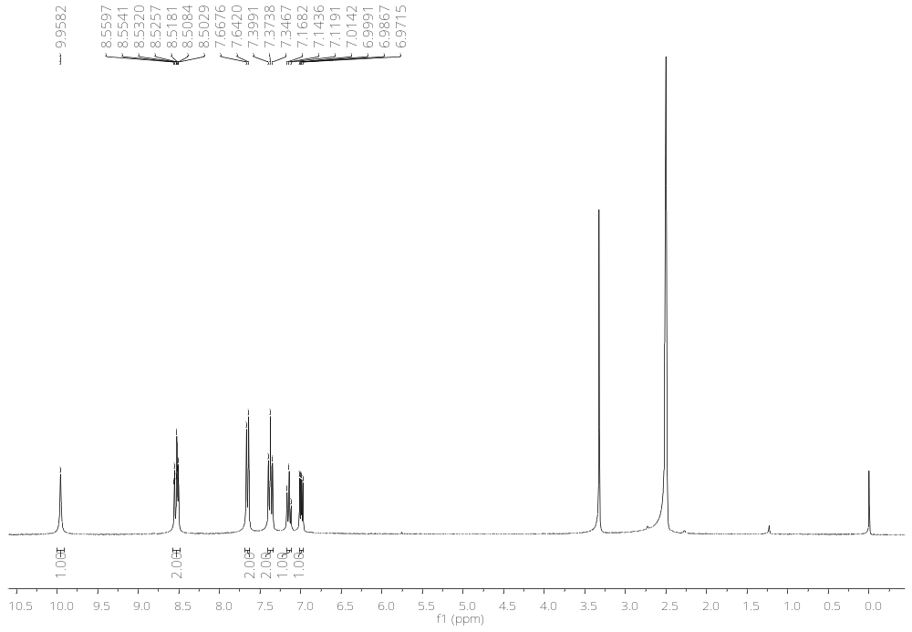
Figure S3. ¹H NMR spectrum (DMSO-d₆, 300 MHz) of 3-nitro-N-phenylpyridin-2-amine 3

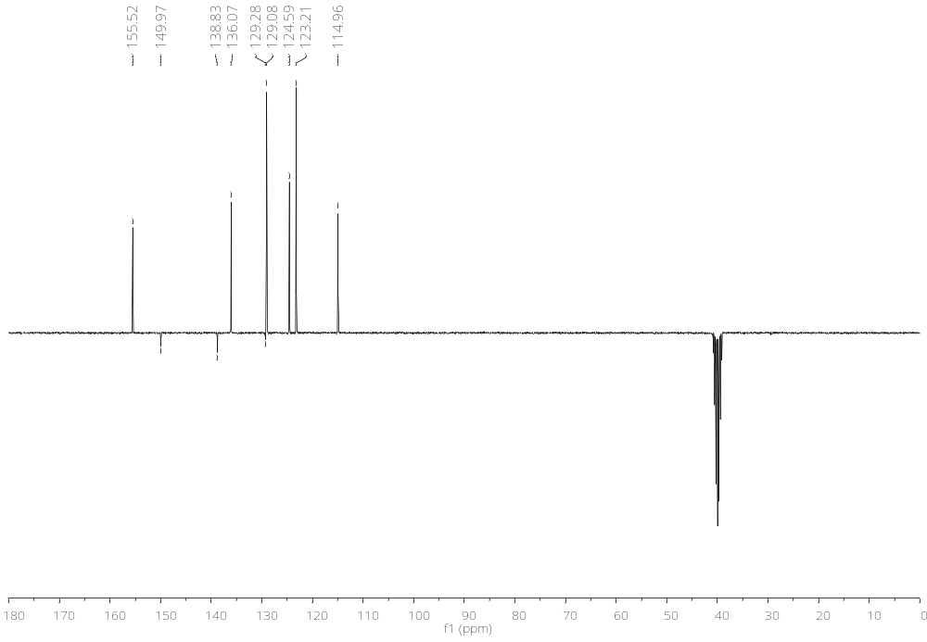
Figure S4. ¹³C NMR spectrum (DMSO-d₆, 75 MHz) of 3-nitro-N-phenylpyridin-2-amine 3
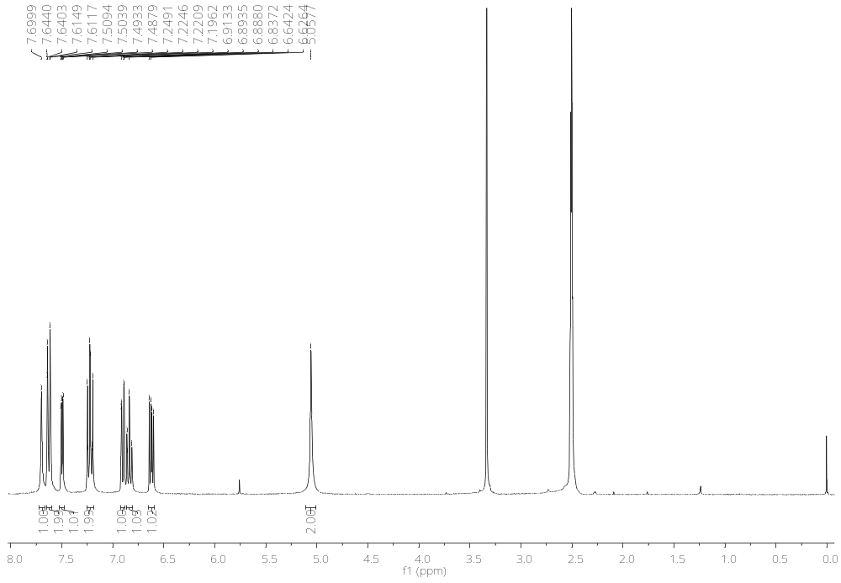
Figure S5. ¹H NMR spectrum (DMSO-d₆, 300 MHz) of N²-phenylpyridine-2,3-diamine 4

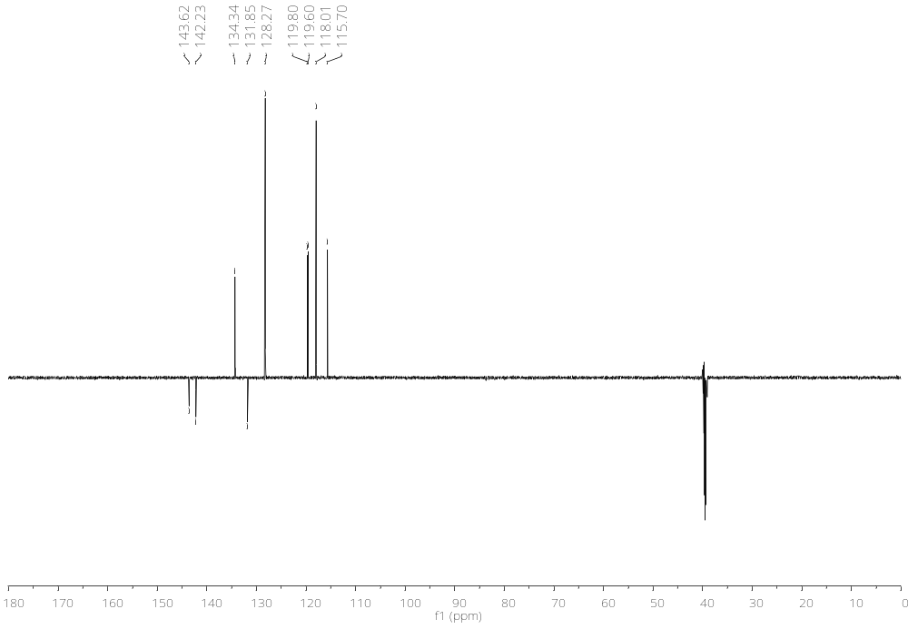
Figure S6. ¹³C NMR spectrum (DMSO-d₆, 151 MHz) of N²-phenylpyridine-2,3-diamine 4
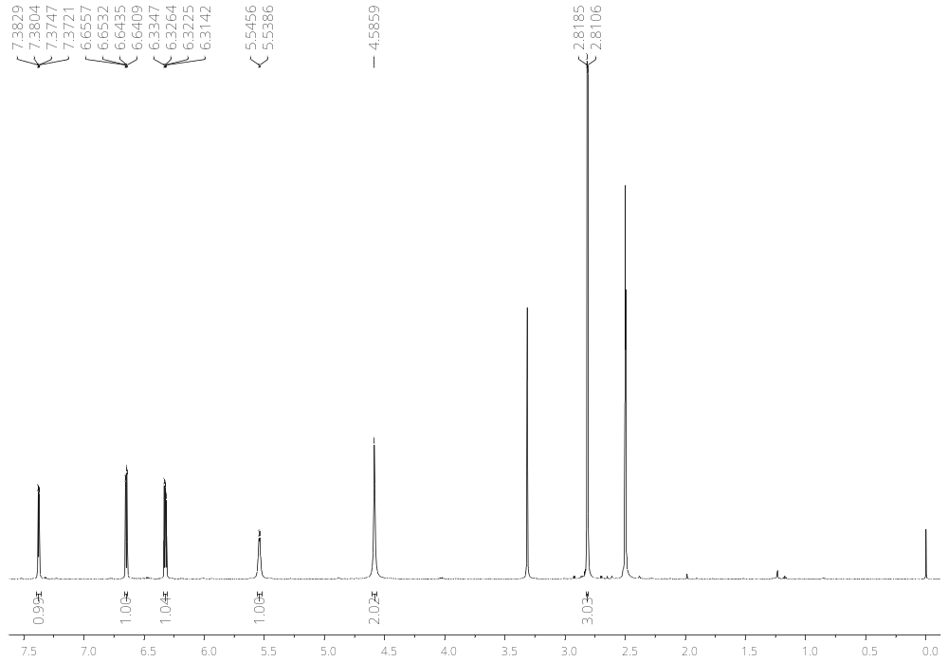
Figure S7. ¹H NMR spectrum (DMSO-d₆, 600 MHz) of N²-methylpyridine-2,3-diamine 5

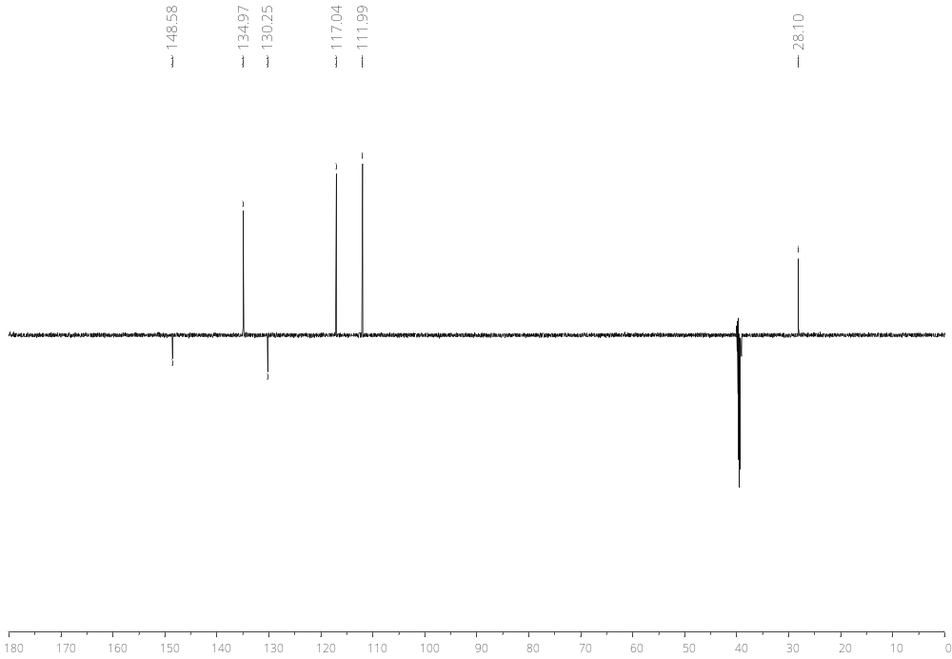
Figure S8. ¹³C NMR spectrum (DMSO-d₆, 151 MHz) of N²-methylpyridine-2,3-diamine 5

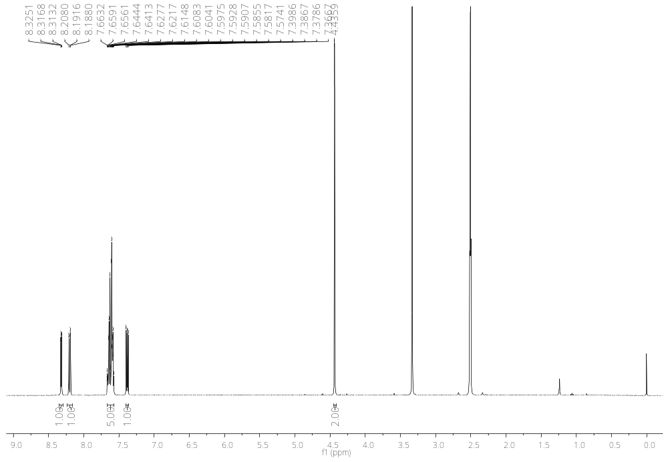
Figure S9. ¹H NMR spectrum (DMSO-d₆, 400 MHz) of 2-(3-phenyl-3H-imidazo[4,5-b]pyridin-2-yl)acetonitrile 7

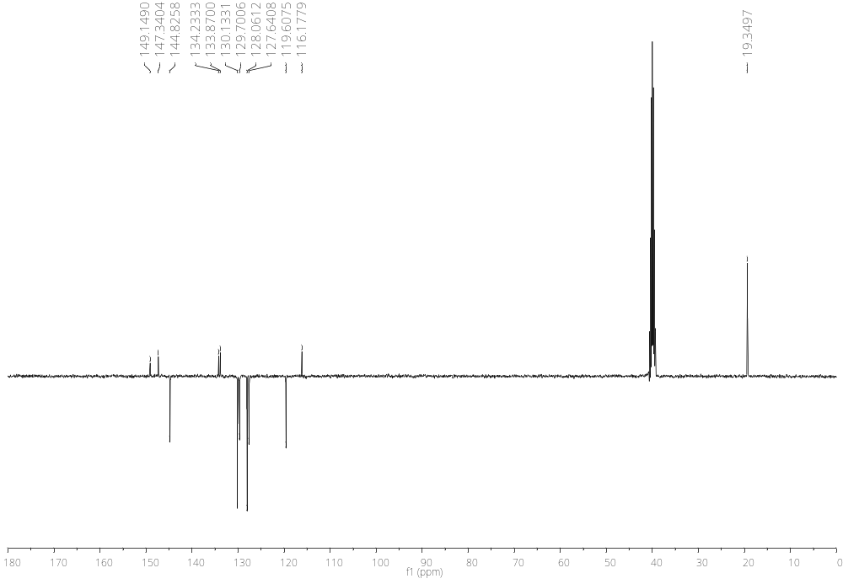
Figure S10. ¹H NMR spectrum (DMSO-d₆, 600 MHz) of 2-(3-phenyl-3H-imidazo[4,5-b]pyridin-2-yl)acetonitrile 7
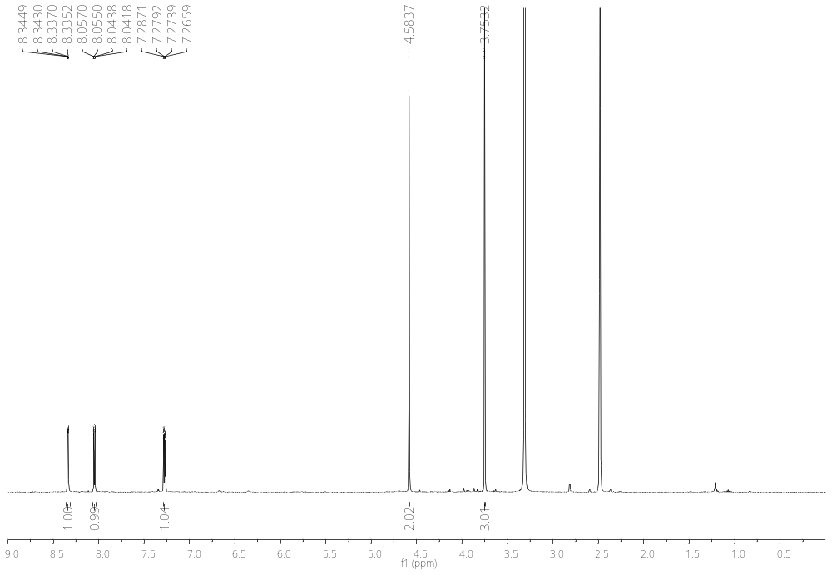
Figure S11. ¹H NMR spectrum (DMSO-d₆, 400 MHz) of 2-(3-methyl-3H-imidazo[4,5-b]pyridin-2-yl)acetonitrile 8

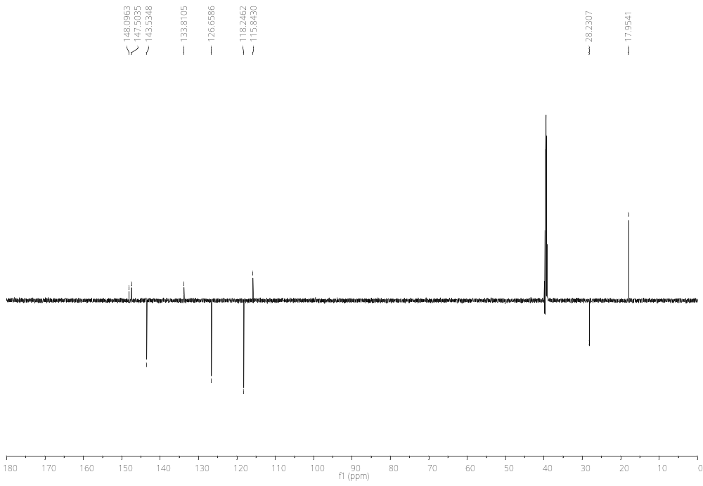
Figure S12. ¹³C NMR spectrum (DMSO-d₆, 151 MHz) of 2-(3-methyl-3H-imidazo[4,5-b]pyridin-2-yl)acetonitrile 8

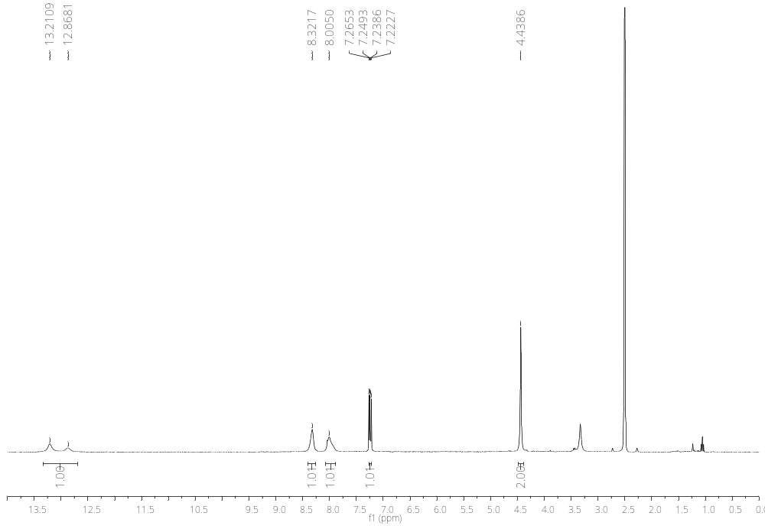
Figure S13. ¹H NMR spectrum (DMSO-d₆, 300 MHz) of 2-(3H-imidazo[4,5-b]pyridine-2-yl)acetonitrile 9

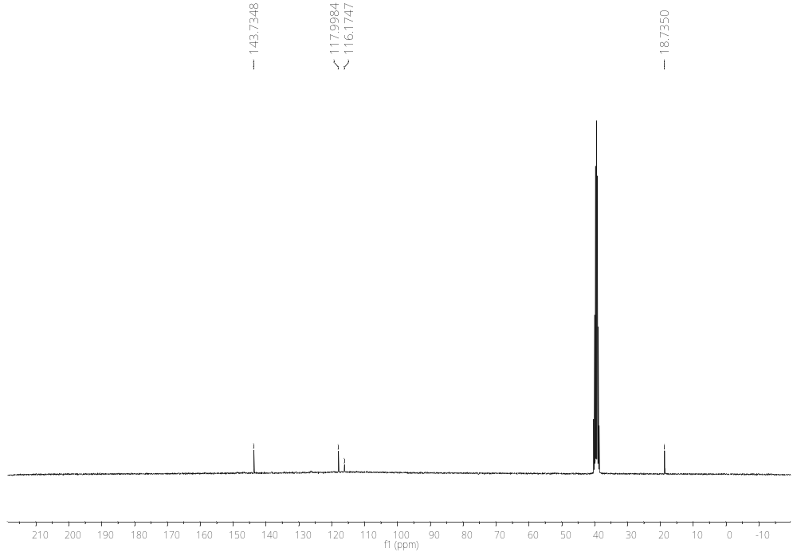
Figure S14. ¹³C NMR spectrum (DMSO-d₆, 75 MHz) of 2-(3H-imidazo[4,5-b]pyridine-2-yl)acetonitrile 9

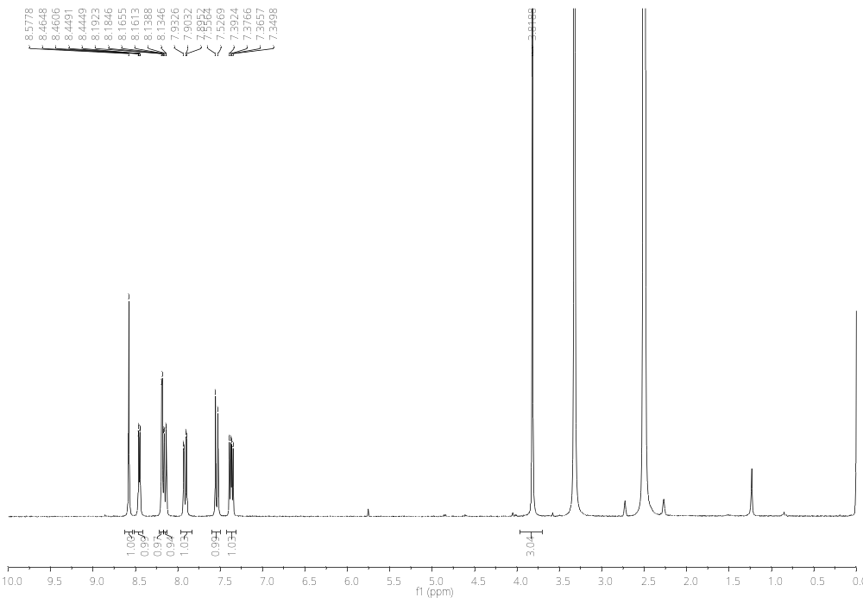
Figure S15. ¹H NMR spectrum (DMSO-d₆, 300 MHz) of 6-bromo-3-(3-methyl-3H-imidazo[4,5-b]pyridin-2-yl)-2H-chromen-2-imine 15

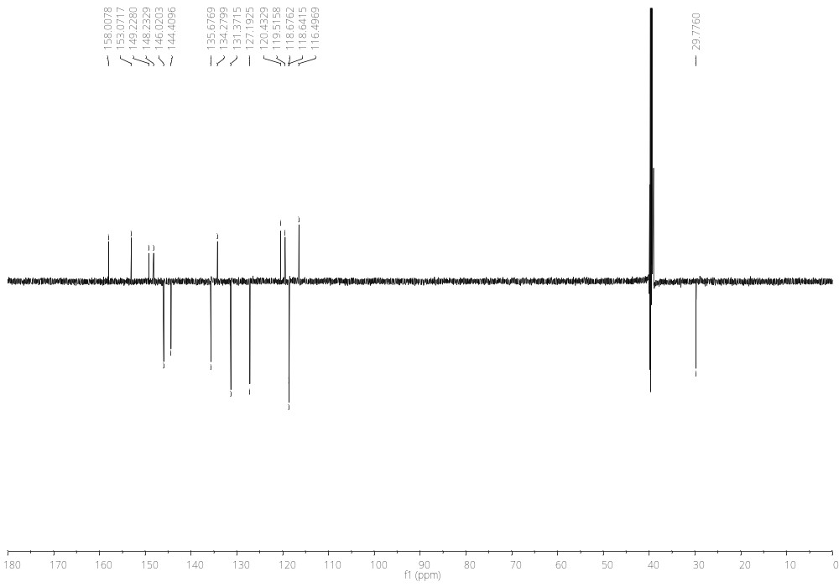
Figure S16. ¹³C NMR spectrum (DMSO-d₆, 151 MHz) of 6-bromo-3-(3-methyl-3H-imidazo[4,5-b]pyridin-2-yl)-2H-chromen-2-imine 15

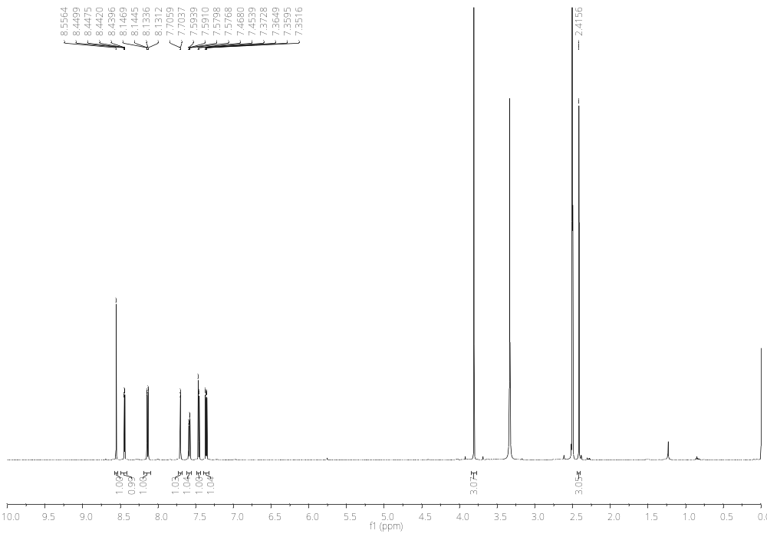
Figure S17. ¹H NMR spectrum (DMSO-d₆, 600 MHz) of 6-methyl-3-(3-methyl-3H-imidazo[4,5-b]pyridin-2-yl)-2H-chromen-2-imine 16

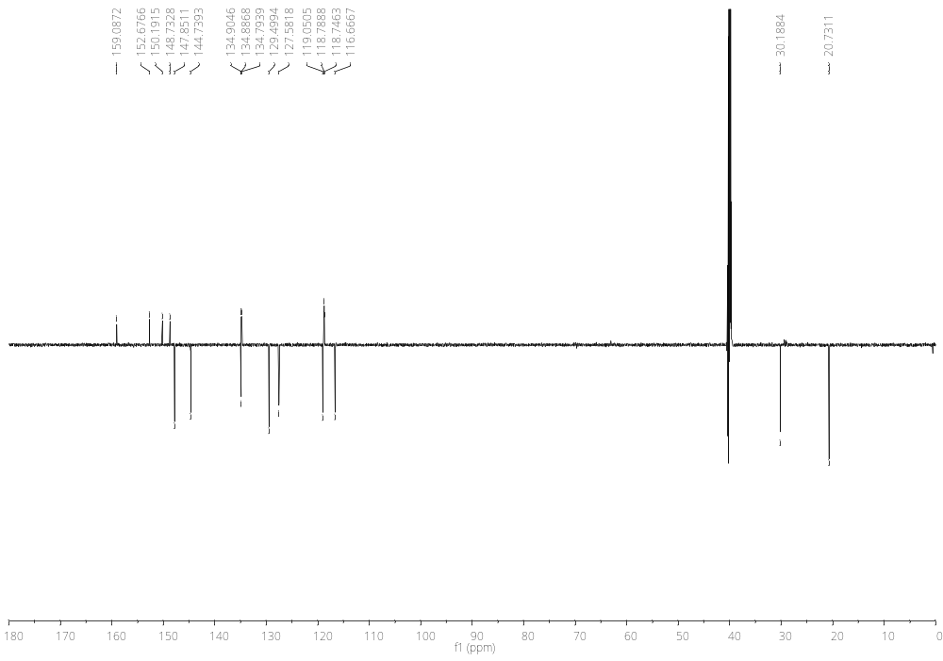
Figure S18. ¹³C NMR spectrum (DMSO-d₆, 151 MHz) of 6-methyl-3-(3-methyl-3H-imidazo[4,5-b]pyridin-2-yl)-2H-chromen-2-imine 16

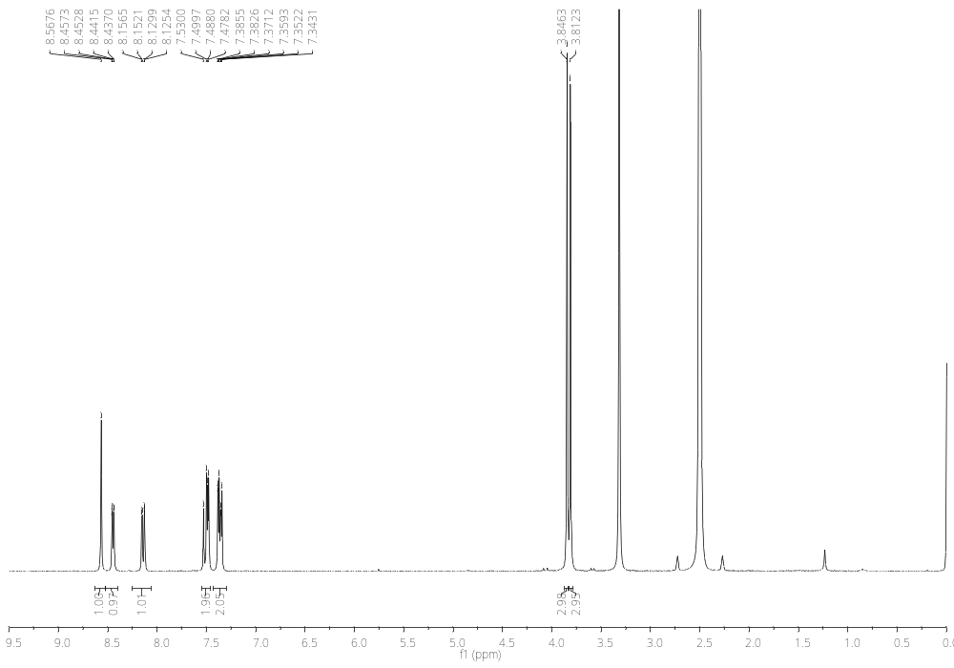
Figure S19. ¹H NMR spectrum (DMSO-d₆, 300 MHz) of 6-methoxy-3-(3-methyl-3H-imidazo[4,5-b]pyridin-2-yl)-2H-chromen-2-imine 17
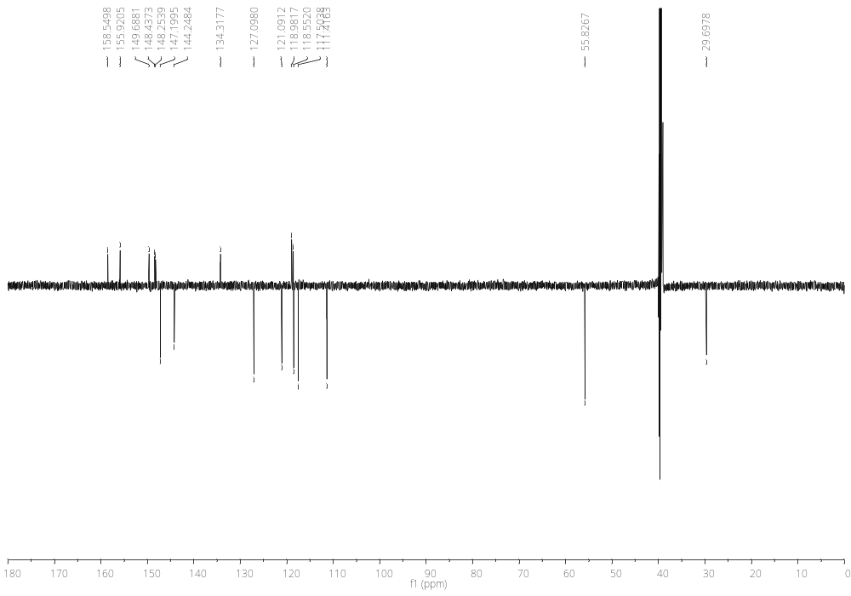
Figure S20. ¹³C NMR spectrum (DMSO-d₆, 151 MHz) of 6-methoxy-3-(3-methyl-3H-imidazo[4,5-b]pyridin-2-yl)-2H-chromen-2-imine 17
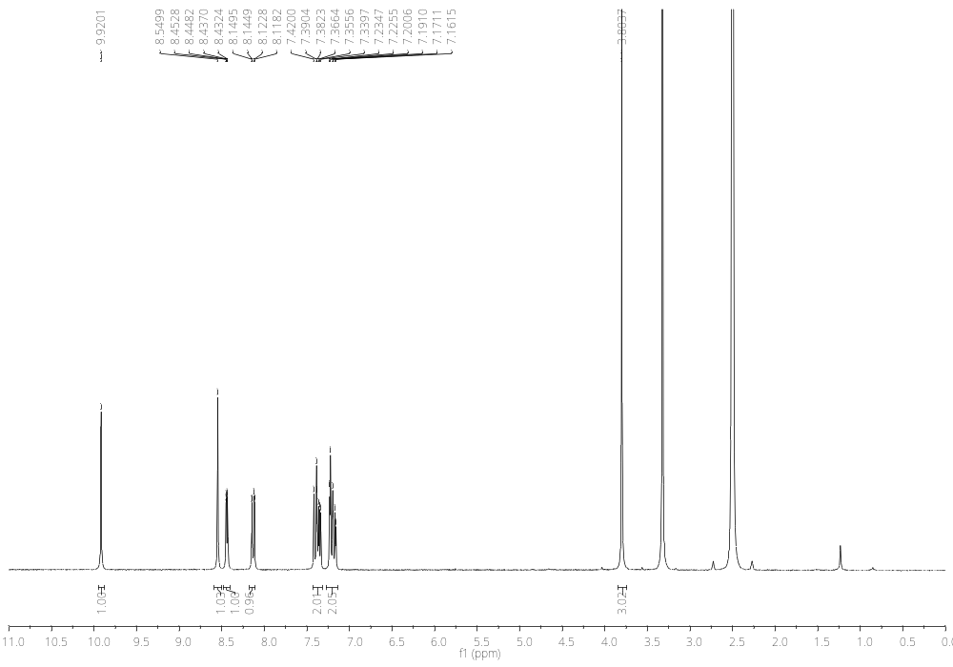
Figure S21. ¹H NMR spectrum (DMSO-d₆, 300 MHz) of 2-imino-3-(3-methyl-3H-imidazo[4,5-b]pyridin-2-yl)-2H-chromen-6-ol 18
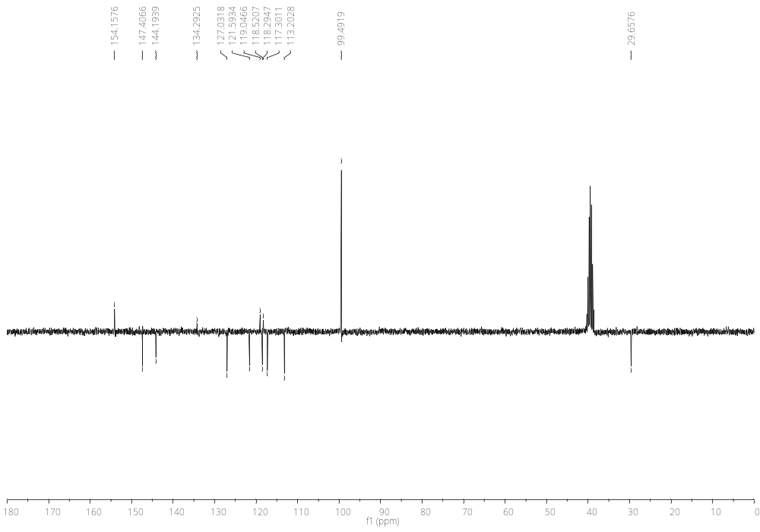
Figure S22. ¹³C NMR spectrum (DMSO-d₆, 75 MHz) of 2-imino-3-(3-methyl-3H-imidazo[4,5-b]pyridin-2-yl)-2H-chromen-6-ol 18

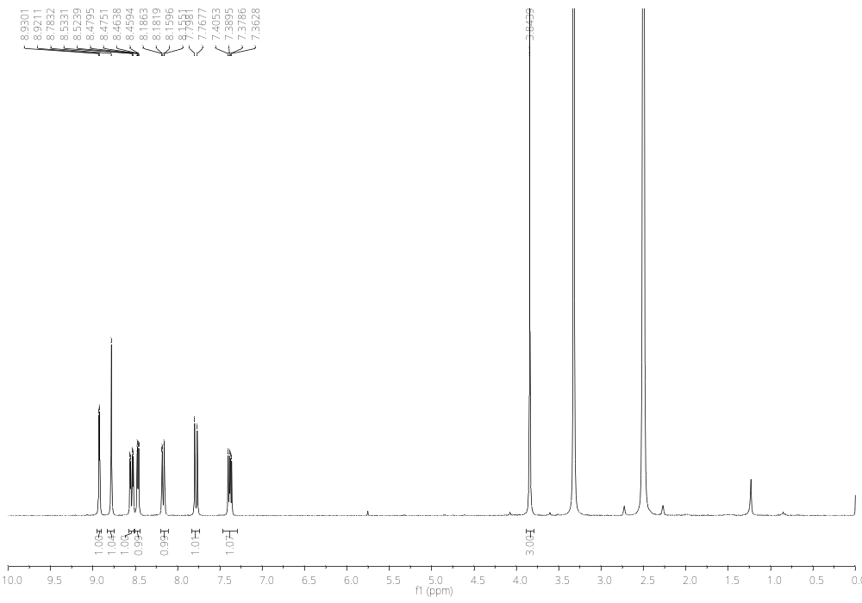
Figure S23. ¹H NMR spectrum (DMSO-d₆, 600 MHz) of 3-(3H-imidazo[4,5-b]pyridin-2-yl)-6-nitro-2H-chromen-2-imine 19
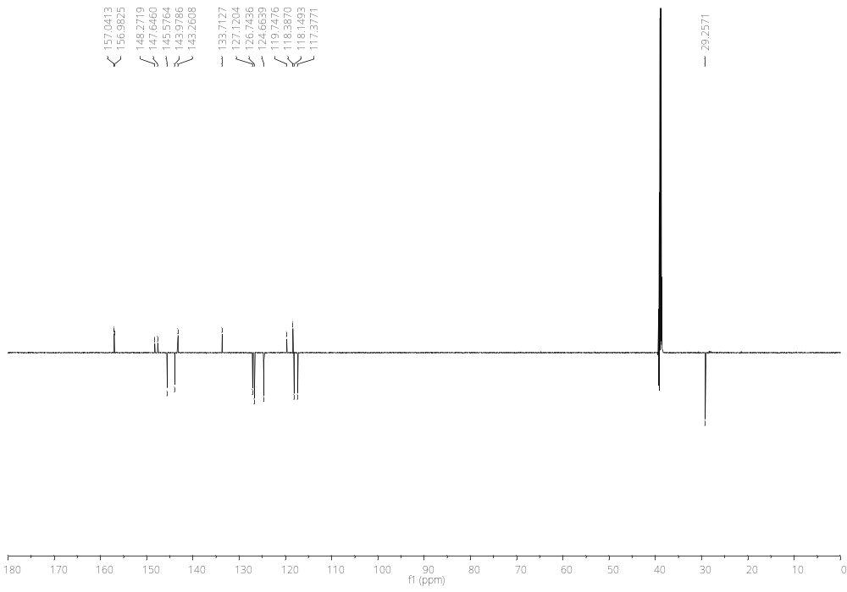
Figure S24. ¹³C NMR spectrum (DMSO-d₆, 151 MHz) of 3-(3H-imidazo[4,5-b]pyridin-2-yl)-6-nitro-2H-chromen-2-imine 19

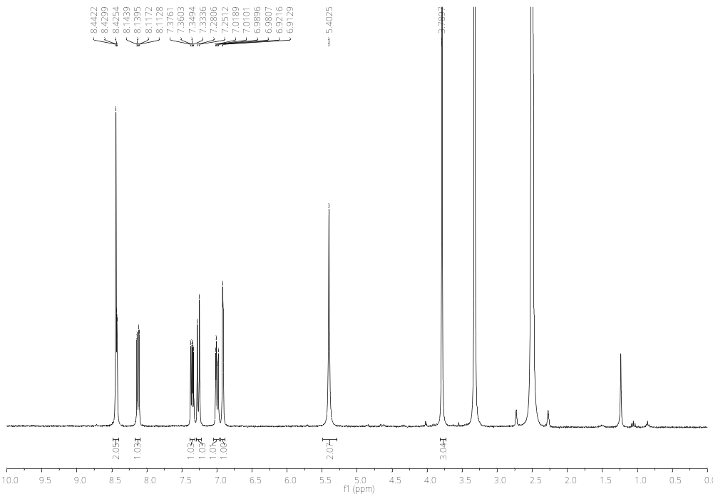
Figure S25. ¹H NMR spectrum (DMSO-d₆, 300 MHz) of 3-(3H-imidazo[4,5-b]pyridin-2-yl)-2-imino-2H-chromen-6-amine 20
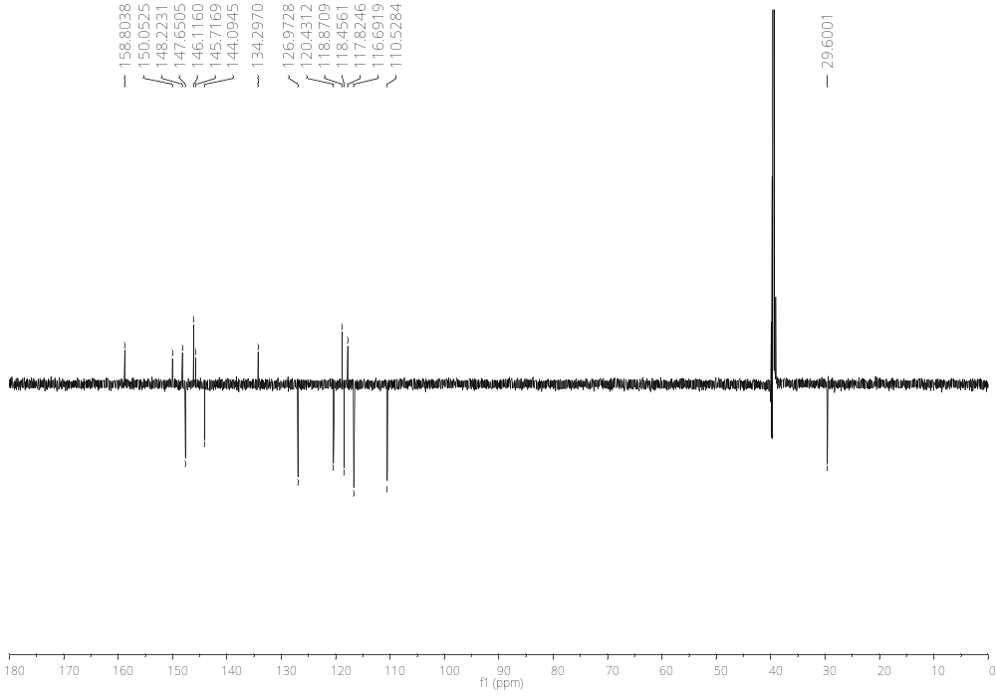
Figure S26. ¹³C NMR spectrum (DMSO-d₆, 151 MHz) of 3-(3H-imidazo[4,5-b]pyridin-2-yl)-2-imino-2H-chromen-6-amine 20
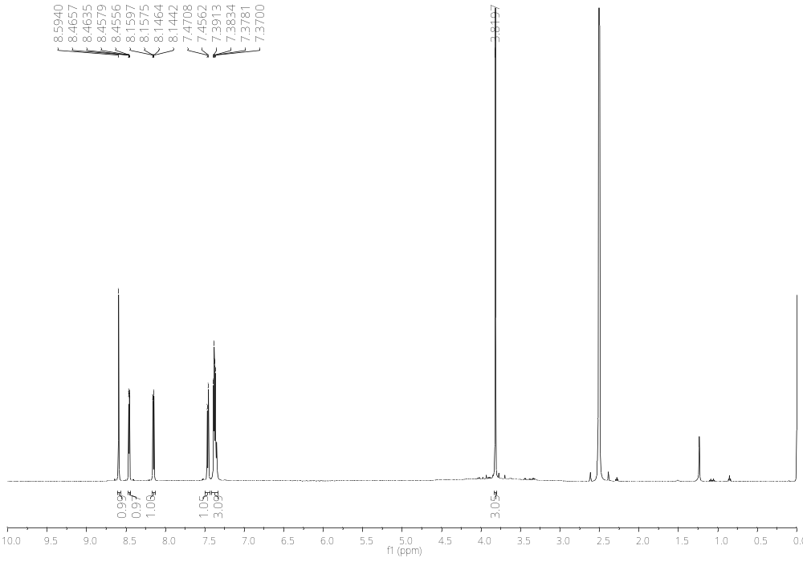
Figure S27. ¹H NMR spectrum (DMSO-d₆, 600 MHz) of 2-imino-3-(3-methyl-3H-imidazo[4,5-b]pyridin-2-yl)-2H-chromen-6-amine hydrochloride 21
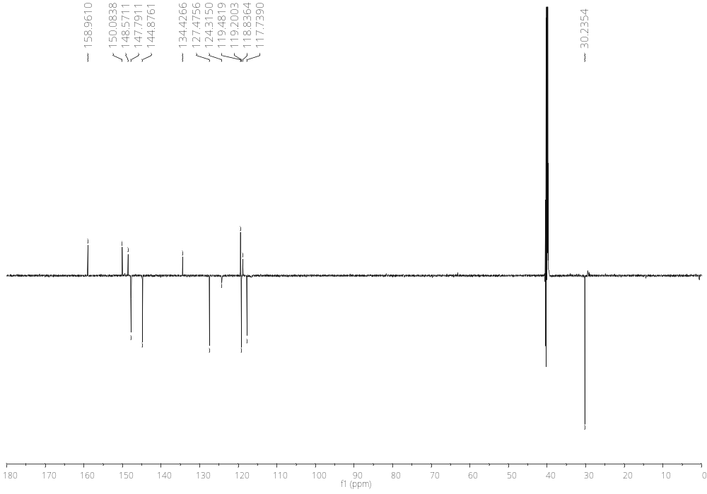
Figure S28. ¹³C NMR spectrum (DMSO-d₆, 151 MHz) of 2-imino-3-(3-methyl-3H-imidazo[4,5-b]pyridin-2-yl)-2H-chromen-6-amine hydrochloride 21
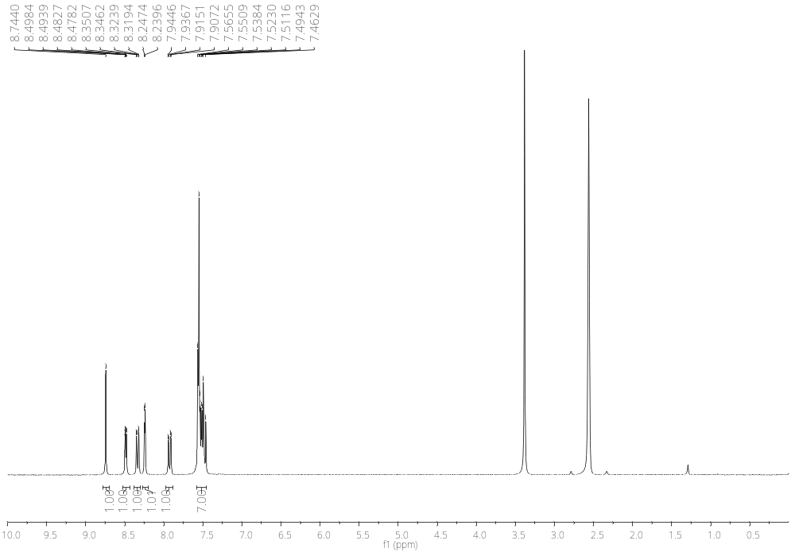
Figure S29. ¹H NMR spectrum (DMSO-d₆, 300 MHz) of 6-bromo-3-(3-phenyl-3H-imidazo[4,5-b]pyridin-2-yl)-2H-chromen-2-imine 22
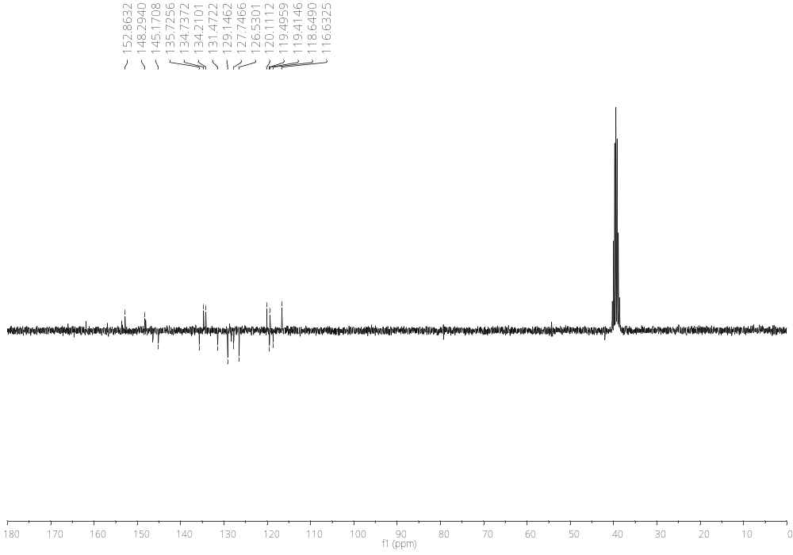
Figure S30. ¹³C NMR spectrum (DMSO-d₆, 75 MHz) of 6-bromo-3-(3-phenyl-3H-imidazo[4,5-b]pyridin-2-yl)-2H-chromen-2-imine 22

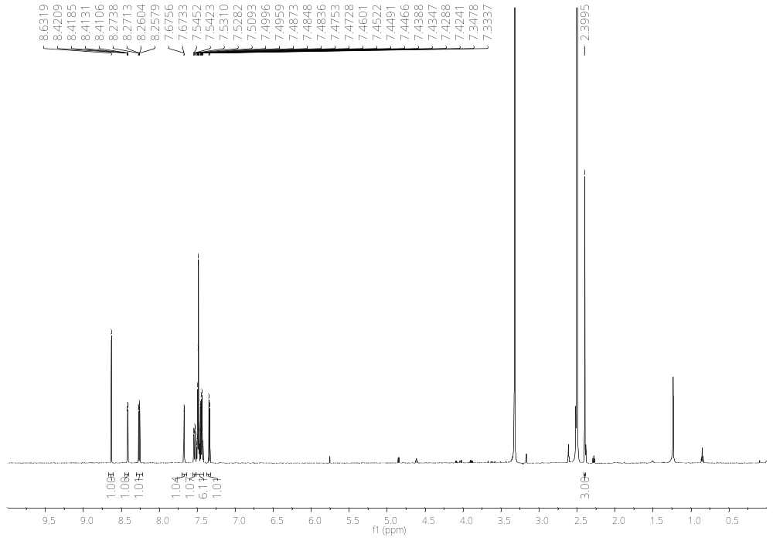
Figure S31. ¹H NMR spectrum (DMSO-d₆, 600 MHz) of 6-methyl-3-(3-phenyl-3H-imidazo[4,5-b]pyridin-2-yl)-2H-chromen-2-imine 23
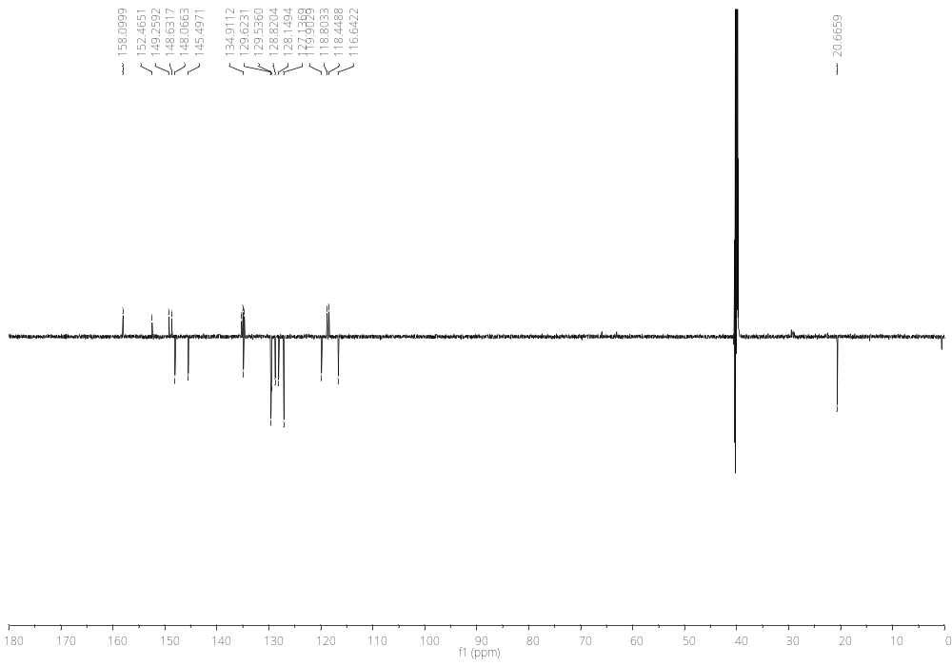
Figure S32. ¹³C NMR spectrum (DMSO-d₆, 151 MHz) of 6-methyl-3-(3-phenyl-3H-imidazo[4,5-b]pyridin-2-yl)-2H-chromen-2-imine 23
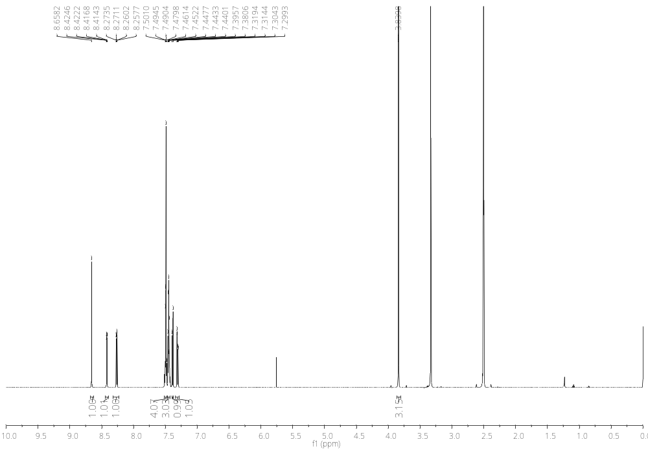

Figure S33. ¹H NMR spectrum (DMSO-d₆, 600 MHz) of 6-methoxy-3-(3-phenyl-3H-imidazo[4,5-b]pyridin-2-yl)-2H-chromen-2-imine 24
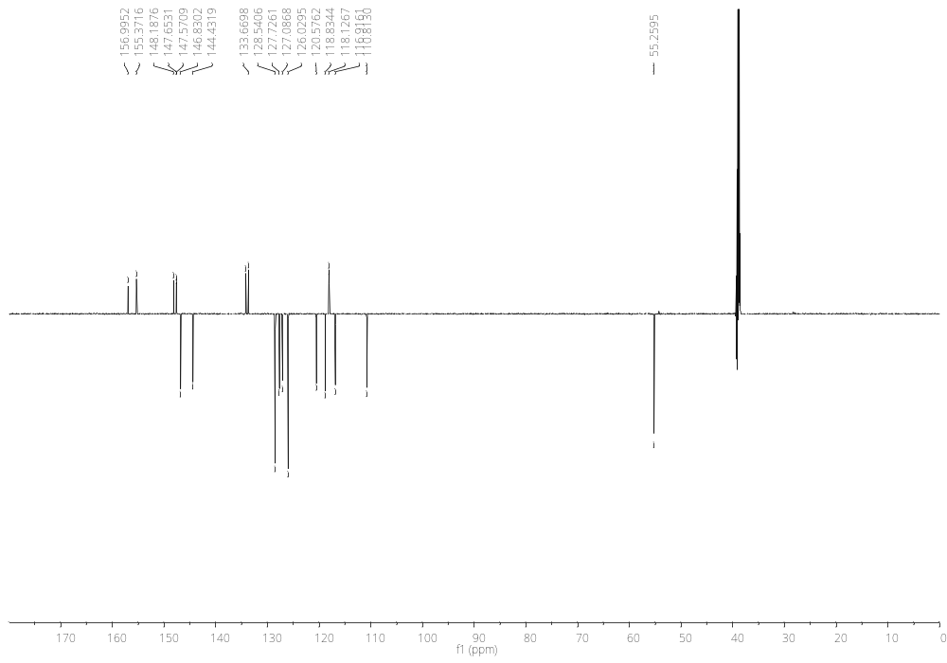
Figure S34. ¹³C NMR spectrum (DMSO-d₆, 151 MHz) of 6-methoxy-3-(3-phenyl-3H-imidazo[4,5-b]pyridin-2-yl)-2H-chromen-2-imine 24
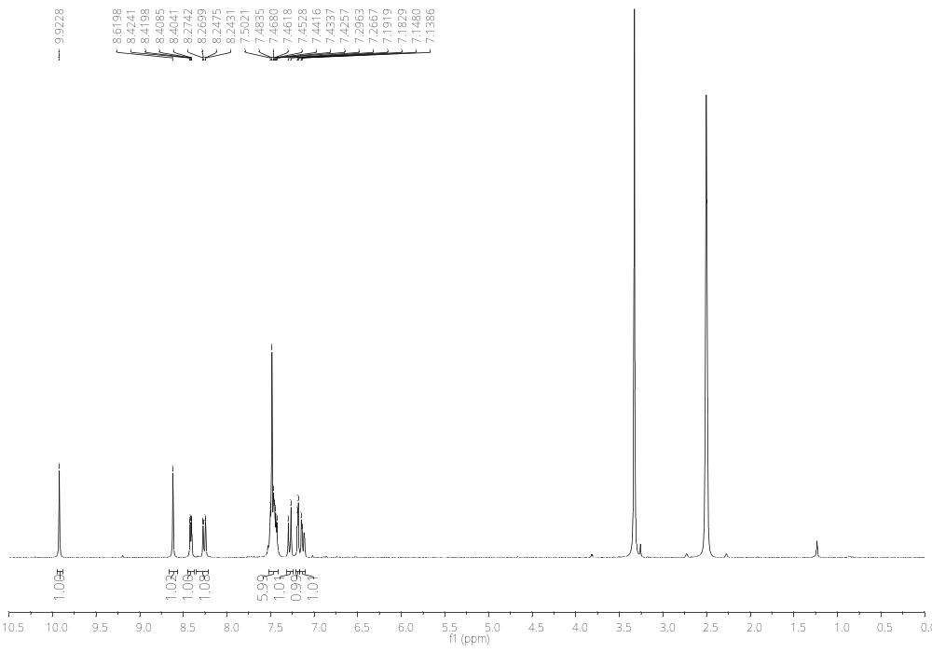
Figure S35. ¹H NMR spectrum (DMSO-d₆, 300 MHz) of 2-imino-3-(3-phenyl-3H-imidazo[4,5-b]pyridin-2-yl)-2H-chromen-6-ol 25
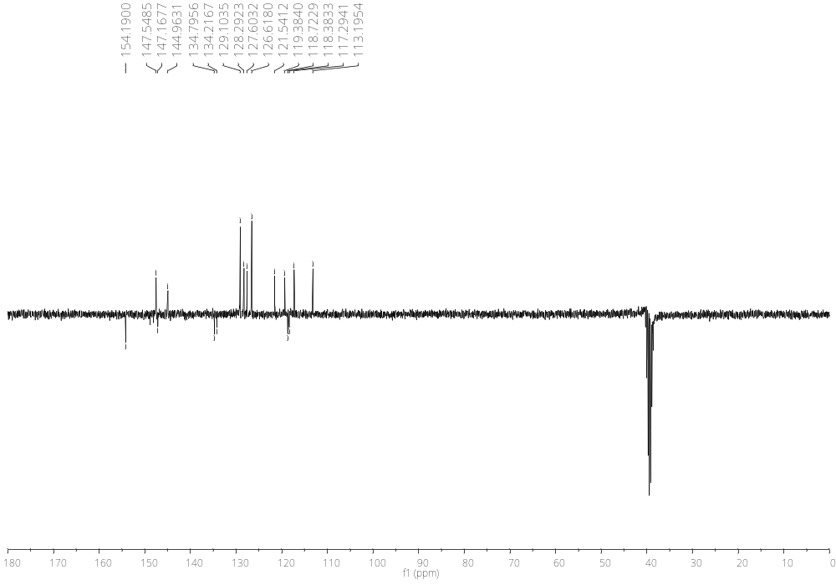
Figure S36. ¹³C NMR spectrum (DMSO-d₆, 75 MHz) of 2-imino-3-(3-phenyl-3H-imidazo[4,5-b]pyridin-2-yl)-2H-chromen-6-ol 25
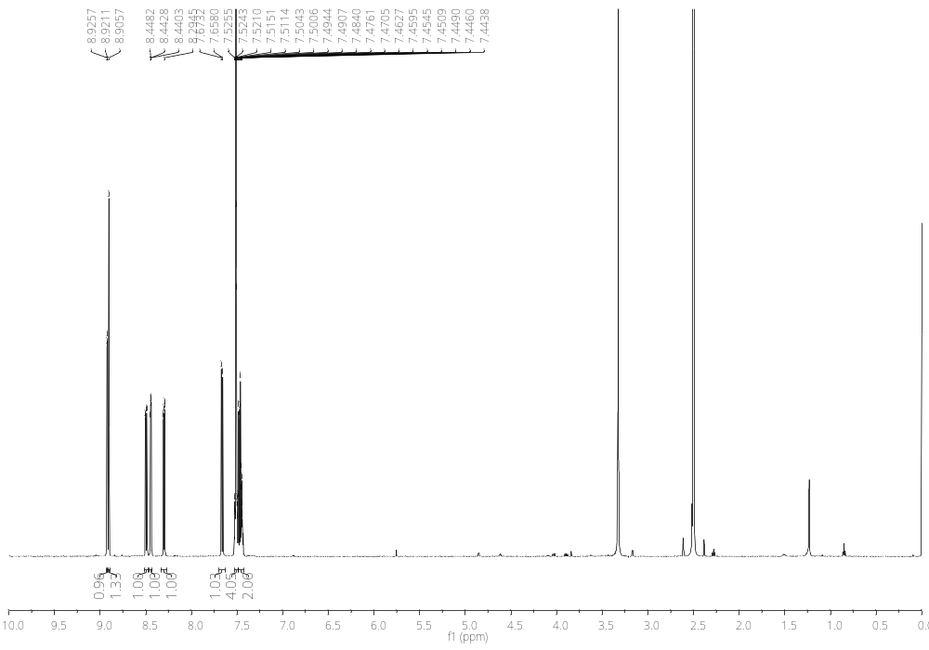
Figure S37. ¹H NMR spectrum (DMSO-d₆, 300 MHz) of 6-nitro-3-(3-phenyl-3H-imidazo[4,5-b]pyridin-2-yl)-2H-chromen-2-imine 26
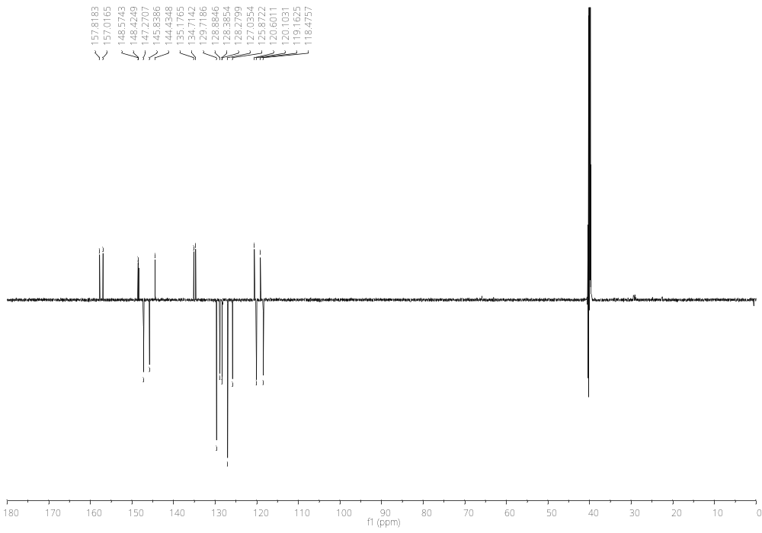
Figure S38. ¹³C NMR spectrum (DMSO-d₆, 75 MHz) of 6-nitro-3-(3-phenyl-3H-imidazo[4,5-b]pyridin-2-yl)-2H-chromen-2-imine 26
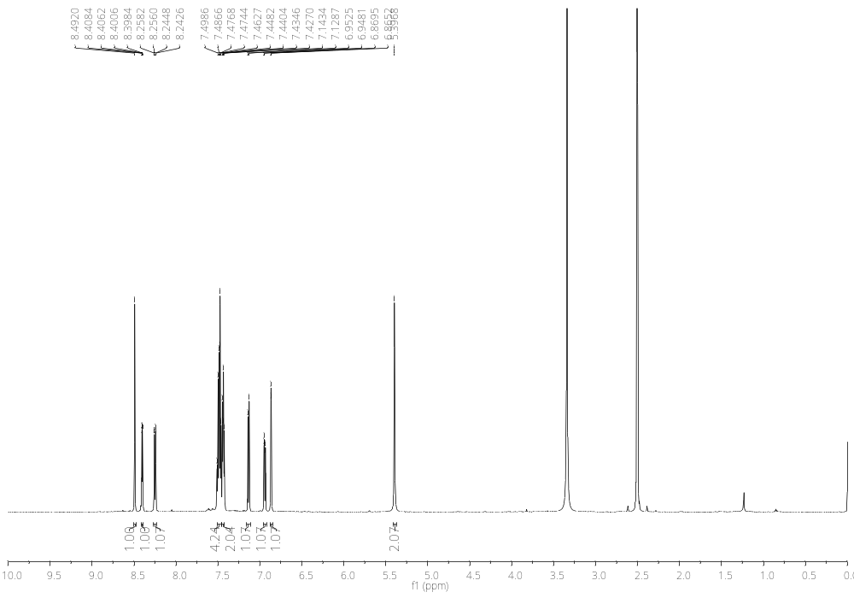
Figure S39. ¹H NMR spectrum (DMSO-d₆, 600 MHz) of 2-imino-3-(3-phenyl-3H-imidazo[4,5-b]pyridin-2-yl)-2H-chromen-6-amine 27
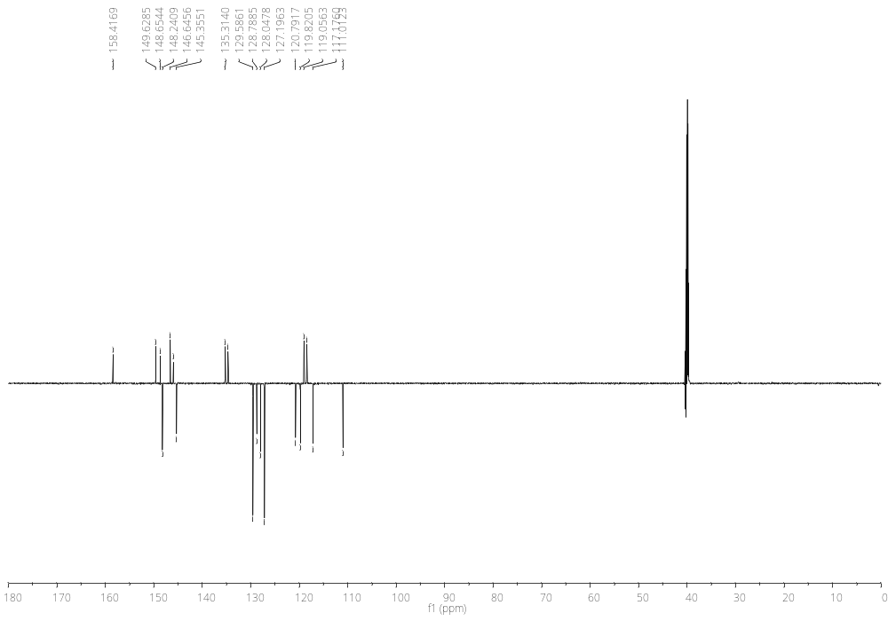
Figure S40. ¹³C NMR spectrum (DMSO-d₆, 151 MHz) of 2-imino-3-(3-phenyl-3H-imidazo[4,5-b]pyridin-2-yl)-2H-chromen-6-amine 27

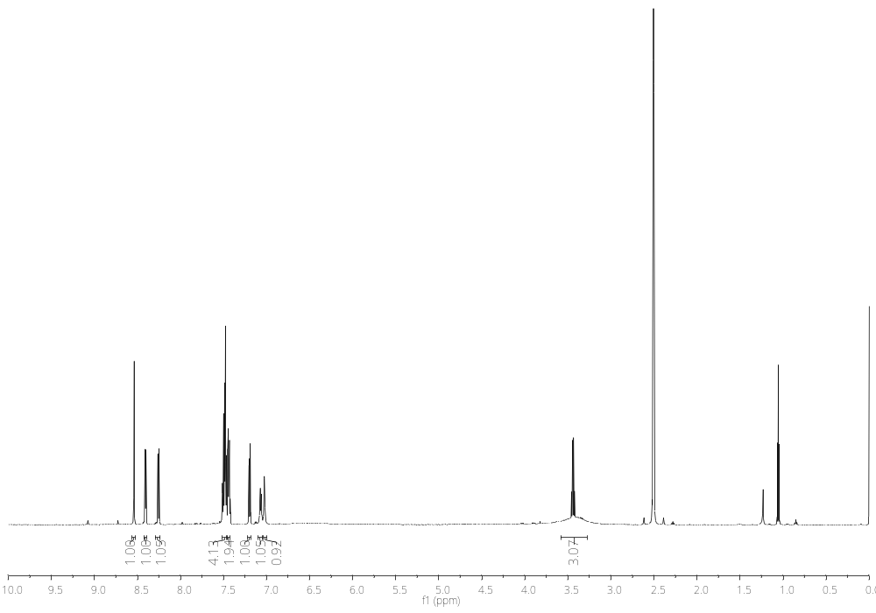
Figure S41. ¹H NMR spectrum (DMSO-d₆, 600 MHz) of 2-imino-3-(3-phenyl-3H-imidazo[4,5-b]pyridin-2-yl)-2H-chromen-6-amine hydrochloride 28
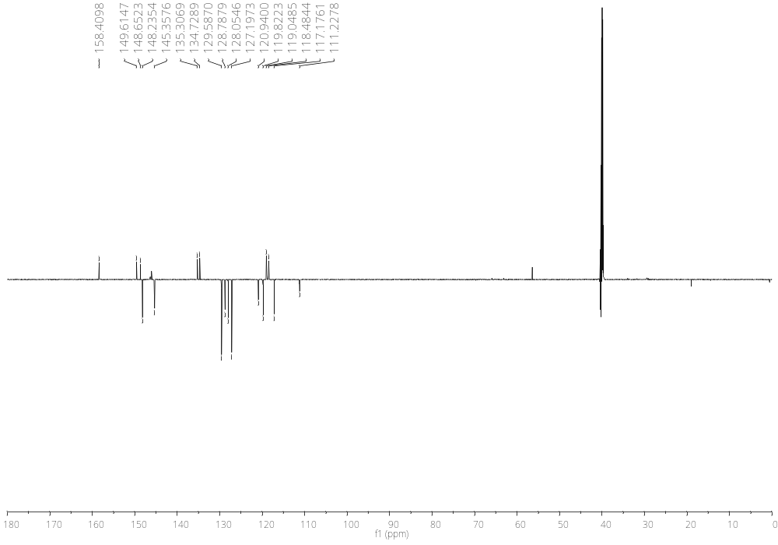
Figure S42. ¹³C NMR spectrum (DMSO-d₆, 151 MHz) of 2-imino-3-(3-phenyl-3H-imidazo[4,5-b]pyridin-2-yl)-2H-chromen-6-amine hydrochloride 28

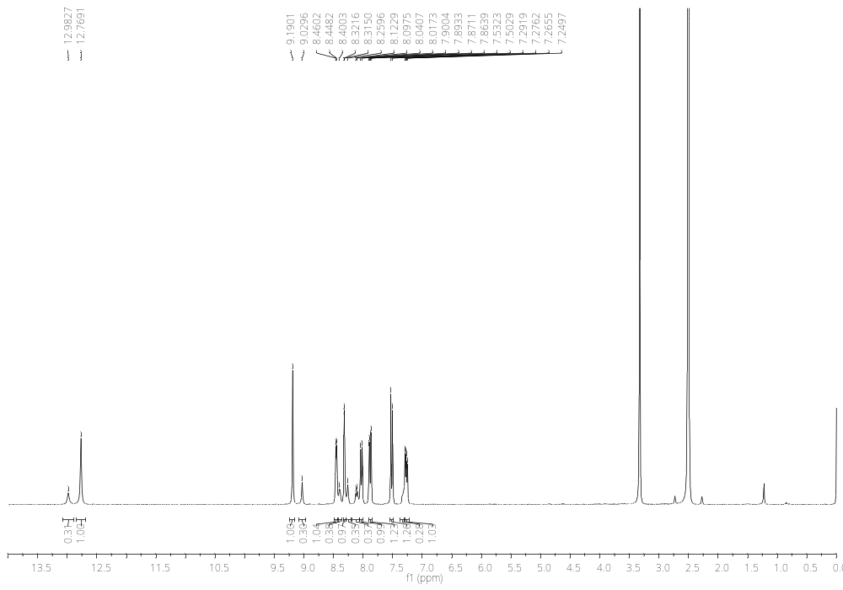
Figure S43. ¹H NMR spectrum (DMSO-d₆, 300 MHz) of 6-bromo-3-(3H-imidazo[4,5-b]pyridin-2-yl)-2H-chromen-2-imine 29
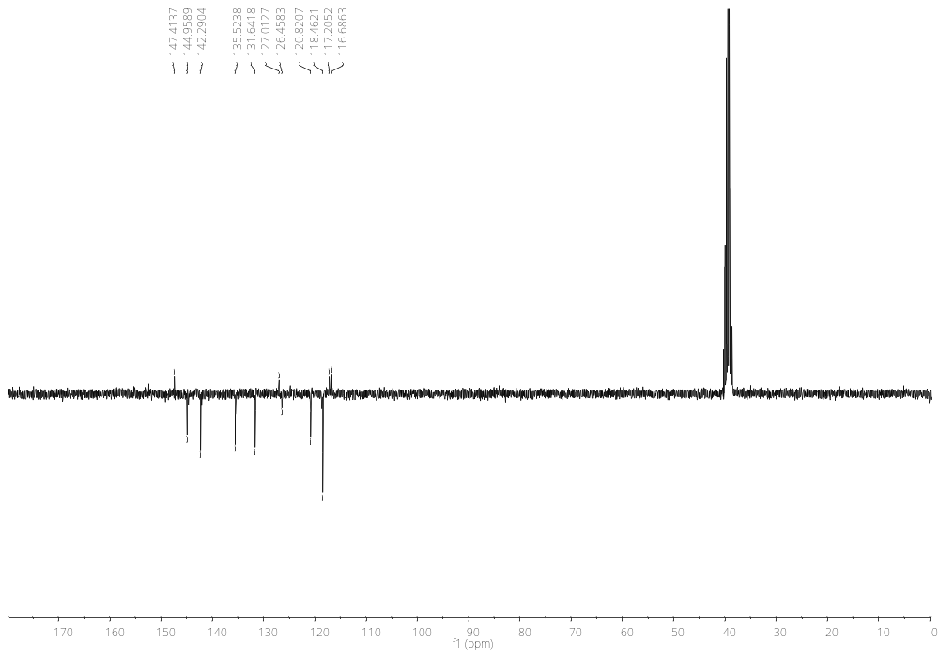
Figure S44. ¹³C NMR spectrum (DMSO-d₆, 75 MHz) of 6-bromo-3-(3H-imidazo[4,5-b]pyridin-2-yl)-2H-chromen-2-imine 29
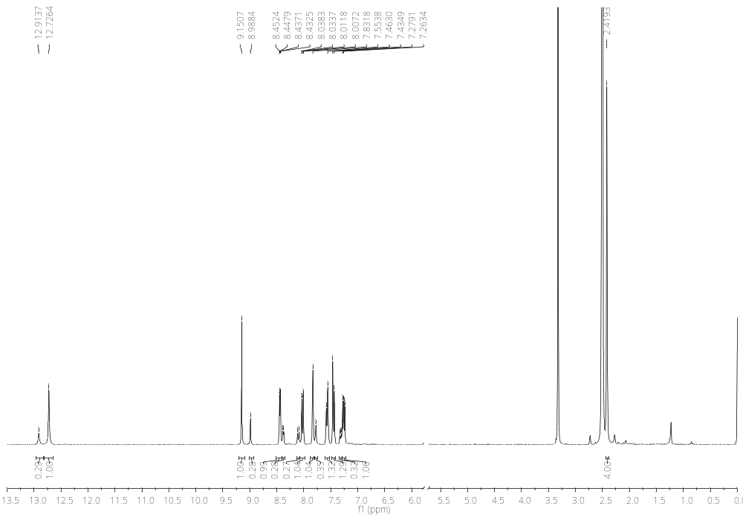
Figure S45. ¹H NMR spectrum (DMSO-d₆, 300 MHz) of 3-(3H-imidazo[4,5-b]pyridin-2-yl)-6-methyl-2H-chromen-2-imine 30
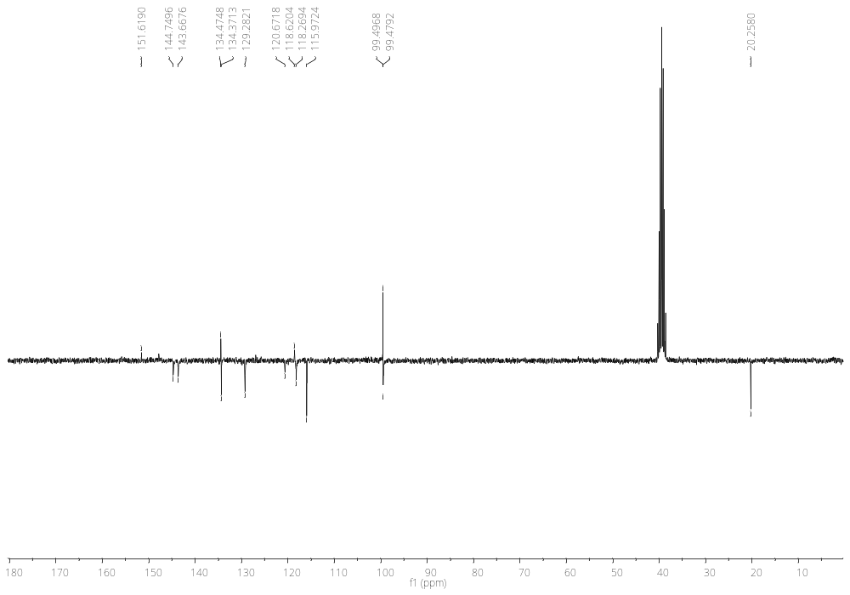
Figure S46. ¹³C NMR spectrum (DMSO-d₆, 75 MHz) of 3-(3H-imidazo[4,5-b]pyridin-2-yl)-6-methyl-2H-chromen-2-imine 30
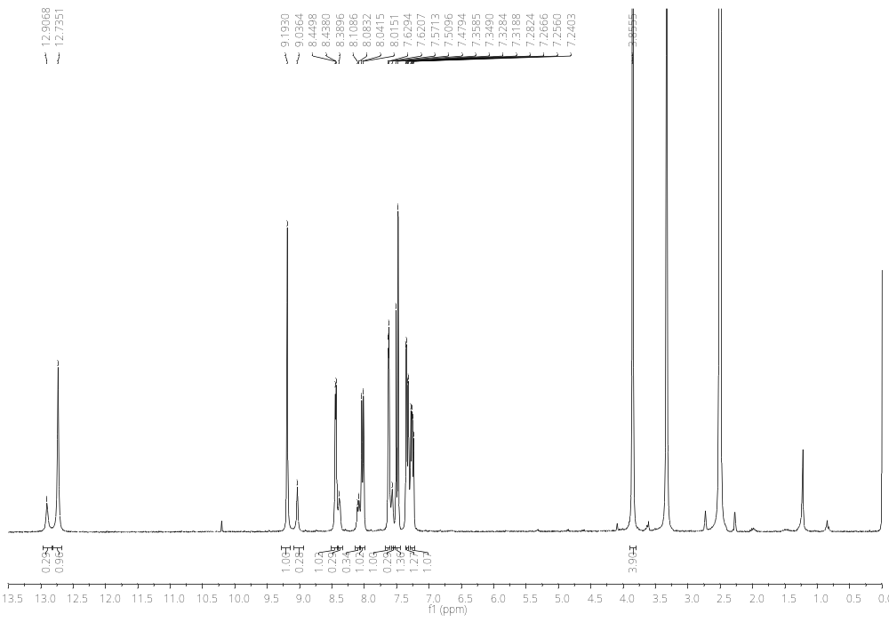
Figure S47. ¹H NMR spectrum (DMSO-d₆, 300 MHz) of 3-(3H-imidazo[4,5-b]pyridin-2-yl)-6-methoxy-2H-chromen-2-imine 31
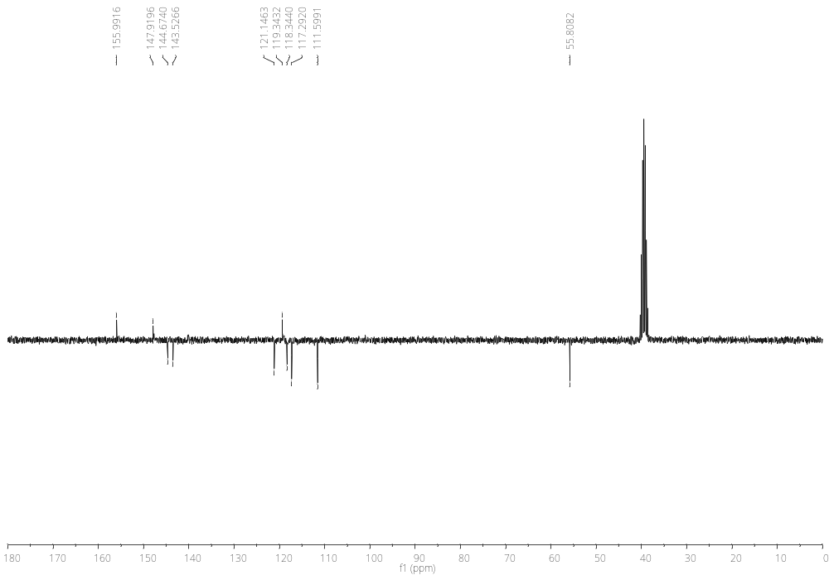
Figure S48. ¹³C NMR spectrum (DMSO-d₆, 75 MHz) of 3-(3H-imidazo[4,5-b]pyridin-2-yl)-6-methoxy-2H-chromen-2-imine 31

