Supplementary Information
to
Green Preparation of Flexible and Transparent SiO₂-Fe₂O₃-PS film for Dye Adsorption and UV-Shielding Applications
Abhijit Nath*, Mrityunjoy Mahato*
Physics Division, Department of Basic Sciences and Social Sciences, School of Technology, North-Eastern Hill University, Shillong, Meghalaya, 793022, India
*To whom correspondence should be addressed: mrityunjoyphy@gmail.com, abhijitnsh46@gmail.com,

TableS1: Experimental XRD peak position, planes of SiO₂, Fe₂O₃ and SiO₂-Fe₂O₃ heterostructure.
Sl No | XRD Peak Position |  |  | Planes  (hkl) | Phase and Literature 2𝜽 value | Reference
Sl No | SiO₂ Nanoparticle | Fe₂O₃  Nanoparticle | SiO₂-Fe₂O₃  Heterostructure | Planes  (hkl) | Phase and Literature 2𝜽 value | Reference
1 | - | 24.16 | 24.01 | [012] | ⍺-Fe₂O₃ (24.20) | Nath et al 2023
2 | 27.37 | - | 26.71 | [101] | SiO₂ (27) | Barma 2020
3 | 31.42 | 33.16 | - | [220] | ⍺-Fe₂O₃ (33.22) | Nath et al 2023
4 | - | 35.64 | - | [104] | ⍺-Fe₂O₃ (35.62) | Nath et al 2023
5 | - | - | 37.90 | - | SiO₂ (27) | Barma 2020
6 | - | 40.92 | 40.33 | [113] | ⍺-Fe₂O₃ (40.79) | Nath et al 2023
7 | 45.27 | - | 44.87 | [102] | SiO₂ (45) | Barma 2020
8 | - | 49.52 | 47.29 | [024] | ⍺-Fe₂O₃ (49.45) | Nath et al 2023
9 | - | 54.08 | - | [116] | ⍺-Fe₂O₃ (54.25) | Nath et al 2023
10 | 56.80 | - | - | [202] | SiO₂ (56) | Barma 2020
11 | - | 57.56 | 57.79 | [018] | ⍺-Fe₂O₃ (57.67) | Nath et al 2023
12 | - | 62.52 | 62.20 | [214] | ⍺-Fe₂O₃ (62.59) | Nath et al 2023
13 | - | 64.08 | - | [300] | ⍺-Fe₂O₃ (63.59) | Nath et al 2023
14 | 64.65 | - | 64.75 | [113] | SiO₂ (65) | Barma 2020
15 | - | - | 69.01 | - | SiO₂ (70) | Barma 2020
16 | - | 72.12 | - | [119] | ⍺-Fe₂O₃ (72.19) | Nath et al 2023
17 | 75.29 | 75.52 | 74.56 | [101] | ⍺-Fe₂O₃ (75.67) | Nath et al 2023
18 | 77.90 | - | 77.82 | - | SiO₂ (76) | Barma 2020

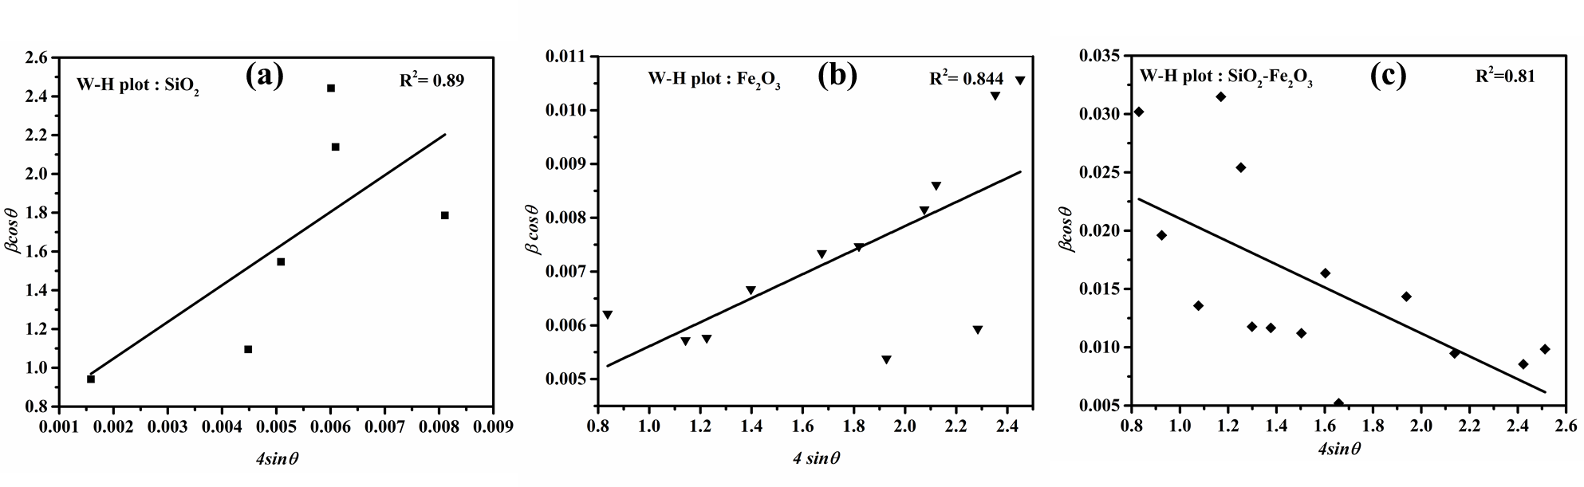

Fig. S1 W-H plot for SiO₂, Fe₂O₃ and SiO₂-Fe₂O₃ heterostructures.

