Inflammatory Macrophages Lysate-based Macroporous Hydrogel for Effective Immunomodulation to Inhibit Tumor Progression, Recurrence and Metastasis
Wanyu Li,¹ Dan Wang,¹ Tianshou Cao,¹ Yanan Chen,¹ Jilong Wang,^{2,3,4} Chihao Lin,⁵ Huiling Yang,^{1,*} Jiantao Lin,^{1,*} Junjie Deng,^{2,3,4*}
- Guangdong Provincial Key Laboratory of Research and Development of Natural Drugs, School of Pharmacy, Guangdong Medical University, Dongguan 523000, China.
- Joint Centre of Translational Medicine, The First Affiliated Hospital of Wenzhou Medical University, Wenzhou, Zhejiang 325000, China.
- Joint Centre of Translational Medicine, Wenzhou Institute, University of Chinese Academy of Sciences, Wenzhou, Zhejiang 325000, China.
- Zhejiang Engineering Research Center for Tissue Repair Materials, Wenzhou Institute, University of Chinese Academy of Sciences, Wenzhou, Zhejiang 325000, China.
- The Second School of Medicine, Wenzhou Medical University, Wenzhou, Zhejiang 325000, China.

Supporting Table
Supporting Table 1. Primer sequences of all genes used in PCR.
Supporting Figures
Supporting Figure 1. The relative mRNA expression (INOS, TNF-α, ARG, and TGF-β) of M0, M1, and M2 macrophages. Data were expressed as mean ± SD (n=3, **p < 0.01, ***p < 0.001, ****p < 0.0001).
Supporting Figure 2. Representative transwell invasion assays of M0, M1, and M2 macrophages after Alg-MA or M1LMH-100 treatments. Scale bar = 100 µm.
Supporting Figure 3. (a) Fluorescence microscope pictures of B16F10-mCherry after different treatments. Scale bar = 100 µm. (b) The corresponding fluorescence intensities of B16F10-mCherry after different treatments via Image J soft. (c) The fluorescence intensities of B16F10-mCherry after different treatments via using a full wavelength microplate reader at a wavelength of 587 nm. Data are expressed as mean ± SD (n = 3, *p< 0.05, **p < 0.01).
Supporting Figure 4. (a) Flow cytometry analysis and geometric median fluorescence intensity of Rho signals in M0 macrophages after incubation with Rho-labeled M1LMH-100 for 1, 2, and 3 days, respectively. (b) Representative confocal microscopy images of M0 macrophages after incubation with fluorescence-labeled M1LMH-100. Scale bar = 20 µm. Data are expressed as mean ± SD (n = 3).
Supporting Figure 5. Optical image of BMDCs after incubation with Alg-MA or M1LMH-100. Scale bar = 100 µm.
Supporting Figure 6. Viability of B16F10 cells after different concentrations of OXA treatments.
Supporting Figure 7. (a) Representative pictures of the fluorescence degradation of subcutaneously injected Rho-labeled M1LMH-100. (b) The statistics of fluorescence intensity. Data are expressed as mean ± SD (n = 3).
Supporting Figure 8. Contents of TNF-α, IL-6, and IL-10 in mouse serum. Data are expressed as mean ± SD (n = 6, *p< 0.05, **p < 0.01).
Supporting Figure 9. (a) Representative flow cytometry plots of CD3⁺CD4⁺ T cells and CD3⁺CD8⁺ T cells in TDLNs. (b) The statistics of CD8⁺ T and CD4⁺ T cells. Data are expressed as mean ± SD (n = 6, *p< 0.05).
Supporting Figure 10. H&E staining images of heart, liver, spleen, lung, and kidney in the mice lungs after different treatments. Scale bar = 100 µm.
Supporting Figure 11. Representative flow cytometry plots of CD3⁺CD4⁺ T cells in TDLNs and the statistics of CD3⁺CD4⁺ T cells. Data are expressed as mean ± SD (n =6, *p< 0.05, **p < 0.01).
Supporting Figure 12. Representative flow cytometry plots of CD3⁺CD4⁺ T cells in tumor and the statistics of CD3⁺CD4⁺ T cells. Data are expressed as mean ± SD (n = 6, *p< 0.05).

Table S1. Primer sequences of all genes used in PCR.
Gene | Forward | Reverse
TNF-α | AGGGTCTGGGCCATAGAAC | CCACCACGCTCTTCTGTCTAC
INOS | GAGACGCACAGGCAGAGG | CAGGCACACGCAATGATGG
INF-γ | GAGACGCACAGGCAGAGG | CAGGCACACGCAATGATGG
IL-12 | GCTTCTCCCACAGGAGGTTT | CTAGACAAGGGCATGCTGGT
ARG | TTGGGTGGATGCTCACACTG | GTACACGATGTC TTTGGCAGA
TGF-β | CAACCCAGGTCCTTCCTAAA | GGAGAGCCCTGGATACCAAC
NF-κB | TGGTGAAGACGCCAGTGGA | TCAACTCCCCTGAAAGGGTCCG
GAPDH | GCACCGTCAAGGCTGAGAAC | TGGTGAAGACGCCAGTGGA

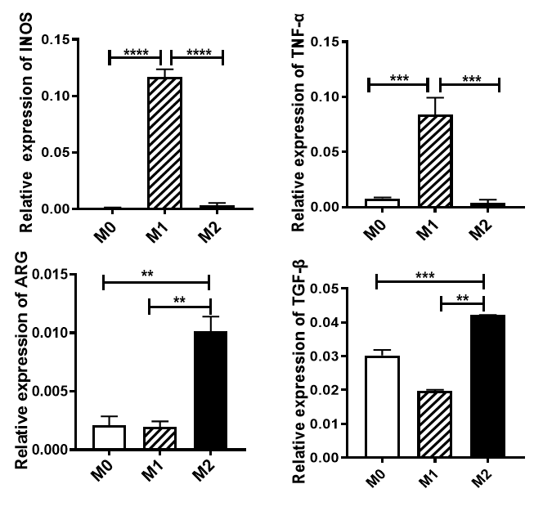
Figure S1. The relative mRNA expression (INOS, TNF-α, ARG, and TGF-β) of M0, M1, and M2 macrophages. Data were expressed as mean ± SD (n=3, **p < 0.01, ***p < 0.001, ****p < 0.0001).

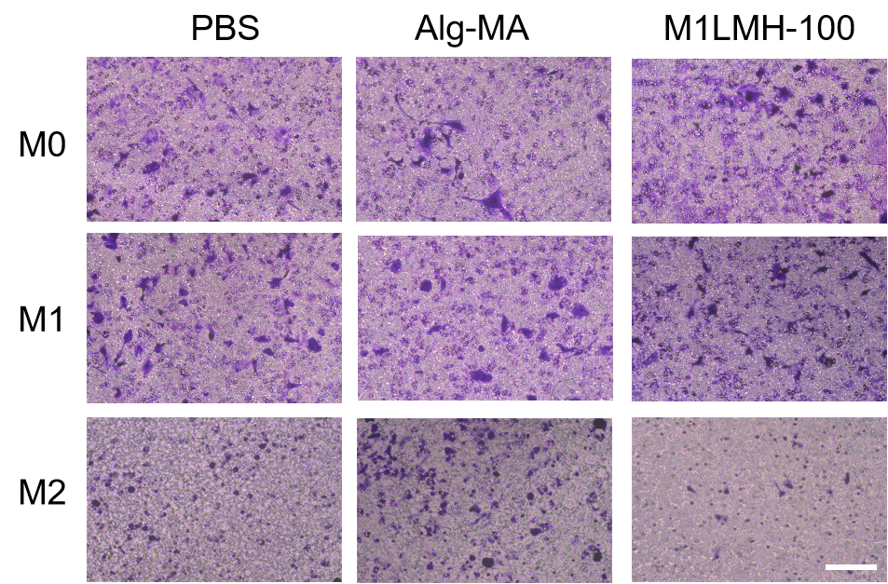
Figure S2. Representative transwell invasion assays of M0, M1, and M2 macrophages after Alg-MA or M1LMH-100 treatments. Scale bar = 100 µm.

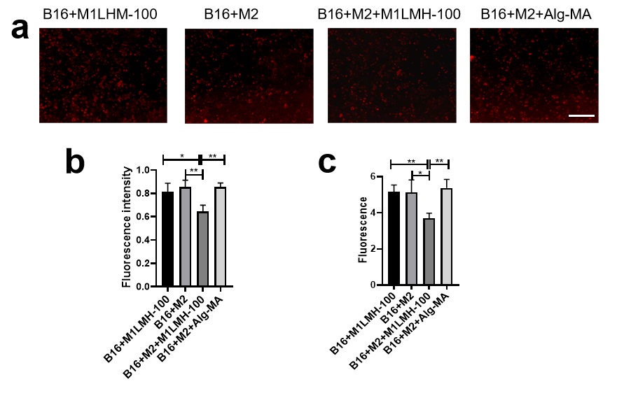
Figure S3. (a) Fluorescence microscope pictures of B16F10-mCherry after different treatments. Scale bar = 100 µm. (b) The corresponding fluorescence intensities of B16F10-mCherry after different treatments via Image J soft. (c) The fluorescence intensities of B16F10-mCherry after different treatments via using a full wavelength microplate reader at a wavelength of 587 nm. Data are expressed as mean ± SD (n = 3, *p < 0.05, **p < 0.01).

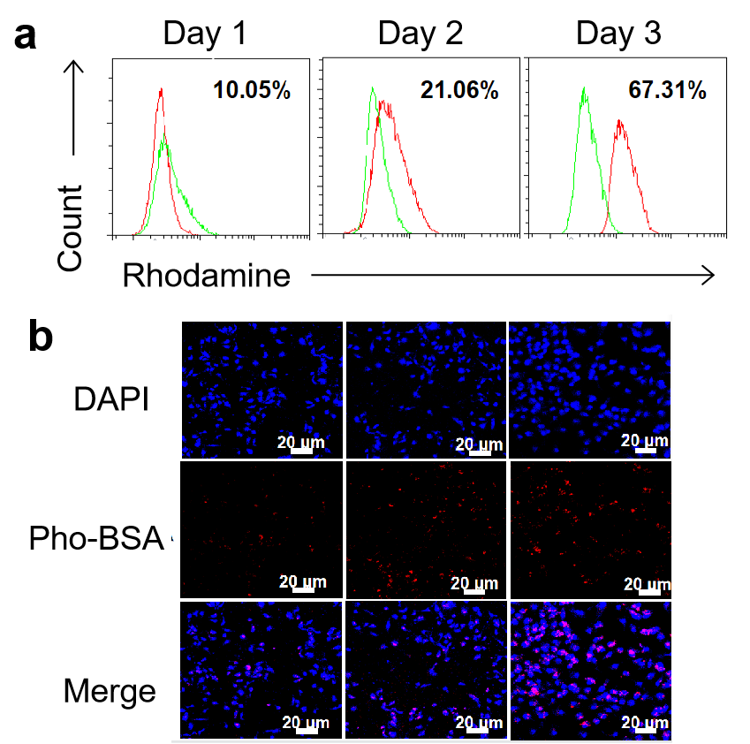
Figure S4. (a) Flow cytometry analysis and geometric median fluorescence intensity of Rho signals in M0 macrophages after incubation with Rho-labeled M1LMH-100 for 1, 2, and 3 days, respectively. (b) Representative confocal microscopy images of M0 macrophages after incubation with fluorescence-labeled M1LMH-100. Scale bar = 20 µm. Data are expressed as mean ± SD (n = 3).

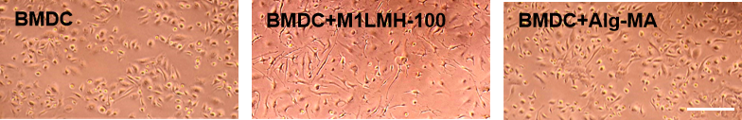
Figure S5. Optical image of BMDC after incubation with Alg-MA or M1LMH-100. Scale bar = 100 µm.

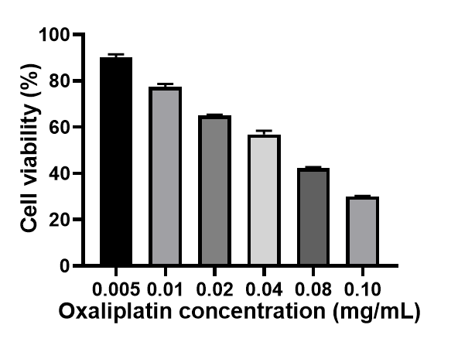
Figure S6. Viability of B16F10 cells after different concentrations of OXA treatments.

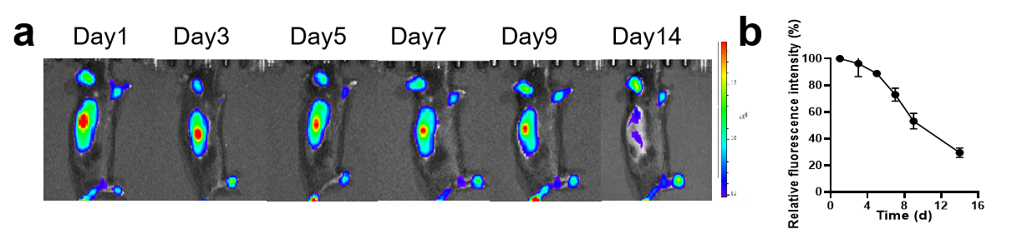
Figure S7. (a) Representative pictures of the fluorescence degradation of subcutaneously injected Rho-labeled M1LMH-100. (b) The statistics of fluorescence intensity. Data are expressed as mean ± SD (n = 3).

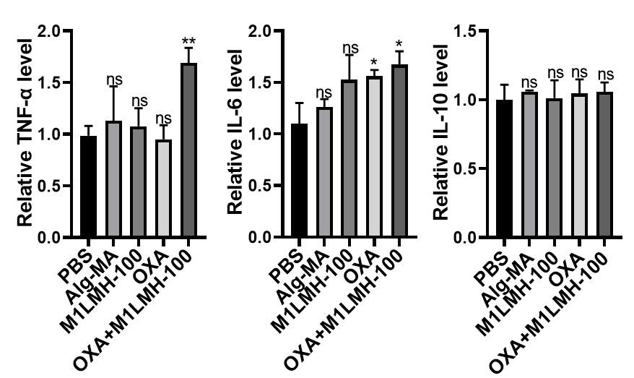
Figure S8. Contents of TNF-α, IL-6, and IL-10 in mouse serum. Data are expressed as mean ± SD (n = 6, *p < 0.05, **p < 0.01).

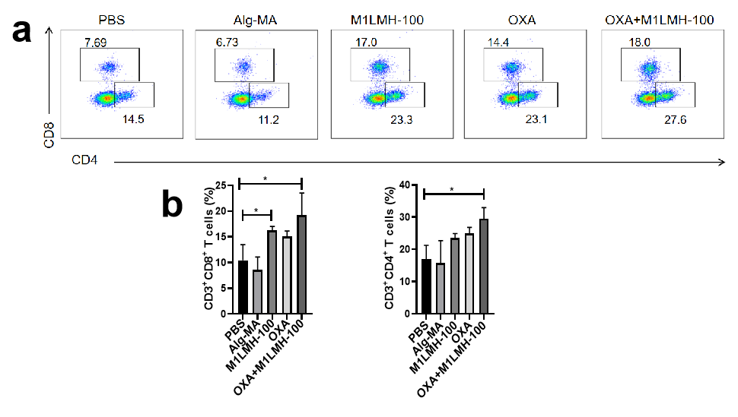
Figure S9. (a) Representative flow cytometry plots of CD3⁺CD4⁺ T cells and CD3⁺CD8⁺ T cells in TDLNs. (b) The statistics of CD8⁺ T and CD4⁺ T cells. Data are expressed as mean ± SD (n = 6, *p < 0.05).

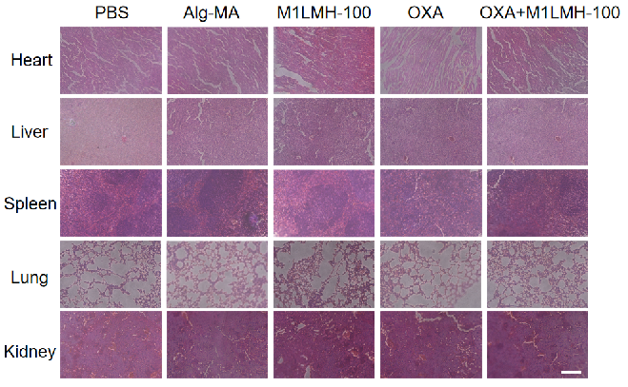
Figure S10. H&E staining images of heart, liver, spleen, lung and kidney in the mice lungs after different treatments. Scale bar = 100 µm.
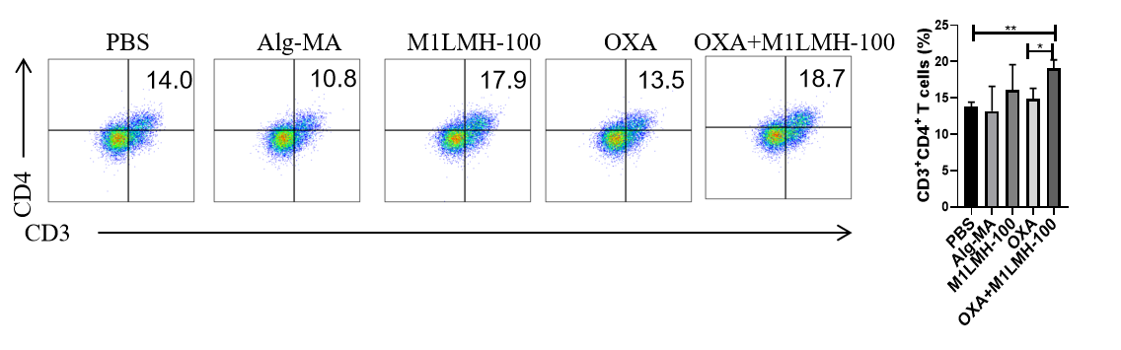
Figure S11. Representative flow cytometry plots of CD3⁺CD4⁺ T cells in TDLNs and the statistics of CD3⁺CD4⁺ T cells. Data are expressed as mean ± SD (n =6, *p < 0.05, **p < 0.01).

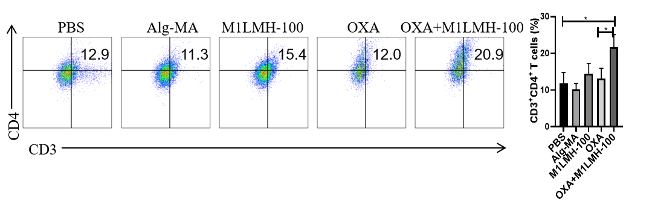
Figure S12. Representative flow cytometry plots of CD3⁺CD4⁺ T cells in tumor and the statistics of CD3⁺CD4⁺ T cells. Data are expressed as mean ± SD (n = 6, *p < 0.05).

