Supplementary Materials
Supplementary 1. Description of the linear/fixed effects
Here, we report a summary of the fixed effects estimated to be significant. Hence, with a 95% Credible Interval that does not cross the zero line of the regression coefficient. In other words, we consider significant a covariate whose 2.5 and 97.5 percentiles share the same sign. Whether this is negative or positive, it will only influence the interpretation. However, in this work, four significant covariates were estimated by our LGCP (Log-Gaussian Cox Process) namely, Elevation, Planar Curvature, Relative Slope Position and Distance to road or trail. They are shown in Figure S1, where they stand out to reduce the estimated landslide intensity. The role of the elevation could be interpreted as a result of the dissipation of the auto-regenerative cloudburst coming from the sea. In fact, the storm responsible for the landslides we mapped came from the Tyrrhenian Sea (south of the study area) and quickly released the rainfall as it moved uphill. Thus, the vast majority of landslides clusters at medium elevations. This effect is relatively common in similar steep coastal settings and an exact analogous example can be found in Lombardo et al. (2015). The role of the Planar Curvature can be interpreted in terms of favorable morphologies to slope instability. Specifically, a negative regression coefficient implies that laterally convex shapes contribute to decrease the expected number of landslides. Conversely, laterally concave morphologies contribute to increase the landslide intensity. The negative role of the Relative Slope Position reaffirms that landslides predominantly triggered half-way through the topographic profile (e.g., Desmore and Hovius, 2000). As for the distance to road or trail, a negative mean regression coefficient could be interpreted with an anthropic control on the slope stability. In fact, a negative sign implies that the intensity decreases as the distance increases. Thus, locations proximal to road cuts or trails are estimated to contribute to the intensity estimation (e.g., Tanyas et al., 2022). These lineaments not only may destabilize a slope modifying the previous equilibrium. But, they also modify the hydrological behavior of overland flows, establishing surfaces with reduced permeability and subsequently increasing the runoff, which in turn can bring instability in the lower sections of the topographic profile.
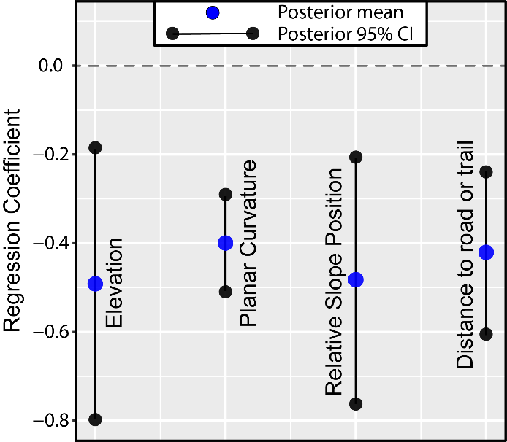
Figure S1. Posterior means (blue dots) of significant fixed effects, together with their 95% credible intervals (black dots). The horizontal black dashed lines indicate no contribution to the landslide intensity.

Supplementary 2. Description of the nonlinear/random effects
Here, we report a summary of the random effects by plotting their posterior means together with their 95% credible intervals (see Figure S2). The panel reports covariates that have been used in a purely categorical form, i.e., with class effects being mutually independent a priori (this is the case for Land Use, Terraced slopes Status and Geology). As for covariates that have been modeled with some degree of dependence, we have two examples. The first one corresponds to the Slope Steepness. This covariate has been binned into twenty classes, with a constraint of adjacent class dependence driven by a random walk of the first order (RW1, see Ruiz-Cárdenas et al., 2010). The second case corresponds to a Latent Spatial Effect (LSE, see Bakka et al., 2018). In this work we have opted for a Besag model (Martino and Rue, 2009). This model essentially corresponds to a RW1 in two dimensions and contributes to drive dependence across the geographic space. Specifically, the adjacent matrix computed for the slope unit partition provides the structure upon which the Besag is run, and makes it so that close slope units behave more similarly than slope units far away from each other. In Figure S2, the first covariate we present is the Slope Steepness. Its nonlinear effect appears to be quite sigmoidal, with three main sections. The range between 0° and 25° contributes to decrease the expected landslide intensity, albeit within this range the negative contribution decreases down to negligible effects at 25°. Then, from this value up to roughly 40°, the contribution to the landslide intensity increases quite linearly, only to flatten from 40° to the maximum steepness of around 65°. This behavior is in line with the type of landslides we consider, i.e. superficial and rapid landslides (Cevasco et al., 2013).
Concerning Land Use, LU7 and LU8, namely vineyards and abandoned vineyards respectively, contribute to increase the landslide intensity. This is also in agreement with the literature on shallow landslides in the Cinque Terre (Cevasco et al., 2014; Brandolini et al., 2018; Di Napoli et al., 2021). This also stands out in the Terraced slopes Status covariate. Cultivated terraces areas (T2) and, especially, abandoned terraces with poor vegetation cover (T3) appear prone to instability. Along these lines, Pepe et al. (2019) conducted a detailed investigation on land-use transformations from the early 1950s to 2011, analyzing the influence that the abandonment of cultivated terraced slopes exerted on the distribution and magnitude of rainfall-induced shallow landslides. Geology is not to be considered secondary in these analyses. Although most of the classes appear to be non-significant, G2 (or Canetolo Shales and Limestones) positively contributes to the landslide intensity. This politic-dominant and impermeable type of bedrock can be responsible for the genesis of widespread slope failures (Cevasco et al., 2014). Ultimately, the LSE shows that the easternmost sector of the study area is linked to the highest positive residuals between observed and estimated intensities. This pattern briefly transitions to negative values and assumes positive LSE values in the westernmost region of the study area. This may have to do to with the spatio-temporal pattern of the cloudburst and how the rainfall may have been discharged through the study area (Cevasco et al., 2015).
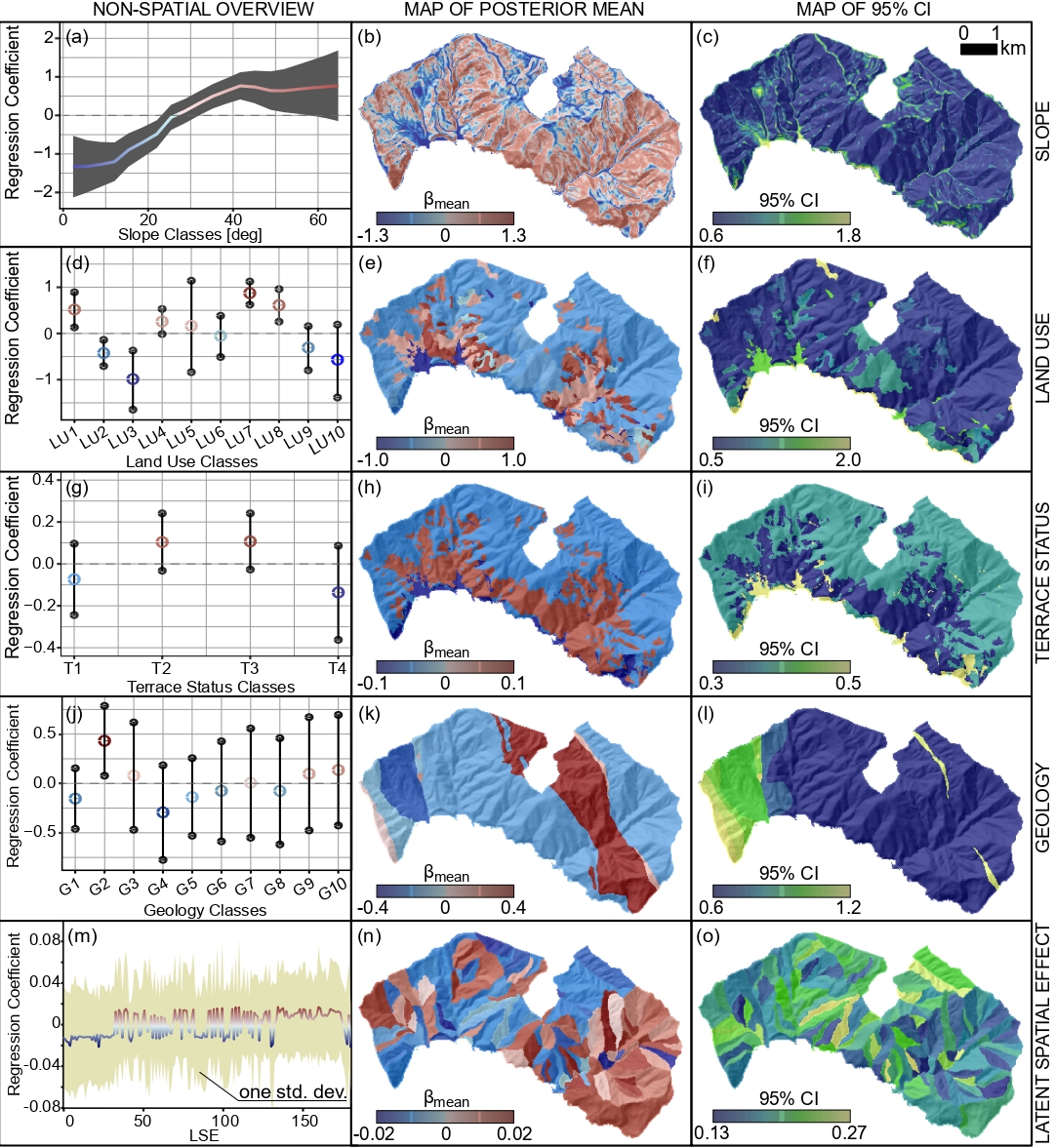
Figure S2. Random effects for the performed model, from top to bottom: slope ranging from 0 to 90 degrees, land use classes (LU1 = Complex Cultivation Patterns, LU2 = Mixed Forest, LU3 = Urban and Industrial Area, LU4 = Olive Groves, LU5 = Moors and Scrubs, LU6 = Abandoned Olive Groves, LU7 = Vineyards, LU8 = Abandoned Vineyards, LU9 = Sclerophyllous Vegetation, LU10 = Beaches, Dunes, Sands and Bare rocks), agricultural terraced slopes status (T1 = abandoned terraces with dense vegetation cover - advanced state of abandonment, T2 = cultivated terraced areas, T3 = abandoned terraces with poor vegetation cover - initial state of abandonment, T4 = non-terraced areas - including either urban areas, outcropping rocks and woods), geology (G1 = Macigno Sandstones, G2 = Canetolo Shales and Limestones, G3 = T. Pignone Marls, G4 = Gabbros, G5 = M.te Veri Argillites and Limestones, G6 = Serpentinites, G7 = Gottero Sandstones, G8 = Val Lavagna Schists, G9 = Basalts and G10 = Cherts) and Latent Spatial Effect.

