Supporting Information

Synergistic Adsorption/Photodegradation of Ciprofloxacin by UV light-driven Nanocomposite Photocatalyst of Cu doped AC/TiO₂: Experimental design via RSM-CCD.

N.A. Yaacobª, A. Khasri^{a,b}, M.J.M. Ridzuan^{c}, N. H. M. Sallehª, P. Chaijak
ªFaculty of Chemical Engineering & Technology, Universiti Malaysia Perlis (UniMAP), Perlis, Malaysia.
^{b}Water Research and Environmental Sustainability Growth, Centre of Excellence (WAREG), Universiti Malaysia Perlis, 02600 Arau, Perlis, Malaysia.
^{c}Faculty of Mechanical Engineering & Technology, Universiti Malaysia Perlis (UniMAP), Perlis, Malaysia.
^{d}Department of Biology, Faculty of Science, Thaksin University, Thailand.

*Corresponding author
Author’s email: ayuniatiqah.yaacob@gmail.com, azduwin@unimap.edu.my, hasyierah@unimap.edu.my, ridzuanjamir@unimap.edu.my, chaijak.pimprapa@gmail.com

Text S1 Experimental conditions of the effects of initial concentration and time, pH, and temperature solution on adsorption/photodegradation of CFx removal by Cu doped AC/TiO₂ nanocomposite photocatalyst

Effect of initial concentration and contact time
The effect of the initial concentration of CFx on the adsorption-photodegradation activity was measured at 30 °C and initial solution pH 7.0. 0.2 g of photocatalyst was added to 250 mL double-walled borosilicate glass reaction vessel containing 200 mL of different concentrations of 25, 50,100, 200, 250 and 300 mg/L of adsorbates solution. The adsorbate solution was magnetically stirred for 120 min. 3.0 ml of the adsorbates solution was withdrawn after equilibrium stage and the concentration of the sample was analysed by using UV-Vis spectrophotometer.

Effect of solution temperature

The effect of solution pH of CFx on the adsorption-photodegradation activity was measured at 30 °C and initial solution pH 7.0. 0.2 g of photocatalyst was added to 250 mL double-walled borosilicate glass reaction vessel containing 200 mL of 100 mg/L of adsorbates by varying the temperature of solution at 30, 45 and 60 °C. The adsorbate solution was magnetically stirred for 120 min. The solution temperature was controlled using temperature controller of the chiller. The adsorbates solution was withdrawn after equilibrium stage and the concentration of the sample was analyzed by using UV-Vis spectrophotometer.

Effect of solution pH.
The effect of solution pH on the photocatalytic activity of the sponges was carried out at 30 °C. 0.2 g of photocatalyst was added to 250 mL double-walled borosilicate glass reaction vessel containing 200 mL of 100 mg/L of adsorbates by varying the pH of the solution at 3, 5, 6, 7, 8 and 10. 0.1 M HCl and 0.1 M NaOH were used for the adjusting of required pH. The adsorbates solution was withdrawn after equilibrium stage and the concentration of the sample was analyzed by using UV-Vis spectrophotometer.

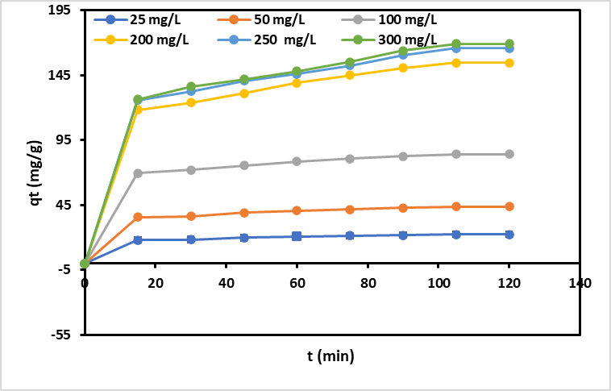
(a)
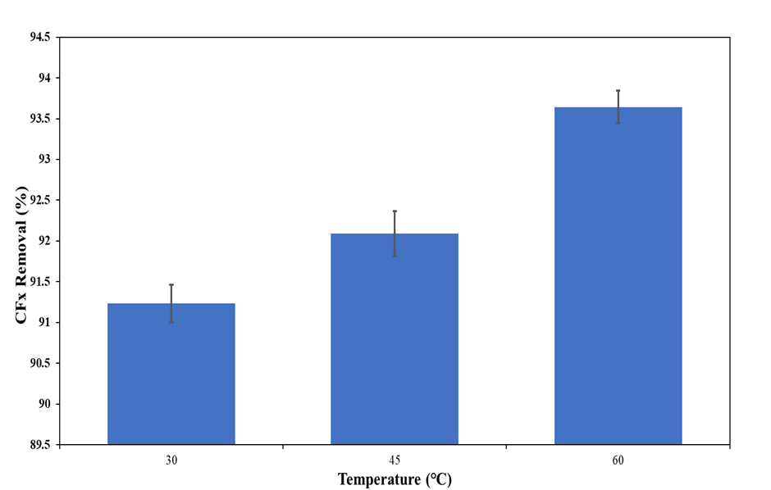
(b)
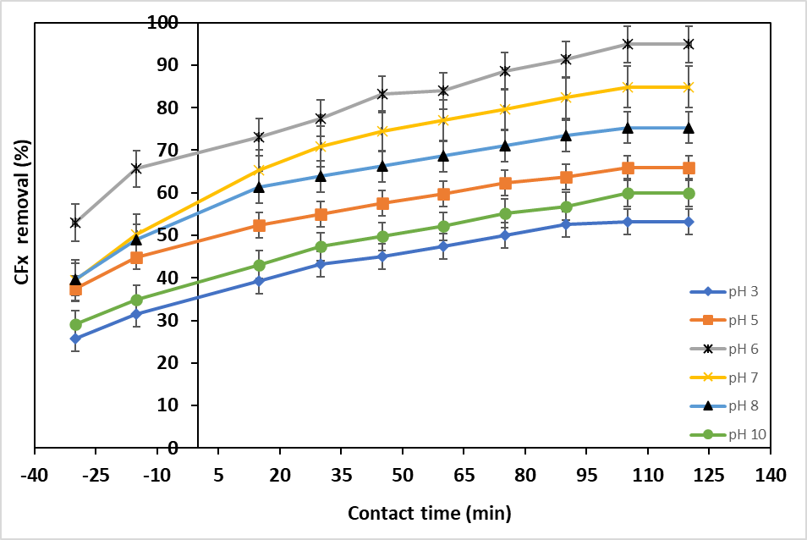
(c)
Fig. S1 Effect of (a) initial concentration and contact time (b) solution temperture (c) solution pH for CFx systems

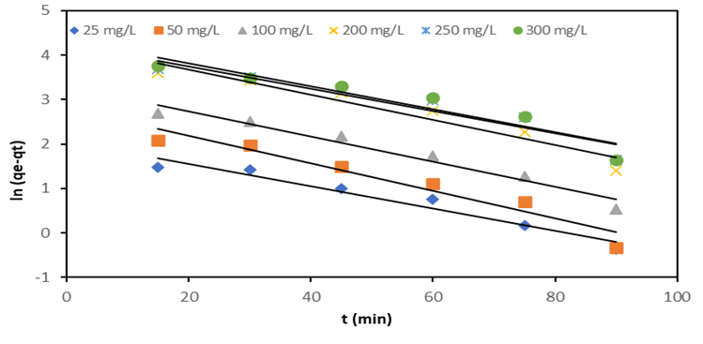
(a)
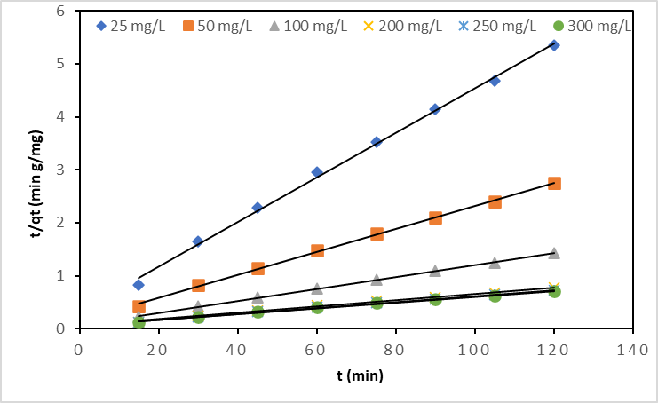
(b)
Fig. S2. Linearized plots of (a) pseudo-first order kinetic model (b) pseudo-second order kinetic model for CFx systems at 30 °C

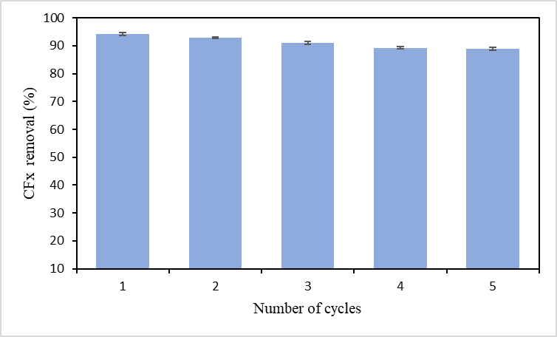
Fig. S3. The reusability of Cu doped AC/TiO₂ nanocomposite photocatalyst for five cycles of adsorption-photodegradation of CFx removal

