Supplementary Table 1. Primers used in this study for amplification and sequencing.
Locus | Primers | Sequence (5’-3’) | Annealing temperature (°C) | Fragment size (bp) | Referencesª
ITS | ITS1F  ITS5  ITS4  Tf-1 | CTTGGTCATTTAGAGGAAGTAA  GGAAGTAAAAGTCGTAACAAGG  TCCTCCGCTTATTGATATGC  AACACATCTCAACAACCC | 52 | 600–700 or 1000–2000 (in some T. funiculosus isolates) | (White et al. 1990); this study
TUB2 | Bt2a  Bt2b  T10 | GGTAACCAAATCGGTGCTGCTTTC  ACCCTCAGTGTAGTGACCCTTGGC  ACGATAGGTTCACCTCCAGAC | 55 | 400–500 | (Glass and Donaldson 1995; Hubka and Kolarik 2012)
RPB2 | 5F_Eur  7CR_Eur | GAYGAYCGKGAYCAYTTCGG  CCCATRGCYTGYTTRCCCAT | 48–51 | 1000–1100 | (Houbraken et al. 2012)
TEF-1α | ef1  ef2 | ATGGGTAAGGAGGACAAGAC  GGAAGTACCAGTGATCATGTT | 62 | 600–700 | (O’Donnell et al. 1998)
ª White, T. J., Bruns, T., Lee, S., & Taylor, J. W. (1990). Amplification and direct sequencing of fungal ribosomal RNA genes for phylogenetics. In M. A. Innis, D. H. Gelfand, J. J. Sninsky, & T. J. White (Eds.), PCR Protocols: A Guide to Methods and Applications (pp. 315–322). San Diego, California, USA: Academic Press.
Glass, N. L., & Donaldson, G. C. (1995). Development of primer sets designed for use with the PCR to amplify conserved genes from filamentous ascomycetes. Appl. Environ. Microbiol., 61(4), 1323-1330.
Houbraken, J., Spierenburg, H., &Frisvad, J. C. (2012). Rasamsonia, a new genus comprising thermotolerant and thermophilic Talaromyces and Geosmithia species. Antonie van Leeuwenhoek, International Journal of General and Molecular Microbiology, 101(2), 403–421. https://doi.org/10.1007/s10482-011-9647-1
Hubka, V., &Kolarik, M. (2012). β-tubulin paralogue tubC is frequently misidentified as the benA gene in Aspergillus section Nigri taxonomy: primer specificity testing and taxonomic consequences. Persoonia, 29, 1–10. https://doi.org/10.3767/003158512X658123
O’Donnell, K., Kistler, H. C., Cigelnik, E., &Ploetz, R. C. (1998). Multiple evolutionary origins of the fungus causing Panama disease of banana: Concordant evidence from nuclear and mitochondrial gene genealogies. Proceedings of the National Academy of Sciences, 95(5), 2044 LP – 2049. https://doi.org/10.1073/pnas.95.5.2044

Supplementary Table 2. GenBank accession numbers of DNA sequences of Talaromyces spp. used for phylogenetic analyses and design of species-specific primers.
Species | Isolateª | GenBank accession number^{b}
Species | Isolateª | ITS | TUB2 | RPB2
T. aculeatus | CBS 289.48* | KF741995 | KF741929 | -
T. adpressus | CBS 140620* | KU866657 | KU866844 | -
T. alveolaris | CBS 142379* | LT558969 | LT559086 | -
T. amazonensis | CBS 140373* | KX011509 | KX011490 | -
T. amestolkiae | CBS 132696* | JX315660 | JX315623 | JX315698
T. amestolkiae | DTO 179E4 | KJ775706 | KJ775199 | -
T. amestolkiae | DTO 179F1 | KJ775707 | KJ775200 | -
T. amestolkiae | DTO 179F6 | KJ775708 | KJ775201 | -
T. amestolkiae | P236 | OL687418 | OL697335 | OM249702
T. amestolkiae | P246_1 | OL687423 | OL697340 | OM249707
T. amestolkiae | P250 | OL687424 | OL697341 | OM249708
T. amestolkiae | P350 | OL687425 | OL697342 | OM249709
T. amestolkiae | P358 | OL687427 | OL697344 | OM249711
T. amestolkiae | P542 | OL687432 | OL697349 | -
T. amestolkiae | P543 | OL687433 | OL697350 | -
T. amestolkiae | P544 | OL687434 | OL697351 | -
T. amestolkiae | P607 | OL687440 | OL697357 | -
T. angelicae | KACC 46611* | KF183638 | KF183640 | -
T. annesophieae | CBS 142939* | MF574592 | MF590098 | -
T. apiculatus | CBS 312.59* | JN899375 | KF741916 | -
T. argentinensis | NRRL 28750* | MH793045 | MH792917 | -
T. aurantiacus | CBS 314.59* | JN899380 | KF741917 | -
T. australis | CBS 137102* | KF741991 | KF741922 | -
T. beijingensis | CBS 140617* | KU866649 | KU866837 | -
T. calidicanius | CBS 112002* | JN899319 | HQ156944 | -
T. californicus | NRRL 58168* | MH793056 | MH792928 | -
T. cnidii | KACC 46617* | KF183639 | KF183641 | -
T. coprophilus | CBS 142756 | LT899794 | LT898319
T. dendriticus | CBS 660.80* | JN899339 | JX091391 | -
T. derxii | CBS 412.89* | JN899327 | JX494305 | -
T. dimorphus | AS3.15692* | KY007095 | KY007111 | -
T. domesticus | NRRL 58121* | MH793055 | MH792927 | -
T. duclauxii | CBS 322.48* | JN899342 | JX091384 | -
T. euchlorocarpius | DTO 176-I3* | AB176617 | KJ865733 | -
T. flavovirens | CBS 102801* | JN899392 | JX091376 | -
T. flavus | CBS 310.38* | JN899360 | JX494302 | -
T. francoae | CBS 113134* | KX011510 | KX011489 | -
T. funiculosus | CBS171.91 | KM066193 | KM066162 | MK450873
T. funiculosus | CBS 272.86* | JN899377 | JX091383 | KM023293
T. funiculosus | CBS 883.70 | KM066196 | KM066163 | MK450874
T. funiculosus | CBS 884.70 | KM066195 | KM066164 | MK450875
T. funiculosus | CBS 885.71 | KM066194 | KM066165 | MK450876
T. funiculosus | P357 | OL687426 | OL697343 | OM249710
T. funiculosus | P362 | OL687429 | OL697346 | OM249713
T. funiculosus | P392 | OL687430 | OL697347 | OM249714
T. funiculosus | P516 | OL687431 | OL697348 | -
T. funiculosus | P547 | OL687435 | OL697352 | -
T. funiculosus | P548 | OL687436 | OL697353 | -
T. fuscoviridis | CBS 193.69* | KF741979 | KF741912 | -
T. fusiformis | CBS 140637* | KU866656 | KU866843 | -
T. galapagensis | CBS 751.74* | JN899358 | JX091388 | -
T. indigoticus | CBS 100534* | JN899331 | JX494308 | -
T. intermedius | CBS 152.65* | JN899332 | JX091387 | -
T. kabodanensis | CBS 139564* | KP851981 | KP851986 | -
T. kendrickii | CBS 136666* | KF741987 | KF741921 | -
T. lentulus | AS 3.15689* | KY007088 | KY007104 | -
T. liani | CBS 225.66* | JN899395 | JX091380 | -
T. louisianensis | NRRL 35823* | MH793052 | MH792924 | -
T. macrosporus | CBS 317.63* | JN899333 | JX091382 | -
T. mae | AS 3.15690* | KY007090 | KY007106 | -
T. malicola | NRRL 3724* | MH909513 | MH909406 | -
T. mangshanicus | CGMCC 3.18013* | KX447531 | KX447530 | -
T. marneffei | CBS 388.87* | JN899344 | JX091389 | -
T. muroii | CBS 756.96* | JN899351 | KJ865727 | -
T. mycothecae | CBS 142494* | MF278326 | LT855561 | -
T. neofusisporus | CBS 139516* | KP765385 | KP765381 | -
T. oumae-annae | CBS 138208* | KJ775720 | KJ775213 | -
T. panamensis | CBS 128.89* | JN899362 | HQ156948 | -
T. pinophilus | CBS 631.66* | JN899382 | JX091381 | -
T. pratensis | NRRL 62170* | MH793075 | MH792948 | -
T. primulinus | CBS 321.48* | JN899317 | JX494305 | -
T. purgamentorum | CBS 113145* | KX011504 | KX011487 | -
T. purpurogenus | CBS 286.36* | JN899372 | JX315639 | -
T. qii | CBS 139515* | KP765384 | KP765380
T. rapidus | CBS 142382* | LT558970 | LT559087
T. ruber | CBS 132704* | JX315662 | JX315629 | -
T. rubicundus | CBS 342.59* | JN899384 | JX494309 | -
T. sayulitensis | CBS 138204* | KJ775713 | KJ775206 | -
T. siamensis | CBS 475.88* | JN899385 | JX091379 | -
T. soli | NRRL 62165* | MH793074 | OK104790 | -
T. stellenboschiensis | CBS 135665* | JX091605 | JX091471
T. stipitatus | CBS 375.48* | JN899348 | KM111288
T. stollii | CBS 265.93 | JX315670 | JX315635 | -
T. stollii | CBS 408.93* | JX315674 | JX315633 | JX315712
T. stollii | CBS 581.94 | JX315675 | JX315632 | JX315713
T. stollii | CBS 624.93 | JX315676 | JX315636 | JX965315
T. stollii | P238 | OL687419 | OL697336 | OM249703
T. stollii | P239 | OL687420 | OL697337 | OM249704
T. stollii | P240_1 | OL687421 | OL697338 | OM249705
T. stollii | P242 | OL687422 | OL697339 | OM249706
T. stollii | P361 | OL687428 | OL697345 | OM249712
T. stollii | P549 | OL687437 | OL697354 | -
T. stollii | P550 | OL687438 | OL697355 | -
T. stollii | P568 | OL687439 | OL697356 | -
T. striatoconidius | CBS 550.89* | MN431418 | MN969441 | -
T. thailandensis | CBS 133147* | JX898041 | JX494294 | -
T. tumuli | NRRL 62151 | MH793071 | MH792944
T. veerkampii | CBS 500.78* | KF741984 | KF741918
T. verruculosus | CBS 388.48* | KF741994 | KF741928 | -
T. versatilis | DTO 326-B7* | MN431395 | MN969412 | -
T. viridis | CBS 114.72* | AF285782 | JX494310 | -
T. viridulus | CBS 252.87* | JN899314 | JX091385 | -
T. xishaensis | CGMCC 3.17995* | KU644580 | KU644581 | -
ª Isolates in bold were obtained in this study; isolates with asterisks are ex-type cultures.
^{b} ITS: internal transcribed spacer regions 1 and 2, including the 5.8S ribosomal RNA gene; TUB2: β-tubulin; accession numbers in bold were obtained in this study; accession numbers in italics were used for the design of primers.

Supplementary Table 3. GenBank accession numbers of translation elongation factor 1-α sequences of Fusarium spp. used for the phylogenetic analyses and design of specific primers.
Species | Isolateª | GenBank accession number^{b}
F. acutatum | CBS 402.97* | MW402125
F. agapanthi | NRRL 54463* | KU900630
F. ananatum | CBS 118516* | LT996091
F. ananatum | CBS 118517 | MN533988
F. ananatum | CBS 118518 | MW401979
F. ananatum | CBS 118519 | MW401980
F. ananatum | CBS 184.29 | MW402105
F. ananatum | CMW 28597 | MW402155
F. ananatum | CMW 28598 | MW402156
F. ananatum | CMW 28599 | MW402157
F. ananatum | P268 | OM249715
F. ananatum | P269 | OM249716
F. ananatum | P274 | OM249717
F. ananatum | P288 | OM249718
F. ananatum | P297 | OM249719
F. ananatum | P298 | OM249720
F. ananatum | P385 | OM249721
F. ananatum | P461 | OM249722
F. ananatum | P465 | OM249723
F. ananatum | P466 | OM249724
F. ananatum | P524 | OM249725
F. ananatum | P537 | OM249726
F. ananatum | P538 | OM249727
F. ananatum | P552 | OM249728
F. ananatum | P565 | OM249729
F. andiyazi | CBS 119857* | MN193854
F. annulatum | CBS 115.97 | MW401973
F. annulatum | CBS 217.76 | AF160280
F. annulatum | CBS 258.54* | MT010994
F. annulatum | CBS 791.91 | MW402152
F. annulatum | CBS 143592 | MW402088
F. annulatum | CBS 143605 | MW402094
F. annulatum | P528 | OM304334
F. annulatum | P553 | OM304335
F. anthophilum | CBS 222.76* | MW402114
F. awaxy | LGMF 1930* | MG839004
F. bactridioides | CBS 100057* | MN533993
F. begoniae | CBS 452.97* | MN533994
F. brevicatenulatum | CBS 404.97* | MN533995
F. bulbicola | CBS 220.76* | KF466415
F. chinhoyiense | NRRL 25221* | MN534050
F. circinatum | CBS 405.97* | MN533997
F. coicis | NRRL 66233* | KP083251
F. concentricum | CBS 450.97* | AF160282
F. denticulatum | CBS 407.97* | MN534000
F. dlaminii | CBS 119860* | MW401995
F. fredkrugeri | CBS 144209* | LT996097
F. fujikuroi | CBS 221.76* | MN534010
F. globosum | CBS 428.97* | KF466417
F. guttiforme | CBS 409.97* | MT010999
F. konzum | CBS 119849* | LT996098
F. madaense | CBS 146669* | MW402098
F. mangiferae | CBS119853 | MN534016
F. mangiferae | CBS 120994* | MN534017
F. mexicanum | NRRL 53147* | GU737282
F. musae | CBS 624.87* | FN552086
F. napiforme | CBS 748.97* | MN193863
F. nygamai | CBS 749.97* | MW402151
F. ophioides | CBS 118512* | MN534022
F. oxysporum FOSC-PS1 | AUST_122 | KJ397043
F. oxysporum FOSC-PS2 | AUST_82 | KJ397075
F. oxysporum | BTGN4 | MN386726
F. oxysporum | FJ122 | MT754670
F. oxysporum | FJVP-9 | MK810785
F. oxysporum | MLGB1 | MN386735
F. oxysporum | P315 | OM304336
F. oxysporum | P382 | OM304337
F. oxysporum | P386 | OM304338
F. oxysporum | P445 | OM304339
F. oxysporum | P446 | OM304340
F. oxysporum | P504 | OM304341
F. oxysporum | P505 | OM304342
F. oxysporum | P525 | OM304343
F. oxysporum | P539 | OM304344
F. oxysporum | P554 | OM304345
F. oxysporum | P566 | OM304346
F. oxysporum | PLAB10 | MN386738
F. oxysporum | SPL15020 | KY508356
F. proliferatum | CBS 480.96* | MN534059
F. pseudoanthophilum | CBS 414.97* | MW402128
F. pseudocircinatum | CBS 449.97* | AF160271
F. pseudonygamai | CBS 417.97* | AF160263
F. ramigenum | CBS 418.97* | KF466423
F. redolens | NRRL 25600* | MT409453
F. sacchari | CBS 223.76* | MW402115
F. sterilihyposum | NRRL 25623* | MN193869
F. sterilihyposum | NRRL 53991 | GU737413
F. subglutinans | CBS 215.76 | MN534061
F. subglutinans | CBS 747.97* | MW402150
F. temperatum | CBS 135538 | MN534039
F. thapsinum | CBS 776.96* | MN534044
F. udum | NRRL 25199* | KY498862
F. verticillioides | CBS 167.87 | MW402101
F. verticillioides | CBS 218.76* | MW402113
ª Isolates in bold were obtained in this study; ex-type, ex-epitype, and ex-neotype cultures are indicated by asterisks.
^{b} Accession numbers in bold were obtained in this study; accession numbers in italics were used for the design of primers.

Supplementary Table 4. List of the fungal isolates from this study and information about taxon, location, host tissue, and collection date.
Isolate | Species name | Location | Host tissueª | Date collected
P236 | T. amestolkiae | Minxiong | W | 28-Aug-2020
P238 | T. stollii | Minxiong | D | 28-Aug-2020
P239 | T. stollii | Minxiong | W | 28-Aug-2020
P240_1 | T. stollii | Minxiong | W | 28-Aug-2020
P242 | T. stollii | Minxiong | W | 28-Aug-2020
P246_1 | T. amestolkiae | Minxiong | W | 28-Aug-2020
P250 | T. amestolkiae | Minxiong | W | 28-Aug-2020
P268 | F. ananatum | Minxiong | D | 28-Aug-2020
P269 | F. ananatum | Minxiong | W | 28-Aug-2020
P274 | F. ananatum | Minxiong | W | 28-Aug-2020
P288 | F. ananatum | Minxiong | W | 28-Aug-2020
P297 | F. ananatum | Minxiong | D | 28-Aug-2020
P298 | F. ananatum | Minxiong | W | 28-Aug-2020
P315 | F. oxysporum | Minxiong | FD | 16-Sep-2020
P350 | T. amestolkiae | Minxiong | W | 17-Sep-2020
P357 | T. funiculosus | Minxiong | W | 17-Sep-2020
P358 | T. amestolkiae | Minxiong | W | 17-Sep-2020
P361 | T. stollii | Minxiong | W | 17-Sep-2020
P362 | T. funiculosus | Minxiong | W | 17-Sep-2020
P382 | F. oxysporum | Minxiong | W | 28-Aug-2020
P385 | F. ananatum | Minxiong | W | 28-Aug-2020
P386 | F. oxysporum | Minxiong | W | 28-Aug-2020
P392 | T. funiculosus | Minxiong | D | 3-Sep-2020
P445 | F. oxysporum | Minxiong | S | 16-Jul-2021
P446 | F. oxysporum | Minxiong | S | 16-Jul-2021
P461 | F. ananatum | Minxiong | FD | 5-Aug-2021
P465 | F. ananatum | Minxiong | W | 5-Aug-2021
P466 | F. ananatum | Minxiong | D | 5-Aug-2021
P504 | F. oxysporum | Minxiong | S | 5-Aug-2021
P505 | F. oxysporum | Minxiong | W | 5-Aug-2021
P516 | T. funiculosus | Minxiong | D | 16-Aug-2021
P524 | F. ananatum | Minxiong | D | 16-Aug-2021
P525 | F. oxysporum | Minxiong | D | 16-Aug-2021
P528 | F. annulatum | Minxiong | W | 16-Aug-2021
P537 | F. ananatum | Dalin | D | 20-Aug-2021
P538 | F. ananatum | Dalin | D | 20-Aug-2021
P539 | F. oxysporum | Dalin | D | 20-Aug-2021
P542 | T. amestolkiae | Dalin | D | 20-Aug-2021
P543 | T. amestolkiae | Dalin | D | 20-Aug-2021
P544 | T. amestolkiae | Dalin | W | 20-Aug-2021
P547 | T. funiculosus | Dalin | W | 20-Aug-2021
P548 | T. funiculosus | Dalin | D | 20-Aug-2021
P549 | T. stollii | Dalin | D | 20-Aug-2021
P550 | T. stollii | Dalin | D | 20-Aug-2021
P552 | F. ananatum | Dalin | CT | 20-Aug-2021
P553 | F. annulatum | Dalin | CT | 2-Sep-2021
P554 | F. oxysporum | Dalin | S | 2-Sep-2021
P555 | F. annulatum | Dalin | S | 2-Sep-2021
P565 | F. ananatum | Minxiong | D | 16-Aug-2021
P566 | F. oxysporum | Dalin | W | 2-Sep-2021
P568 | T. stollii | Dalin | FD | 2-Sep-2021
P607 | T. amestolkiae | Minxiong | D | 6-Sep-2021

ª Abbreviations: D, dry-type diseased fruitlet; W, wet-type diseased fruitlet; S, style and stamen; FD, flower disk; CT, carpellary tissue

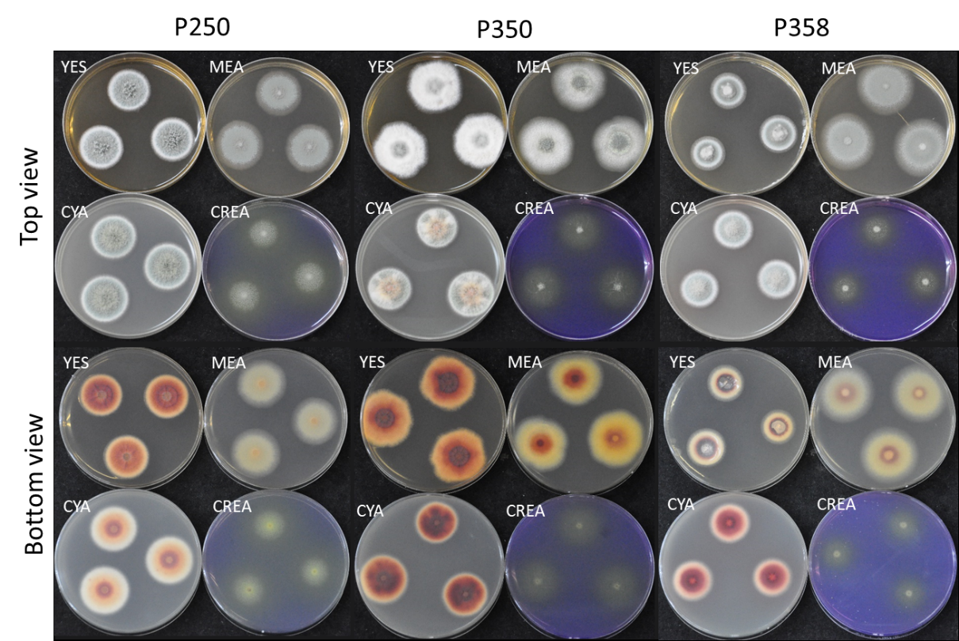
Supplementary Figure 1. Culture morphology of T. amestolkiae P250, P350, and P358 on different media. Abbreviations: YES, yeast extract sucrose agar; MEA, malt extract agar; CYA, Czapek yeast extract agar; CREA, creatine sucrose agar.

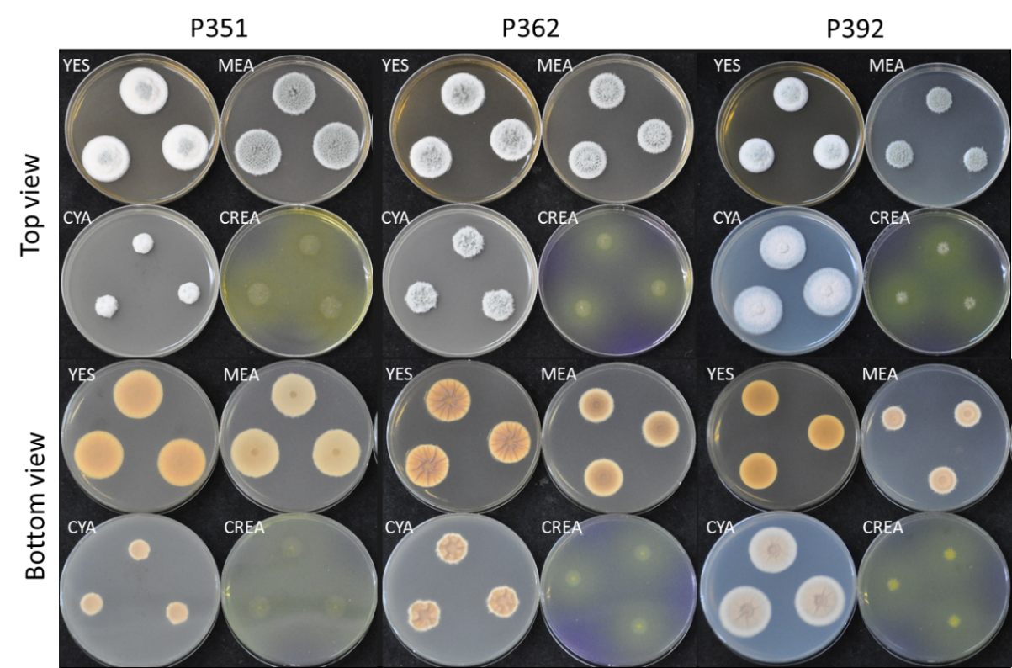
Supplementary Figure 2. Culture morphology of T. funiculosus P357, P362, and P392 on different media. Abbreviations: YES, yeast extract sucrose agar; MEA, malt extract agar; CYA, Czapek yeast extract agar; CREA, creatine sucrose agar.

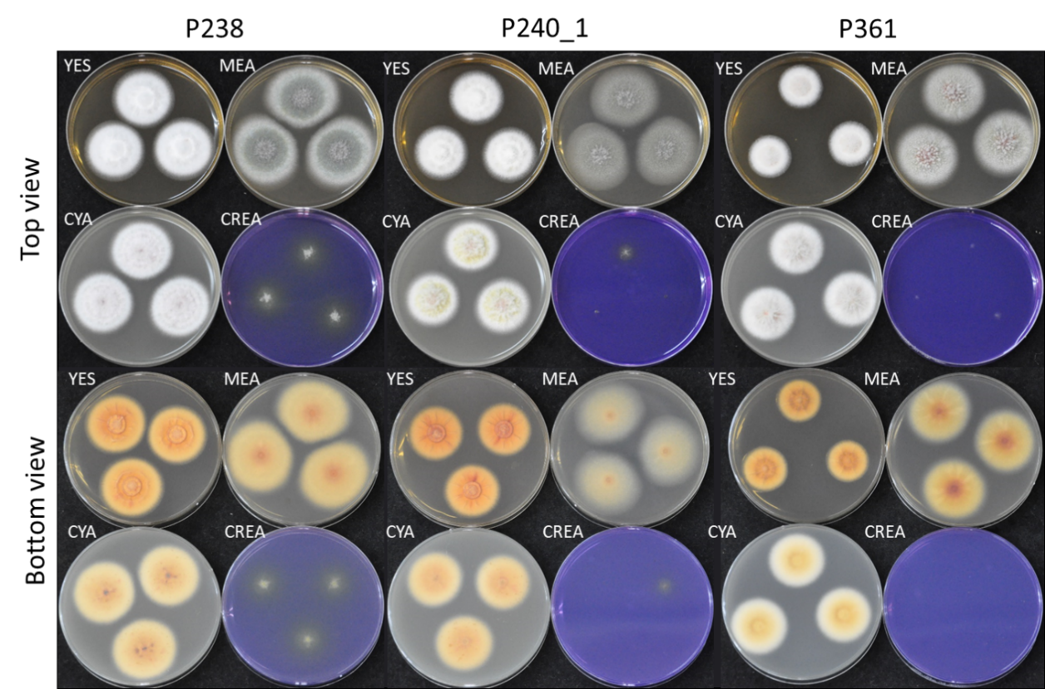
Supplementary Figure 3. Culture morphology of T. stollii P238, P240_1, and P361 on different media. Abbreviations: YES, yeast extract sucrose agar; MEA, malt extract agar; CYA, Czapek yeast extract agar; CREA, creatine sucrose agar.

