Supplementary Information
A synergistic dual-phase air electrode enables ultrahigh and durable performance of reversible proton ceramic electrochemical cells

Zuoqing Liu¹, Yuesheng Bai¹, Hainan Sun², Daqin Guan³, Wenhuai Li¹, Wei-Hsiang Huang⁴, Chih-Wen Pao⁴, Zhiwei Hu⁵, Guangming Yang^{1*}, Yinlong Zhu^{6*}, Ran Ran¹, Wei Zhou¹, Zongping Shao^{1,7*}

¹ State Key Laboratory of Materials-Oriented Chemical Engineering, College of Chemical Engineering, Nanjing Tech University, Nanjing, 211816, PR China
² Department of Materials Science and Engineering, Korea Advanced Institute of Science and Technology (KAIST), Daejeon, 34141, Republic of Korea
³ Department of Building and Real Estate, Research Institute for Sustainable Urban Development (RISUD) & Research Institute for Smart Energy (RISE), The Hong Kong Polytechnic University, Kowloon, China
⁴ National Synchrotron Radiation Research Center, 101 Hsin-Ann Road, Hsinchu 30076, Taiwan
⁵ Max-Planck-Institute for Chemical Physics of Solids, Nöthnitzer Str. 40, Dresden 01187, Germany
⁶ Institute for Frontier Science, Nanjing University of Aeronautics and Astronautics, Nanjing 210016, PR China
⁷ WA School of Mines: Minerals, Energy and Chemical Engineering (WASM-MECE), Curtin University, Perth, WA 6845, Australia
* Guangming Yang: ygm89525@njtech.edu.cn; Yinlong Zhu: zhuyl1989@nuaa.edu.cn; Zongping Shao: shaozp@njtech.edu.cn;

Supplementary Fig. 1 XRD patterns of C-BSCF, C/H-BSCF and H-BSCF.
The X-ray diffraction (XRD) patterns of Ba_{0.5}Sr_{0.5}Co_{0.8}Fe_{0.2}O_{3−δ} (C-BSCF), Ba_{1.5}Sr_{1.5}Co_{1.6}Fe_{0.4}O_{7−δ} (C/H-BSCF) and Ba₄Sr₄Co_{3.2}Fe_{0.8}O_{16−δ} (H-BSCF) powders after calcination at 1000 °C for 5 h in still air are shown in Supplementary Fig. 1. All observed peaks of the as-prepared C-BSCF oxide led to the cubic perovskite structure, while H-BSCF exhibits the characteristic peaks of hexagonal perovskite without any other impurity peaks present. Meanwhile, the diffraction peaks of the synthesized C/H-BSCF coincide with the superposition of C-BSCF and H-BSCF peaks, so it is tentatively concluded that C/H-BSCF is composed of cubic C-BSCF and hexagonal H-BSCF phases together.

Supplementary Fig. 2 XRD patterns of (Ba_{0.5}Sr_{0.5})_{x}Co_{0.8}Fe_{0.2}O_{2+x−δ} (BSCF-x, where x varies from 1 to 2 in increments of 0.1) oxides.
To investigate the applicability of the strategy of modulating the content of alkaline earth metals at the A-site to induce the formation of dual-phase hybrids, here we synthesized a number of air electrodes (Ba_{0.5}Sr_{0.5})_{x}Co_{0.8}Fe_{0.2}O_{2+x−δ} (BSCF-x, where x varies from 1 to 2 in increments of 0.1). The XRD patterns of the samples are shown in the Supplementary Fig. 2, which clearly reveals that C-BSCF and H-BSCF are single cubic and hexagonal perovskite phases, respectively, while the rest of the samples BSCF-x (x = 1.1, 1.2, 1.3, 1.4, 1.5, 1.6, 1.7, 1.8 and 1.9) show characteristic peaks of composites composed of cubic and hexagonal phases. In addition, it is observed from the peak intensities that the hexagonal phase content increases with the increase of the alkaline earth metal content at the A-site¹.

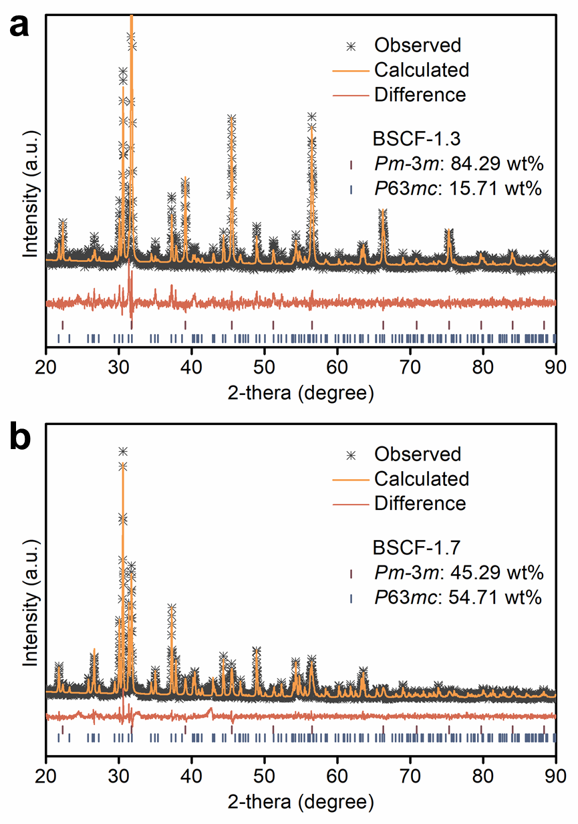
Supplementary Fig. 3 Refined XRD profiles of the prepared (a) BSCF-1.3 and (b) BSCF-1.7 oxides.
To determine the A-site modulation is capable of changing the ratio of the two phases in the hybrids², Rietveld refinement of the XRD data of the BSCF-1.3 and BSCF-1.7 samples was performed with the results shown in Supplementary Fig. 3a, b. The content of the cubic and hexagonal phases in the BSCF-1.3 sample was 84.29 wt% and 15.71 wt%, respectively. The cubic phase of the hybrid BSCF-1.3 has a space group of Pm-3m with lattice parameters of a = b = c = 3.9917(0) Å, and the hexagonal phase has a space group of P63mc with lattice parameters of a = b = 11.7077(2) Å and c = 6.9066(3) Å (Rexp = 4.90%, Rwp = 6.84%, GOF = 1.40). In addition, BSCF-1.7 samples contained 45.29 wt% and 54.71 wt% of cubic and hexagonal phases, respectively, and the lattice parameters of the two phases are shown in Supplementary Table 1.

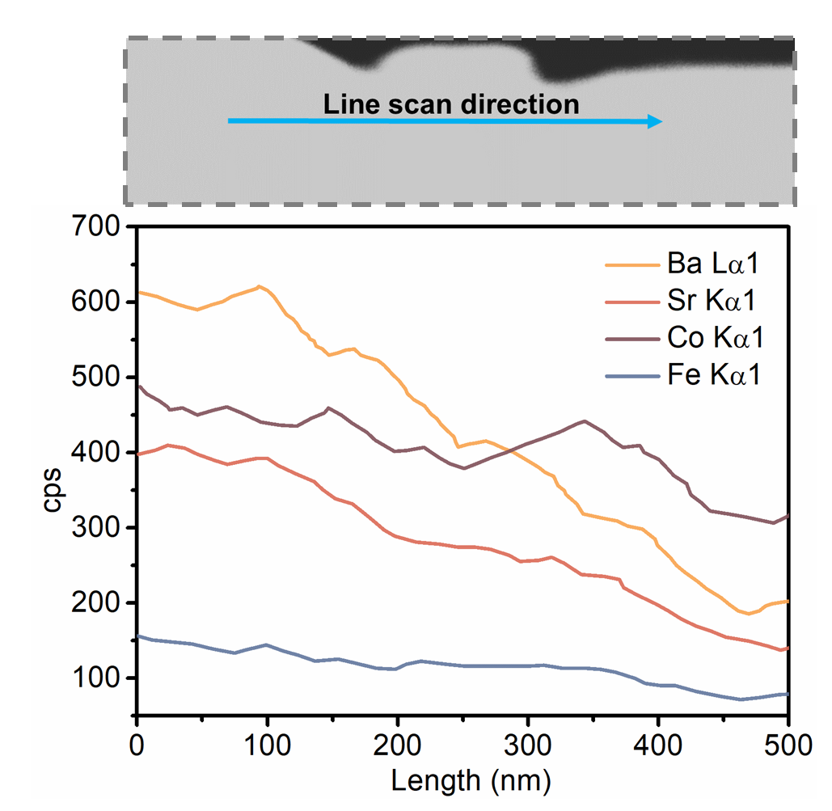
Supplementary Fig. 4 Energy dispersive X-ray (EDX) spectroscopy line-scan profiles of C/H-BSCF oxide.

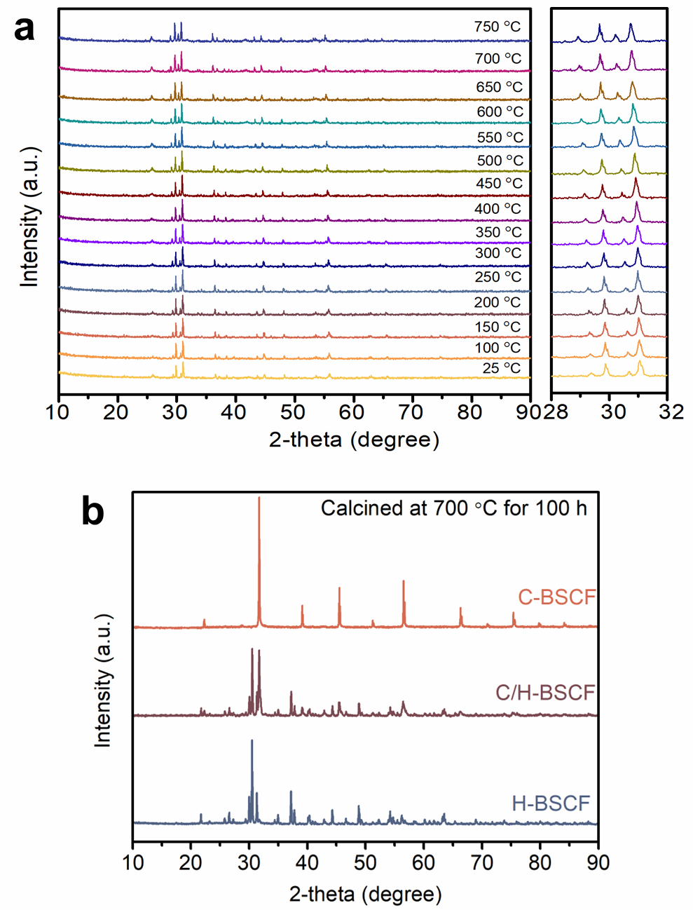
Supplementary Fig. 5 a High-temperature XRD patterns of C/H-BSCF. b XRD patterns of C-BSCF, C/H-BSCF and H-BSCF powders after calcination at 700 ℃ for 100h.
Through high temperature in-situ XRD, it can be clearly found that the C/H-BSCF powder still maintains a stable crystal structure in the temperature range from room temperature to 750 °C (Supplementary Fig. 5a). Meanwhile, the hybrid C/H-BSCF still shows the characteristic peaks of cubic and hexagonal phases without impurity peaks. With increasing temperature, reasonable lattice expansion was also found due to the shift of the characteristic peaks to lower degree³. Supplementary Fig. 5b exhibits the XRD patterns of C-BSCF, C/H-BSCF and H-BSCF powders after calcination at 700 °C for 100 h. It is observed that the three samples maintain their original phase structure and composition after long calcination, indicating that C-BSCF, C/H-BSCF and H-BSCF powders have excellent thermal stability.

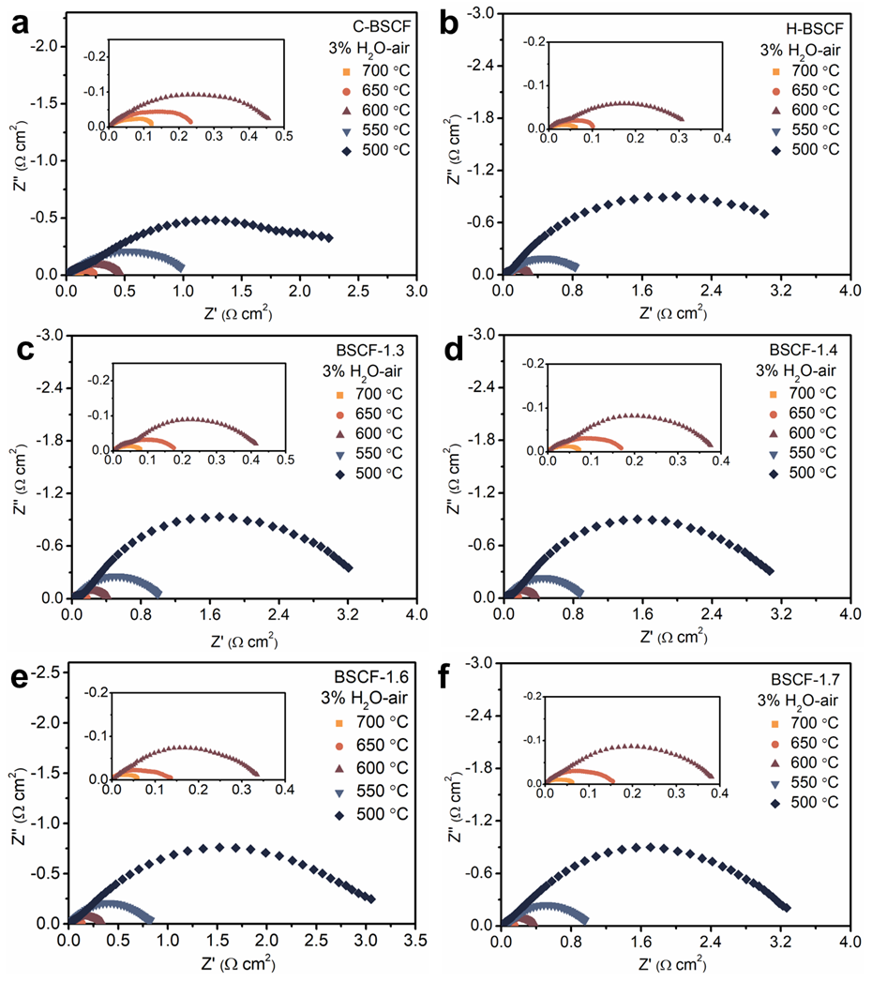
Supplementary Fig. 6 a-f EIS plots of BZCYYb-supported symmetric cells with C-BSCF, H-BSCF and BSCF-x electrode (x = 1.3, 1.4, 1.6 and 1.7) at 500-700 ℃ under 3% H₂O-air.
The oxygen activation performance of the air electrode was determined from the area specific resistance (ASR), which was obtained via electrochemical impedance spectroscopy (EIS) in a symmetrical cell (electrode |BZCYYb|electrode). The typical EIS of the symmetric cell with C-BSCF air electrode in 3% H₂O-air with ASRs of 0.126, 0.243, 0.478, 1.093 and 3.390 Ω cm² at 700, 650, 600, 550, and 500 °C, respectively, is shown in Supplementary Fig. 6a. Under the same test conditions, the ASRs of the symmetric cell with H-BSCF electrode are 0.063, 0.117, 0.343, 0.979 and 4.002 Ω cm² at 700, 650, 600, 550 and 500 °C, respectively. compared with the C-BSCF electrode, H-BSCF has better oxygen activation at higher temperatures, while the activity decays with decreasing temperature faster. Thus, owing to the synergistic effect of the dual phases, the hybrid air electrode has higher electrochemical activity than the C-BSCF at high temperatures, while the hybrid electrode outperforms the H-BSCF electrode at lower test temperatures. For instance, the cell with BSCF-1.4 electrode has the ASRs of 0.074, 0.171, 0.387, 0.909 and 3.245 Ω cm² at 700, 650, 600, 550, and 500 °C, respectively.

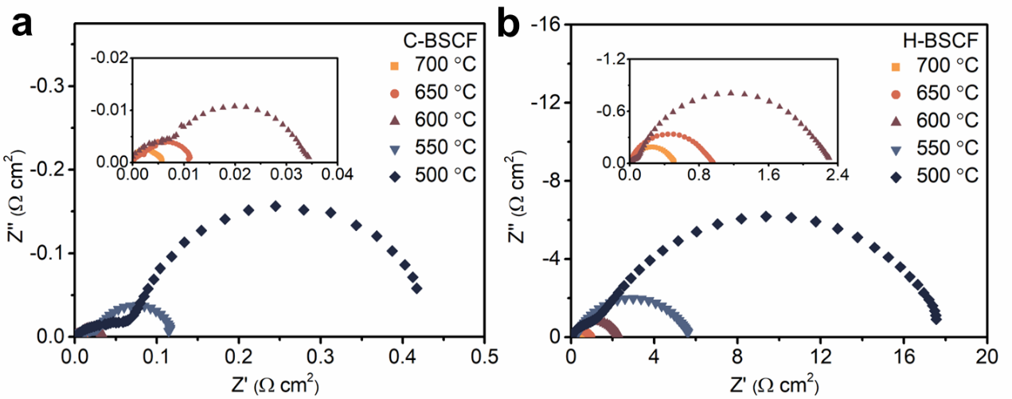
Supplementary Fig. 7 EIS of C-BSCF and H-BSCF electrodes on symmetric cells using SDC electrolyte at 500-700 ℃ under dry air.

Supplementary Fig. 8 EIS plots of symmetric cell with C/H-BSCF-PM electrode at 500-700 ℃ under 3% H₂O-air.
To gain insight into the dual-phase synergistic effect of the hybrid electrode C/H-BSCF on the ORR activity, we supplementally tested the EIS of the C/H-BSCF-PM air electrode prepared by physically mixing C-BSCF and H-BSCF powders. as shown in the supplementary Fig. 8, the EIS of this electrode is measured on a symmetric cell with ASRs of 0.08, 0.18, 0.47,1.20 and 3.56 Ω cm² at 3% H₂O-air at 700, 650, 600, 550 and 500 °C, respectively.

Supplementary Fig. 9 Arrhenius plot of the ASRs for C/H-BSCF and C/H-BSCF-PM electrodes.
Supplementary Fig. 9 shows the temperature dependence of ASR for the C/H-BSCF and C/H-BSCF-PM electrodes. the C/H-BSCF and C/H-BSCF-PM electrodes have similar activation energies of 1.21 and 1.22 eV, respectively. the similar temperature dependence of the two electrodes is attributed to the identical phase composition⁴. Furthermore, the C/H-BSCF electrode exhibits a lower ASR at 500-700 °C than the C/H-BSCF-PM electrode. This may be due to the better ion diffusion and surface mass transfer of the self-assembled electrodes compared to the electrodes prepared by physical mixing methods.

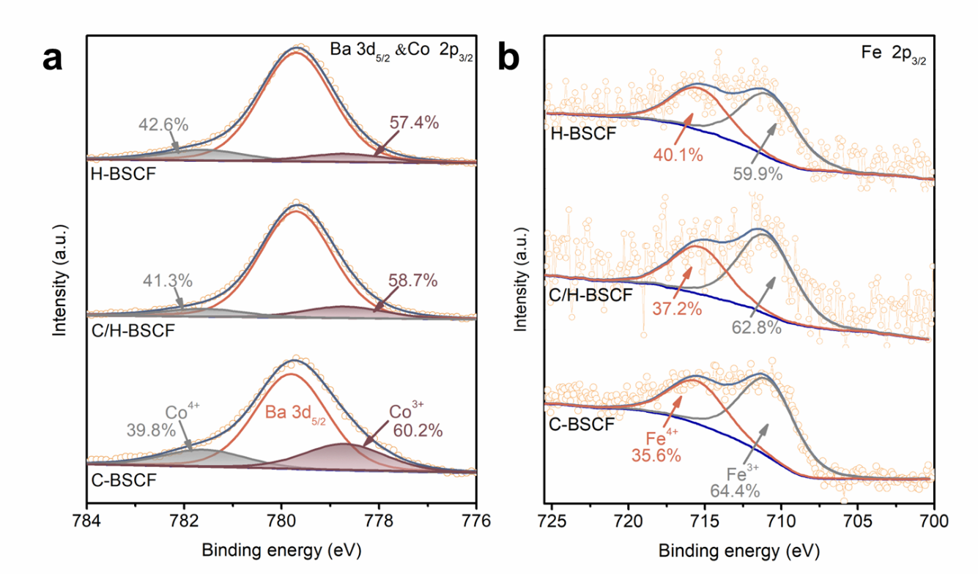
Supplementary Fig. 10 The XPS spectra of Co 2p_{3/2} and Fe 2p_{3/2} for C-BSCF, C/H-BSCF and H-BSCF.
In order to understand the initial oxidation states of air electrodes with different phase structures and compositions at room temperature, the valence states of Co and Fe in C-BSCF, C/H-BSCF and H-BSCF electrodes were investigated by X-ray photoelectron spectroscopy (XPS). The XPS fitted plots of Co 2p_{3/2} and Fe 2p_{3/2} in the C-BSCF, C/H-BSCF and H-BSCF samples are exhibited in Supplementary Fig. 10. The binding energies of Co³⁺ and Co⁴⁺ are 778.5 ± 0.3 and 781.5 ± 0.3 eV, respectively⁵. In the C-BSCF sample, the concentrations of Co³⁺ and Co⁴⁺ are 60.2% and 39.8%, while they are 57.4% and 42.6% for H-BSCF, respectively. As expected, the concentrations of Co³⁺ and Co⁴⁺ by the hybrid C/H-BSCF sample were intermediate between the single-phase C-BSCF and H-BSCF. Moreover, the Fe 2p_{3/2} spectra of C-BSCF, C/H-BSCF and H-BSCF were divided into two bands (Fe³⁺ and Fe⁴⁺)⁶. As displayed in Supplementary Fig. 10b, the valence of Fe in H-BSCF is slightly higher than that in C-BSCF and C/H-BSCF.

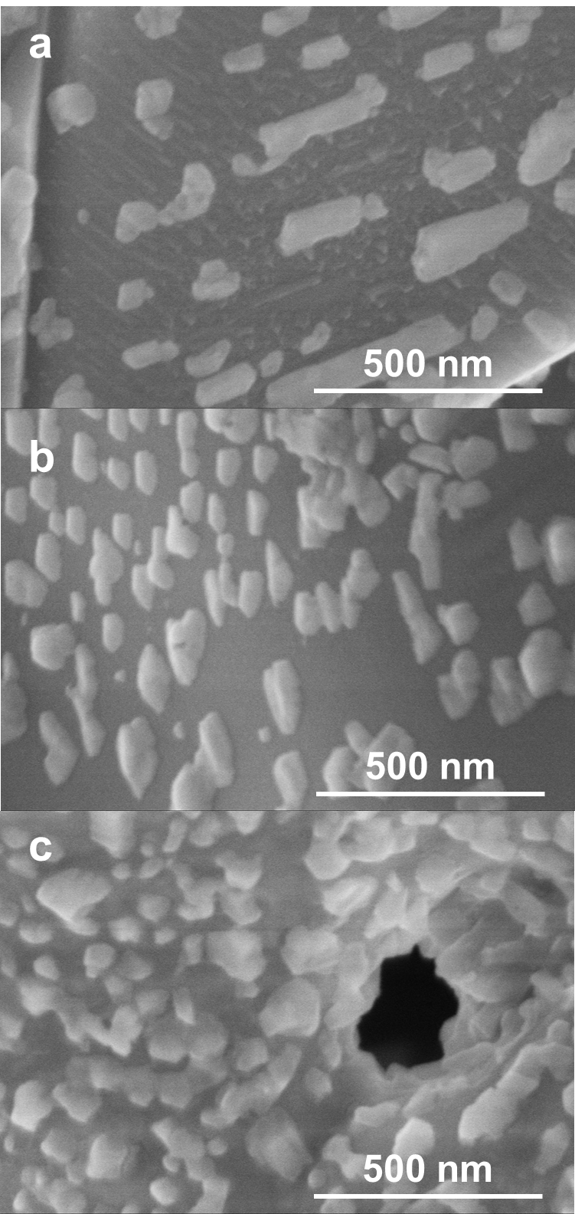
Supplementary Fig. 11 the SEM images of (a) C-BSCF, (b) C/H-BSCF and (c) H-BSCF powders.
The surface morphologies of C-BSCF, C/H-BSCF and H-BSCF powders after calcination in ambient air at 1000 °C for 5 h were obtained by scanning electron microscope (SEM). As shown in Supplementary Fig. 11, the surface of H-BSCF samples has more BaO particles compared to C-BSCF and C/H-BSCF, which was attributed to the higher content of alkaline earth metals in H-BSCF. In addition, more BaO particles on the surface of H-BSCF is beneficial to improve the ORR activity of the air electrode⁷.
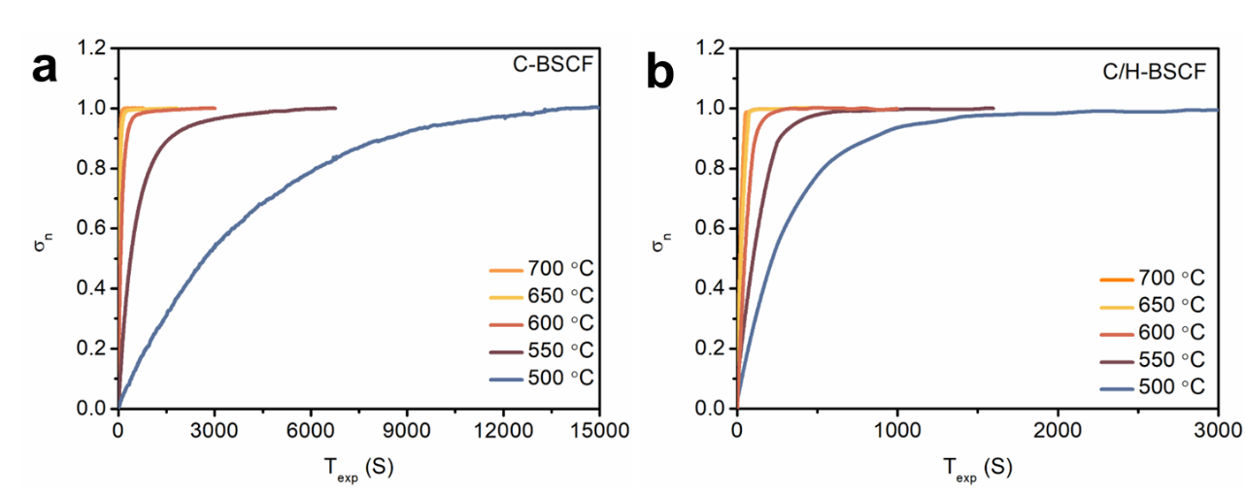
Supplementary Fig. 12 ECR curves for (a) C-BSCF and (b) C/H-BSCF samples at 500-700 °C with pO₂ changes from 21% to 10%.
The efficient descriptors (k_{chem} and D_{chem}) for catalytic activity of the air electrode materials were measured by the electrical conductivity relaxation (ECR) technique. Supplementary Fig. 12 shows the normalized conductivity response curves of the C-BSCF and C/H-BSCF samples at 500-700 °C after suddenly changing the pO₂ from 0.21 to 0.1 atm. The conductivity of C/H-BSCF sample was able to restabilize in a shorter time than C-BSCF sample after oxygen partial pressure conversion, indicating that C/H-BSCF has a faster rate of oxygen surface exchange and bulk phase diffusion.

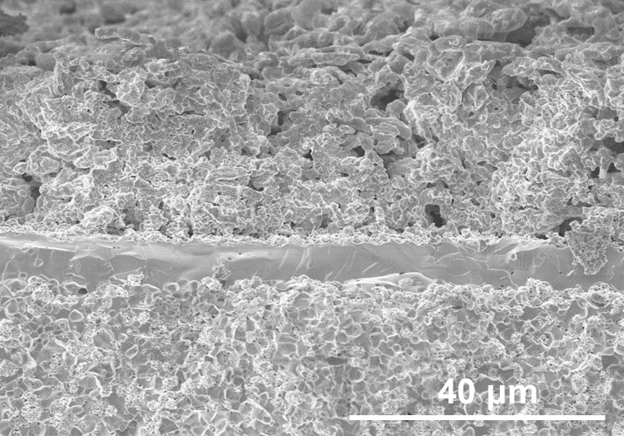
Supplementary Fig. 13 SEM image of R-PCEC with C/H-BSCF air electrode.
The highly active and stable C/H-BSCF air electrode was further applied to R-PCECs. Shown in Supplementary Fig. 13 is a cross-sectional view of a test cell, composed of a porous C/H-BSCF air electrode (≈30 μm), a thin (≈10 μm) BZCYYb electrolyte, and a NiO-BZCYYb fuel electrode.

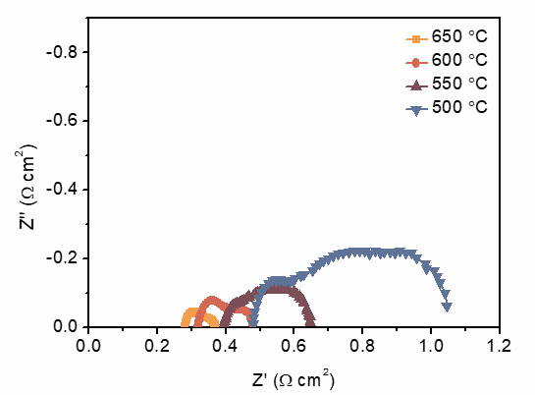
Supplementary Fig. 14 EIS of single cell with C/H-BSCF air electrode under open circuit voltage (OCV) condition at 500-650 ℃.
Supplementary Fig. 14 shows the typical EIS curves of the cell with the C/H-BSCF air electrode tested at 500-650 ℃ under open-circuit voltage (OCV) conditions. The cell performance was limited by ohmic resistance (R_{o}) at temperatures higher than 550 °C, while by polarization resistance (R_{p}) at temperatures lower than 550 °C. The cell with C/H-BSCF air electrode has R_{p} of 0.09, 0.16, 0.25 and 0.56 Ω cm² at 650, 600, 550 and 500 °C, respectively.

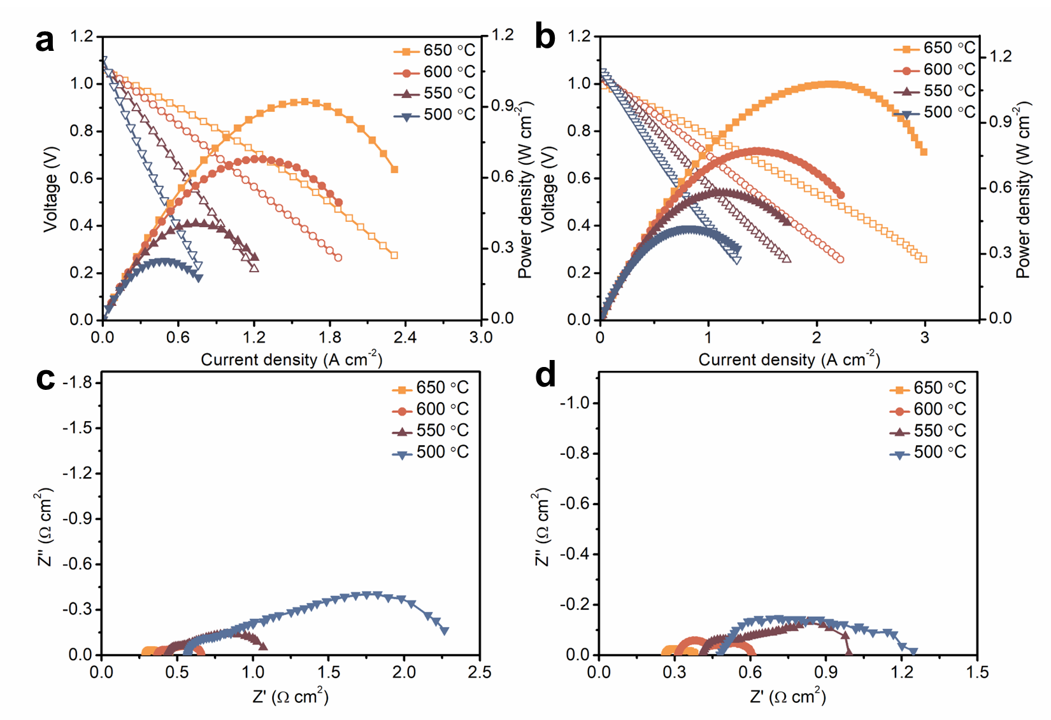
Supplementary Fig. 15 I-V and I-P curves and EIS of single cells with (a,c) C-BSCF and (b,d) H-BSCF air electrodes in FC mode at 500-650 ℃.
The electrochemical Performance of single cells with C-BSCF and H-BSCF air electrodes was extensively studied at 500-650 °C using dry hydrogen on the fuel electrode side and wet air (10% H₂O-air) on the air electrode side for R-PCECs, respectively. I-V and I-P curves of the C-BSCF cell in FC mode are presented in Supplementary Fig. 15a. The peak power densities (PPDs) of the C-BSCF cell were 0.25, 0.41, 0.68 and 0.92 W cm⁻² at 500, 550, 600 and 650 °C, respectively. Under the same test conditions, the cell using H-BSCF air electrode obtained higher performance compared to C-BSCF, e.g., PPD of 1.08 W cm⁻² at 650 °C. This indicates that H-BSCF has higher ORR activity than C-BSCF. In addition, EIS of single cells with C-BSCF and H-BSCF air electrodes were obtained as shown in Supplementary Fig. 15c, d, which further confirmed that due to the excellent catalytic activity of H-BSCF thus exhibited a smaller R_{p} than the C-BSCF electrode.

Supplementary Fig. 16 Arrhenius plots of the R_{p} of the C-BSCF, C/H-BSCF and H-BSCF air electrodes in FC mode.

Supplementary Fig. 17 I-V and I-P curves of single cell with C/H-BSCF-PM electrode in FC mode at 500-650 ℃.
To further verify the synergistic enhancement of the cubic and hexagonal phases, we prepared C/H-BSCF-PM air electrodes by physically mixing C-BSCF and H-BSCF in accordance with the two-phase ratio of hybrid C/H-BSCF. Supplementary Fig. 17 shows the I-V and I-P curves of single cell with C/H-BSCF-PM electrode in FC mode at 500-650 ℃. Despite the catalytic activity of the physically mixed BSCF-1.5-PM oxide is slightly less than that of the hybrid BSCF-1.5, BSCF-1.5-PM still showed good performance as an air electrode for R-PCECs in FC mode with PPDs of 1.47, 0.94, 0.68 and 0.45 W cm⁻² at 650, 600, 550 and 500 °C, respectively.

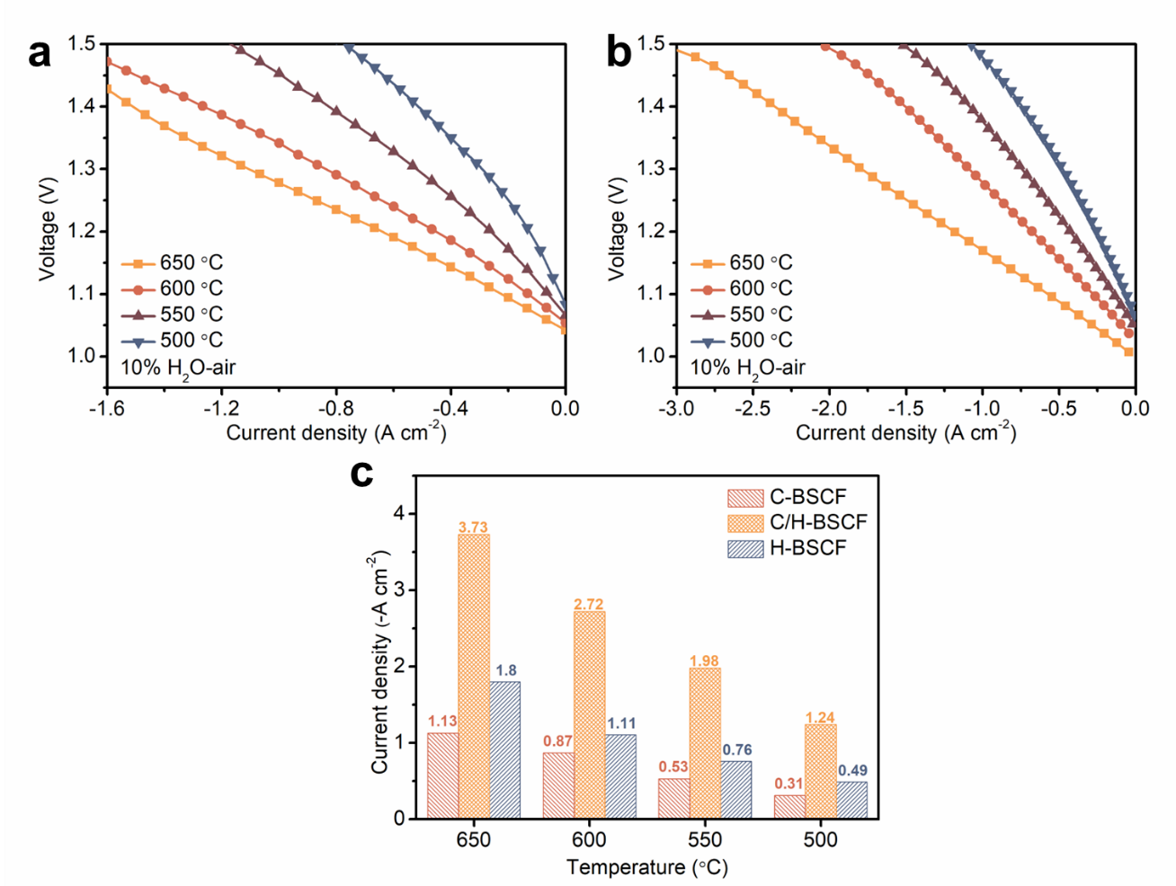
Supplementary Fig. 18 I-V curves of single cells with (a) C-BSCF and (b) H-BSCF air electrodes in EC mode at 500-650 °C. c Comparison of current densities at different temperatures for single cells with C-BSCF, C/H-BSCF and H-BSCF electrodes.
C-BSCF and H-BSCF as air electrodes for R-PCECs were also tested in electrolysis mode. Supplementary Fig. 18 shows the I-V curves of the single cells at 500-650 °C when the fuel electrode was exposed to dry hydrogen and the air electrode supplied with humidified air (10% H₂O-air). The current densities of H-BSCF electrode were -1.80, -1.11, -0.76 and -0.49 A cm⁻² at 650, 600, 550 and 500 °C, respectively, and the cell voltage was 1.3 V (Supplementary Fig. 18b). Compared with C-BSCF, C/H-BSCF and H-BSCF has excellent electrolytic performance (Supplementary Fig. 18c). For example, at 600 °C, the current density of C/H-BSCF is -2.72 A cm⁻², compared with C-BSCF and H-BSCF air electrodes (-0.87 and -1.11 A cm⁻²), which are improved by 213% and 145%, respectively. Such excellent electrolytic performance of the hybrid C/H-BSCF air electrode is attributed to the synergistic effect of two phases.

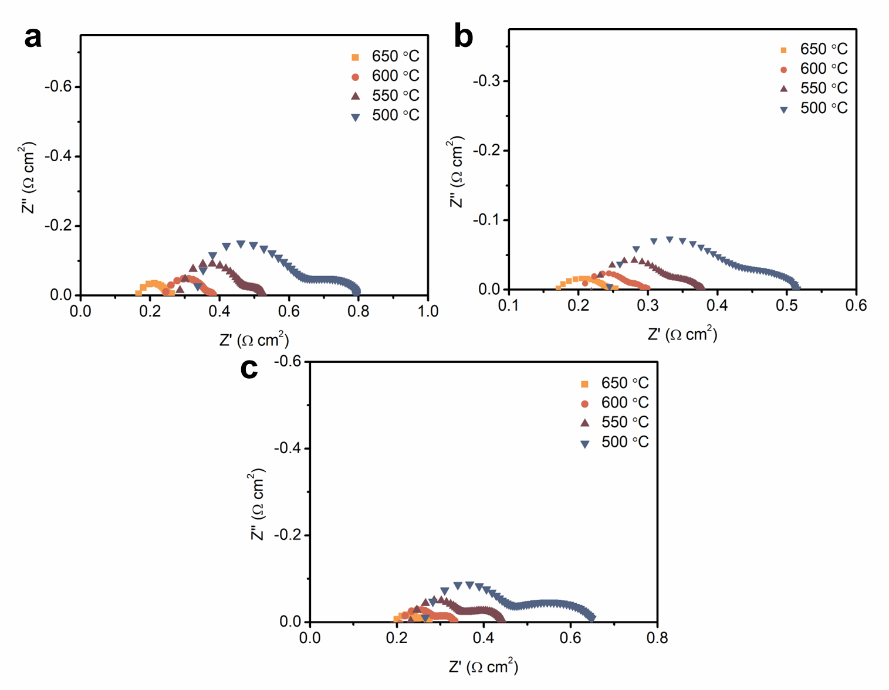
Supplementary Fig. 19 EIS of single cells with (a) C-BSCF, (b) C/H-BSCF and (c) H-BSCF air electrodes in EC mode at 500-650 ℃.
To reveal the excellent OER activity of the C/H-BSCF air electrode in EC mode, the EIS of the single cell with C/H-BSCF electrode was simultaneously measured under a constant voltage condition of 1.3 V with R_{p} values of 0.065, 0.110, 0.162 and 0.273 Ω cm² at 650, 600, 550 and 500 °C, respectively. At 600 °C, the cells of C-BSCF and H-BSCF electrodes have R_{p} of 0.152 and 0.135 Ω cm², respectively. therefore, the optimal performance obtained for C/H-BSCF electrodes at similar R_{o} is attributed to their excellent OER activity.

Supplementary Fig. 20 I-V curves of single cell with C/H-BSCF-PM air electrode in EC mode at 500-650 °C
I-V curves of a single cell with a C/H-BSCF-PM air electrode in EC mode were measured for the evaluation of the OER activity of the electrode with a hybrid of cubic and hexagonal phases. As shown in Supplementary Fig. 20, cell with C/H-BSCF-PM electrode measured high performance of -2.15, -1.23, -0.79 and -0.45 A cm⁻² at 650, 600, 550 and 500 °C under 10% H₂O-air, respectively, further confirming the result that the dual-phase hybrid oxide has better OER catalytic activity than either phase acting alone.

Supplementary Table 1. XRD refinements information of BSCF-x samples (x = 1, 1.3, 1.5, 1.7 and 2).
Sample | Crystal parameters |  | Phase proportions (wt.%) |  | Refinement parameters
C-BSCF | Cubic  (Pm-3m) | a = 3.9865(3)  b = 3.9865(3)  c = 3.9865(3) |  | 100 | R_{exp} = 5.19  R_{wp} = 5.61  GOF = 1.08
BSCF-1.3 | Cubic  (Pm-3m) | a = 3.9917(0)  b = 3.9917(0)  c = 3.9917(0) |  | 84.29 | R_{exp} = 4.90  R_{wp} = 6.84  GOF = 1.40
BSCF-1.3 | hexagonal (P63mc) | a = 11.7077(2)  b = 11.7077(2)  c = 6.9066(3) |  | 15.71 | R_{exp} = 4.90  R_{wp} = 6.84  GOF = 1.40
C/H-BSCF | Cubic  (Pm-3m) | a = 3.9875(7)  b = 3.9875(7)  c = 3.9875(7) |  | 60.63 | R_{exp} = 5.44  R_{wp} = 5.94  GOF = 1.09
C/H-BSCF | hexagonal (P63mc) | a = 11.7080(9)  b = 11.7080(9)  c = 6.9082(9) |  | 39.37 | R_{exp} = 5.44  R_{wp} = 5.94  GOF = 1.09
BSCF-1.7 | Cubic  (Pm-3m) | a = 3.9876(0)  b = 3.9876(0)  c = 3.9876(0) |  | 45.29 | R_{exp} = 5.12  R_{wp} = 6.28  GOF = 1.23
BSCF-1.7 | hexagonal (P63mc) | a = 11.7113(0)  b = 11.7113(0)  c = 6.9050(6) |  | 54.71 | R_{exp} = 5.12  R_{wp} = 6.28  GOF = 1.23
H-BSCF | hexagonal (P63mc) | a = 11.7115(7)  b = 11.7115(7)  c = 6.9075(4) |  | 100 | R_{exp} = 5.53  R_{wp} = 8.81  GOF = 1.59

Supplementary Table 2. ASR values for the impedance spectra of symmetric cells with C-BSCF, H-BSCF and BSCF-x (x = 1.3, 1.4, 1.5, 1.6 and 1.7) electrodes in the temperature range of 500-700 ℃ under 3% H₂O-air.
 | ASR (Ω cm²)
 | 700 ℃ | 650 ℃ | 600 ℃ | 550 ℃ | 500 ℃
C-BSCF | 0.126 | 0.243 | 0.478 | 1.093 | 3.390
BSCF-1.3 | 0.081 | 0.186 | 0.426 | 1.023 | 3.407
BSCF-1.4 | 0.074 | 0.171 | 0.387 | 0.909 | 3.245
BSCF-1.5 | 0.050 | 0.110 | 0.260 | 0.680 | 2.129
BSCF-1.6 | 0.060 | 0.143 | 0.357 | 0.828 | 3.311
BSCF-1.7 | 0.061 | 0.160 | 0.390 | 0.980 | 3.450
H-BSCF | 0.063 | 0.117 | 0.343 | 0.979 | 4.002

Supplementary Table 3. The fitted values of D_{chem} (cm² s⁻¹) and k_{chem} (cm s⁻¹) of C-BSCF and C/H-BSCF samples at 500-700 °C.
 |  |  | 700 °C | 650 °C | 600 °C | 550 °C | 500 °C
C-BSCF | D_{chem} |  | 2.27×10⁻⁴ | 1.33×10⁻⁴ | 4.64×10⁻⁵ | 7.94×10⁻⁶ | 1.42×10⁻⁶
C-BSCF | k_{chem} |  | 0.00251 | 0.00135 | 4.63×10⁻⁴ | 7.80×10⁻⁵ | 1.46×10⁻⁵
C/H-BSCF | D_{chem} |  | 4.88×10⁻⁴ | 3.17×10⁻⁴ | 1.47×10⁻⁴ | 6.00×10⁻⁵ | 1.99×10⁻⁵
C/H-BSCF | k_{chem} |  | 0.00469 | 0.00298 | 0.00136 | 5.48×10⁻⁴ | 1.78×10⁻⁴

References
1. Zhong, F. et al. Geometric structure distribution and oxidation state demand of cations in spinel Ni_{x}Fe_{1-x}Co₂O₄ composite cathodes for solid oxide fuel cells. Chem. Eng. J. 425, 131822 (2021).
2. Guan, D. et al. Utilizing ion leaching effects for achieving high oxygen-evolving performance on hybrid nanocomposite with self-optimized behaviors. Nat. Commun. 11, 3376 (2020).
3. Kim, J. H. et al. Self-assembled nano-composite perovskites as highly efficient and robust hybrid cathodes for solid oxide fuel cells. J. Mater. Chem. A 10, 2496-2508 (2022).
4. Pei, K. et al. Constructing an active and stable oxygen electrode surface for reversible protonic ceramic electrochemical cells. Appl. Catal. B: Environ. 330, 122601 (2023).
5. Kuai, X. et al. Boosting the activity of BaCo_{0.4}Fe_{0.4}Zr_{0.1}Y_{0.1}O_{3−δ} perovskite for oxygen reduction reactions at low‐to‐intermediate temperatures through tuning B‐site cation deficiency. Adv. Energy Mater. 9, 1902384 (2019).
6. Liu, Z. et al. Robust bifunctional phosphorus-doped perovskite oxygen electrode for reversible proton ceramic electrochemical cells. Chem. Eng. J. 450, 137787 (2022).
7. Zhu, Y. et al. Oxygen activation on Ba-containing perovskite materials. Sci. Adv. 8, eabn4072 (2022).

