Table 1. The distribution of established demographic, clinical and radiological predictors of pre-treatment rebleeding post aSAH amongst patients of the reviewed prediction model formulation cohorts EVD, external ventricular drain. CT, computerised tomography. SBP, systolic blood pressure. WFNS, World Federation of Neurosurgical Societies. mFisher, modified Fisher. SD, standard deviation. IQR, interquartile range.
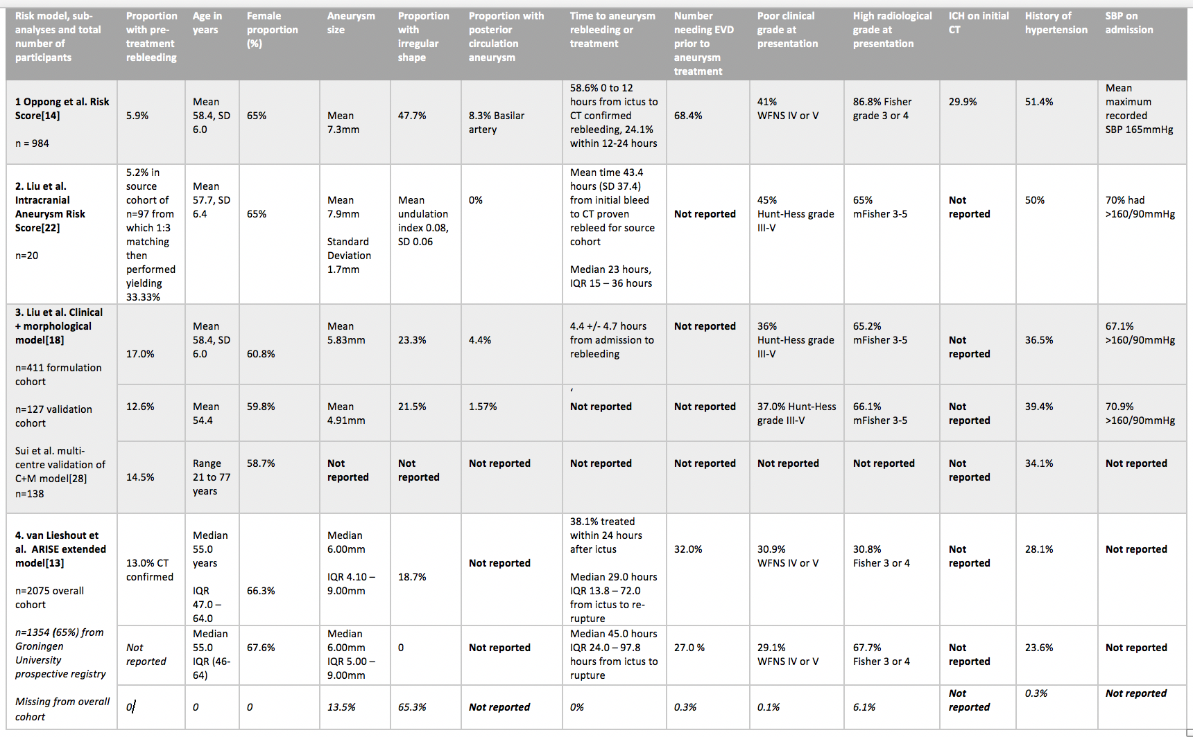
Risk model, sub-analyses and total number of participants | Area under the receiver operator characteristic curve or Harrell’s concordance statistic | 95% Confidence Intervals | p-value
1. Oppong et al. Risk Score [14]  n = 984 | 0.780 | Not reported | <0.001
2. Liu et al. Intracranial Aneurysm Risk Score [22]  n=20 | 0.793 | 0.559 – 0.967 | 0.025
3. Liu et al. Clinical + Morphological model [18]  n=411 formulation cohort  n=127 validation cohort  Sui et al. multi-centre validation of C+M model [28]  n=138 | 0.830 | 0.780 – 0.900 | <0.001
 | 0.860 | 0.750 – 0.980 | <0.001
 | 0.939 | Not reported | <0.001
4. van Lieshout et al. ARISE extended model [16]  n=2075 | 0.80  0.79 (optimism corrected) | Not reported | Not reported
Table 2. The discriminatory performance of each reviewed predictive model.

