Supplementary S – TRIPOD-SRMA Checklist for manuscript
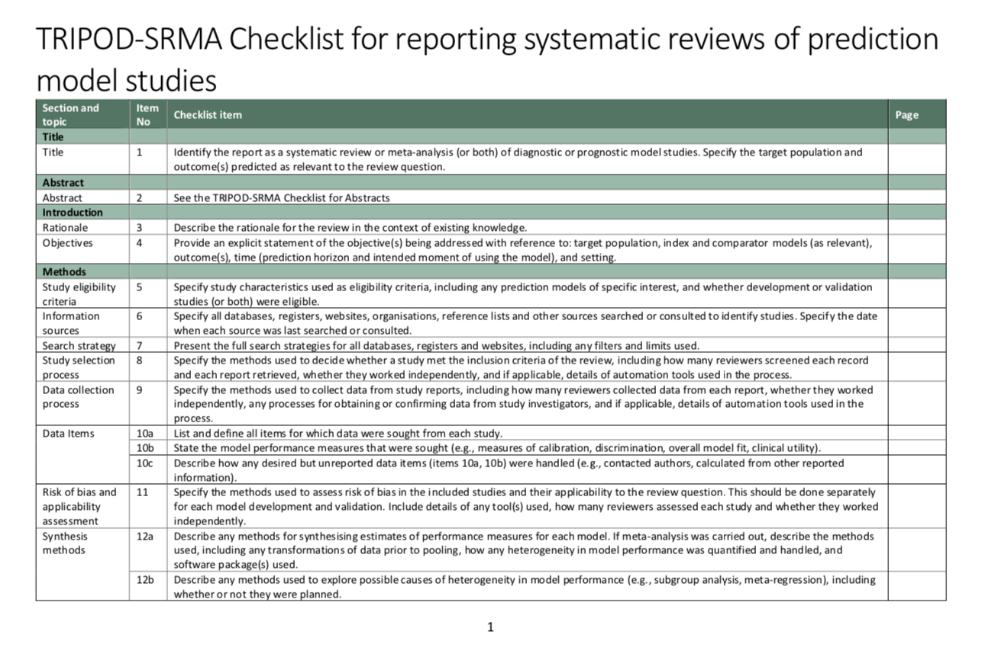
N/A
4, 7
4
4, 5, 13
4, 13
3, 4, 12
17
3
3
3
3
3
3
NA
1
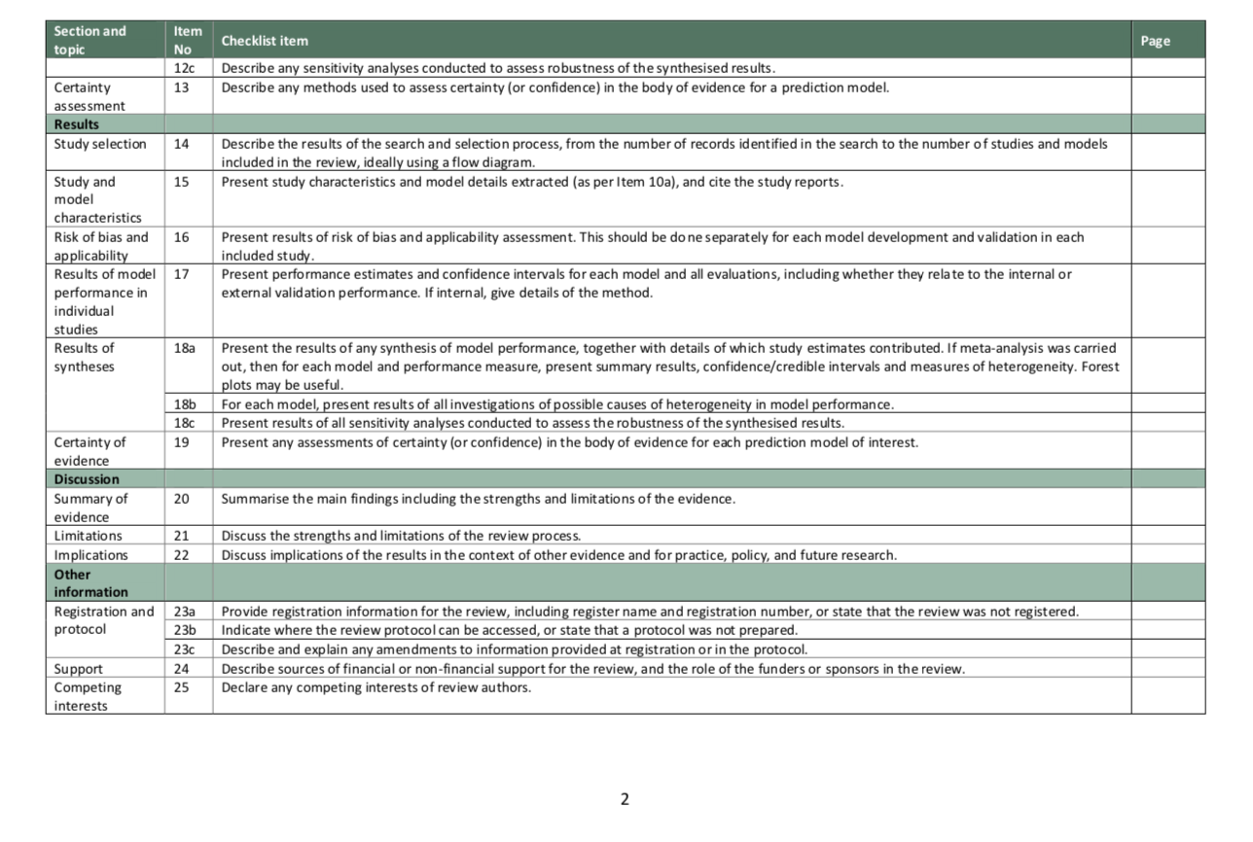
1 - NA
1 - NA
NA
3
3
7, 8
7
7
6, 11
NA
4,5,6,7
5, 6 ,13
5, 6 ,13
7
4,5,6 12
4, 10
4
N/A
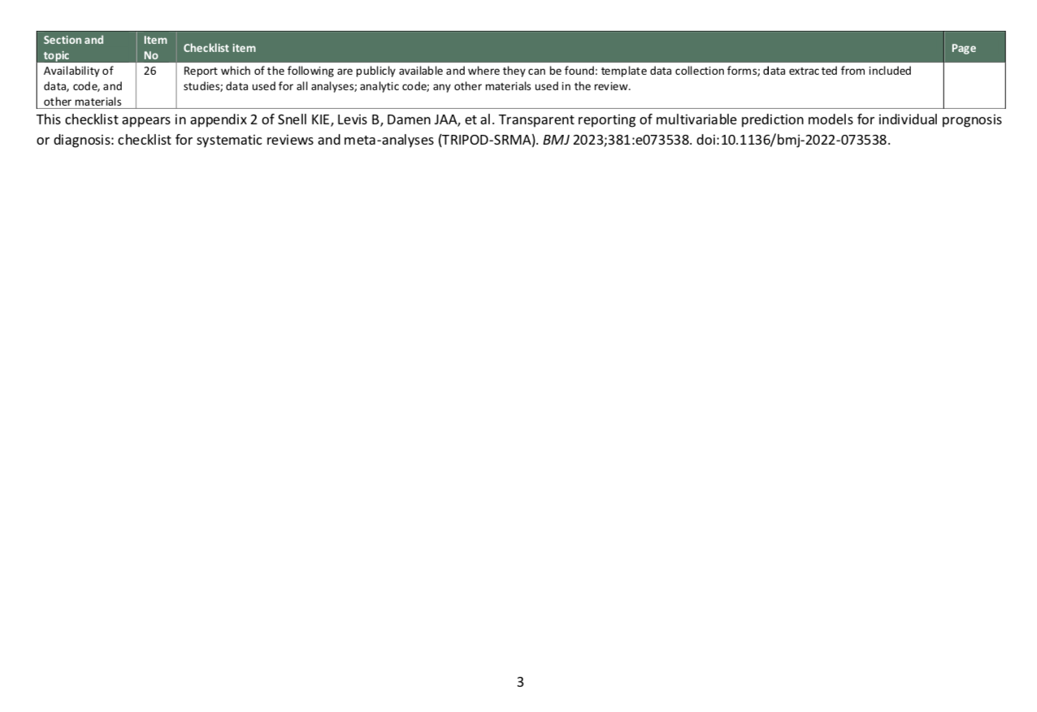
3,4,12, 17 1

Supplementary S2 – Search Syntax

Pubmed
(("subarachnoid hemorrhage"[mesh] or "subarachnoid"[tw] or "subarachnoid"[tw] or sah*[tw] or "subarachnoid hemorrhage"[tw] or "subarachnoid haemorrhage"[tw] or "subarachnoid haemorrhage"[tw] or "subarachnoid haemorrhage"[tw]) and ("rebleed prediction model"[tw] or "rebleed models"[tw] or r bleed model*[tw] or "rebleed prediction model"[tw] or "rerupture model"[tw] or "re-rupture models"[tw] or re-rupture model*[tw] or "rerupture model"[tw] or "rebleed models"[tw] or r rupture prediction model*[tw] or "rebleed predictive model"[tw] or "rerupture predictive models"[tw] or r bleed predictive model*[tw])) or (("sah"[mesh] or "subarachnoid hemorrhage"[tw] or "subarachnoid haemorrhage"[tw] or subarachnoid*[tw] or "subarachnoid hemorrhage"[tw] or "re-bleed"[tw] or "aneurysm rebleed"[tw] or "cerebral aneurysm rebleed"[tw]) and ("rebleed prediction"[mesh] and ("models, theoretical"[mesh:noexp] or "models, statistical"[mesh]))) or (("cerebral aneurysm"[majr] or "aneurysmal sah"[ti] or "aneurysm rerupture"[ti] or aneurysm rebleed*[ti] or "subarachnoid "[ti] or "subarachnoid hemorrhage"[ti] or "sah rebleed"[ti] or "subarachnoid rebleed"[ti]) and (("prognosis"[mesh] or "prognosis"[ti] or prognostic*[ti] or prognos*[ti] or "prediction"[ti] or "predictive"[ti]) and ("models, theoretical"[mesh:noexp] or "models, statistical"[mesh] or "model"[ti] or "models"[ti] or model*[ti])))

Embase
((subarachnoid or arachnoid) adj6 (haemorrhage$ or hemorrhage$ or bleed$ or blood$)).tw. AND prediction/

GoogleScholar
prediction model rebleed OR rerupture OR re-bleed OR re-rupture "subarachnoid”

