Additional file 1

Mining structural information in gas chromatography–mass spectrometry data for analytical-descriptor-based quantitative structure–activity relationship

Yasuyuki Zushi ^{1,2*}
¹ Research Institute of Science for Safety and Sustainability, National Institute of Advanced Industrial Science and Technology, Japan
² Graduate School of Science and Technology, University of Tsukuba, Japan

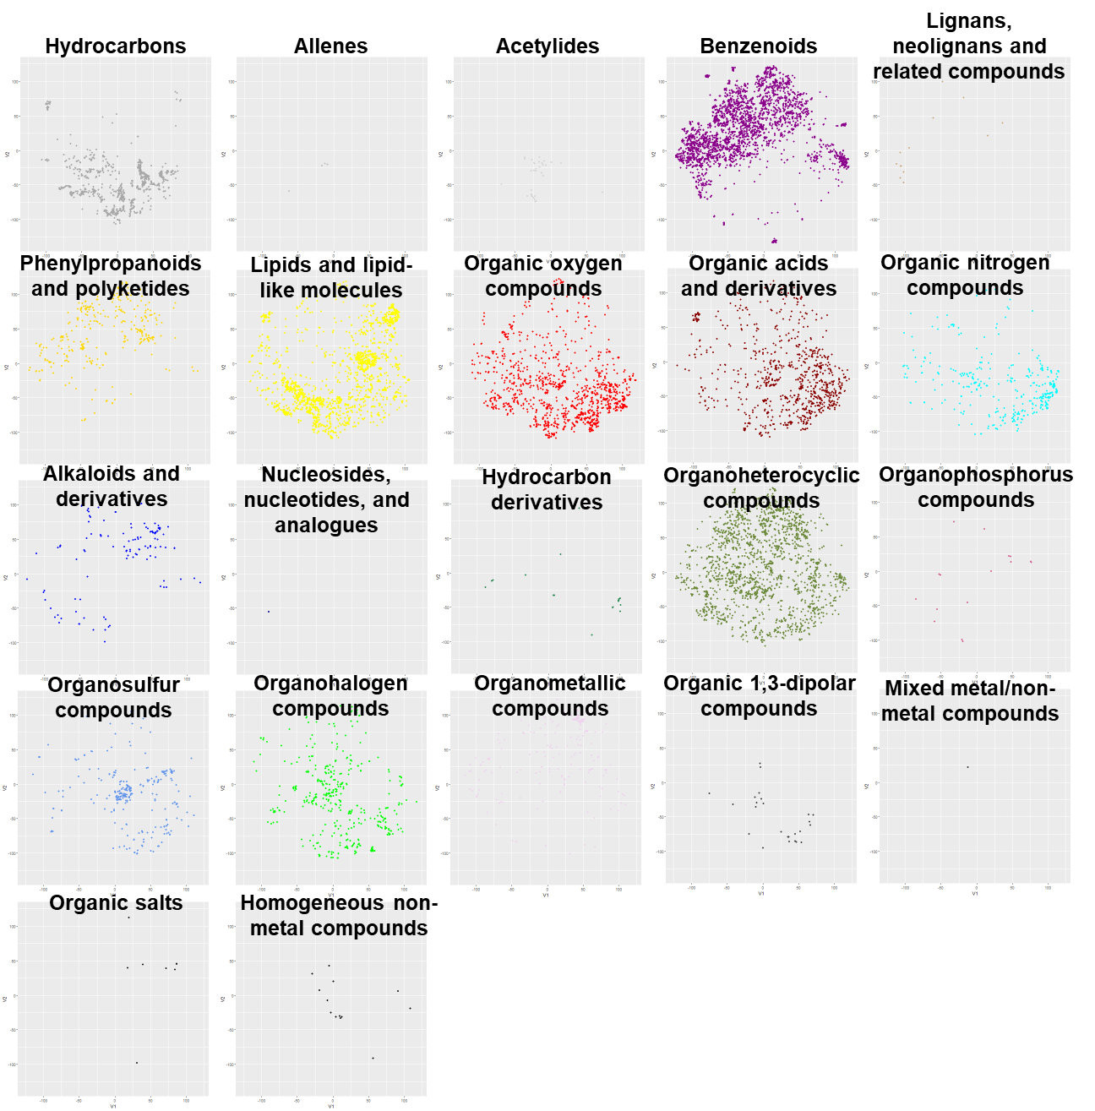
Figure S-1. t-SNE map based on standardized analytical descriptor for each superclass using ClassyFire.
See Figure 1 for color legends.

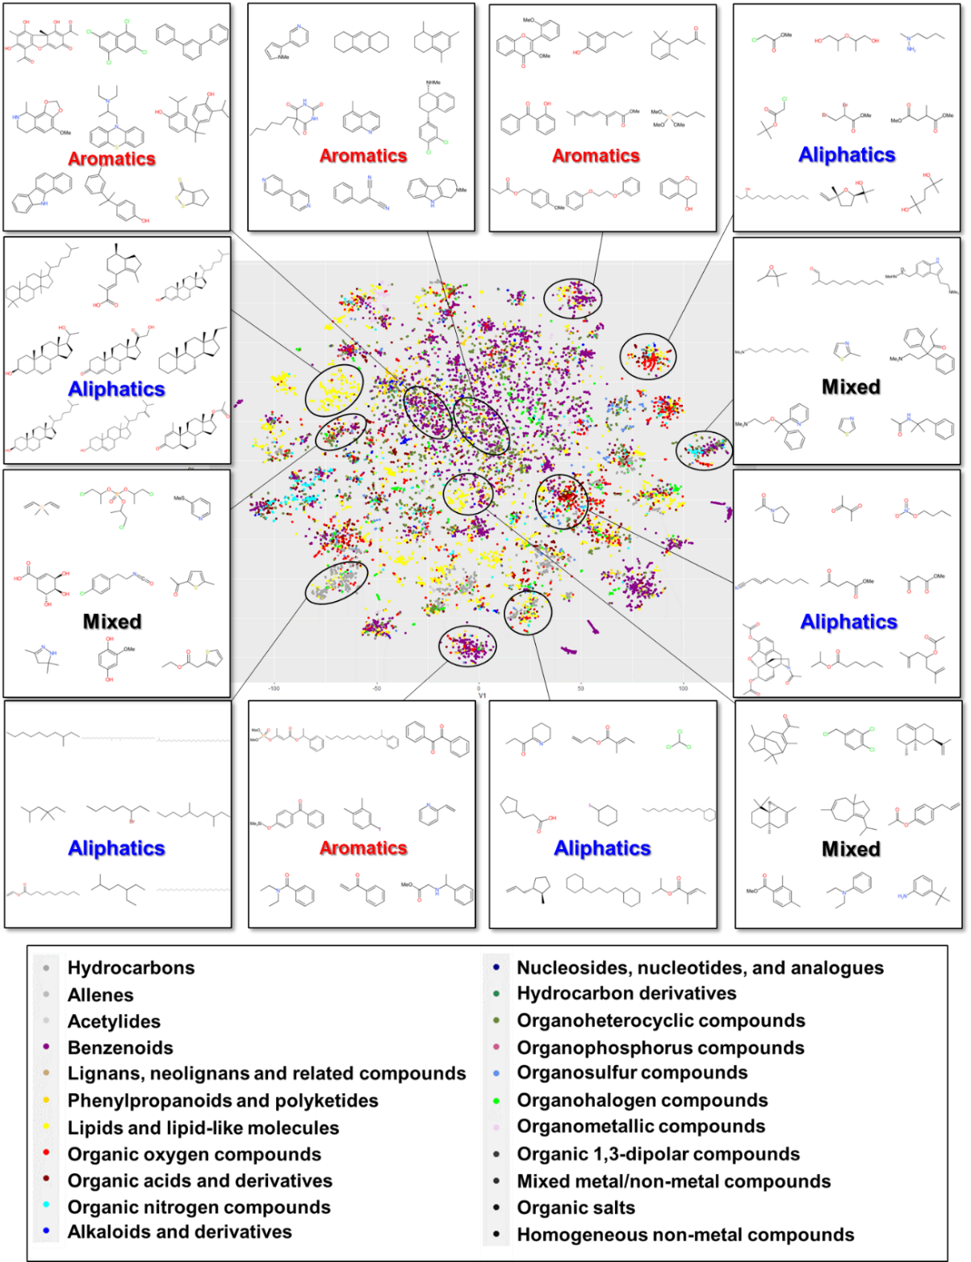
Figure S-2. t-SNE map based on analytical descriptor without standardization
The colors of the plots indicate the superclasses of chemicals obtained using ClassyFire.
The circled clusters were designated as aliphatics, aromatics, or mixed based on the chemical structure of their predominant members.

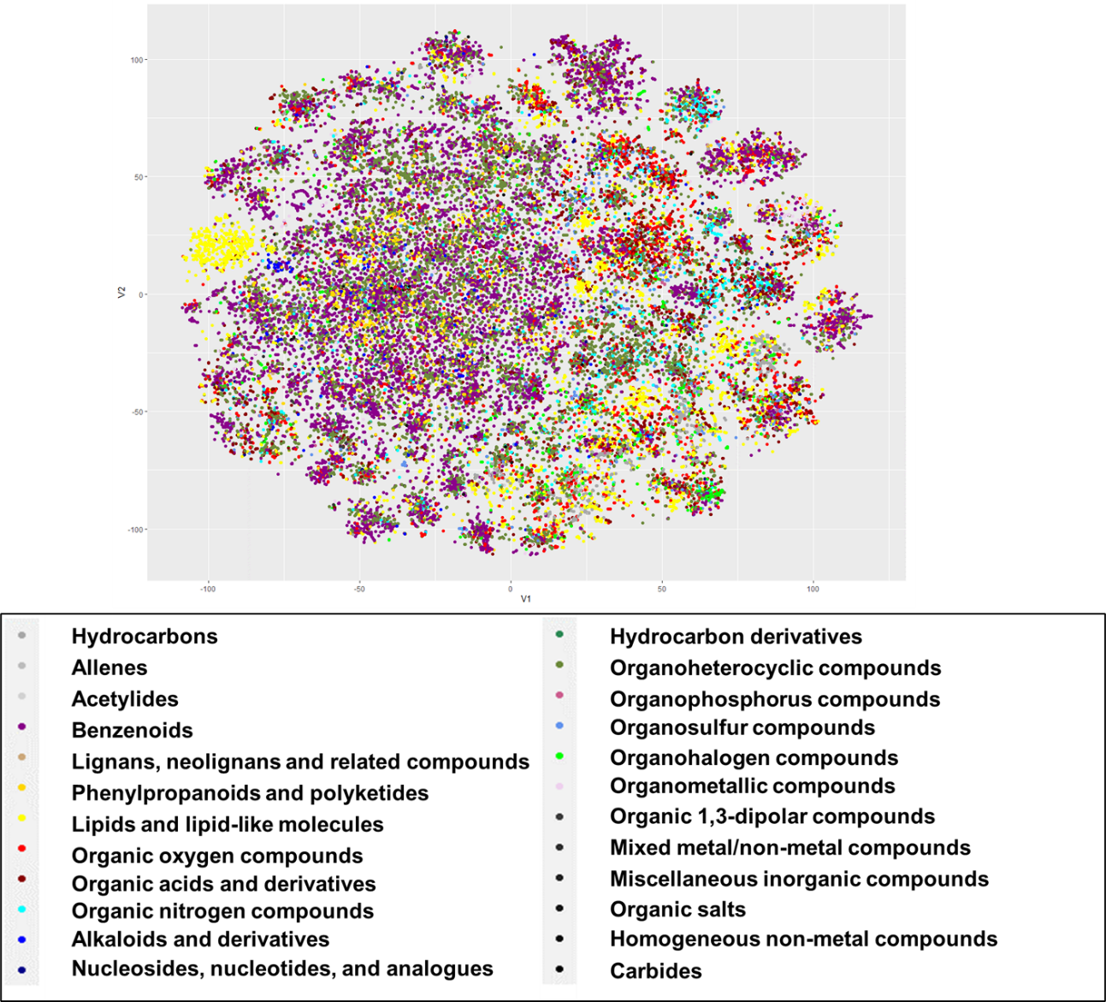
Figure S-3. t-SNE map based on analytical descriptor without standardization
For all available data analyzed using GC-MS.

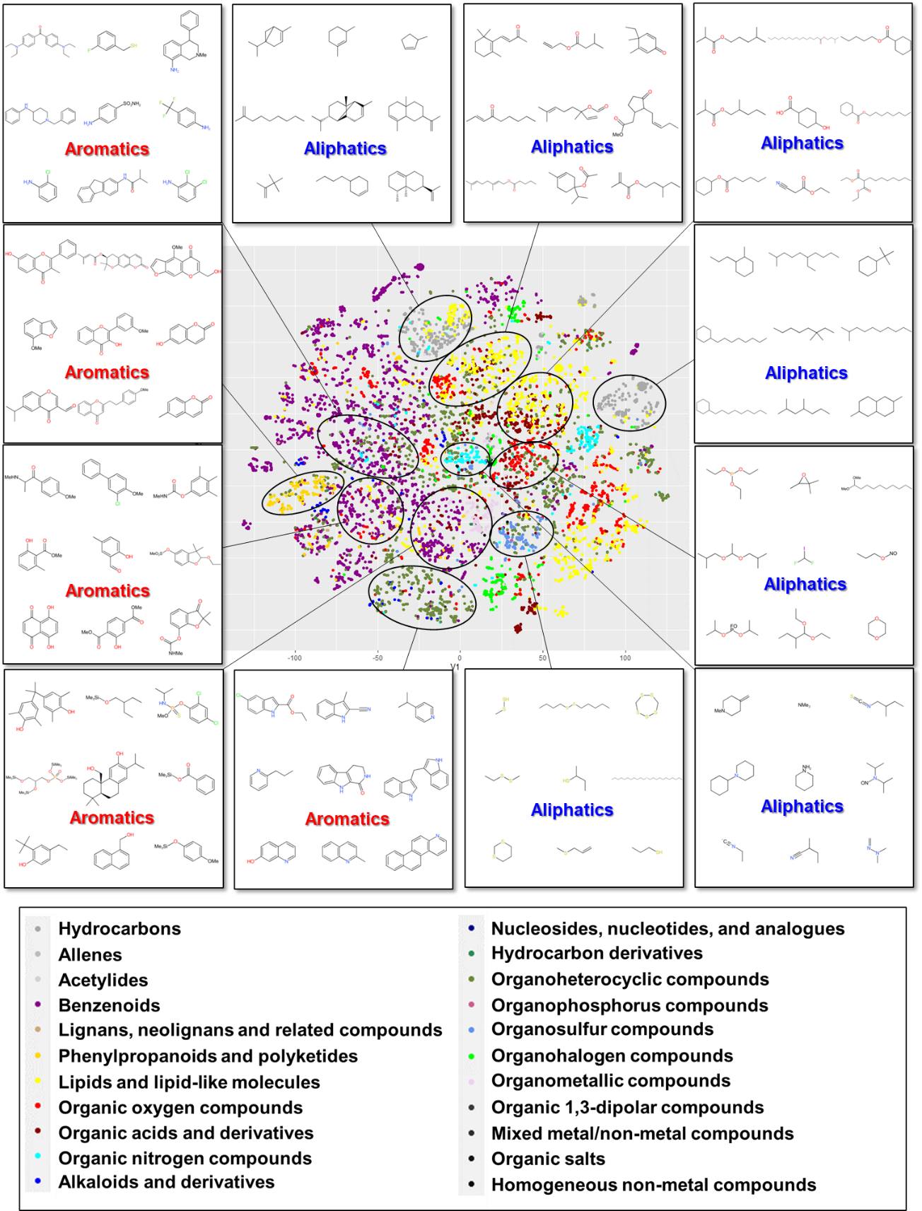
Figure S-4. t-SNE map based on a molecular descriptor (PubChem fingerprint)
The colors of the plots indicate the superclasses of chemicals obtained using ClassyFire.
The circled clusters were designated as aliphatics, aromatics, or mixed based on the chemical structure of their predominant members.

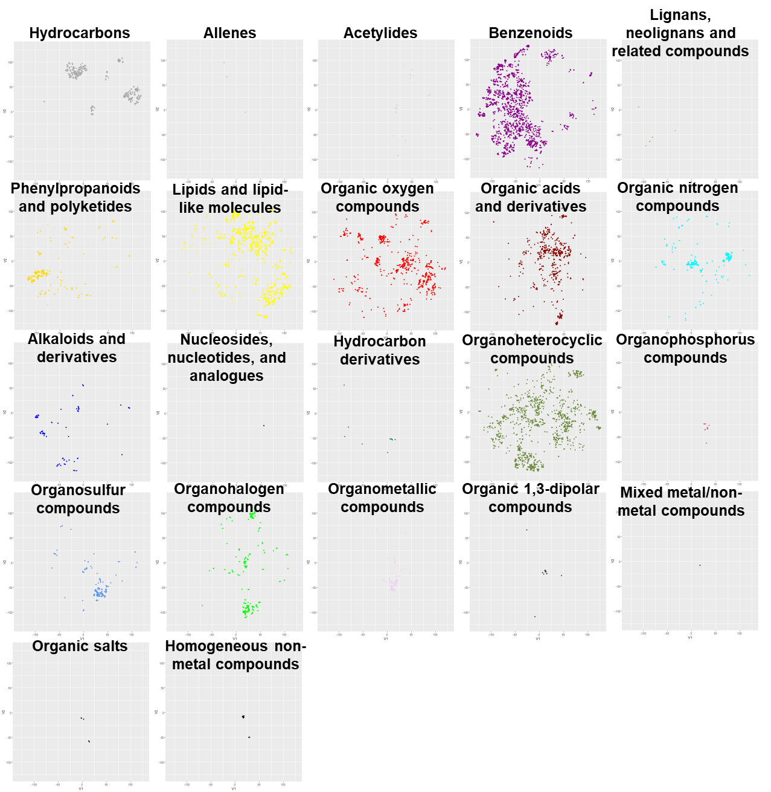
Figure S-5. t-SNE map based on molecular descriptor (PubChem fingerprint)
For each superclass by ClassyFire. See Figure S-4 for the color legend.

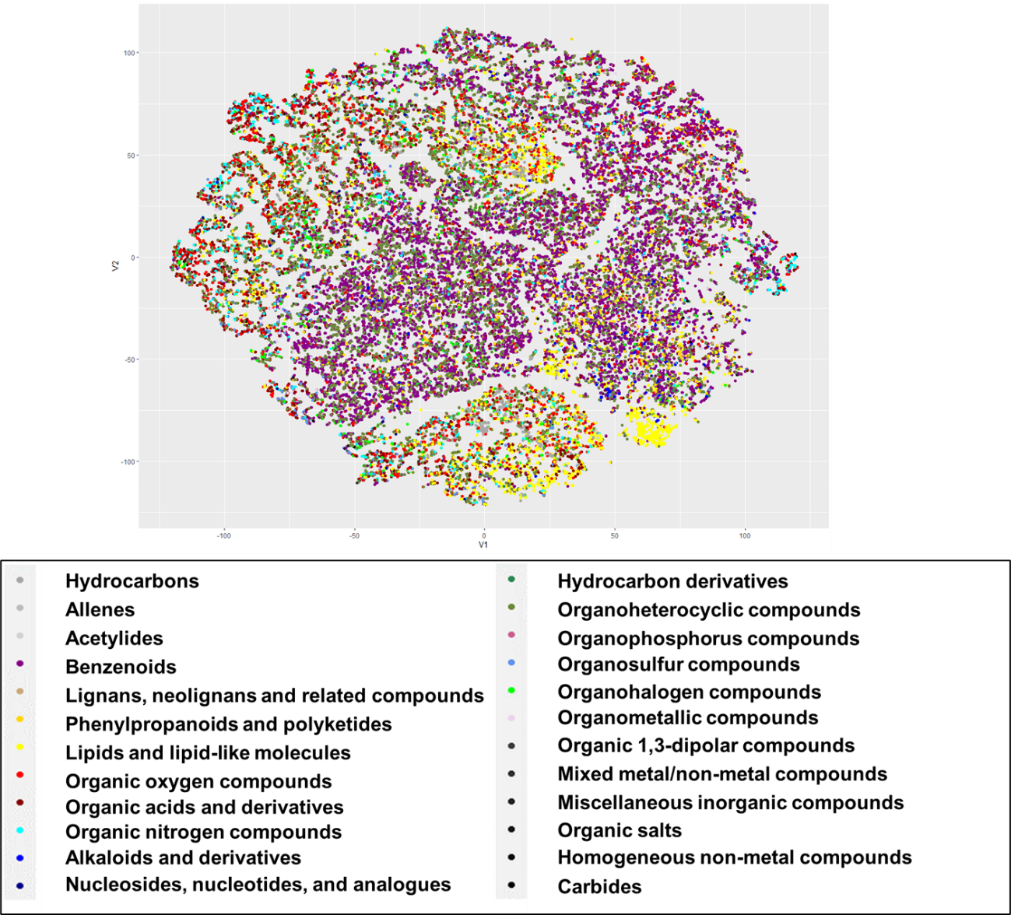
Figure S-6. t-SNE map based on standardized analytical descriptor
For all available data analyzed by GC-MS.

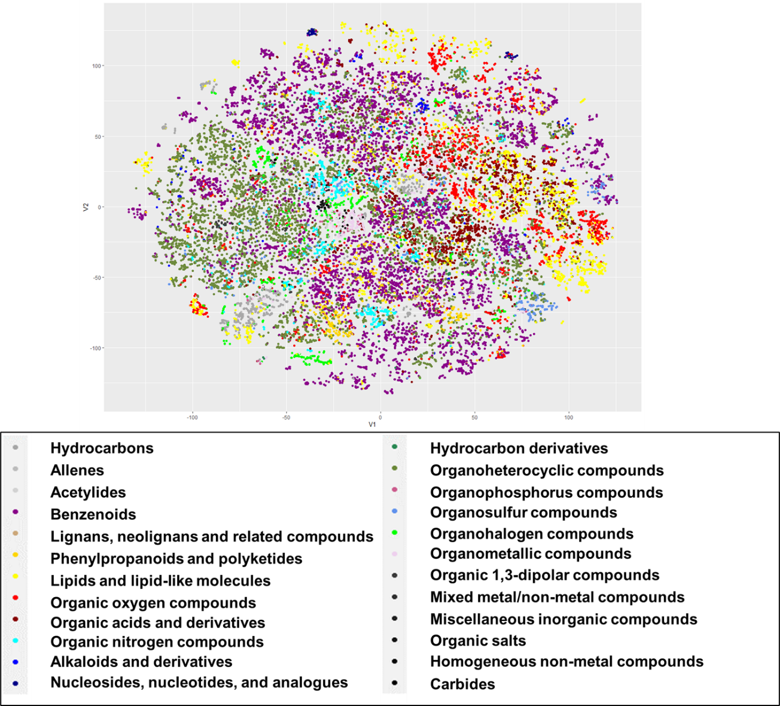
Figure S-7. t-SNE map based on molecular descriptor (PubChem fingerprint)
For all available data analyzed by GC-MS.
Table S-1. Cosine similarities of standardized mass spectra between/within analytical-descriptor-based t-SNE clusters.
 | Cluster 1a | Cluster 2a | Cluster 3a | Cluster 4a | Cluster 5a | Cluster 6a | Cluster 7a | Cluster 8a | Cluster 9a | Cluster 10a | Cluster 11a | Cluster 12a
Cluster 1a | 0.086 ± 0.159
Cluster 2a | 0.001 ± 0.040 | 0.027 ± 0.091
Cluster 3a | 0.029 ± 0.094 | 0.005 ± 0.065 | 0.234 ± 0.176
Cluster 4a | –0.015 ± 0.073 | –0.007 ± 0.047 | –0.018 ± 0.052 | 0.137 ± 0.150
Cluster 5a | –0.003 ± 0.052 | –0.008 ± 0.045 | –0.103 ± 0.061 | 0.025 ± 0.091 | 0.219 ± 0.219
Cluster 6a | –0.020 ± 0.047 | –0.018 ± 0.037 | –0.084 ± 0.054 | 0.059 ± 0.103 | 0.163 ± 0.168 | 0.198 ± 0.183
Cluster 7a | –0.055 ± 0.042 | –0.028 ± 0.035 | –0.018 ± 0.060 | 0.115 ± 0.124 | 0.023 ± 0.081 | 0.102 ± 0.133 | 0.319 ± 0.219
Cluster 8a | –0.015 ± 0.053 | –0.018 ± 0.027 | –0.044 ± 0.040 | 0.040 ± 0.099 | 0.054 ± 0.109 | 0.099 ± 0.128 | 0.039 ± 0.103 | 0.135 ± 0.156
Cluster 9a | –0.022 ± 0.042 | –0.016 ± 0.030 | 0.018 ± 0.084 | –0.016 ± 0.051 | 0.021 ± 0.061 | 0.020 ± 0.069 | 0.057 ± 0.111 | –0.009 ± 0.056 | 0.120 ± 0.190
Cluster 10a | 0.023 ± 0.078 | –0.008 ± 0.035 | 0.021 ± 0.093 | –0.055 ± 0.039 | 0.031 ± 0.051 | 0.001 ± 0.046 | –0.050 ± 0.058 | –0.030 ± 0.041 | 0.022 ± 0.083 | 0.120 ± 0.179
Cluster 11a | 0.008 ± 0.065 | –0.002 ± 0.040 | –0.036 ± 0.046 | –0.009 ± 0.069 | –0.009 ± 0.039 | –0.024 ± 0.038 | –0.040 ± 0.058 | –0.013 ± 0.050 | –0.019 ± 0.046 | 0.001 ± 0.060 | 0.071 ± 0.154
Cluster 12a | –0.008 ± 0.030 | 0.004 ± 0.043 | –0.035 ± 0.041 | –0.024 ± 0.038 | 0.005 ± 0.042 | –0.014 ± 0.034 | –0.033 ± 0.044 | –0.023 ± 0.030 | –0.003 ± 0.051 | 0.010 ± 0.052 | 0.013 ± 0.076 | 0.049 ± 0.127
The values represent the median ± standard deviation.
See Figure S-8 for each cluster ID.
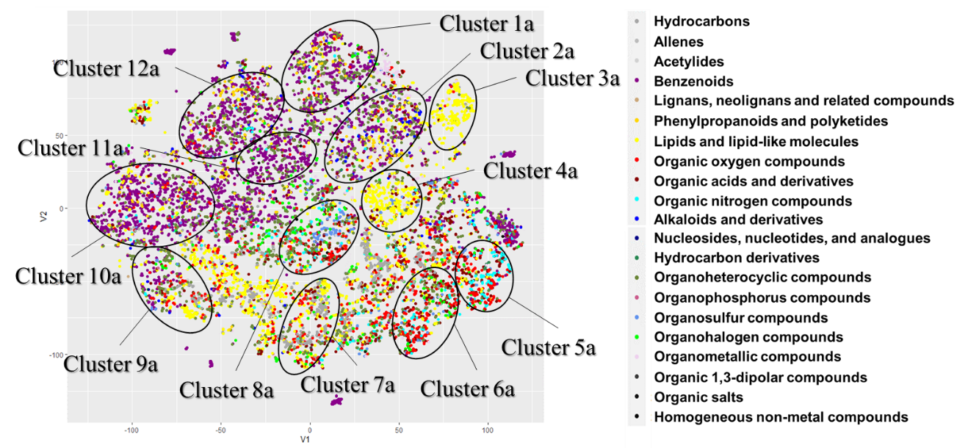 Figure S-8. Cluster IDs on analytical-descriptor-based t-SNE map used for calculating cosine similarities

Table S-2. Cosine similarities of standardized mass spectra between/within molecular-descriptor-based t-SNE clusters.
 | Cluster 1b | Cluster 2b | Cluster 3b | Cluster 4b | Cluster 5b | Cluster 6b | Cluster 7b | Cluster 8b | Cluster 9b | Cluster 10b | Cluster 11b | Cluster 12b
Cluster 1b | 0.338 ± 0.234
Cluster 2b | 0.292 ± 0.193 | 0.301 ± 0.193
Cluster 3b | 0.207 ± 0.181 | 0.242 ± 0.176 | 0.334 ± 0.206
Cluster 4b | 0.288 ± 0.222 | 0.300 ± 0.187 | 0.342 ± 0.223 | 0.434 ± 0.286
Cluster 5b | 0.162 ± 0.166 | 0.178 ± 0.158 | 0.233 ± 0.188 | 0.233 ± 0.208 | 0.203 ± 0.195
Cluster 6b | 0.138 ± 0.154 | 0.143 ± 0.146 | 0.174 ± 0.160 | 0.180 ± 0.174 | 0.144 ± 0.157 | 0.152 ± 0.169
Cluster 7b | 0.185 ± 0.166 | 0.188 ± 0.158 | 0.230 ± 0.186 | 0.229 ± 0.205 | 0.193 ± 0.167 | 0.140 ± 0.147 | 0.244 ± 0.184
Cluster 8b | 0.078 ± 0.090 | 0.082 ± 0.093 | 0.063 ± 0.078 | 0.056 ± 0.074 | 0.058 ± 0.089 | 0.042 ± 0.071 | 0.064 ± 0.074 | 0.084 ± 0.136
Cluster 9b | 0.066 ± 0.090 | 0.061 ± 0.079 | 0.041 ± 0.054 | 0.041 ± 0.060 | 0.035 ± 0.053 | 0.038 ± 0.069 | 0.045 ± 0.057 | 0.051 ± 0.084 | 0.062 ± 0.116
Cluster 10b | 0.086 ± 0.093 | 0.087 ± 0.096 | 0.055 ± 0.075 | 0.062 ± 0.086 | 0.044 ± 0.063 | 0.038 ± 0.067 | 0.054 ± 0.067 | 0.074 ± 0.113 | 0.055 ± 0.084 | 0.106 ± 0.156
Cluster 11b | 0.067 ± 0.079 | 0.067 ± 0.077 | 0.046 ± 0.069 | 0.047 ± 0.076 | 0.034 ± 0.055 | 0.030 ± 0.051 | 0.044 ± 0.059 | 0.058 ± 0.079 | 0.050 ± 0.068 | 0.072 ± 0.103 | 0.072 ± 0.101
Cluster 12b | 0.077 ± 0.089 | 0.077 ± 0.088 | 0.062 ± 0.089 | 0.065 ± 0.096 | 0.051 ± 0.076 | 0.046 ± 0.076 | 0.058 ± 0.079 | 0.058 ± 0.082 | 0.055 ± 0.089 | 0.068 ± 0.094 | 0.060 ± 0.078 | 0.068 ± 0.104
The values represent the median ± standard deviation. The molecular descriptor was the PubChem fingerprint.
See Figure S-8 for each cluster ID.

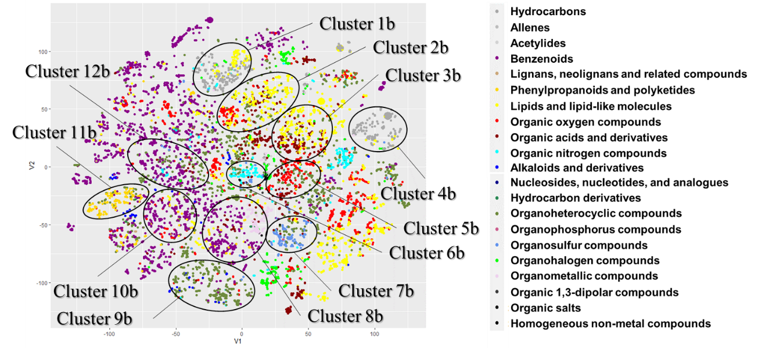
Figure S-9. Cluster IDs on molecular-descriptor-based t-SNE map used for calculating cosine similarities
The molecular descriptor was the PubChem fingerprint.

Table S-3. Cosine similarities of randomly selected 200 standardized mass spectra inter/intra-superclass by ClassyFire.
 | Organic oxygen compounds | Organic acids and derivatives | Benzenoids | Hydrocarbons | Organoheterocyclic compounds | Lipids and lipid-like molecules
Organic oxygen compounds | 0.060 ± 0.156  (n = 19,900)
Organic acids and derivatives | 0.053 ± 0.141  (n = 40,000) | 0.063 ± 0.153  (n = 19,900)
Benzenoids | –0.017 ± 0.067  (n = 40,000) | –0.014 ± 0.063  (n = 40,000) | 0.019 ± 0.088  (n = 19,900)
Hydrocarbons | 0.068 ± 0.160  (n = 40,000) | 0.061 ± 0.163  (n = 40,000) | –0.033 ± 0.067  (n = 40,000) | 0.174 ± 0.261  (n = 19,900)
Organoheterocyclic compounds | 0.011 ± 0.097  (n = 40,000) | 0.008 ± 0.086  (n = 40,000) | 0.0001 ± 0.066  (n = 40,000) | 0.005 ± 0.106  (n = 40,000) | 0.009 ± 0.085  (n = 19,900)
Lipids and lipid-like molecules | 0.024 ± 0.131  (n = 40,000) | 0.017 ± 0.128  (n = 40,000) | –0.021 ± 0.071  (n = 40,000) | 0.063 ± 0.169  (n = 40,000) | –0.005 ± 0.089  (n = 40,000) | 0.054 ± 0.155  (n = 19,900)
The values represent the median ± standard deviation.

Table S-4. MAE-based predictive performances of analytical- and molecular-descriptor-based QSAR models.
 | Detective-QSAR | Topological Descriptor | ECFP6 | MACCS Key | PubChem Fingerprint
log Mw | 0.027 | 0.003 | 0.034 | 0.038 | 0.026
log K_{o-w} | 0.762 | 0.356 | 0.596 | 0.541 | 0.408
BP | 13.6 | 11.5 | 30.1 | 25.2 | 17.9
MP | 39.2 | 29.6 | 37.7 | 37.0 | 32.2
log VP | 0.51 | 0.36 | 0.83 | 0.65 | 0.51
log WS | 1.01 | 0.54 | 0.92 | 0.77 | 0.57
log LD₅₀ (rat, oral) | 0.53 | 0.44 | 0.48 | 0.44 | 0.42
log LD₅₀ (mouse, oral) | 0.52 | 0.41 | 0.42 | 0.41 | 0.40

Table S-5. Number of training data for analytical- and molecular-descriptor-based QSAR models.
 | Detective-QSAR | Topological Descriptor | ECFP6 | MACCS Key | PubChem Fingerprint
log Mw | 10248 | 10224 | 10224 | 10224 | 10224
log K_{o-w} | 2140 | 2120 | 2120 | 2120 | 2120
BP | 2709 | 2603 | 2603 | 2603 | 2603
MP | 3068 | 2983 | 2983 | 2983 | 2983
log VP | 1039 | 1260 | 1260 | 1260 | 1260
log WS | 1107 | 1100 | 1100 | 1100 | 1100
log LD₅₀ (rat, oral) | 1664 | 1643 | 1643 | 1643 | 1643
log LD₅₀ (mouse, oral) | 1304 | 1290 | 1290 | 1290 | 1290

Table S-6. MAE-based predictive performances of various models
 | Detective-QSAR | Detective-QSAR (without RI) | All-six-variable model | maxint_mz | RI | centroid_mz
log Mw | 0.027 | 0.101 | 0.040 | 0.040 | 0.072 | 0.106
log K_{o-w} | 0.76 | 0.68 | 1.08 | 1.17 | 1.37 | 1.16
BP | 13.6 | 29.2 | 19.9 | 45.8 | 20.3 | 49.4
MP | 39.2 | 43.8 | 48.0 | 64.0 | 52.0 | 60.8
log VP | 0.51 | 0.94 | 0.52 | 1.15 | 0.53 | 1.70
log WS | 1.01 | 0.93 | 1.30 | 1.45 | 1.65 | 1.37
log LD₅₀ (rat, oral) | 0.53 | 0.49 | 0.60 | 0.60 | 0.61 | 0.63
log LD₅₀ (mouse, oral) | 0.52 | 0.48 | 0.53 | 0.53 | 0.55 | 0.56
QSAR model based on analytical descriptors; regression models based on indicators of GC-MS data. All-six-variable model: centroid_mz + maxint_mz + max_mz + sd_mz + bin_num + RI.

Table S-7. Number of training data for various models
 | Detective-QSAR | Detective-QSAR (without RI) | All-six-variable model | maxint_mz | RI | centroid_mz
log Mw | 10248 | 10236 | 10236 | 10236 | 10236 | 10236
log K_{o-w} | 2140 | 2140 | 2119 | 2119 | 2119 | 2119
BP | 2709 | 2709 | 2615 | 2615 | 2615 | 2615
MP | 3068 | 3068 | 3047 | 3047 | 3047 | 3047
log VP | 1039 | 1039 | 1267 | 1267 | 1267 | 1267
log WS | 1107 | 1107 | 1101 | 1101 | 1101 | 1101
log LD₅₀ (rat, oral) | 1664 | 1643 | 1810 | 1810 | 1810 | 1810
log LD₅₀ (mouse, oral) | 1304 | 1290 | 1290 | 1290 | 1290 | 1290
QSAR model based on analytical descriptors; regression models based on indicators of GC-MS data. All-six-variable model: centroid_mz + maxint_mz + max_mz + sd_mz + bin_num + RI.

