SUPPLEMENTARY APPENDIX for IL-13Rα2-specific Allogeneic CAR-T Cells in Recurrent Glioblastoma
Co-authors: Li et al.

Table of Contents to the Supplementary Appendix
I. Supplementary Methods 2
Constructing Of Cell Products 2
Inclusion and Exclusion Criteria 2
II. Supplementary Tables 3
Table S1. Baseline demographic and clinical characteristics 3
Table S2. Genetic and immunopathological testing results of individual patients 3
Table S3. Important evaluation time points and results of individual patients 4
III. Supplementary Figures 5
Figure S1. Schematic diagram of anti-IL13RA2 CAR structure. 5
Figure S2. Characteristics of IL13RA2 UCAR-T 6
Figure S3. IL13RA2 UCAR-T safety verification 6
Figure S4. In vivo half-life of IL13Rα2 UCAR-T cells 7
Figure S5. Anti-tumor effect of IL13RA2 UCAR T 8
Figure S6. Study Schema 9
Figure S7. Overview of brief medical records of individual patients 11
Figure S8. IL-6 concentrations in cerebrospinal fluid and blood of individual patients before and after each administration 12
Figure S9. Radiological evaluation results of individual patients 16
Figure S10. Pharmacokinetic Characteristics of MT026 17
Figure S11. CAR DNA copies in cerebrospinal fluid of individual patients before and after each administration 19
Figure S12. Change of pharmacodynamic parameters after administration of MT026 20

I. Supplementary Methods

Constructing Of Cell Products
MT026 is IL-13Rα2 specific CAR T cells manufactured using enriched T cells from healthy allogeneic donors. The CAR molecule (vector construct) contained in MT026 is composed of CD8A signal, the extracellular IL-13Rα2 nanobody sequence, CD8A hinge, CD8A transmembrane domain, 4-1BB costimulatory signaling domain, and CD3ζ signaling domain. Its expression is initiated by the promoter EF1α. The CAR can recognize and eradicate the IL-13Rα2 expressing malignant cells. T cell receptors (TCRs) and class A human leukocyte antigen (HLA-A) are knocked out from the T cells of healthy donors with CRISPR/Cas9 technology to prevent graft-versus-host-disease (GvHD) and host-versus-graft-reaction (HvGR), the two anticipated adverse reactions from the interaction between exogenous T cells and host immune system of patients.

Inclusion and Exclusion Criteria
In addition to the criteria mentioned in the manuscript, patients included in the study had to
have adequate renal, liver and bone marrow function, and a life expectancy of ≥3 months. Key exclusion criteria were previous treatment with any gene therapies, long-term recipient of immunosuppressants, recipient of systemic steroid therapies, any severe and uncontrollable systemic autoimmune diseases, severe dysfunction of vital organs, surgical history of or planned elective surgery of organ transplantation, and other concomitant tumors.

II. Supplementary Tables

Table S1. Baseline demographic and clinical characteristics
Patient ID | Sex/age | KPS score | IL-13Rα2 antigen expression level in tumor tissue | Prior temozolomide before recurrence | No. of injection before BOR
MT026-001 | M/50 | 60 | Medium | Yes | 1
MT026-002 | F/63 | 40 | High | Yes | 5
MT026-003 | F/52 | 60 | Medium | Yes | 3
MT026-004 | F/57 | 90 | Medium | Yes | 5
MT026-005 | F/45 | 50 | Medium | Yes | 3

Table S2. Genetic and immunopathological testing results of individual patients
Patient ID | Genetic testing | Immunopathological testing
MT026-001 | MGMT promoter methylation (-), 1p/19q co-deletion (-), IDH1/2 mutation (-), TERT mutation (-), BRAF mutations (-) | GFAP (+), Ki-67 (~10% +), P53 (partial +), EGFR (+), S100 (+), Vimentin (weak +), Olig-2 (-), IDH-1 (-), NeuN (-), ATRX (+), H3K27M (-), CD34 (-)
MT026-002 | MGMT promoter methylation (-), 1p/19q co-deletion (-), IDH1/2 mutation (-), TERT C228T mutation (-), TERT C250T mutation (+), BRAF mutation (-) | GFAP (+), S100 (+), Vimentin (+), Olig-2 (+), MAP2 (+), ATRX (focal +), EGFR (focal +), Ki-67 (+10%), P53 (scattered +), IDH-1 (-), MGMT (-), NeuN (-), H3K27M (-), Syn (-), CD34 (-)
MT026-003 | IDH 1/2 mutation (-), 1p/19q co-deletion (-), MGMT promoter methylation (-), TERT C250T (16.43%), H3-K27M mutation (-), ATRX mutation (-), RELA fusion (-), BRAF fusion (-), EGFR amplification (+) | GFAP (+), P53 (+), EGFR (+), S100 (+), Vimentin (+), Olig-2 (+), IDH-1 (partial+), NeuN (small amount +), ATRX (+), H3K27M (-), Syn (+), CD34 (weak +), EMA (small amount +), LCA (small amount +), Ki-67 (about 2%+)
MT026-004 | IDH1/2 mutation (-), 1p/19q co-deletion (+), MGMT promoter methylation (-), TERT mutation (-), BRAF mutation (-), EGFR amplification (+), EGFRvIII mutation (-), TP53 mutation (+), PTEN mutation (+), PIK3CA mutation (-), ATRX mutation (-), H3F3A mutation (-), HIST1H3B mutation (-), HIST1H3C mutation (-), CDKN2A mutation (-), CDKN2B mutation (-) | GFAP (+), H3K27M (-), IDH1 (-), Ki67 (about 25% +), LCA/CD45 (lymphocyte +), olig-2 (partial +), P53 (30% +), S100 (+), EGFR (scattered +)
MT026-005 | IDH1/2 mutation (-), 1p/19q co-deletion (-), MGMT promoter methylation (+), TERT mutation (-), BRAF mutation (+), EGFR amplification (+), EGFRvIII mutation (-), TP53 mutation (+), PTEN mutation (-), PIK3CA mutation (-), ATRX mutation (+), H3F3A/HIST1H3B/HIST1H3C mutation (-), CDKN2A/2B mutation (-). | ATRX (-), CD34 (vascular +), GFAP (+), H3K27M (-), IDH1 (-), Ki67 (hotspot 40% +), NeuN (-), olig-2 (partial +), P53 (about 40% +), S100 (scattered +)
- = negative
+ = positive

Table S3. Important evaluation time points and results of individual patients
Patient ID | Date of recurrence | Date of 1st dosing | Date of BOR | BOR | Date of progression | Date of death | Cause of death
MT026-001 | 24-July-2020 | 18-Aug-2020 | 24-Sep-2020 | SD | 26-Nov-2020 | 30-Mar-2021 | Disease progression
MT026-002 | 21-Apr-2020 | 3-Sep-2020 | 23-Nov-2020 | CR | 29-Apr-2021 | 10-Feb-2022 | Disease progression
MT026-003 | 3-Nov-2020 | 30-Nov-2020 | 2-Feb-2021 | PR | 25-Mar-2021 | 9-Aug-2021 | Disease progression
MT026-004 | 20-Apr-2021 | 28-May-2021 | 27-Aug-2021 | PR | 2-Jan-2022 | 12-Jun-2022 | Disease progression
MT026-005 | 10-Jun-2022 | 14-Jan-2022 | 10-Mar-2022 | PR | 6-Jul-2022 | 6-Jul-2022 | Disease progression

III. Supplementary Figures
A.

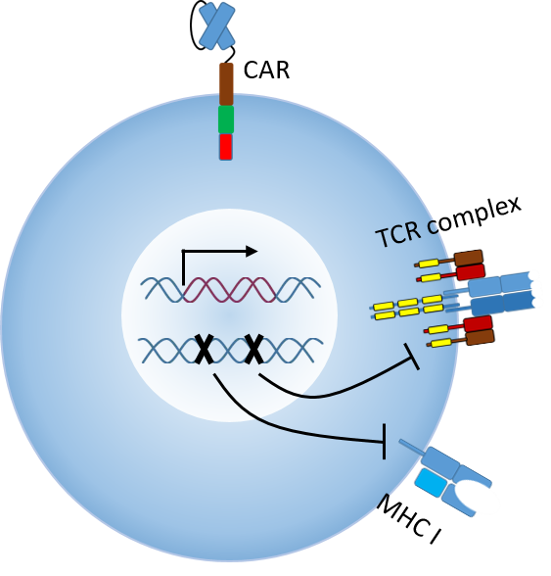
B.

Figure S1. Schematic diagram of anti-IL13RA2 CAR structure. Anti-IL13RA2 CAR is composed of CD8A signal peptide, IL13Rα2-specific scFv, CD8A hinge region, CD8A transmembrane region, 4-1BB costimulatory signal region and CD3zeta signal transduction region; EF1a promoter is used to promote CAR expression (A); anti-IL13RA2 UCAR-T knockout TCR and HLA-A of T cells by gene editing technology, and T cells express anti-IL13Rα2 CAR molecule by lentiviral transfection (B).

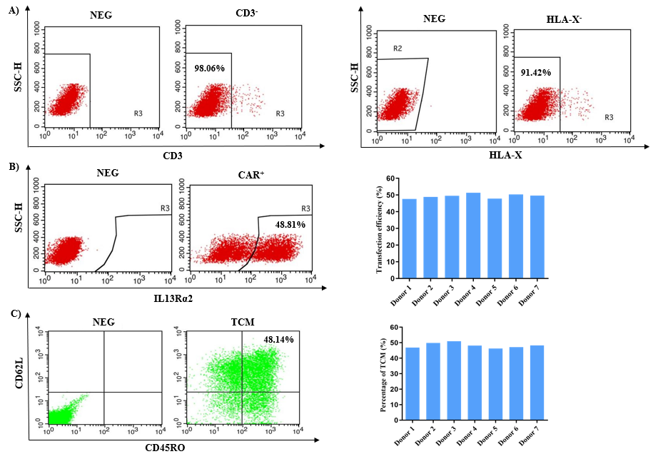

Figure S2. Characteristics of IL13RA2 UCAR-T. IL13Rα2 UCAR-T was manufactured by lentiviral transduction of the CAR transgene, followed by electroporation of TRAC⁻ and HLA-X⁻ targeting Cas9 RNP. A) TRAC and HLA-X knockout efficiency (>90%), B) CAR expression (approximately 50%), C) TCM phenotype (>45%).

A.

B.

C.

Figure S3. IL13RA2 UCAR-T safety verification. All three TRAC knockout groups had very low cytokine secretion levels when stimulated by allogeneic PBMC, indicating that TRAC knockout largely reduced the GVHD responses (A); three groups of HLA-A knockout showed very low cytokine secretion levels when stimulated by allogeneic PBMCs, indicating that HLA-A knockout greatly reduced allogeneic reaction (B); After co-injection of 5 x 10⁶ IL13Rα2 UCAR-T cells and 5 x 10⁶ allogeneic T cells into NSG mice (different knockout strategies), the copy number of IL13Rα2 UCAR-T(TRAC⁻HLA-A⁻) group was still at a high level on day 24, indicating that the rejection reaction of the experimental group was significantly attenuated, which prolonged the survival time of cells in mice in the experimental group.

Figure S4. In vivo half-life of IL13Rα2 UCAR-T cells. 1 x 10⁷ IL13Rα2 UCAR-T cells (TRAC⁻HLA-A⁻) in the experimental group and IL13Rα2 UCAR-T cells (TRAC⁻B2M⁻) and CAR-T cells in the control group were injected, respectively. Blood samples were taken at different time points. Genomes were extracted from blood samples at different time points, and copy/ng genome DNA was calculated by QPCR absolute quantification. In the experimental group, IL13Rα2 UCAR-T cells survived for about 70 days in mice, and secondary amplification was performed on week 4-week 7.

A.

B.

Figure S5. Anti-tumor effect of IL13RA2 UCAR T. Anti-IL13RA2 UCAR-T cells, CAR-T cells and T cells were incubated with target cell U251, respectively, to achieve more than 90% killing efficiency at the effector-to-target ratio of 2:1 (A); a glioma mouse model was established. Mice inoculated with U251-LG were intratumorally injected with IL13Rα2 UCAR-T cells, IL13Rα2 CAR-T cells and knockout free T cells, respectively, and tumor regression was monitored by luciferase (B).

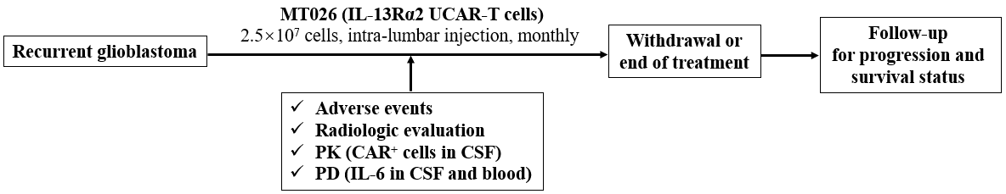

Figure S6. Study Schema.

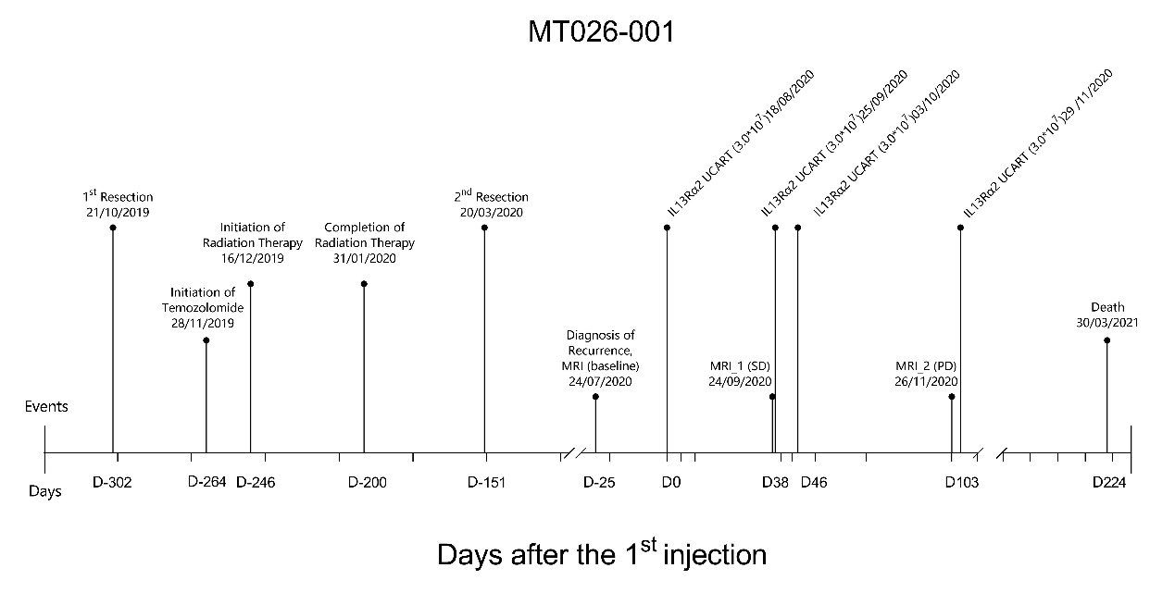
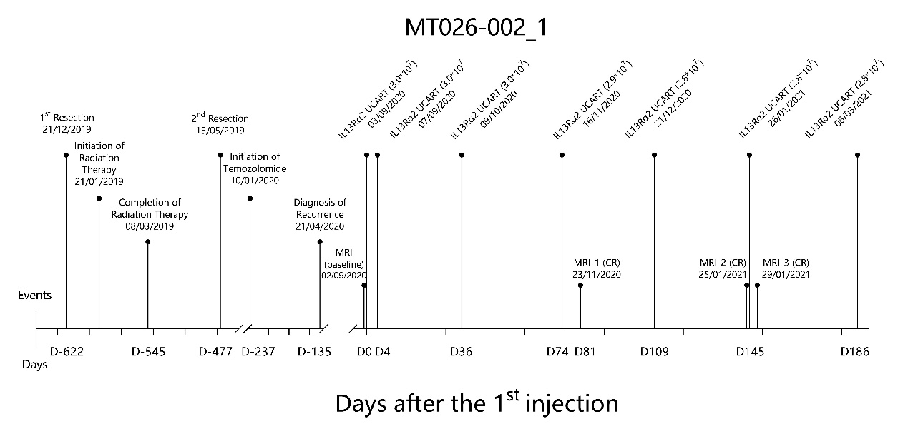
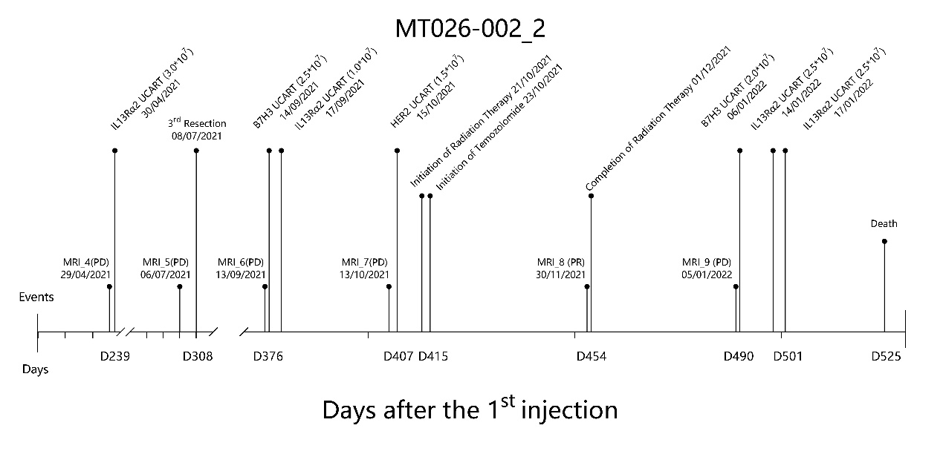
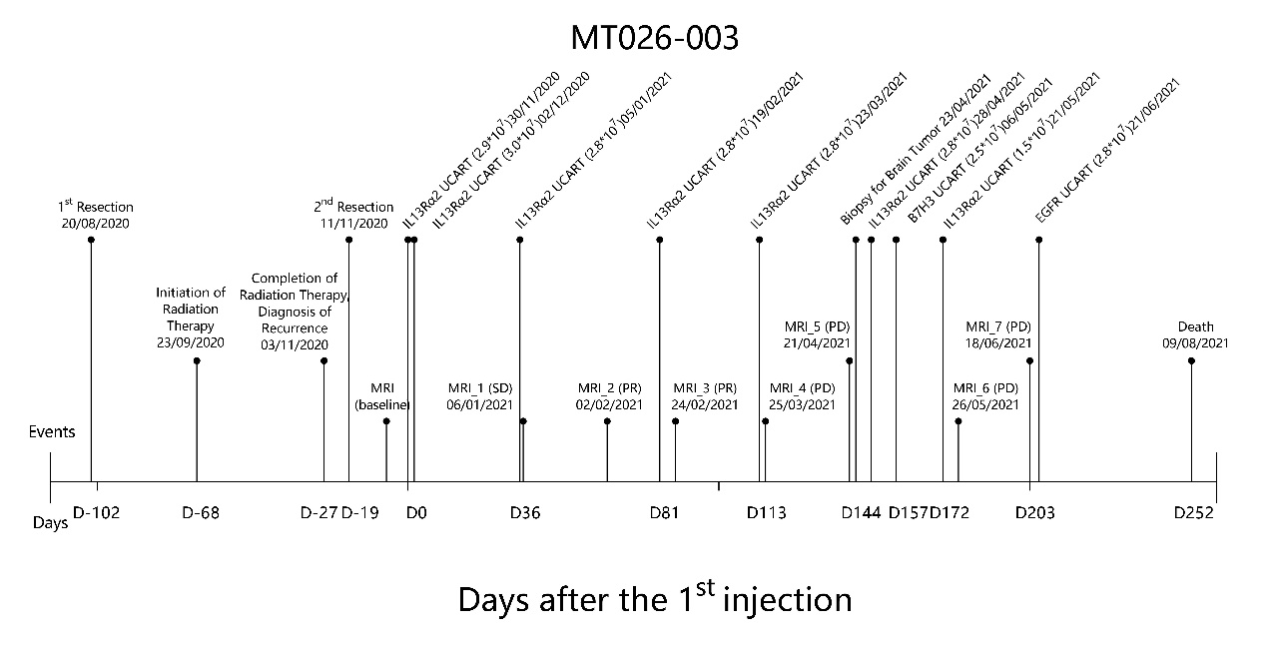
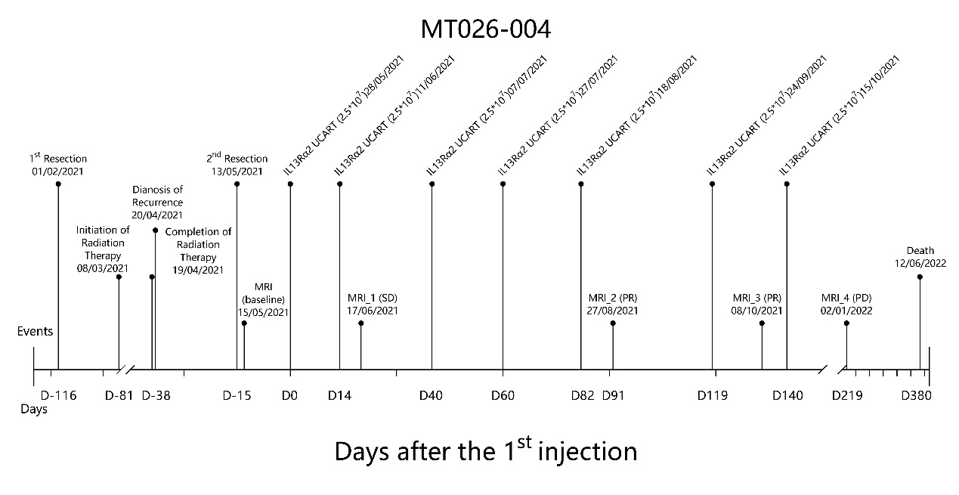
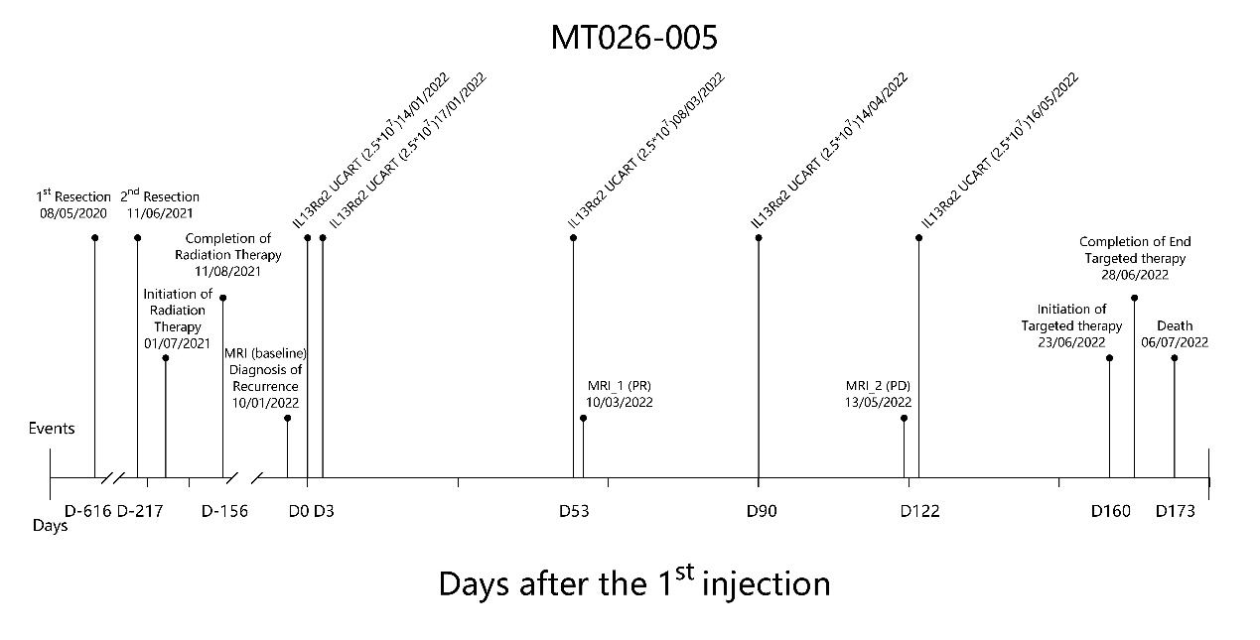

Figure S7. Overview of brief medical records of individual patients.

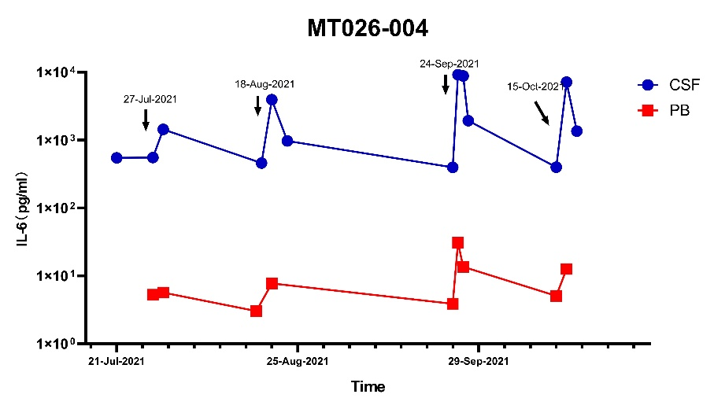
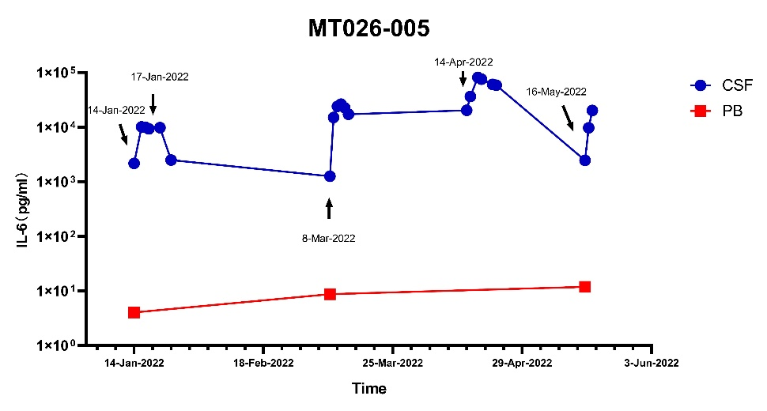

Figure S8. IL-6 concentrations in cerebrospinal fluid and blood of individual patients before and after each administration. Patients 001-003 were not detected for IL-6 concentration.

Patient MT026-001
Before Treatment | After Treatment
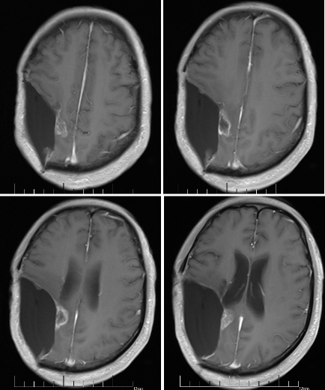 | 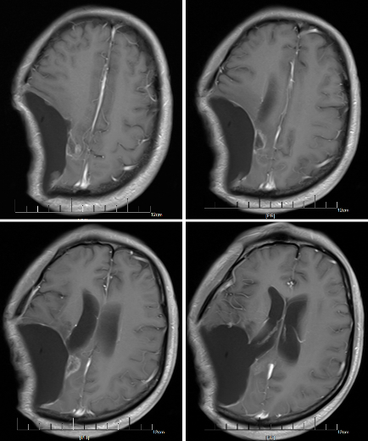
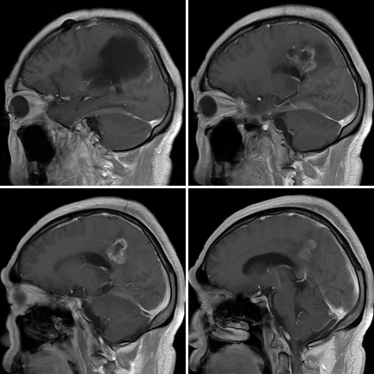 | 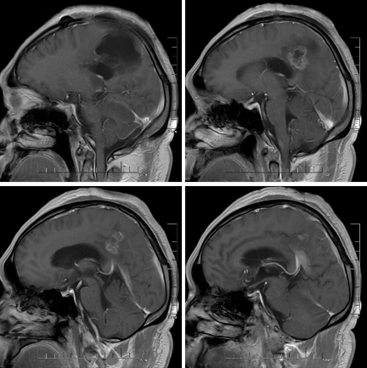
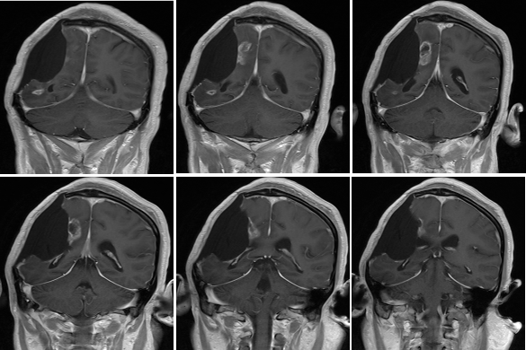 | 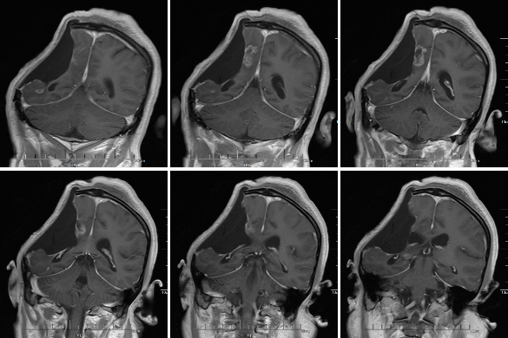
Patient MT026-002
Before Treatment | After Treatment
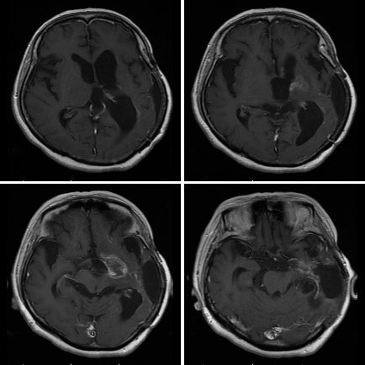 | 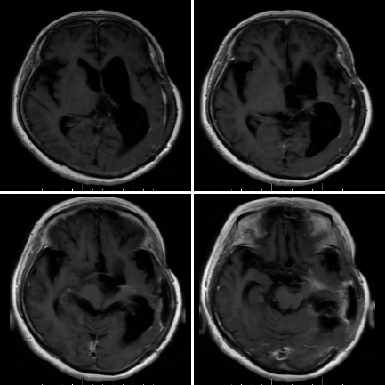
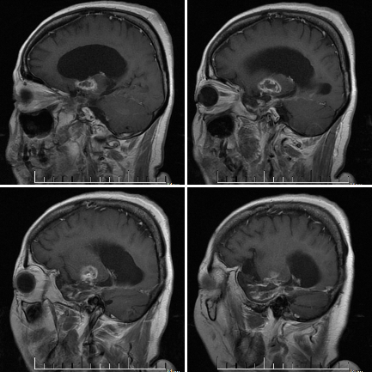 | 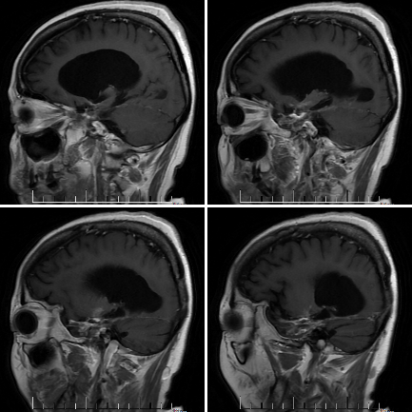
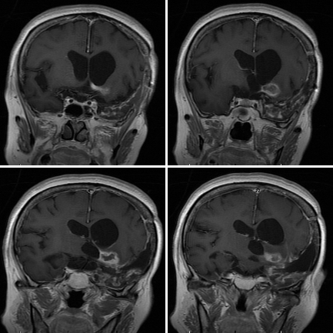 | 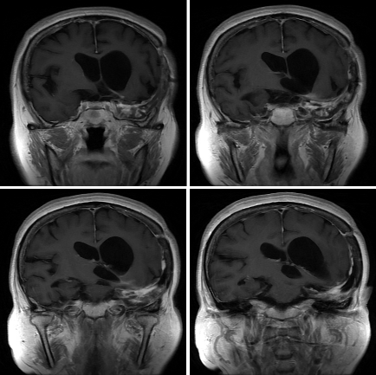
Patient MT026-003
Before Treatment | After Treatment
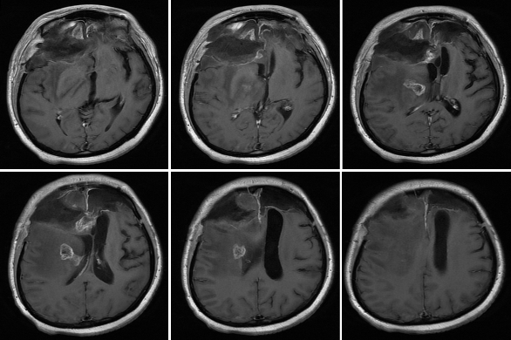 | 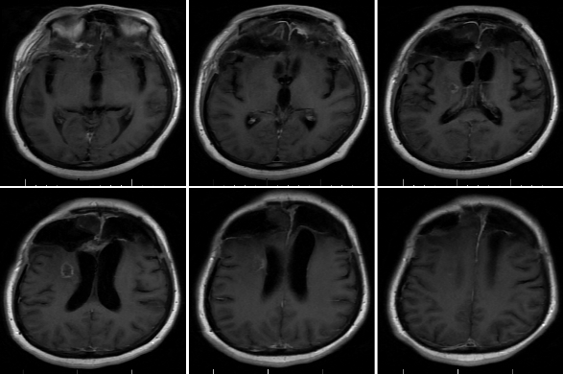
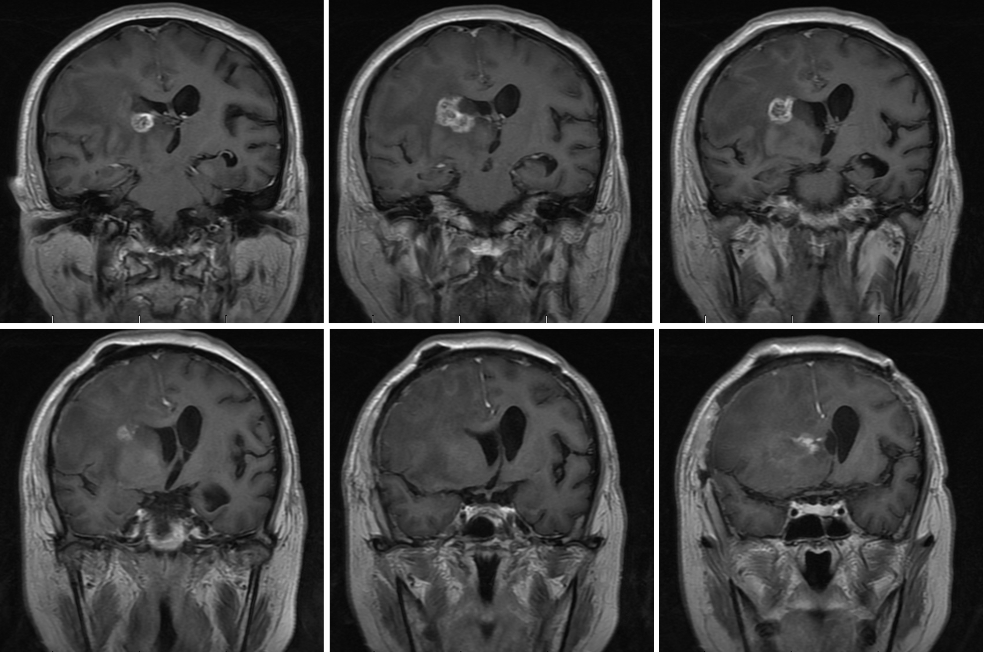 | 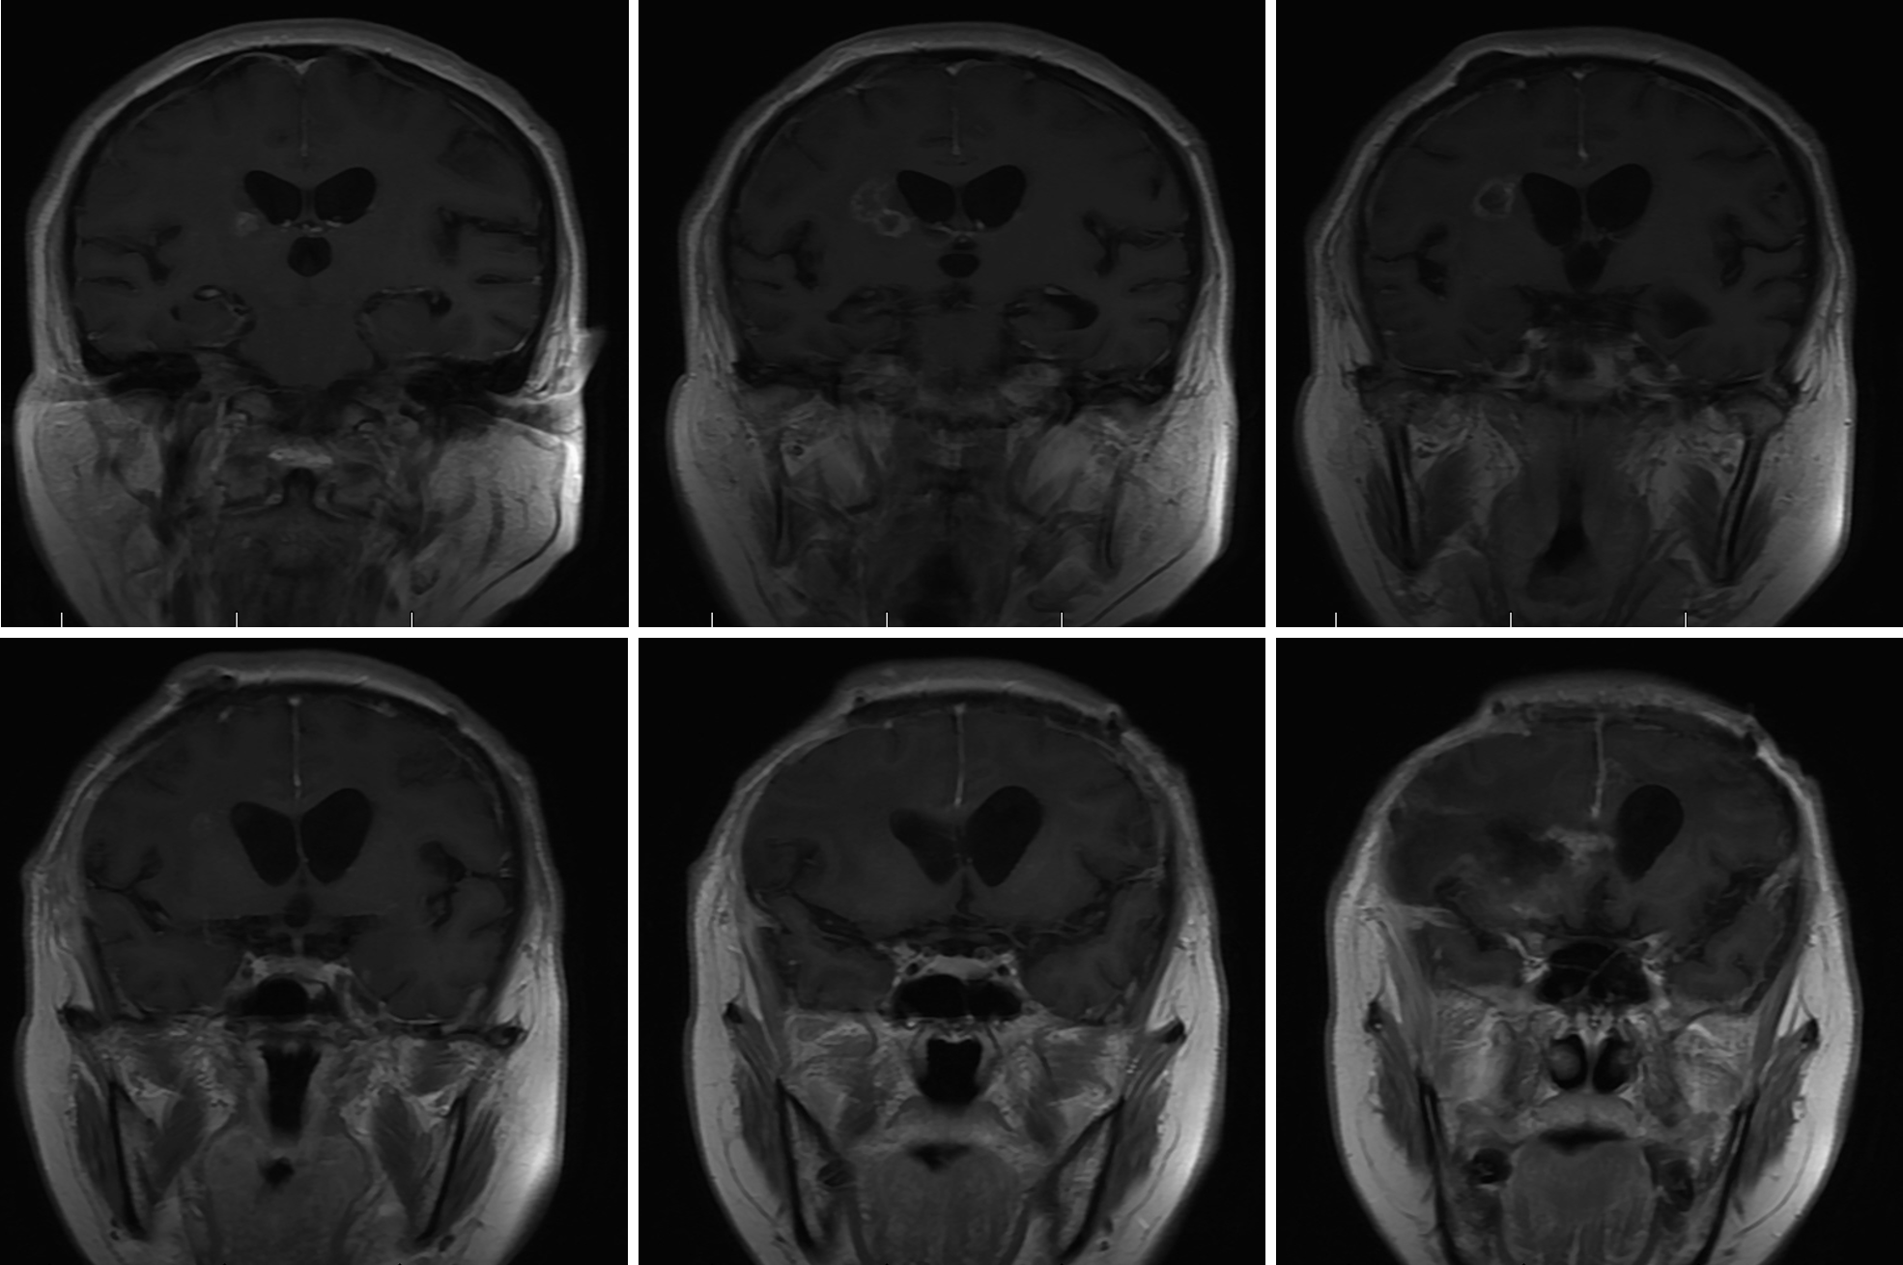
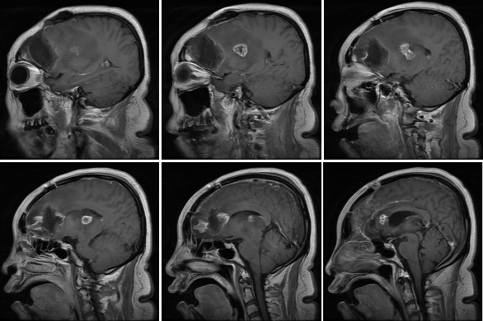 | 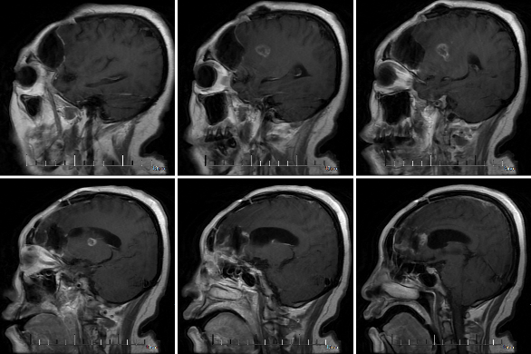
Patient MT026-004
Before Treatment | After Treatment
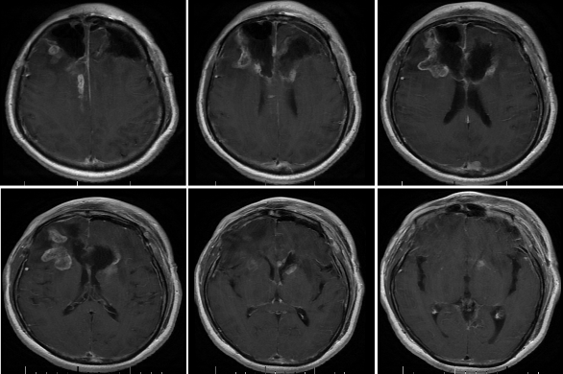 | 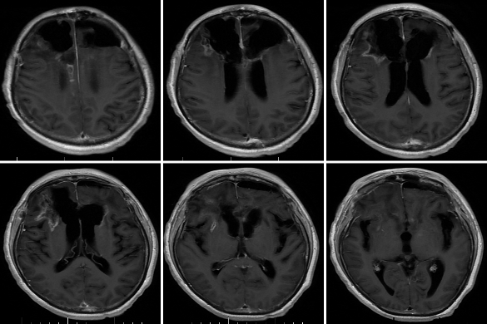
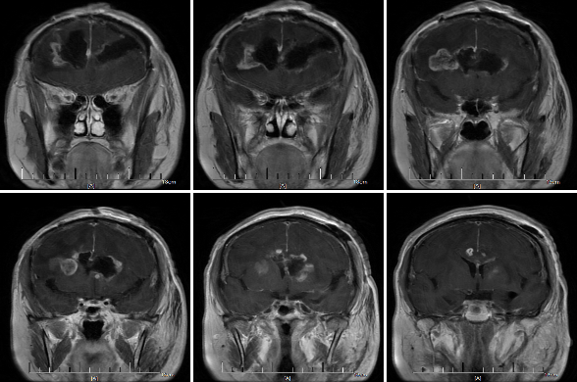 | 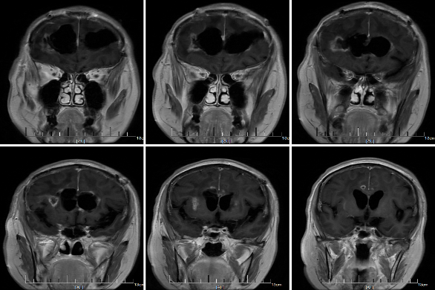
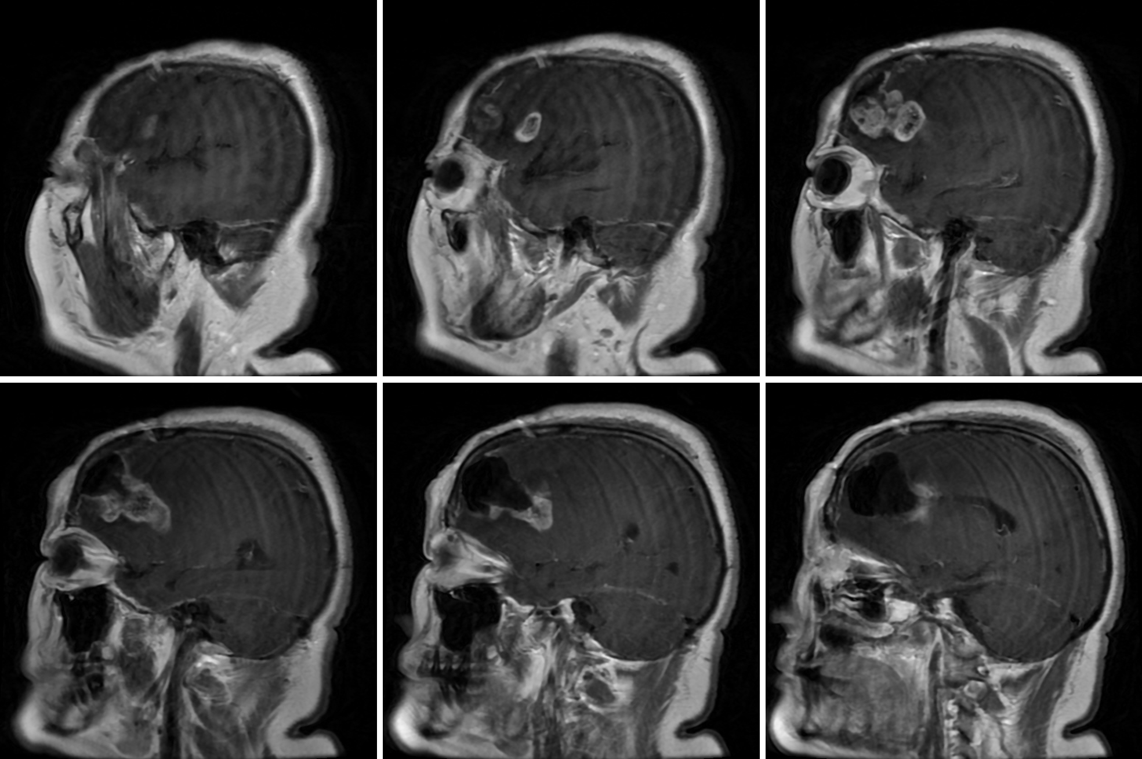 | 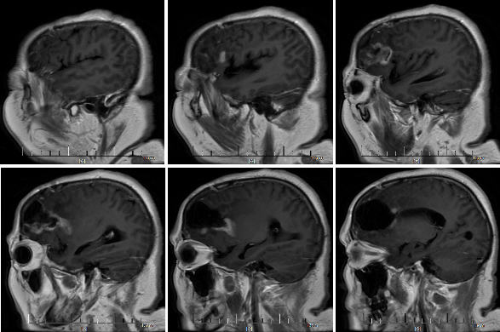
Patient MT026-005
Before Treatment | After Treatment
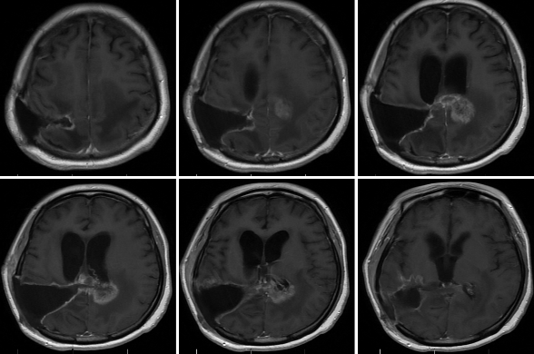 | 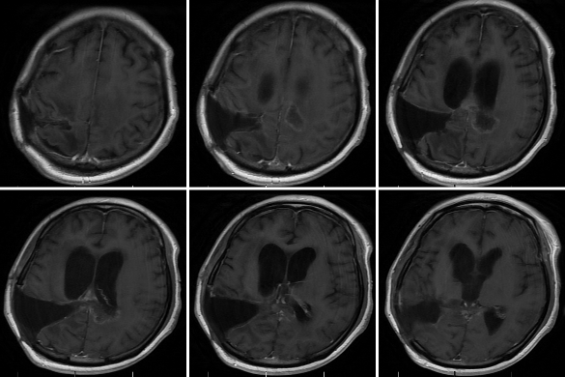
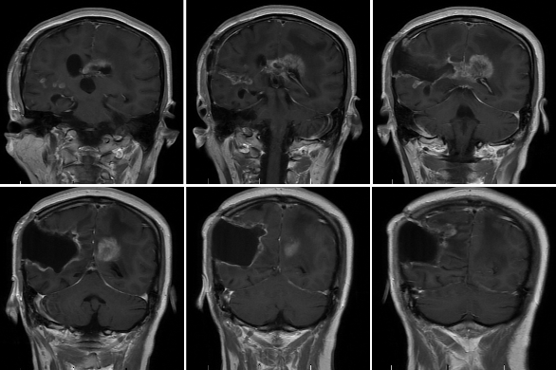 | 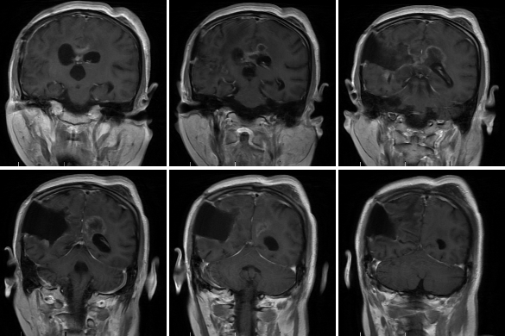

Figure S9. Radiological evaluation results of individual patients.

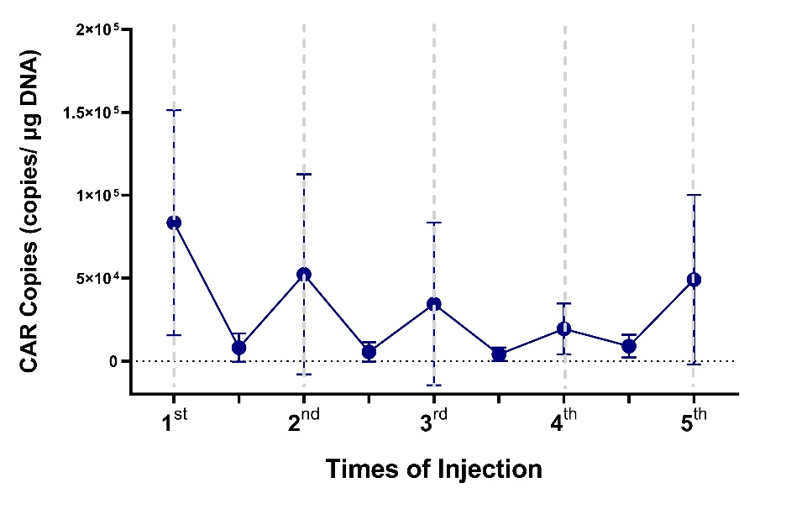

Figure S10. Pharmacokinetic Characteristics of MT026. Shown are CAR DNA copies of MT026 in CSF before and 1 day after each administration. Baseline value is defaulted to zero. The administration interval is approximately 1 month.

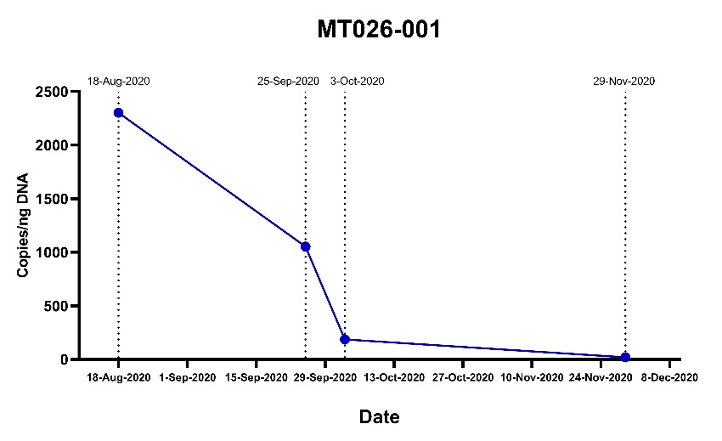

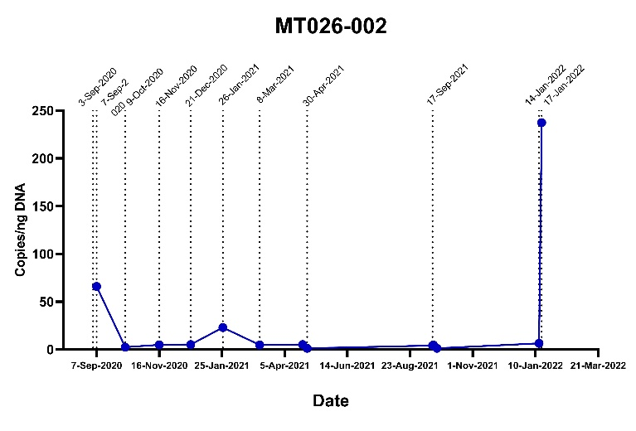

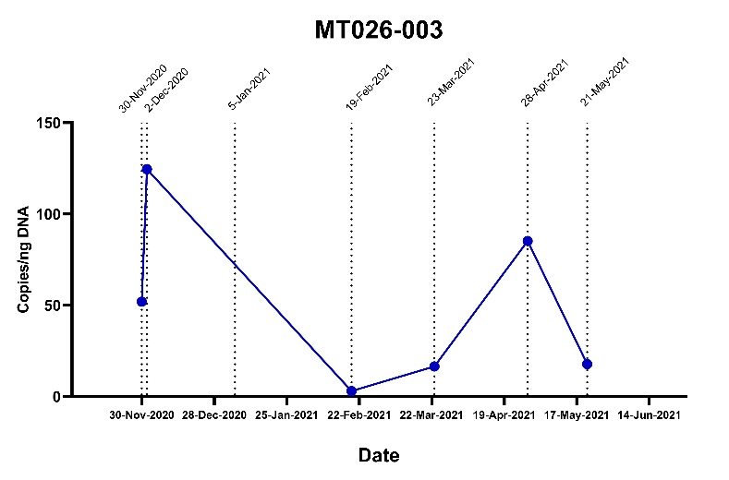

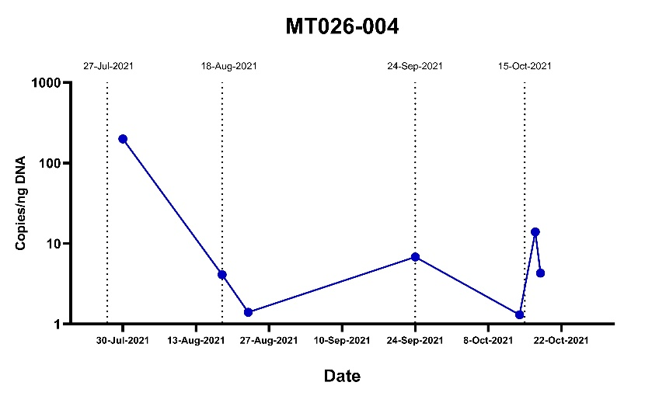

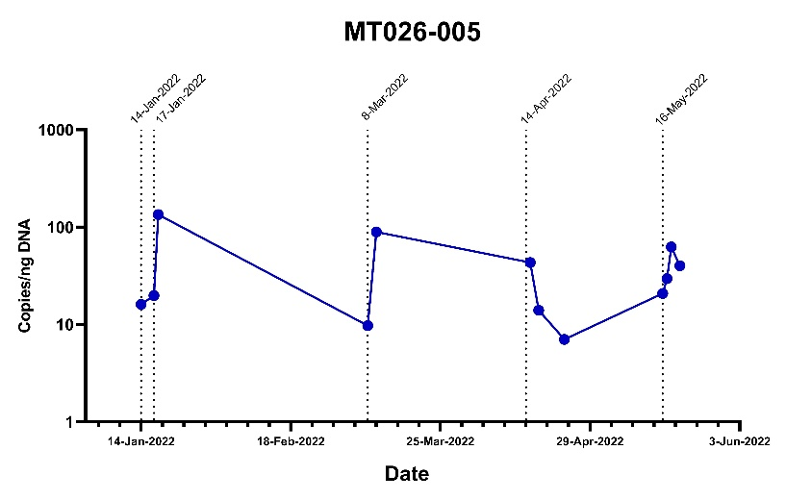

Figure S11. CAR DNA copies in cerebrospinal fluid of individual patients before and after each administration. Sampling was only performed at patients’ convenience so that we did not collect cerebrospinal fluid at a series of accurate time points. However, a marked increase immediately after administration and then a slow decrease was also observed and CAR DNA copies could be still detected before the next administration.

A
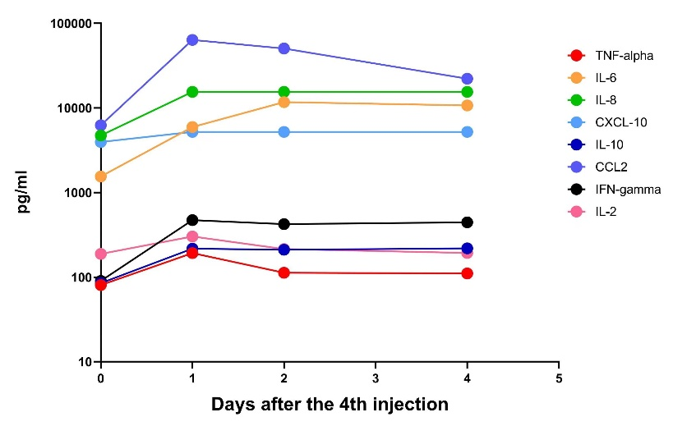

B
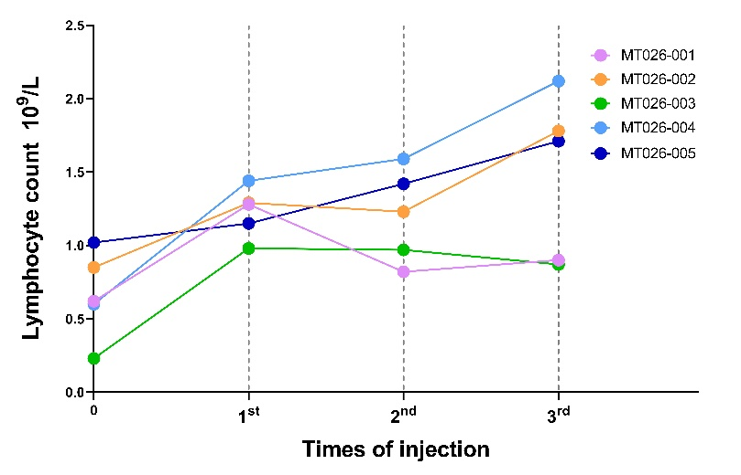

C
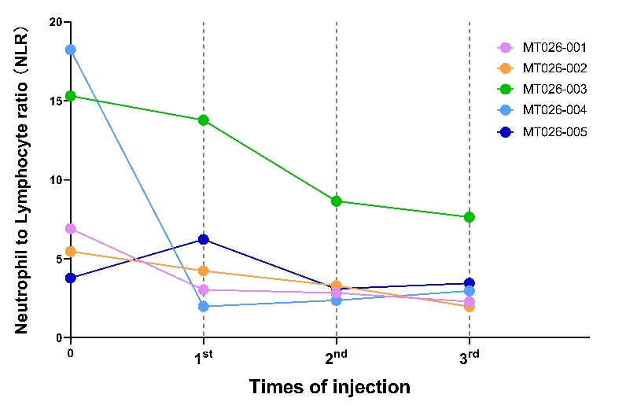

Figure S12. Change of pharmacodynamic parameters after administration of MT026. Panel A shows change of multiple cytokines in CSF before and after the 4th MT026 administration in Patient 005. Panel B shows change of blood lymphocyte count with treatment of MT026 in the 5 patients. Panel C shows change of neutrophils to lymphocytes ratio in blood with treatment of MT026 in the 5 patients.

