Conductive Glassy Non-conjugated Open-shell Radical Polymer with Organosulfur Backbone for Macroscopic Conductivity
Authors: Quyen Vu Thi,^{1,†} Quynh H. Nguyen,^{1,†} Seung-Yeol Jeon^{1*}, Bryan Boudouris, ^{2,3*} Yongho Joo^{1,4*}
Affiliations
¹Institute of Advanced Composite Materials, Korea Institute of Science and Technology (KIST), Wanju-gun, Jeonbuk 55324, Republic of Korea.
²Charles D. Davidson School of Chemical Engineering, 480 Stadium Mall Drive, Purdue University, West Lafayette, IN 47906, USA.
³Department of Chemistry, 560 Oval Drive, Purdue University, West Lafayette, IN 47906, USA.
⁴Division of Nano and Information Technology, KIST School, Korea University of Science and Technology (UST), Jeonbuk 55324 South Korea
*Correspondence to boudouris@purdue.edu (B.W.B), yjoo0727@kist.re.kr (Y. J.)
†These authors contribute equally

Materials and Methods ---------------------------------------------------------------------------------- page 1
Figure S1 ---------------------------------------------------------------------------------------------------- page 7
Figure S2 ---------------------------------------------------------------------------------------------------- page 9
Figure S3 ---------------------------------------------------------------------------------------------------- page 10
Figure S4 ---------------------------------------------------------------------------------------------------- page 11
Figure S5 ---------------------------------------------------------------------------------------------------- page 12
Figure S6 ---------------------------------------------------------------------------------------------------- page 13

Materials and Methods
Materials
All reagents were used as they were received and without further purification. The 4-glycidyloxy-2,2,6,6-tetramethylpiperidine-1-oxyl (GTEMPO), 1,8-diazabicyclo(5.4.0)undec-7-ene (DBU), 1-butanethiol (C₄H₉SH, ^{n}BuSH), and iodomethane (CH₃-I, against initiator) were obtained from TCI Tokyo. Tetrahydrofuran (THF), diethyl ether, and hexanes (HPLC grade) were purchased from Daejung Co. Korea.
Preparation of the Monomer
To a solution of GTEMPO (1.0 g, 4.4 mmol) in 100 mL ethanol, was added NaHCO₃ (8.8 mmol) and thiourea (8.8 mmol). The mixture was stirred at 70 ºC for 1 h. After the reaction, the ethanol was removed through evaporation. The resulting residue was extracted using water and dichloromethane, and the combined organic layers were dried over MgSO₄ and concentrated by rotary. The crude product was purified by silica-gel column chromatography (ethyl acetate/hexane = 1:1). The product was obtained as a red solid (75% yield).
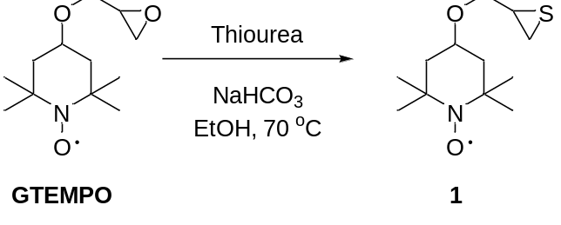
Preparation of Poly-(TEMPO-substituted ethylene sulfide) (PTES)
Poly-(TEMPO-substituted ethylene sulfide) (PTES) was synthesized following the literature.¹ The polymerization was conducted at room temperature in an argon-filled glove box to avoid water and oxygen. First, 1,8-diazabicyclo(5.4.0)undec-7-ene (DBU) (0.21 mmol) and C₄H₉SH (0.21 mmol) were dissolved in THF (1 mL) and stirred for 1 h to obtain the initiator solution. After dissolving the monomer, 1 (525 mg, 2.15 mmol), in 2 mL THF, the initiator solution (0.2 mL, [monomer]/[initiator] = 50/1) was added to initiate the polymerization. After stirring for 2 h at room temperature, 100 equivalent amounts of iodomethane (against the initiator) were added to quench the reaction.
The mixture was purified by precipitation from diethyl ether to obtain the desired polymer. The number-average molecular weight (Mn) of produced Poly-(TEMPO-substituted ethylene sulfide) (PTES) was 19.8 kg mol⁻¹, with a dispersity value (Đ) of 1.21, as measured using size exclusion chromatography (SEC) using polystyrene standards. The radical density of PTES characterized by the EPR was 99%.
Characterization Methods
The ¹H NMR spectra were recorded on an Agilent (600 MHz) spectrometer with TMS as an internal standard. The optical transmittance of PTES was measured using a UV-VIS-NIR spectrophotometer (V-670, Jasco Corporation, Tokyo, Japan) in the range of 300-800 nm. Electron paramagnetic resonance (EPR) spectroscopy experiments were measured using a Bruker EMX-EPR spectrometer. For the solution EPR experiments, the PTES was dissolved in chloroform and transferred into the EPR tubes before locating it in the holder. The set-up experiment was kept under a given temperature for 10 minutes to allow for thermal equilibration. In this study, the EPR data were collected at 288 K, 293K, and 323K, respectively.
Differential scanning calorimetry (DSC) analysis was carried out utilizing a TA Instruments STDQ600 TGA-DSC. The polymer was initially heated to 90 °C and held isothermally for 10 min. The cooling process was then down to −50 °C under a nitrogen gas purge. All of the heating and cooling ramps occurred at a rate of 10 °C min⁻¹. The presented data were obtained from the second scan. Thermogravimetric (TGA) analysis data were collected using a Discovery TGA 55 (TA instrument). To analyze the degradation temperature, the polymer was heated from 5 °C to 700 °C at a scan rate of 5 °C min⁻¹ under air. For the thermal stability analysis, the sample was annealed at 50 °C for 30 min in a vacuum oven before the TGA measurement. X-ray diffraction (XRD) measurements were made using a Rigaku X-ray imaging system with Cu Kα radiation, λ = 0.15418 nm, 30 mA, and 40 kV (energy step size in the narrow scan of 0.1 eV). X-ray photoelectron spectrometer (XPS) analyses were measured using a Thermo Scientific K-Alpha (Thermo Fisher Scientific Co., United States) using a 400 μm spot size, Al Kα micro-focused monochromator. The thin films of the polymer sample used for XPS were prepared on a silicon wafer substrate, where the uniform thickness of the samples was obtained through spin-coating. TEM images were collected on a transmission electron microscope (Titan G2, FEI) with an accelerating voltage of 200 kV.
Current-voltage (I-V) measurements were acquired by sweeping the voltage across the range of −1 V ≤ V ≤ +1 V for the device at the channel size of 0.2, 1.5, and 3 µm. The data were analyzed using Lab Tracer Software, and the electrical conductivity was extrapolated. The measurement was conducted under the vacuum in a home-built probe station with a Keithley 2400 source meter for recording I-V sweep. The temperature-dependent conductivity variations were collected by the same probe station under vacuum conditions (1 × 10⁻⁶ bar) in the temperature range of 150 K < T < 400 K. The temperature was controlled through the combination of liquid nitrogen and a temperature controller. To reach the steady-state temperature for both the stage and sample, devices were kept for 60 min at each temperature step before the I-V sweep was recorded. In addition, some experiments were implemented under ambient conditions.
PTES Thin Film Coating and Device Fabrication
The ITO glass was used as the substrate and underwent the cleaning process by bath sonication in acetone, isopropyl alcohol, and DI water. After that, the substrates were baked on a hot template at 100 °C for 60 s. The PTES was dispersed in acetone with a concentration of 20 mg per 1 mL. The thickness of PTES on ITO glass was controlled by spin–coating at 8000 rpm, 3000 rpm, and 2000 rpm for the 90s, resulting in the transparent film. After that, the electrodes (Pt, Cu, Ag, Au) were deposited on the PTES-on glass ITO using a shadow mask with the help of an e-beam evaporator at the pressure of 5×10⁻⁶ torr to create the contact electrode on the top of the PTES thin film. The thickness of the electrode was controlled at 50 nm.
Geometry Optimization by Density Functional Theory (DFT)
DFT simulations were performed based on the plane-wave periodic density functional method using Vienna ab initio Simulation Package (VASP)¹. The projector-augmented wave (PAW) method was utilized to depict the electron-ion interaction. The electron exchange and correlation were accounted for using the generalized gradient approximation (GGA) with Perdew–Burke–Ernzerhof (PBE) functional with a cutoff energy of 300 eV. Using Avogadro software (version 1.2.0)², repeat units for each PTES and PTEO polymer were created and placed at the center of a cubic periodic box. A minimum of 20 Å of vacuum was maintained in all spatial directions surrounding the structures. The geometry optimizations were carried out without imposing any constraints on the atomic or symmetry parameters. The total energy convergence criterion was set as 10⁻⁵.
Polymer Structure Generation and Optimization in Molecular Mechanics (MM)
For the generation and optimization of PTES and PTEO polymer structures, Avogadro software (version 1.2.0)² was employed. In the production of the polymer structures, the hydrogen atoms situated on the carbon atoms at both ends of the backbone were initially eliminated from a DFT-optimized repeating unit. Polymer structures with dihedral angles between optimized repeat units were generated at 15° intervals, spanning from -180° to 165° (Figure S5A). Moreover, the polymer structures were developed, taking into account the polymer tacticity (isotactic and syndiotactic) by designating the carbon atom of the backbone connected to the TEMPO molecule as the chiral inversion center (Figure S5B). The generated polymers (the number of repeat units is 8) were subsequently optimized using the general AMBER force field (GAFF). The energy minimization process employed the steepest descent algorithm and ran for 10000 steps, with an energy convergence threshold of 10⁻⁷(Figure S5C). Figure S6 summarizes the minimized potential energies calculated for all PTES and PTEO polymer structures.
Figure S1.
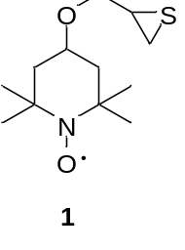
Figure S1a. 1H NMR of thiirane precursor (1) (chloroform d).
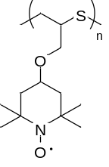
Figure S1b: 1H NMR of PTES (chloroform d) after quenching the radical with phenyl hydrazine.

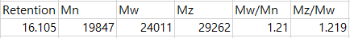
Figure S2. DSC of PTES.

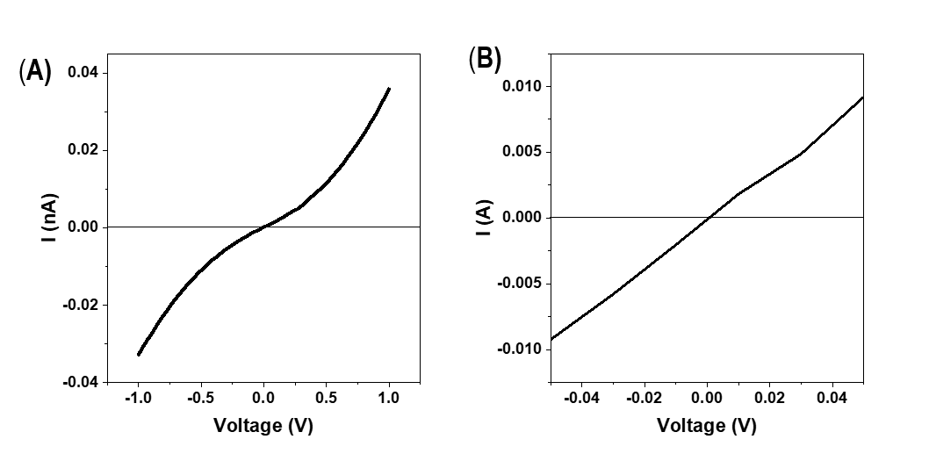
Figure S3. Representative current-voltage data of PTES thin film with low and high conductivity with electrode distances of 1.5 µm.

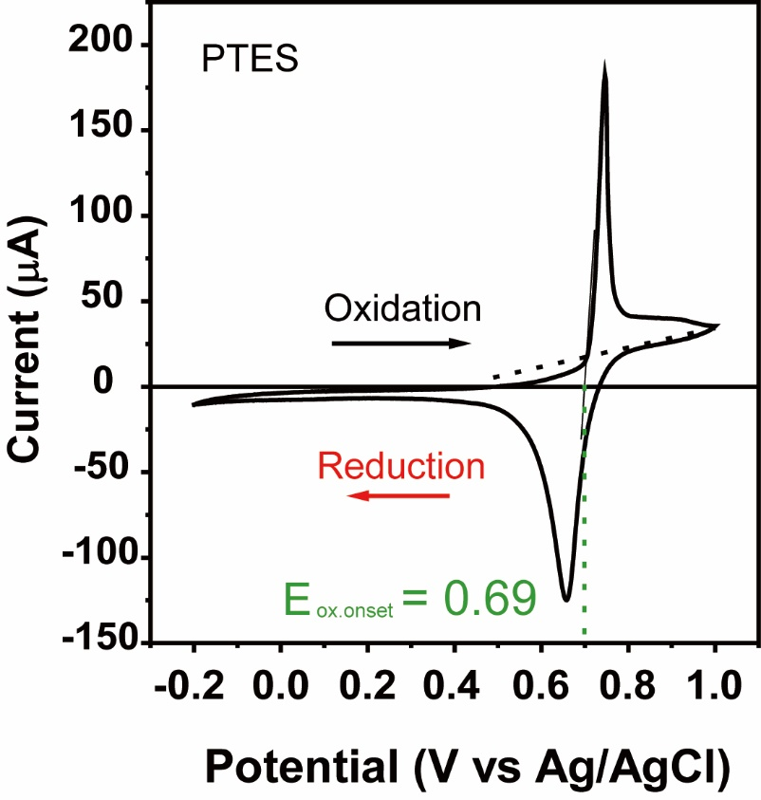

Figure S4. Cyclic voltammetry of PTES acquired at a scan rate of 25 mVs⁻¹ with Ag/AgCl as a reference electrode.

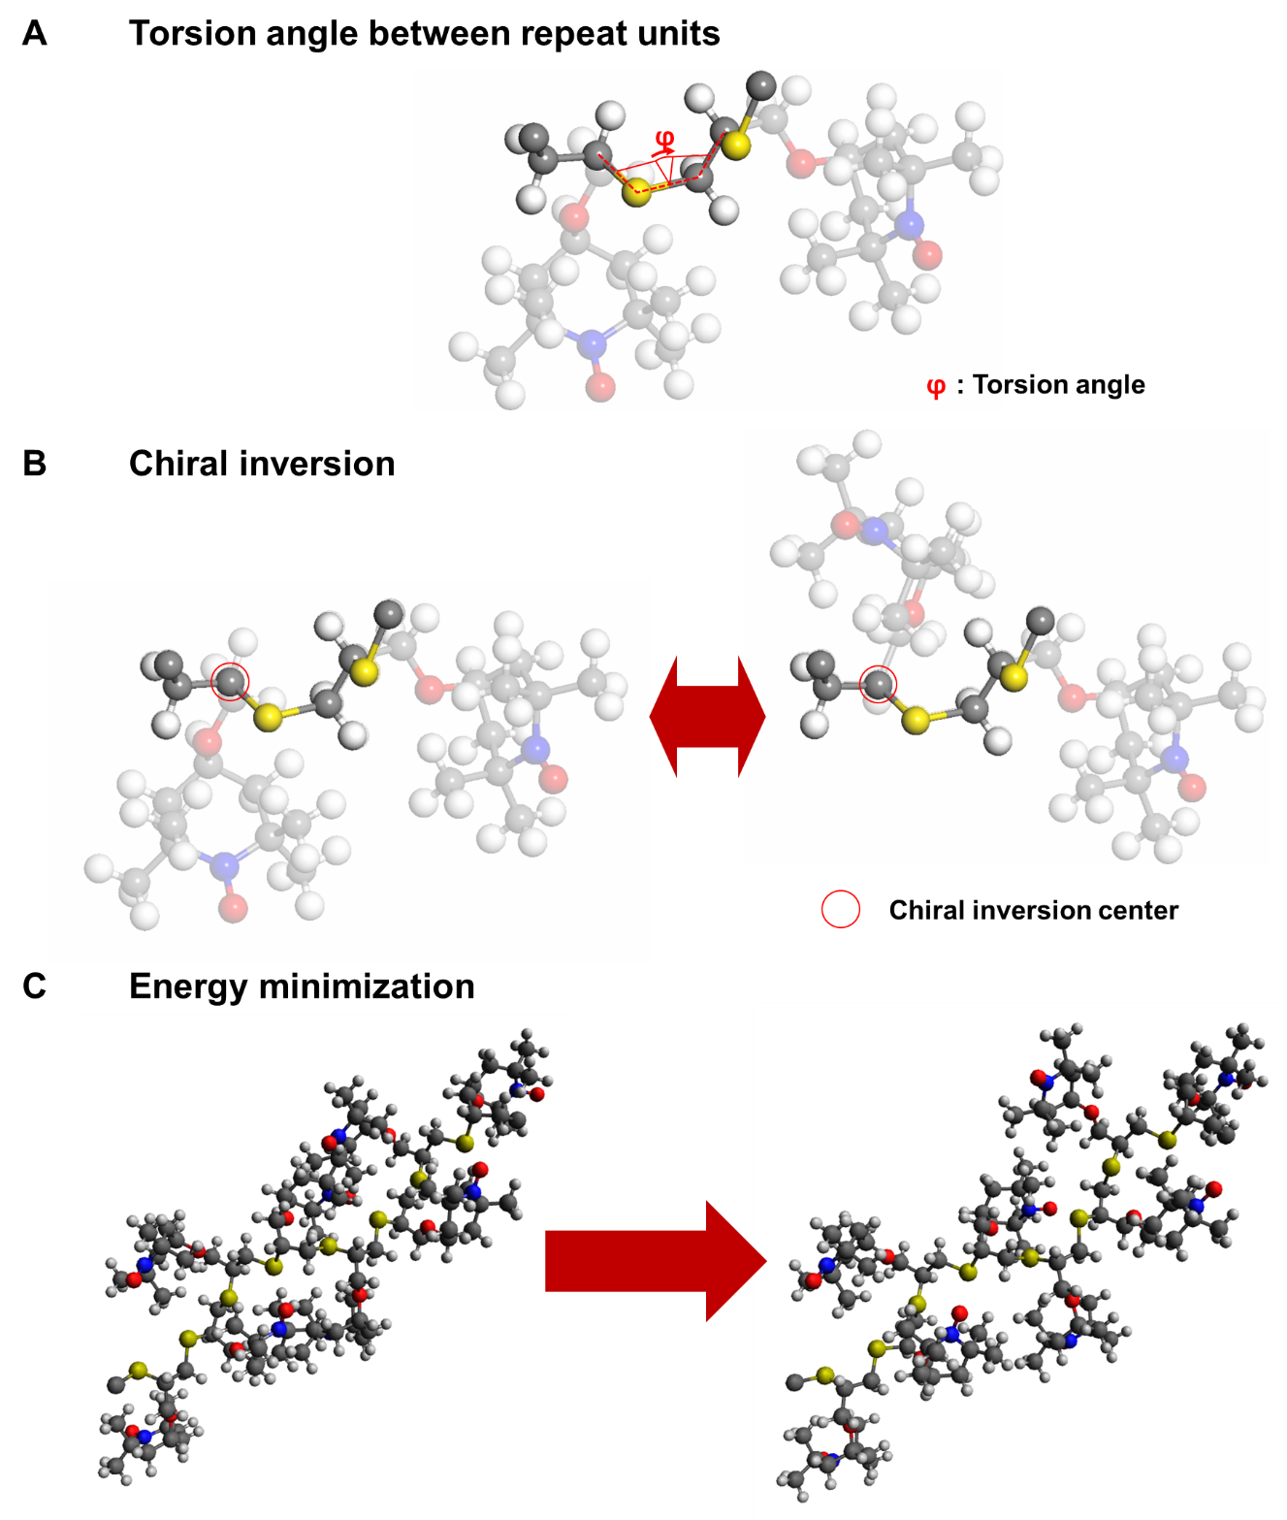
Figure S5. Geometry optimization of polymers. The polymer structures were created by taking into account geometric characteristics such as (A) the torsion angle between the repeat unit and (B) chiral inversion, based on the DFT-optimized repeat unit. (C) Molecular mechanics simulations were conducted to identify the lowest potential energy conformation of polymer structures by determining the appropriate molecular arrangement.
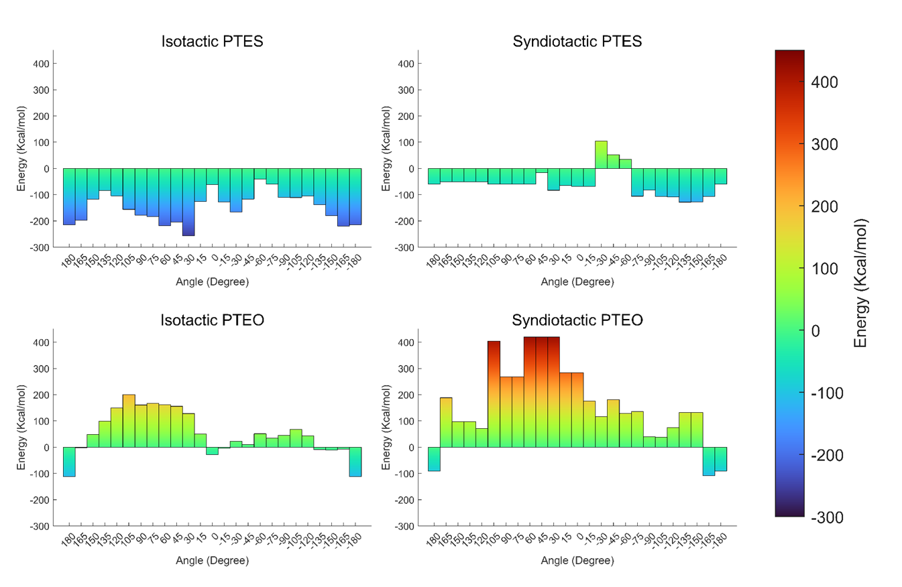
Figure S6. Minimized potential energy for various structures of PTES and PTEO polymers. Using molecular mechanics, the minimum conformational energy of the polymers was calculated by taking into account the different torsion angles between the repeat units and two distinct tacticities (isotactic and syndiotactic).

References
1 Kresse, G. & Furthmüller, J. Efficient iterative schemes for ab initio total-energy calculations using a plane-wave basis set. Phys. Rev. B 54, 11169 (1996).
2 Hanwell, M. D. et al. Avogadro: an advanced semantic chemical editor, visualization, and analysis platform. J. Cheminformatics 4, 17 (2012).

