Supplementary Section

1. Image Annotation: Prostate and PCa lesion segmentation was performed with an in-house software (Oncology Imaging Analysis version 2; Shanghai Key Laboratory. of MRI, ECNU, Shanghai, China) on T₂WI, DWI, and ADC by two experienced genitourinary radiologists from the two participating institutions. In patients with prostatectomy, postsurgical ex vivo prostates were processed using a previously described protocol. Key steps included sectioning, digitization, and annotation of cancer regions by highly experienced genitourinary pathologists. The histopathological specimens were then assembled into pseudo-whole-mount sections and co-registered to the MRI images using a previously described registration method. In this way, regions of annotated PCa were mapped onto the images to produce the ground truth maps. A central challenge in image labeling is the presence of ambiguous regions, where the true tumor boundary cannot be deduced precisely from the image, and thus multiple equally plausible interpretations exist. To fill this gap, the ROI of each lesion was drawn twice by each of two independent radiologists. Regional identification overlapping in two instances was identified as the authorized ROI of the targeted lesion. For the patient with multiple PCa lesions, only a leading lesion was annotated, referring to those with the higher Prostate Imaging and Reporting and Data System (PI-RADS) version 2.1 (v2.1) score or larger diameter if the score was the same.
2. Image preprocess: An open-source Elastix software (v. 4.10) referring to the suggested parameter file “par0001bspline16” was used for image registration [21]. Aligned images of T2WI, DWI, and ADC with the ROIs of prostate and PCa lesion were resampled to the inner-resolution of 0.5 × 0.5 mm² by the Bicubic method or linear method (for ROIs). Then the slice including the largest area of the tumor lesion was extracted and cropped a patch with a size of 200×200 with the center of the prostate to increase computation efficiency and focusing on the targeted lesion. All patches of T2WI, ADC, and DWI were normalized by Z-score to make the scale similar before importing into the model.
3. Architecture of Network: A ResNeXt-based model with a convolutional block attention module (CBAM) was used to analyze the multiparametric images by concatenated use of high-resolution T2WI, high-b value (1500 s²/mm) DWI and ADC. Four bottleneck blocks included 3/4/4/3 bottlenecks with 16/32/64/96 filters. In each bottleneck, CBAM was used to self-learn the valid features from a channel-attention module and a spatial-attention module. At the end of the 4th block, we applied two fully connected (FC) layers with 256 nodes and 32 nodes. In the first FC layer, we applied batch-normalization and parametric rectified linear units (ReLU) to extract features. And in the second FC layer, we implemented a sigmoid function to predict the risk of ECE. The details of the ResNeXt was shown in Fig. S3d.
Additionally, to guide the ResNeXt network to emulate the judgments of experts who provided the labels of the targeted lesion, we brought in a prior-attention guide (PAGNet) unit, that guides the model to form a computational map highly embedding the expert’ interpretations. To construct this expert-gated network, we first generated a prior-attention map based on the ROIs of PCa and prostate. The attention value of one voxel was set according to its location (Fig. S4a): i) if the voxel is localized in intratumor region and out of the prostate counters, we set an attention value of 100%; ii) if the voxel is localized in intratumor regions and in the prostate, we measured the distance (DP) from this voxel to the surface of prostate. The attention value was given to , in which r denoted the inner-resolution weighted a coefficient. (light blue). iii) if the voxel is localized outside of the tumor region, the attention value was given to , which was related to the distance () from the voxel to the surface of the cancer (light yellow). Then the attention region extended outside with value attenuating as a ratio of . Examples of the generated attention map were shown in Fig. S4b. Then we embedded the above generated-attention map in the CBAM to guide the model in focusing on the PCa region. In CBAM, spatial attention was self-learned and generated the weighted coefficients to focus on the spatial region. The self-learned attention and our generated attention were implemented on all channels of the corresponding feature layers, respectively. Then we concatenated the scaled results and applied the following process (red part of Fig. S3d). This process can utilize both information of the data-driven self-learned features and the annotated prior-generated attention to guide the model focus on the candidate region.
4. Integration of PAGNet and Clinical Identifications: Last, to evaluate the integrative effects of clinical factors on the deep diagnostic networks for improving diagnostic performance. The PSA, age, biopsy Gleason score, percentage of positive cores, and biopsy perineural invasion were added to the PAGNet model, namely PAGNet + C, in which, clinical information was directly added to the second FC layer (32 nodes) of PAGNet by increasing the number of neurons (purple part of Fig. S3d).
5. Model Training and Inference Approach: In the training stage, we used an ensemble learning approach with 5-fold cross-validation to develop a robust model. The cases of training cohort were split into 5 parts, and we used 4 parts as the train data set and the remained 1 part as the validation. For each fold, We first balanced the data set by up-sampling the positive cases randomly and initialized the parameters of the model by the He method. Adam with an initial step of 0.001 was used as the optimizer and the negative log-likelihood loss was used as the loss function. In the first FC layer, we also used a dropout with a ratio of 0.5 in the training process. In each epoch, we balanced the positive and negative samples by random up-sampling. The batch size was set to 24. During the training process, we monitor the loss of the validation data set. If the loss does not decrease in 10 contiguous epochs, we reduced the step of the optimizer to half. If the loss does not decrease in 50 contiguous epochs, we stopped the training. In each fold of training, we applied an online augmentation strategy on the training cohort, which meant that we generated a random transform on each batch of the data set. The transform included rotation, flip, stretch, zoom, and elastic transformations. We also added random Gaussian noise and bias filed of MR images to simulate scanning images to make the model more robust. At last, we developed 5 independent models. (Fig. S3b)
In the inference stage, we used the trained 5 models to predict one image and average the prediction to get the final predicted value. Additionally, since one case included several slices with PCa, we could use the model to predict the slice with the largest area of the PCa which was the same as the preprocessing, termed as PAGNet-OneSlice. Or we could predict all slices including PCa lesion and used the maximum value as the final prediction of ECE for this case, termed as PAGNet-MultSlices (Fig. S3c).
6. Package of Model Implementation All above was implemented on Ubuntu 18.04 by 2 NVIDIA Titan X Graphic Cards. The AI model was developed by Python 3.7 with the PyTorch 1.4.1.

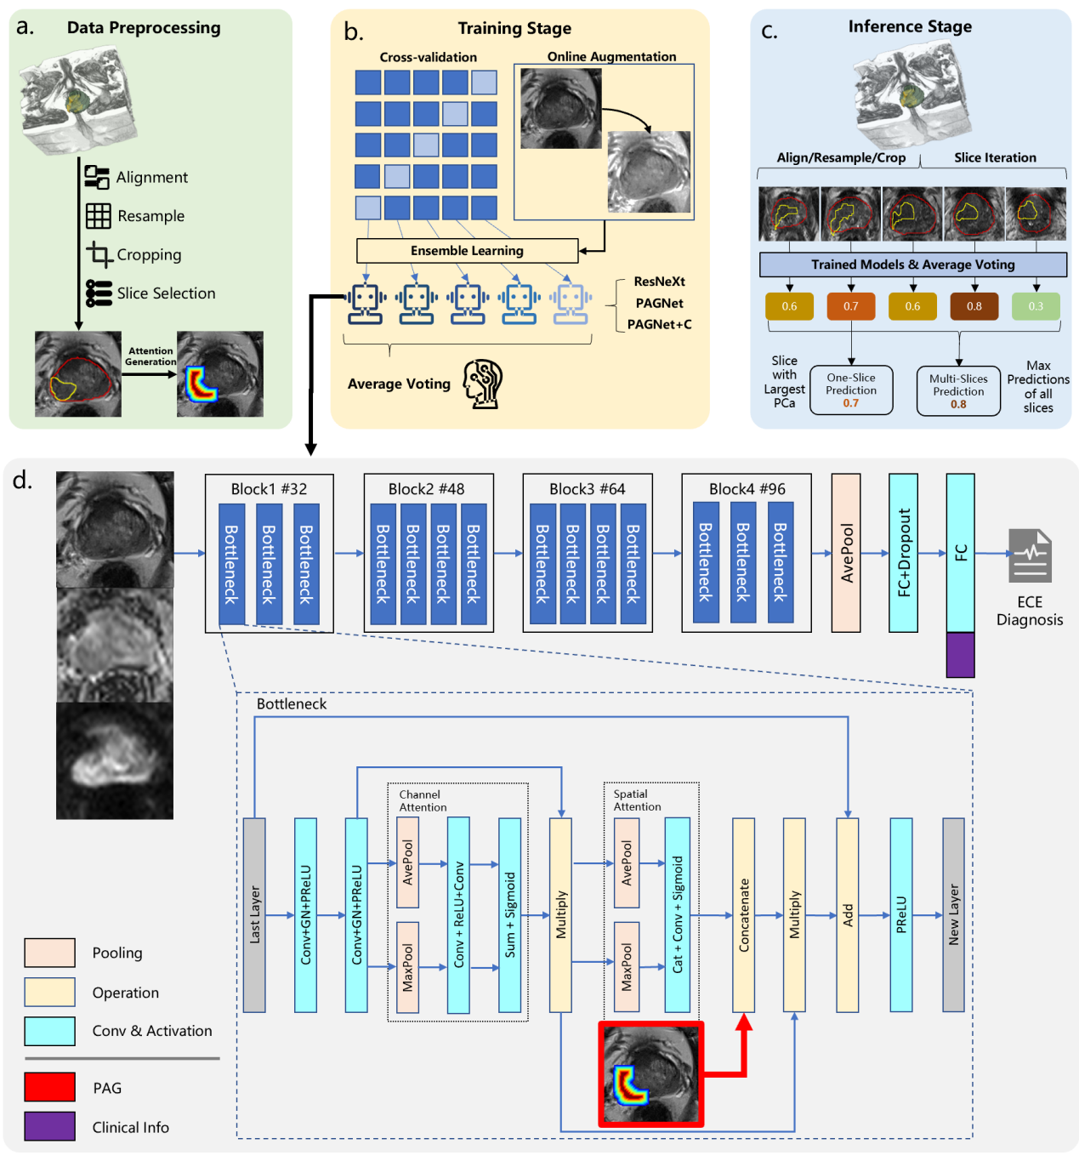
Fig. S3 Overview of the model development in this study. a. Data preprocessing: 3D mp-MR images were preprocessed to prepare the training data set with the generated attention map. b. Training stage: Ensemble learning with 5-fold cross-validation was used to develop independent AI models by online augmentation. c. Inference stage: The trained model was used to predict one/each slice of MR images to estimate the prediction of ECE. d. Model architecture: ResNeXt model with CBAM was used as the base model. We modified the ResNeXt by embedding the prior-attention in each bottleneck (PAGNet, red part) and the clinical features in the second FC layer (PAGNet+C, purple part). Block1 #32 denoted in the first bottleneck block, the number of all convolution filters was 32.
ECE, extracapsular extension.
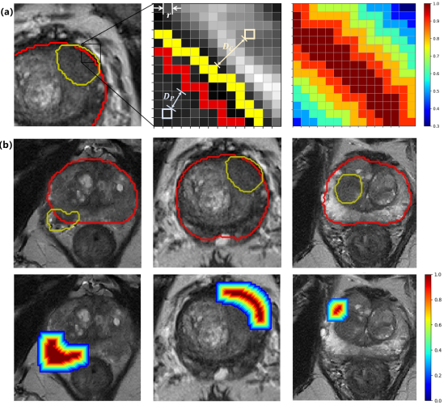
Fig. S4 The process of the generated attention and the random selected examples. Radiological experts labeled the boundary of the prostate and lesion by referring the mp-MR images manually first. Then a prior-attention map was calculated based on these boundaries. The region with a higher value in the attention map denoted the higher risk region of occurring ECE. (a) denotes the calculation of the attention map and (b) denotes the random selected examples of the annotation (bottom) and the corresponding attention map (bottom).
ECE, extracapsular extension.

Table Checklist of the key consideration of artificial intelligence in medical images.
Key considerations | Check
Are all three image sets (training, validation, and test sets) defined? | Yes
Is an external test set used for final statistical reporting | Yes
Have multivendor images been used to evaluate the AI algorithm? | Yes
Are the sizes of the training, validation, and test sets justified? | Yes
Was the AI algorithm trained using a standard of reference that is widely accepted in our field? | Yes
Was preparation of images for the AI algorithm adequately  described? | Yes
Were the results of the AI algorithm compared with radiology experts and/or pathology? | Yes
Was the manner in which the AI algorithm makes decisions demonstrated | Yes
Is the AI algorithm publicly available? | Yes

- Carefully define all three image sets (training, validation, and test sets of images) of the AI experiment.
Training and validation cohort: 596 cases (151 positive) of Center 1. We used ensemble learning with 5-fold cross-validation to build 5 models. For each model, we used 80% of 596 cases as training and the left 20% of 596 cases as the validation.
Testing cohort: 150 cases (40 positive) of Center 1 and 103 cases (33 positive) of Center 2.

- Is an external test set used for final statistical reporting?
The model was trained using 596 cases from Center 1. 150 internal cases and 103 external cases were used for test.

- Have multivendor images been used to evaluate the AI algorithm?
746 cases from Center 1 scanned by 3T Skyra, Siemens Healthcare.
103 cases from Center 2 canned by 3T Skyra, Siemens Healthcare, as the external test.

- Are the size of the training, validation, and test sets justified?
Training/validation cohort and the testing cohort in Center 1 were split randomly. There was no significant difference between these data set.

- Was the AI algorithm trained using a standard of reference that is widely accepted in our field?
The reference was determined based on the histopathological outcomes. All biopsies and surgical specimens were prepared and examined by two pathologists who had 10-yr experience in urologic pathology according to the ISUP 2005 recommendations. Historical ECE was defined as the breach of the prostatic capsule into the periprostatic fat..

- Was preparation of images for the AI algorithm adequately described?
We make a detailed description of the preparation methods in the Image preparation section (supplementary Section 1). The scanning parameters and preprocessing were described. The preprocessing included registration (Elastix), resampling (0.5mm$×$0.5mm), cropping (200$×$200), and normalization (Z-score).

- Were the results of the AI algorithm compared with radiology experts and/or pathology?
AI model, ECE grade reported by two radiological experts, and the AI-expert interaction approach were compared.

- Was the manner in which the AI algorithm makes decisions demonstrated?
The Grad-CAM was used to interpret the model visually. The region with a higher value of the Grad-CAM denoted a higher contribution to the final diagnosis. The Grad-CAM of the ResNeXt and the proposed PAGNet was shown in Fig. S4.

- Is the AI algorithm publicly available?
The code is available on https://github.com/Cherishzyh/ProstrateECE.

