Legends for Supplementary Materials

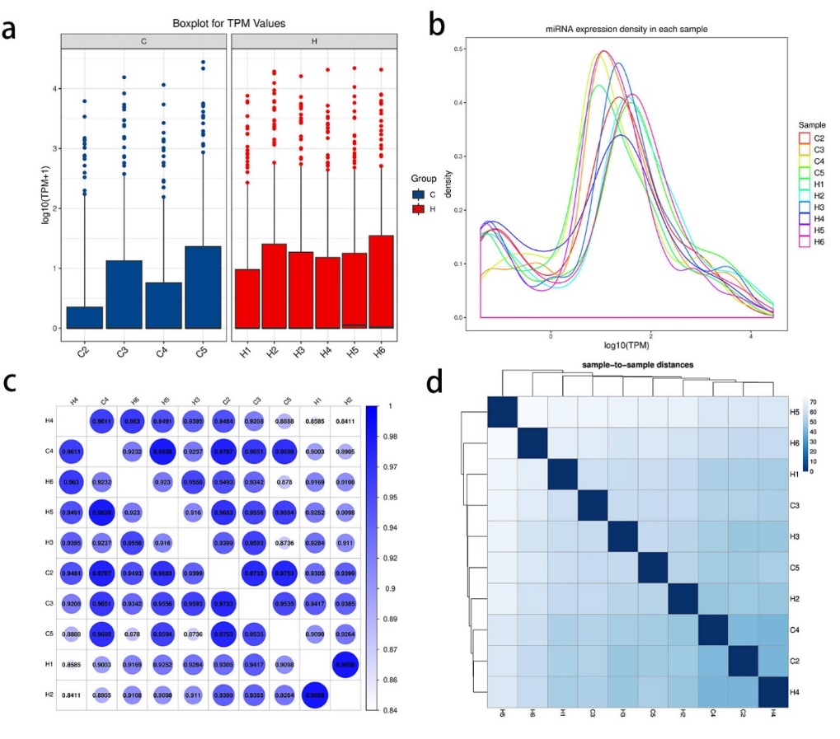

Fig. S1 Analysis of miRNA expression. a Boxplot for TPM values. b MiRNA expression density in each sample. c Heatmap of correlation coefficient between any two samples. d Sample-to-sample clustering diagram. c and d examine the similarity among samples.

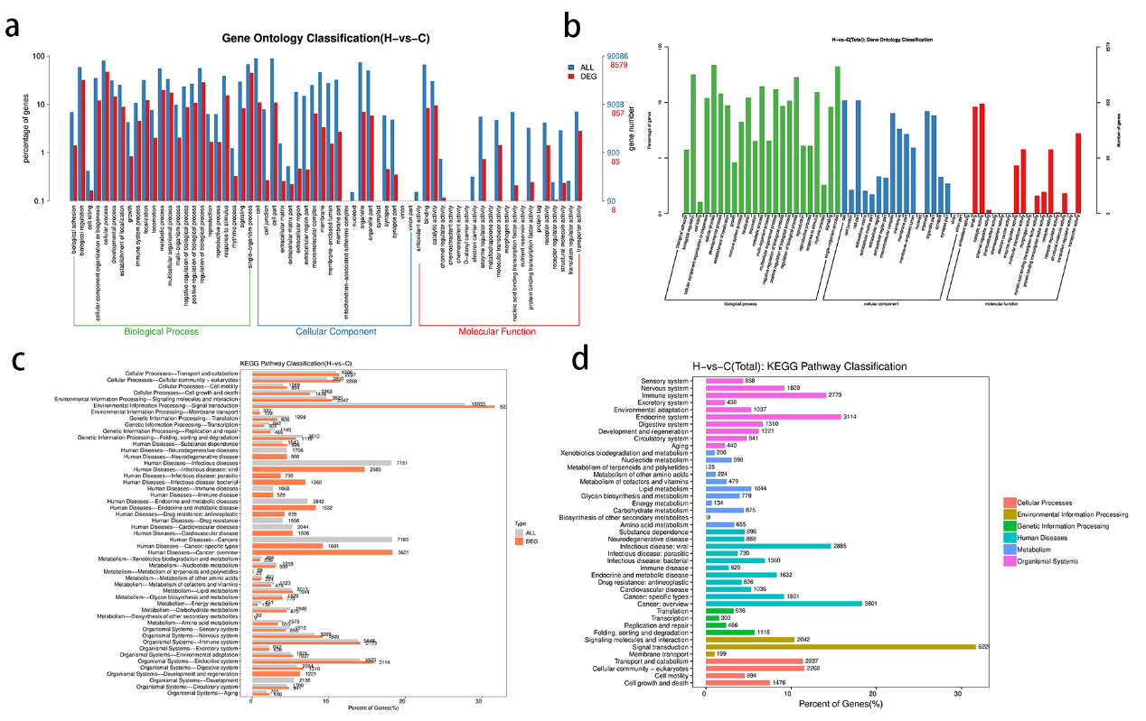

Fig. S2 Pathways analysis using differentially expressed miRNAs.
a Gene ontology classification (H-vs-C). Comparison of distribution of differential miRNA target genes and all genes at GO Level 2. b H-vs-C(total): Gene ontology classification. Distribution of differential miRNA target genes and all genes at GO Level 2. c KEGG pathway classification (H-vs-C). Comparison of distribution of differential miRNA target genes and all genes at KEGG Level 2. d H-vs-C (total): KEGG pathway classification. Distribution of differential miRNA target genes at KEGG Level 2.

Supplementary Tables
Table S1 Materials for isolation of exosomes/RNA extraction and library construction.
Table S2 Distribution of small RNA in each sample.
Table S3 Gene Ontology (GO) for the DE miRNAs in exosomes derived from PTC subjects with and without lymph node metastases.

Table S1 Materials for isolation of exosomes/RNA extraction and library construction
名称 | 品牌 | 货号
PBS | Sangon Biotech | E607008
0.45 filter membrane | Millipore | R6BA09493
Pipette | Eppendorf | Research Plus
Freezing centrifuge | Beckman | Microfuge 20R
Ultra-low temperature freezer | Thermo | 905
Ultracentrifuge | Hitachi | CP100MX
Transmission electron microscope | Hitachi | HT-7700
Particle size analyzer | NanoFCM | N30E
Desktop centrifuge | eppendorf | Centrifuge 5418R
PCR instrument | Bio-rad | MyCycler
Ultraviolet spectrophotometer | Thermo | Nano Drop 2000
Quantizer | Invitrogen | Qubit2.0
Dark Reader transilluminator or UV transilluminator | Clare Chemical Research | D195M
Bioanalyzer | Aglient | 2100
XCell Sure Lock Mini-Cell electrophoresis unit | Invitrogen | EI0001
5 μm filter tube | IST Engineering | 5388-50
Gel Breaker tube | IST Engineering | 3388-100
Tips and centrifuge tube | Axygen

Table S2: Distribution of small RNA in each sample
Annotation type | Number of total | % of total(%) | Number of uniq | % of uniq(%)
repeat | 7070292 | 52.41 | 28798 | 11.34
unannotation | 6303185 | 46.72 | 220899 | 87.01
known_miRNA | 38092 | 0.28 | 627 | 0.25
rRNA | 29842 | 0.22 | 476 | 0.19
Cis-reg | 18537 | 0.14 | 326 | 0.13
gene | 12660 | 0.09 | 1808 | 0.71
other_Rfam_RNA | 9076 | 0.07 | 603 | 0.24
snRNA | 4650 | 0.03 | 268 | 0.11
tRNA | 3914 | 0.03 | 83 | 0.03

Table S3: Gene Ontology (GO) for the DE miRNAs in exosomes derived from PTC subjects with and without lymph node metastases. Cellular components, biological processes, and molecular functions are as follows:

Cellular components
Cellular component ID | Cellular component term | % | p-value
GO:0005634 | nucleus | 0.486911 | 0.999978834
GO:0005829 | cytosol | 0.496336 | 0.677966327
GO:0005737 | cytoplasm | 0.516335 | 7.69E-11
GO:0005886 | plasma membrane | 0.553946 | 2.31E-67
GO:0016021 | an integral component of membrane | 0.5204 | 1.84E-10
GO:0005654 | nucleoplasm | 0.503326 | 0.055371622
GO:0070062 | extracellular exosome | 0.49715 | 0.538173474
GO:0016020 | membrane | 0.509558 | 0.007974086
GO:0005887 | integral component of plasma membrane | 0.574129 | 1.59E-31
GO:0005794 | Golgi apparatus | 0.554228 | 2.71E-15
Biological process
Biological process | Biological process term | % | p-value
GO:0006351 | transcription, DNA-templated | 0.497728 | 0.654253987
GO:0006355 | regulation of transcription, DNA-templated | 0.466971 | 0.99999999
GO:0007165 | signal transduction | 0.541726 | 1.02E-08
GO:0045944 | positive regulation of transcription from RNA polymerase II promoter | 0.533869 | 4.51E-06
GO:0000122 | negative regulation of transcription from RNA polymerase II promoter | 0.540968 | 8.27E-07
GO:0007275 | multicellular organism development | 0.589988 | 1.33E-20
GO:0035556 | intracellular signal transduction | 0.561323 | 7.75E-11
GO:0045893 | positive regulation of transcription, DNA-templated | 0.532468 | 0.000573511
GO:0007186 | G-protein coupled receptor signaling pathway | 0.607386 | 1.49E-23
GO:0030154 | cell differentiation | 0.499796 | 0.496185415
Molecular function
Molecular function ID | Molecular function term | % | p-value
GO:0046872 | metal ion binding | 0.500036 | 0.500699928
GO:0005524 | ATP binding | 0.485348 | 0.997637204
GO:0003677 | DNA binding | 0.448036 | 1
GO:0003723 | RNA binding | 0.478429 | 0.999948453
GO:0042802 | identical protein binding | 0.483788 | 0.989331729
GO:0008270 | zinc ion binding | 0.523638 | 0.000888779
GO:0003700 | DNA binding transcription factor activity | 0.975846 | 0.95046365
GO:0005509 | calcium ion binding | 0.558445 | 2.47E-12
GO:0042803 | protein homodimerization activity | 0.516149 | 0.029813812
GO:0003779 | actin binding | 0.674081 | 2.55E-59

