Supporting information for:

Using Future Climate and Land-Use Change Scenarios to Predict Amphibian Distribution Change in the Upper Missouri River Basin

Kaitlyn S. Campbell^{1,2*}, Andrew P. Baltensperger^{1,3}, Jacob L. Kerby¹

¹Department of Biology, University of South Dakota, Vermillion, SD, USA
²Department of Natural Resources and the Environment, University of Connecticut, Storrs, CT, USA
³International Artic Research Center (IARC), University of Alaska Fairbanks, Fairbanks, AK, USA
*Corresponding author: kaitlynscampbell@gmail.com

For submission to:
Landscape Ecology

*Corresponding author contact information:
Email: Kaitlynscampbell@gmail.com

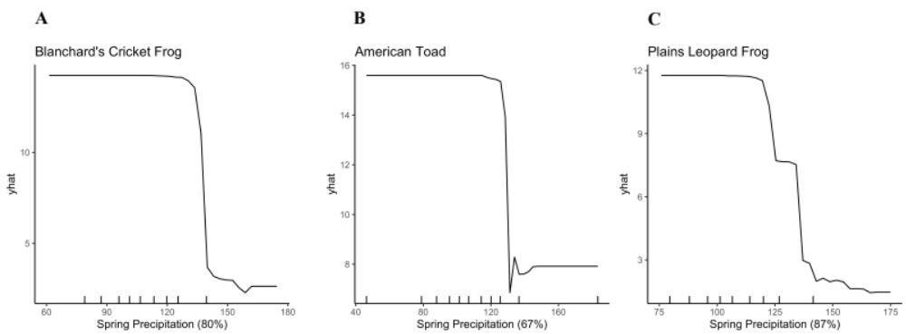
Online Resource 1. Partial dependence plots depicting the influence of spring precipitation (mm) for a) Blanchard’s cricket frogs, b) American toads, c) Plains leopard frogs.

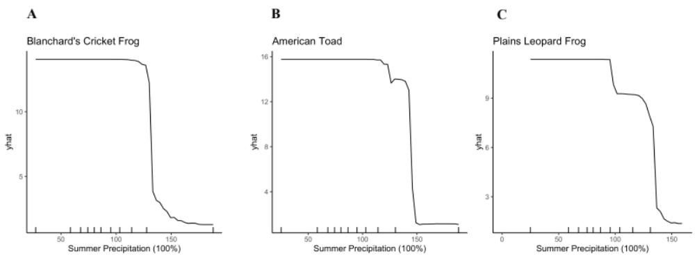
Online Resource 2. Partial dependence plots depicting the influence of summer precipitation (mm) for a) Blanchard’s cricket frogs, b) American toads, c) Plains leopard frogs.

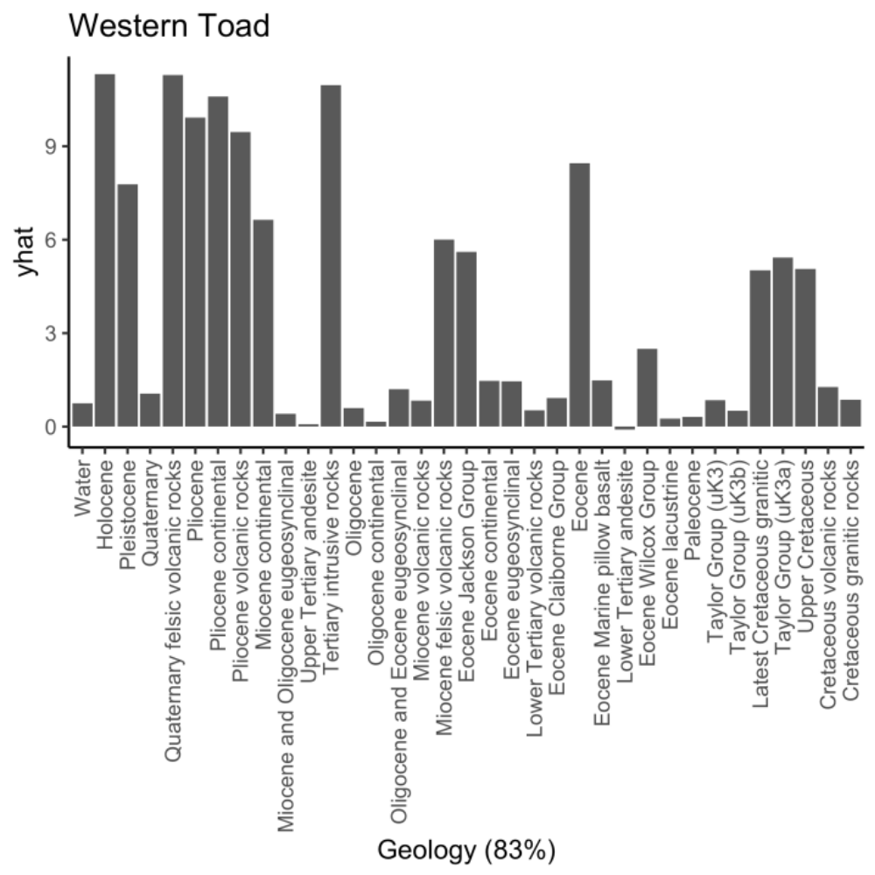
Online Resource 3. Partial dependence plot depicting the influence of geology on Western toad distribution in the Upper Missouri River Basin.
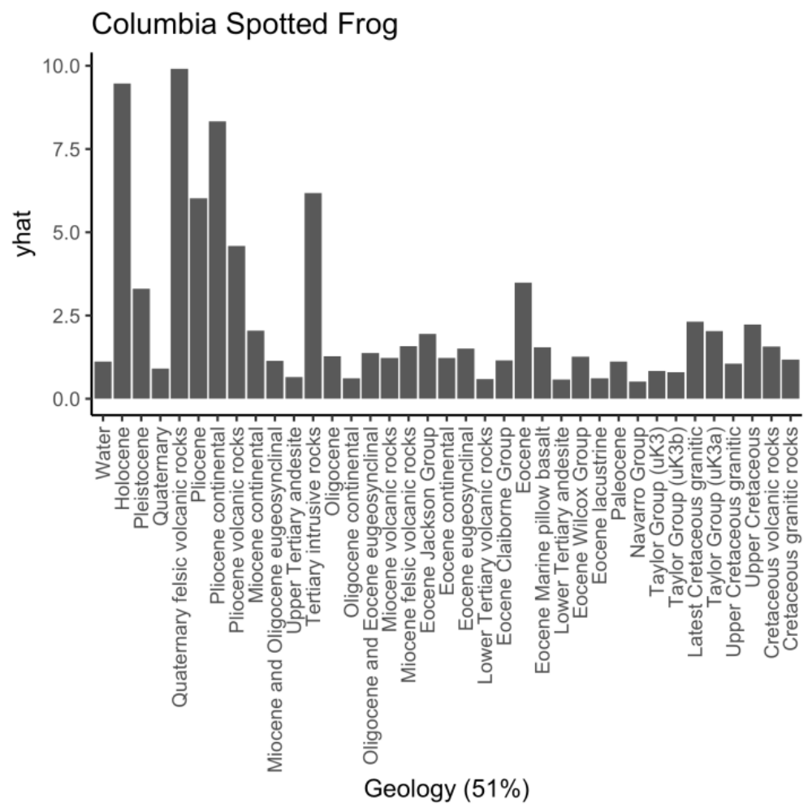
Online Resource 4. Partial dependence plot depicting the influence of geology on Columbia spotted frog distribution in the Upper Missouri River Basin.
Online Resource 5. Partial dependence plot depicting the influence of land cover on American toad distribution in the Upper Missouri River Basin.
Online Resource 6. Partial dependence plot depicting the influence of land cover on Rocky Mountain tailed frog distribution in the Upper Missouri River Basin.
Online Resource 7. Partial dependence plot depicting the influence of pollution distance on Great Plains toad distribution in the Upper Missouri River Basin.

