SUPPLEMENTARY MATERIAL
Hurricane transport of ocean-sourced microplastic in the North Atlantic

Authors
Anna C. Ryan¹, Deonie Allen², Steve Allen¹, Vittorio Maselli¹, Amber LeBlanc³, Liam Kelleher⁴, Stefan Krause^{4, 5}, Tony R. Walker³

Affiliations
¹ Department of Earth and Environmental Sciences, Dalhousie University, Halifax, NS B3H 4R2, Canada
² Department of Civil and Environmental Engineering, University of Strathclyde, Glasgow, G1 1XQ, United Kingdom
³ School of Environmental Management, Dalhousie University, Halifax, NS B3H 4R2, Canada
⁴ School of Geography, Earth and Environmental Sciences, University of Birmingham, Birmingham, B15 2TT, United Kingdom
⁵ Univ Lyon, Université Claude Bernard Lyon 1, CNRS, ENTPE, UMR5023, Ecologie des Hydrosystèmes Naturels et Anthropisés (LEHNA), 69622, Villeurbanne, France

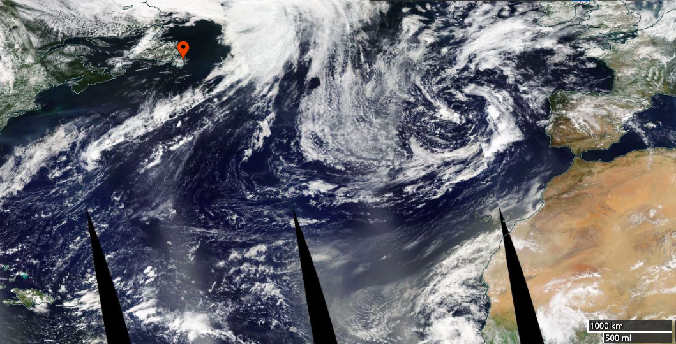
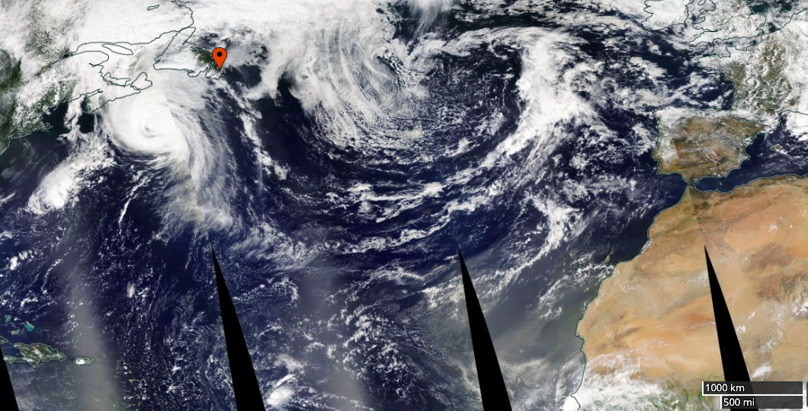
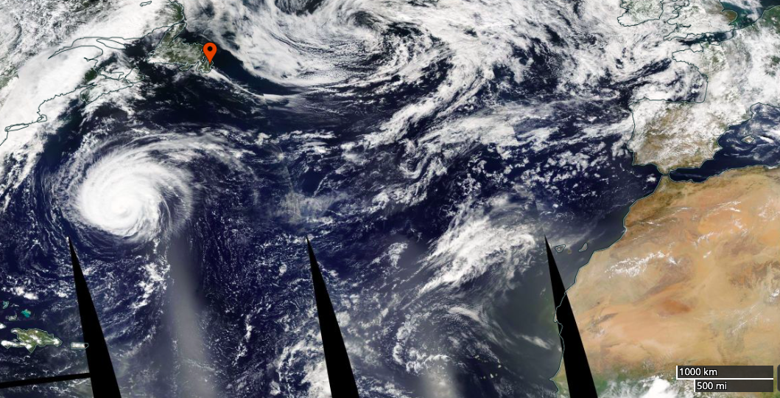
S1 – Meteorological Conditions
11/09/21
10/09/21
08/09/21
06/09/21
09/09/21
04/09/21
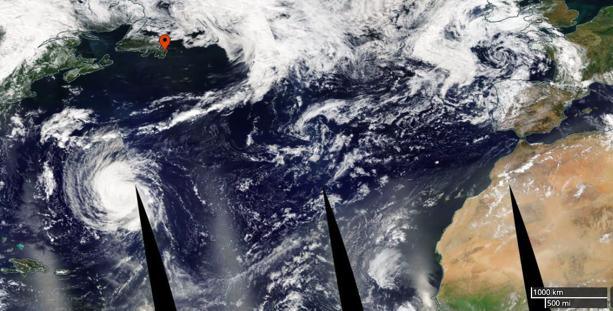
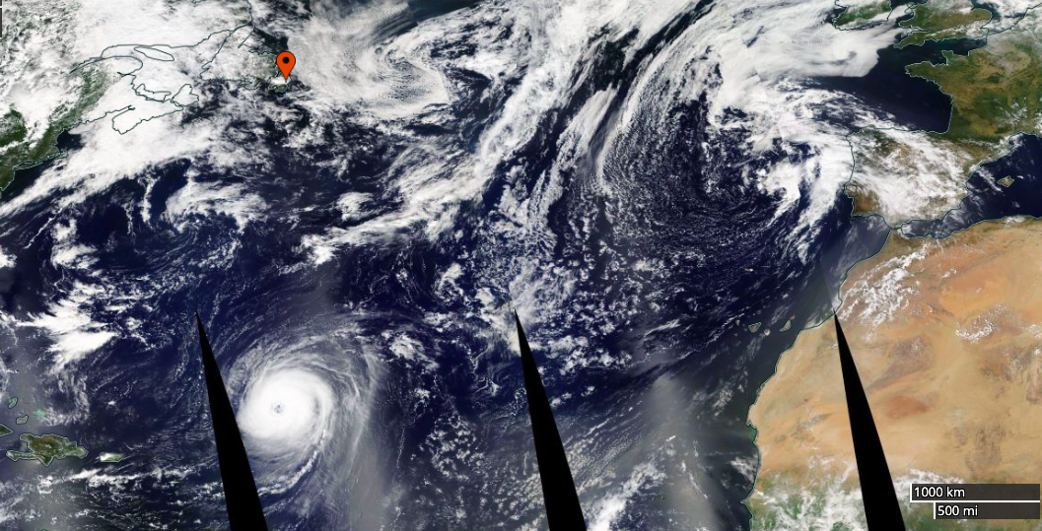
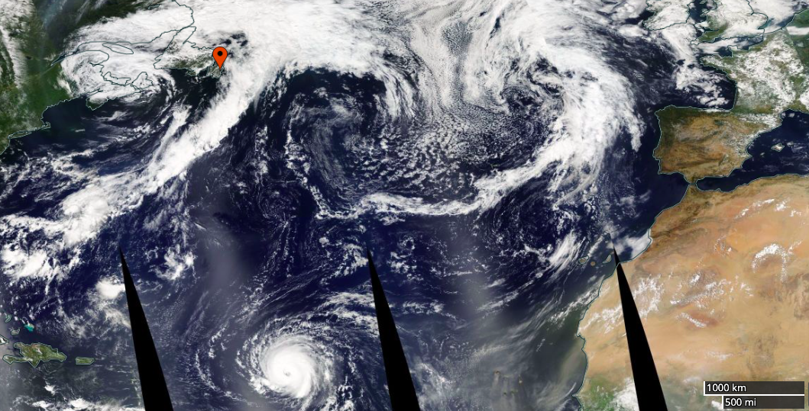
Figure S1. Satellite view of Hurricane Larry track with sample site indicated by red marker (EOSDIS Worldview).

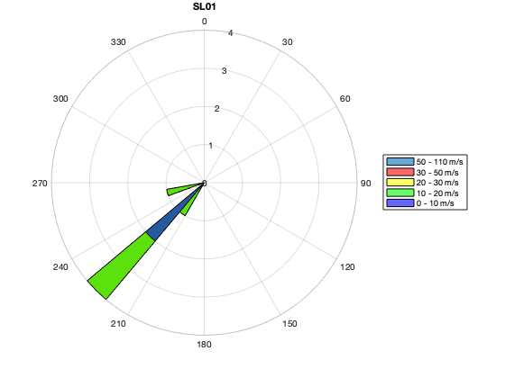
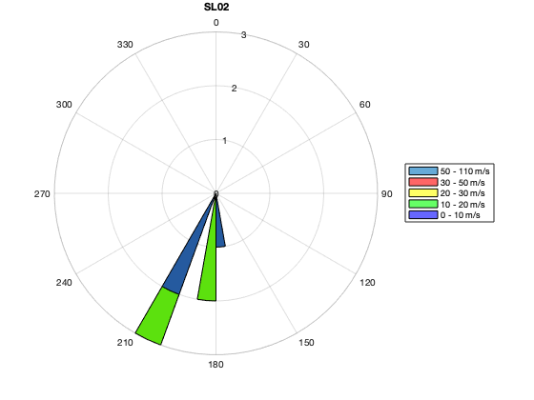
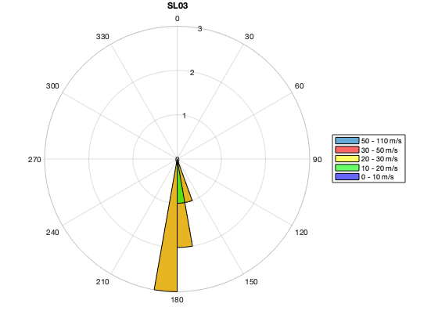
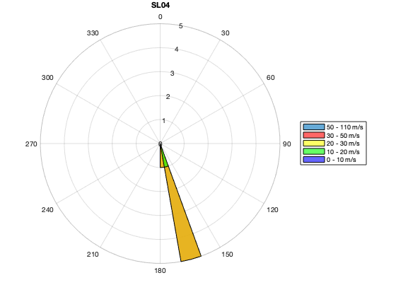
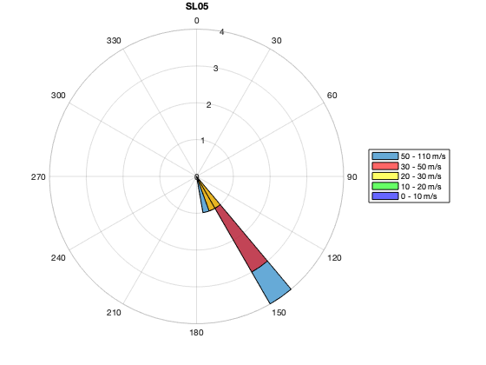
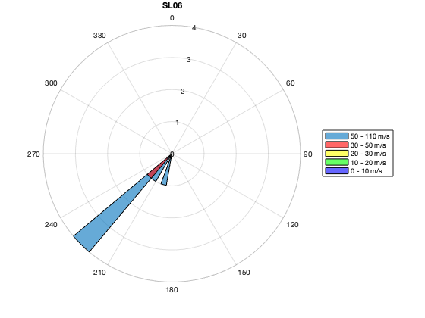
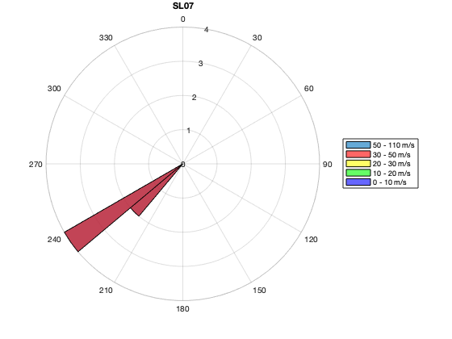
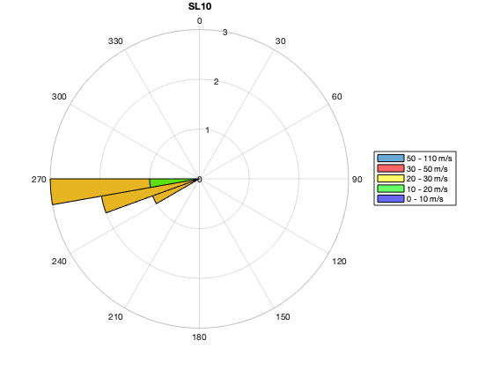
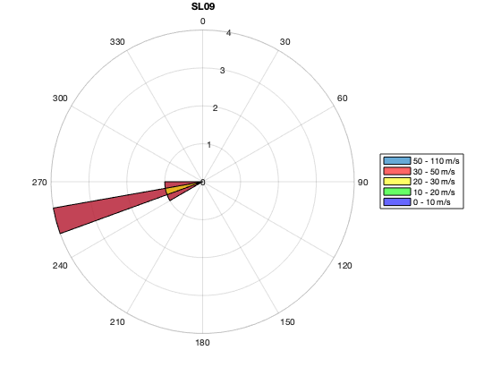
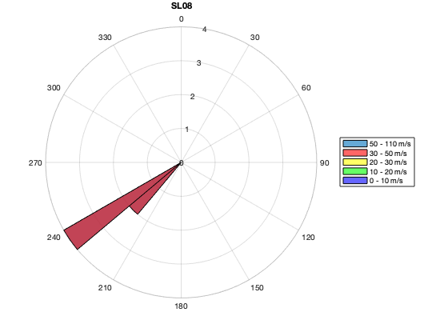

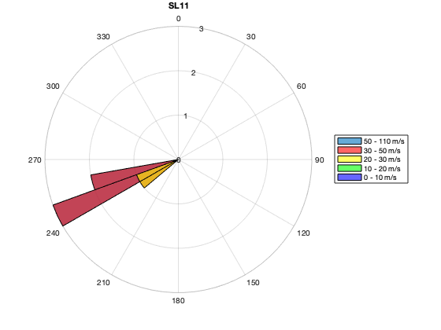
Figure S2. Wind rose for each sample duration based on Cape Race weather station data.

S2 – Polymer Types

Figure S3. Polymer type distribution for each sample.

Figure S4. Left: Overall polymer composition of microplastic deposition. Right: Overall polymer composition excluding SL01.

S3 – Size Distribution
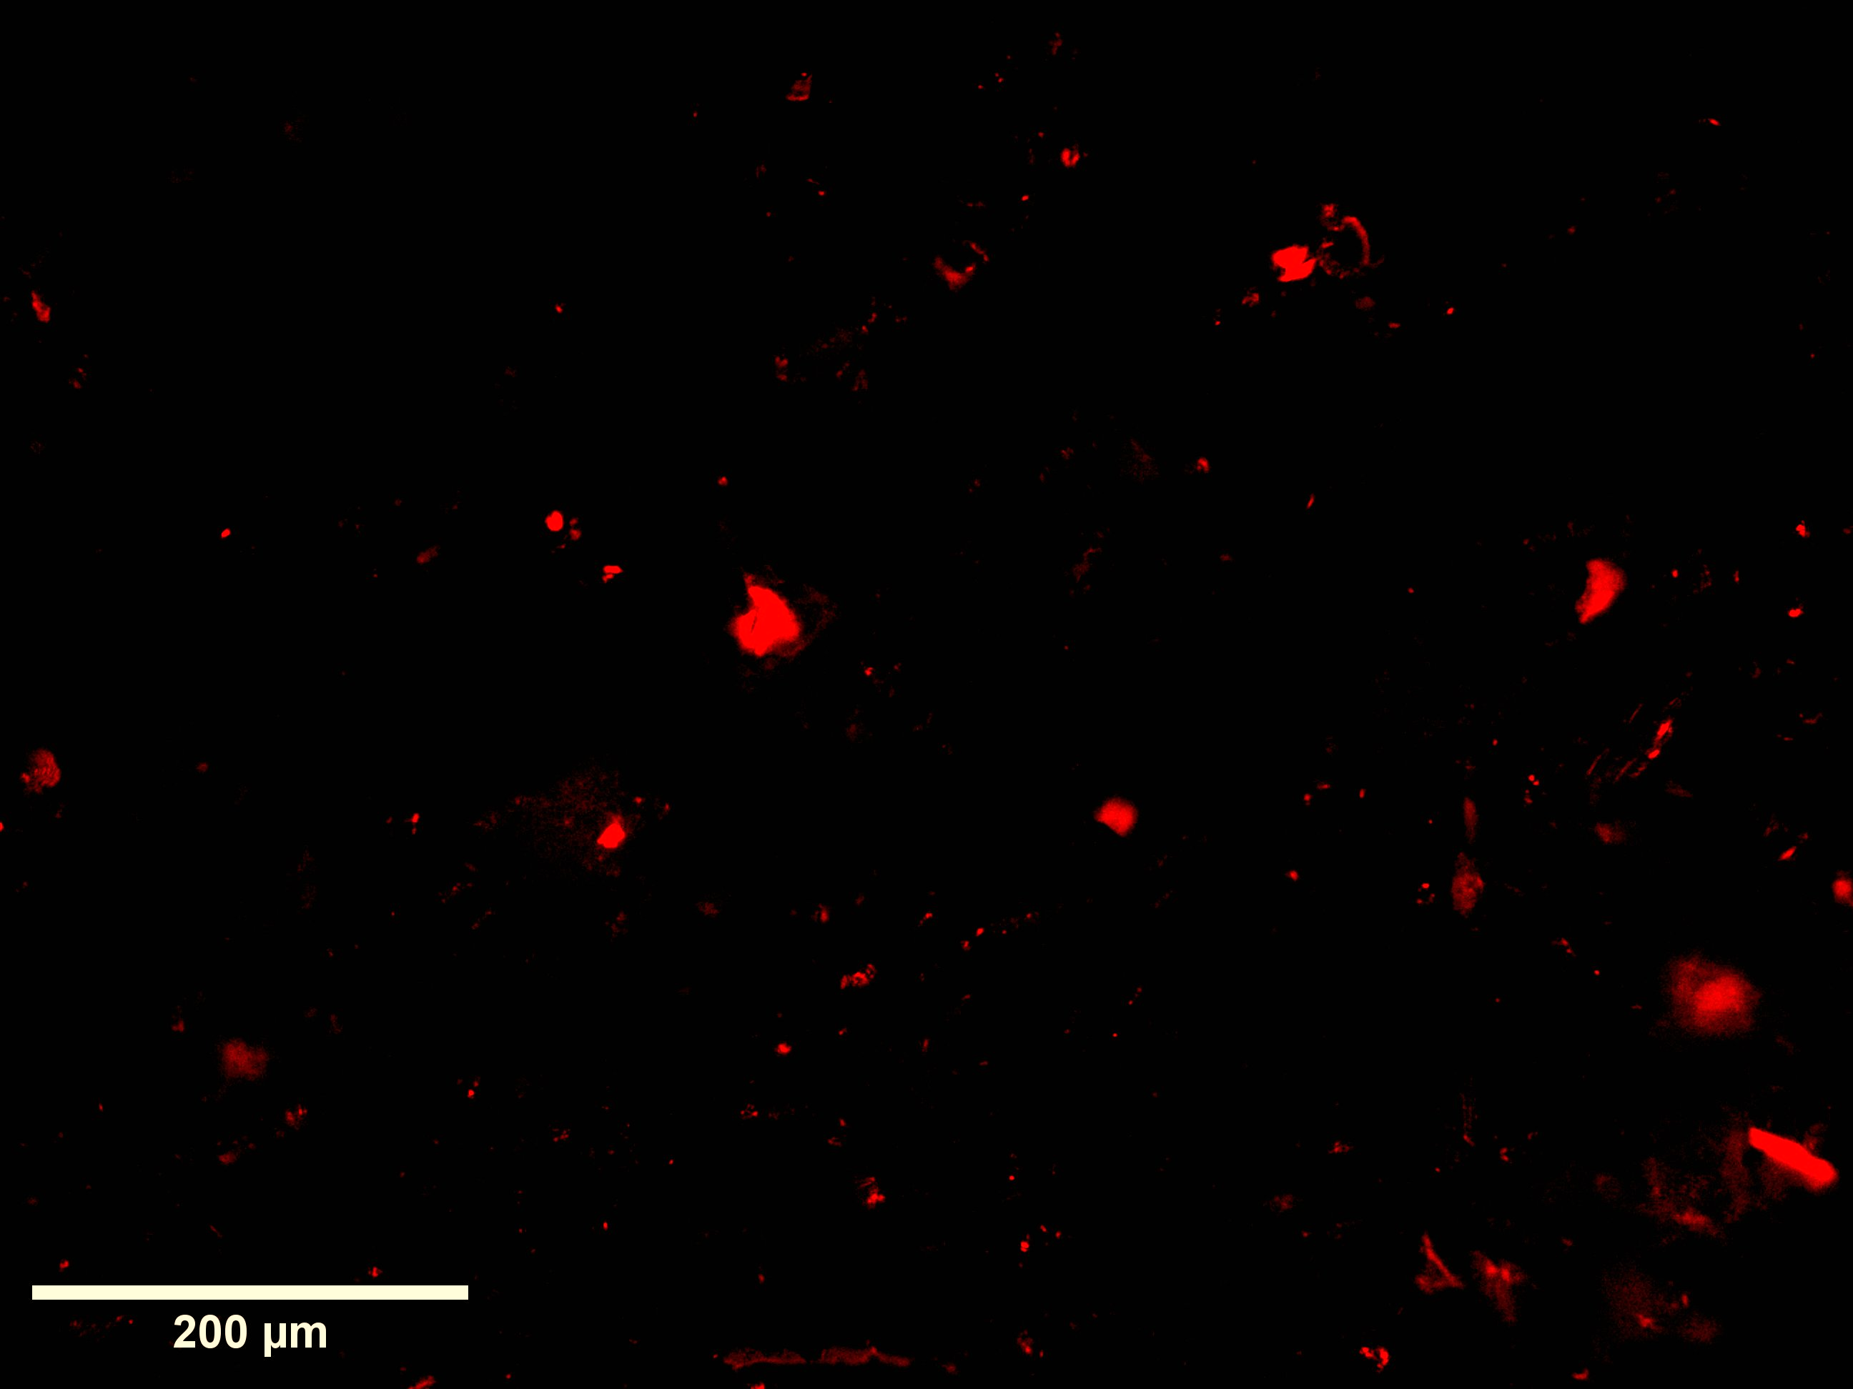
MP particle size classification was performed using FIJI/ImageJ. This method is subject to user bias.

Figure S5. Image of SL06 filter with Nile Red under fluorescent light.

Figure S6. Number of MP particles (n MP/5% of sample filter) for each class size calculated by averaging values for samples collected before (SL01 – SL03), during (SL04 – SL06), and after (SL07 – SL11) Hurricane Larry.

Figure S7. MP particle (n MP/5% of sample filter) size distribution for each sample.

S4 – Back-trajectory modelling

Figure S8. Elevation above ground level versus horizontal distance for air masses in 48 h backwards trajectory HYSPLIT4 model for average flight durations before (SL01-SL03), during (SL04-SL06), and after (SL07-SL11) Hurricane Larry.

Figure S9. Elevation above ground level versus time before deposition for air masses in 48 h backwards trajectory HYSPLIT4 model for average flight durations before (SL01-SL03), during (SL04-SL06), and after (SL07-SL11) Hurricane Larry.

Figure S10. Elevation above ground level versus horizontal distance for air masses in 48 h backwards trajectory HYSPLIT4 model for each sample.

Figure S11. Elevation above ground level versus time before deposition for air masses in 48 h backwards trajectory HYSPLIT4 model for each sample.

Table S1: Summary of particle deposition, model results, and weather conditions at Cape Race weather station for each sample.
*Maximum distance transported in 48 h, air mass did not fall below 10 m.
**Maximum flight duration, air mass did not fall below 10 m.

sample | Total particles (n/m²/d) | MPs (n/m²/d) | Flight distance  (km, average, under 10 m) | Flight distance  (km, 10th percentile, under 10 m) | Flight duration (km, average, under 10 m) | Flight duration  (km, 10th percentile, under 10 m) | Total rainfall (mm) | Max wind speed (km/h) | Min wind speed (km/h) | Dominant wind direction | Dominant particle size  (µm) | dominant polymer type
1 | 40282 | 753 | (1032)** | (950)** | (48)** | (48)** | 0.2 | 13 | 8 | SW | 2-10 | acrylic
2 | 50447 | 13553 | 83.869 | 63.734 | 4 | 3 | 0 | 19 | 5 | SW | <2 | Acrylic/PMMA
3 | 115953 | 28612 | 76.315 | 48.076 | 3 | 2 | 0 | 26 | 18 | SSW | 2-10 | PMMA
4 | 370196 | 87843 | 32.315 | 31.768 | 1 | 1 | 0 | 24 | 19 | SSE | 2-10 | PMMA
5 | 165020 | 49569 | 59.308 | 38.194 | 1 | 1 | 5.7 | 64 | 24 | SE | 2-10 | PES
6 | 405961 | 113569 | 176.89 | 81.85 | 2 | 1 | 3.7 | 109 | 47 | SW | 2-10 | Acrylic
7 | 104941 | 23059 | 170.04 | 110.78 | 3 | 2 | 0 | 48 | 35 | SW | 2-10 | PMMA
8 | 126118 | 30588 | 156.15 | 152.36 | 3 | 3 | 0 | 49 | 39 | SW | 2-10 | PMMA
9 | 126118 | 9035 | 150.05 | 140.12 | 3 | 3 | 0 | 41 | 29 | WSW | <2 | PE/PES/acrylic/PMMA/PLS
10 | 97882 | 25725 | 116.62 | 104.88 | 3 | 3 | 0 | 29 | 19 | W | <2 | PLS
11 | 57412 | 15059 | 145.4 | 109.13 | 5 | 4 | 0 | 35 | 21 | WSW | 2-10 | PES/PET/PLS

