Nanopore creation in graphene at the nanoscale for water desalination.
Sidi Abdelmajid Ait Abdelkader^{1,+}, Ismail Benabdallah^{1,+}, Mohammed Amlieh^{1,+}, Abdelouahad El Fatimy^{1,*}
¹ Institute of Applied Physics, Mohammed VI Polytechnic University, Lot 660, Hay Moulay Rachid, Ben Guerir, 43150, Morocco.
⁺ These authors contributed equally
*Corresponding author: Abdelouahed.ELFATIMY@um6p.ma

Supplementary Video 1: Water flow across a 2E-NPG/SiO₂ under an applied pressure of 100 MPa. (Salt ions size was increased for better visibility)

Water permeability calculation:
Figure S1 represents the water flux through the membrane. We have restricted the pressure values from 50 to 300 MPa to calculate it. As discussed in Figure 4, the number of molecules filtered increases linearly until saturation at a given time, depending on the pressure. For example, the saturation appeared after three ns in the case of SiC filtration for 300 MPa, while it appeared at four ns with SiO₂ for a pressure of 250 MPa. To remain in the transitory regime, the time intervals considered are 0 to 3 ns, and each slope represents the flow rate per unit of time.
To find this slope, we worked in a linear regime represented in Figure 6-b, and we converted the number of molecules into a volume depending on the geometry occupied by the molecules. After we normalized the functional surface of the membrane and we finally found the flux using this expression:
$$Flux=\frac{V}{S×∆t}$$
V represents the volume of the molecules filtered, S is the functional surface of the membrane, and $∆t$ is the time duration. The flux results were proportional to the applied pressure, as shown in Figure 6-a; The water permeability was calculated from the slope of the flux curve as a function of pressure; this calculation was performed for the three types of membranes.
Water permeability calculation for bigger pores
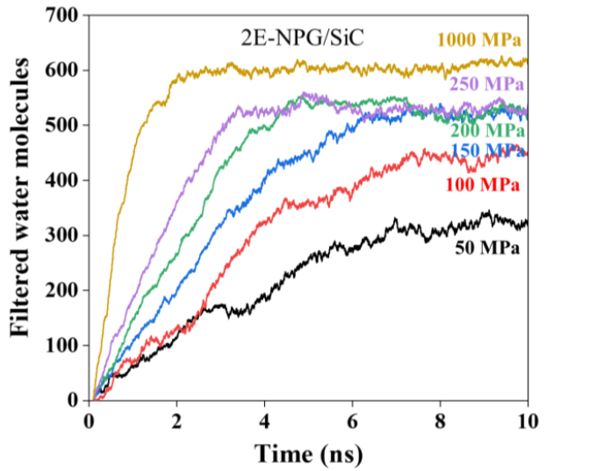
The water permeability for larger pores was approximated based on the analysis conducted by Tanugi et al.,¹ where water permeability is plotted as a function of pore size. Since we are simulating hydrogenated graphene nanopores, we assumed having the same slope as the mentioned study. The approximation involved plotting a linear curve starting from our calculated permeability, corresponding to a pore size of 0.81 nm, and interpolating to determine water permeabilities for sizes of 1 nm. This approximation was performed for the three types of membranes.
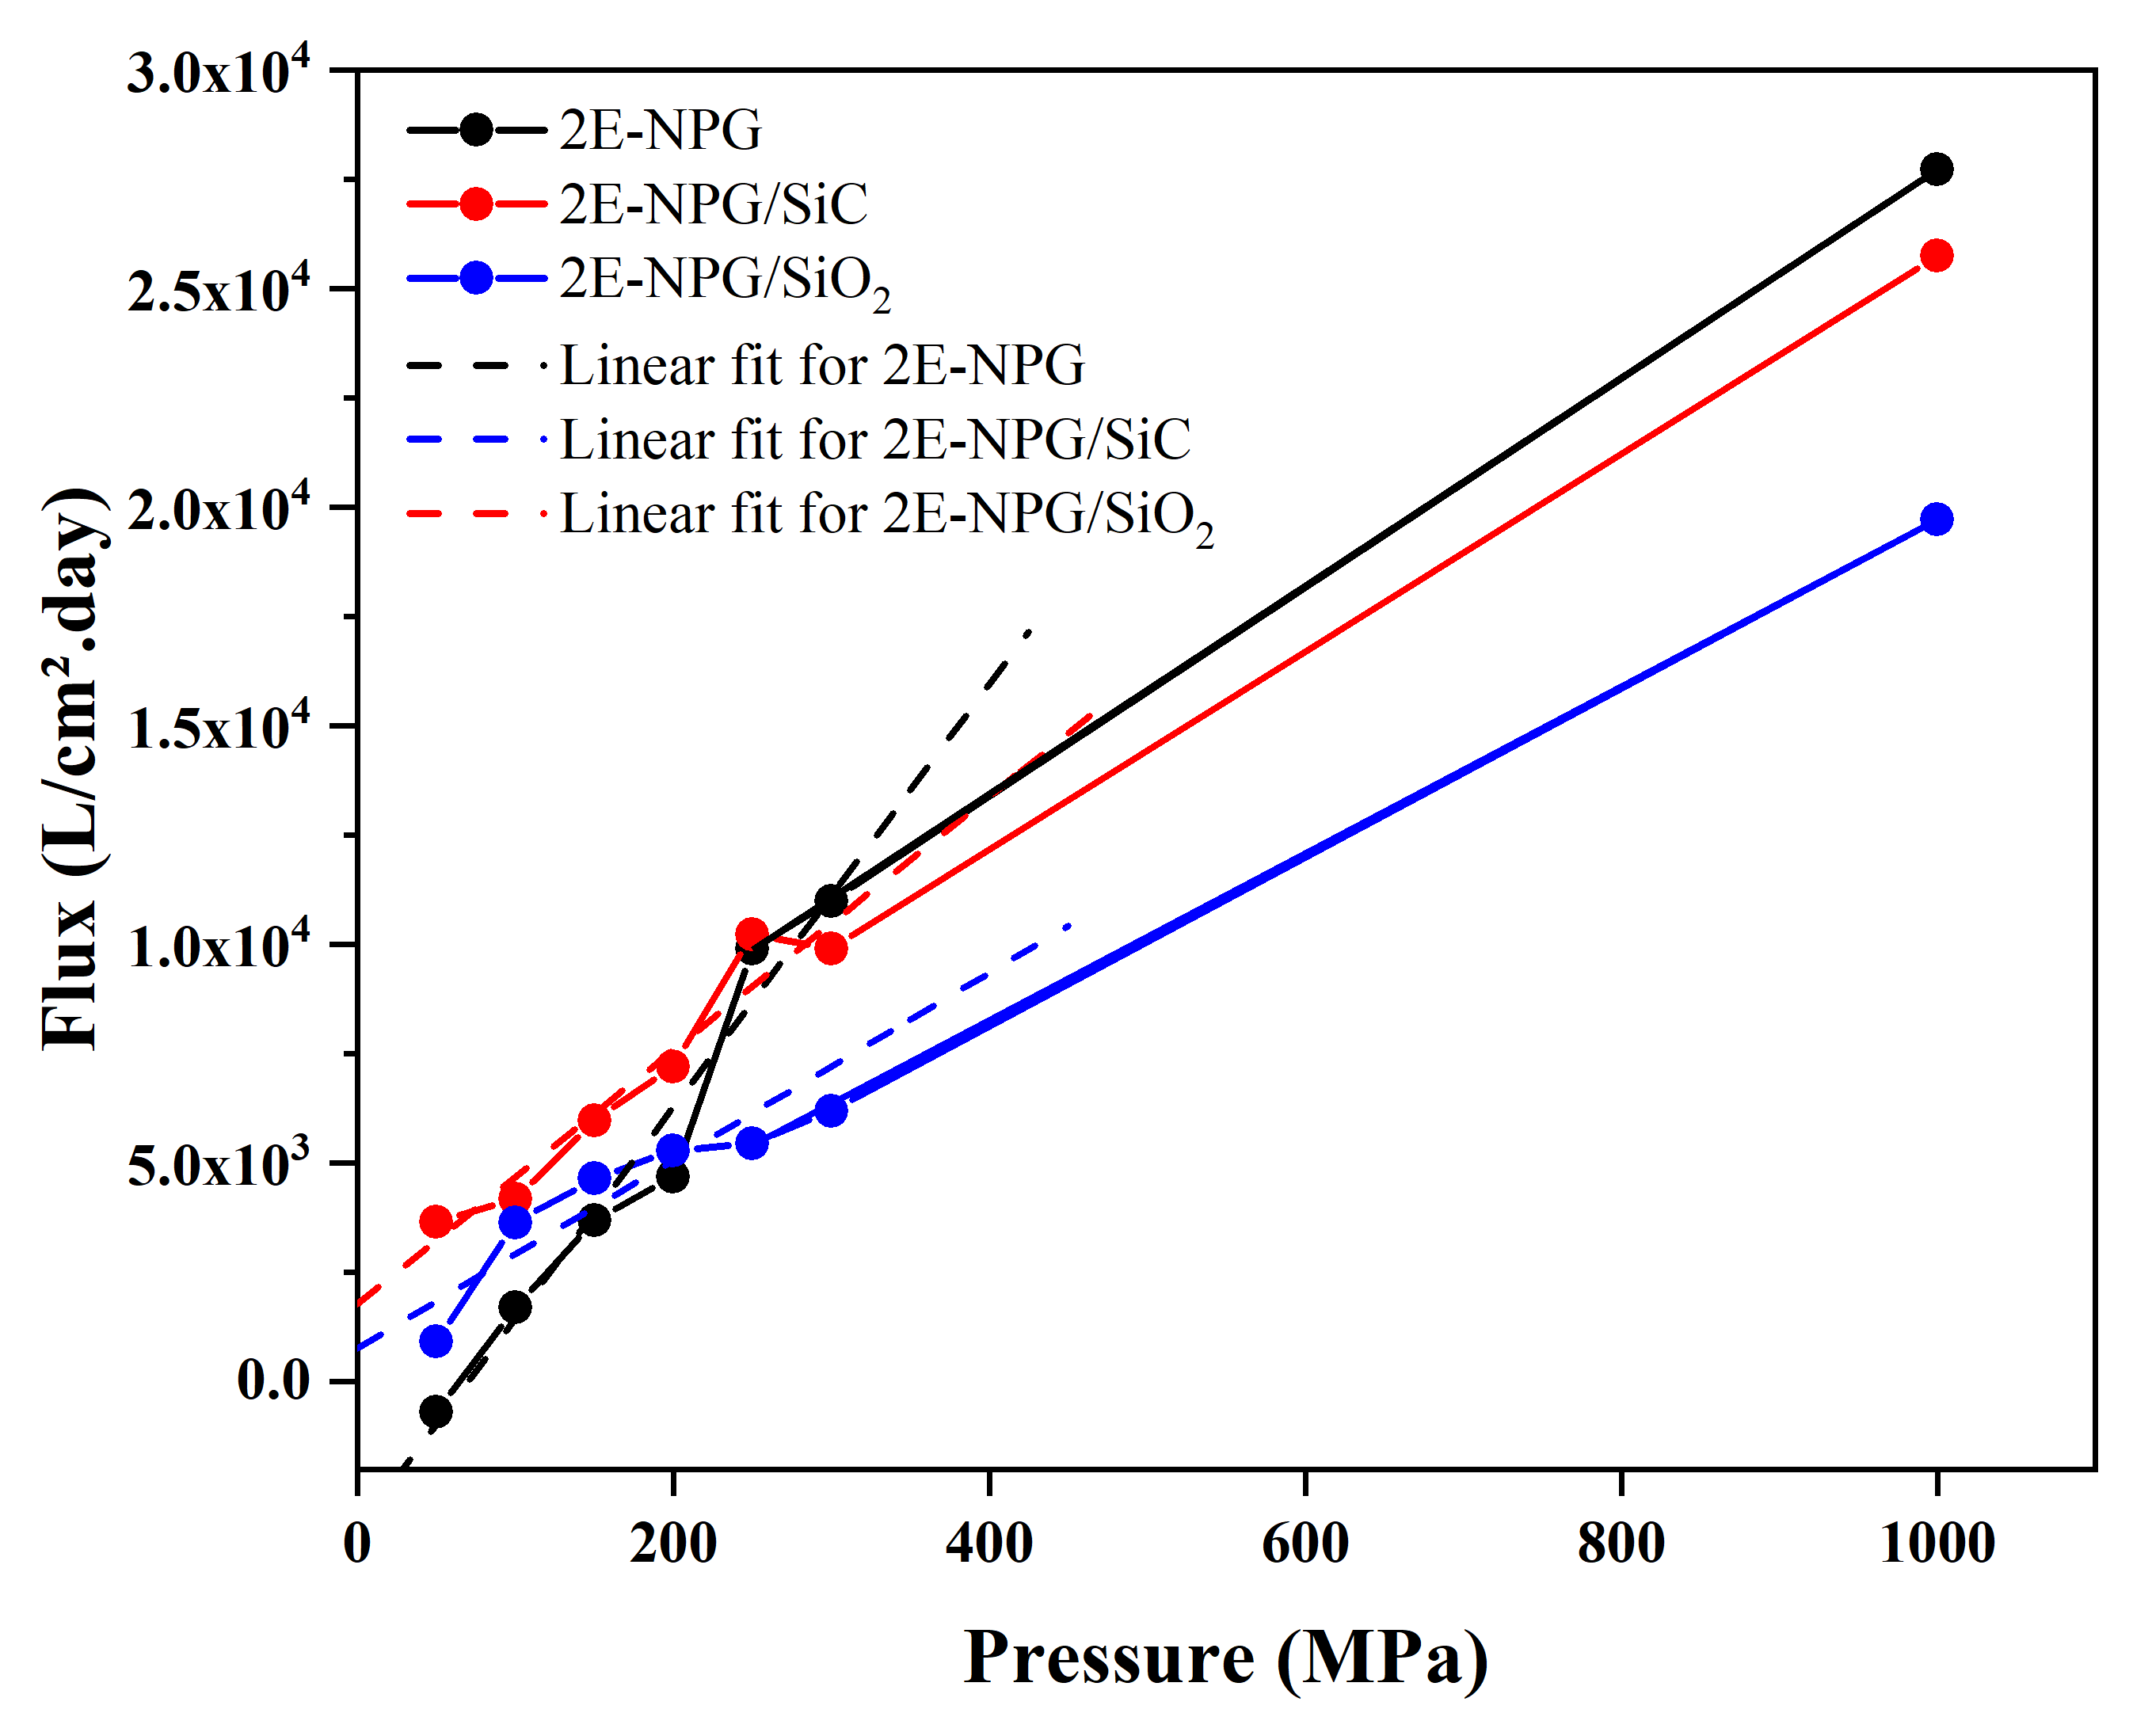
Figure S1: a-left: Calculated water flux through 2E-NPG/SiO₂, 2E-NPG/SiC and 2E-NPG as a function of applied pressure.b-right: Number of molecules filtered in term of time using NPG/SiC membrane

1. Cohen-Tanugi, D., & Grossman, J. C. (2012). Water desalination across nanoporous graphene. Nano letters, 12(7), 3602-3608.

