“Mortality or not mortality, that is a question …”
How to treat removals in tree survival analysis of managed forests
Supplementary material
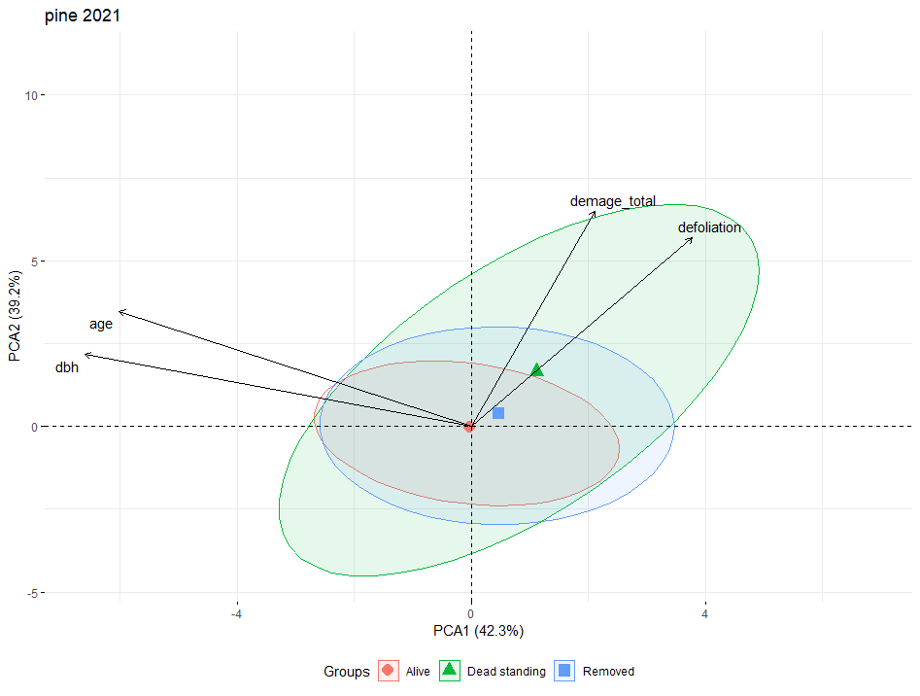
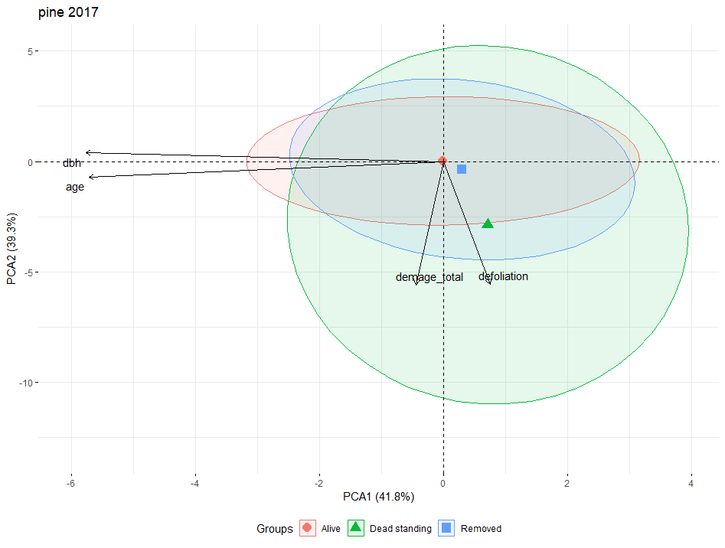
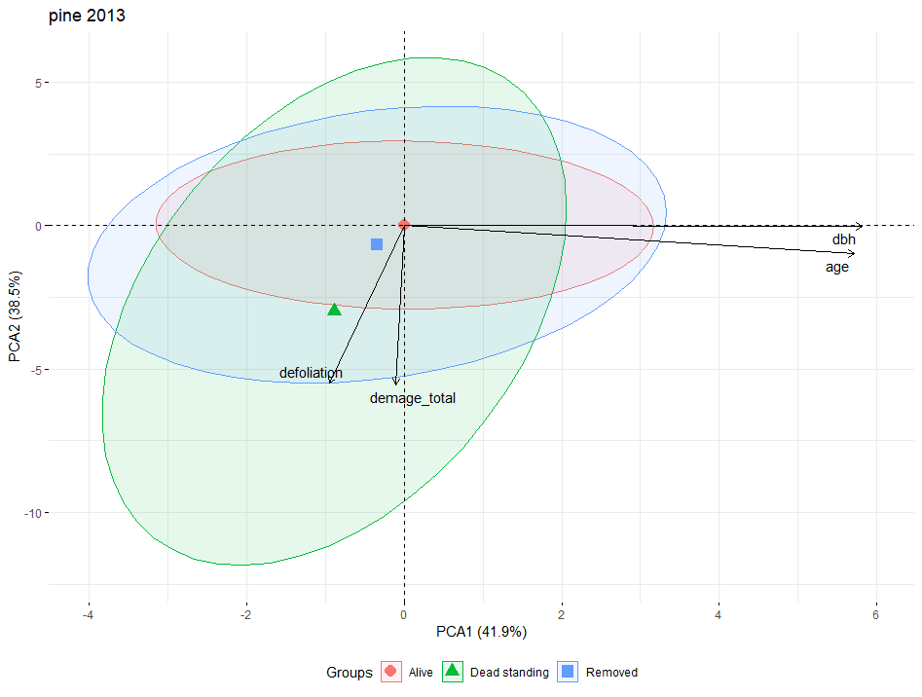
Figure S1. PCA biplots of the first two principal components for Scots pine 2021 (top), 2017 (middle) and 2013 data sets (bottom).

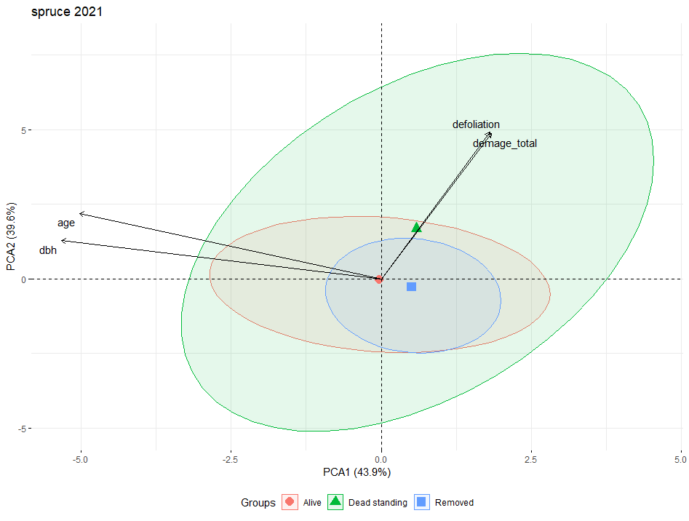
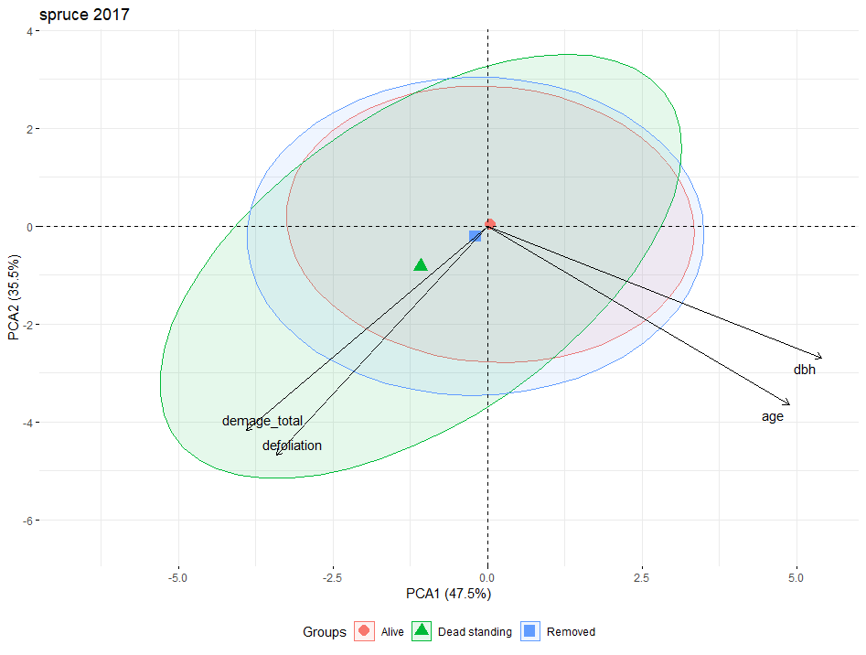
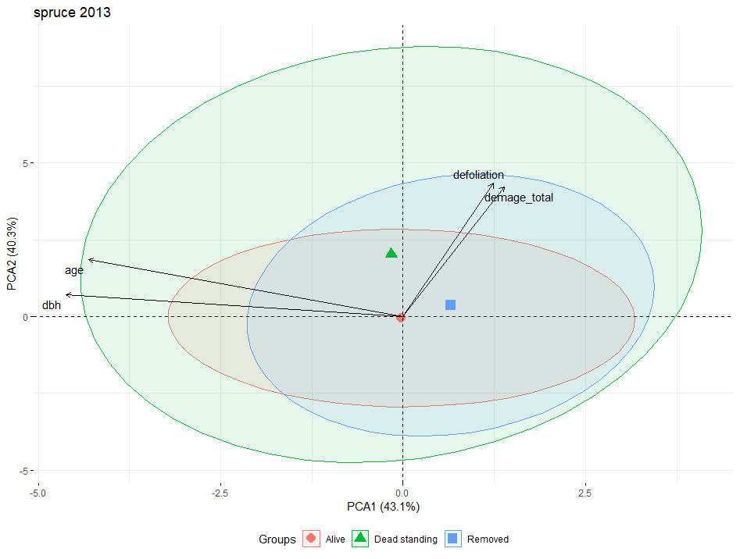
Figure S2. PCA biplots of the first two principal components for Norway spruce 2021 (top), 2017 (middle) and 2013 data sets (bottom).

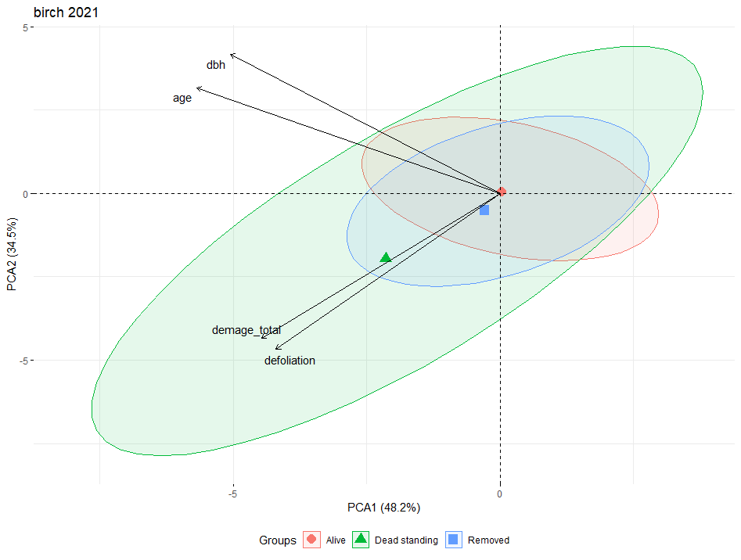
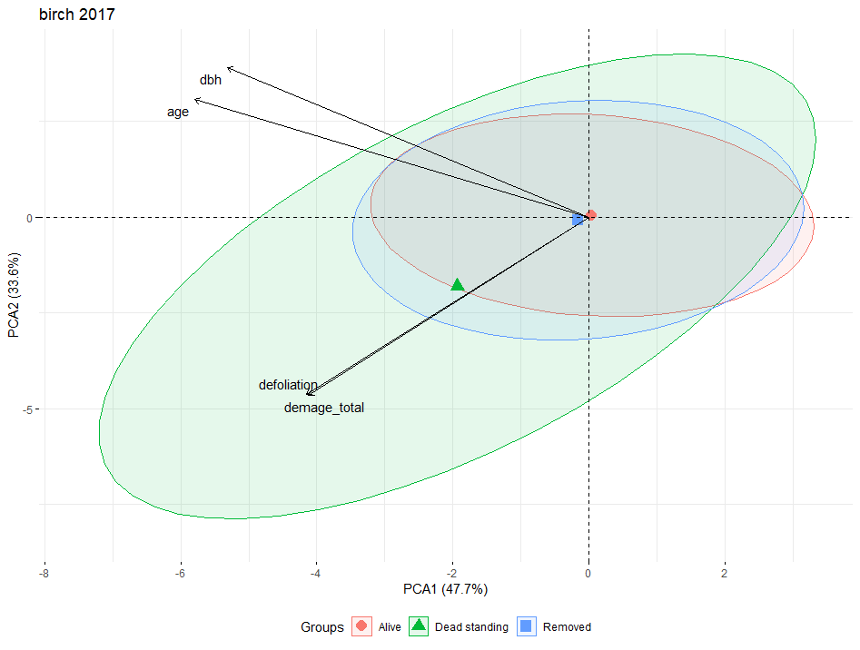
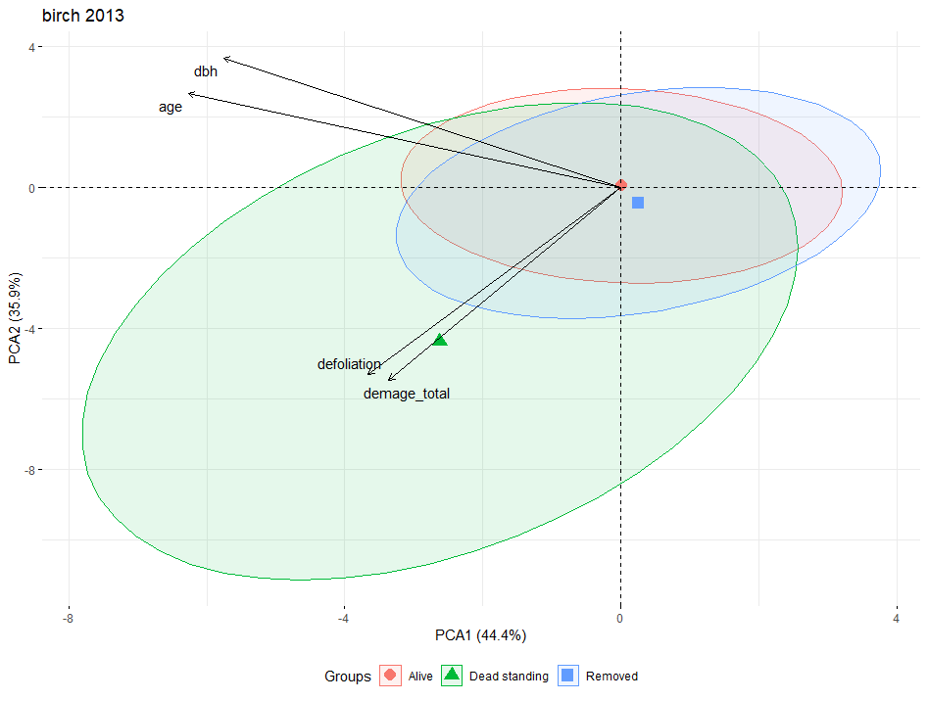
Figure S3. PCA biplots of the first two principal components for silver birch 2021 (top), 2017 (middle) and 2013 data sets (bottom).

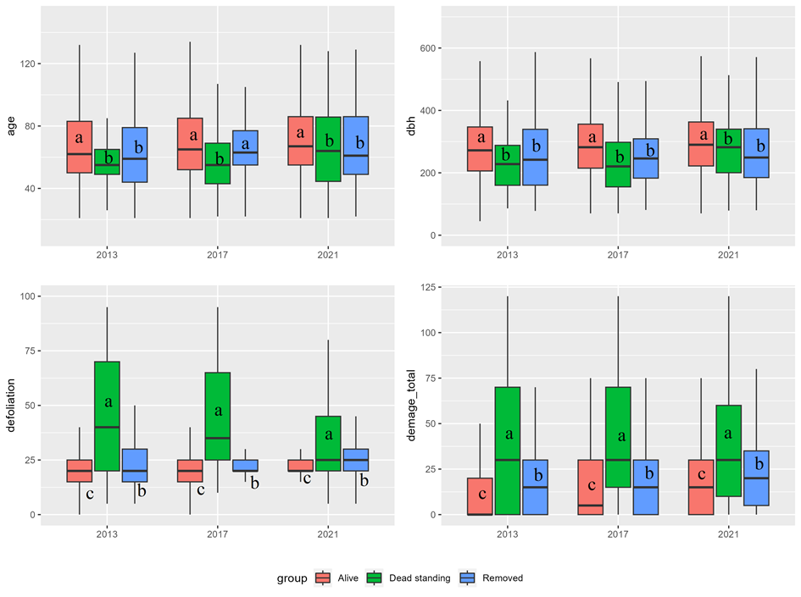
Figure S4. Box-and-whisker plots of Scots pine characteristics for different categories of trees. The first and third quartiles define the box, the median is shown as “—”, and the whisker defines the range of the data without outliers. Letters “a”, “b”, “c” identify homogenous groups with no significant differences (based on the Kruskal-Wallis test).

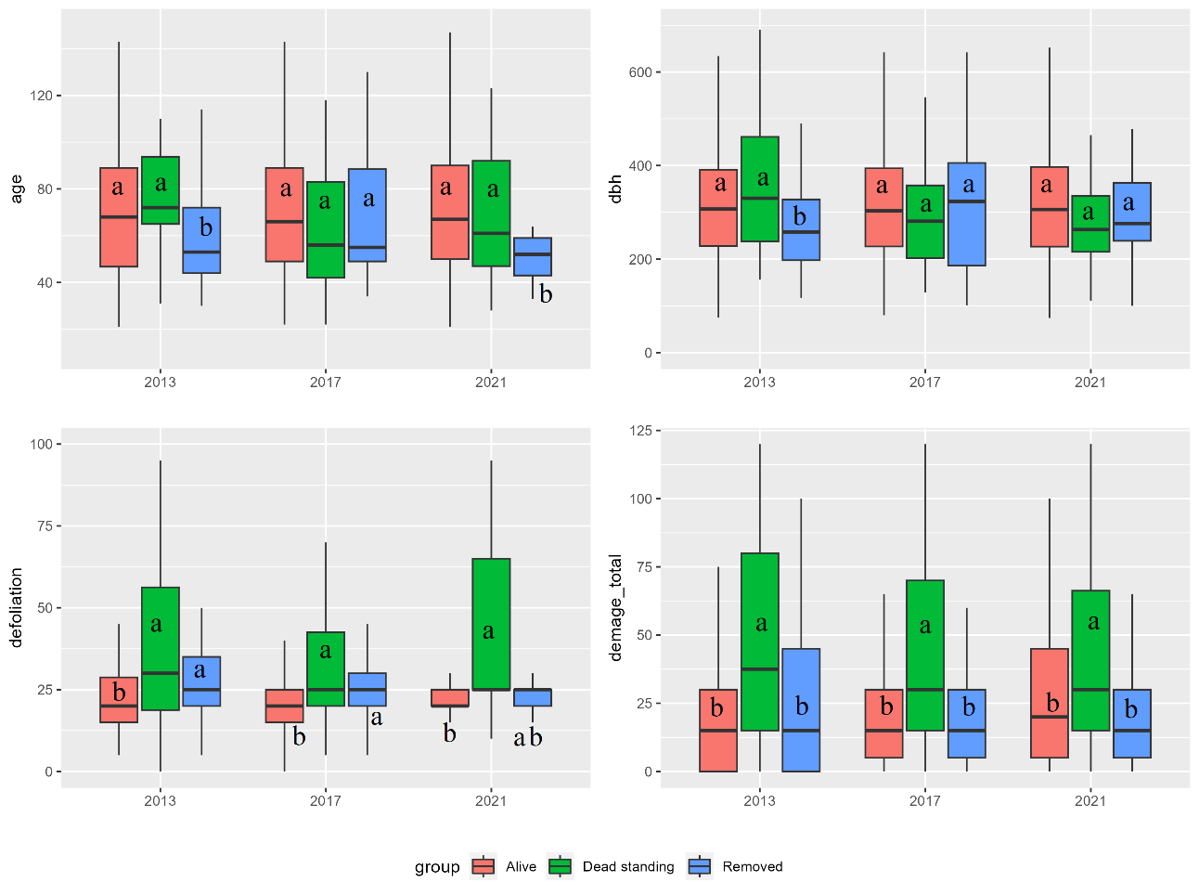
Figure S5. Box-and-whisker plots of Norway spruce characteristics for different categories of trees. The first and third quartiles define the box, the median is shown as “—”, and the whisker defines the range of the data without outliers. Letters “a”, “b”, “c” identify homogenous groups with no significant differences (based on the Kruskal-Wallis test).

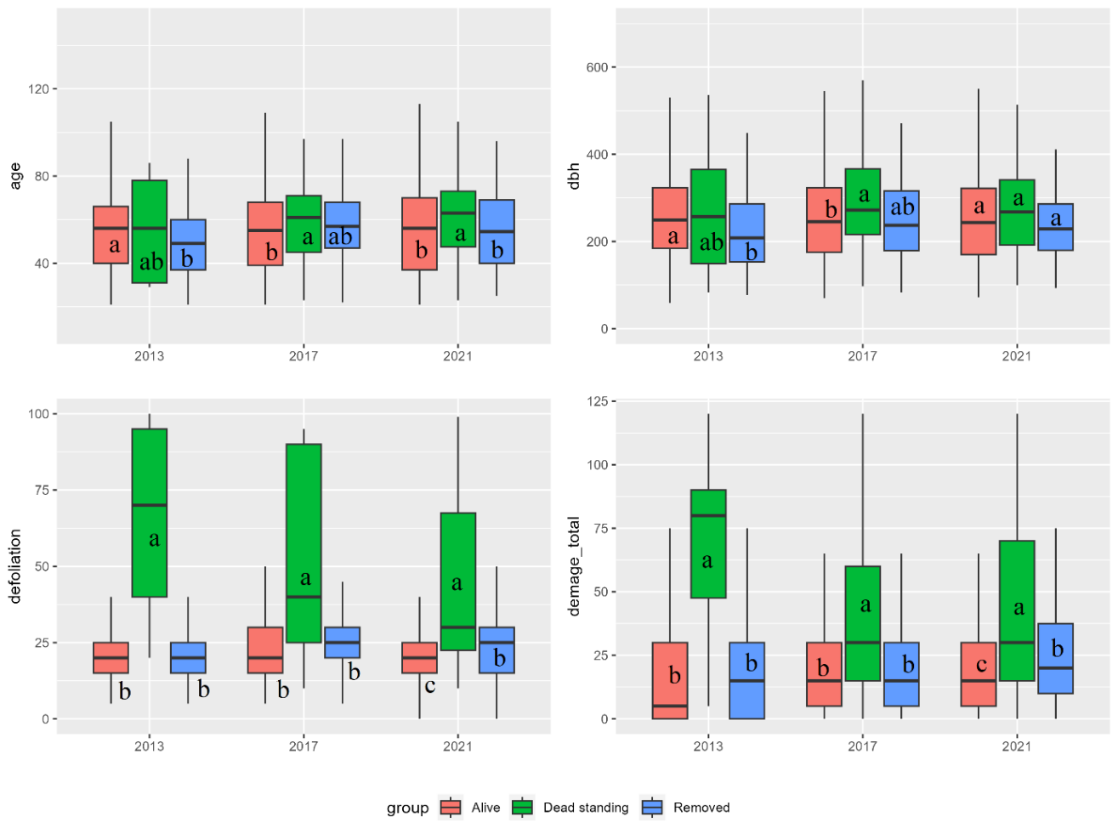
Figure S6. Box-and-whisker plots of silver birch characteristics for different groups of trees. The first and third quartiles define the box, the median is shown as “—”, and the whisker defines the range of the data without outliers. Letters “a”, “b”, “c” identify homogenous groups with no significant differences (based on the Kruskal-Wallis test).

