Temperature Inhibition of Plasma-Driven Methane Conversion in DBD Systems

Ibukunoluwa Akintola, Gerardo Rivera-Castro, Jinyu Yang¹, Jeffrey Secrist², Jason C. Hicks², Felipe Veloso, David B. Go^{1,2,*}
*corresponding author email: dgo@nd.edu

Supplementary Information

1. Electrical Circuit Analysis to Determine Ionization of Gas with Increasing Temperature
As noted in the main text, an increase in temperature from 400-700 ℃ would increase relative permittivity of the quartz tube from ~40 to ~200. A simple analytical model shows that this change in 𝜀_{d} would result in the discharge cell capacitance C_{cell} increasing by 0.0169 pF from 2.8745 pF to 2.8914 pF. However, over the same temperature range, a much larger increase is observed in our experimental C_{cell} values from 5.41 to 14.4 pF. To understand the potential cause of the increase in C_{cell}, we used a commercially available circuit analysis software LTspice® to model various equivalent circuits for Z_{off}.
An initial baseline model of a purely capacitive circuit with capacitances of the gas C_{gas} and the dielectric C_{diel} in series shows an increase of 0.01 pF in C_{cell} when 𝜀_{d} increases from 40 to 200 (Supplementary Figure S1), consistent with the analytical estimations in the main text. Further analysis was conducted for three different potential circuits, shown in Supplementary Figure S2, that could provide a change in C_{cell} similar to what was observed experimentally. The first circuit assumes the gas itself has an additional resistance, modeled as a parallel resistor to C_{gas} (Supplementary Figure S2(a)). The second assumes that the quartz tube becomes a leaky dielectric [1, 2], such that there is a parallel resistor to C_{diel} (Supplementary Figure S2(b)). The last circuit considers a secondary discharge outside the tube (between the external grounded electrode and the outer surface of the quartz tube), which is modeled as a resistor in series with C_{gas} and C_{diel} (Supplementary Figure S2(c)). Results of these analyses can be found in the main paper.
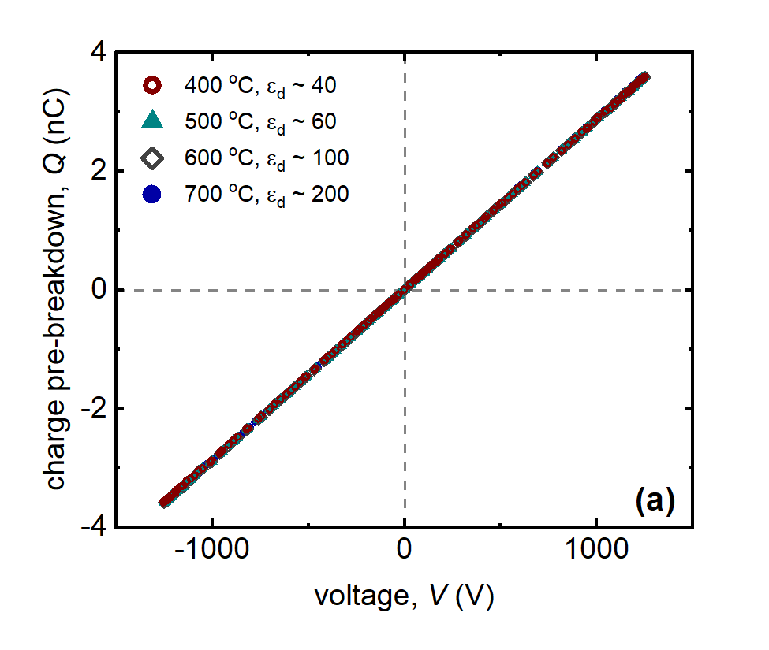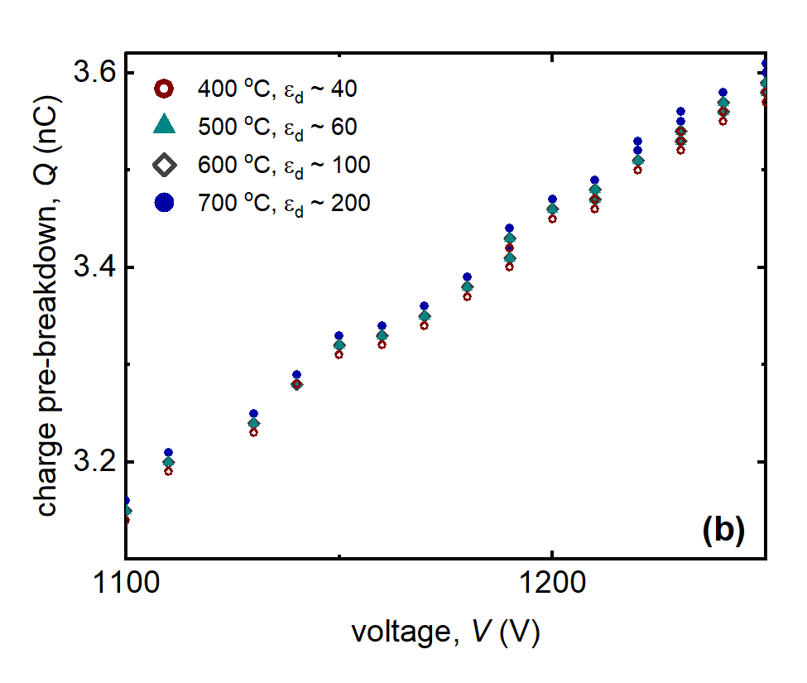
Fig. S1 A Lissajous plot of expected simulated charge showing a very small increase of 0.01 pF in the discharge cell capacitance when capacitance is increased only due to an increase in dielectric capacitance with dielectric constants changing from 40 to 200.
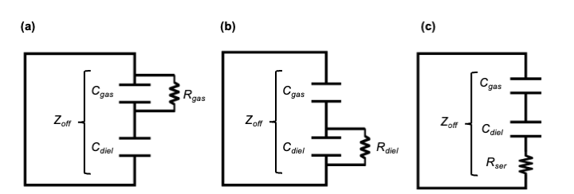
Fig. S2 Simulated equivalent circuits for Z_{off} depicting a resistive component in it (a) parallel to the capacitance of the gas gap, (b) parallel to the capacitance of the dielectric and (c) in series to both the capacitance of the gas gap and dielectric.

Analysis of the additional resistors in parallel to the gas gap, Figure S2(a), and in series to both capacitances, Figure S2(c), prove to cause the most changes to the Lissajous curve. As shown in Figure S3(a), a resistor parallel with the gas gap leads to a counterclockwise rotation of the Lissajous curve, which agrees with experimental data. The addition of a resistive element in series to both capacitances also causes a rotation of the Lissajous curve, but it is a clockwise rotation as shown in Figure S3(b), which does not agree with experimental data.
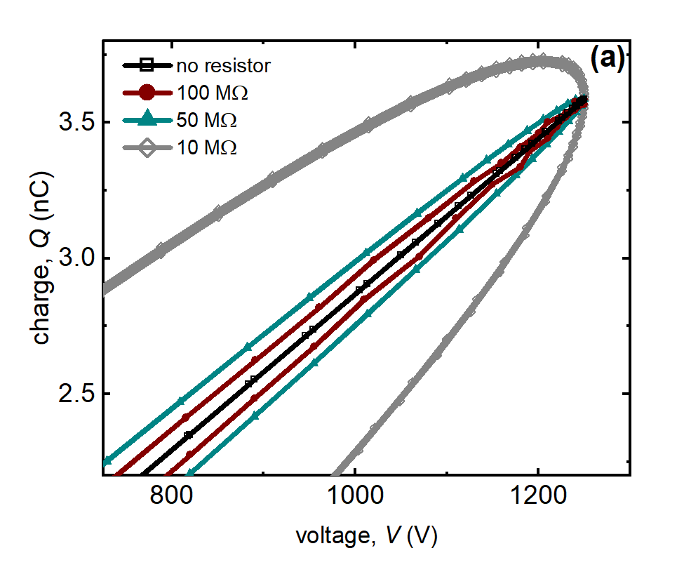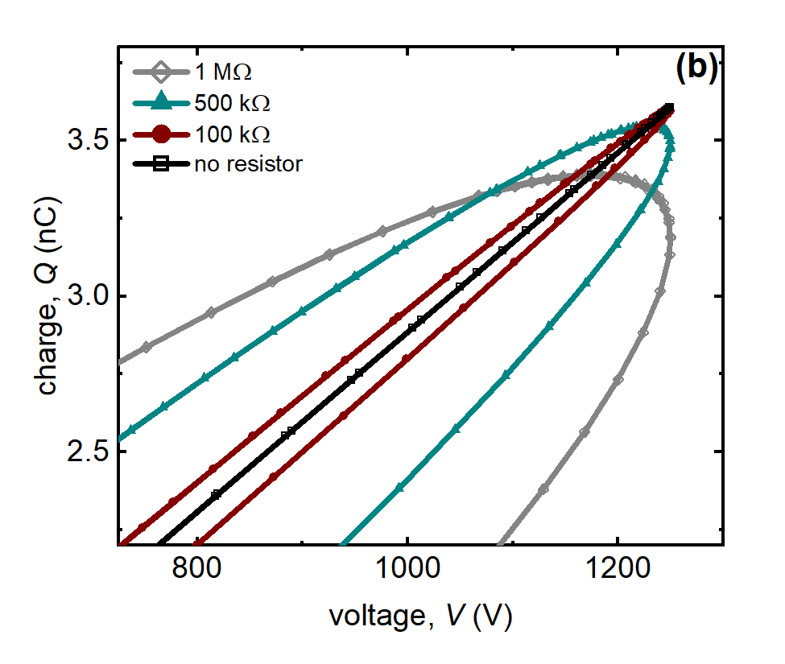
Fig. S3 Simulated Lissajous curves with varying resistive elements (a) parallel to the gas capacitance and (b) in series with the gas and dielectric capacitance.

2. Estimated Electron Density Calculations
Estimations of the electron density prior to plasma formation were made using estimates from simulated resistances. Prior to plasma formation at and applied voltage of V_{a} = 1500 V, an estimated electric field of 2.09 $×$ 10⁵ V m⁻¹ is obtained using
$E=\frac{V_{a}}{r_{1}ln\left(\frac{r_{1}}{r_{o}}\right)}$, (S1)
where r₁ is the radius of the gas gap from the electrode center and r_{o} is the radius of the electrode [3]. Assuming an ideal gas at 700 ℃, a gas density of 7.55 $×$ 10²⁴ m⁻³ gives an $E/N$ of 27.7 Td. Using Bolsig+ with a one-to-one CH₄/N₂ gas composition at 973 K and non-Maxwellian parameters, a total collisional frequency of 3.61 $×$ 10¹¹ s⁻¹ is predicted [4]. The conductivity of the gas can be estimated from the simulated resistance of R = 10 MΩ using
$σ=\frac{L}{RA}$, (S2)
where L is the length of the discharge region (60 mm) and A (70.6 mm²) is the cross-sectional area of the discharge region. This gives a conductivity of $σ$ = 85 𝜇S m⁻¹. The electron density n_{e} can then be estimated from the conductivity and collisional frequency by
$σ=\frac{n_{e}e^{2}}{mν_{en}}$, (S3)
where e is the charge of an electron, m is the mass of an electron, and $ν_{en}$ is the electron-neutral collision frequency[5]. This provides an estimated electron density of approximately 10⁸ cm⁻³.

3. Analytical Model for Electric Field at The Gas/Dielectric Interface
Analysis of the radial electric field was studied and an analytical expression for the electric field at the interface between the gas gap and the dielectric was derived to understand how the dielectric constant potentially affects the electric field. Supplementary Figure S4 shows the representative cross-section of the reactor.
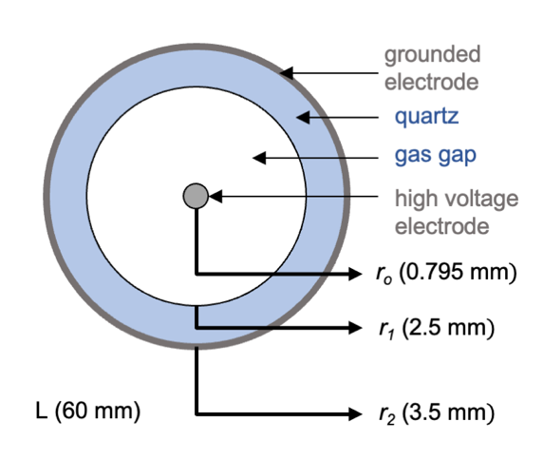
Fig. S4 Cross-sectional view of the reactor, showing the dimensions used for the electric field calculations.

Using the boundary conditions for our experiment,
$V_{g}\left(r=r_{o}\right)=V_{a}$, (S4)
$V_{d}\left(r=r_{2}\right)=0$, (S5)
and the geometric parameters shown in Figure S4, we can obtain the voltages across the gas and dielectric as a function of the radius by
$V_{g}= V_{a}-\frac{ε_{d}}{ε_{g}}V_{o}{\left[\frac{ε_{d}}{ε_{g}}\text{ln}\left(\frac{r_{1}}{r_{o}}\right)+\text{ln}\left(\frac{r_{2}}{r_{1}}\right)\right]}^{-1}\text{ln}\left(\frac{r}{r_{o}}\right)$, (S6)
and
$V_{d}= V_{a}{\left[\frac{ε_{d}}{ε_{g}}\text{ln}\left(\frac{r_{1}}{r_{o}}\right)+\text{ln}\left(\frac{r_{2}}{r_{1}}\right)\right]}^{-1}\text{ln}\left(\frac{r_{2}}{r_{1}}\right)-V_{a}{\left[\frac{ε_{d}}{ε_{g}}\text{ln}\left(\frac{r_{1}}{r_{o}}\right)+\text{ln}\left(\frac{r_{2}}{r_{1}}\right)\right]}^{-1}\text{ln}\left(\frac{r}{r_{1}}\right)$, (S7)
respectively. Hence, the electric field of the dielectric at the gas/dielectric interface ($r=r_{1}$) is
$E_{d}=\frac{V_{a}}{r_{1}}{\left[\frac{ε_{d}}{ε_{g}}\text{ln}\left(\frac{r_{1}}{r_{o}}\right)+\text{ln}\left(\frac{r_{2}}{r_{1}}\right)\right]}^{-1}$. (S8)
At the gas/dielectric interface from Equation S8, it can be observed that the electric field at the interface explicitly depends on 𝜀_{d}, noting that 𝜀_{g} is constant and approximately equal to 1. Supplementary Figure S5 shows the reduction in the electric field from 2447 V cm⁻¹ to 500 V cm⁻¹ (reduction by a factor of about 5) as 𝜀_{d} increases from 40 to 200, reflecting the inversely proportional relationship.

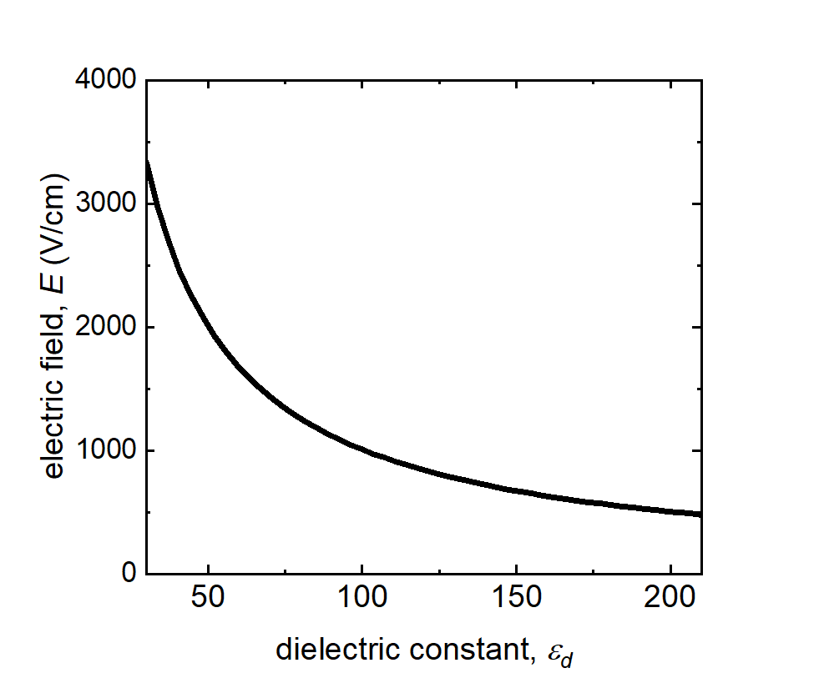
Fig. S5 Electric field as a function of the dielectric constant, 𝜀_{d}, showing a reduction in the electric field at the gas/quartz interface.

4. Filamentary Behavior and Sampling Rate Effects
Oscilloscope data of current-time traces was saved to determine electrical properties of the plasma. Supplementary Figure S6 shows representative current-time traces of 10 W DBD plasmas at 400, 500, 600, and 700 ℃, respectively, for a one-to-one CH₄/N₂ gas composition. In all cases, the capacitive current has been subtracted from the raw data. The panels illustrate the transition from a more filamentary plasma to a more glow-like/diffuse plasma as temperature increases. At 700 ℃, the current trace broadens and there are fewer filamentary peaks with weaker magnitudes. Zoomed in traces of singular positive and negative half cycles (Figure 6(a) in the main manuscript) were used to extract electrical properties such as total and average charge per filament, as well as the average lifetime of a filament. Traces were saved at various sampling rates to ensure resolution an accurate number of filaments as this was crucial in determining many of our electrical properties. Supplementary Figure S7 shows the number of filaments as a function of the sampling rate and a convergence of the number of filaments at larger sampling rates. A sampling rate of 500 MS s⁻¹ was used for all cases.

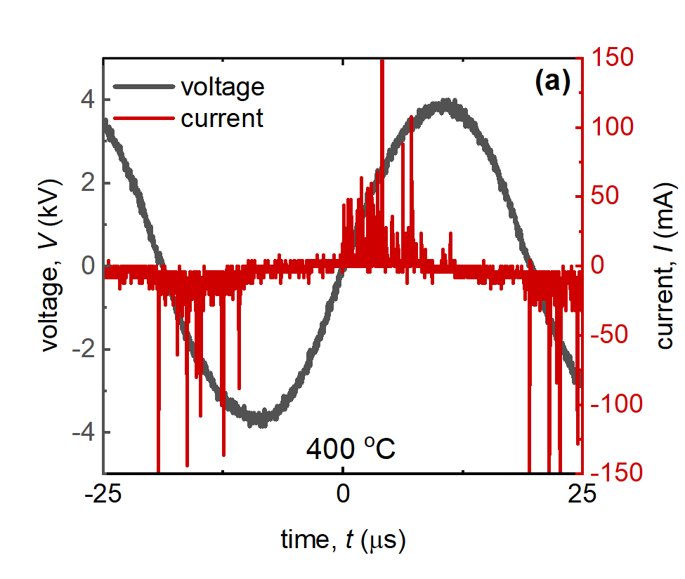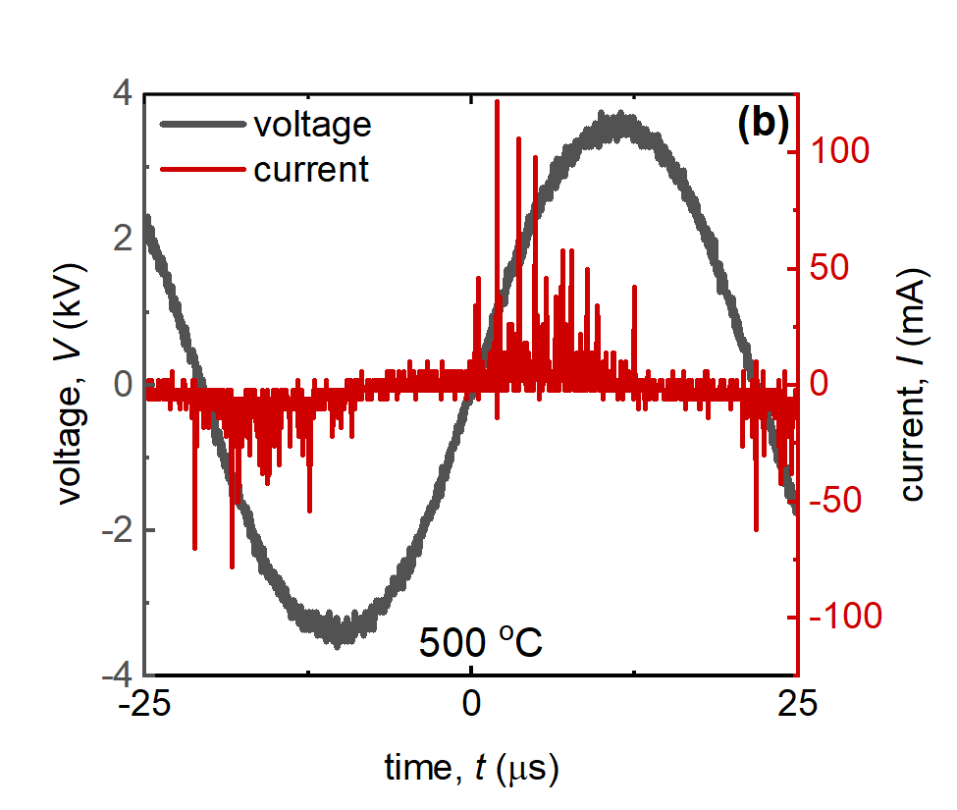
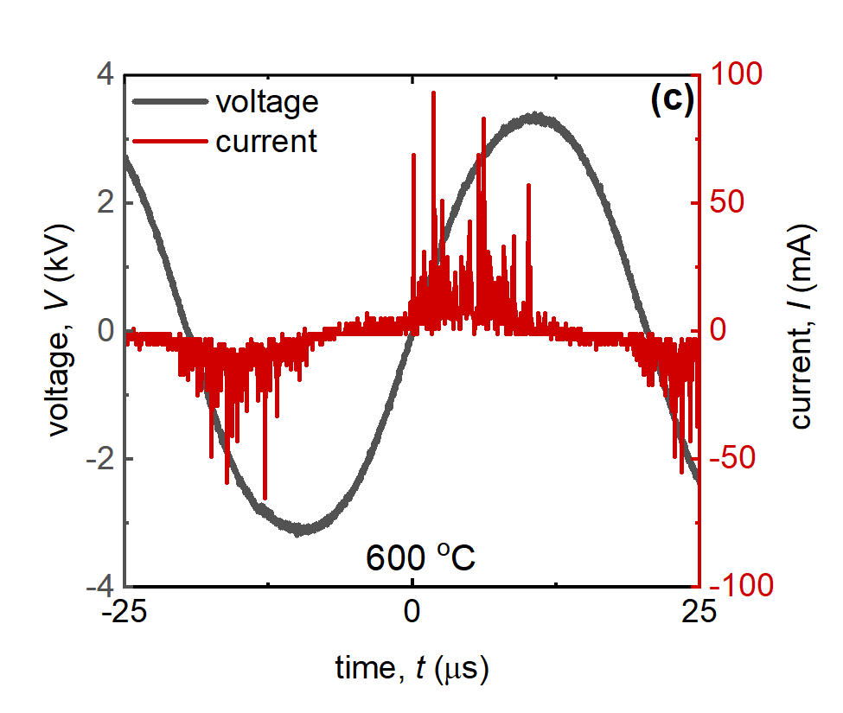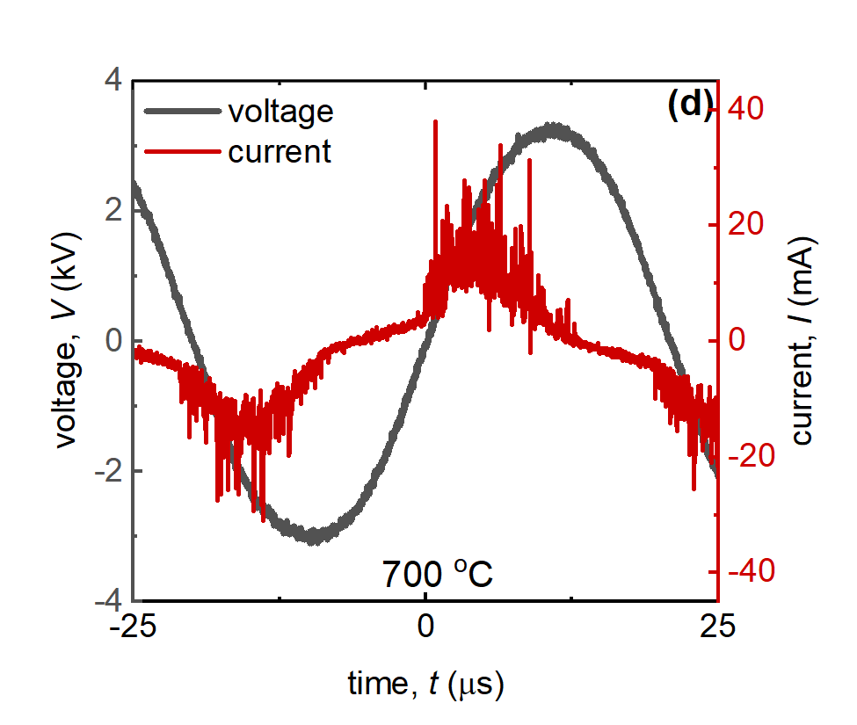
Fig. S6 Current-time traces of CH₄/N₂ plasma from 400 to 700 ℃, both at 10 W and a one-to-one gas composition.

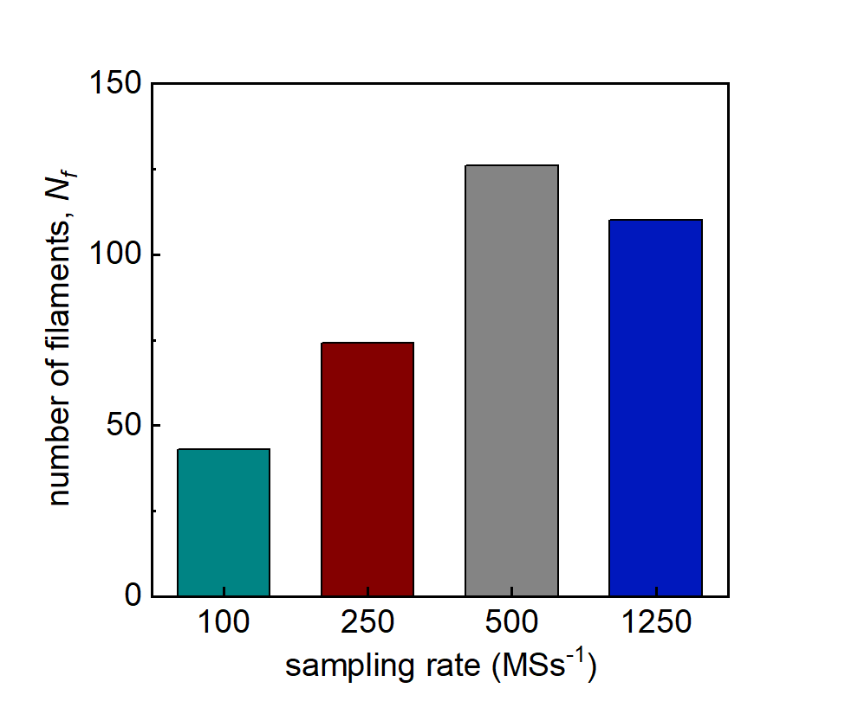
Fig. S7 Number of filaments as a function of the sampling rate showing the convergence into a more accurate value

5. Electrical Properties for CH₄/Ar Plasma Show Similar Trends As CH₄/N₂ Plasma
Additional information from results of CH₄/Ar DBD plasma, at a constant 10 W plasma power and total flow rate of 50 mL min⁻¹ with a one-to-one gas composition, are shown in this section. Results show a consistent trend when compared to a CH₄/N₂ DBD plasma that determine the relationships proposed in the main paper are not specific to CH₄/N₂ DBD plasmas but could potentially be applied to methane reactions themselves.
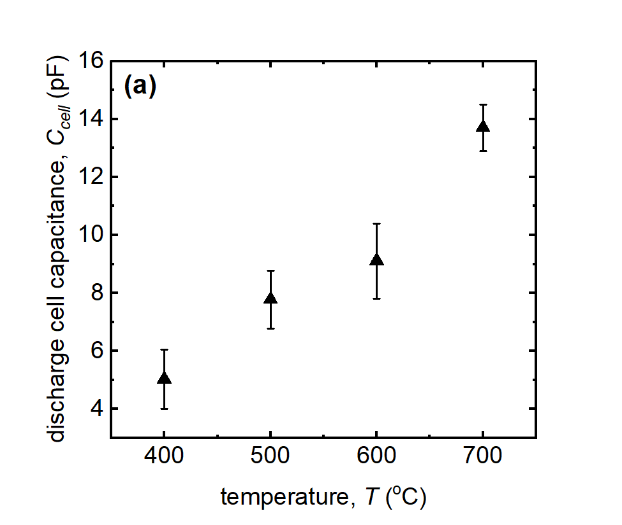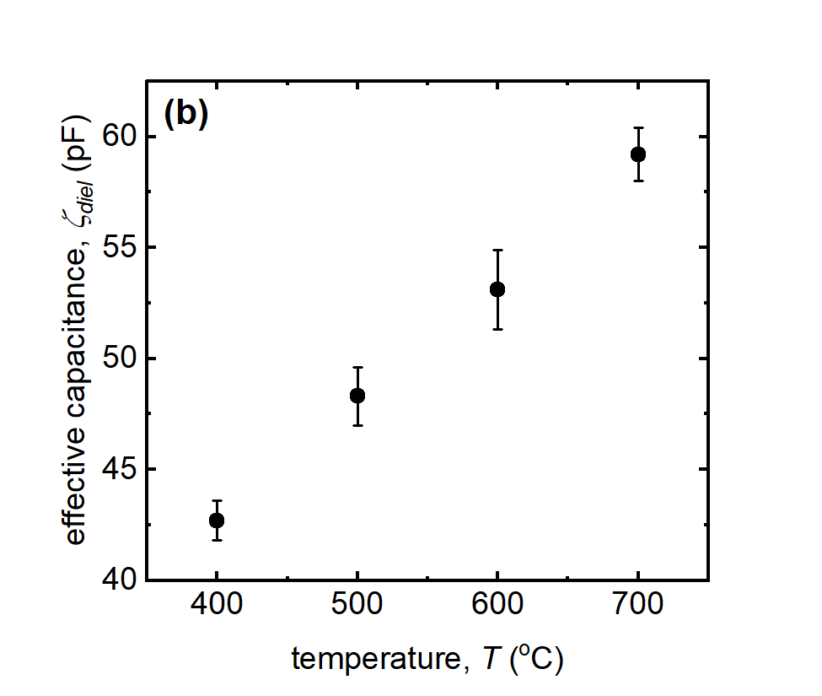
Fig. S8 Discharge cell capacitance and the effective capacitance in a CH₄/Ar plasma for a 10 W DBD with a total flow rate of 50 mL min⁻¹ and a one-to-one gas composition ratio.
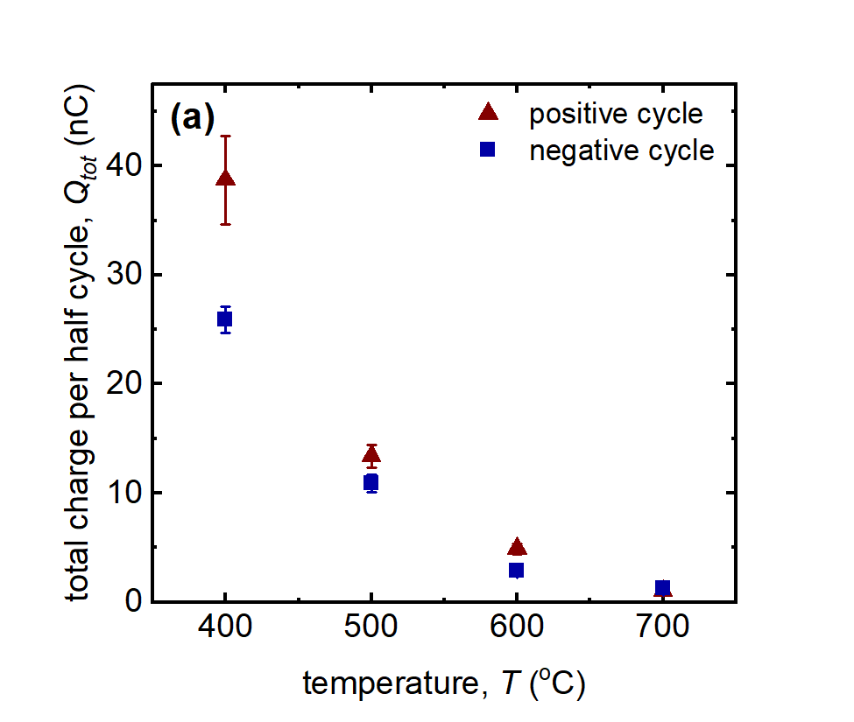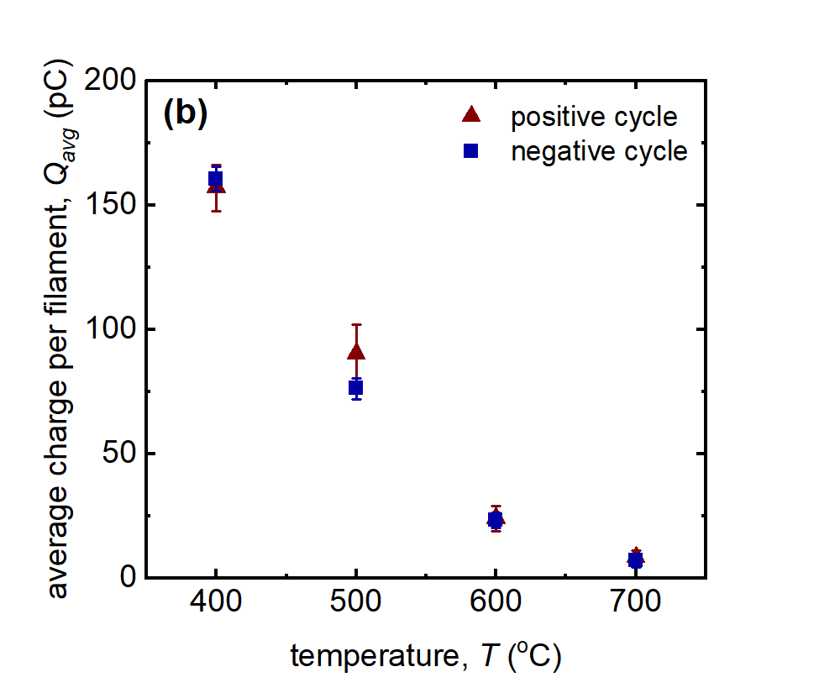
Fig. S9 Total charge per half cycle and average charge per filament for both the positive and negative half cycles as a function of temperature in a CH₄/Ar plasma for a 10 W DBD with a total flow rate of 50 mL min⁻¹ and a one-to-one gas composition ratio.
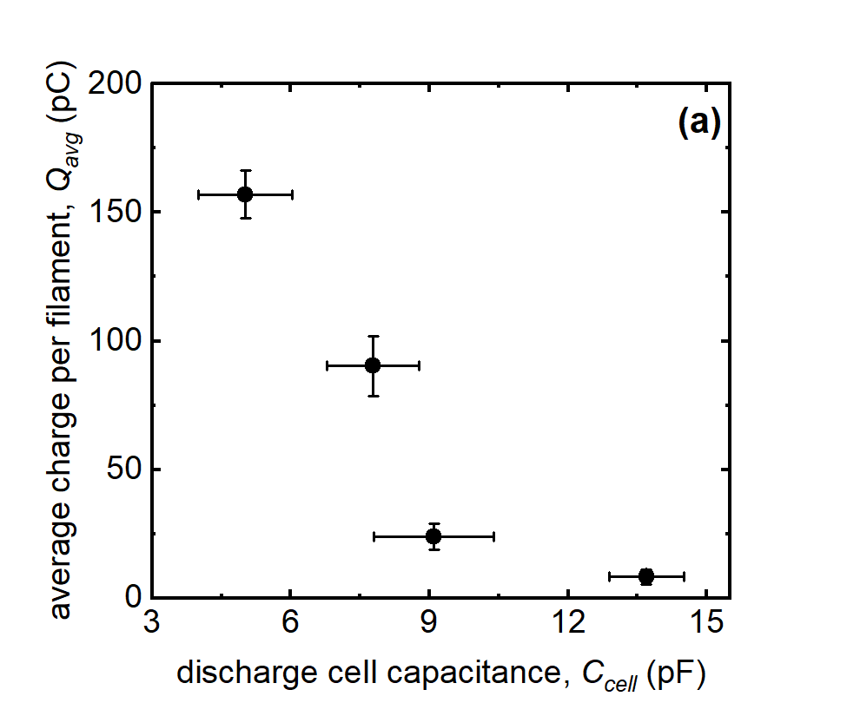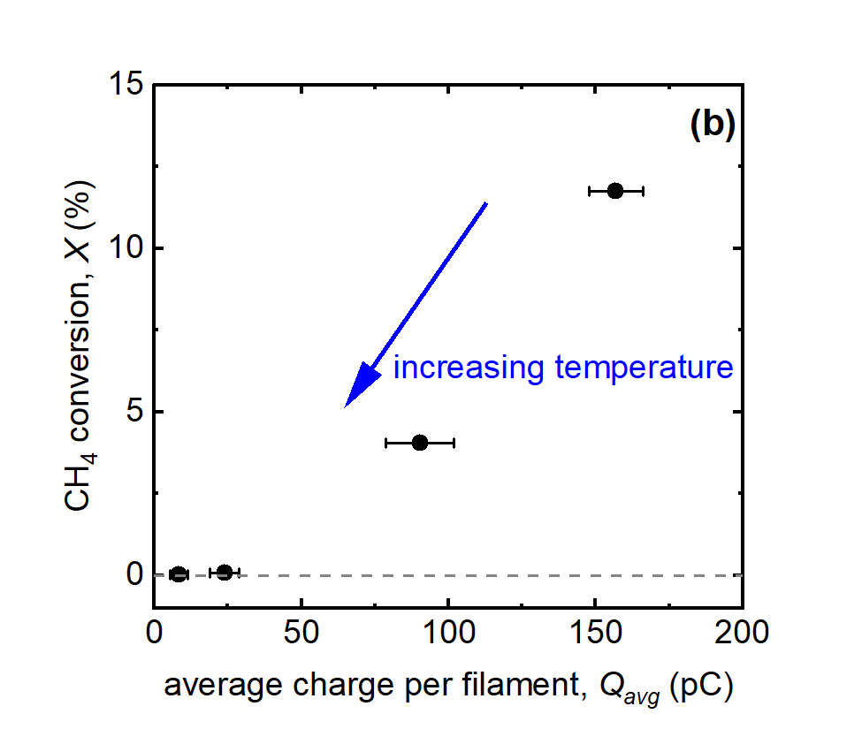
Fig. S10 Charge per filament and the discharge cell capacitance showing an inverse relationship and CH₄ conversion and charge per filament showing a positive correlation even with decreasing temperature in a CH₄/Ar plasma for a 10 W DBD with a total flow rate of 50 mL min⁻¹ and a one-to-one gas composition ratio.

References
1. Saeed A, Adewuyi SO, Ahmed HAM, et al (2022) Electrical and Dielectric Properties of the Natural Calcite and Quartz. Silicon 14:5265–5276. https://doi.org/10.1007/s12633-021-01318-7
2. Saville DA (1997) ELECTROHYDRODYNAMICS: The Taylor-Melcher Leaky Dielectric Model. Annual Review of Fluid Mechanics 29:27–64. https://doi.org/10.1146/annurev.fluid.29.1.27
3. Davydov YI (2006) On the first Townsend coefficient at high electric field. IEEE Trans Nucl Sci 53:2931–2935. https://doi.org/10.1109/TNS.2006.881543
4. Hagelaar GJM, Pitchford LC (2005) Solving the Boltzmann equation to obtain electron transport coefficients and rate coefficients for fluid models. Plasma Sources Sci Technol 14:722–733. https://doi.org/10.1088/0963-0252/14/4/011
5. Fridman A (2008) Plasma Chemistry. Cambridge University Press, Cambridge

Department of Aerospace and Mechanical Engineering, University of Notre Dame, Notre Dame, Indiana 46556 USA
Department of Chemical and Biomolecular Engineering, University of Notre Dame, Notre Dame, Indiana 46556 USA
Instituto de Física, Pontificia Universidad Catolica de Chile, Santiago, Region Metropolitana, Chile

