Micro and Nanoplastics size distribution in mussel tissues: first evidence, identification, and quantification in the nanogram range.
S. Fraissinetª, G. De Benedetto^{b}, C. Malitestaª, R. Holzinger^{c} , D. Materić^{c,d}.
a Dipartimento di Scienze e Tecnologie Biologiche e Ambientali (DISTEBA), UniSalento, Lecce, Italy
b Laboratorio di Spettrometria di Massa Analitica e Isotopica, Dipartimento di Beni Culturali, UniSalento, Lecce, Italy
c Institute for Marine and Atmospheric Research Utrecht, Utrecht University, Princetonplein, Utrecht, the Netherlands
d Helmholtz Centre for Environmental Research – UFZ Department of Analytical Chemistry Permoserstraße 15 | 04318 Leipzig | Germany

Table S1 Details about the size and weight of mussels
sample name | mussel dry weight (mg) | mussel shell lenght (cm)
M1 | 612,2 | 6,2
M2 | 485,8 | 5,5
M3 | 558,8 | 6
M4 | 353,1 | 4,9
M5 | 429 | 5,3

Table S2 Table summarizing information used in the size distribution of micro and nanoplastics experiment to calculate the mass content in nanogram related to the dry weight of mussels.
mussel dry weight (mg) | filter size ø (mm) | real filter size (mm) | filter area (mm²) | pieces diameter (mm) | area pieces (mm²) | mg on filter pieces | pore size filter
558.8 | 25 | 22 | 379.94 | 1 | 0.785 | 1.26 | 2.2 µm
558.8 | 47 | 33 | 854.865 | 1 | 3.14 | 2.05 | 1.4 µm
558.8 | 25 | 22 | 379.94 | 1 | 0.785 | 1.26 | 700nm
558.8 | 47 | 33 | 854.865 | 2 | 3.14 | 2.05 | 400nm
558.8 | 25 | 22 | cracked filter |  | 12 | 17.65 | 200nm
 |  |  |  |  | 11 | 16.18 | 200nm
 |  |  |  |  | 10 | 14.71 | 200nm
558.8 | 25 | 22 | cracked filter |  | 2.899 | 4.26 | 20nm
 |  |  |  |  | 2.504 | 3.68 | 20nm
 |  |  |  |  | 3.1 | 4.56 | 20nm

Table S3 Table summarizing data to calculate the final mass content of nanoplastics in mussels related to the dry weight. All mussels used have similar sizes, in this experiment just 20nm size fraction was analysed cracking Anodisc filters.
sample name | mussel dry weight (mg) | filter size ø (mm) | real filter size (mm) | filter area (mm²) | pieces diameter | area pieces (mm²) | mg on filter pieces | pore size filter
M1 | 612.2 | 25 | 22 | 379.94 | cracked filter | 4.61 | 7.43 | 20nm
 |  |  |  |  |  | 4.70 | 7.57 | 20nm
 |  |  |  |  |  | 4.37 | 7.03 | 20nm
M2 | 485.8 | 25 | 22 | 379.94 | cracked filter | 3.73 | 4.77 | 20nm
 |  |  |  |  |  | 3.57 | 4.56 | 20nm
 |  |  |  |  |  | 3.75 | 4.79 | 20nm
M3 | 558.8 | 25 | 22 | 379.94 | cracked filter | 2.90 | 4.26 | 20nm
 |  |  |  |  |  | 2.50 | 3.68 | 20nm
 |  |  |  |  |  | 3.10 | 4.56 | 20nm
M4 | 353.1 | 25 | 22 | 379.94 | cracked filter | 4.19 | 3.89 | 20nm
 |  |  |  |  |  | 3.55 | 3.29 | 20nm
 |  |  |  |  |  | 4.34 | 4.03 | 20nm
M5 | 429 | 25 | 22 | 379.94 | cracked filter | 5.51 | 6.22 | 20nm
 |  |  |  |  |  | 3.07 | 3.47 | 20nm
 |  |  |  |  |  | 2.70 | 3.05 | 20nm

Table S4 Table reporting the values, the average and the standard deviation of ng NPs/mg DW of mussels for all the filter replicas analyzed for each mussels. In the last column is reported “global” standard deviation calculated as the square root of the quadrats of all the calculated standard deviations.
organism ID | PVC | PE | TIRE | PP | PS | PET | global st.dev
M1_a | 29,82 | 45,41 | 0 | 0 | 18,14 | 17,27
M1_b | 18,84 | 29,17 | 13,45 | 0 | 11,80 | 11,18
M1_c | 15,38 | 24,20 | 10,90 | 0 | 11,35 | 9,04
average | 21,34 | 32,93 | 8,12 | 0 | 13,76 | 12,50
devst | 7,54 | 11,09 | 7,14 | 0 | 3,80 | 4,27 | 16,23
M2_a | 4,01 | 0,00 | 3,52 | 0 | 3,19 | 0
M2_b | 3,82 | 5,37 | 2,93 | 4,48 | 2,71 | 0
M2_c | 0 | 0 | 0 | 0 | 0 | 0
average | 2,61 | 1,79 | 2,15 | 1,49 | 1,97 | 0
devst | 2,26 | 3,10 | 1,88 | 2,59 | 1,72 | 0 | 5,28
M3_a | 30,81 | 53,00 | 0 | 46,50 | 21,90 | 0
M3_b | 46,80 | 74,00 | 36,66 | 60,30 | 30,25 | 0
M3_c | 34,41 | 56,97 | 0,00 | 47,98 | 21,79 | 0
average | 37,34 | 61,32 | 12,22 | 51,59 | 24,65 | 0
devst | 8,39 | 11,16 | 21,16 | 7,58 | 4,85 | 0 | 26,90
M4_a | 25,97 | 41,79 | 4,44 | 0,00 | 17,27 | 14,88
M4_b | 41,70 | 60,77 | 6,70 | 49,24 | 29,68 | 25,04
M4_c | 20,43 | 32,49 | 0 | 0 | 13,29 | 12,09
average | 29,36 | 45,01 | 3,71 | 16,41 | 20,08 | 17,34
devst | 11,03 | 14,41 | 3,41 | 28,43 | 8,55 | 6,81 | 35,62
M5_a | 3,50 | 5,28 | 5,28 | 0 | 2,60 | 2,25
M1_b | 9,79 | 14,51 | 14,51 | 0 | 7,23 | 0
M1_c | 6,35 | 11,13 | 11,13 | 0 | 5,09 | 0
average | 6,55 | 10,31 | 10,31 | 0 | 4,97 | 0,75
devst | 3,15 | 4,67 | 4,67 | 0 | 2,32 | 1,30 | 7,78

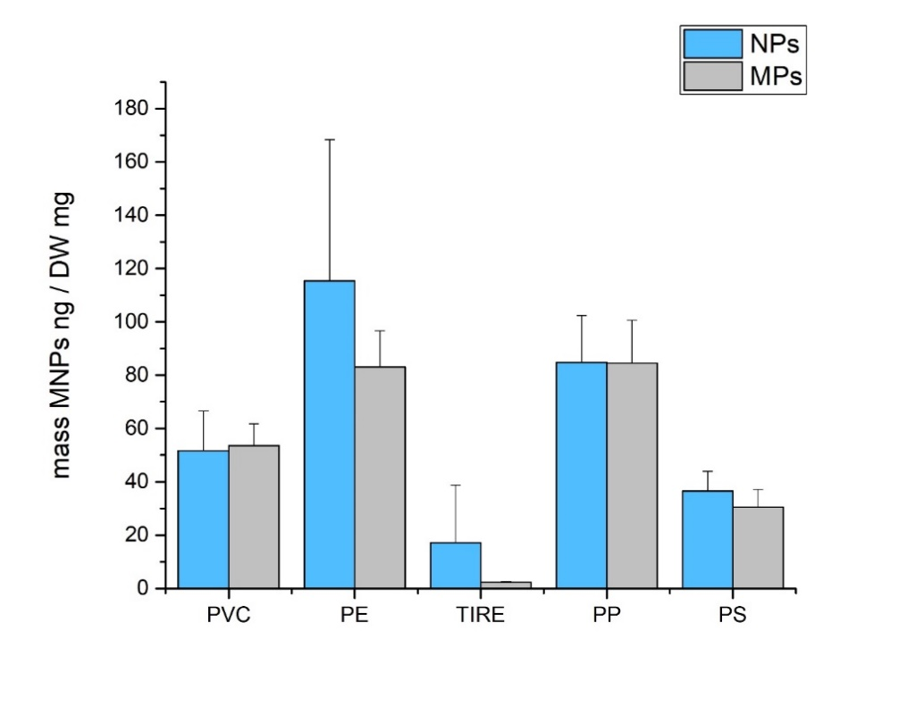
Figure 1S Mass content of MPs and NPs in mussel sample. Values were summed up using 700nm as the size threshold between micro and nanoplastics.

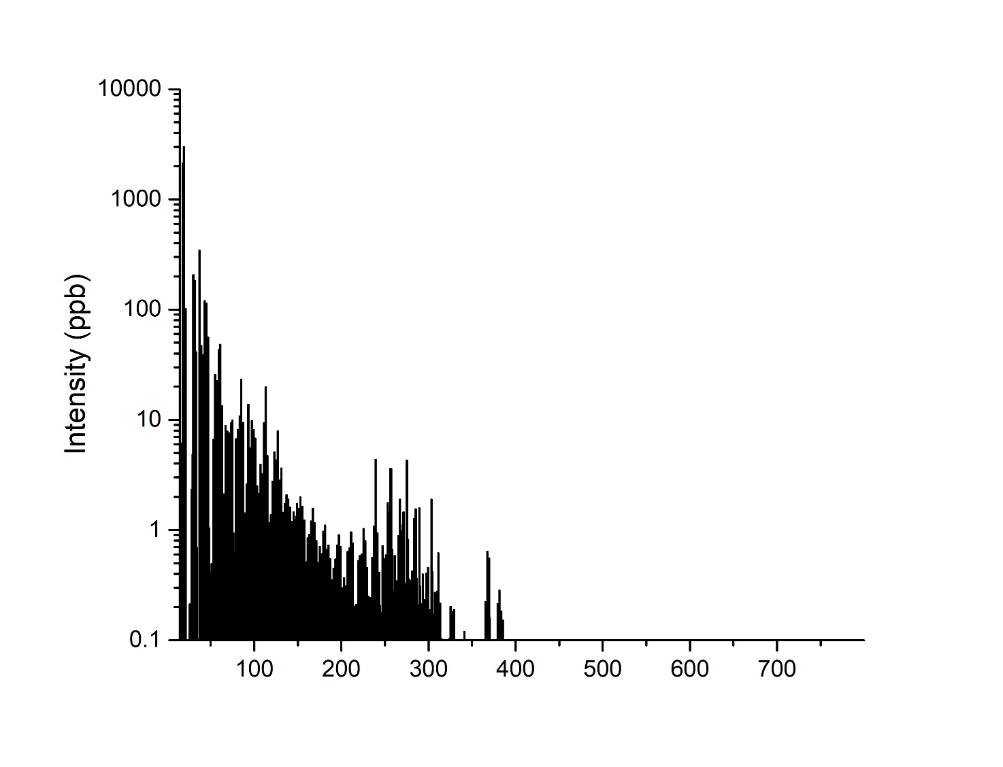
Figure 2S PTR-TD-MS mass spectrum of mussel sample (M4).

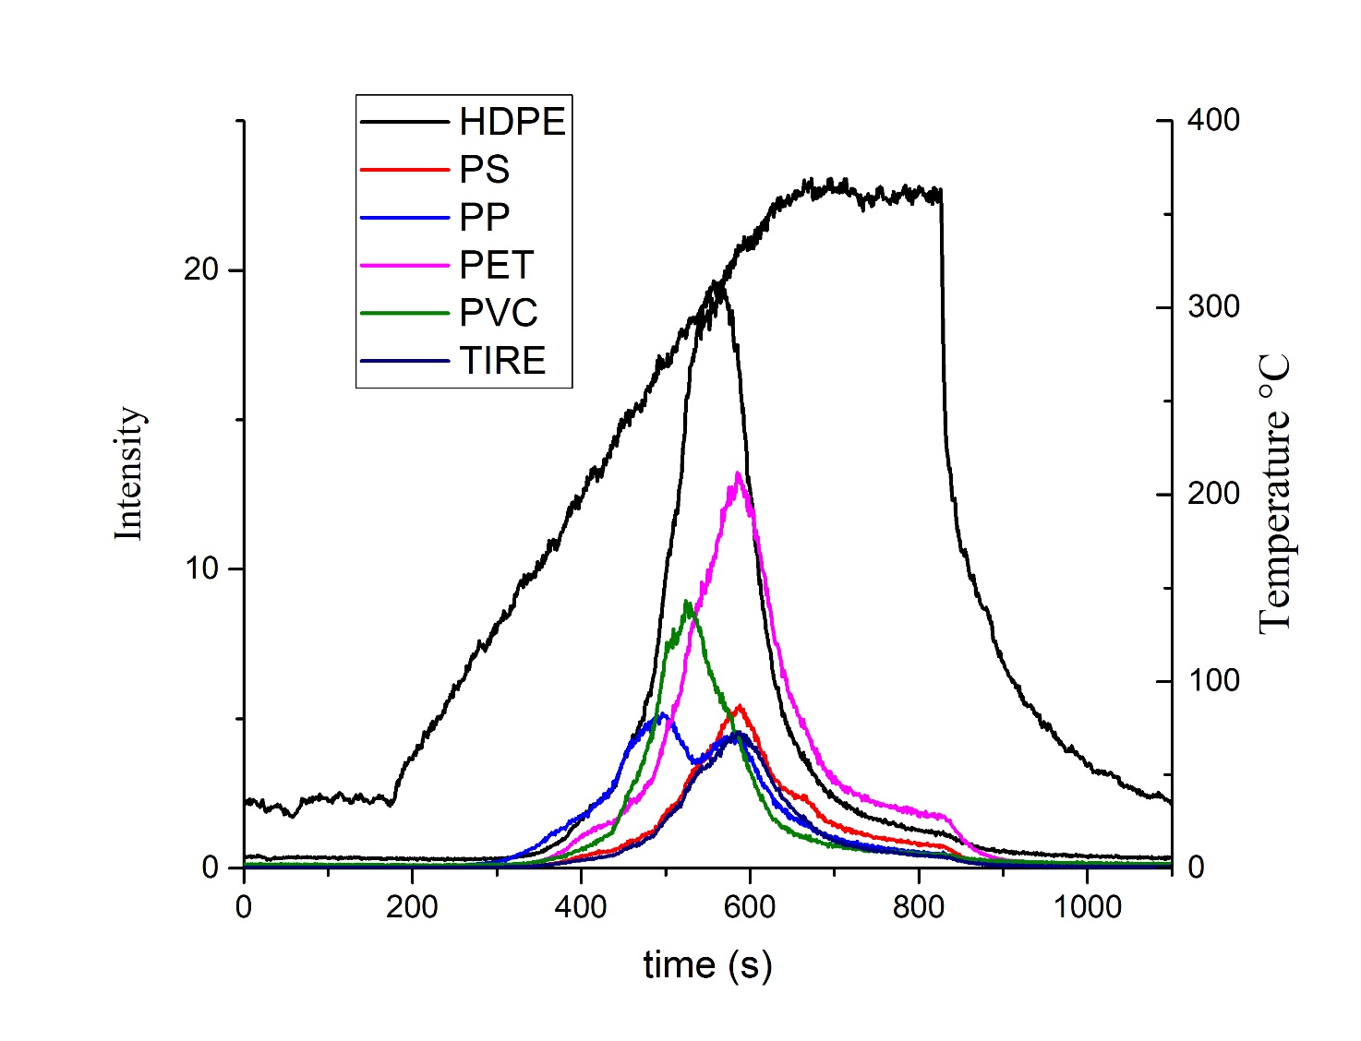Figure 3S Thermogram of all the plastic types found in mussel M4

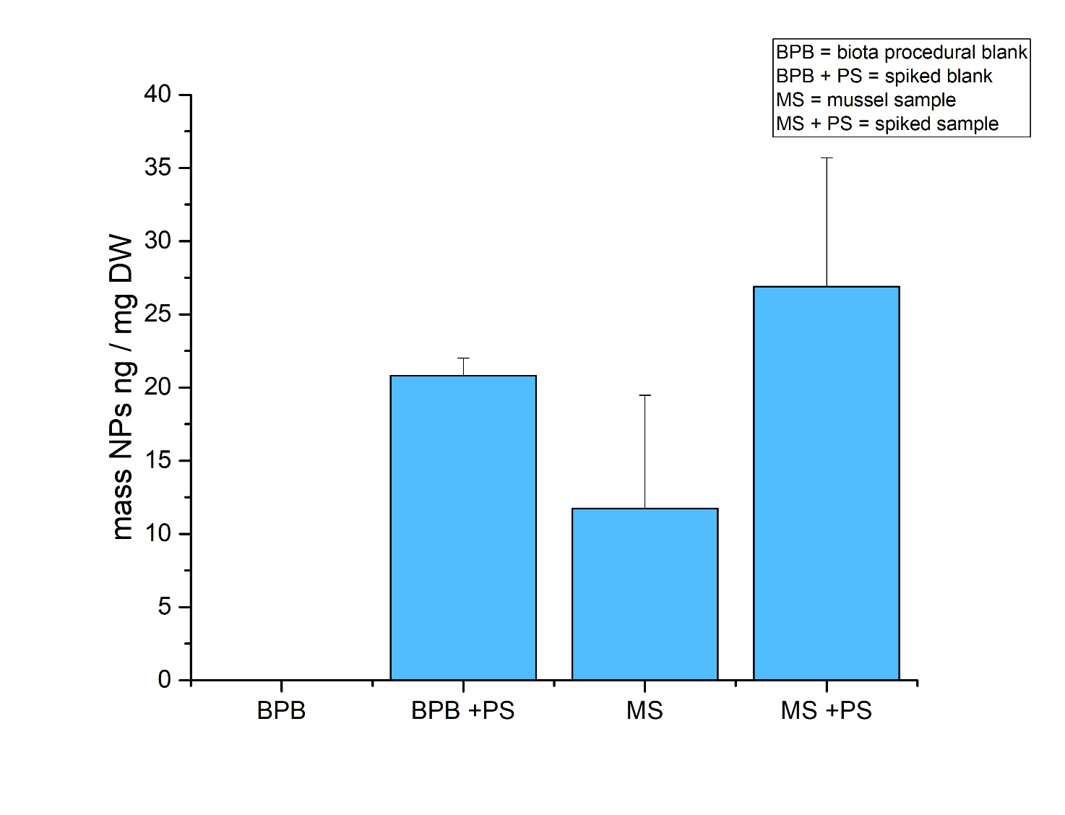
Figure 4S Graph to show the average quantities of PS in spiked and not spiked filters with relative error bars.

