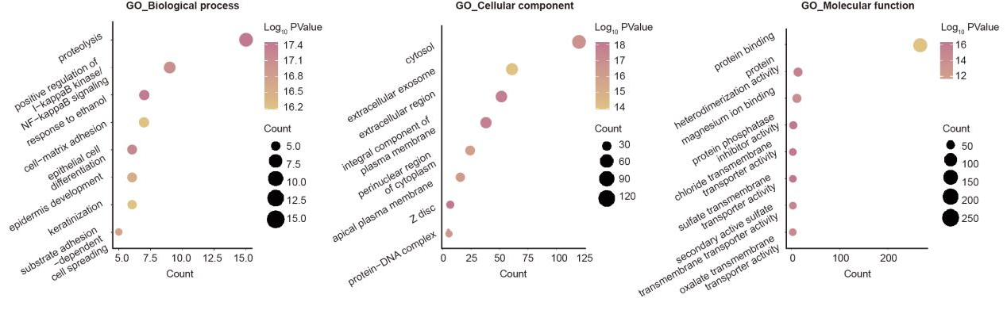
Supplementary Figure 1. The GO enrichment analysis of 400 key genes.

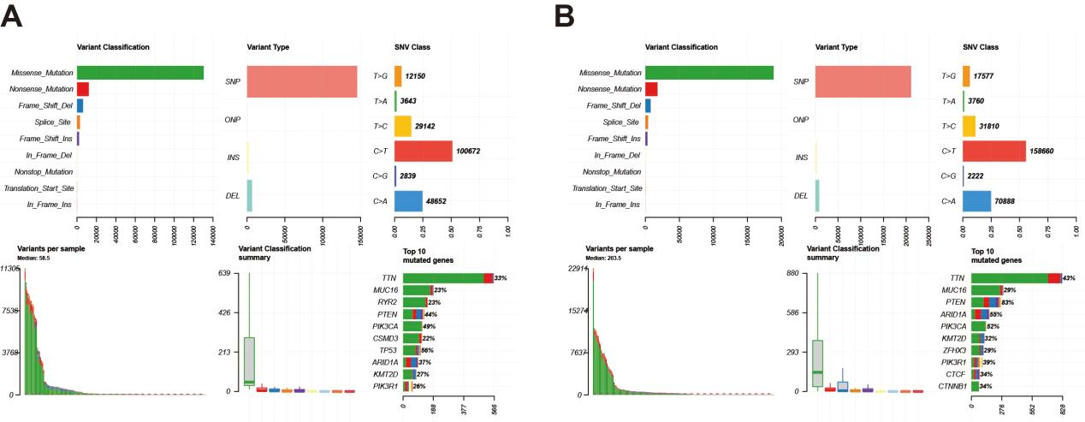
Supplementary Figure 2. Summary of the mutation information in the high- (A) and low- (B) risk groups with statistical calculations.

