Supporting Information

Novel Potential Binding Sites for Selective Inhibitor Design of Human Soluble Epoxide Hydrolase
Authors’ Names
Maria Bzówka¹, Karolina Mitusińska¹, Artur Góra^{1*}
Affiliations
¹Tunneling Group, Biotechnology Centre, ul. Krzywoustego 8, Silesian University of Technology, Gliwice, 44-100, Poland

Contents:
Figure S1 S3
Table S1 S3
Figure S2 S4
Table S2 S5
Table S3 S6

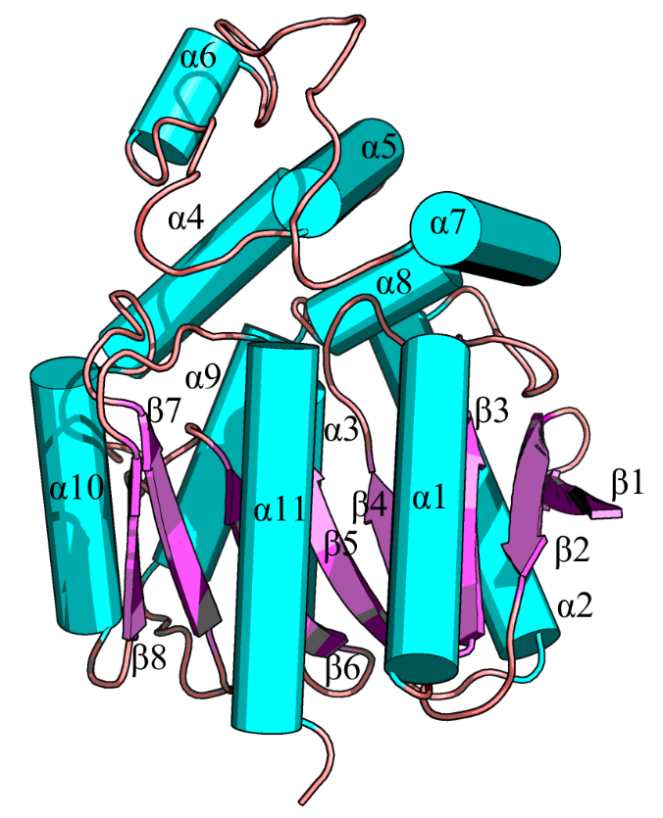
Supplementary Table S1. Secondary structures motifs of hsEH.

Supplementary Figure S1. Secondary structure motifs showed on the protein structure.
Secondary structure name | Residues
Main domain | S238-M369 and  M469-M555
Cap domain | S370-R467
NC-loop | Y348-S370
Cap-loop | F409-T443
β1 | S238-K245
β2 | V248-L255
β3 | A260-C264
α1 | S270-A284
β4 | R287-D292
α2 | E304-L324
β5 | A329-H334
α3 | D335-Y348
β6 | V352-L358
α4 | S370-E389
α5 | G391-F409
α6 | K421-G426
α7 | T443-K455
α8 | F459-W465
α9 | N468-L480
β7 | A488-A493
α10 | V500-I511
β8 | K515-I519
α11 | W525-A546

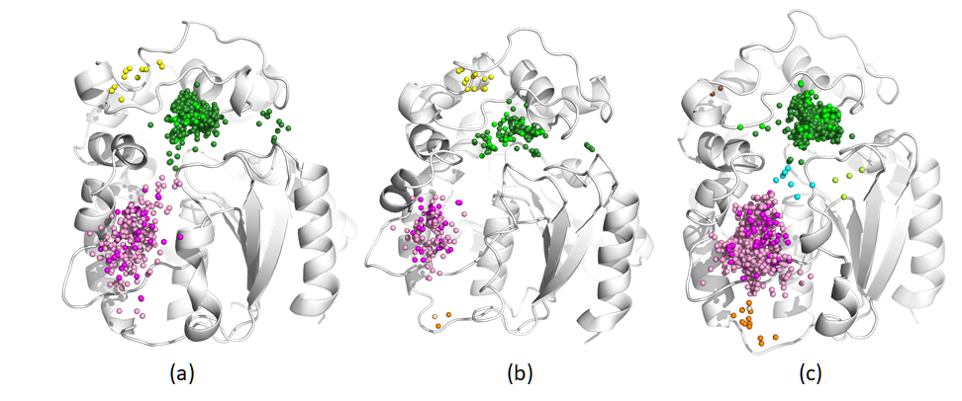

Supplementary Figure S2. Localisation of areas of water/cosolvent molecule entry/egress (clusters) to the active site of hsEH – (a) MixMD simulation with water and acetonitrile molecules, (b) MixMD simulation with water and urea molecules, (c) MixMD simulation with water and methanol molecules. Small balls represent single inlets of water/cosolvent molecule entry/egress, colours correspond to identified tunnels (pink – Tm1, green – Tc/m, cyan – Tg, orange – Tm2, yellow – Tcap1, limon – Tm3). Different shades of colour within a given cluster makes it possible to distinguish the space occupied by water (light pink, deep green) or particular cosolvent (deep pink, light green – acetonitrile, urea, methanol). Newly opened Tcap1 and Tm3 tunnels are frequented by water molecules.

Supplementary Table S2. Complete list of interactions identified by Ligplot between hsEH and inhibitors in various crystal structures. Amino acids colour coding corresponds to the cluster analysis presented in the Figure 2; C-1a (light pink), C-1b (deep pink), C-2 (cyan), C-3 (green), C-4 (yellow). NNB refers to non-bonded interactions, and HHB refers to hydrogen bonds.
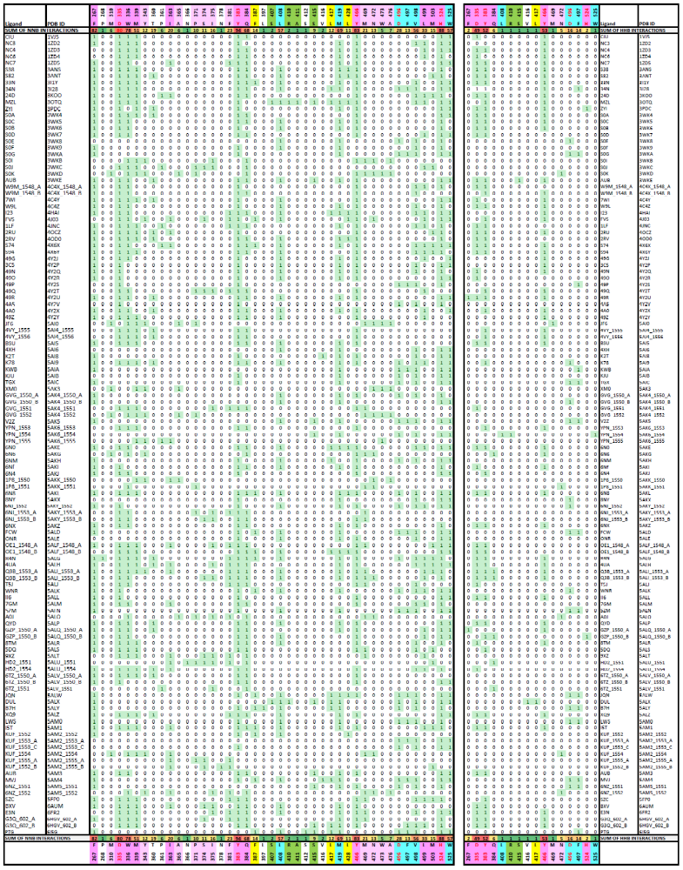

Supplementary Table S3. The number of added water molecules added for classical MD simulation, together with the number of added water and cosolvent molecules for mixed-solvent MD simulations and their percentage concentrations.

(Co)solvent | Concentration [%] | Number of added molecules
WAT | - | WAT: 9983
ACN | 15.58 | ACN: 800  WAT: 9980
DMSO | 13.45 | DMSO: 400  WAT: 10980
MEO | 10.86 | MEO: 800  WAT: 9980
PHN | 0.60 | PHN: 15  WAT: 9980
URE | 18.23 | URE: 800  WAT: 9980

