Supplement Materials:
Figure S1. OA, F and LG dose selection
b
a

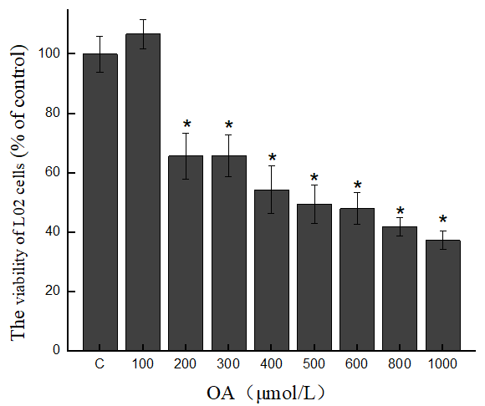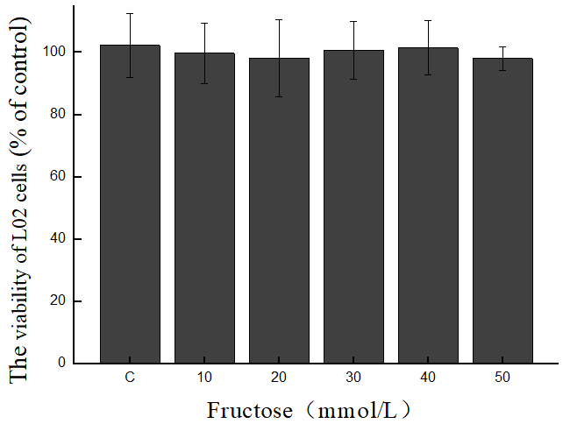
d
c
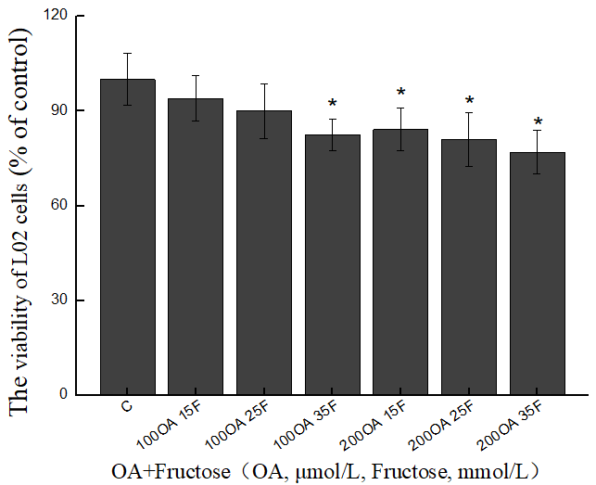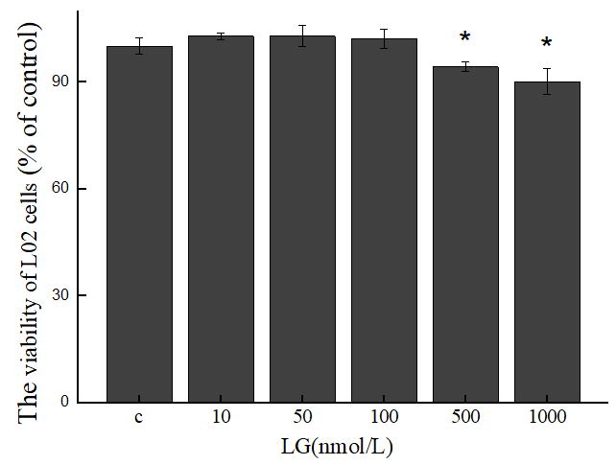
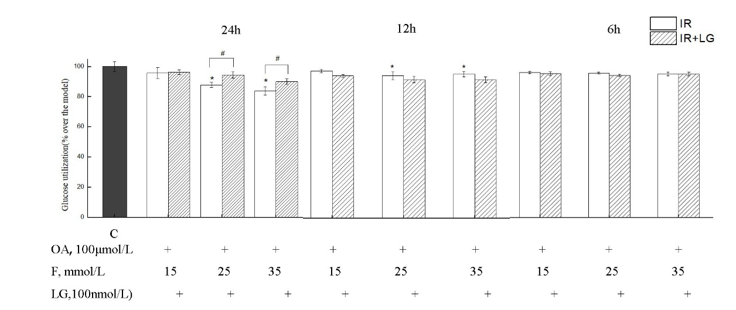
e
(a)The effects of OA on the viability of L02 cells. (b) The effects of F on the viability of L02 cells. (c) The effects of OA+F(IR) on the viability of L02 cells. (d) The effects of LG on the viability of L02 cells. (e) The effect of different dose and time of IR on glucose utilization. Data are expressed as means ± SD (n=3) *p<0.05 compared with Control, #p<0.05 compared with IR.
Figure S2. Effects of GLP-1R gene silencing on the expression of L02cells.
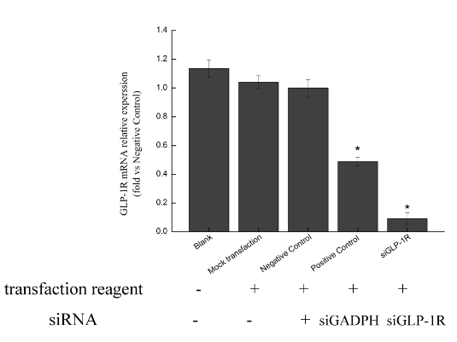
GLP-1R mRNA expression was assessed by qPCR in Blank (Normal L02 cells), mock transfection (Normal L02 cells incubated with transfection reagent), and positive control (Normal L02 cells incubated with siGADPH).

