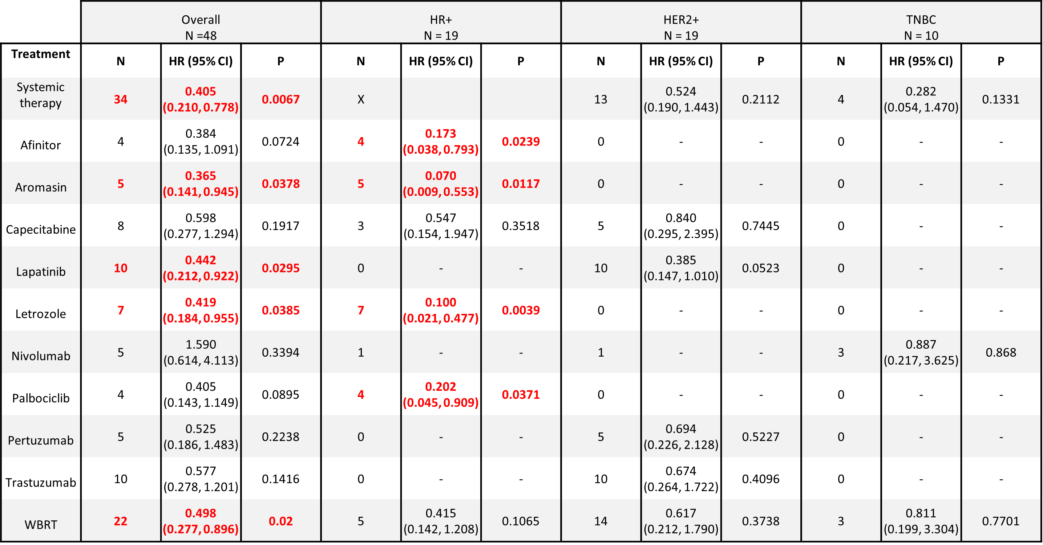
Supplementary Table 1. Univariable Cox proportional hazard regression analysis to estimate Hazard Ratios (HR) and 95% confidence intervals (CI) for various treatments administered to patients post CNS metastasis/pre BC-LMD diagnosis. Treatments that were found to significantly prolong time between CNS metastasis and BC-LMD are highlighted in red.
Abbreviations: Hormone Receptor Positive (HR+); Human Epidermal Growth Factor Receptor 2-Positive (HER2+); Triple Negative Breast Cancer (TNBC); Whole Brain Radiation Therapy (WBRT); Hazard Ratio (HR); Confidence Interval (CI).

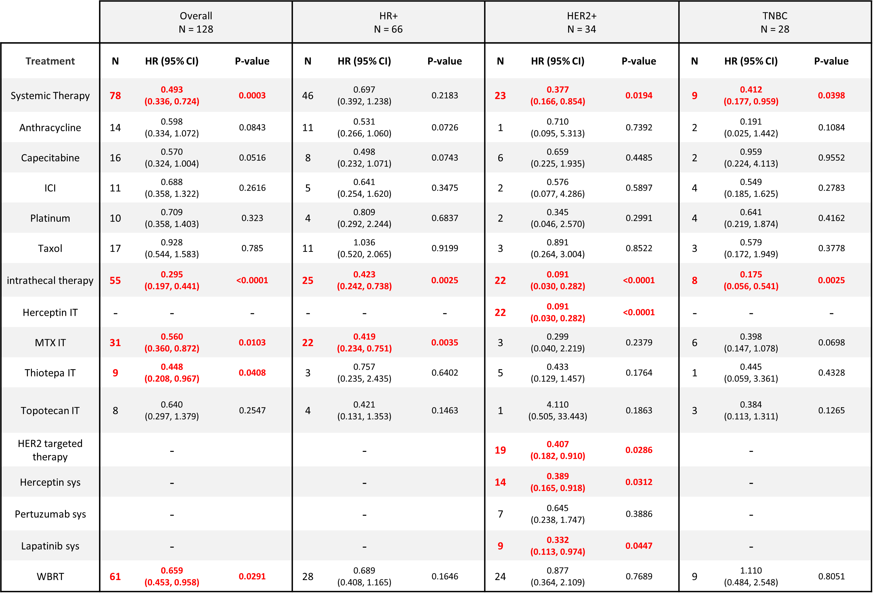
Supplementary Table 2. Univariable Cox proportional hazard regression analysis to estimate Hazard Ratios (HR) and 95% confidence intervals (CI) for various treatments administered to patients post BC-LMD diagnosis. Treatments found to significantly enhance overall survival are highlighted in red.
Abbreviations: Hormone Receptor Positive (HR+); Human Epidermal Growth Factor Receptor 2-Positive (HER2+); Triple Negative Breast Cancer (TNBC); Immune Checkpoint Inhibitors (ICI); Intrathecal Therapy (IT); Systemic (sys); Whole Brain Radiation Therapy (WBRT); Hazard Ratio (HR); Confidence Interval (CI).

