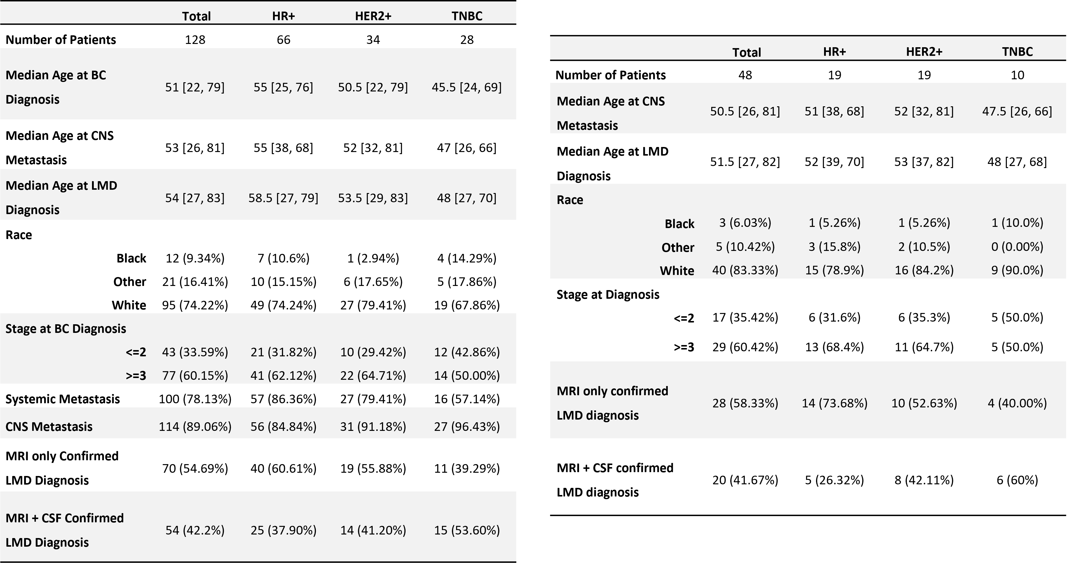
Table 1 (left). Demographic data for all patients diagnosed with BC-LMD at Moffitt Cancer Center between 2011-2020.

Table 2 (right). Demographic data for patients with at least one month between the CNS metastatic disease diagnosis and the BC-LMD diagnosis.
Abbreviations: Breast Cancer (BC); Hormone Receptor Positive (HR+); Human Epidermal Growth Factor Receptor 2-Positive (HER2+); Triple Negative Breast Cancer (TNBC); Central Nervous System (CNS); Leptomeningeal Disease (LMD); Magnetic Resonance Imagining (MRI); Cerebrospinal Fluid (CSF).

