The 1H NMR spectrum of HMOPF
In this NMR hydrogen spectrum, the deuterated acetone peak at 2.05 ppm is shown in Fig. S1. To briefly summarize the hydrogen spectra, the NMR hydrogen spectra were organized as Table S1.
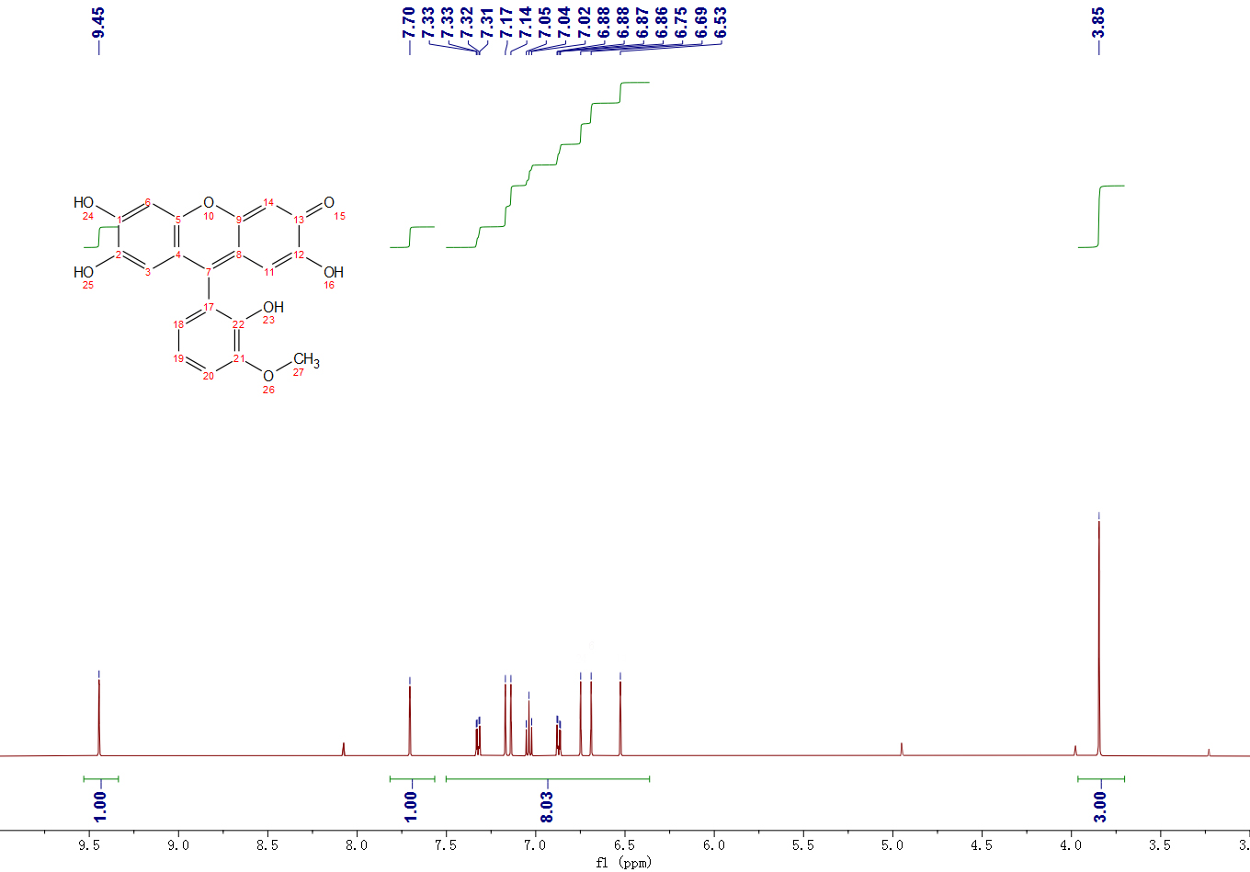
Fig. S1 1H NMR spectrum of HMOPF

Table S1 NMR hydrogen spectrum analysis of HMOPF
Hydrogen Attributions | Number of peaks | Number of hydrogen | Chemical shifts
Ar-H | Multiple peaks | 5 | 6.88-7.33
-OH | 1 | 3 | 7.70, 7.14, 6.87
C-H | 1 | 2 | 7.17, 6.53
-OH | 1 | 1 | 9.45
C-H | 1 | 3 | 3.85

Infrared spectrum of HMOPF
The IR spectrum of o-vanillin fluorescence ketone is shown in Fig. S2, which is resolved as follows: there is a strong and broad absorption peak at 3127 cm⁻¹, which is generated by O-H stretching vibration; the moderately strong absorption peak at 1640 cm⁻¹ is due to the stretching vibration of C=O double bond in the cyclic alkene; the absorption peak of C-C stretching vibration of aromatic ring skeleton is at 1500 cm⁻¹; the absorption peak at 1400 cm⁻¹ is generated by the bending vibration of methyl group on methoxy; the absorption peak at 1280 cm⁻¹ belongs to the stretching vibration of C-O single bond in o-vanillin fluorescence ketone molecule.
Fig. S2 Infrared spectrum of o-vanillin fluorescent ketone

