Supplementary Information
Biointerference-free signal generation via a self-floating transporter for early diagnosis of bladder cancer at the point of care
Changjoon Keum ^{1,7}, Haejin Yeom ^{1,2,7}, Tae Il Noh ^{3,7}, Seung Yong Yi ^{1,2}, Soyoung Jin ^{1,4}, Chaekyu Kim ⁵, Ji Sung Shim ³, Sung Goo Yoon ³, Hojun Kim ¹, Kwan Hyi Lee ^{1,6,*}, Seok Ho Kang ^{3,*}, and Youngdo Jeong ^{1,2,*}

¹Center for Advanced Biomolecular Recognition, Biomedical Research Division, Korea Institute of Science and Technology (KIST), Seoul 02792, Republic of Korea
²Department of HY-KIST Bio-convergence, Hanyang University, Seoul 04763, Republic of Korea
³Department of Urology, Korea University School of Medicine, Seoul 02841, Republic of Korea
⁴Department of Chemistry, Hanyang University, Seoul 04763, Republic of Korea
⁵Fusion Biotechnology, Inc., Ulsan 44919, Republic of Korea
⁶KU-KIST Graduate School of Converging Science and Technology, Korea University, Seoul 02841, Republic of Korea.
⁷These authors contributed equally: Changjoon Keum, Haejin Yeom, and Tae Il Noh
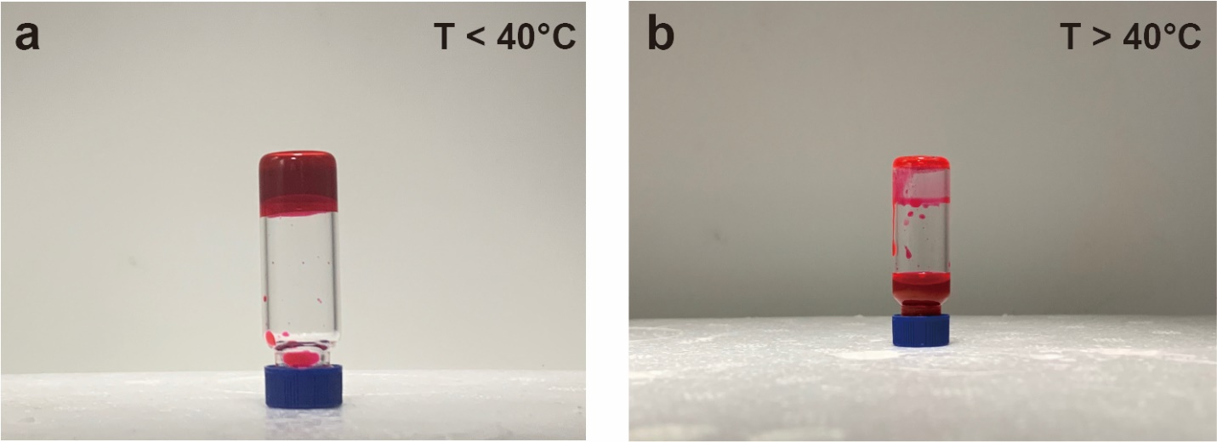
Supplementary Fig. 1. Photographs of the HSA organogel. (a) Under and (b) above 40°C, respectively.
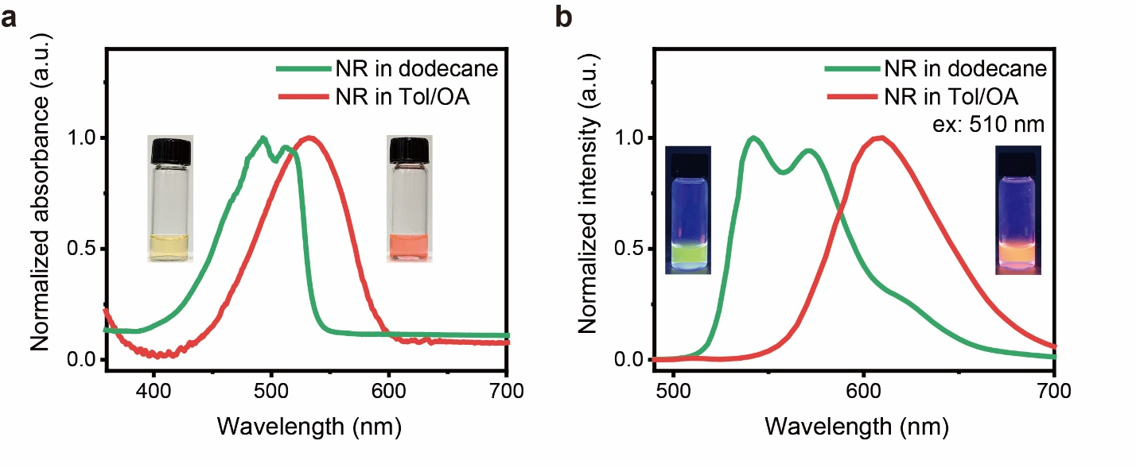
Supplementary Fig. 2. UV-Vis absorbance and fluorescence spectra of Nile red (NR). (a) Normalized UV-Vis absorbance of NR in a dodecane and toluene/oleic acid (Tol/OA) mixture. (Inset: photographs of the NR solution in dodecane and Tol/OA) (b) Normalized fluorescence spectra of NR in a dodecane and Tol/OA mixture. (Ex: 510 nm; insets: photographs of the NR solution in dodecane and Tol/OA under UV light exposure)

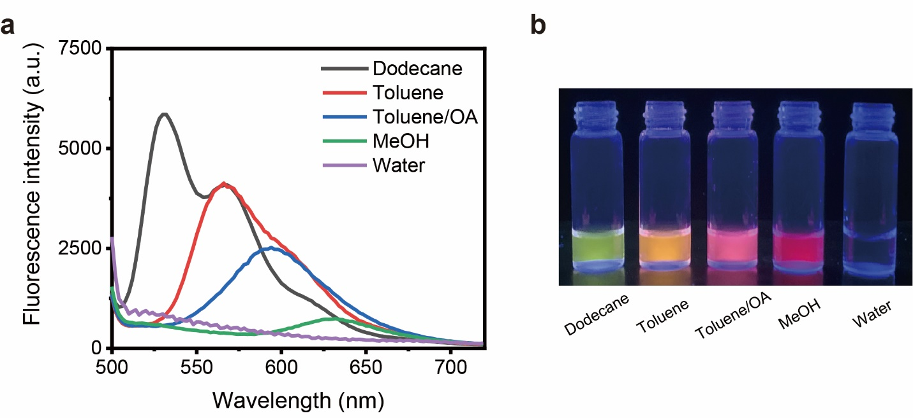
Supplementary Fig. 3. NR fluorescence varies with the polarity of solvents. (a) Fluorescence emission spectra and (b) optical images of Nile red dissolved in solvents of varying polarity from nonpolar dodecane to polar water. Solutions were excited with 460 nm light to demonstrate the substantial color shift of emitted fluorescence. Solvents with greater polarity resulted in less intense and longer wavelength emissions.
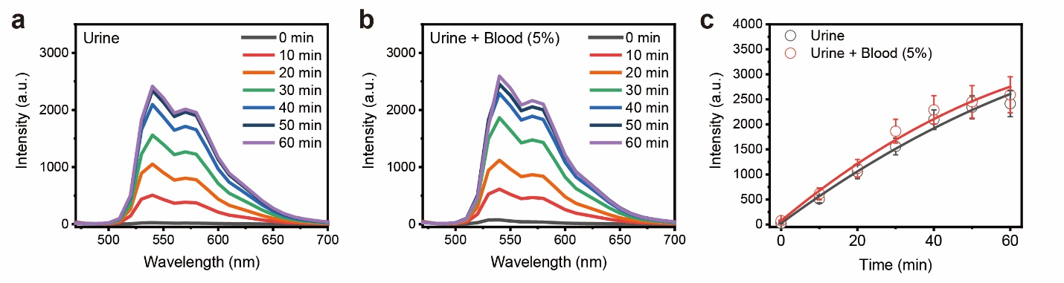
Supplementary Fig. 4. Fluorescence intensity in the n-dodecane layer with various conditions of the aqueous layer. Increase in fluorescence intensity at 540 nm in the n-dodecane layer of the biphasic system with an aqueous layer of (a) normal pooled urine (NPU) and (b) NPU + 5% laked horse blood. (c) Increase in fluorescence intensity at 540 nm over time under the conditions of the aqueous layers.
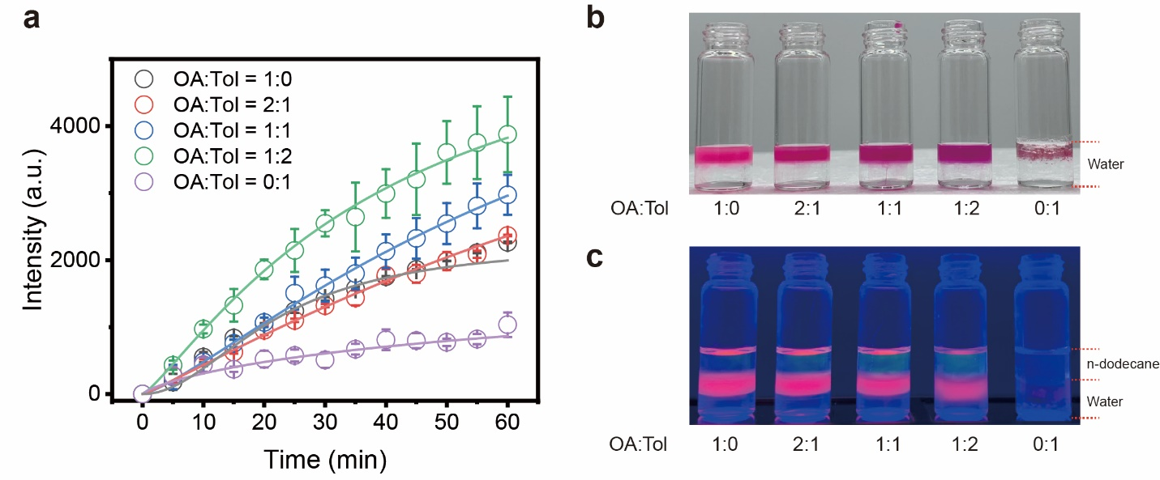
Supplementary Fig. 5. Fluorescence intensity of Nile red dissolved in an n-dodecane layer with various oleic acid:toluene (OA:Tol) ratios in buoyant organogel. (a) Increase in fluorescence intensity of Nile red dissolved in an n-dodecane layer at 540 nm over time with various OA:Tol volume ratios. (b) Photographs of the buoyant organogel synthesized with various volume ratios of OA:Tol in an aqueous solution. Without OA, organogel particles were not obtained. (c) Photographs of dissolved Nile red in an n-dodecane layer with organogel particles synthesized by various volume ratios of OA:Tol under UV irradiation. The strongest green fluorescence was observed in the sample with a volume ratio of OA:Tol of 1:2.

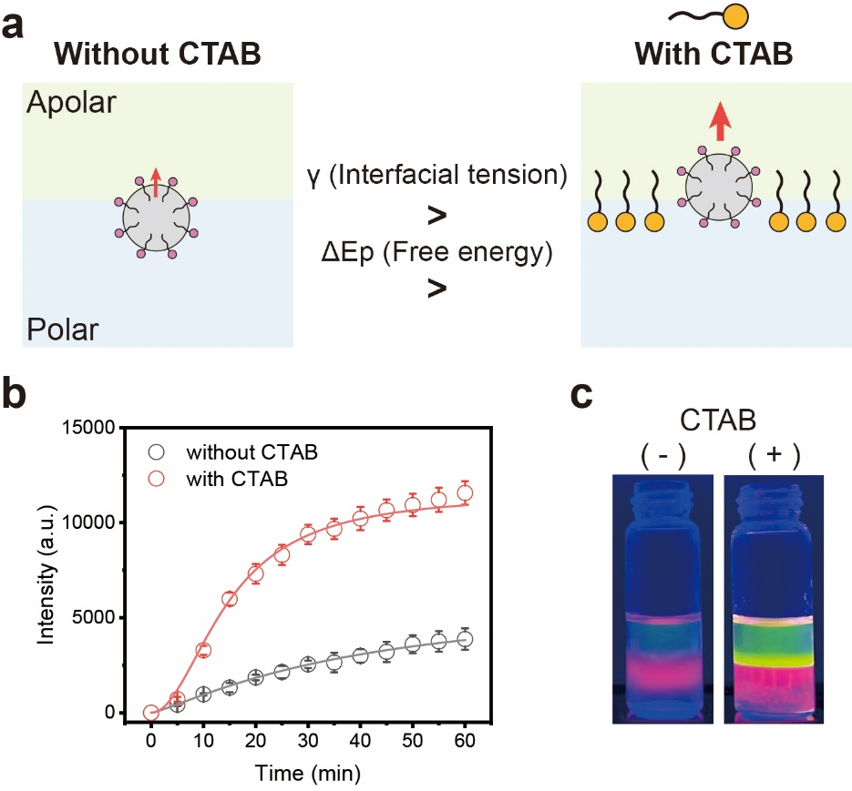
Supplementary Fig. 6. Effect of interfacial tension on signal transduction in the biphasic system. (a) Schematic illustration of the interface in the biphasic system with and without CTAB. (b) Fluorescence intensities of Nile red in a dodecane layer with and without CTAB. (c) Photographs of the BLOOM biphasic system under UV irradiation.

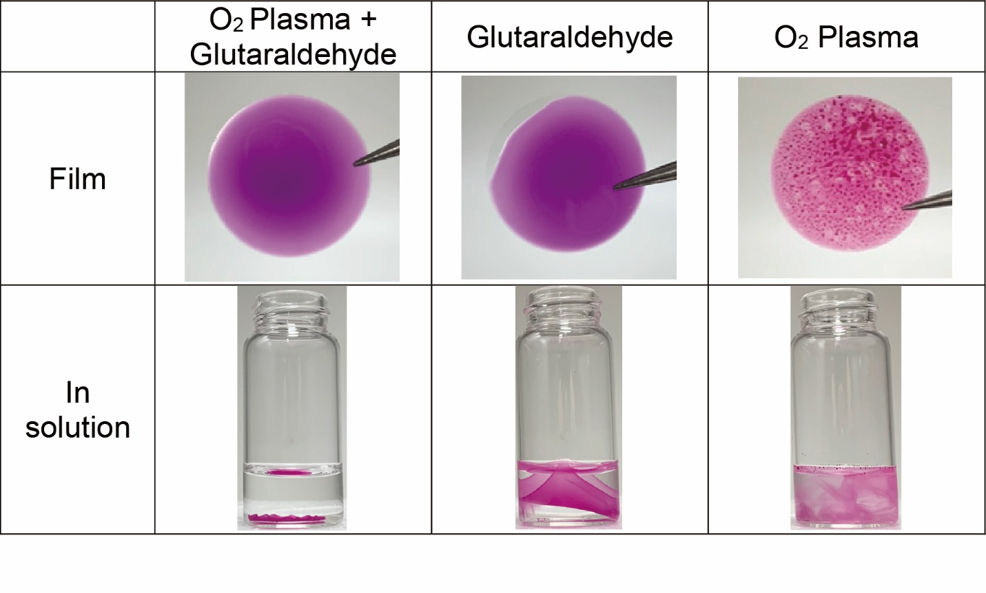
Supplementary Fig. 7. Bigel film fabrication containing hyaluronic acid and buoyant organogel on glass substrates. As shown in the photographs, the O₂ plasma-treated glass substrate and bigel film showed good spreadability and adhesion. Therefore, the bigel film on O₂ plasma-treated glass substrate showed good adhesion, even after incubating in solution for 1 h. However, without O₂ plasma, the bigel film showed unintentional overall film floating, which interferes with the use of bigel films for Hdase detection. Without glutaraldehyde, the bigel film was not formed.

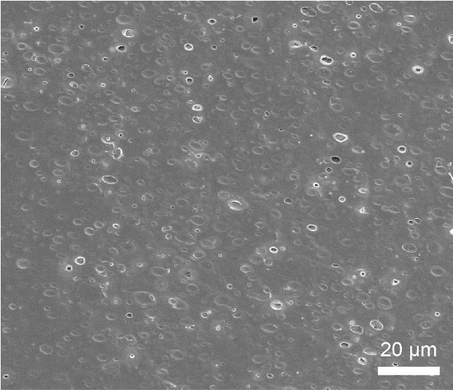
Supplementary Fig. 8. Cryo-SEM image of the bigel film. Cryo-SEM image of the bigel film without organogel signal messenger outside. (Scale bar: 20 µm)

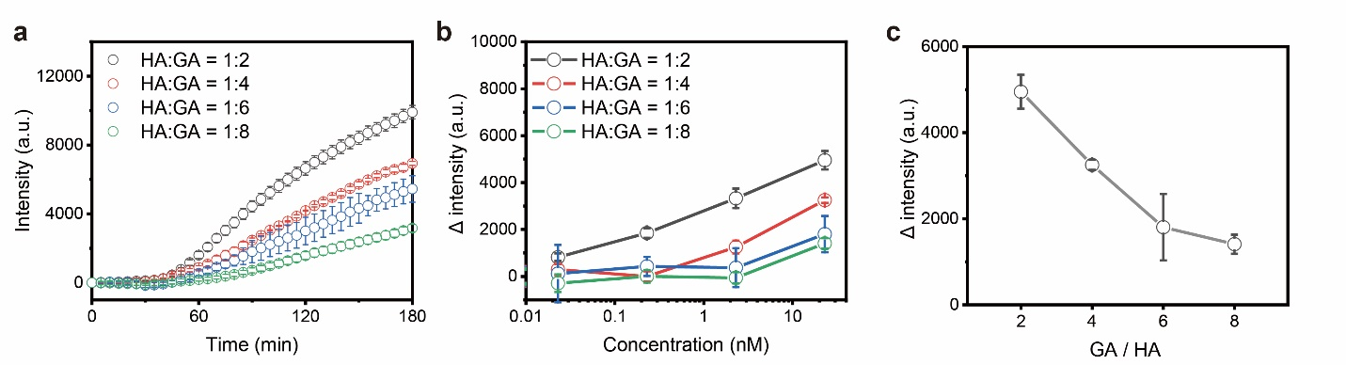
Supplementary Fig. 9. Effect of hydrogel cross-linking for Hdase detection. (a) Fluorescence intensities of the Hdase (1 U/mL) detection experiments using bigel film synthesized by varying the HA:GA mass ratio from 1:2 to 1:8. (b) Hdase concentration-dependent normalized fluorescence intensities using bigel film synthesized by varying the HA:GA mass ratio from 1:2 to 1:8. (c) Normalized fluorescence intensities under different GA/HA mass ratios for Hdase (1 U/mL) detection. (n=3)
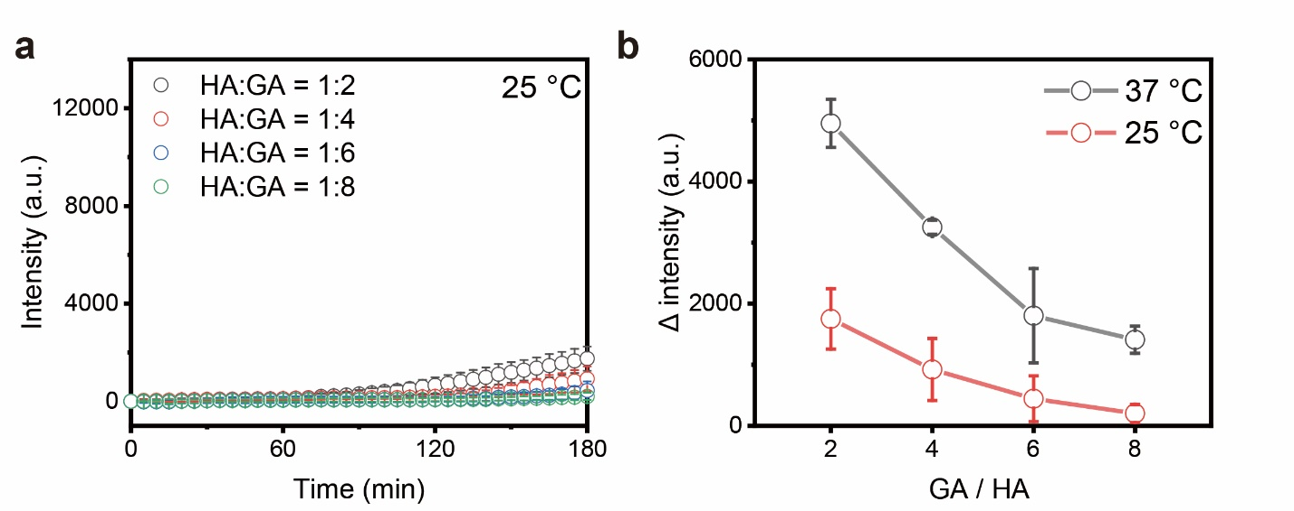
Supplementary Fig. 10. Effect of incubation temperature on the Hdase concentration. (a) Fluorescence intensities of the Hdase (1 U/mL) detection experiments at 25°C using bigel film synthesized by varying the HA:GA mass ratio from 1:2 to 1:8. (b) Comparison of the normalized fluorescence intensities between incubation temperatures of 37°C and 25°C for Hdase detection. (n=3)

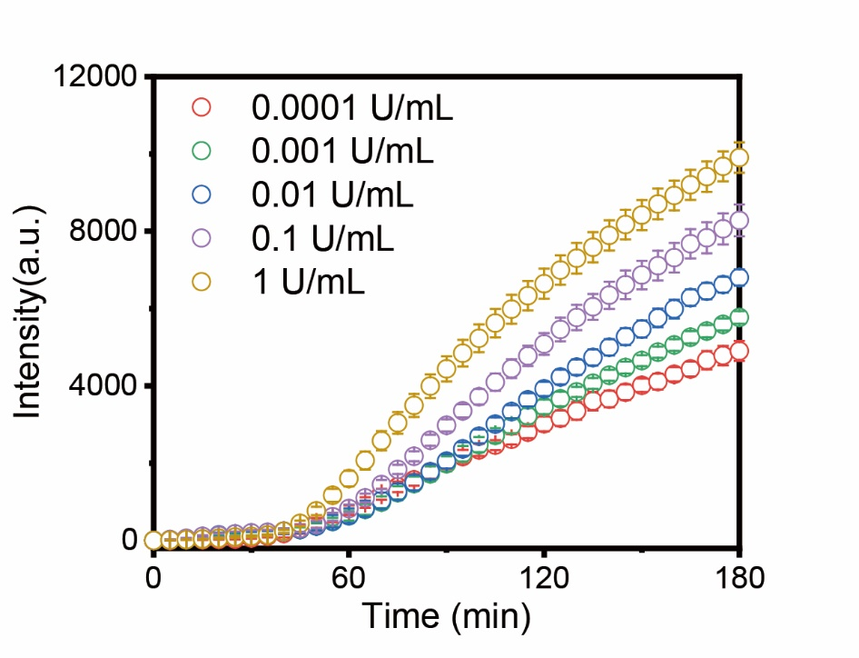
Supplementary Fig. 11. Hdase concentration-dependent fluorescence intensities over time. Increases in fluorescence intensity over time (up to 180 min) by varying the Hdase concentrations from 0.1 mU/mL to 1 U/mL (Ex: 460 nm, Em: 540 nm).

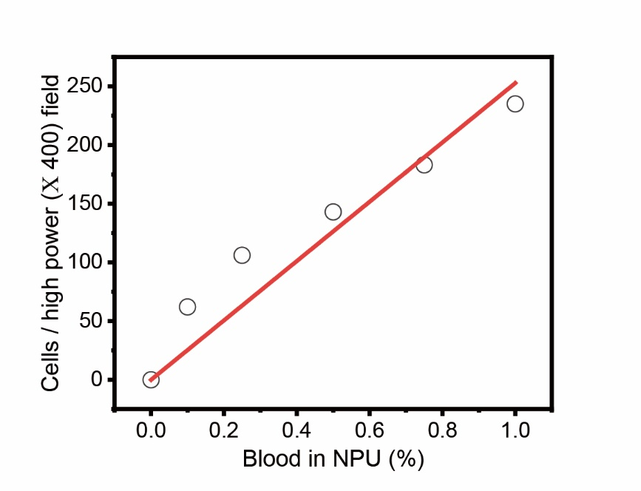
Supplementary Fig. 12. Red blood cells per high power field (RBCs/HPF) measurements in artificial hematuria samples. RBCs/HPF in artificial hematuria samples, which were composed of varying concentrations of horse blood (from 0.1 % to 1 %) in normal pooled urine (NPU).

Supplementary Table 1. Summary of BC patients, GU patients, and healthy controls.
 | Healthy controls | GU patients¹ | BC patients
Number | 25 | 20 | 60
Age
Average | 54.3 ± 8.1 | 62.3 ± 12.1 | 68.2 ± 10.2
Range | 32 – 67 | 43 – 89 | 47 – 85
Sex
Male | 12 | 10 | 50
Female | 13 | 10 | 10
NMIBC | - | - | 47
MIBC | - | - | 13
T stage
Ta | - | - | 24
T1 | - | - | 19
≥T2 | - | - | 13
Tis | - | - | 4
¹ GU patients: benign prostate hyperplasia (n=5), chronic inflammation (n=7), cystitis (n=2), paraganglioma (n=1), leiomyoma (n=2), arteriovenous malformation (n=1), and papillary lesion (n=2).
Supplementary Table 2. Hematuria in BC patient samples used in a double-blind test.
Hematuria (RBCs/HPF) | Few or No  (0≤RBCs<5) | Moderate  (5≤RBCs<30) | High  (30≤RBCs)
No. | 20 | 13 | 27
Percentage | 33.3% | 21.7% | 45.0%
 |  | 66.7%

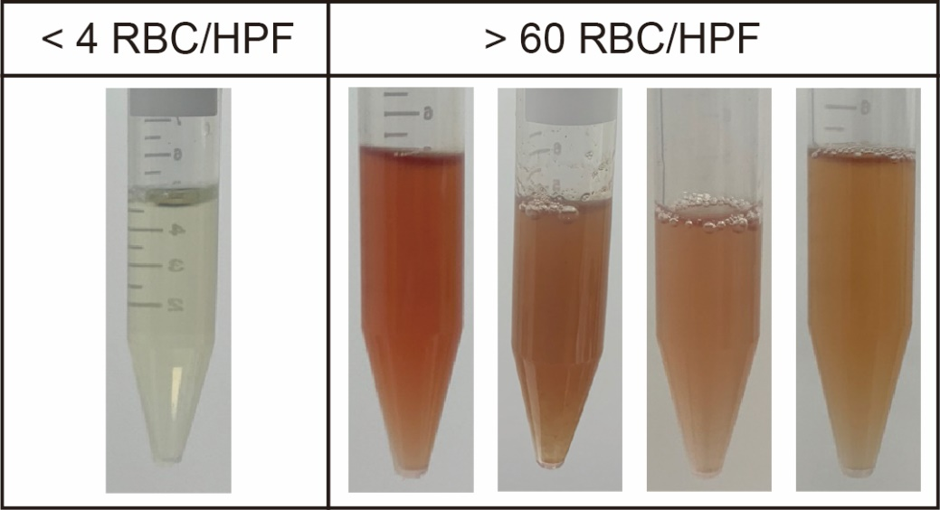
Supplementary Fig. 13. Photographs of hematuric urine samples of BC patients. Photographs of patient samples with low or absent RBCs/HPF (left, RBCs/HPF<4) and gross hematuria (right, RBCs/HPF>60).

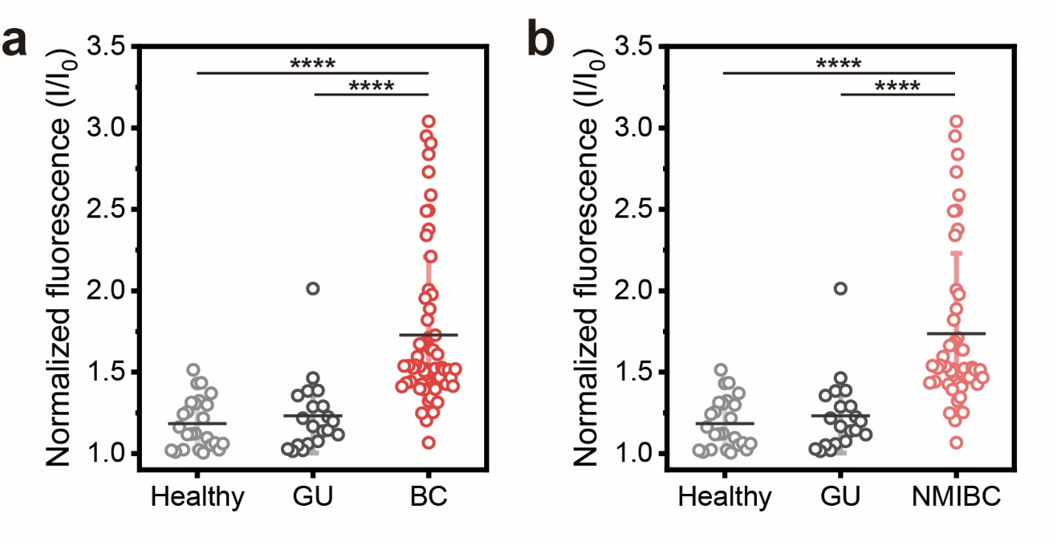
Supplementary Fig. 14. Normalized fluorescence intensities of BLOOM. Normalized fluorescence intensities of urine samples acquired from BLOOM of (a) BC patients and (b) NMIBC patients versus healthy controls and GU patients independently. Two-tailed Student’s t-tests were used for comparisons. ****p<0.0001.

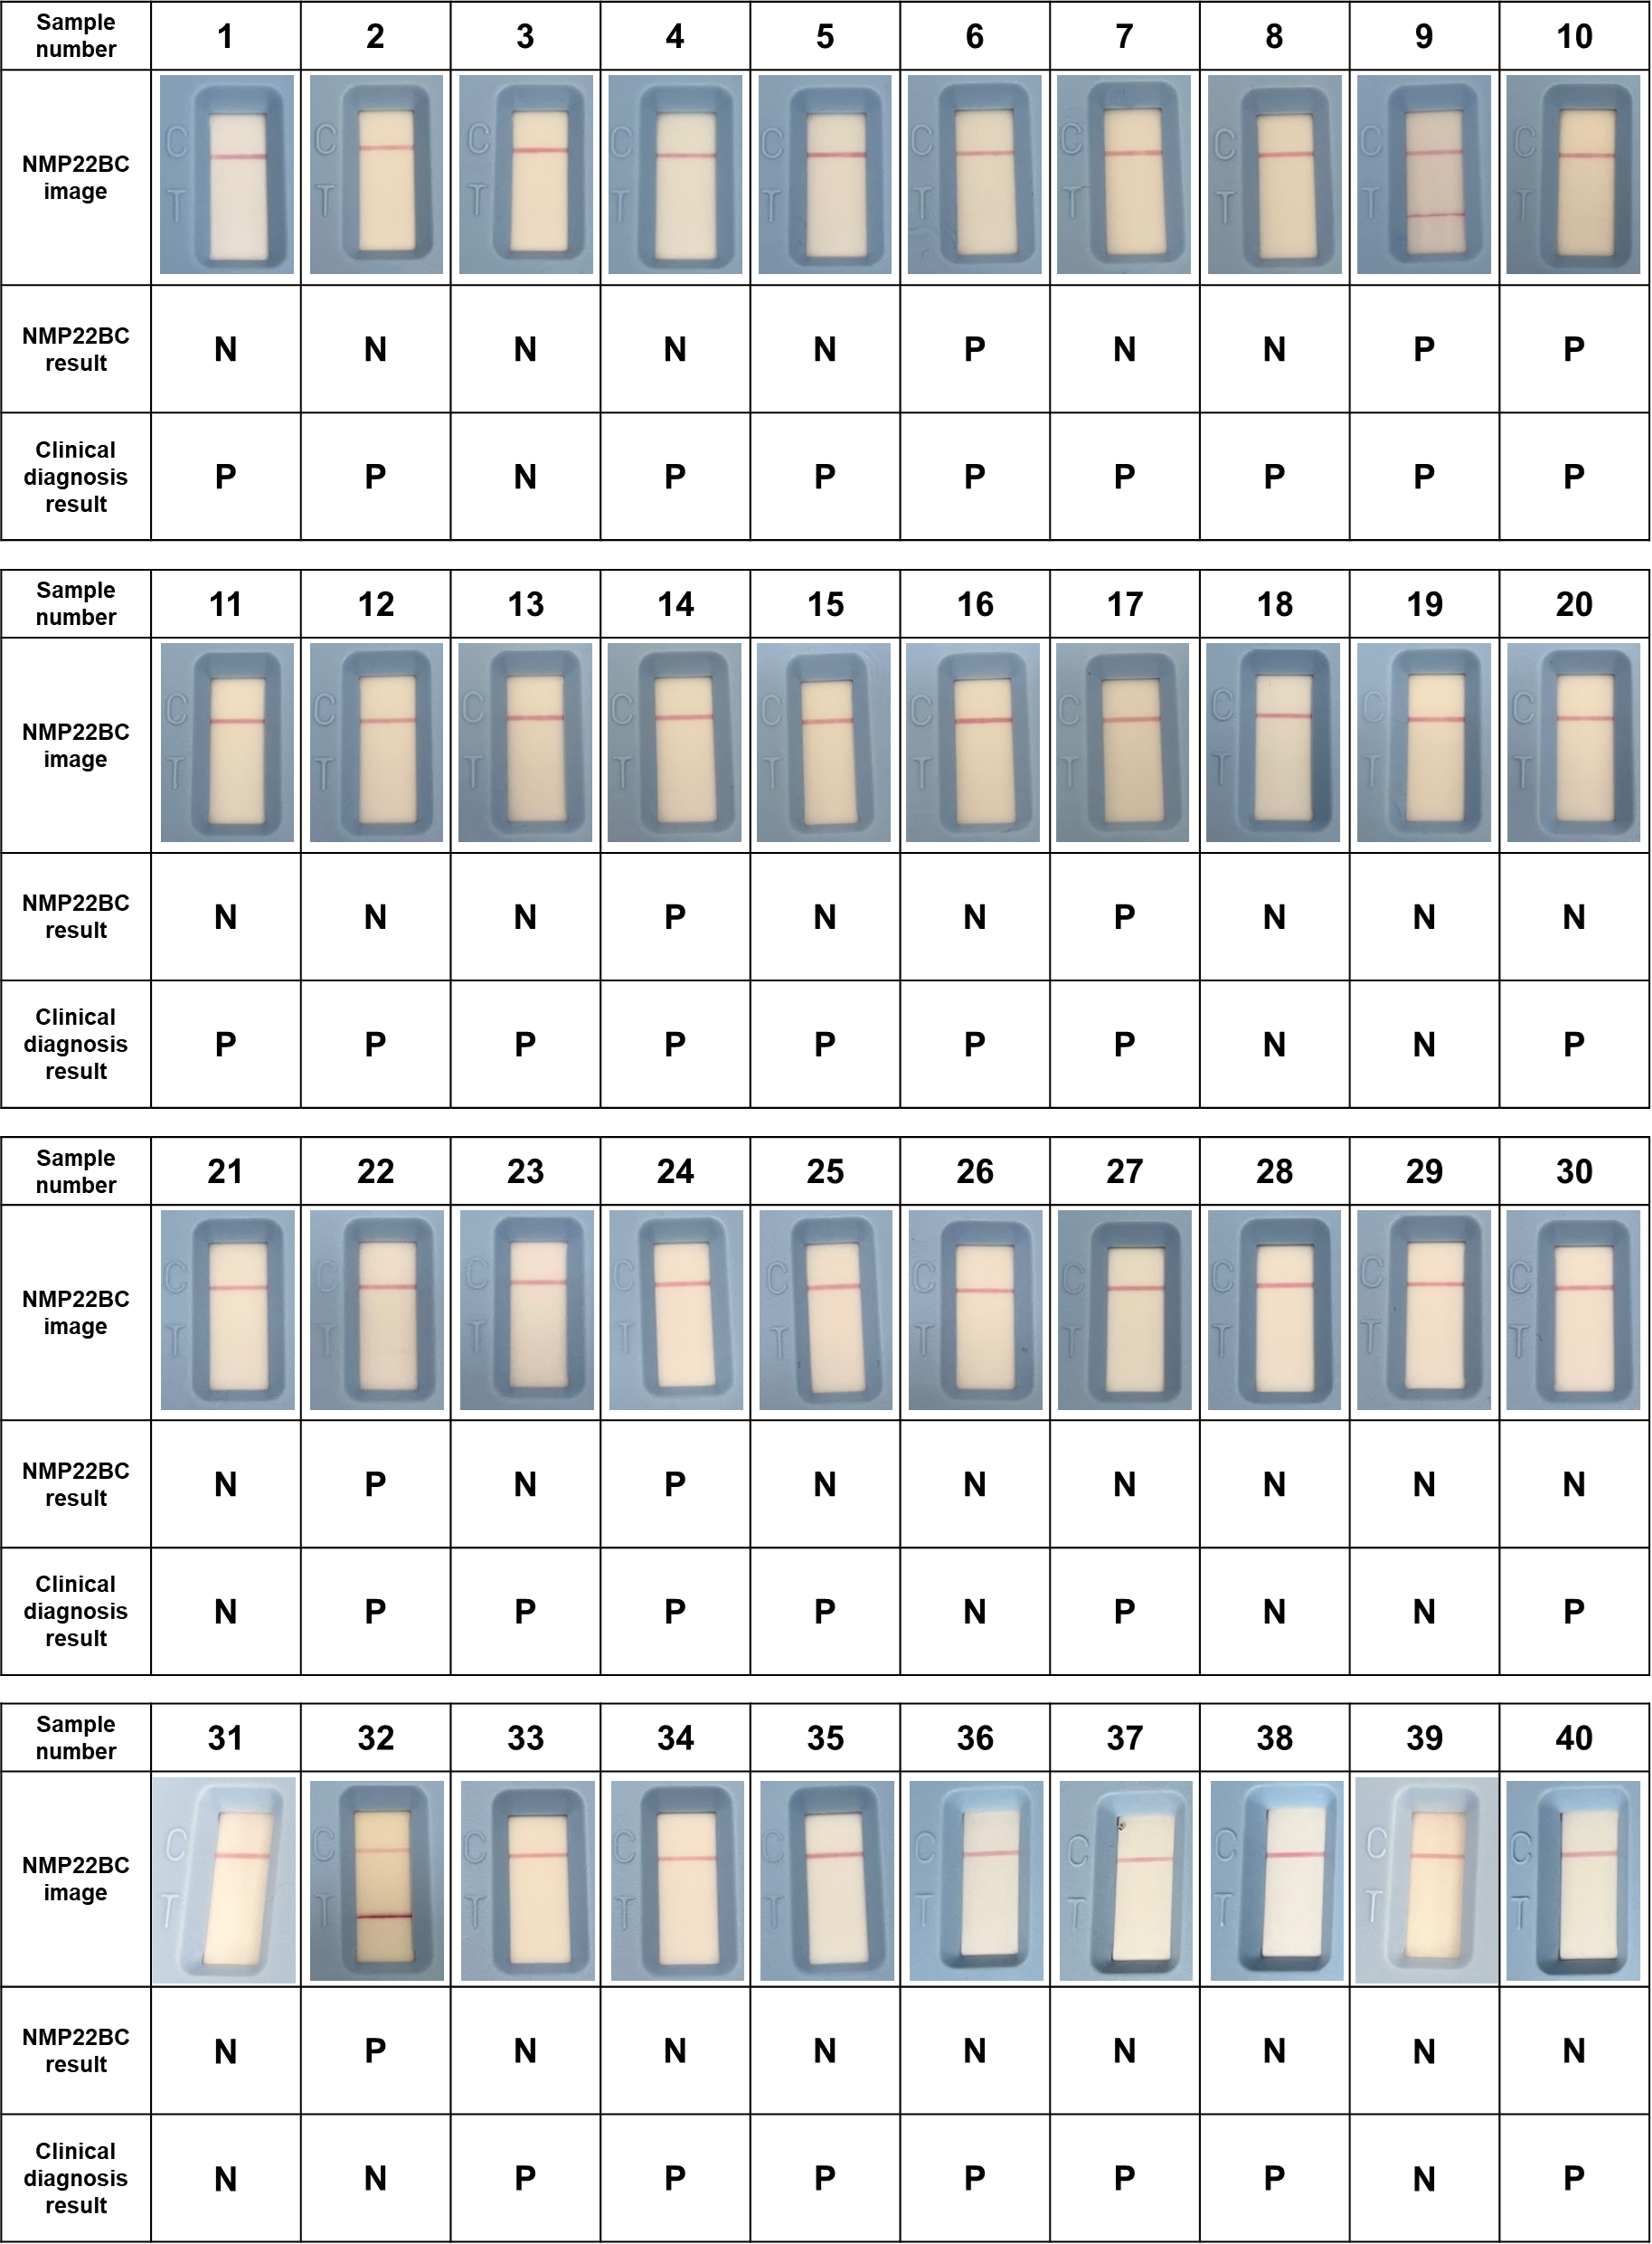
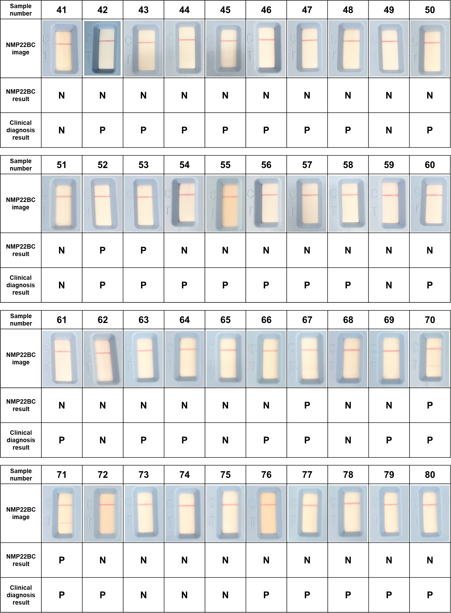
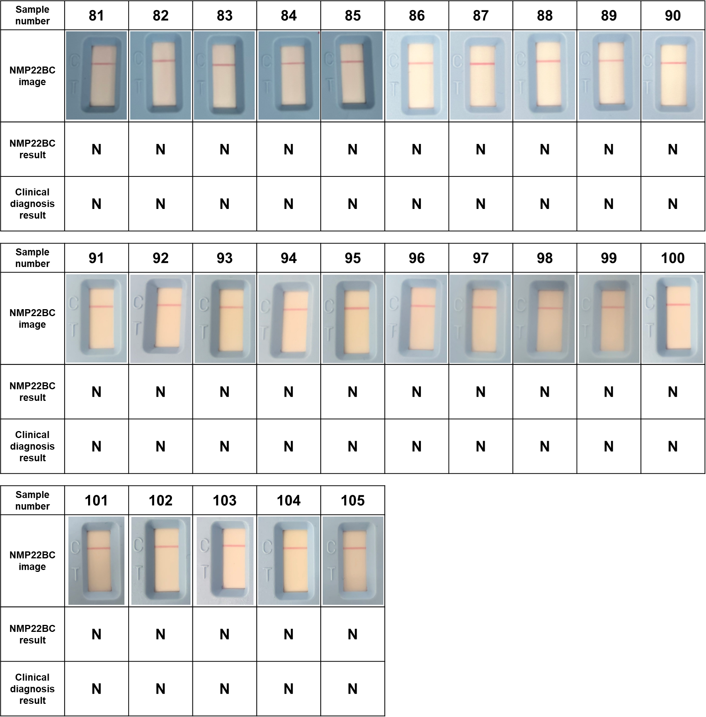
Supplementary Fig. 15. Results of NMP22BC testing using clinical samples. Images of test region of NMP22BC rapid kit using clinical samples with the same patient population of BLOOM assay (P: positive, N: negative). Results were marked as positive when the faint line on the test line could be confirmed with the naked eye.

Supplementary Table 3. Sensitivity and specificity of BLOOM and NMP22BC. The Sensitivity, specificity, accuracy, positive predictive value (PPV), and negative predictive value (NPV) of the BLOOM assay and NMP22BC using the same patient population.
BC
n=105 | Sensitivity | Specificity | Accuracy | PPV | NPV
NMP22BC | 20.0% | 97.8% | 53.3% | 92.3% | 47.8%
BLOOM | 88.3% | 88.9% | 88.6% | 91.4% | 85.1%
NMIBC
n=92 | Sensitivity | Specificity | Accuracy | PPV | NPV
NMP22BC | 23.4% | 97.8% | 59.8% | 91.7% | 55.0%
BLOOM | 87.2% | 88.9% | 88.0% | 89.1% | 87.0%

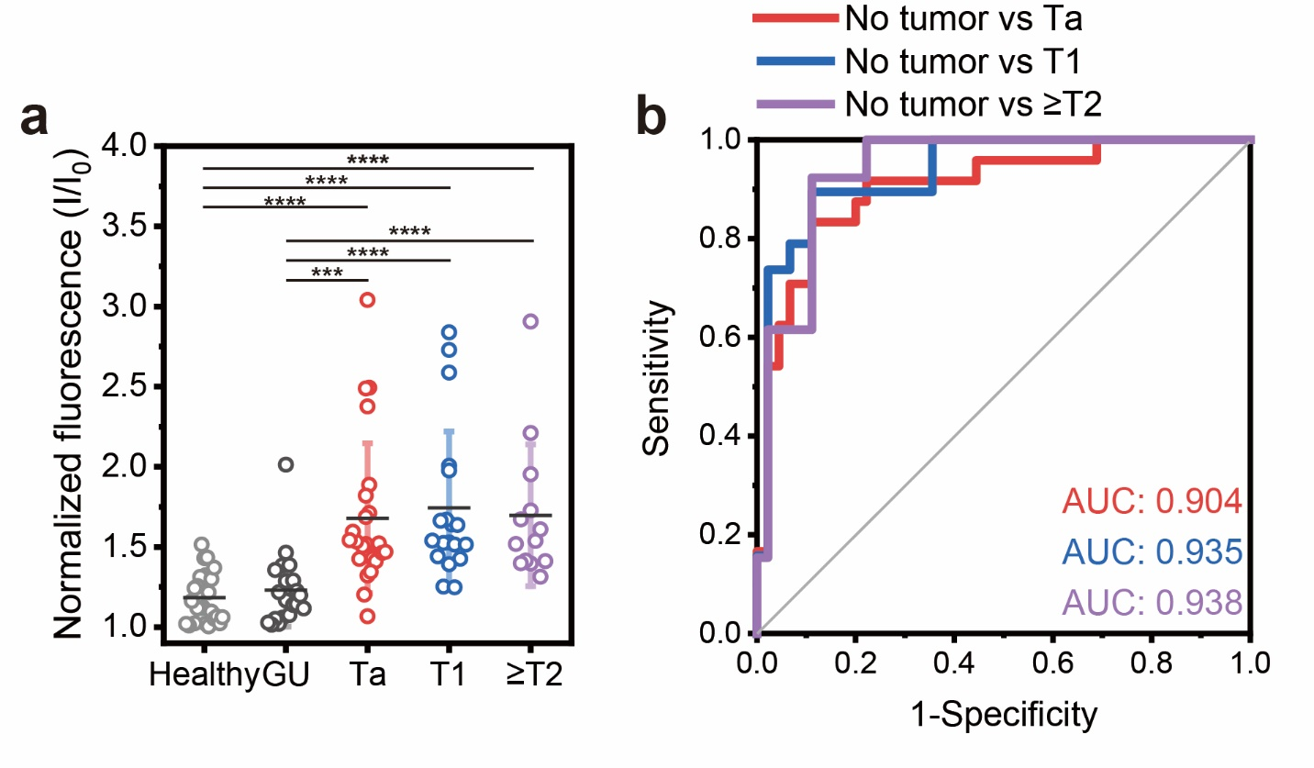
Supplementary Fig. 16. BLOOM results according to the T stage of BC. (a) Normalized fluorescence intensities of urine samples acquired from BLOOM according to the T stage of BC. Two-tailed Student’s t-tests were used for comparisons. ***p<0.001 and ****p<0.0001. (b) ROC curves and AUC values of BC patients against no tumor controls according to the T stage of BC.

Supplementary Table 4. Cost estimate of the BLOOM bigel film
Description | Supplier | Order unit |  | BLOOM assay
Description | Supplier | Quantity | Price (USD) | Quantity | Price (USD)
Nile red | TCI chemicals¹ | 5 g | 636.00 | 0.027 mg | 0.0034
12-hydroxystearic acid | TCI chemicals² | 500 g | 67.00 | 0.364 mg | 0.000049
Oleic acid | Sigma Aldrich³ | 4 L | 189.00 | 0.00275 mL | 0.00013
Hyaluronic acid | Sigma Aldrich⁴ | 10 g | 504.00 | 0.667 mg | 0.034
Glutaraldehyde | TCI chemicals⁵ | 500 mL | 57.00 | 0.0025 mL | 0.00029
Cover glass | Electron Microscopy Sciences⁶ | 1000 ea | 76.00 | 1 ea | 0.076
Estimated total price per bigel film in BLOOM |  |  |  |  | 0.11
¹ https://www.tcichemicals.com/TH/en/p/N0659
² https://www.tcichemicals.com/US/en/p/H0308
³ https://www.sigmaaldrich.com/US/en/product/aldrich/364525
⁴ https://www.sigmaaldrich.com/US/en/product/sigma/53747
⁵ https://www.tcichemicals.com/TH/en/p/G0068
⁶ https://www.emsdiasum.com/marienfeld-superior-cover-glass
Supplementary Table 5. Cost estimate of the BLOOM POC kit (2022-12-15 base)
Description | Supplier | Order unit |  | BLOOM POC kit
Description | Supplier | Quantity | Price (USD) | Quantity | Price (USD)
PLA | Huizhou Qiya Technology Co., Ltd.¹ | 2 kg | 14.74 | 200 g | 1.474
Super Bright Blue 5-mm LED | Adafruit² | 25 ea | 8 | 2 ea | 0.64
220 Ω resistor | Digikey³ | 100 | 3.54 | 1 | 0.035
N-channel MOSFET | Digikey⁴ | 100 | 86.72 | 1 | 0.87
10 kΩ resistor | Digikey⁵ | 100 | 3.54 | 1 | 0.035
Temperature Sensor | Digikey⁶ | 25 | 56.62 | 1 | 2.26
120 kΩ resistor | Digikey⁷ | 100 | 3.54 | 1 | 0.035
Polyimide heater | Alibaba⁸ | 1 | 1.4 | 1 | 1.40
Orange acrylic Sheet | Inventables⁹ | 12 in 24 in | 11.89 | 2 in × 2 in | 0.17
Battery | Alibaba¹⁰ | 1 | 1.2 | 2 | 2.40
Switch | Alibaba¹¹ | 1 | 0.1 | 2 | 0.20
Estimated total price per BLOOM POC kit |  |  |  |  | 9.519
20 mL vial | Cangzhou ShengFeng Plastic Product Co., Ltd., China¹² | 10,000 ea | 3500 | 2 ea | 0.70
Dodecane | Sigma Aldrich¹³ | 1 L | 251.0 | 6 mL | 1.506
Liquid dispenser | Cangzhou ShengFeng Plastic Product Co., Ltd., China¹⁴ | 5000 ea | 100 | 2 ea | 0.04
bigel film in BLOOM | This study | 1 ea | 0.11 | 2 ea | 0.22
Estimated total price per assay using BLOOM POC kit |  |  |  |  | 11.985
¹ https://www.alibaba.com/product-detail/High-Quality-1kg-roll-PLA-ABS_1600405433864.html?spm=a2700.galleryofferlist.normal_offer.d_image.cc0e7ddc09kzVc&s=p
² https://www.adafruit.com/product/301
³ https://www.digikey.kr/en/products/detail/stackpole-electronics-inc/RNMF14FTC220R/2617314?s=N4IgTCBcDaIMpjABgMIEEUBUC0A5AIiALoC%2BQA
⁴ https://www.digikey.kr/en/products/detail/infineon-technologies/IRLB8721PBF/2127670?s=N4IgTCBcDaIJICUAyAhAHAdjARgAooDEBaAOQBEQBdAXyA
⁵ https://www.digikey.kr/en/products/detail/stackpole-electronics-inc/RNMF14FTC10R0/2617280?s=N4IgTCBcDaIMoEYAMBhAgigKgWgHIBEQBdAXyA
⁶ https://www.digikey.kr/en/products/detail/microchip-technology/TC622VAT/418685?s=N4IgTCBcDaICoGEBsYwDUCCcC0A5AIiALoC%2BQA
⁷ https://www.digikey.kr/en/products/detail/stackpole-electronics-inc/RNMF14FTC120K/2617284?s=N4IgTCBcDaIMoEYwAYDSBhAgugKgWgDkAREAXQF8g
⁸ https://www.alibaba.com/product-detail/flexible-heating-film-polyimide-heater_1600162642489.html?spm=a2700.shop_plser.41413.39.47065f998AQYMj
⁹ https://www.inventables.com/technologies/transparent-orange-acrylic-sheet
¹⁰ https://www.alibaba.com/product-detail/Customized-Small-Size-Deep-Cycle-18650_1600448264265.html?spm=a2700.galleryofferlist.normal_offer.d_image.3c0631daVqjJ7I
¹¹ https://www.alibaba.com/product-detail/2-Pins-2-Position-15-21mm_1600357474628.html?spm=a2700.galleryofferlist.normal_offer.d_image.19a1570cnDybqP
¹² https://www.alibaba.com/product-detail/20-ml-clear-glass-tubular-vials_1600303354629.html?spm=a2700.galleryofferlist.normal_offer.d_image.5a826997kzh6Qc
¹³ https://www.sigmaaldrich.com/US/en/product/mm/820543
¹⁴ https://www.alibaba.com/product-detail/High-quality-disposable-plastic-dropper-graduated_60829828899.html?spm=a2700.wholesale.0.0.40403ad2cmW0wI

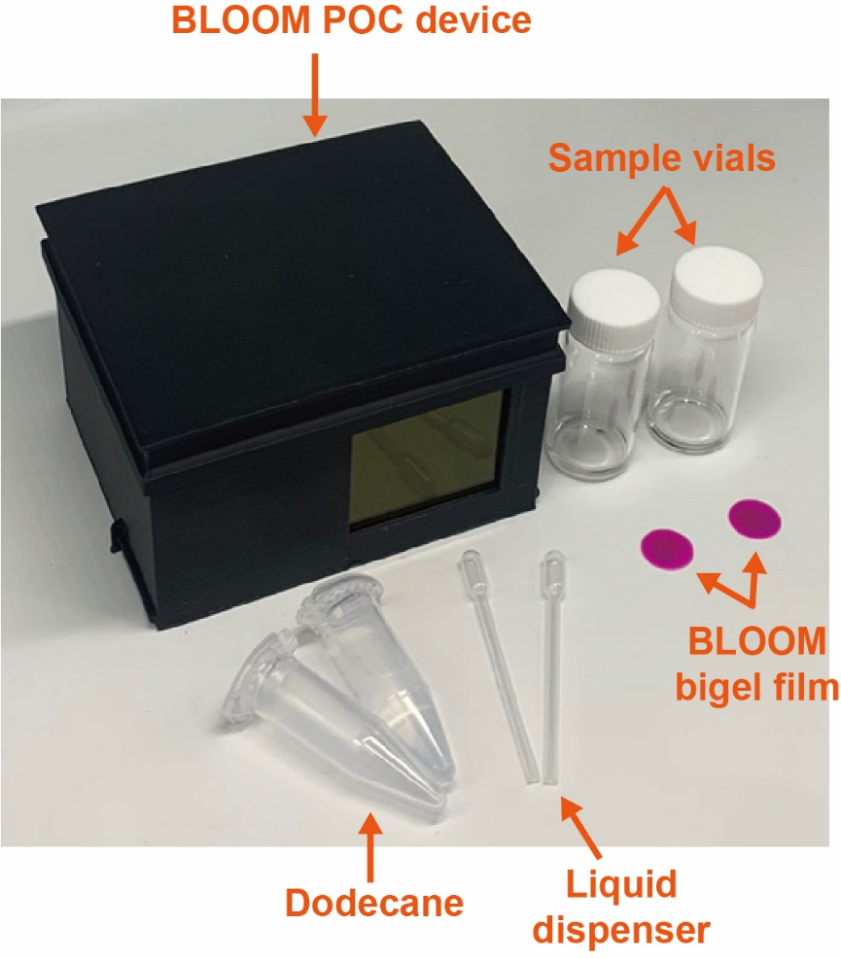
Supplementary Fig. 17. Components of the BLOOM POC test. The BLOOM POC test consists of the BLOOM POD device, sample vials, BLOOM bigel films, liquid dispenser, and dodecane.

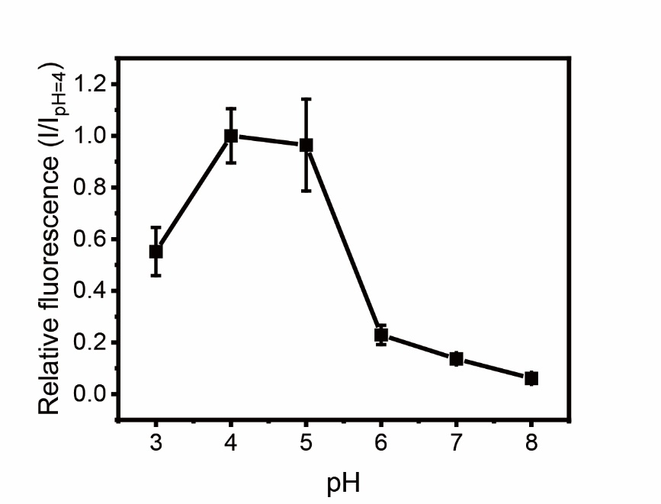
Supplementary Fig. 18. pH-dependent fluorescence intensity of the BLOOM assay. pH-dependent fluorescence intensity of the BLOOM assay using clinical samples acquired from BC patients. Urine samples from BC patients were used after dilution with reaction buffer (1:1, acetate buffer for pH 3–5, phosphate buffer for pH 6–8).

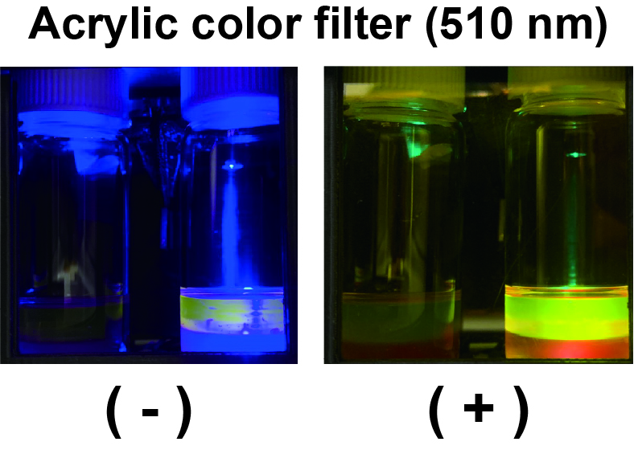
Supplementary Fig. 19. Acrylic color filter for transillumination. Effect of acrylic orange color filter for fluorescence readout to eliminate disturbance from blue LEDs (left: without acrylic color filter and right: without acrylic color filter).

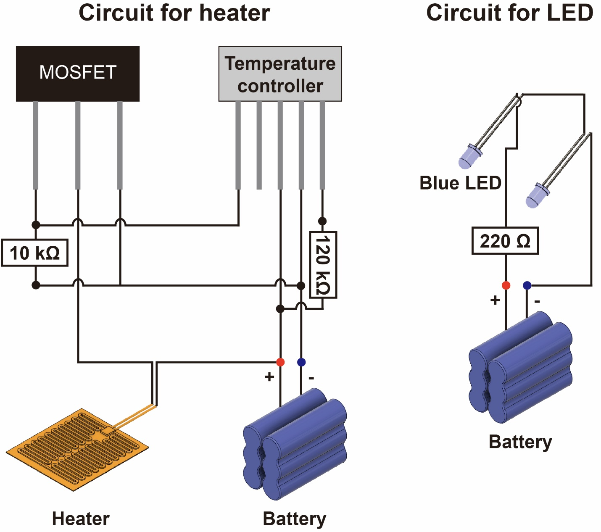
Supplementary Fig. 20. Circuit diagrams for the temperature controller and LEDs. Circuit diagram of the temperature controller containing a polyimide heater and battery, and diagram of the blue LEDs equipped with batteries.
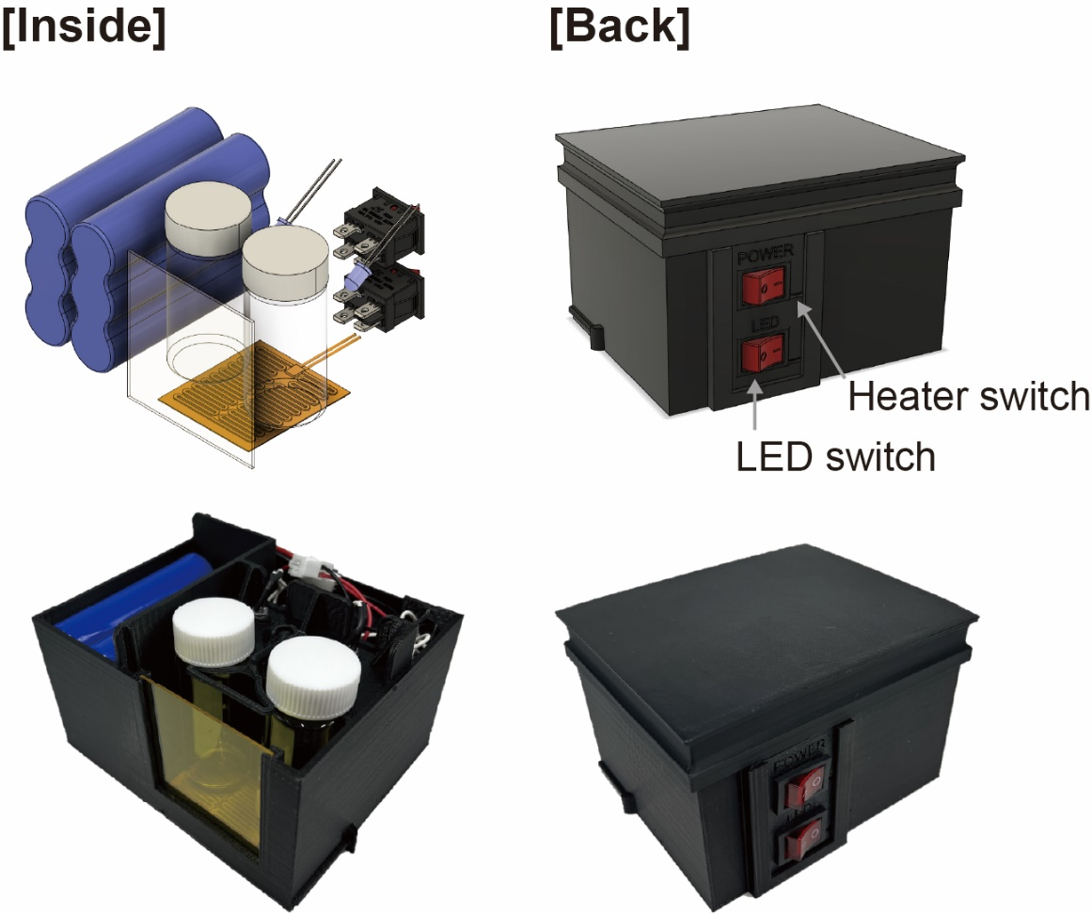
Supplementary Fig. 21. Placement of components in the BLOOM POC device. Designed images and photographs of the BLOOM POC kit showing the placement of components (left: inside of the device and right: back of the device).
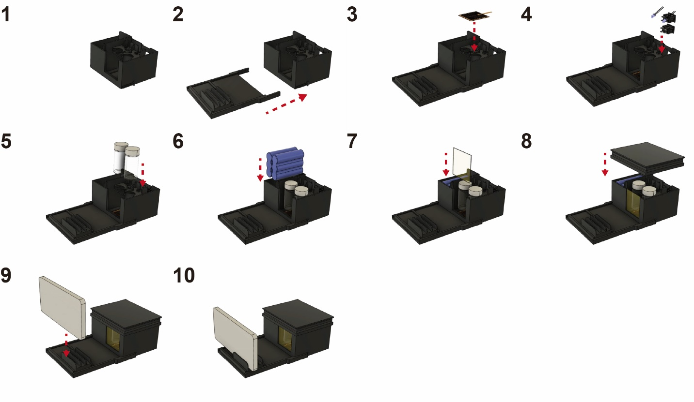
Supplementary Fig. 22. Assembly method and order of the POC device. Method of assembling all components for the BLOOM POC device containing a detachable smartphone holder and smartphone.

Supplementary Videos

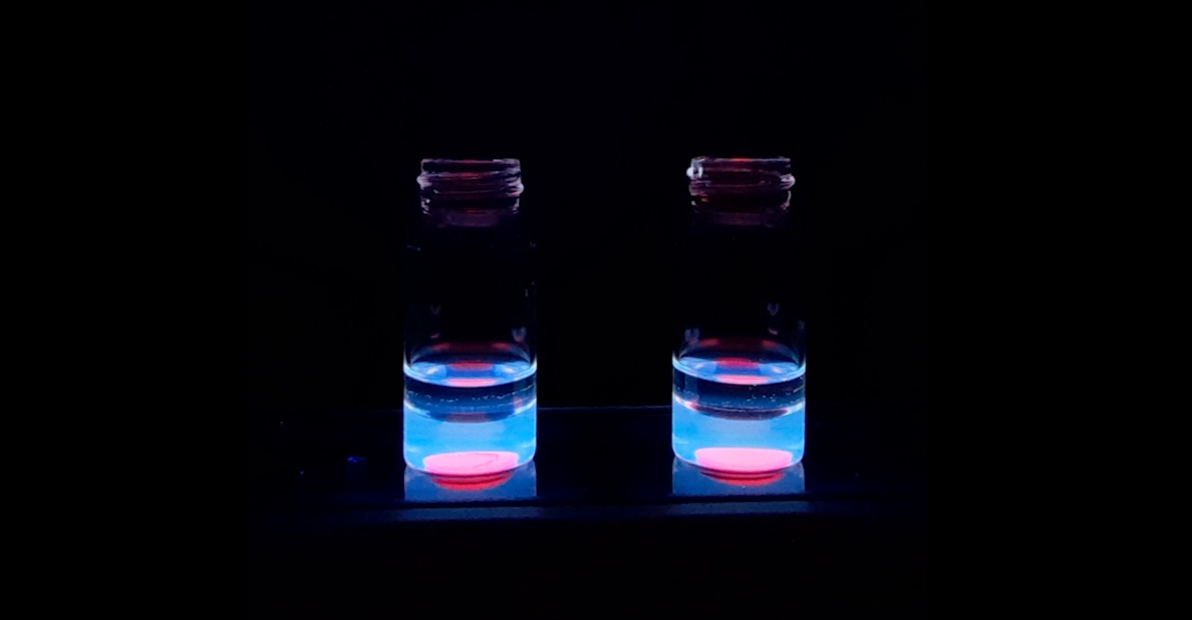
Supplementary Video 1. BLOOM in a biphasic system. Hdase-responsive bigel films are placed at the bottom of a glass vial. The biphasic system consists of a dodecane layer on the upper side and normal pooled urine (NPU) on the bottom (left: control; right: 1 U/mL of Hdase).

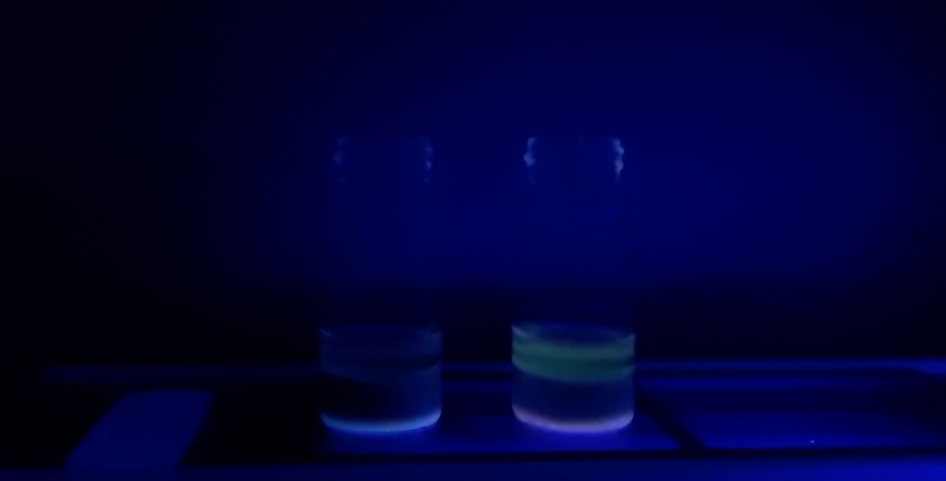
Supplementary Video 2. BLOOM in a biphasic system using artificial hematuria samples. Hdase-responsive bigel films are placed at the bottom of the vial. The biphasic system consists of a dodecane layer on the upper side and artificial hematuria sample (1250 RBCs/HPF) on the bottom (left: control; right: 1 U/mL of Hdase).

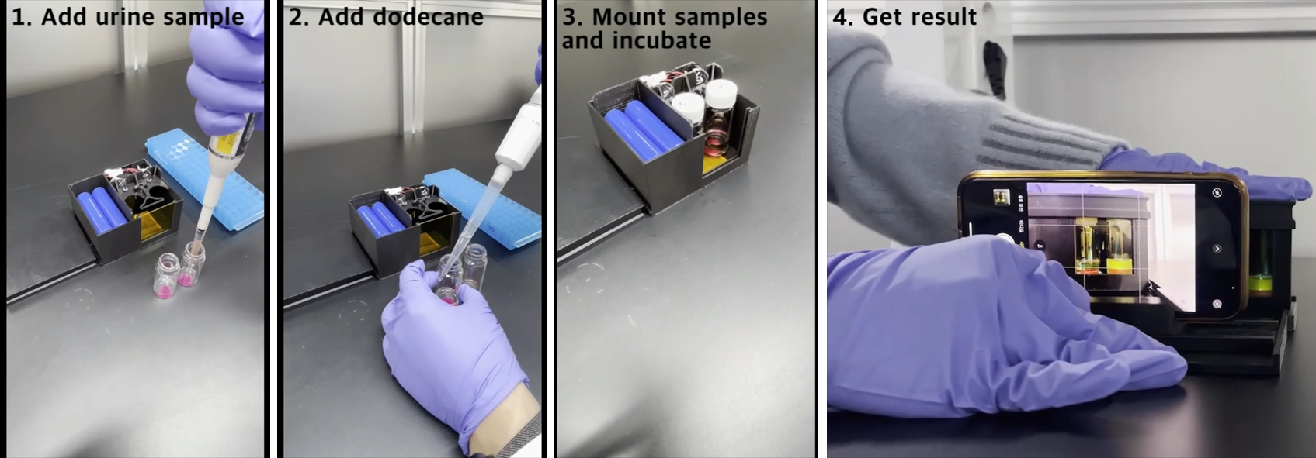 Supplementary Video 3. Clinical sample test procedure using the BLOOM POC device. BLOOM assay procedure for point-of-care testing of bladder cancer patients’ clinical samples.

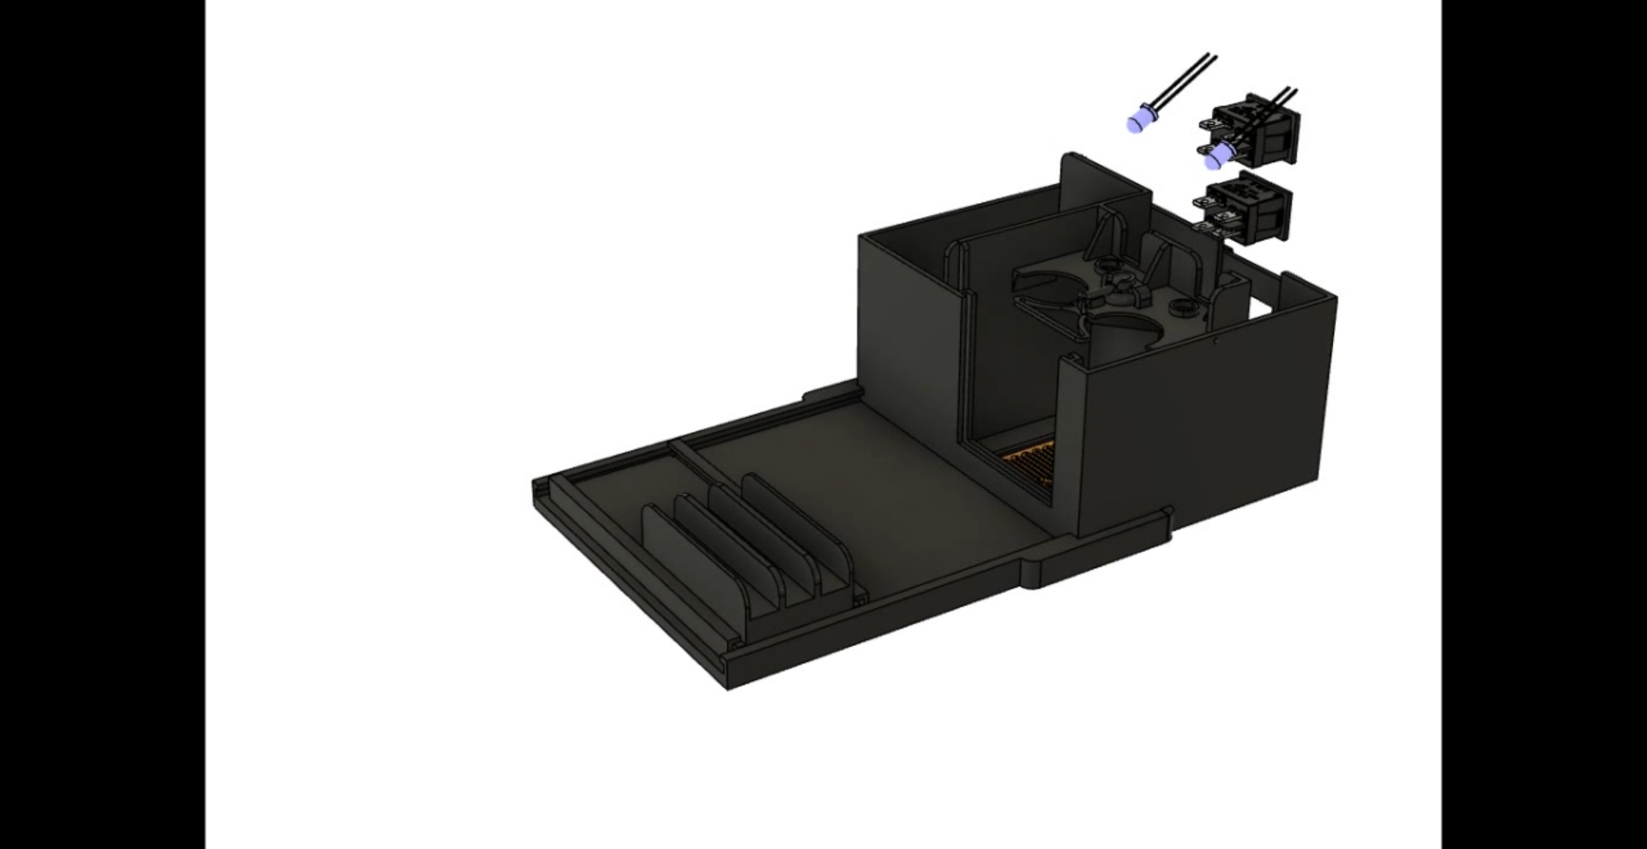
Supplementary Video 4. Assembly of the BLOOM POC device. Assembly and placement of the components and electronic circuits in the POC device.

