ADDITIONAL FILE 1
Supplementary information for

Targeting FGFRs by pemigatinib induces G1 phase cell cycle arrest, cellular stress and upregulation of tumor suppressor miRNAs
Angelica Pace¹*, Fabio Scirocchi¹*, Chiara Napoletano^{1@}, Ilaria Grazia Zizzari¹, Agnese Po², Francesca Megiorni¹, Angela Asquino¹, Paola Pontecorvi¹, Hassan Rahimi¹, Cinzia Marchese¹, Elisabetta Ferretti¹, Marianna Nuti¹, Aurelia Rughetti¹
@corresponding: chiara.napoletano@uniroma1.it

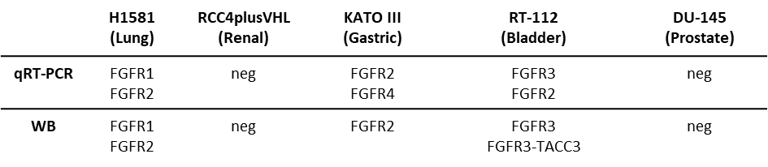
TABLE S1. FGFR expression in cancer cell lines.
FGFR expression was evaluated by Western blots and q-RT‒PCR experiments in H1581, KATO III, RT-112, RCC4plusVHL and DU-145 cancer cell lines employed as cell models of lung, gastric, bladder, renal and prostate cancer, respectively.

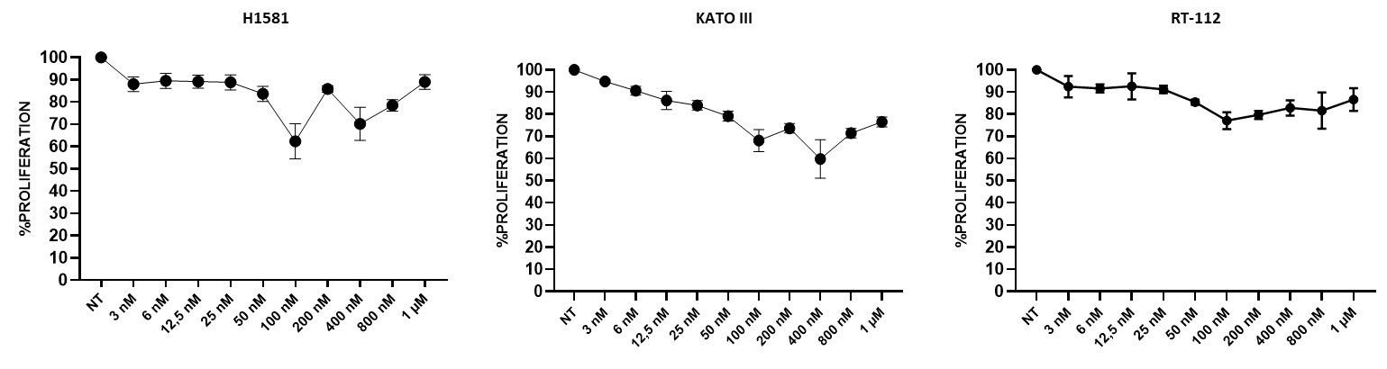
Figure S1. Serial dilution of pemigatinib and MTT proliferation assay. For selection of the optimal drug concentration, H1581, KATO III and RT-112 cells were exposed to serial dilutions of pemigatinib (3-1000 nM) for 24 h, and MTT proliferation assay was then performed. Data are reported as the mean of three independent experiments ± SEM as variability.

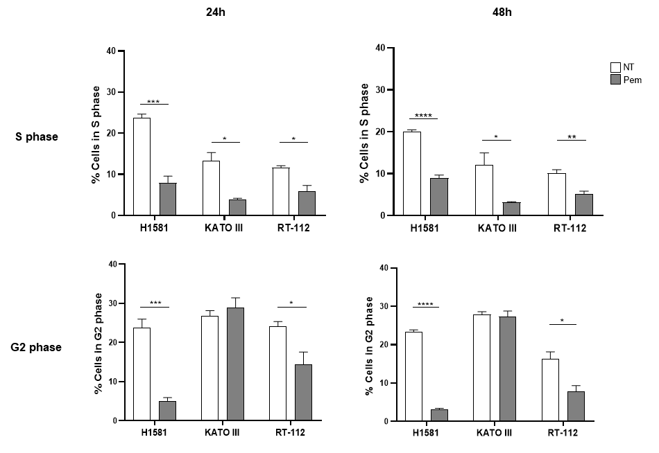
Figure S2. Effect of pemigatinib on the S and G2 phases of cell cycle. The histograms represent the count of PI-positive cells found in S- and G2-phase in untreated (NT, white) and pemigatinib-treated (100 nM, grey) H1581, KATO III and RT-112 cells and are represented as mean of three independent experiments ± SEM. *, p<0,05; **, p< 0,01; ***, p≤ 0,001. Student’s t test.
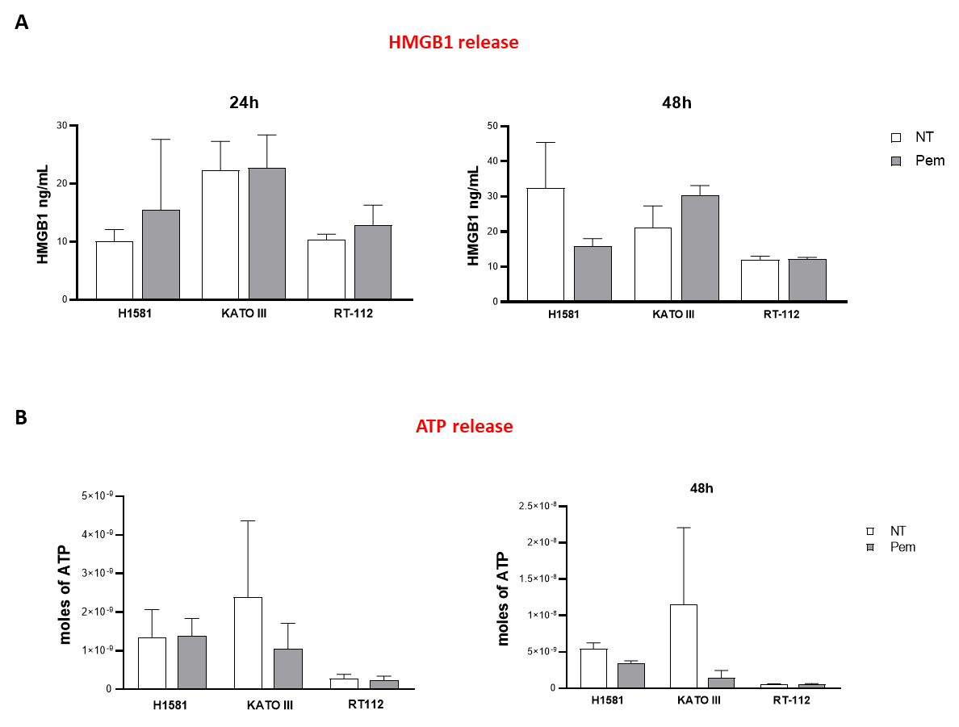

Figure S3. Effect of pemigatinib on ATP and HMGB1 release. A) Extracellular HMGB1 release upon pemigatinib treatment. The extracellular HMGB1 release was measured by means of an enzyme-linked immunosorbent assay (ELISA) kit (TECAN, Zürich, Switzerland), according to the manufacturer’s protocol. Histograms represent the mean values of three independent experiments ± SEM of HMGB1 released by untreated cells (NT, white) and pemigatinib-treated cells (Pem, grey) at 24 and 48 h. B) Extracellular ATP release upon pemigatinib treatment. The ATP release was measured by ENLITEN-Promega KIT as luminescence signals. The histograms represent the mean value of ATP moles of three independent experiments ± SEM by untreated cells (NT, white) and pemigatinib-treated cells (Pem, grey) at 24 and 48 h.

