Extended Data Figures
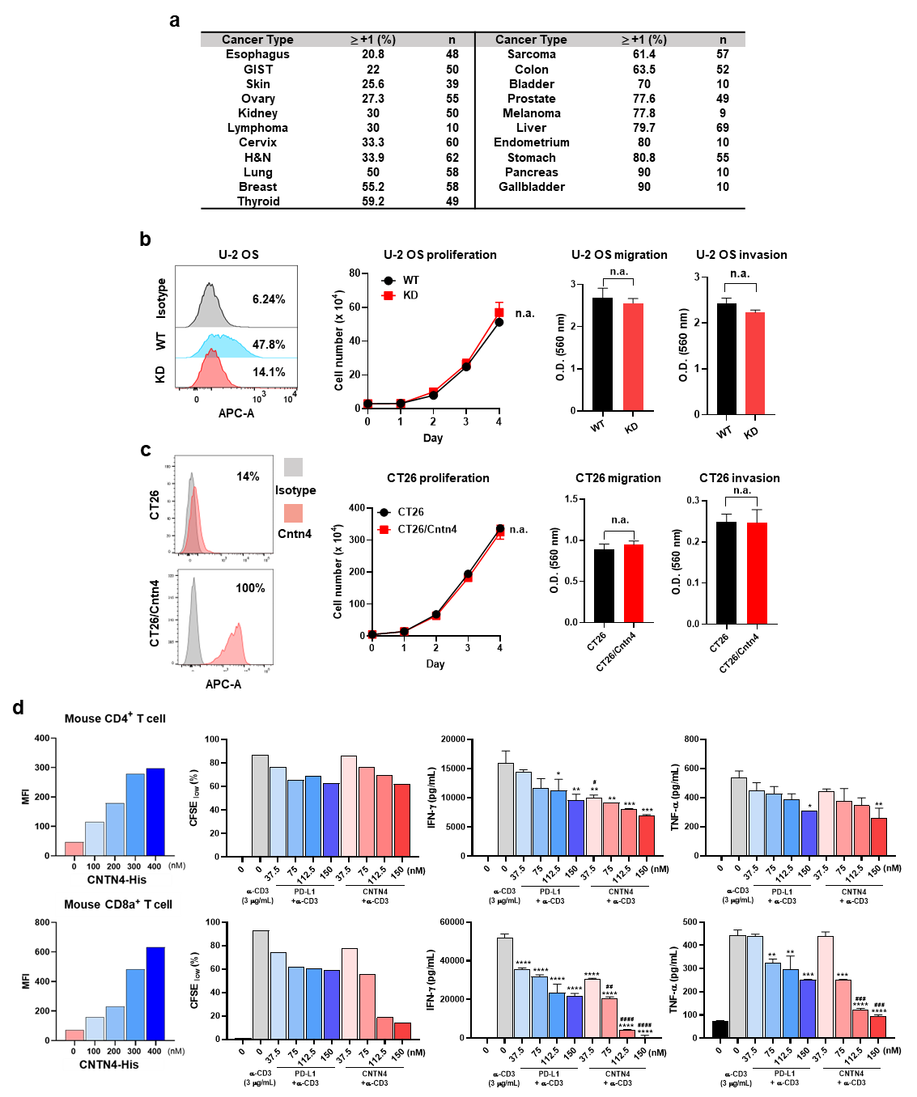
Extended Data Fig. 1. Cancerous characteristics and T-cell inhibition effects depending on CNTN4 expression levels. a, CNTN4 IHC staining of human cancer tissues using validated antibody for IHC. Seventeen TMA slides containing approximately 900 human tumors. The rate of samples with a CNTN4 IHC score of +1 or higher in the tested samples for each human cancer type. Sample size for each human cancer type. b, c, Surface expression of CNTN4 in U-2 OS or CT26 cells. Cancer cells were stained with APC-isotype control IgG or APC-anti CNTN4. The expression pattern of CNTN4 was determined in both cancer cell lines by flow cytometry. Ability of proliferation in each clone of cancer cells was analyzed by cell counting. Cells were counted for 4 days after seeding. Cells were seeded at 2 × 10⁵ cells/well and allowed to migrate and invade toward FBS containing media for 40 h or 18 h. Migratory cells on the bottom of trans-well were stained and quantified at O.D. 560 nM after extraction. Invaded cells on the bottom of invasion chamber were stained and quantified at O.D. 560 nM after extraction. d, CD4⁺ and CD8a⁺ T-cells were isolated from mouse spleen. For T cell binding of recombinant proteins, T-cells were activated with anti-Cd3/28 antibodies (2 μg/mL, respectively) for 2 days with rIL-2. Cntn4 protein (His tagged) were treated in a dose-dependent manner and FITC conjugated His antibody were sequentially treated. Then, the Cntn4 binding was determined by flow cytometry. MFI values are presented as bar graphs. For T-cell proliferation by recombinant proteins, T-cells stained with CFSE were incubated on an anti-Cd3 antibody (3 μg/mL) pre-coated plate with Cntn4 or Pd-l1 recombinant protein (37.5 ~ 150 nM) for 72 h. T-cell proliferation was analyzed by FACS, and cytokine secretion (Ifn-γ and Tnf-α) was analyzed by ELISA using culture supernatant. One-way analysis of variance (ANOVA) was employed on data, then if significant, statistical significance was determined by Tukey’s multiple tests. Compared to anti-CD3 only *, p < 0.05; **, p < 0.01; ***, p < 0.005; ****, p < 0.001 and compared to the same concentration of Pd-l1 #, p < 0.05; ##, p < 0.01; ###, p < 0.005; ####, p < 0.001

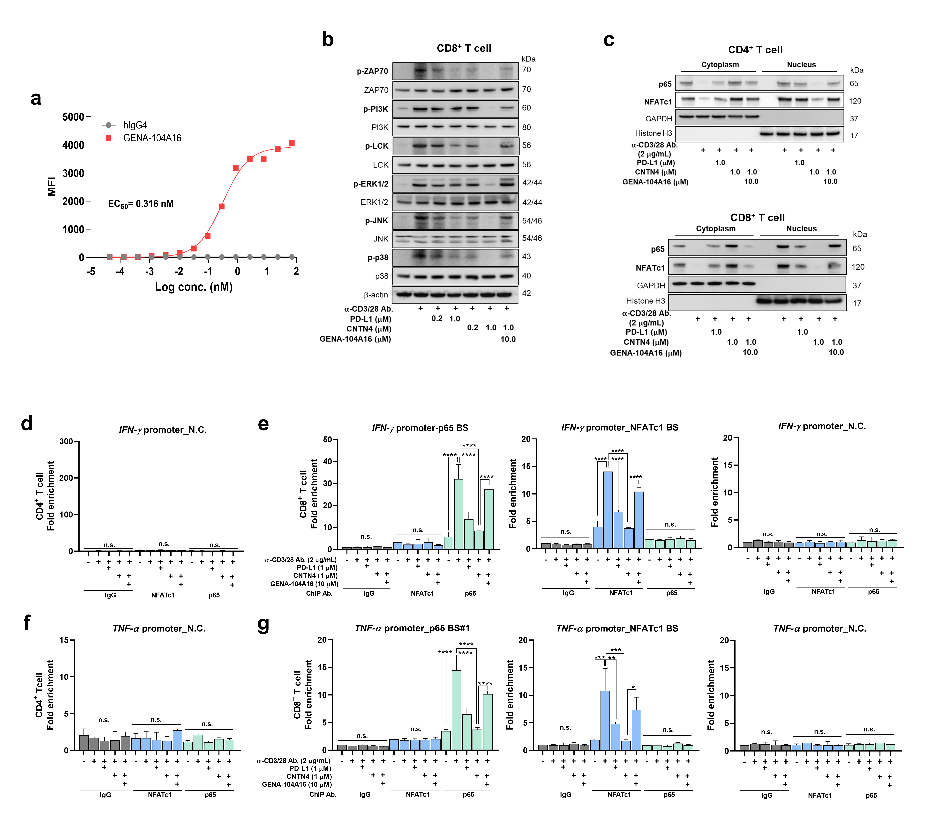
Extended Data Fig. 2. Neutralization of human T cell suppression by CNTN4 through GENA-104A16 treatment. a, The cellular binding affinity of GENA-104A16 on HEK293 overexpressing human CNTN4 was determined by flow cytometry. EC₅₀ value was determined with nonlinear four-parameter logistic curve using GraphPad PRISM. b, GENA-104A16 (10.0 μM) were treated on anti-CD3/28 antibodies (2 μg/mL, respectively) pre-coated plate with CNTN4 or PD-L1 recombinant protein (0.2 or 1.0 μM). After activating human clonal expansion of CD8⁺ T-cells with prepared plate for 30 min, the expression of the phospho-form of the T-cell activation signaling pathway-related proteins was confirmed by western blotting. c, The above cells in (b) were further incubated for 6 h, the translocation of transcription factors related to T cell activation from the cytoplasm to the nucleus was confirmed through fractionation and western blotting. d~g, The above cells in (b) were further incubated for 12 h, the binding of p65 or NFATc1 to the IFN-γ (e) or TNF-α (g) gene promoter was confirmed through ChIP and qRT-PCR. IgG and negative control region (d, f) were used a negative control of the antibody and the primer, respectively. Statistical analysis was performed using GraphPad PRISM. One-way analysis of variance (ANOVA) was employed on data, then if significant, statistical significance was determined by tukey’s multiple tests. *, p < 0.05; **, p < 0.01; ***, p < 0.005; ****, p < 0.001; n.s., not significant.

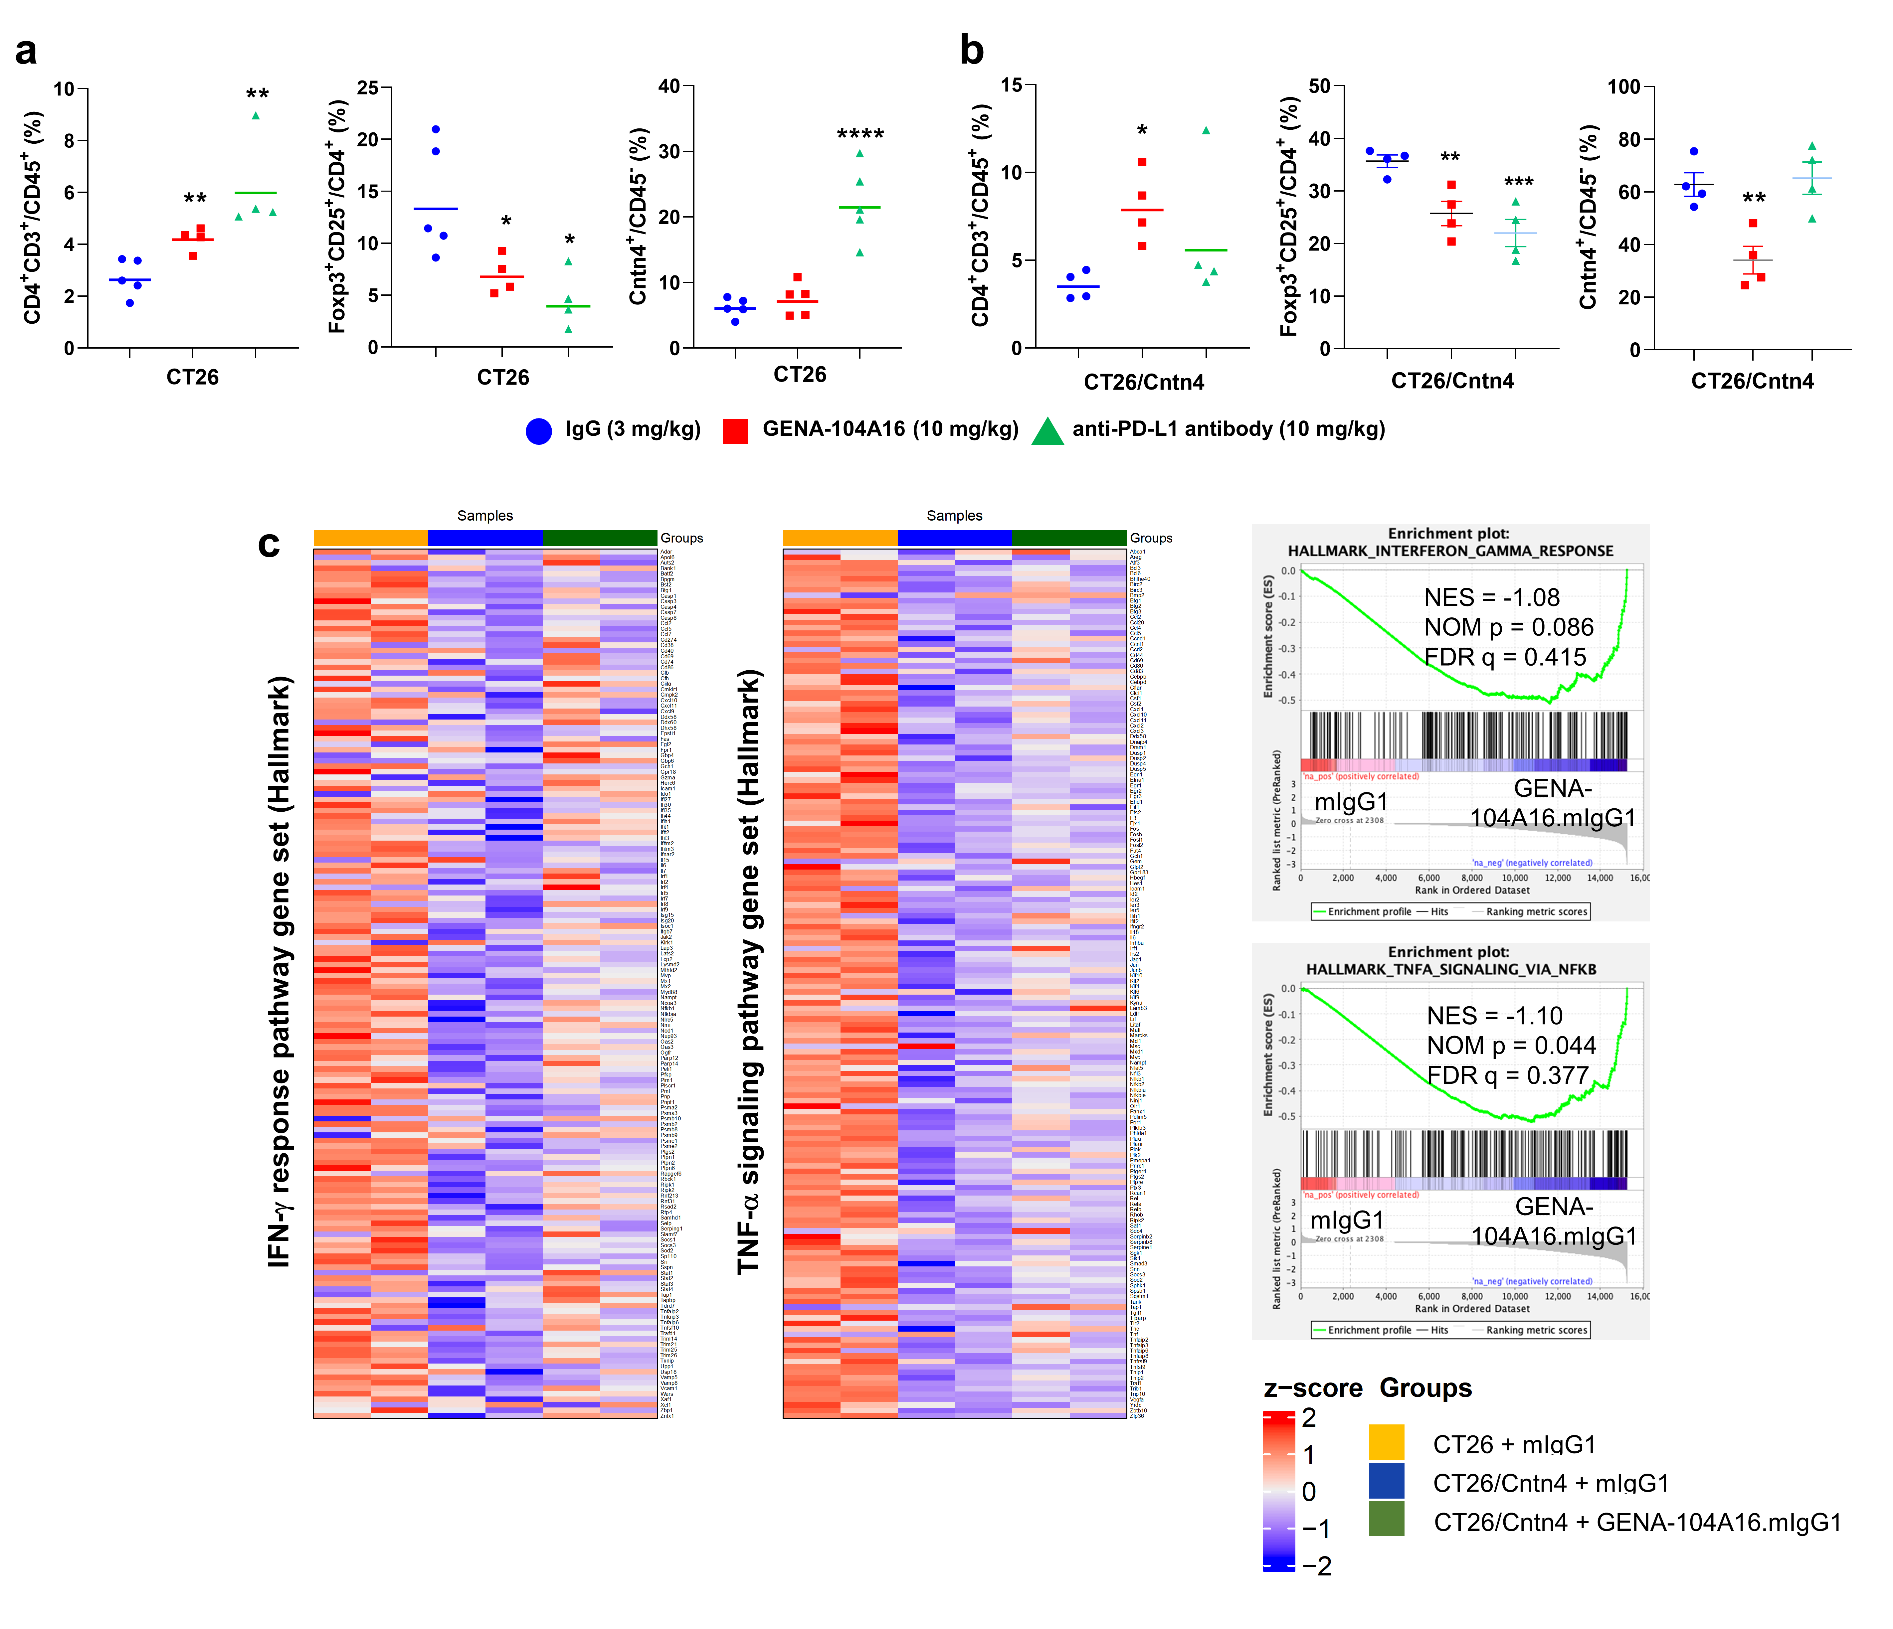
Extended Data Fig. 3. Increased immune cell populations and immune-related pathways by GENA-104A16 treatment. a, b, Changes in immune cell ratio in tumor tissues after GENA-104A16 treatment. Flow cytometric analyzes to determine the percentages of CD4⁺ T-cells, Foxp3⁺ T-cells, or Cntn4 expressing cells among viable cells after enzymatic dissociation of tumors. c, GSEA and heatmap from CT26 and CT26/Cntn4 tumors transcriptome treated with IgG or GENA-104A16. BALB/c mice were subcutaneously injected with 1 × 10⁶ CT26 or CT26/Cntn4 cells per mouse, respectively. Two intraperitoneal (i.p.) injections of IgG or GEN-104A16 (1 mg/kg) were administered at 3-day intervals to treat cancer cells once they had reached a size of 100 mm³. The tumor tissues were extracted 2 days after twice administration of antibody, total RNA was isolated, and transcriptomic analysis was performed. Left panel: GSEA for Hallmark database. Right panel: Heatmap of expression of genes related to each pathway. Statistical analysis was performed using GraphPad PRISM. One-way analysis of variance (ANOVA) was employed on data, then if significant, statistical significance was determined by Tukey’s multiple tests. Compared to WT cells n.s., not significant
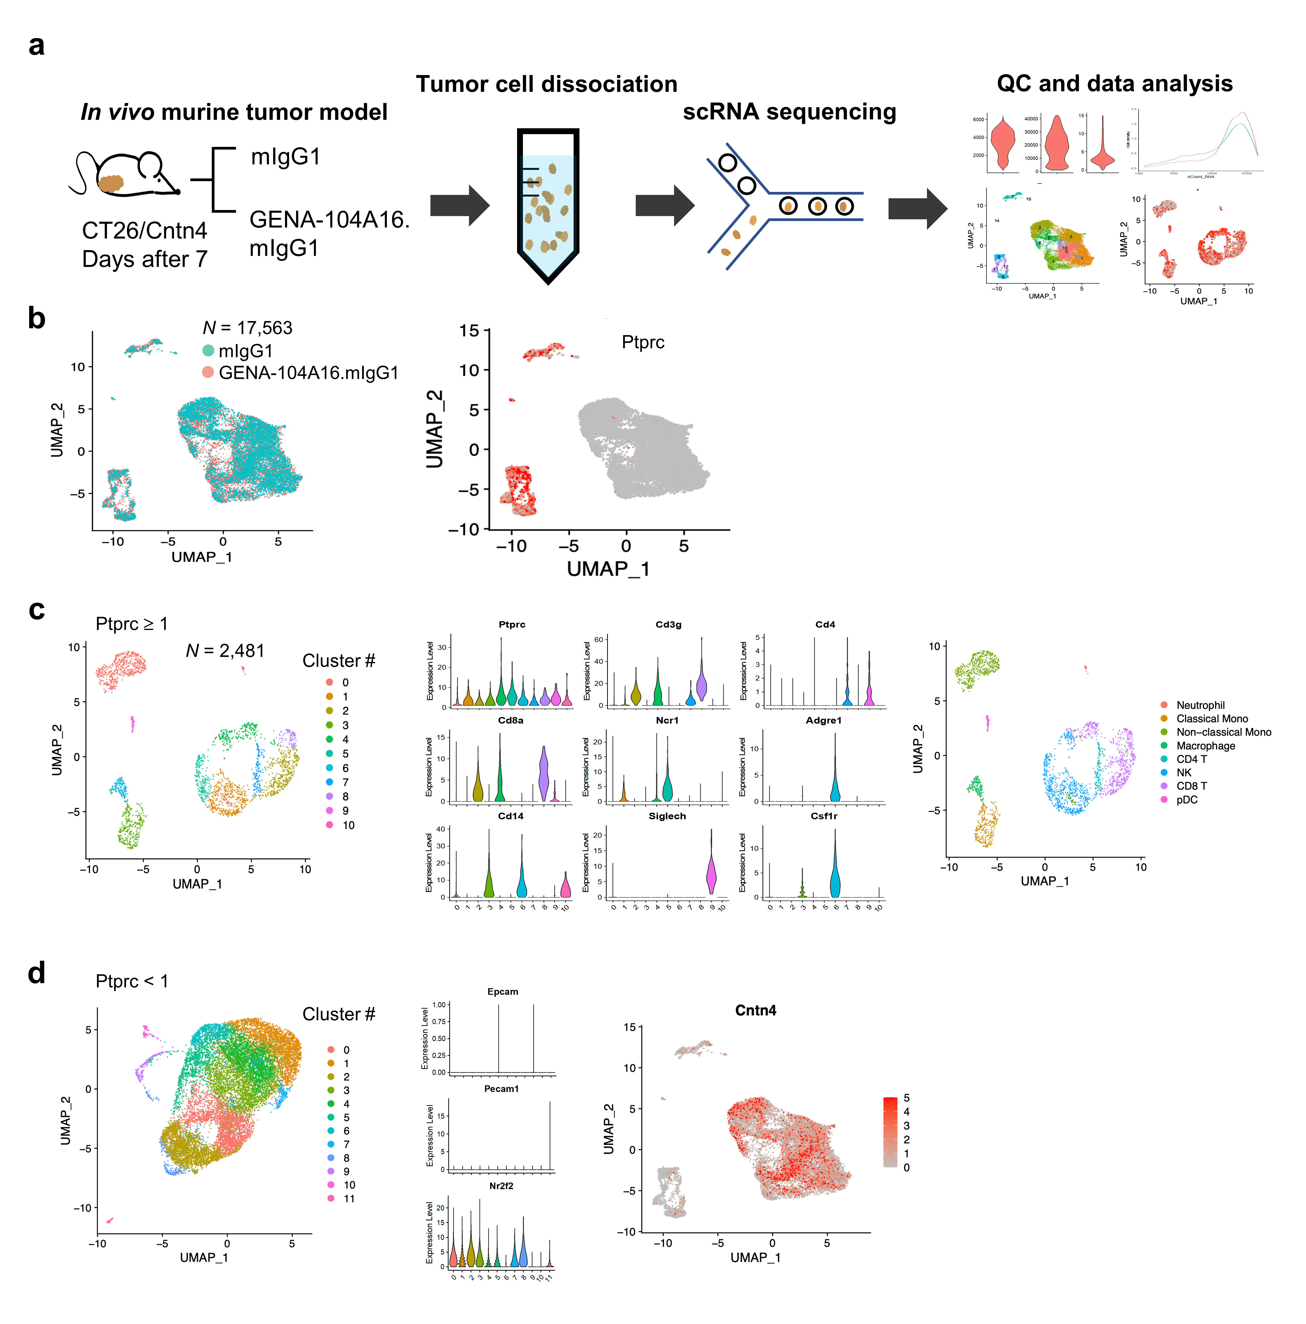
Extended Data Fig. 4. Single cell RNA sequencing and analysis identifies tumor-infiltrated immune cells and tumor cells. a, A schematic overview of experimental design. b, UMAP shows the cluster of all cells after integration by treatment type (mIgG1 vs GENA-104A16.mIgG1) (left). Expression of lymphocyte marker, Ptprc (Cd45) (right). c, UMAP plot of re-sorting and re-clustering cells which express Ptprc ≥ 1 (left). Violin plot shows the expression of canonical lymphocyte markers among each cluster from left panel (middle). UMAP plot of classified immune cell clusters (right). d, UMAP of re-sorting and re-clustering cells which express Ptptrc < 1 (left). Violin plot shows the expression of Pecam, Epcam and Nr2f2 for endotheial, epithelial, and fibroblast markers respectively (middle). Expression of Cd274 (PD-L1) and Cntn4 in CT26/Cntn4 tumor (right).

Extended Data Fig. 5. App KO T-cells are less responsive to recombinant CNTN4 than App WT T-cells. a, Human clonal expansion CD4⁺ and CD8⁺ T-cells were stimulated with anti-CD3 antibody (2 μg/mL). APP expression was analyzed by FACS. b, Primer design and genotyping for App KO mice. c, After activating App WT or KO mouse clonal expansion CD4⁺ or CD8a⁺ T-cells with anti-CD3/28 antibodies (2 μg/mL, respectively) pre-coated plate with PD-L1 or CNTN4 recombinant protein (0.2 μM) for 30 min, the expression of the phospho-form of the T-cell activation signaling pathway-related proteins was confirmed by western blotting. d, The above cells in (c) were further incubated for 6 h, the translocation of transcription factors related to T cell activation from the cytoplasm to the nucleus was confirmed through fractionation and western blotting. e, f, The above cells in (c) were further incubated for 12 h, the binding of p65 or Nfatc1 to the Ifn-γ (e) or Tnf-α (f) gene promoter was confirmed through ChIP and qRT-PCR. g, Jurkat-LuciaTM NFAT cells were transiently transfected with APP or APPΔICD expression plasmid. APP expression was analyzed by FACS. Statistical analysis was performed using GraphPad PRISM. One-way analysis of variance (ANOVA) was employed on data, then if significant, statistical significance was determined by Tukey’s multiple tests. Compared to anti-CD3 only *, p < 0.05; **, p < 0.01; ***, p < 0.005; ****, p < 0.001; n.s., not significant

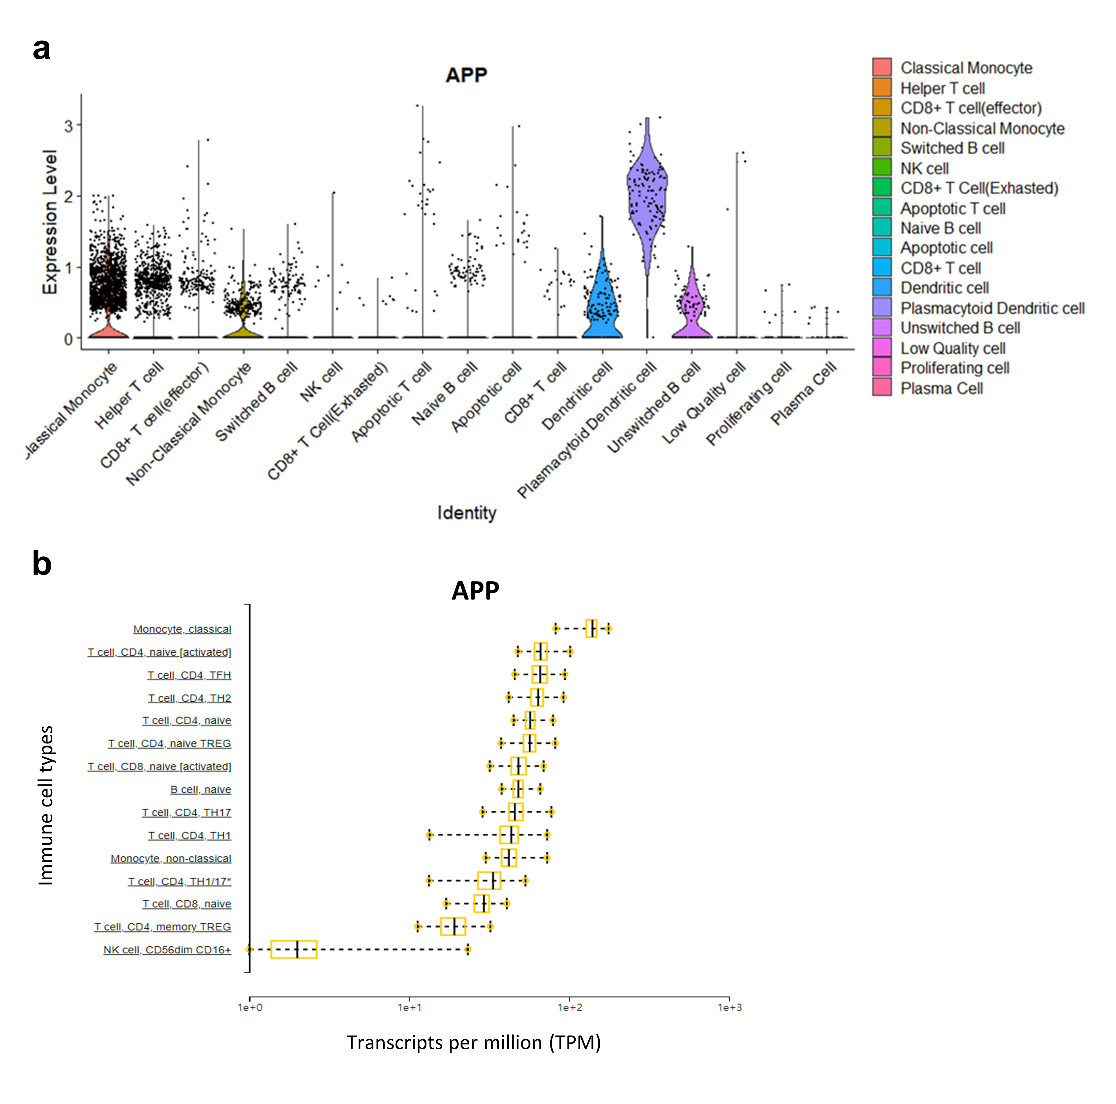
Extended Data Fig. 6. Expression of APP on immune cell subtypes. a, After isolation of PBMC from the blood of healthy donor, single cell analysis was performed through RNA-seq. APP expression in each cluster is represented. b, The expression of APP on several immune cell types using Database of Immune Cell Expression (DICE).

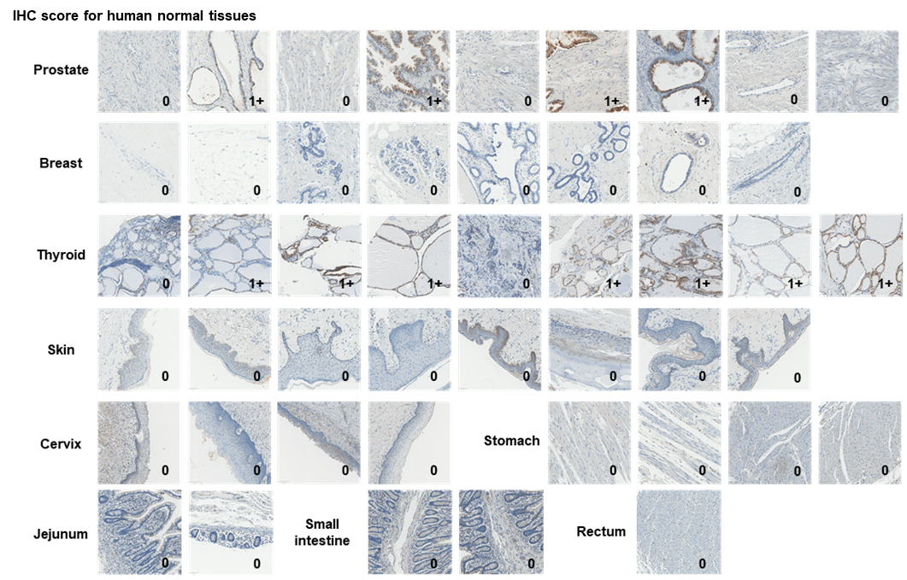
Extended Data Fig. 7. IHC staining of human normal tissues using validated antibody for IHC. Identification and scoring of CNTN4 expression by IHC in human normal tissues.

