Supporting Information for:

The polyketide to fatty acid transition in the evolution of animal lipid metabolism

Zhenjian Lin, Feng Li, Patrick J Krug and Eric W. Schmidt

This PDF file includes:

Supporting Figure: Figure S1 to S2
Supporting Table: Table S1
Legends for Datasets: S1 to S11

Other supporting materials for this manuscript include the following:

Datasets S1 to S11
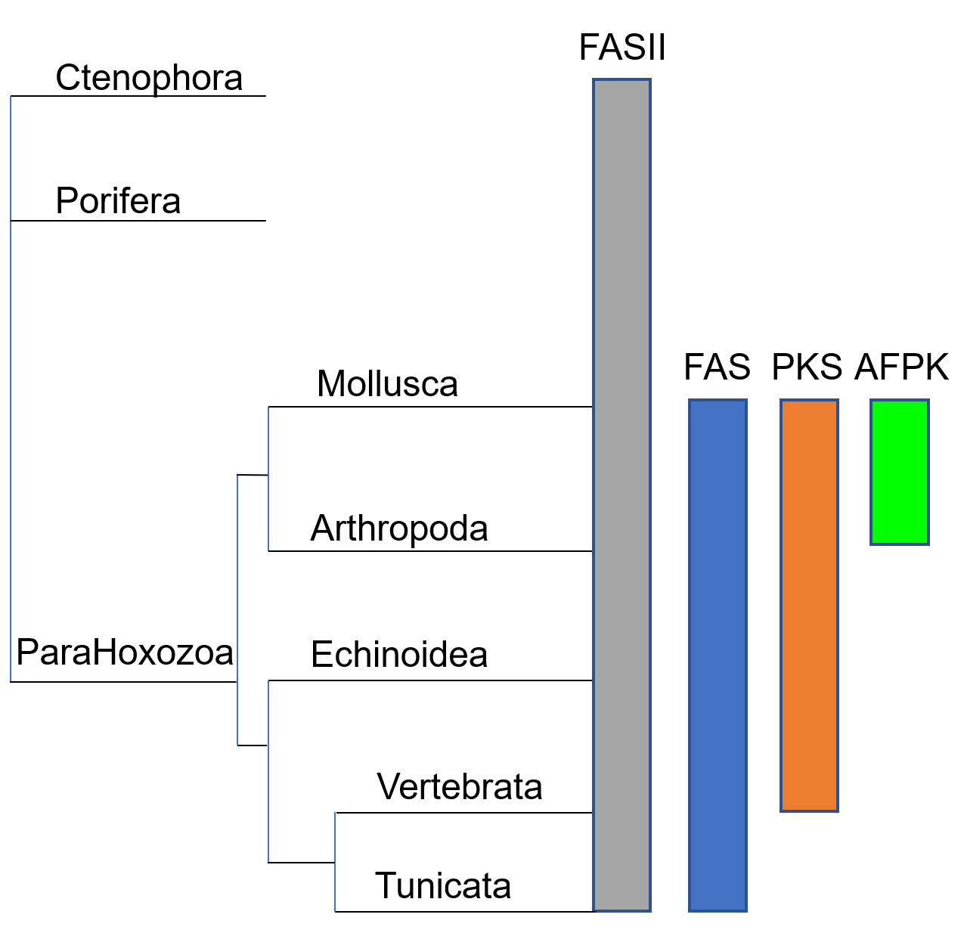
Figure S1. The distribution of the KS-containing genes in different animal phyla. AFPK can be found in Mollusca and Arthropoda.

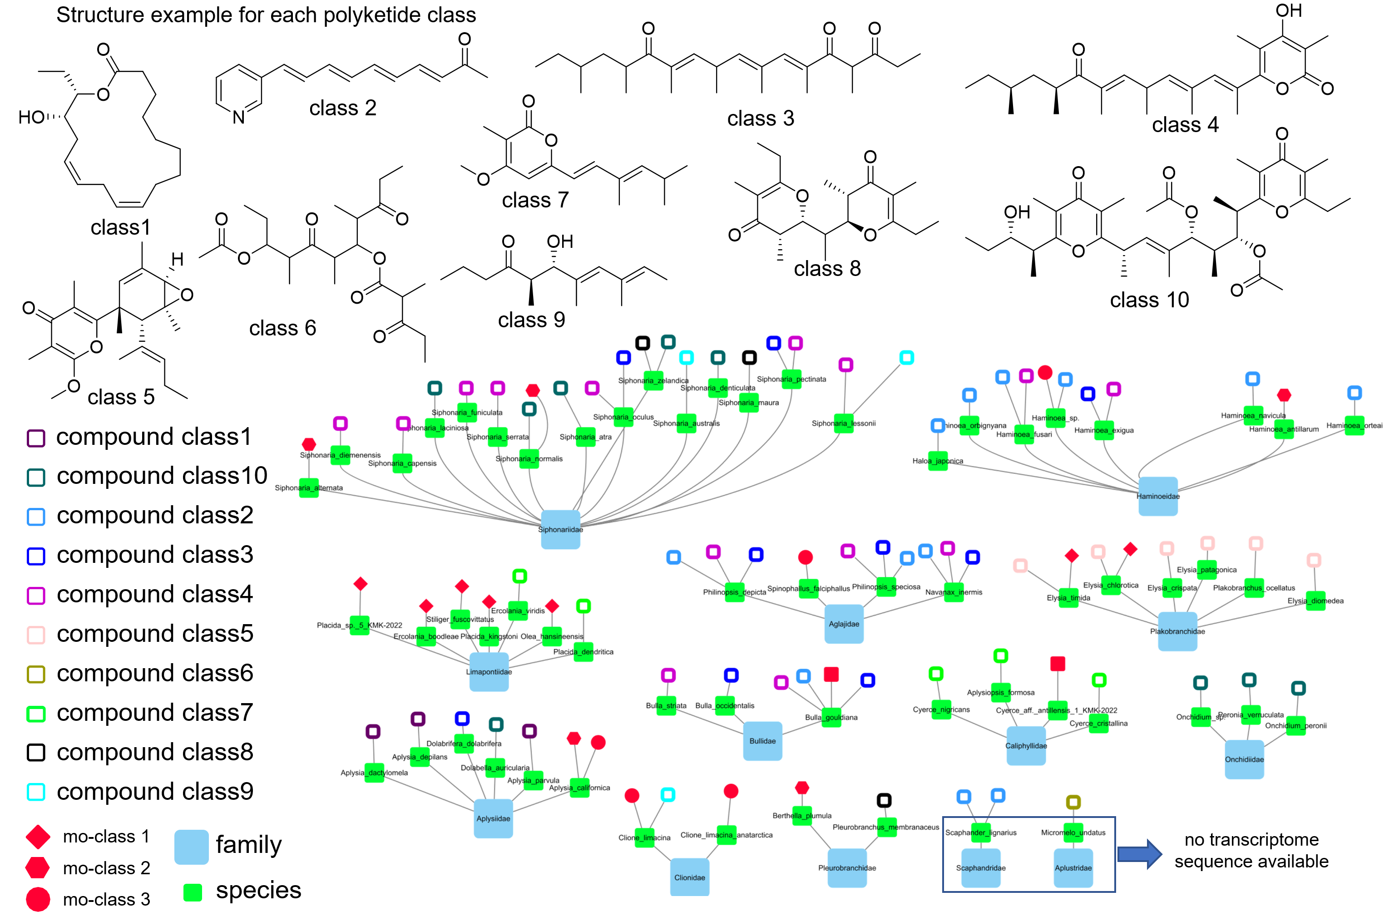

Figure S2. The distribution of the mollusca species that were found to contain polyketide compounds and the species that contain AFPKs. For most of the species that were studied for both chemistry and transcriptome sequences, they fall into the same family. Only Onchidiidae is an exception. There are no transcriptome sequences available for any species in family Scaphandridae or Aplustridae.

Table S1. The number of SRA data sets analyzed in this study.
Phylum | Mollusca | 558
Phylum | Porifera | 896
Subphylum | Vertebrata | 482
Phylum | Arthropoda | 4166
Class | Echinoidea | 732
Subphylum | Tunicata | 232

Dataset S1 (separate file).
The alignment file in PHYLIP format for making ANIMAL_KS HMM model used in Figures 2 and 6.

Dataset S2 (separate file).
The alignment file in PHYLIP format for making FAS_KS HMM model used in Figures 2 and 6.

Dataset S3 (separate file).
The alignment file in PHYLIP format for making FASII_KS HMM model used in Figures 2 and 6.

Dataset S4 (separate file).
The alignment file in PHYLIP format for making tree in Figure 3A.

Dataset S5 (separate file).
The alignment file in PHYLIP format for making mollusk FAS_KS HMM model used in Figure 3B.

Dataset S6 (separate file).
The alignment file in PHYLIP format for making mollusk PKS_KS HMM model used in Figure 3B.

Dataset S7 (separate file).
The alignment file in PHYLIP format for making tree in Figure 6B tree1.

Dataset S8 (separate file).
The alignment file in PHYLIP format for making tree in Figure 6B tree2.

Dataset S9 (separate file).
The alignment file in PHYLIP format for making mollusk arthropod ar-clade3_KS HMM model used in Figure 6C.

Dataset S10 (separate file).
The alignment file in PHYLIP format for making tree in Figure 7.

Dataset S11 (separate file).
AFPK-Finder code package

