Effect of symptomatic rate on spreading of COVID-19 evaluated by a flexible compartment model
Hiroo Ohmori, Department of Natural Environmental Studies, Graduate School of Frontier Sciences, The
University of Tokyo, 5-1-5 Kashiwanoha, Kashiwa city, Chiba Prefecture 277-8563, Japan
e-mails: ohmori@edu.k.u-tokyo.ac.jp

Tables 1-6

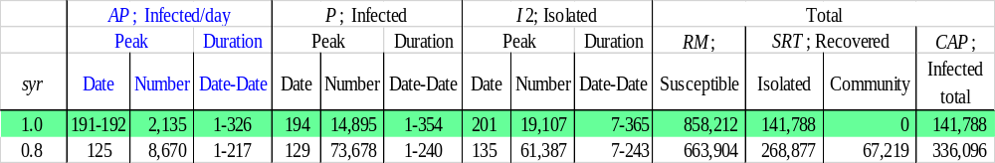
Table 1. Comparison of the number of ‘Infected/day’, ‘Infected’, ‘Isolated’, ‘Susceptible’ and ‘Recovered’ cases with symptomatic rates, syr, of 1 and 0.8. SRT is the total number of recovered individuals. The initial population, TN(1), is 1,000,000, the initial number of infected individuals, P(1), is 1, the potential (biological) infectious capacity of coronavirus, pfc(n), is 1.0, the latent period, lp(n), is 5, and the recovery period, rp(n), is 14.

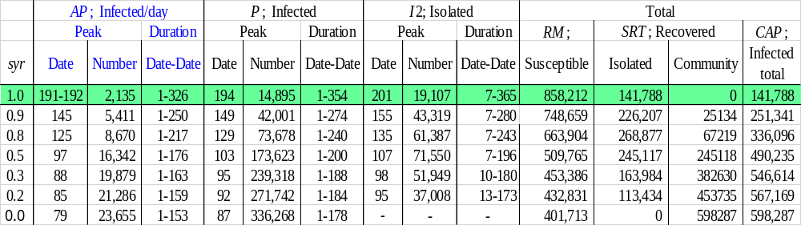
Table 2 The number of ‘infected/day’, ‘infected’, ‘isolated’, ‘susceptible’ and ‘recovered’ by different symptomatic rates (syr). TN(1) is 1,000,000, P(1) is 1, pfc(n) is 1.0, lp(n) is 5, and rp(n) is 14.

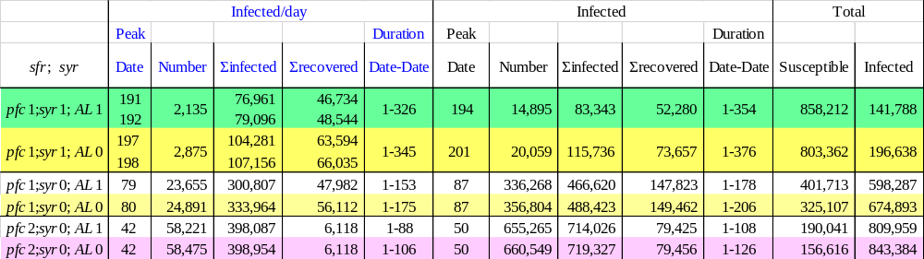
Table 3. The number of infected individuals by different pfcs when syr is set to 1 and 0.0. ‘Recovered’ for the case with a syr of 1 indicates the individuals who became symptomatic, then were isolated and recovered after the isolation period and returned to the community. ‘Recovered’ for the case with a syr of 0 indicates the individuals who were not symptomatic, were not isolated, stayed in the community and recovered after the recovery period. ‘ΣInfected’ indicates the cumulative number of infected individuals up to the peak, and ‘ΣRecovered’ indicates the cumulative number of recovered individuals up to the peak. ‘Total’ indicates the total number on the last day of the duration of the ‘Infected’. ‘AL1’ means the activity level of the recovered individuals is the same level as that of the susceptible individuals, and ‘AL0’ indicates that the recovered individuals are not active, meaning that the reduction effect of the recovered individuals on the contact rate is left out of the calculation. TN (1) is 1,000,000, P (1) is 1, lp(n) is 5 and rp(n) is 14.

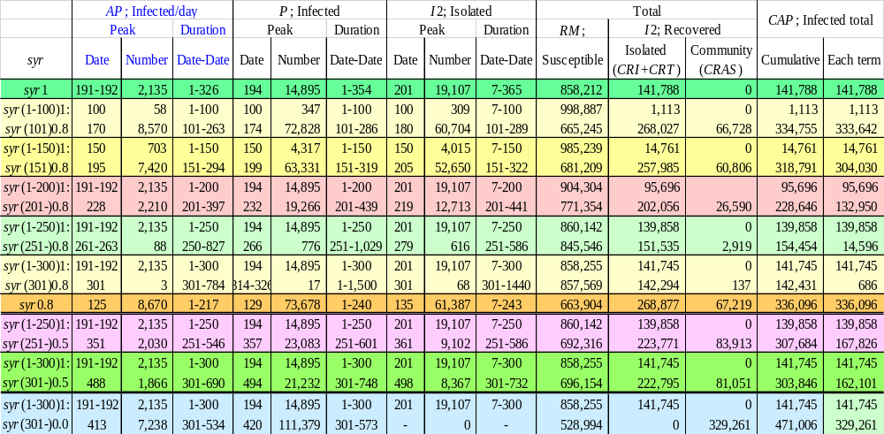
Table 4. The number of infected individuals by different ‘syr setting date’ when the symptomatic rate is set. ‘Isolated’ of ‘I2: Recovered’ indicates the individuals who became symptomatic, then were isolated and recovered after the isolation period and returned to the community, while ‘Community’ of ‘I2: Recovered’ indicates the individuals who were not symptomatic, were not isolated, stayed in the community and recovered after the recovery period. ‘Total’ indicates the total number on the last day of the duration of the ‘Infected’. ‘syr (1-300)1; syr (301-)0.5’ indicates that the symptomatic rate, syr, is 1 from the 1st to the 300th, and syr is 0.5 for the period from the 301st to the end of infection duration. TN(1) is 1,000,000, P(1) is 1, pfc(n) is 1.0, lp(n) is 5 and rp(n) is 14.

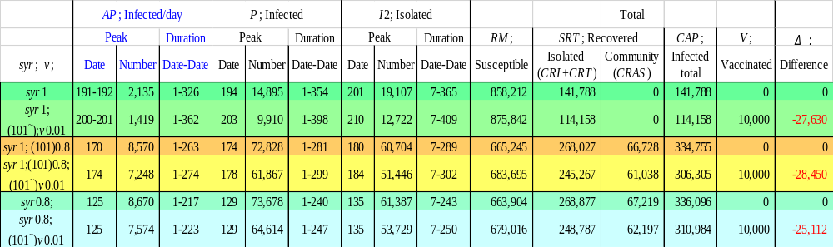
Table 5. The number of infected individuals by different ‘syr setting date’ with different vaccination rates, v, 0 or 0.01. ‘syr1;(101-)0.8; (101~)v0.01’ indicates that the symptomatic rate, syr, is 1 for the period from the 1st to the 100th, syr is 0.8 and v is 0.01 for the period from the 101st to the end of infection duration. TN(1) is 1,000,000, P(1) is 1, pfc(n) is 1.0, lp(n) is 5 and rp(n) is 14.

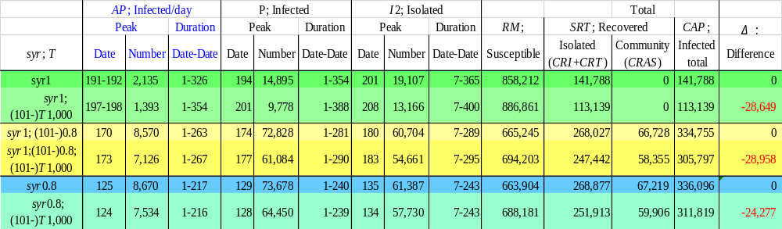
Table 6. The number of infected individuals by different ‘syr setting date’ with different numbers in tested individuals, T, 0 or 1,000. ‘syr1;(101-)0.8; (101-) T1,000’ indicates that the symptomatic rate, syr, is 1 for the period from the 1st to the 100th, and syr is 0.8 and T(n) is 1,000 for the period from the 101st to the end of infection duration. TN(1) is 1,000,000, P(1) is 1, pfc(n) is 1.0, lp(n) is 5 and rp(n) is 14.

