Journal: Plant and Soil

Nitrification inhibitor 3,4-dimethylpyrazole phosphate improves nitrogen recovery and accumulation in cotton plants by reducing NO₃⁻ leaching under ¹⁵N-urea fertilization

Ezio Nalin de Pauloª, Fernando Shintate Galindoª, Flávio Henrique Silveira Rabêlo^{b}, Joaquim José Frazãoª, José Lavres^{a,}*

ª University of São Paulo, Center for Nuclear Energy in Agriculture, Piracicaba, 13416-000, Brazil
^{b}University of São Paulo, College of Agriculture Luiz de Queiroz, Piracicaba, 13418-900, Brazil.

* For correspondence: jlavres@usp.br (J Lavres)
Mailing address: University of Sao Paulo, Centre for Nuclear Energy in Agriculture, Avenida Centenario, 303. CP 96, CEP 13416-000, Piracicaba, Brazil.
Phone number: +55 19 3429 4844

Sup. Table 1. Initial fertilization performed to cotton cultivation
Nutrient | Rate | Source
 | --- mg dm⁻³ ---
Nitrogen | 20 | NH₄SO₄
Phosphorus | 165 | Ca(H₂PO₄)₂
Potassium | 120 | KCl
Magnesium | 5 | MgCl.₇H₂O
Calcium | 84 | Ca(H₂PO₄)₂
Boron | 2 | H₃BO₃
Manganese | 2 | MnSO₄.H₂O
Zinc | 6 | ZnSO_{4.}7H₂O
Cooper | 1.5 | CuSO_{4.}5H₂O

Sup. Fig. 1. Experiment overview: Leaching columns with PVC rings positioned at 150, 300 and 450 mm in height in the internal wall (A), detail of the drip irrigation system showing the water emitter position in the column (B), overview of the leaching columns and the irrigation system (C) and overview of the cotton plants at 80 days after emergence (D).
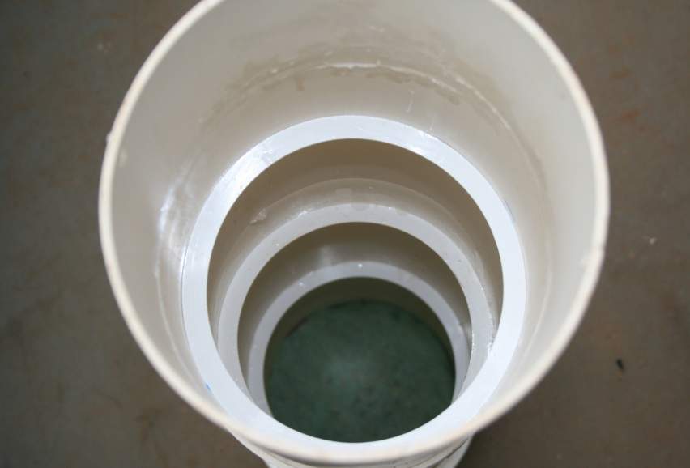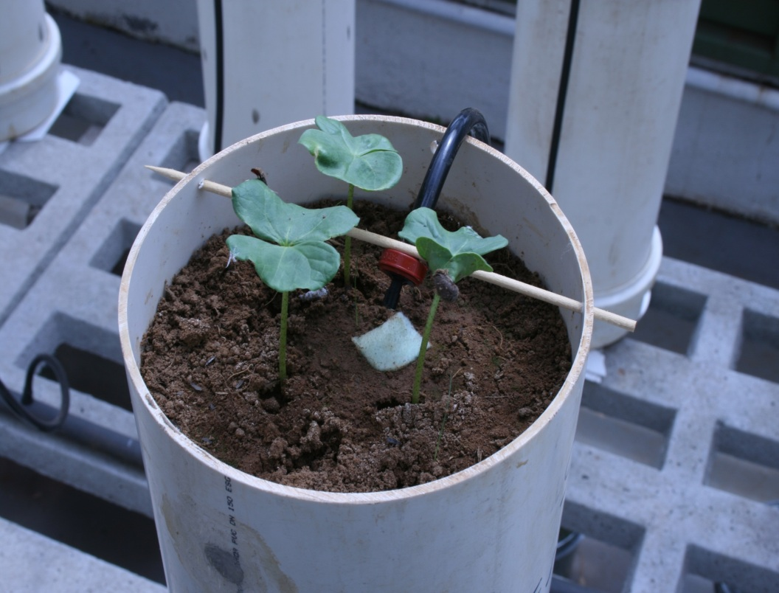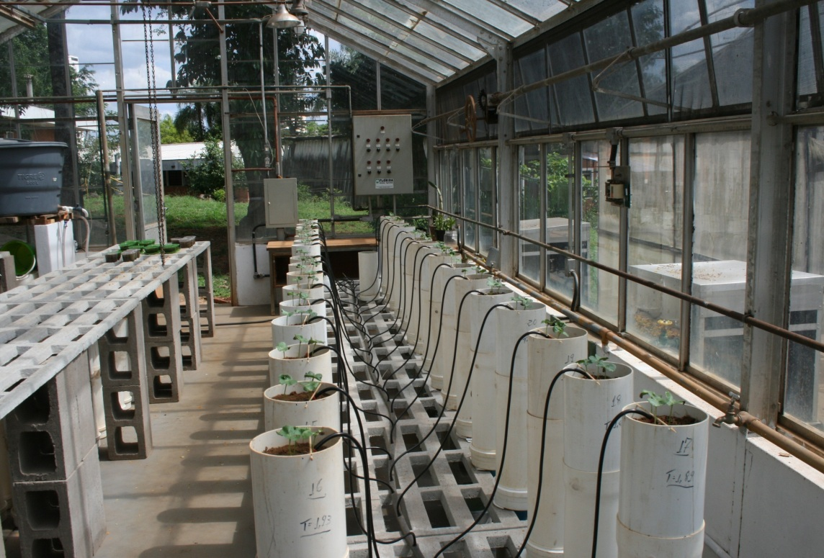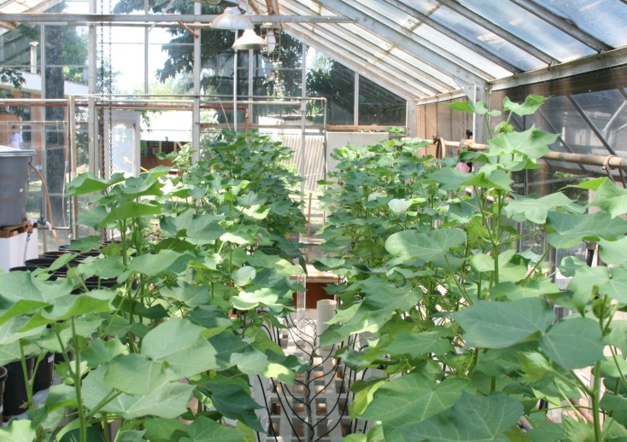
A
B
C
D

Sup. Fig. 2. Cotton shoot dry matter (A), root dry matter (B) and plant (shoot + root) dry matter (C) and N concentration in shoot (D) and root (E) as a function of N levels as urea or urea + 3,4-dimethylpyrazole phosphate (DMPP).
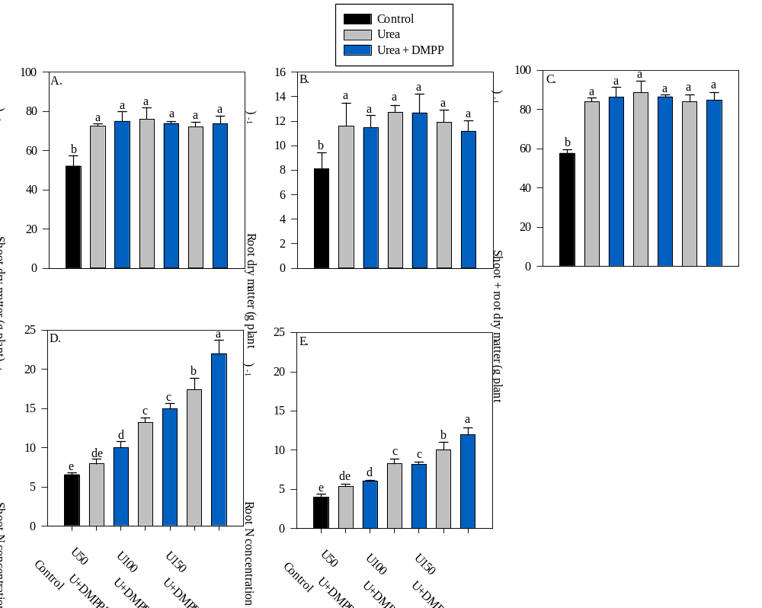
Different letters indicate significant differences between treatments according to Tukey test (p ≤ 0.05). Error bars indicate standard deviations (n = 4). Least significant difference [L.S.D. (5%)] = 9.1 (A); 2.8 (B); 8.3 (C); 2.2 (D); 1.3 (E).

